Supplementary material
Clinical risk factors for mortality among critically ill Mexican patients with COVID-19
Intensive care medicine
Carmen M. Hernández-Cárdenas¹, José Alberto Choreño-Parra^{2,3}, Carlos Torruco-Sotelo¹, Felipe Jurado¹, Héctor Serna-Secundino¹, Cristina Aguilar¹, José G. García-Olazarán¹, Diana Hernández-García¹, Eduardo M. Choreño-Parra⁴, Joaquín Zúñiga^{2,5}, and *Gustavo Lugo-Goytia¹
¹Respiratory Intensive Care Unit, Instituto Nacional de Enfermedades Respiratorias Ismael Cosío Villegas, Mexico City, Mexico. ²Laboratory of Immunobiology and Genetics, Instituto Nacional de Enfermedades Respiratorias Ismael Cosío Villegas, Mexico City, Mexico. ³Escuela Nacional de Ciencias Biológicas, Instituto Politécnico Nacional, Mexico City, Mexico. ⁴Posgrado en Ciencias Biológicas, Universidad Nacional Autónoma de México, Mexico City, Mexico. ⁵Tecnologico de Monterrey, Escuela de Medicina y Ciencias de la Salud, Mexico City, Mexico.

*Correspondence:
Gustavo Lugo-Goytia, M.D., Ph.D.
Unidad de Cuidados Intensivos Respiratorios, Instituto Nacional de Enfermedades Respiratorias Ismael Cosío Villegas, Mexico City, Mexico. Email: lugogoytia@iner.gob.mx.

Supplementary Tables
Supplementary Table 1. Logistic regression analysis of risk factors for COVID-19-associated mortality
Variable | Univariate OR | 95% CI | p-value
Male gender | 3.556 | 1.205 – 11.62 | 0.0210
Obesity | 1.868 | 0.6966 – 5.139 | 0.2151
Diabetes | 0.3692 | 0.09141 – 1.265 | 0.1148
SAH | 4.000 | 0.8376 – 28.96 | 0.0838
Prone position | 1.500 | 0.5583 – 4.110 | 0.4220
Norepinephrine | 3.696 | 1.294 – 11.47 | 0.0141
Coinfection | 2.468 | 0.9125 – 6.941 | 0.0754
White blood cells (10⁹/L) | 1.038 | 0.9268 – 1.167 | 0.5192
Neutrophils (10⁹/L) | 1.025 | 0.9099 – 1.157 | 0.6833
Lymphocytes (10⁹/L) | 2.796 | 0.9485 – 10.06 | 0.0629
NLR | 0.9475 | 0.8761 – 0.9989 | 0.0436
Hgb (g/dL) | 1.059 | 0.8244 – 1.377 | 0.6525
Platelets (10⁹/L) | 0.9985 | 0.9933 – 1.003 | 0.5482
Glucose (mg/dL) | 0.9980 | 0.9893 – 1.006 | 0.6428
Na (mmol/L) | 1.039 | 0.9190 – 1.180 | 0.5424
K (mmol/L) | 1.164 | 0.5374 – 2.596 | 0.6958
Total proteins (g/dL) | 1.868 | 0.8080 – 4.582 | 0.1453
Albumin (g/dL) | 0.6553 | 0.2451 – 1.548 | 0.3422
BUN (mg/dL) | 1.007 | 0.9881 – 1.029 | 0.4759
AST (U/L) | 1.005 | 0.9952 – 1.015 | 0.3400
ALT (U/L) | 1.003 | 0.9925 – 1.015 | 0.5485
D dimer (mg/L) | 0.9523 | 0.8068 – 1.053 | 0.3677
INR | 3.656 | 0.01540 – 1026 | 0.6399
PT (sec) | 0.9866 | 0.6924 – 1.401 | 0.9390
ALP (U/L) | 1.009 | 0.9992 – 1.023 | 0.0742
CPK (U/L) | 1.000 | 0.9999 – 1.001 | 0.1524
Procalcitonin (ng/mL) | 1.221 | 0.7334 – 2.157 | 0.4418
SO₂% | 1.008 | 0.9837 – 1.035 | 0.5099
PCO₂ (mmHg) | 0.9743 | 0.9272 – 1.021 | 0.2780
DP (cm H2O) | 1.044 | 0.8884 – 1.232 | 0.5991
Cstat (ml/cm H2O) | 1.006 | 0.9570 – 1.059 | 0.8002
VR | 0.7156 | 0.3202 – 1.514 | 0.3840
SOFA score | 1.314 | 1.030 – 1.711 | 0.0274
APACHE-II score | 1.042 | 0.9630 – 1.130 | 0.3085
95% CI, 95% confidence interval; ALP, alkaline phosphatase; ALT, alanine aminotransferase; APACHE-II, Acute Physiology and Chronic Health disease Classification System II; AST, aspartate aminotransferase; Cstat, static compliance; BUN, blood ureic nitrogen; CPK, creatine phosphokinase; DP, driving pressure; Hgb, hemoglobin; INR, international normalized ratio; NLR, neutrophil/lymphocyte ratio; OR, odds ratio; PCO₂, partial pressure of carbon dioxide in the blood; PT, prothrombin time; SAH, systemic arterial hypertension; SO₂%, oxygen saturation; SOFA, Sequential Organ Failure Assessment; VR, ventilatory ratio.
Supplementary Figures
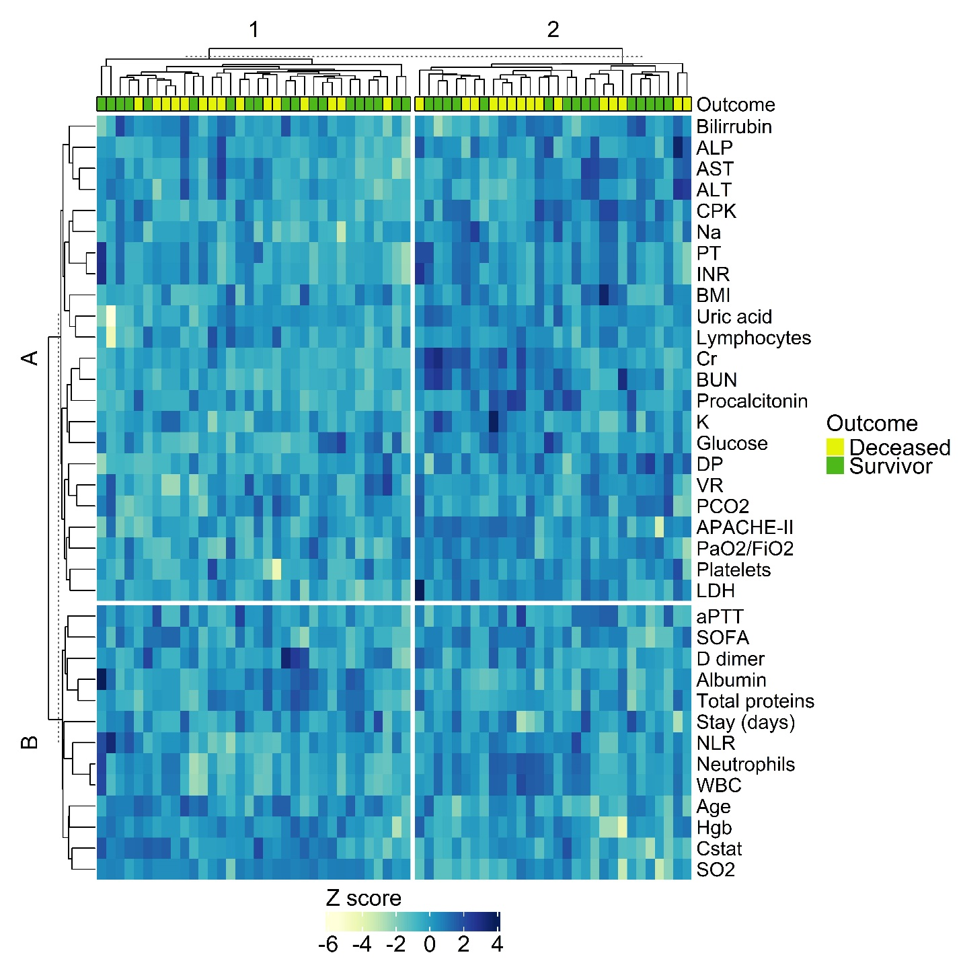Supplementary Fig. 1. K-means clustering algorithm of the clinical and laboratory characteristics of COVID-19 patients in critical condition. Before data visualization, clinical features and laboratory parameters were scaled and centered. Patients with any missing value in the variables of interest were excluded.

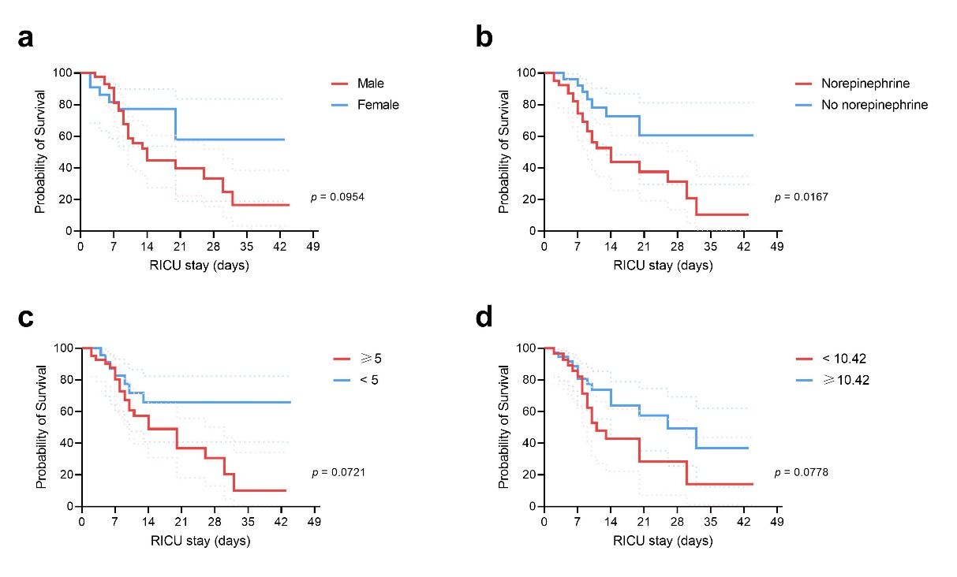
Supplementary Fig. 2. Survival of COVID-19 patients admitted to the RICU according to their clinical characteristics. Critically ill COVID-19 patients were categorized according to different clinical risk factors for mortality identified by binomial logistic regression analyses. (a) Gender. (b) Use of norepinephrine. (c) Sequential Organ Failure Assessment score. (d) Neutrophil to lymphocyte ratio. Survival curves were compared using the Kaplan-Meyer method and the log-rank test. Continuous variables were dichotomized using the best ROC curve threshold determined using the Youden index.

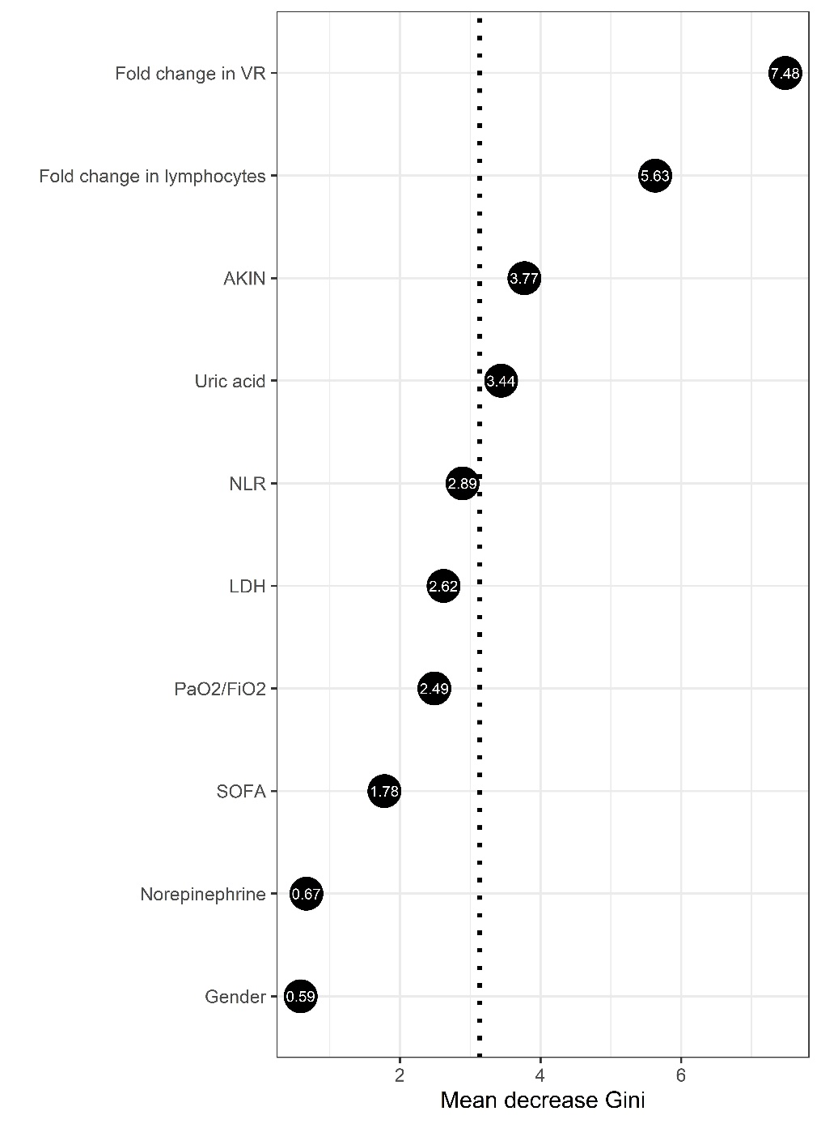

Supplementary Figure 3. Random forest analysis of selected clinical characteristics associated with mortality in critically ill COVID-19 patients. All variables with statistically significant association with mortality in the binomial regression analyses were included in a random forest analysis. The points represent the mean decrease Gini values, indicative of the importance of each variable to mortality. Variables with mean decease Gini values above the mean importance of the model (discontinuous vertical line) were considered as the most explicative variables of severe COVID-19-associated mortality in our cohort.

