Physical characteristics and cell-adhesive property of in vivo fabricated hyaluronan / bacterial cellulose nanocomposites

Ryo Takahama¹, Honami Kato¹, Go Takayama¹, Kenji Tajima² and Tetsuo Kondo¹*

¹ Graduate School of Bioresource and Bioenvironmental Sciences, Kyushu University.
West 5th, 744, Motooka, Nishi-ku, Fukuoka 819-0395, Japan.
² Faculty of Engineering, Hokkaido University, N13W8, Kita-ku, Sapporo 060-8628, Japan.

*To whom correspondence should be addressed.
E-mail: tekondo@agr.kyushu-u.ac.jp, Tel/Fax +81-(0)92-802-4668,
ORCID: 0000-0003-4366-2955

takahama-bio@agr.kyushu-u.ac.jp (R. Takahama)
katohonami1358@icloud.com (H. Kato)
gotakayama@agr.kyushu-u.ac.jp (G. Takayama)
ktajima@eng.hokudai.ac.jp (K. Tajima)
tekondo@agr.kyushu-u.ac.jp (T. Kondo)

Supporting information

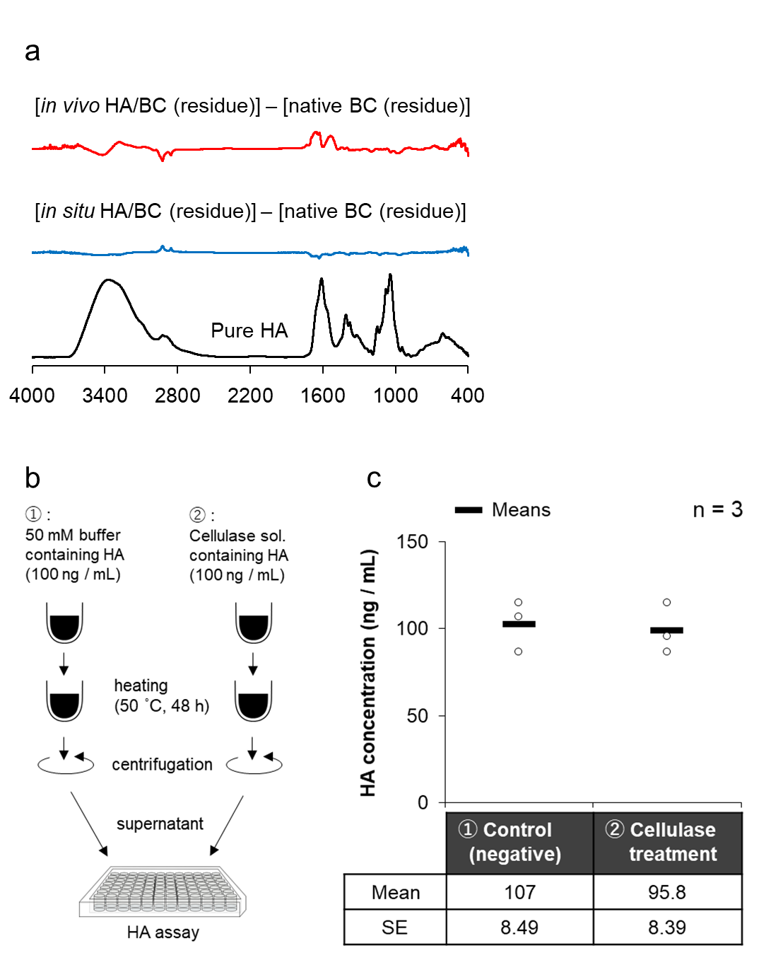
Fig. S1. (a) FT-IR difference spectra of the residues obtained after enzymatic degradation of pellicles by cellulase ONOZUKA R-10. (b, c) Illustration of the procedure (b) and the result (c) of negative control experiment, which assess the effect of cellulase treatment on ELISA-like HA assay and

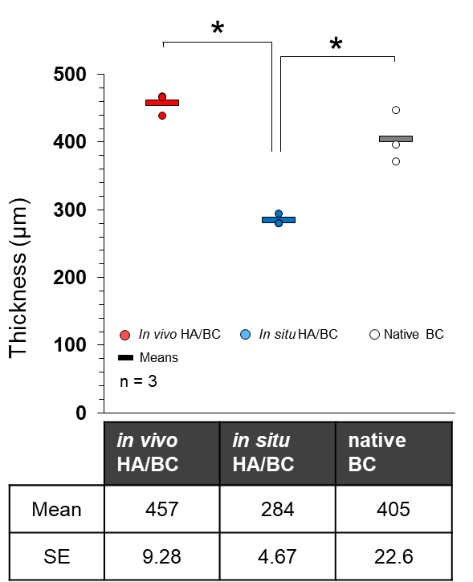
Fig. S2. The thicknesses of pellicles measured by CLSM. The values were compared statistically between groups using Tukey-Kramer test, with p < 0.05 considered as statistically significant (*).

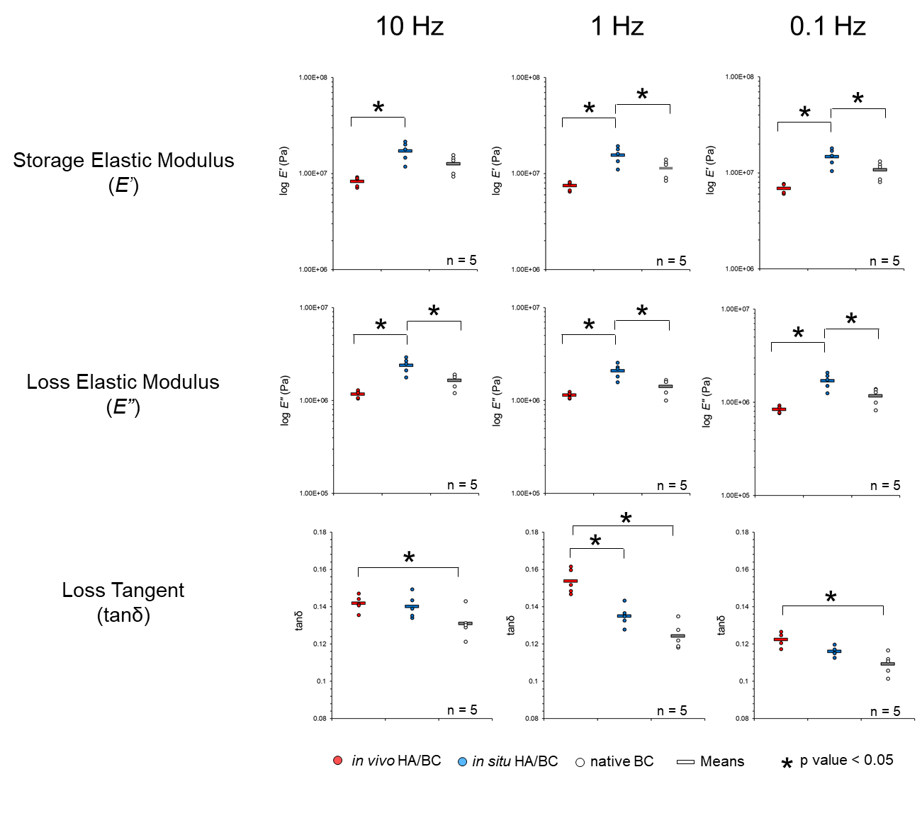
Fig. S3. Results of dynamic mechanical analysis in multiple frequency (10, 1, and 0.1 Hz). All measurements were conducted under water at 37˚C. The values were compared statistically between groups using Tukey-Kramer test, with p < 0.05 considered as statistically significant (*).

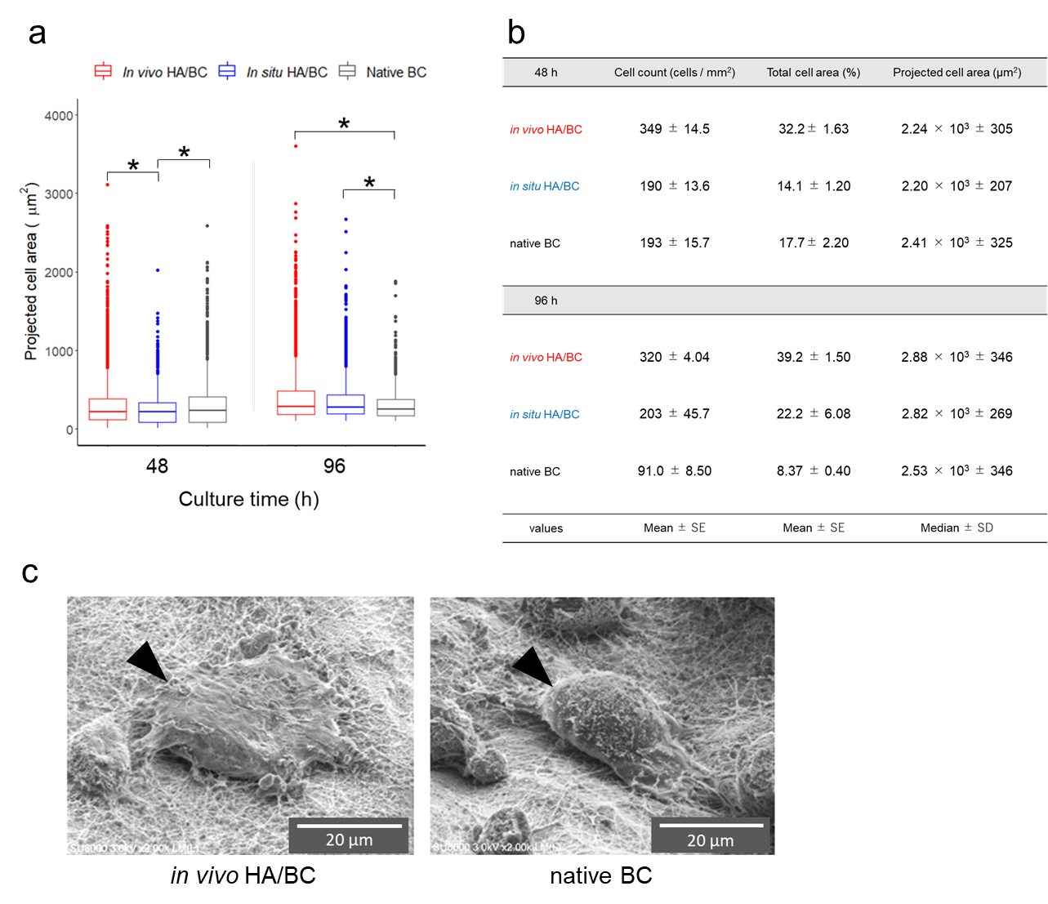
Fig. S4. (a) The projected areas of the individual normal human epidermal keratinocytes (NHEK) grown on the pellicle substrates. The values at culture periods of 48 h and 96 h were measured by CLSM. The values in each culture periods were compared statistically between groups using Tukey-Kramer test, with p < 0.05 considered as statistically significant (*). (c) FE-SEM images of NHEKs grown on the pellicle substrates.

