Additional Figures
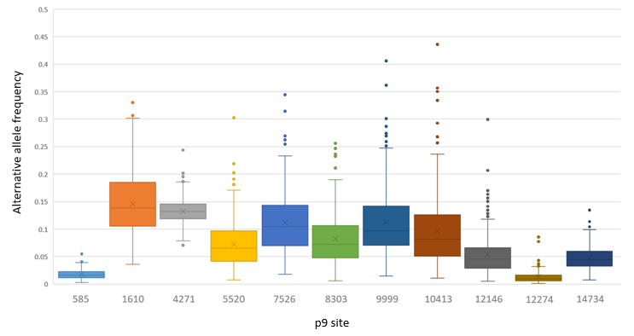Additional Figure 1. Variation in frequency of alternative allele at each of the 11 p9 sites. Alternative allele frequency is cumulative for all 266 individuals.

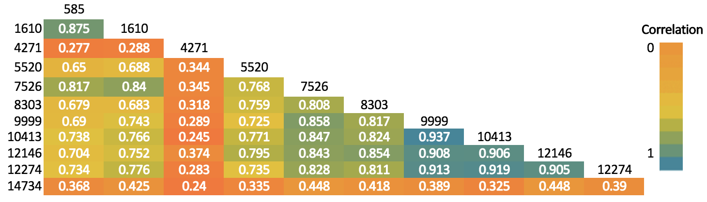Additional Figure 2. Matrix displaying Spearman Rho correlation of methylation across the 11 p9 analyzed sites.
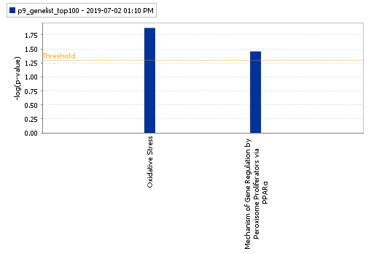
Additional Figure 3. Toxicity enrichment based on the top 100 transcripts significantly correlated with methylation at p9 site 585.

