Supplementary Data
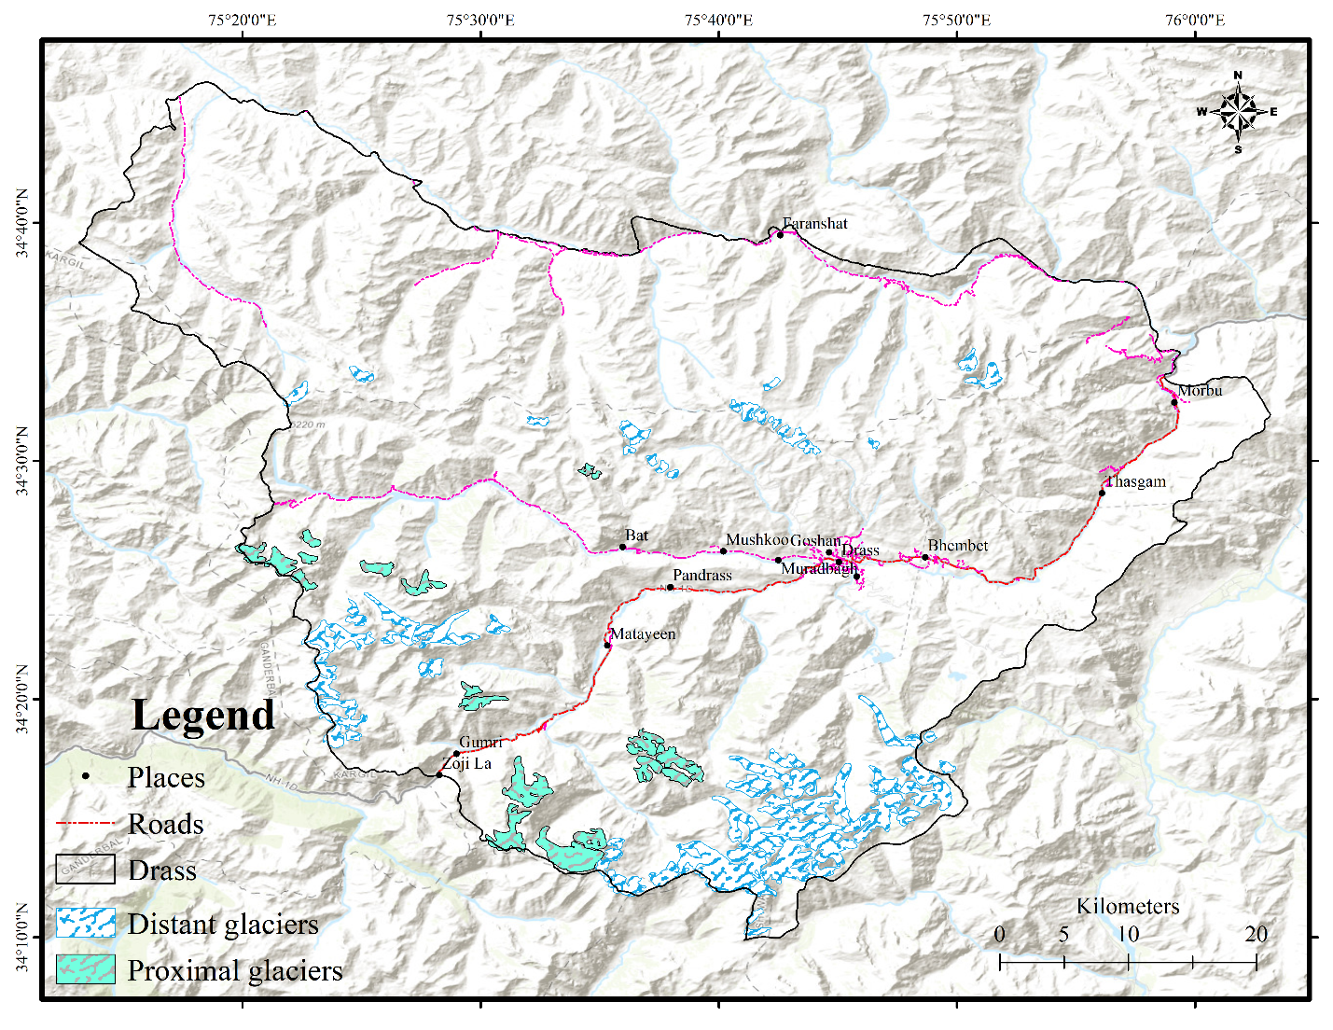
Figure S1: Proximity of the glaciers to the National Highway passing through the study area

Table S1: Glacier area changes observed from 2000-2020 in the study area
GID | Area (km²) |  | Change (km²)  (2000-2020) | % change  (2000-2020)
 | 2000 | 2020
G1 | 3.33±0.3 | 3.25±0.3 | 0.08±0.004 | 2.42
G2 | 6.87±0.5 | 6.82±0.49 | 0.05±0.003 | 0.71
G3 | 6.18±0.32 | 6.09±0.32 | 0.09±0.005 | 1.41
G4 | 1.9±0.04 | 1.82±0.04 | 0.07±0.001 | 3.81
G5 | 1.67±0.06 | 1.59±0.06 | 0.08±-0.002 | 4.58
G6 | 0.82±0.07 | 0.79±0.07 | 0.03±0.004 | 3.65
G7 | 1.14±0.07 | 1.1±0.06 | 0.03±0.009 | 3.00
G8 | 0.69±0.09 | 0.61±0.08 | 0.09±0.008 | 12.64
G9 | 0.64±0.1 | 0.59±0.09 | 0.04±0.003 | 6.94
G10 | 0.74±0.08 | 0.64±0.08 | 0.1±0.003 | 13.74
G11 | 2.83±0.14 | 2.73±0.14 | 0.09±0.007 | 3.32
G12 | 3.55±0.22 | 3.43±0.21 | 0.13±0.007 | 3.60
G13 | 14.01±0.15 | 13.73±0.15 | 0.28±0.01 | 2.01
G14 | 1.11±0.28 | 1.06±0.27 | 0.05±0.012 | 4.68
G15 | 1.37±0.17 | 1.17±0.17 | 0.2±0.004 | 14.79
G16 | 1.65±0.07 | 1.62±0.07 | 0.03±0.001 | 1.79
G17 | 1.97±0.26 | 1.92±0.25 | 0.06±0.013 | 2.89
G18 | 1.15±0.06 | 1.09±0.06 | 0.06±0.002 | 5.15
G19 | 12.02±0.36 | 11.95±0.36 | 0.07±0.005 | 0.62
G20 | 6.37±0.27 | 6.34±0.25 | 0.03±0.018 | 0.54
G21 | 1.36±0.17 | 1.28±0.15 | 0.07±0.012 | 5.50
G22 | 2.02±0.04 | 1.89±0.04 | 0.13±0.002 | 6.40
G23 | 2.54±0.23 | 2.49±0.23 | 0.05±-0.001 | 1.90
G24 | 2.36±0.18 | 2.3±0.17 | 0.06±0.008 | 2.61
G25 | 4.17±0.56 | 4.1±0.55 | 0.08±0.005 | 1.84
G26 | 5.06±0.33 | 4.87±0.33 | 0.19±0.003 | 3.80
G27 | 2.27±0.22 | 2.2±0.21 | 0.08±0.006 | 3.43
G28 | 2.59±0.28 | 2.54±0.28 | 0.05±0.001 | 2.00
G29 | 6.88±0.16 | 6.82±0.15 | 0.05±0.003 | 0.74
G30 | 2.98±0.17 | 2.88±0.16 | 0.1±0.006 | 3.23
G31 | 0.84±0.12 | 0.72±0.12 | 0.12±0.003 | 14.19
G32 | 0.82±0.09 | 0.75±0.08 | 0.07±0.005 | 8.58
G33 | 0.64±0.24 | 0.58±0.24 | 0.06±0.006 | 8.88
G34 | 4.39±0.05 | 4.25±0.05 | 0.14±0.004 | 3.16
G35 | 5.58±0.1 | 5.38±0.09 | 0.19±0.01 | 3.48
G36 | 2.39±0.17 | 2.16±0.16 | 0.23±0.006 | 9.80
G37 | 1.46±0.09 | 1.38±0.08 | 0.09±0.004 | 5.87
G38 | 2.22±0.09 | 2.16±0.09 | 0.06±0.002 | 2.75
G39 | 0.55±0.04 | 0.52±0.04 | 0.03±0.001 | 6.08
G40 | 1.63±0.09 | 1.57±0.09 | 0.06±0.004 | 3.92
G41 | 2.06±0.04 | 1.99±0.03 | 0.06±0.004 | 3.10
G42 | 0.95±0.12 | 0.84±0.12 | 0.11±0.004 | 11.49
G43 | 1.03±0.06 | 0.99±0.06 | 0.04±0.001 | 3.91
G44 | 1.18±0.06 | 1.09±0.05 | 0.09±0.009 | 7.85
G45 | 1.95±0.11 | 1.9±0.1 | 0.05±0.01 | 2.44
G46 | 0.69±0.18 | 0.65±0.17 | 0.04±0.003 | 6.26
G47 | 4.33±0.09 | 4.24±0.09 | 0.1±0.002 | 2.20
G48 | 1.25±0.08 | 1.22±0.07 | 0.03±0.007 | 2.08
G49 | 0.66±0.05 | 0.59±0.05 | 0.07±0.002 | 10.26
G50 | 1.58±0.06 | 1.49±0.06 | 0.09±0.002 | 5.67
G51 | 0.82±0.09 | 0.78±0.08 | 0.04±0.01 | 5.41
G52 | 4.83±0.2 | 4.79±0.2 | 0.04±0.01 | 0.89
G53 | 1.08±0.05 | 1.03±0.05 | 0.05±0.002 | 4.46
G54 | 1.43±0.07 | 1.36±0.07 | 0.07±0.004 | 4.63
G55 | 0.9±0.16 | 0.88±0.15 | 0.03±0.007 | 3.11
G56 | 0.76±0.04 | 0.67±0.04 | 0.09±0.004 | 12.01
G57 | 3.05±0.25 | 3.04±0.25 | 0.01±0.004 | 0.24
G58 | 4.49±0.21 | 4.48±0.21 | 0.01±0.002 | 0.29
G59 | 0.62±0.06 | 0.55±0.05 | 0.07±0.006 | 11.03
G60 | 3.7±0.06 | 3.67±0.06 | 0.03±0.003 | 0.91
G61 | 3.51±0.16 | 3.44±0.15 | 0.07±0.007 | 1.97
G62 | 3.31±0.11 | 3.23±0.1 | 0.08±0.005 | 2.36
G63 | 3.59±0.06 | 3.54±0.07 | 0.05±-0.003 | 1.43
G64 | 0.65±0.11 | 0.6±0.1 | 0.05±0.005 | 8.03
G65 | 0.54±0.11 | 0.5±0.11 | 0.04±-0.005 | 7.23
G66 | 0.38±0.08 | 0.36±0.08 | 0.03±0.006 | 6.83
G67 | 0.48±0.07 | 0.47±0.07 | 0.01±0.006 | 3.07
G68 | 0.43±0.05 | 0.41±0.04 | 0.02±0.004 | 3.62
G69 | 0.4±0.15 | 0.37±0.14 | 0.03±0.009 | 6.29
G70 | 0.41±0.07 | 0.37±0.06 | 0.04±0.004 | 9.51
G71 | 0.39±0.07 | 0.38±0.07 | 0.02±0.002 | 4.28
G72 | 0.4±0.04 | 0.39±0.04 | 0.01±0.001 | 2.18
G73 | 0.57±0.05 | 0.51±0.05 | 0.05±0.001 | 9.40
G74 | 0.27±0.04 | 0.25±0.04 | 0.02±0.001 | 7.00
G75 | 0.31±0.11 | 0.29±0.1 | 0.02±0.006 | 6.32
G76 | 0.52±0.3 | 0.47±0.29 | 0.05±0.007 | 10.12
G77 | 0.52±0.05 | 0.5±0.05 | 0.02±0.002 | 3.41
 | 176.77±10.7 | 171.46±10.37 | 5.31±0.33

Table S2: Surface Ice Velocity (SIV) of the selected 39 glaciers in the study during 1999/2000 and 2019/2020
GID | SIV_1999/2000 (m/y) |  |  | SD | SIV_2019/2020 (m/y) |  |  | SD
 | Min | Max | Mean |  | Min | Max | Mean
G1 | 0.54 | 179.69 | 17.32±3.3 | 2.85 | 0.05 | 198.92 | 14.41±1.9 | 1.6
G2 | 0.48 | 200 | 37.81±3.3 | 11.64 | 0.01 | 191.59 | 27.82±1.9 | 7.88
G3 | 0.07 | 195.41 | 20.29±3.3 | 0.75 | 0.09 | 199.42 | 16.29±1.9 | 0.27
G4 | 0.32 | 196.27 | 13.89±3.3 | 5.27 | 0.17 | 199.81 | 13.18±1.9 | 2.47
G5 | 0.51 | 58.67 | 13.64±3.3 | 5.46 | 0.42 | 36.84 | 11.39±1.9 | 3.74
G11 | 0.3 | 171.92 | 22.68±3.3 | 0.94 | 0.32 | 194.18 | 17.67±1.9 | 0.71
G12 | 1.18 | 195.65 | 28.03±3.3 | 4.72 | 0.05 | 199.84 | 20.13±1.9 | 2.44
G13 | 0.35 | 203.51 | 46.41±3.3 | 17.72 | 0.08 | 198.8 | 32.45±1.9 | 11.15
G14 | 1.15 | 139.03 | 9.24±3.3 | 8.56 | 0.13 | 174.71 | 8.67±1.9 | 5.66
G16 | 0.57 | 156.78 | 13.12±3.3 | 5.82 | 0.16 | 188.52 | 10.91±1.9 | 4.08
G19 | 0.45 | 195.22 | 39.06±3.3 | 12.52 | 0.01 | 199.97 | 32.27±1.9 | 11.03
G20 | 0.26 | 184.99 | 21.70±3.3 | 0.25 | 0.09 | 199.19 | 16.52±1.9 | 0.11
G21 | 2.66 | 18.24 | 14.89±3.3 | 4.57 | 1.33 | 24.28 | 13.35±1.9 | 2.35
G22 | 1.16 | 182.45 | 17.64±3.3 | 2.63 | 0.15 | 36.7 | 15.22±1.9 | 1.03
G23 | 1.43 | 184.05 | 17.67±3.3 | 2.6 | 0.2 | 199.41 | 15.35±1.9 | 0.94
G24 | 1.02 | 186.87 | 16.66±3.3 | 3.32 | 0.03 | 195.74 | 14.35±1.9 | 1.65
G25 | 0.14 | 137.51 | 32.20±3.3 | 7.67 | 0.06 | 196.99 | 22.71±1.9 | 4.27
G26 | 0.6 | 200.77 | 17.74±3.3 | 2.56 | 0.12 | 198.72 | 15.74±1.9 | 0.66
G27 | 0.5 | 178.6 | 15.16±3.3 | 4.38 | 0.07 | 199 | 13.39±1.9 | 2.32
G28 | 0.41 | 182.78 | 21.88±3.3 | 0.37 | 0.08 | 193.06 | 17.27±1.9 | 0.42
G29 | 1.54 | 203.52 | 36.09±3.3 | 10.42 | 0.18 | 197.43 | 26.57±1.9 | 7
G30 | 1.12 | 203.45 | 13.21±3.3 | 5.76 | 0.13 | 156.39 | 11.10±1.9 | 3.94
G34 | 0.5 | 195.02 | 28.01±3.3 | 4.71 | 0.22 | 190.75 | 19.17±1.9 | 1.76
G35 | 0.48 | 164.54 | 31.03±3.3 | 6.84 | 0.08 | 199.35 | 22.55±1.9 | 4.15
G36 | 1.08 | 60.5 | 8.00±3.3 | 9.44 | 0.22 | 57.08 | 7.23±1.9 | 6.68
G37 | 1.41 | 187.33 | 12.36±3.3 | 6.36 | 0.04 | 168.68 | 10.17±1.9 | 4.6
G38 | 1.81 | 123.36 | 13.74±3.3 | 5.39 | 0.01 | 154.54 | 12.28±1.9 | 3.11
G40 | 0.7 | 133.44 | 12.65±3.3 | 6.16 | 0.06 | 181.51 | 10.41±1.9 | 4.43
G41 | 1.07 | 19.93 | 17.60±3.3 | 2.66 | 0.08 | 196.33 | 15.20±1.9 | 1.05
G47 | 0.55 | 179.93 | 25.77±3.3 | 3.12 | 0.14 | 199.9 | 18.43±1.9 | 1.24
G48 | 0.91 | 21.8 | 9.73±3.3 | 8.22 | 0.19 | 185.63 | 9.61±1.9 | 5
G52 | 0.65 | 177.23 | 34.65±3.3 | 9.4 | 0.14 | 199.28 | 24.55±1.9 | 5.57
G53 | 1.87 | 203.4 | 8.39±3.3 | 9.17 | 0.13 | 122.32 | 8.01±1.9 | 6.13
G54 | 0.97 | 67.55 | 11.18±3.3 | 7.19 | 0.35 | 60.13 | 9.82±1.9 | 4.85
G57 | 0.64 | 181.48 | 24.76±3.3 | 2.41 | 0.27 | 199.06 | 18.10±1.9 | 1.01
G58 | 0.41 | 172.97 | 30.21±3.3 | 6.26 | 0.09 | 193.61 | 21.13±1.9 | 3.15
G60 | 0.54 | 174.01 | 29.97±3.3 | 6.09 | 0.23 | 194.93 | 20.81±1.9 | 2.92
G61 | 1.26 | 165.28 | 25.89±3.3 | 3.21 | 0.2 | 149.31 | 18.89±1.9 | 1.56
G62 | 0.28 | 197.68 | 22.56±3.3 | 0.85 | 0.15 | 199.65 | 17.28±1.9 | 0.43
Avg. | 0.82 | 158.48 | 21.35±3.3 |  | 0.17 | 170.04 | 16.68±1.9

Table S3: Uncertainties in the Surface Ice Velocity measurements
Acquisition date |  | Sensor | Uncertainty (m a⁻¹)
Pre | Post |  | N_{Pixels} | M_{stable area} | σ_{stable area} | U_{SIV}  (M_{stable area} + σ_{stable area})
19-08-1999 | 04-09-2000 | ETM⁺ | 5137 | 1.9 | 1.4 | 3.3
16-08-2019 | 05-10-2020 | OLI | 5326 | 1.2 | 0.7 | 1.9
Where (N_{pixels}) is the number of pixels over the non-glaciated stable area, (M_{stable area}) is the mean velocity over the non-glaciated stable area, (σ_{stable area}) is standard deviation of the mean velocity and (U_{SIV}) is the uncertainty in the velocity pairs.

Table S4: Mean mass balance of glaciers in the study area from 2000-2012.
GID | MB (m w.e.a⁻¹) | GID | MB (m w.e.a⁻¹)
G1 | -1.05 ±0.41 | G41 | -1.40 ±0.45
G2 | -1.02 ±0.32 | G42 | -1.31 ±0.37
G3 | -1.08 ±0.37 | G43 | -1.03 ±0.11
G4 | -1.35 ±0.20 | G44 | -1.09 ±0.44
G5 | -1.05 ±0.44 | G45 | -1.18 ±0.47
G6 | -1.17 ±0.22 | G46 | -1.20 ±0.46
G7 | -1.07 ±0.10 | G47 | -0.37 ±0.44
G8 | -1.28 ±0.34 | G48 | -0.44 ±0.28
G9 | -0.83 ±0.20 | G49 | -1.43 ±0.69
G10 | -1.06 ±0.46 | G50 | -1.05 ±0.49
G11 | -1.07 ±0.43 | G51 | -1.13 ±0.57
G12 | -1.07 ±0.26 | G52 | -1.20 ±0.41
G13 | -1.04 ±0.34 | G53 | -1.07 ±0.10
G14 | -0.75 ±0.51 | G54 | -1.12 ±0.16
G15 | -1.13 ±0.24 | G55 | -0.95 ±0.36
G16 | -1.19 ±0.04 | G56 | -0.87 ±0.42
G17 | -1.55 ±0.37 | G57 | -1.26 ±0.29
G18 | -0.36 ±0.33 | G58 | -1.43 ±0.11
G19 | -1.15 ±0.24 | G59 | -1.21 ±0.48
G20 | -1.07 ±0.34 | G60 | -1.24 ±0.45
G21 | -0.70 ±0.09 | G61 | -1.11 ±0.39
G22 | -0.84 ±0.32 | G62 | -1.13 ±0.20
G23 | -1.02 ±0.31 | G63 | -1.19 ±0.43
G24 | -1.11 ±0.30 | G64 | -1.31 ±0.14
G25 | -0.82 ±0.38 | G65 | -1.29 ±0.15
G26 | -0.98 ±0.28 | G66 | -1.37 ±0.18
G27 | -1.05 ±0.17 | G67 | -1.29 ±0.26
G28 | -1.12 ±0.33 | G68 | -1.32 ±0.37
G29 | -1.04 ±0.19 | G69 | -1.12 ±0.18
G30 | -0.78 ±0.43 | G70 | -1.39 ±0.20
G31 | -0.86 ±0.39 | G71 | -0.71 ±0.38
G32 | -0.98 ±0.28 | G72 | -1.13 ±0.15
G33 | -0.89 ±0.35 | G73 | -1.14 ±0.16
G34 | -1.47 ±0.45 | G74 | -1.33 ±0.15
G35 | -1.20 ±0.41 | G75 | -1.26 ±0.14
G36 | -0.83 ±0.28 | G76 | -1.27 ±0.20
G37 | -0.88 ±0.34 | G77 | -0.92 ±0.48
G38 | -1.03 ± 0.40
G39 | -1.04 ±0.32
G40 | -0.83 ± 0.06

Table S5: BC mass concentrations at various high altitude sites in the Hindu Kush Himalaya
Locations | Altitude (m asl) | Study Period | BC  (ng m⁻³) | Reference
Hanle, Leh, India | ~4520 | August 2009 - December 2011 | 109+27 (P) | Nair et al., 2013
 |  |  | 67+ 28 (W)
Satopant glacier, Uttarakhand, India | ~4400 | 28 September - 5 October 2011 | 109 | Nair et al., 2013
NCO-P, Nepal | 5079 | March 2006 - February 2008 | 160 | Marinoni et al. 2010
Linzhi, Tibet, China | 3300 | January, 2009 | 760 | Cao et al. 2010
Qomolangma  (Mt. Everest)  Station | 4276 | May 2015–May  2017 | 298 | Chen et al.  (2018)
Mutztagh Ata, West Tibet, China | 4500 | December 2003-February 2006 | 55 | Cao et al. 2009
Machoi Glacier | ~4110 | 29 September -03 October 2014 | 1518 | Present Study

Table S6: Mean monthly values of GHGs over study area.
Month | NO₂ molecules cm² (OMI) | O₃ ppb (AIRS) | CH₄ ppb (AIRS) | Water Vapour kg/m² (AIRS) | CO₂ ppm (GOSAT)
Jan | 9.22E+14 | 50.71 | 1862.51 | 9.98 | 398.92
Feb | 8.60E+14 | 54.47 | 1859.7 | 11.94 | 400.41
Mar | 8.60E+14 | 56.76 | 1865.09 | 13.96 | 401.37
Apr | 1.22E+15 | 64.86 | 1866.9 | 17.84 | 402.38
May | 1.76E+15 | 68.53 | 1869.9 | 21.82 | 403.39
Jun | 1.87E+15 | 68.08 | 1874.52 | 31.54 | 401.48
Jul | 1.58E+15 | 59.63 | 1871.09 | 43.71 | 396.06
Aug | 1.45E+15 | 55.33 | 1883.7 | 43.67 | 392.71
Sep | 1.23E+15 | 56.72 | 1899.89 | 32.19 | 391.78
Oct | 1.16E+15 | 54.47 | 1882.12 | 18.01 | 393.75
Nov | 1.29E+15 | 49.4 | 1868.48 | 12.15 | 395.87
Dec | 1.27E+15 | 47.95 | 1869.31 | 9.79 | 397.07

