SUPPLEMENT

Study | Rebleeding Rate in EO Group | Rebleeding Rate in PTAE Group
Lau 2019 | 14/123 | 6/96
Laursen 2014 | 8/56 | 1/31
Mille 2015 | 5/47 | 6/55
Kamiski 2017 | 11.50 | 3/25
Kamiski 2019 | 50/341 | 2/58
Total | 88/617 (14.3%) | 18/265 (6.8%)
S. Table 1: Rebleeding rate between EO (14.3%) and PTAE (6.8%) groups. EO: endoscopy only. PTAE: prophylactic transcatheter embolization

Study | Need of Surgical Intervention in EO Group | Need of Surgical Intervention in PTAE Group
Lau 2019 | 1/123 | 0/96
Laursen 2014 | 0/56 | 0/31
Mille 2015 | 0/47 | 0/55
Kamiski 2017 | 17/50 | 2/25
Kamiski 2019 | 71/341 | 6/58
Total | 86/617 (14.4%) | 8/265 (3.0%)
S. Table 2: Pooled rate of surgical intervention after EO (86/617, 14.4%) or PTAE (8/265, 3%). EO: endoscopy only. PTAE: prophylactic transcatheter embolization.

Study | Mortality in EO Group | Mortality in PTAE Group
Lau 2019 | 5/123 | 0/96
Laursen 2014 | 8/56 | 1/31
Mille 2015 | 5/47 | 7/55
Kamiski 2017 | 8/50 | 1/25
Kamiski 2019 | 28/341 | 3/58
Total | 54/617 (8.8%) | 12/265 (4.5%)
S. Table 3: Mortality rate between EO (8.8%) and PTAE (4.5%) groups. EO: endoscopy only. PTAE: prophylactic transcatheter embolization.

Clinical Variable | Study Number | Rebleed |  | Mortality
 |  | OR (95%CI) | P value | OR (95%CI) | P value
Hemoglobin (mean or median)
<8.0 | 3^{c,d,e} | 1.495 (0.694-3.219) | 0.305 | 1.458 (0.545-3.897) | 0.452
≥8.0 | 2^{a,b} | 3.642 (1.491-8.895) | 0.005 | 8.77 (3.344-22.997) | <0.001
Percentage of NSAID use (excluding aspirin)
≥20% | 2^{c,d} | 2.83 (0.91-8.87) | 0.074 | 8.0 (1.753-36.512) | 0.007
<20% | 2^{a,b} | 1.49 (0.69-3.22) | 0.305 | 1.458 (0.545-3.897) | 0.452
Follow-up
30-day | 3^{a,b,c} | 1.816 (0.896-3.683) | 0.098 | 2.209 (0.94-5.192) | 0.069
NS | 2^{d,e} | 3.394 (1.268-9.082) | 0.015 | 8.981 (3.05-26.439) | <0.001
S. Table 4: Subgroup analysis of the efficacy of prophylactic transcatheter embolization in non-variceal upper gastrointestinal bleeding. OR: odds ratio. a: Mile 2015; b: Lau 2018; c :Laursen 2014; d: Kamiski 2017; e: Kamiski 2019

Study Omitted | Estimate | 95% Confidence Interval
Mille 2015 | 2.8606365 | 1.4813247 - 5.5242724
Lau 2018 | 2.5500574 | 1.2757051 - 5.0974102
Larusen 2014 | 2.1709063 | 1.2014346 - 3.9226725
Kamiski 2017 | 2.401356 | 1.2882692 - 4.4761691
Kamiski 2019 | 1.8683306 | .99629974 - 3.5036235
Combined | 2.3438137 | 1.328911 - 4.133808
S. Table 5.1: Sensitivity Analysis of the odds ratio of rebleeding risk after PTAE versus conservative management.

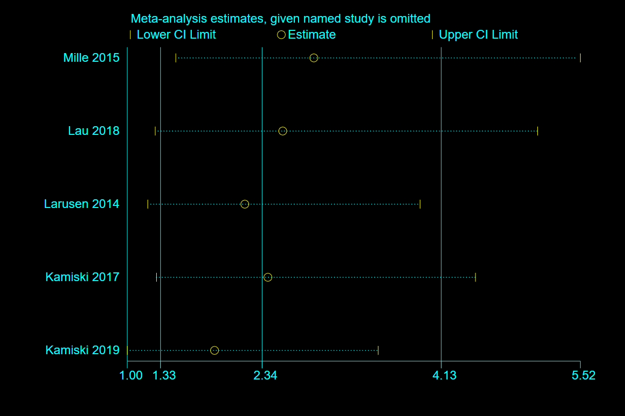
S. Figure 1.1: Sensitivity Analysis of the odds ratio of rebleeding risk after PTAE versus conservative management.

Study Omitted | Estimate | 95% Confidence Interval
Mille 2015 | 3.1018512 | 1.2680222 - 7.5877862
Lau 2018 | 1.8166653 | .89489925 - 3.6878705
Larusen 2014 | 1.8427566 | .89437312 - 3.7967956
Kamiski 2017 | 1.8780748 | .91301966 - 3.8631861
Kamiski 2019 | 2.3633807 | 1.0529445 - 5.3047128
Combined | 2.1060643 | 1.0676613 - 4.1544137
S. Table 5.2: Sensitivity Analysis of the odds ratio of mortality after PTAE versus conservative management.

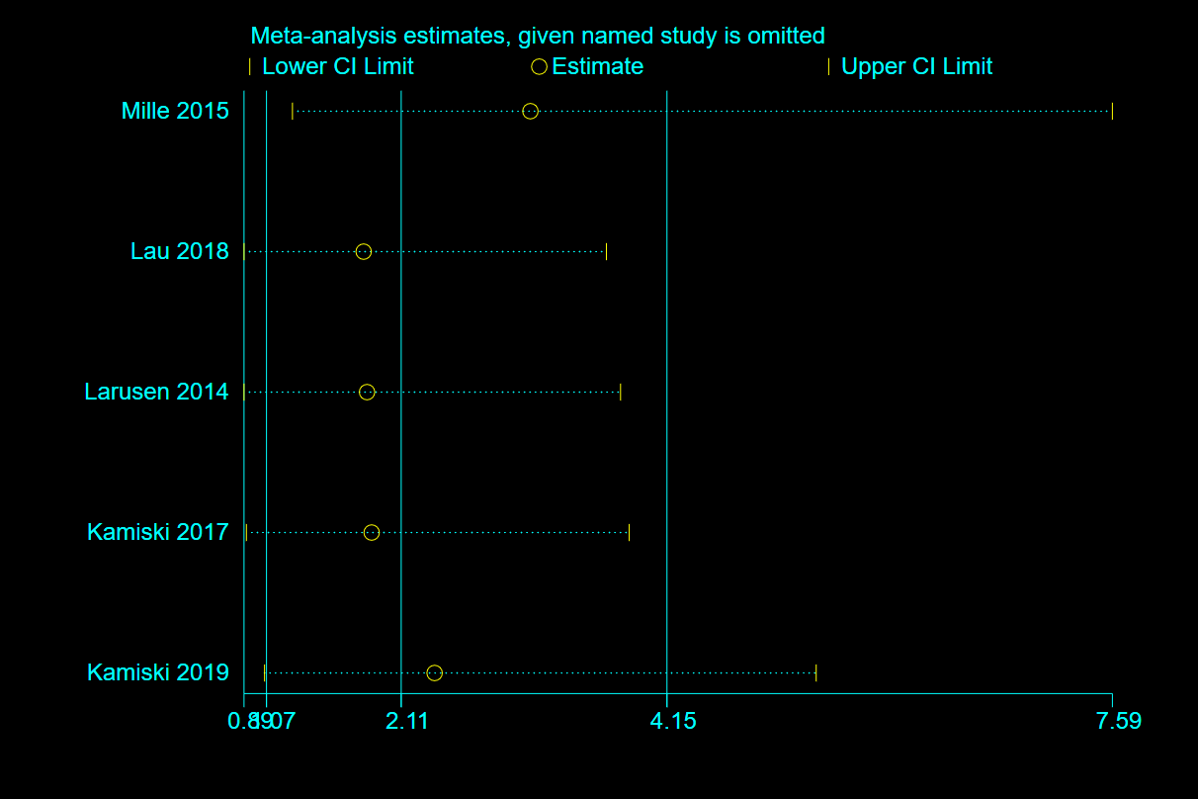
S. Figure 1.2: Sensitivity Analysis of the odds ratio of rebleeding risk after PTAE versus conservative management.

Study | Selection |  |  |  | Comparability | Outcome |  |  | Overall
 | Representativeness  of the exposed  cohort | Selection  of the  non-exposed  cohort | Ascertainment  Of  Exposure | Outcome of  Interest was  not present  at start of study | Comparability of Cohorts on the Basis of the Design or Analysis | Assessment of  Outcome | Follow-Up Long Enough for Outcomes to Occur | Adequacy of Follow Up of Cohorts
Mille 2005 | ★ | ★ | ★ | ★ | ★☆ | ★ | ★ | ★ | 8
Kamiski 2017 | ★ | ★ | ★ | ★ | ★☆ | ★ | ★ | ☆ | 7
Kamiski 2019 | ★ | ★ | ★ | ★ | ★☆ | ★ | ★ | ☆ | 7

Supplement Table 6.1: Newcastle Ottawa Scale (NOS) of cohort studies was used to evaluate the quality for each eligible study.

Study | Selection Bias |  | Performance Bias | Detection Bias | Attrition Bias | Reporting Bias | Other Bias | Total
 | Random Sequence Generation | Allocation Concealment | Blinding of Participants and Personnel | Blinding of Outcome Assessment | Incomplete Outcome Data | Selective Reporting | Many patients allocated to the treatment group did not end up receiving the treatment | Low on Risk of Bias
Lau | Low | High | High | High | Low | Low | High | 3/7
Laursen | Low | High | High | High | Low | Low | High | 3/7
Supplement Table 6.2: The Cochrane Collaboration’s tool for assessing risk of bias in randomized trials.

