SUPPLEMENTARY FIGURES
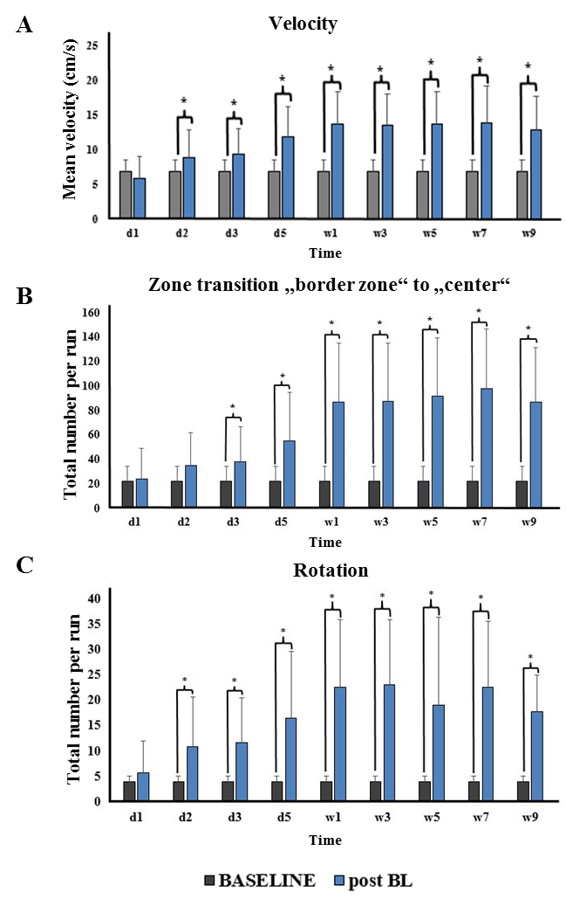
Supplementary Figure 1: Behavioural parameters for the entire group of rats in the open field. A) Locomotor velocity from baseline to 9 weeks post BL. B) Total number of zone transition from border to center zone at different time points post BL compared to baseline. C) Total number of rotations per run at different time points post BL. Values are depicted as mean + standard deviation; *significant difference (p<0.05). BL: bilateral labyrinthectomy, d: day, w: week.

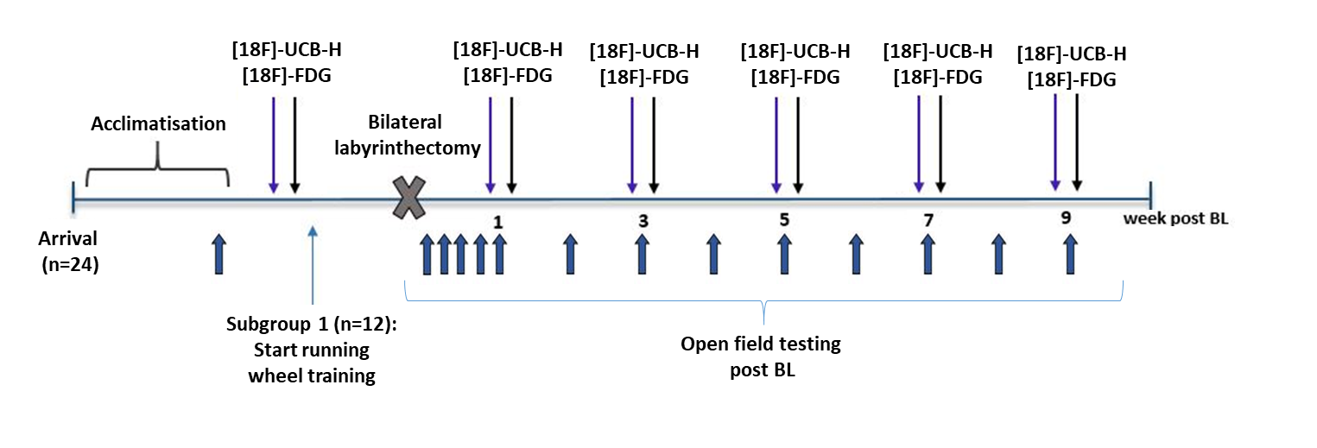
Supplementary Figure 2: Experimental protocol.

