SUPPLEMENTARY MATERIAL
Semiconductor Two-dimensional PdQ₂ (Q=S, Se) monolayer: Strain Modulating electronic band gaps and SQ Efficiencies
Dhara Raval¹, Sanjeev K. Gupta^{2, *}, P. N. Gajjar^{3, *} and Rajeev Ahuja⁴
^{1,3}Department of Physics, University School of Sciences, Gujarat University, Ahmedabad 380009, India.
²Computational Materials and Nanoscience Group, Department of Physics and Electronics, St. Xavier's College, Ahmedabad 380009, India.
³Ångströmlaboratoriet, Department of Physics and Astronomy, Uppsala University, Lägerhyddsvägen 1, Box 516, 751 20 Uppsala, Sweden.

(24, November, 2021)

Keyword (s): 2D monolayer, Density functional theory, Band structure, Carrier mobility, SQ efficiency
*Corresponding authors: Prof. (Dr.) P. N. Gajjar (E-mail: pngajjar@gujaratuniversity.ac.in, pngajjar@rediffmail.com) and Dr. Sanjeev K. Gupta (E-mail: sanjeev.gupta@sxca.edu.in)

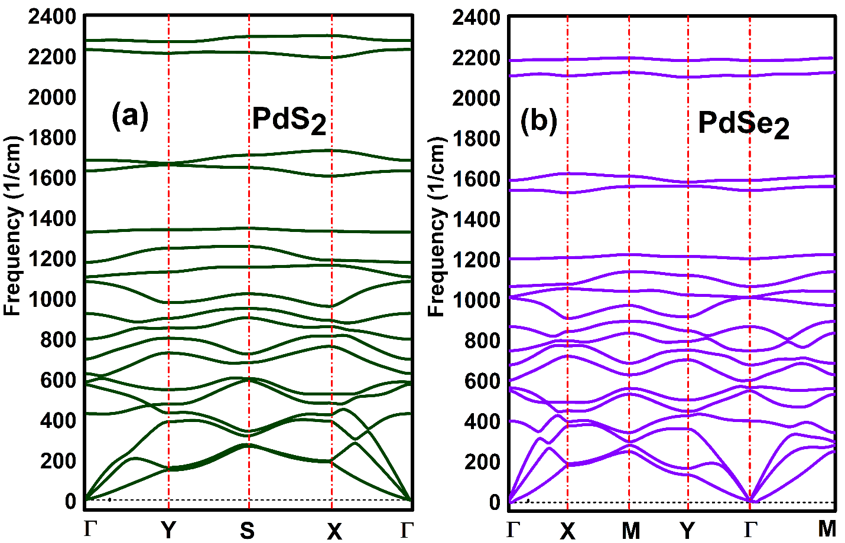

Figure S1. (colour online) Phonon spectrum of penta-PdQ₂ monolayers. (a) For penta-PdS₂ and (b) For penta-PdSe₂.

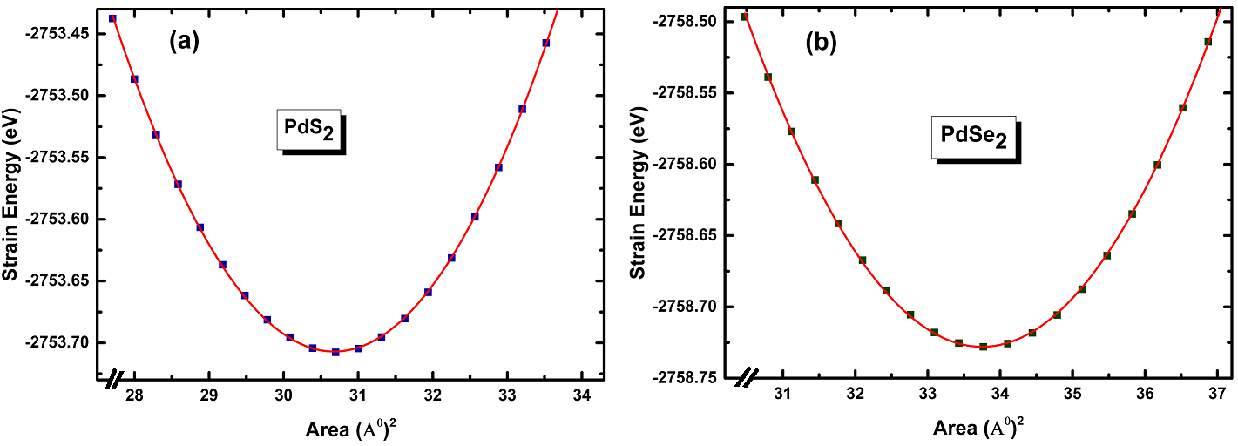
Figure S2. (colour online) The Strain energy (eV) vs area (Å²) curve under unstrained and loaded structures. (a) For penta-PdS₂ and (b) For penta-PdSe₂

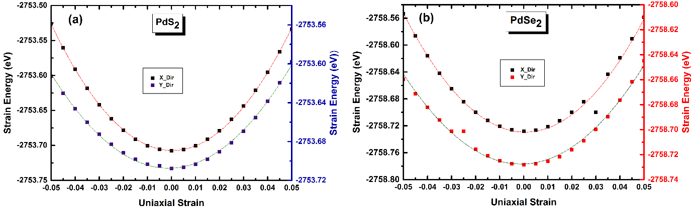

Figure S3. (colour online) The strain energy (eV) vs uniaxial strain (x or y) curve under pristine and loaded structures. (a) For penta-PdS₂ and (b) For penta-PdSe₂

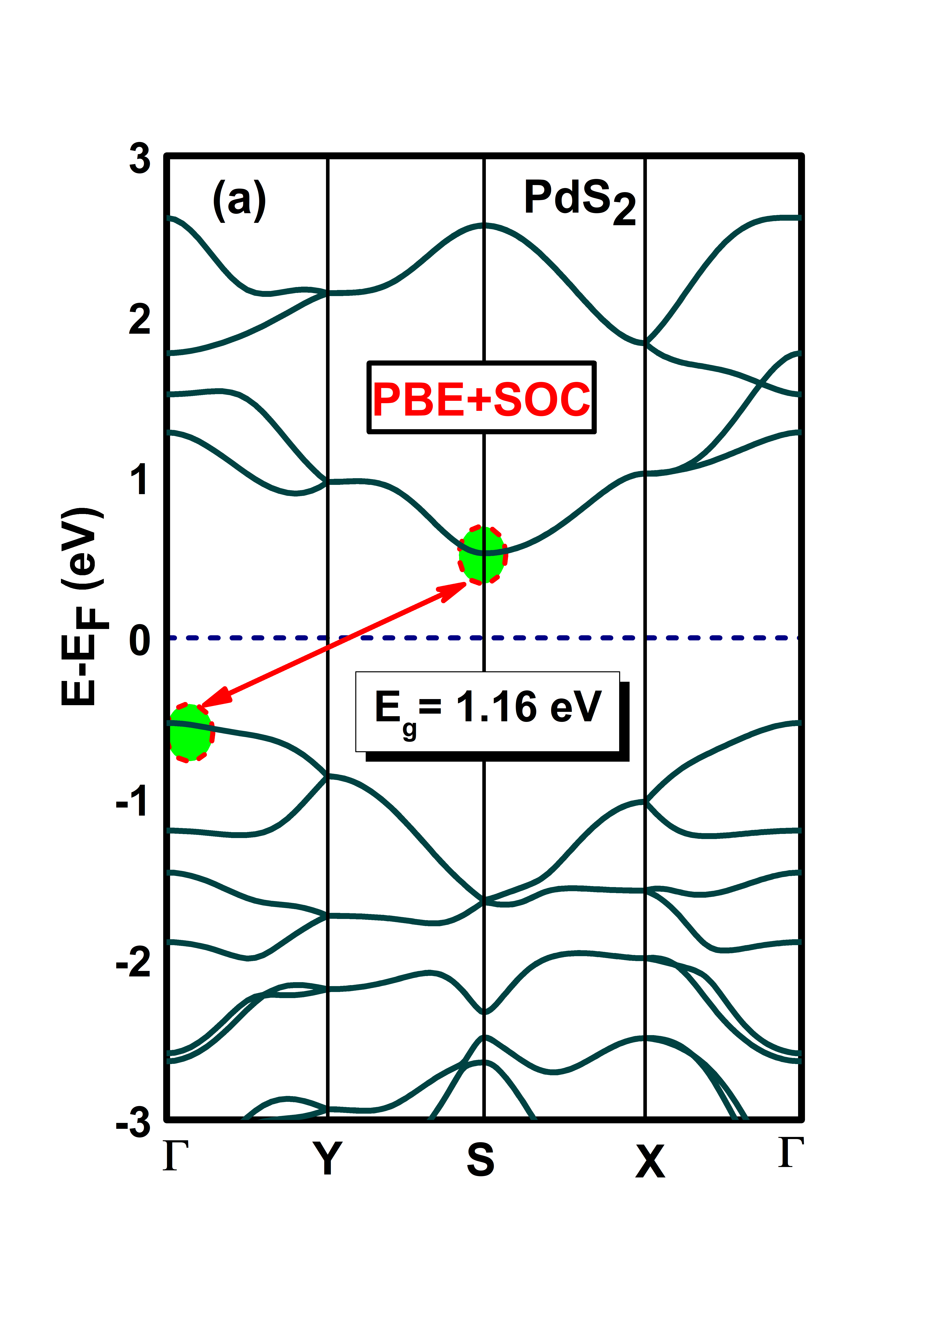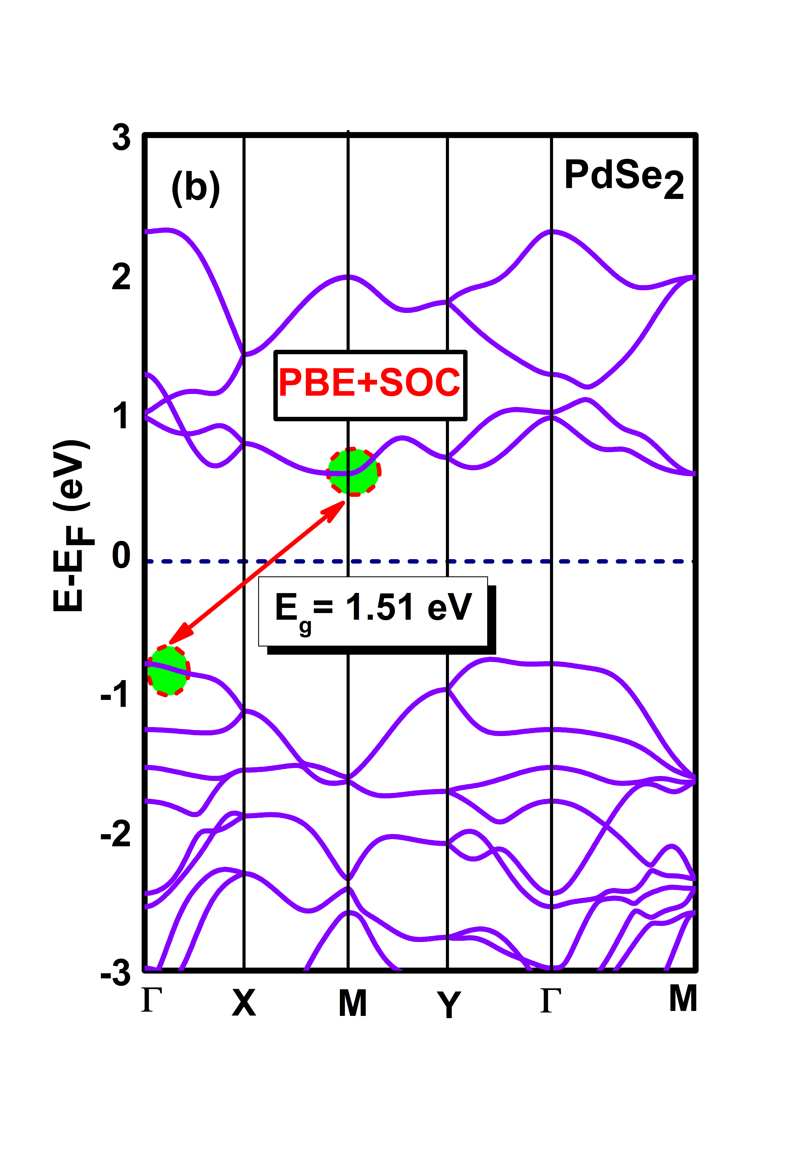
Figure S4. (Colour online) Electronic band structure of 2D-penta-PdQ₂ with PBE+SOC. (a) For penta-PdS₂ monolayer and (b) For penta-PdSe₂ monolayer.

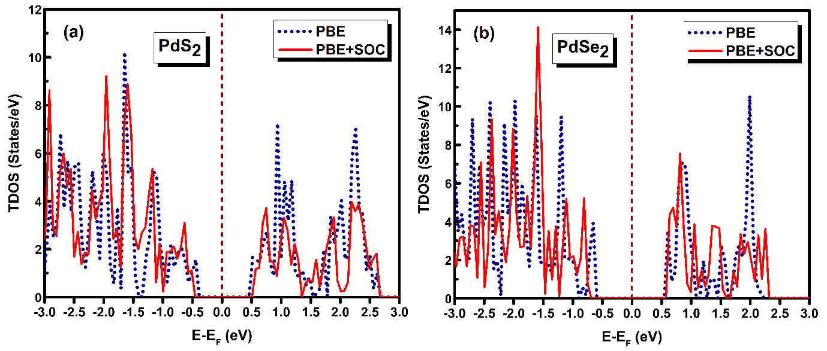
Figure S5. (Colour online) Total density of states (TDOS) States/eV with PBE and PBE+SOC calculations. (a) For penta-PdS₂ monolayer and (b) For penta-PdSe₂ monolayer.

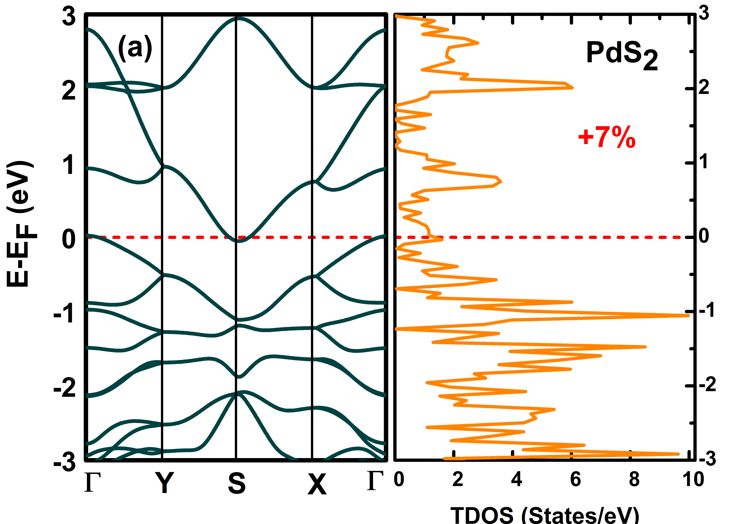 | 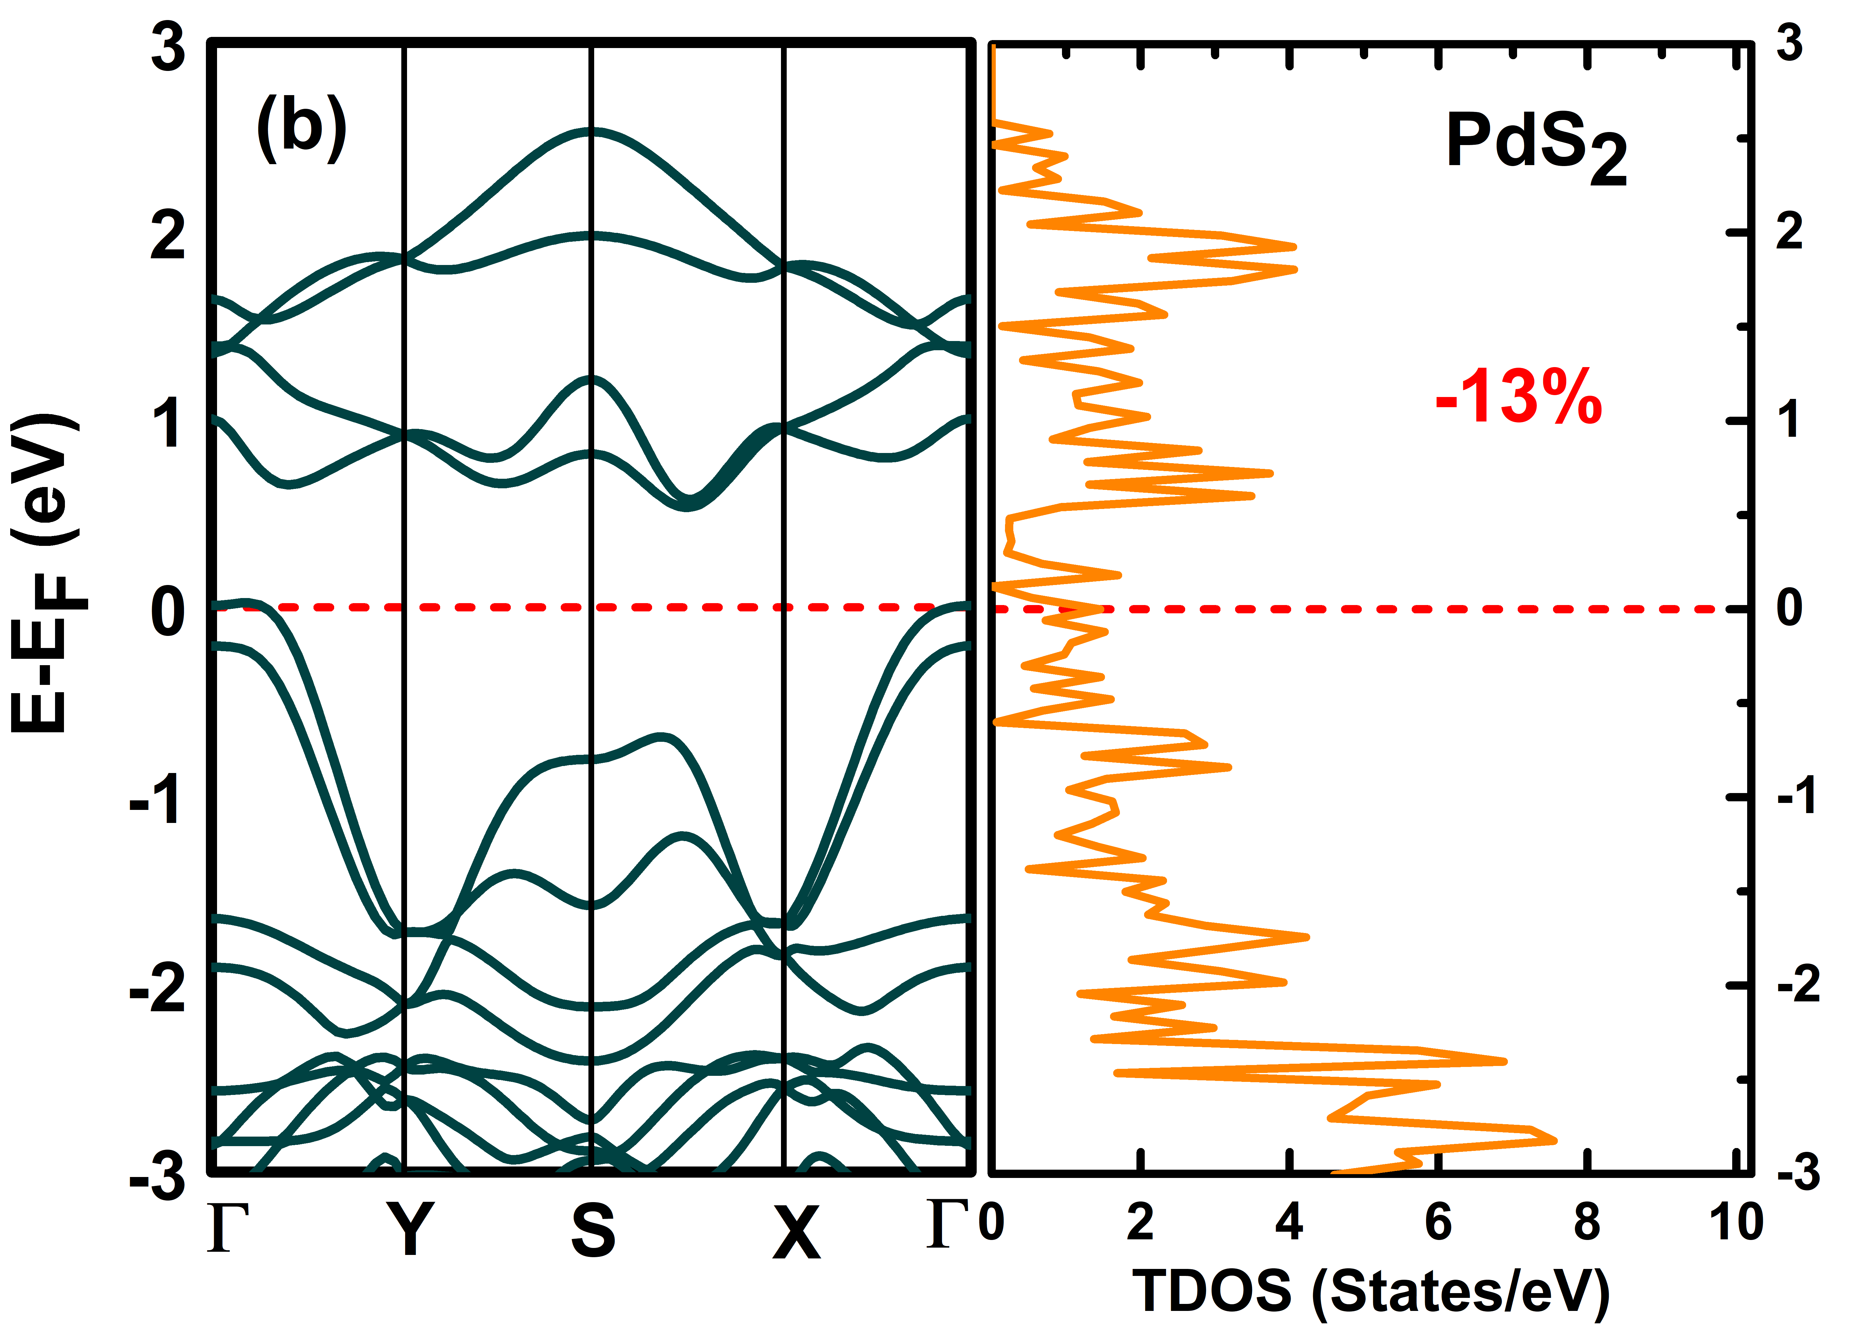
Figure S6. (Colour online) Electronic band structure and total density of states (TDOS) States/eV. (a) For penta-PdS₂ monolayer under critical tensile strain (+7%) and (b) For penta-PdS₂ monolayer under compressive strain (-13%).

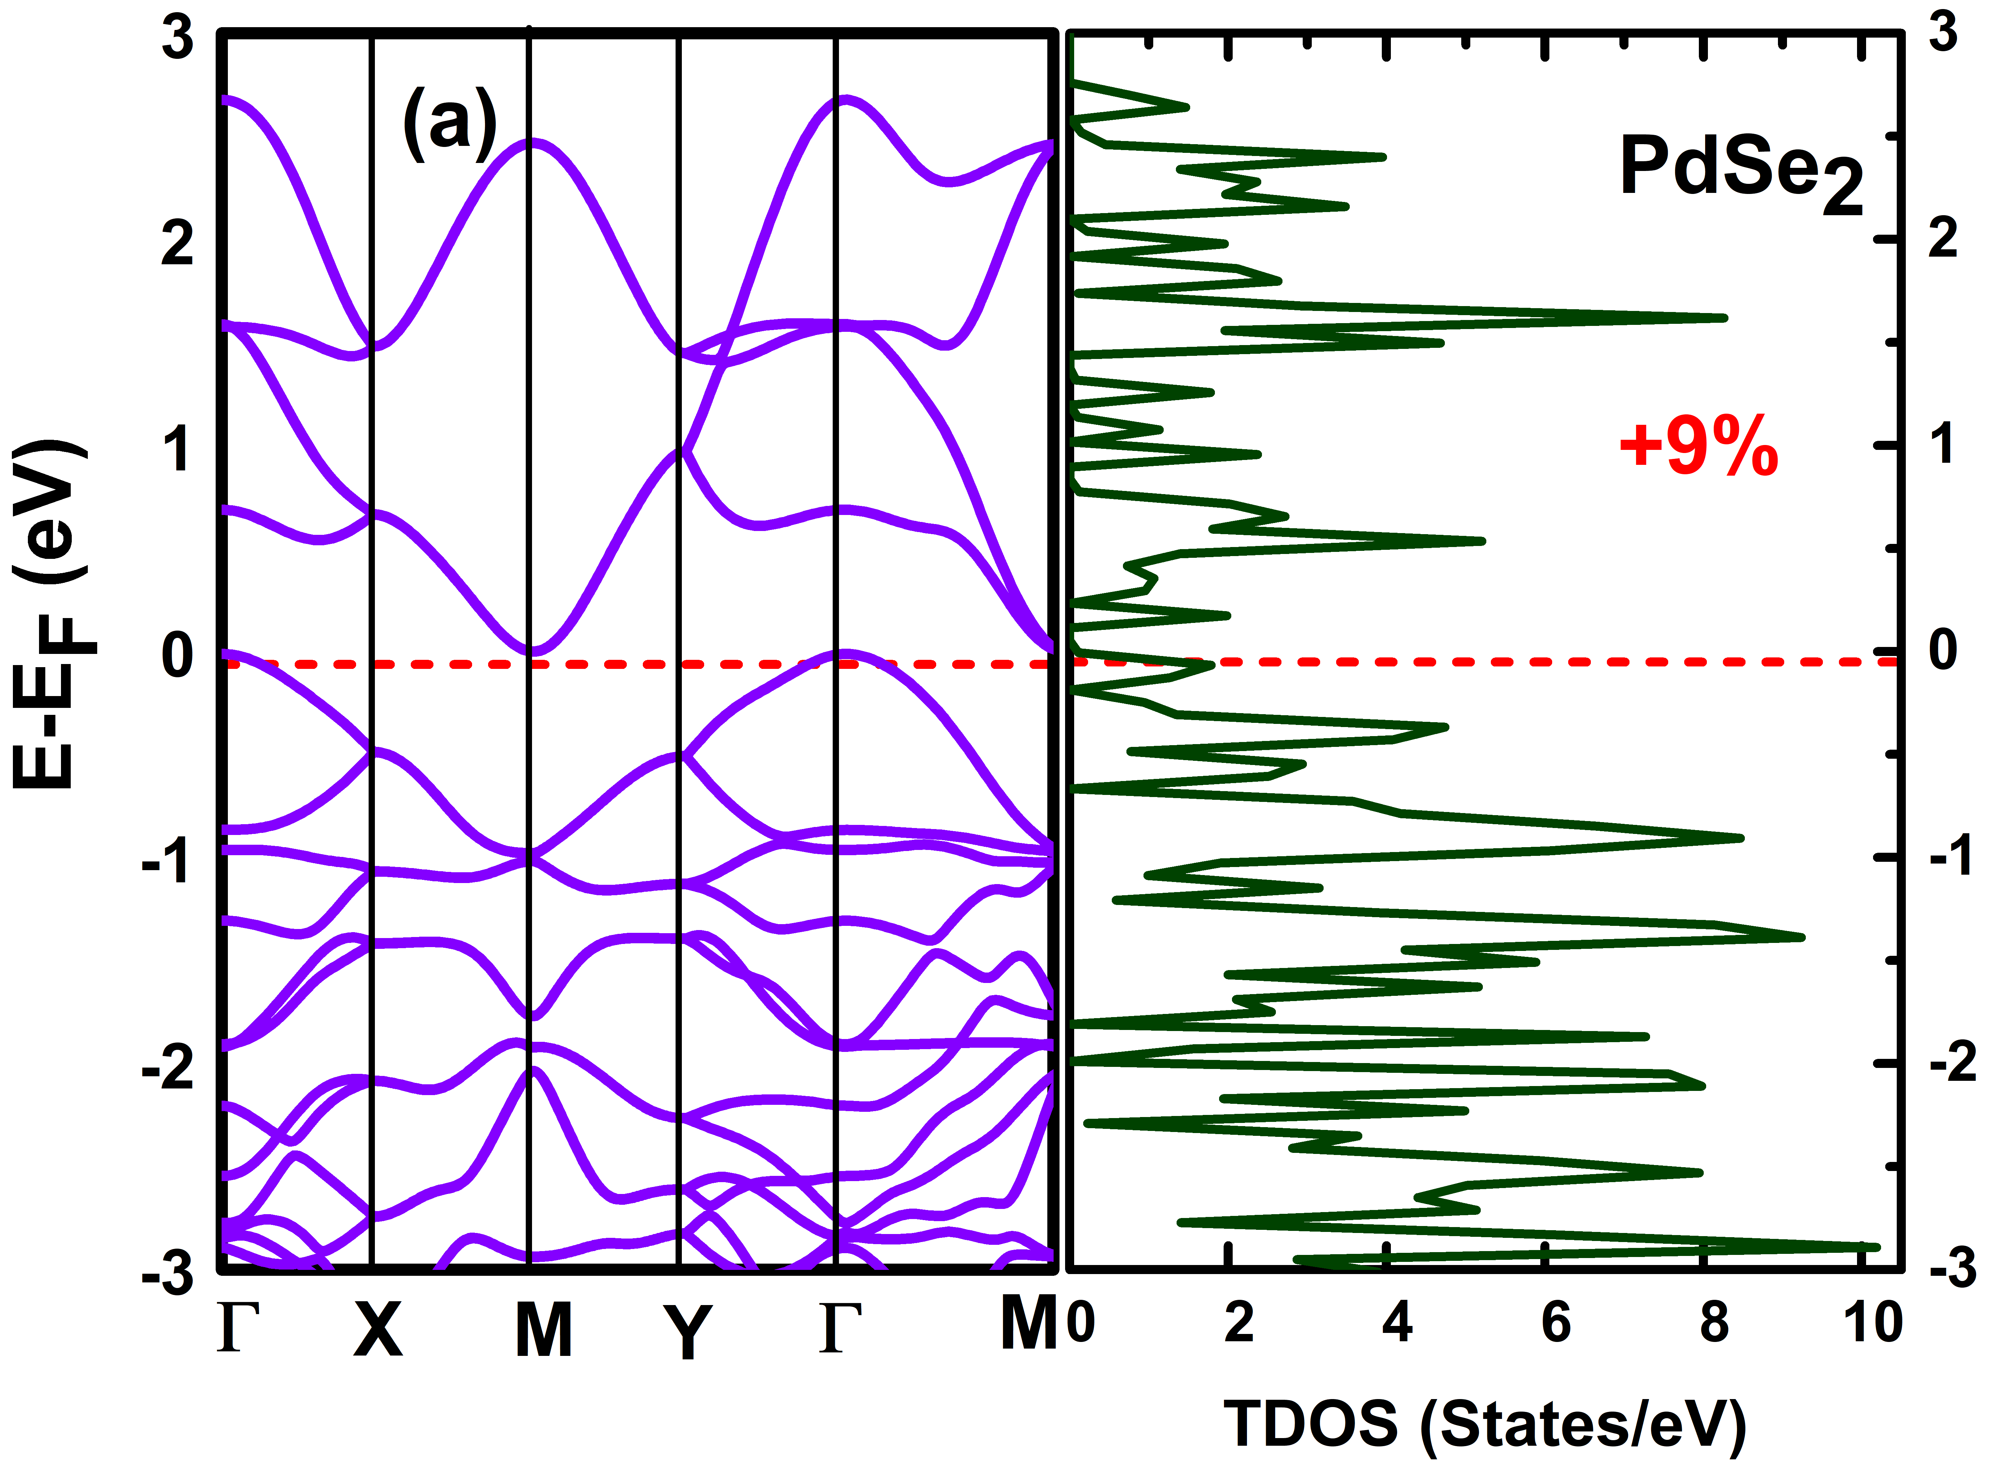 | 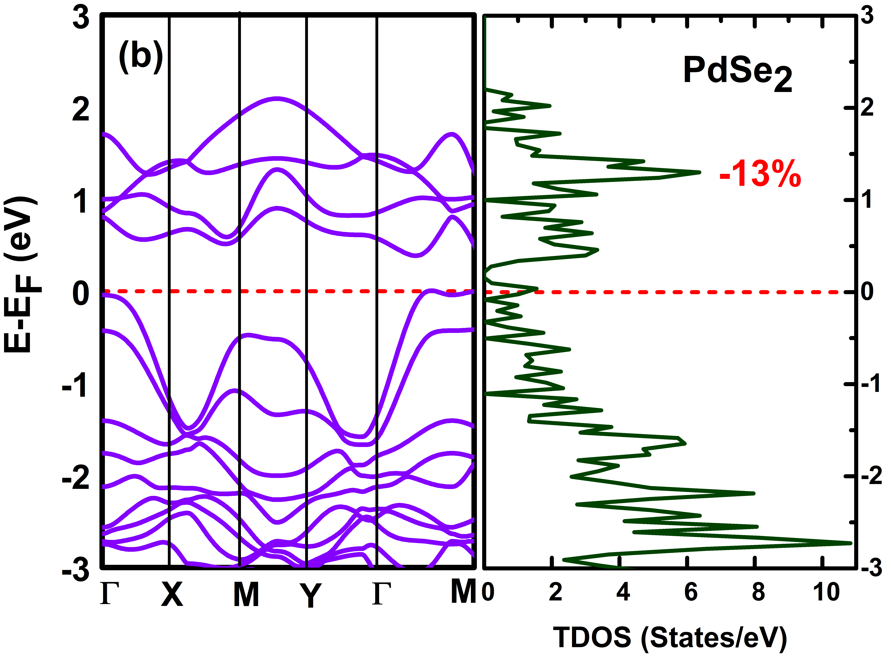
Figure S7. (Colour online) Electronic band structure and total density of states (TDOS) States/eV. (a) For penta-PdSe₂ monolayer under critical tensile strain (+9%) and (b) For penta-PdSe₂ monolayer under critical compressive strain (-13%).

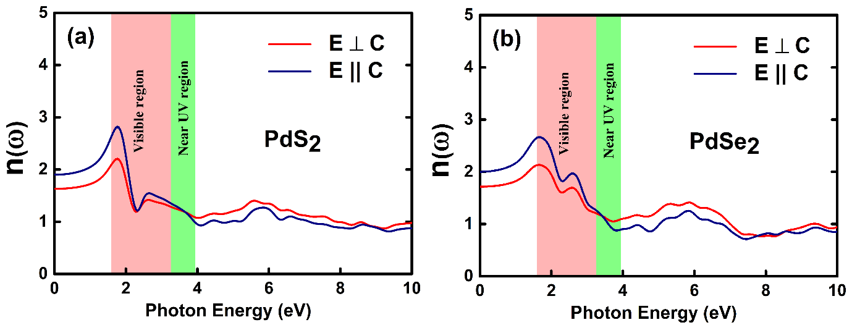
Figure S8. (Colour online) Refractive index $n(ω)$ of penta-PdQ₂ monolayers for parallel and perpendicular polarization. (a) For penta-PdS₂ monolayer and (b) For penta-PdSe₂ monolayer.

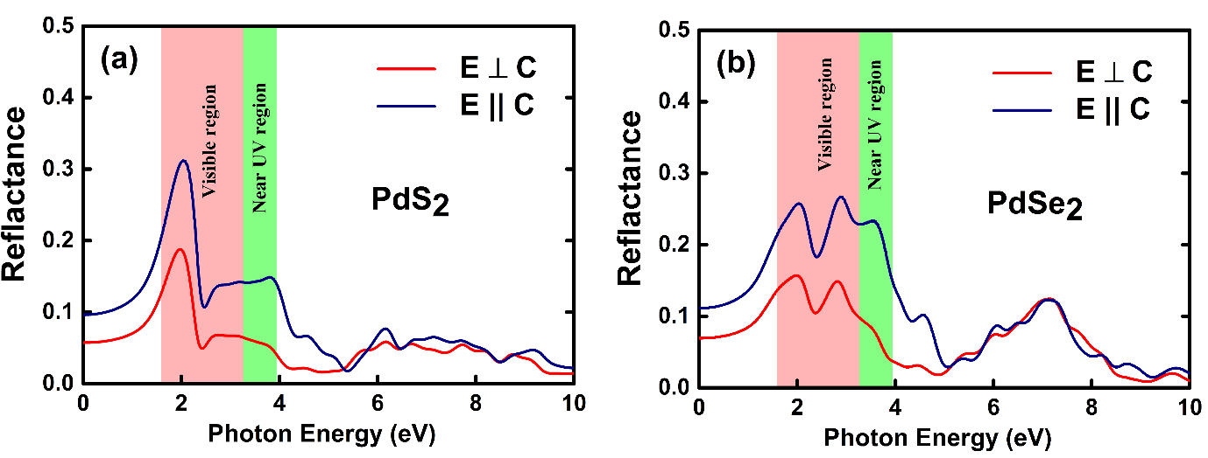
Figure S9. (Colour online) Reflectance $R (ω)$ of penta-PdQ₂ monolayer for parallel and perpendicular polarization. (a) For penta-PdS₂ monolayer and (b) For penta-PdSe₂ monolayer.

Penta-PdS₂ Monolayer |  |  |  | Penta-PdSe₂ Monolayer
Compressive strain %  (-Ve) |  | Tensile strain % (+Ve) |  | Compressive strain % (-Ve) |  | Tensile strain % (+Ve)
-13 % | -345.00 cm⁻¹ | -- | -- | -13 % | -1110 cm⁻¹ | -- | --
-12 % | -123.81 cm⁻¹ | -- | -- | -12 % | -1635 cm⁻¹ | -- | --
-11 % | -62.14 cm⁻¹ | -- | -- | -11 % | -76.71 cm⁻¹ | -- | --
-10 % | -56.78 cm⁻¹ | -- | -- | -10 % | -89.43 cm⁻¹ | -- | --
-9 % | -7.35 cm⁻¹ | -- | -- | -9 % | -78.63 cm⁻¹ | +9 % | -23.11 cm⁻¹
-8 % | -2.30 cm⁻¹ | -- | -- | -8 % | -63.03 cm⁻¹ | +8 % | -6.0 cm⁻¹
-7.0 % | -57.47 cm⁻¹ | +7.0 % | Positive Frequency | -7.0 % | Positive Freq. | +7 % | Positive  Frequency
-6.0 % | -8.05 cm⁻¹ | +6.0 % | Positive Frequency | -6.0 % | -65.78 cm⁻¹ | +6 % | -12.2 cm⁻¹
-5.0 % | Positive  Freq. | +5.0 % | Positive Frequency | -5.0 % | -65.13 cm⁻¹ | +5.0 % | -40.49 cm⁻¹
-4.0 % | -23.15 cm⁻¹ | +4.0 % | Positive Frequency | -4.0 % | -37.65 cm⁻¹ | +4.0 % | Positive Frequency
-3.0 % | -48.68 cm⁻¹ | +3.0 % | Positive  Frequency | -3.0 % | -32.52 cm⁻¹ | +3.0 % | Positive  Frequency
-2.0 % | Positive Freq. | +2.0 % | Positive  Frequency | -2.0 % | -35.62 cm⁻¹ | +2.0 % | -7.50 cm⁻¹
-1.0 % | Positive Freq. | +1.0 % | -61.84 cm⁻¹ | -1.0 % | -50.80 cm⁻¹ | +1.0 % | Positive  Frequency

Table S1. Phonon frequencies (cm⁻¹) at Γ-point for different Compressive (-Ve) and tensile (+Ve) strain % on 2D penta-PdQ₂ monolayers.

