Hierarchical clustering of the CHC profiles of ants and associated silverfish

We conducted a hierarchical cluster analysis (average linkage method) on the matrix with the Bray Curtis similarity distances between the CHC profiles of the ants and silverfish. To avoid overloading of the tree, we grouped the samples of the silverfish found with the same host species and the ant samples per species (by averaging the BC similarites in the matrix). To assess the statistical support of the clusters, we applied multiscale bootstrapping (1000 bootstraps) with the modified pvclust package for the Bray-Curtis similarity matrix. The approximately unbiased P-values are given for each cluster. Values greater than 95% are considered significant (Suzuki and Shimodeira 2006, Hanson 2021). This tree confirms the clustering of Messor specialists with Messor ants, the Aphaenogaster specialist Neoasterolepisma delator with Aphaenogaster, the facultatively associate Lepisma baetica with Tetramorium and three clusters of myrmecophilous silverfish with their Camponotus host.
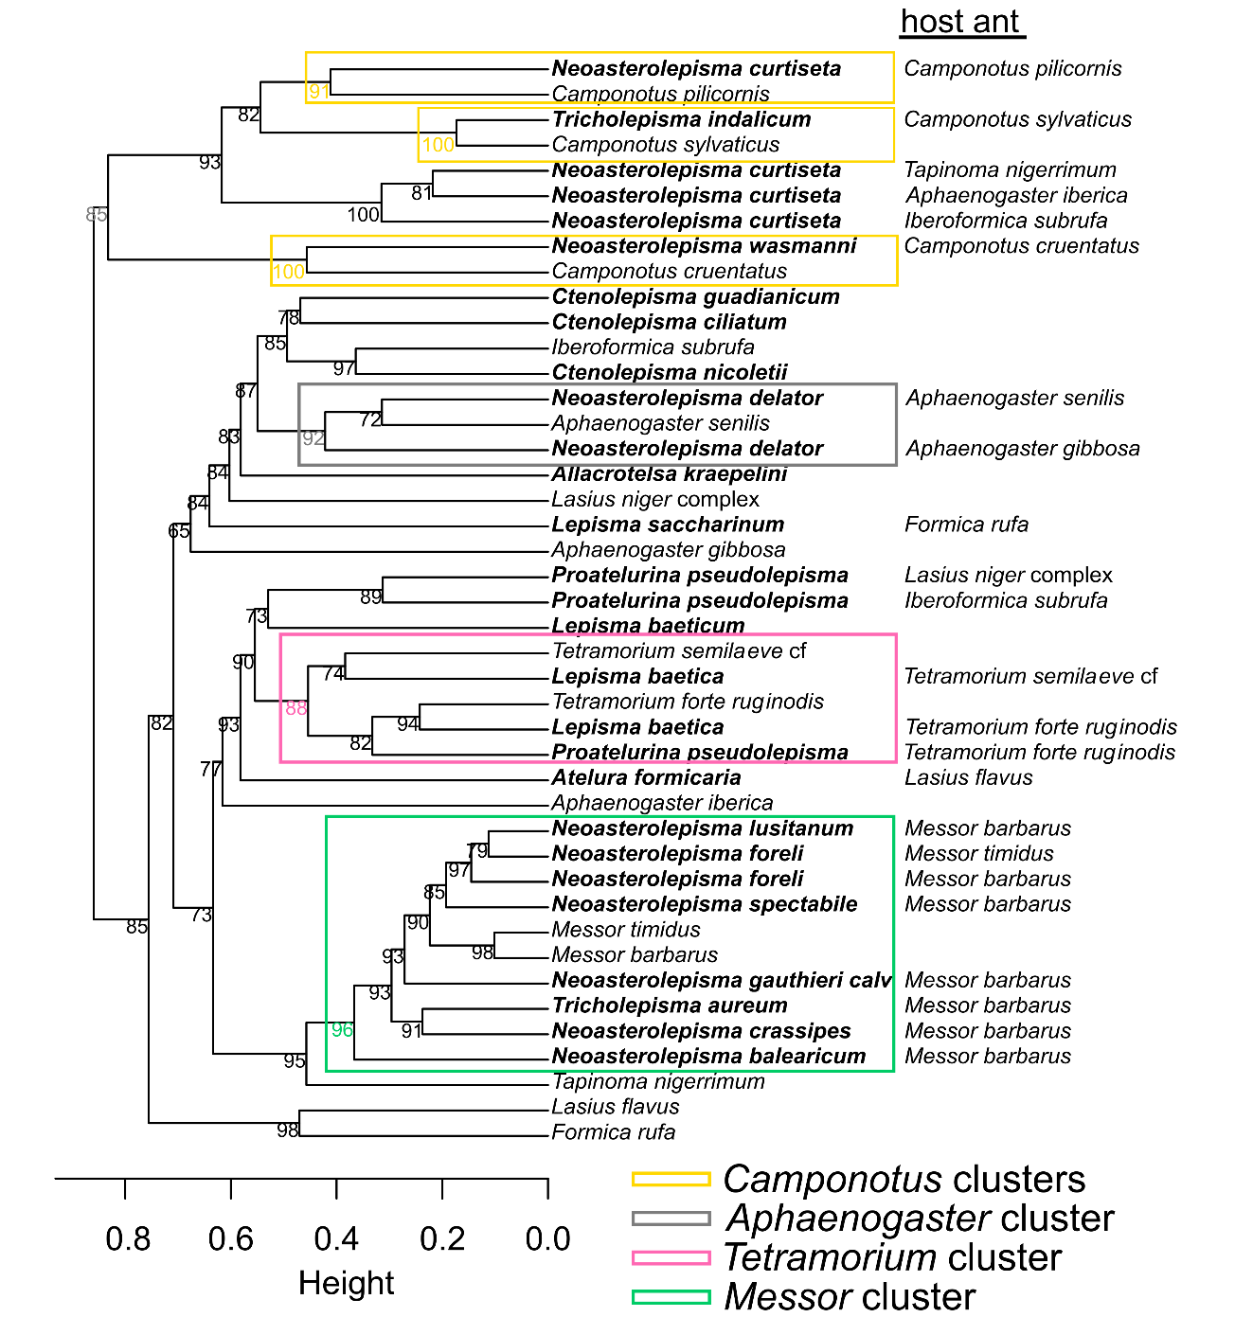

Suzuki R, Shimodaira H. 2006. "Pvclust: an R package for assessing the uncertainty in hierarchical clustering." Bioinformatics. 22: 1540-1542.

Hanson N. https://raw.githubusercontent.com/nielshanson/mp_tutorial/master/taxonomic_analysis/code/pvclust_bcdist.R, Accessed 8th Sept 2021.

