Unraveling the Molecular Heterogeneity in type 2 Diabetes: A Potential Subtype Discovery Study Followed by Metabolic Modeling
Maryam Khoshnejat^{1, 4}, Kaveh Kavousi^{1, 4, *}, Ali Mohammad Banaei- Moghaddam^{2, 4}, Ali Akbar Moosavi-Movahedi^{3, 4}
¹ Laboratory of Complex Biological Systems and Bioinformatics (CBB), Department of Bioinformatics, Institute of Biochemistry and Biophysics (IBB), University of Tehran, Tehran, Iran
² Laboratory of Genomics and Epigenomics (LGE), Department of Biochemistry, Institute of Biochemistry and Biophysics (IBB), University of Tehran, Tehran, Iran
³ Institute of Biochemistry and Biophysics, University of Tehran, Tehran, Iran
⁴ The UNESCO Chair on Interdisciplinary Research in Diabetes, Institute of Biochemistry and Biophysics (IBB), University of Tehran, Tehran, Iran

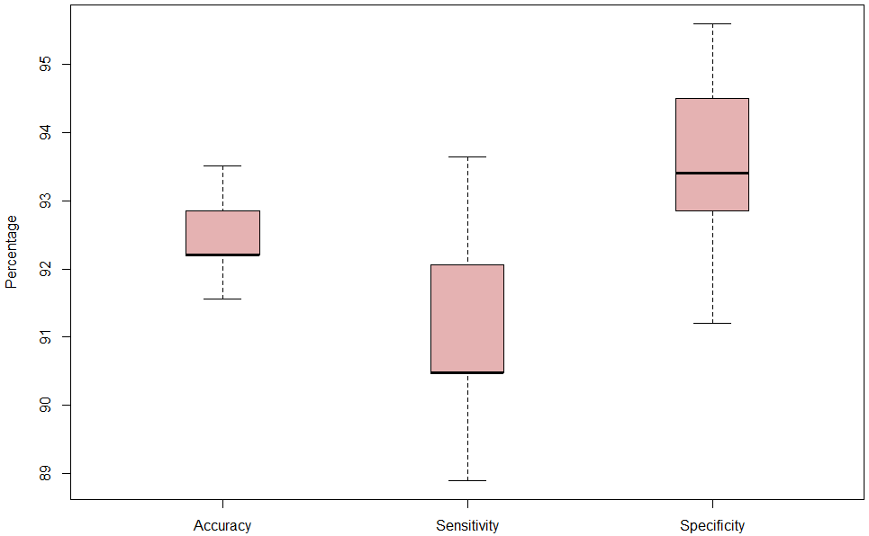
Figure S1. Accuracy, sensitivity and specificity of SVM classifier for 100 repetition of classification with 10-fold cross-validation

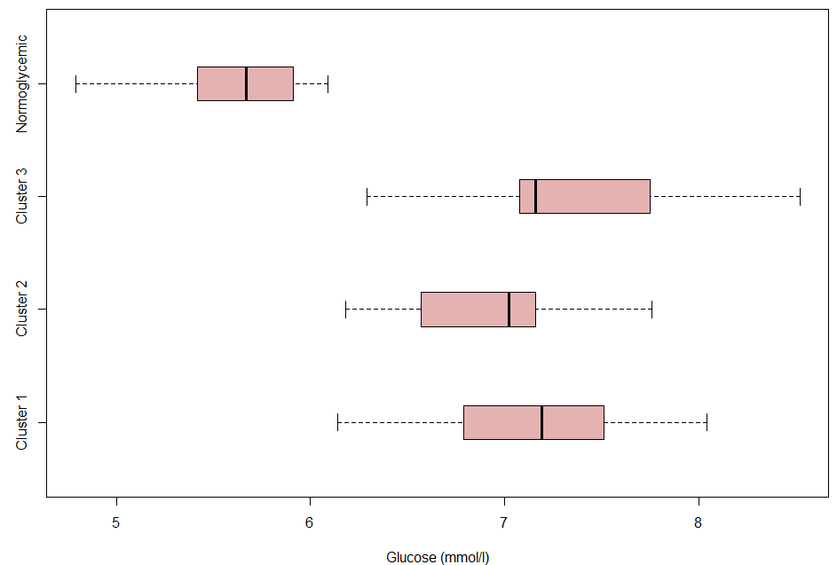
Figure S2. Box plot of fasting glucose values in each diabetic cluster and normoglycemic group.

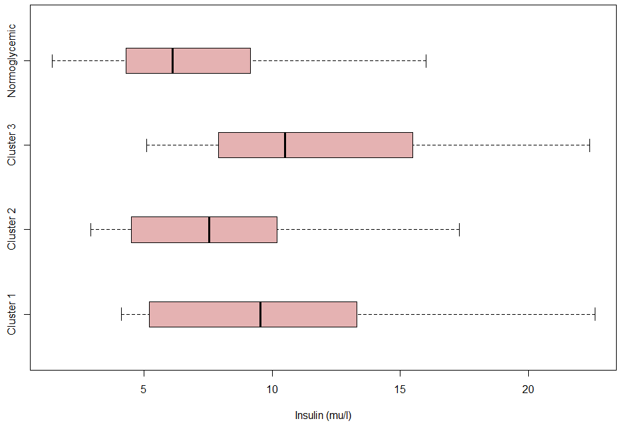
Figure S3. Box plot of fasting insulin values in each diabetic cluster and normoglycemic group.

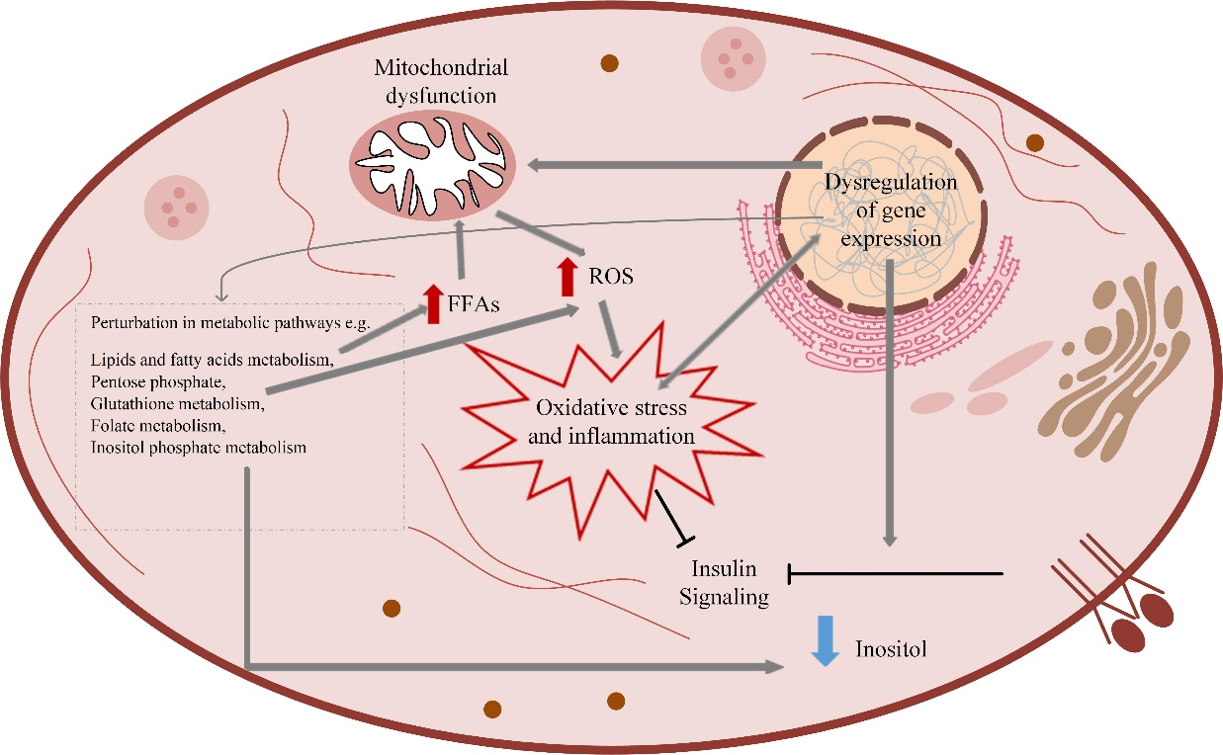
Figure S4. Schematic representation of abnormalities in cluster 1

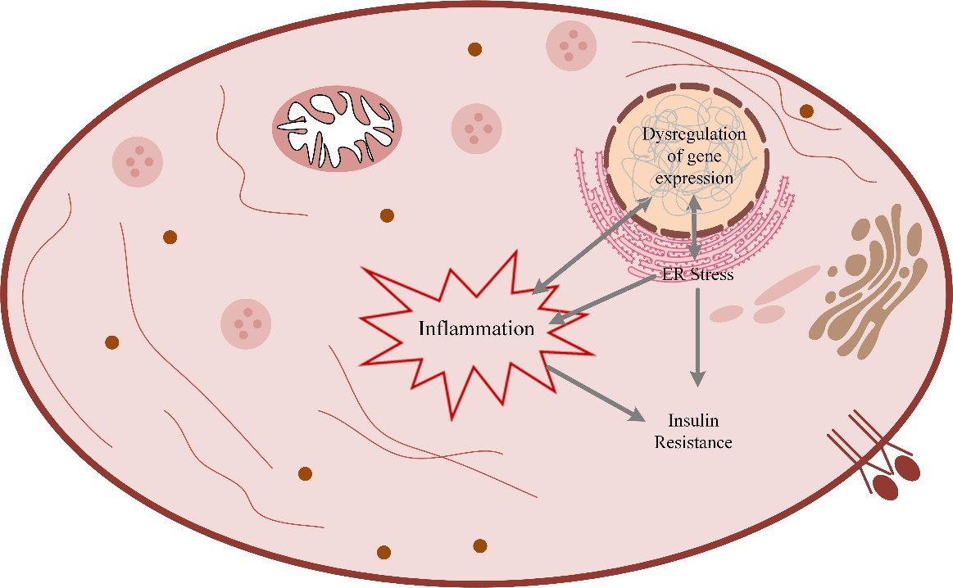
Figure S5. Schematic representation of abnormalities in cluster 2

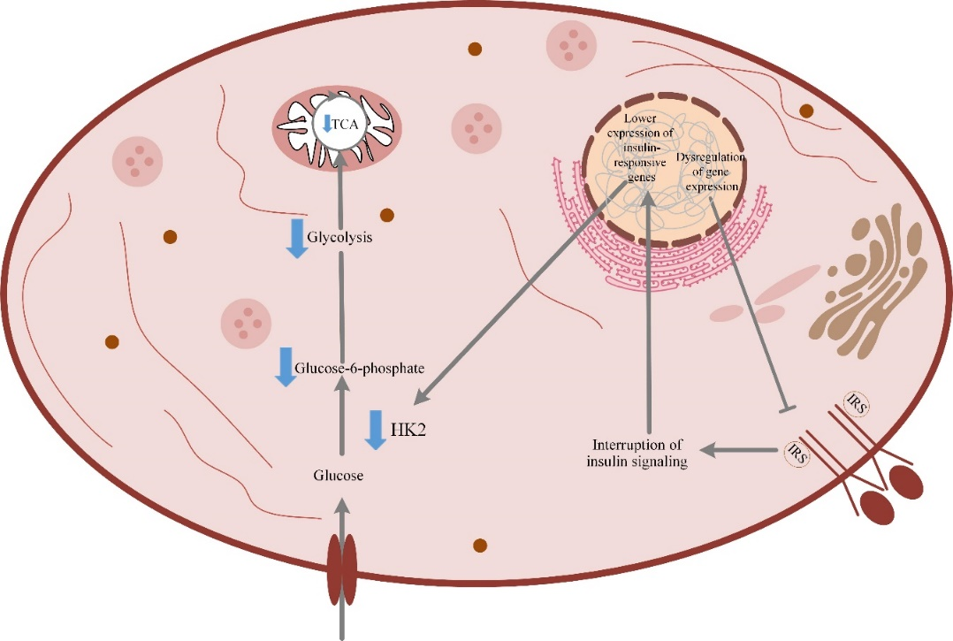
Figure S6. Schematic representation of abnormalities in cluster 3

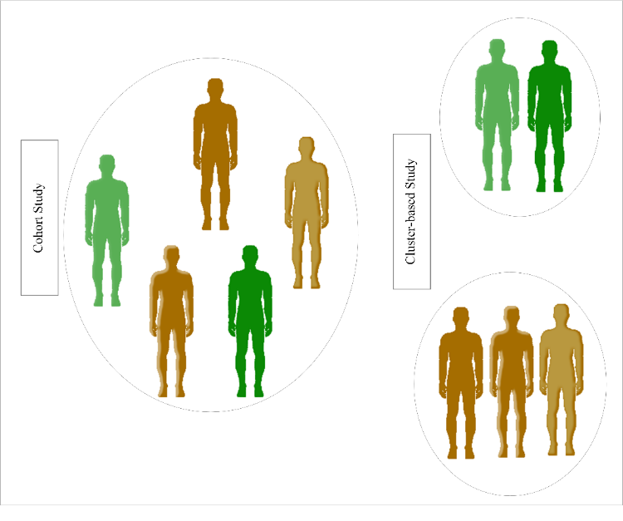
Figure S7. Cluster-based study versus cohort study. In a cohort study, a sample consists of several subjects is gathered and examined. In a cluster-based study, a sample that has been collected in a cohort study is broken down into the sub-groups so that the members within each subgroup have the most similarity and differ from the members of the outer sub-groups.

Name | p-value
Starch and sucrose metabolism | 0.00015
Phenylalanine metabolism | 0.024
Mannose type O-glycan biosynthesis | 0.042
Butanoate metabolism | 0.06
Adipocytokine signaling pathway | 0.076
Tyrosine metabolism | 0.094
Table S1. KEGG pathway enrichment of differentially expressed genes in cluster 1

Name | p-value
ECM-receptor interaction | 0.015
Phenylalanine metabolism | 0.037
Mannose type O-glycan biosynthesis | 0.05
Focal adhesion | 0.07
Tyrosine metabolism | 0.07
Table S2. KEGG pathway enrichment of differentially expressed genes in cluster 2

Name | p-value
Fructose and mannose metabolism | 0.009
Calcium signaling pathway | 0.01
Type II diabetes mellitus | 0.018
MAPK signaling pathway | 0.04
cAMP signaling pathway | 0.07
HIF-1 signaling pathway | 0.07
PI3K-Akt signaling pathway | 0.075
Table S3. KEGG pathway enrichment of differentially expressed genes in cluster 3

