Miao Lv^{a,1} · Wanting He^{a,1} · Tian Liang^{a,1} · Jialei Yangª · Xiaolan Huangª · Shengying Liuª · Xueying Liangª · Jianxiong Long^{a,}* · Li Su^{a,}*

Miao Lv, Wanting He and Tian Liang contributed equally to this work
Correspondence:
Jianxiong Long
longjx12345@163.com
Li Su
suli2018@hotmail.com
a School of Public Health Guangxi Medical University, Nanning, Guangxi, China
¹First co-author
*Corresponding author

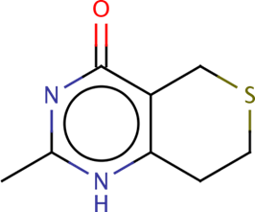
Fig. S1 Chemical formula of small molecule compound DR-2313.

