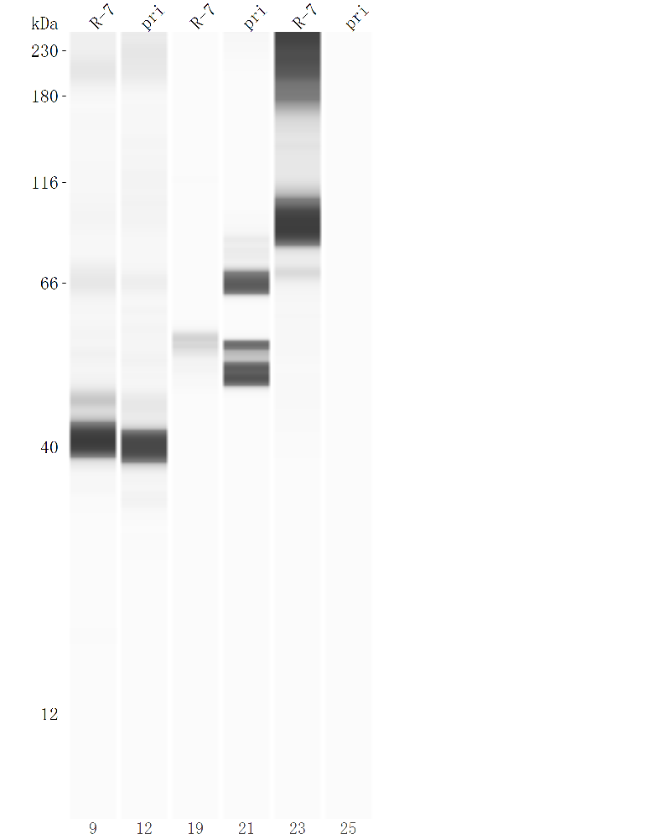
The original export map of the first wes experiment. The antibodies from left to right are GAPDH, GAPDH，VIM，VIM，SV40LT，SV40LT.

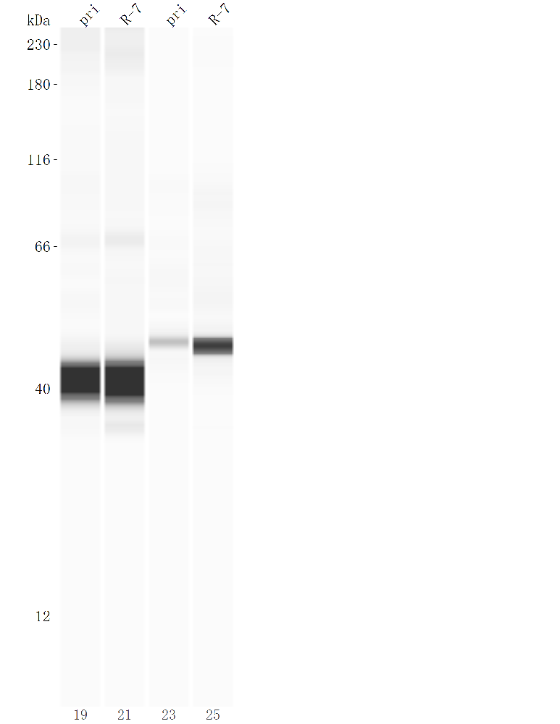
The original export map of the second wes experiment. The antibodies from left to right are GAPDH, GAPDH，α-SMA，α-SMA.

