Table 1. Examples of soil - reinforcement interaction enhancement methods.
Researcher(s) | Method
Horpibulsuk and Niramitkornburee (2010) | Addition of iron bearing bar to reinforcement | 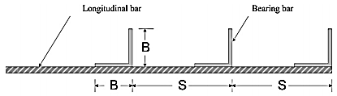
Mosallanezhad et al. (2016) | Rooted geogrid | 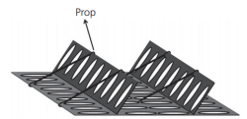
Abdi and Safdari Seh Gonbad  (2018) | Anchored geogrids | 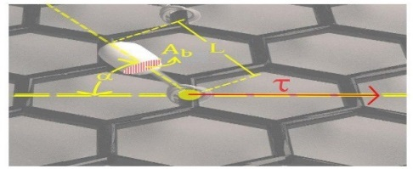
Abdi and Safdari Seh Gonbad  (2019) | Roughened geotextile | 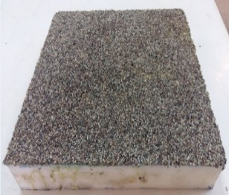
Makkar et al.  (2019) | 3-D geogrid | 