Extended data for a paper entitled
“A 5-km-thick reservoir with >380,000 km³ of magma within the ancient Earth's crust”

by Latypov et al. (2021)

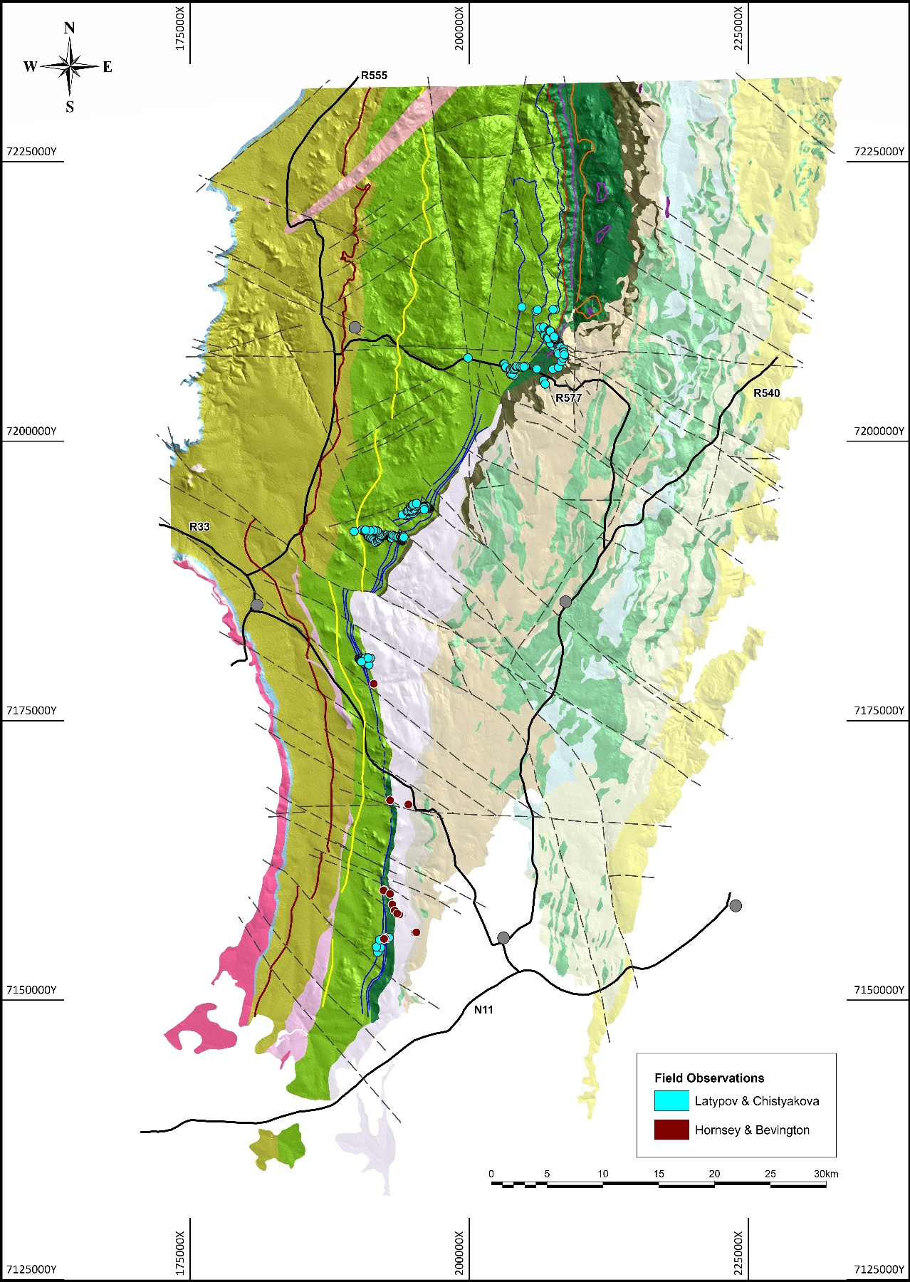

Extended Data Fig. 1. Location of GPS points from seven traverses across the Anorthosite Markers at the basal part of the MZ in the southeastern part of the Bushveld Complex.

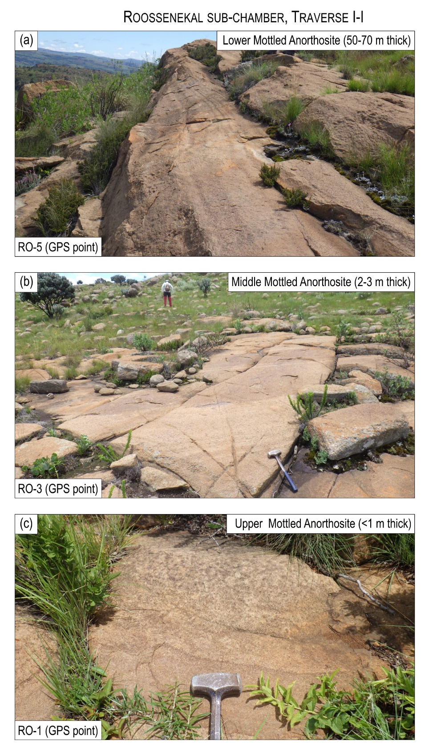
Extended Data Fig. 2. Photos of field outcrops of three anorthosite markers along the traverse I-I of the Roossenekal sub-chamber of the southeastern part of the Bushveld Complex.

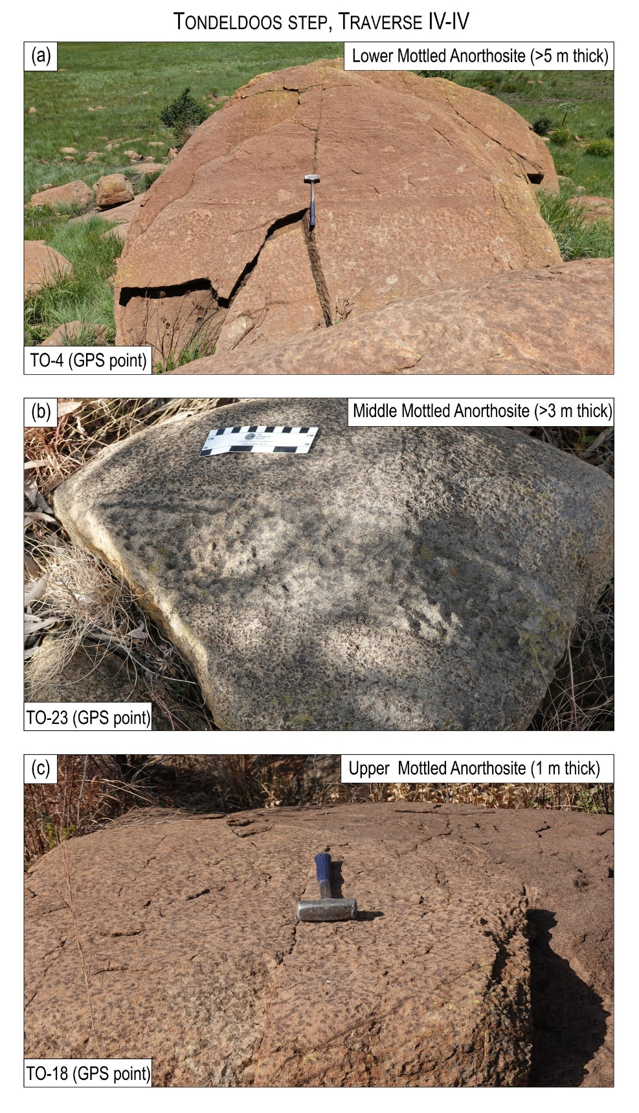

Extended Data Fig. 3. Photos of field outcrops of three anorthosite markers along the traverse IV-IV at the Tondeldoos step of the Roossenekal sub-chamber of the southeastern part of the Bushveld Complex.

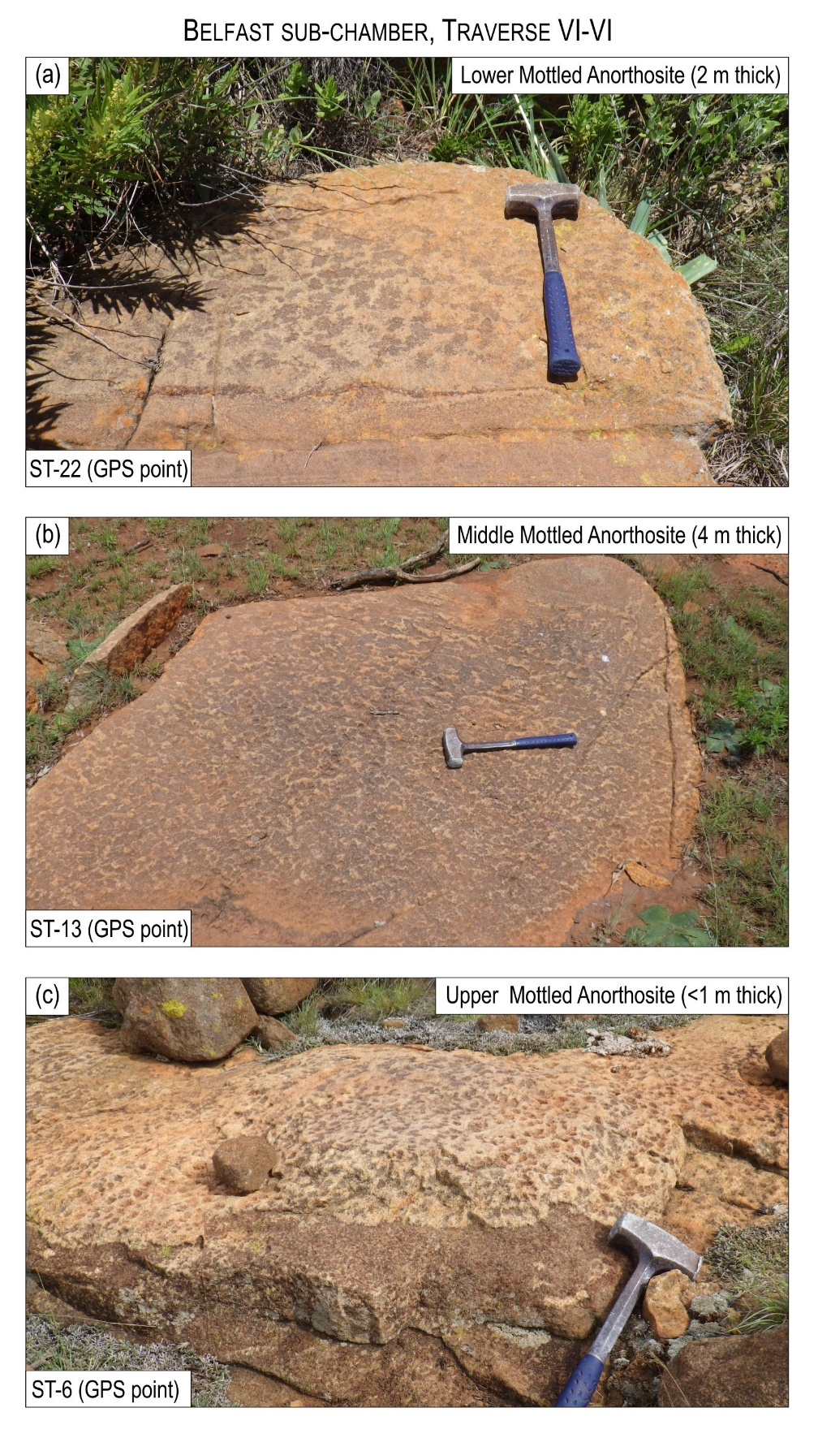
Extended Data Fig. 4. Photos of field outcrops of three anorthosite markers along the traverse VI-VI of the Belfast sub-chamber of the southeastern part of the Bushveld Complex.

Thermodynamic modeling
The crystallization of the Main Zone was modeled using the alphaMELTS 1.9 software (Smith & Asimow, 2005; Asimow, et al., 2004; Ghiorso, et al., 2002; Ghiorso and Sack, 1995). The calculations employed the MELTS algorithm, under fractional crystallization condition at 2 kbar, in steps of 5 °C, under FMQ oxygen buffer. The results are synthesized in Figure X1 and SupplTables SX1 and SX2. There were three steps in the modeling approach:
- step 1 was to identify a melt composition (MZ magma) which by fractional crystallization to produce the zones A, B, C (Fig. 1);
- step 2 was to identify an opx-saturated melt with a similar sequence of crystallization as MZ-magma, but more primitive (higher Mg# in orthopyroxene and An in plagioclase);
- step 3 was designed to model the sequences A’ and B’ (Figure X1) containing the Pyroxenite Marker, by continuously increase the degree of mixing of an opx-saturated magma obtained at step 2 with a residual magma from stage 1, concomitantly with fractional crystallization of the mix at every calculated step.
Step 1 targeted to identify the parent MZ-magma, that obey the following conditions:
- The succession of crystallization A-B-C (Figure X1) with the corresponding mineralogy (phases at equilibrium): A = Pl+Cpx+Opx; B=Pl+Cpx+Opx+Pig; C= Pl-Cpx-Pig).
- The ratio between the calculated volumes to be similar to the ratio between the volumes of cumulates observed in the stratigraphic column.
- The mineral composition to be similar or close to those observed in the real cumulates, with Mg# in orthopyroxene and An in plagioclase continuously decreasing from A to C; the trapped liquid shift effect is to be considered herein, in the shift of both Mg# in orthopyroxene and An in plagioclase from higher to lower values.
- Identifying a residual melt at low temperature with a volume ~ 30% representing the residual-magma (R-magma) that will constitute one endmember of the mix required in step 2.
The starting composition in the calculation of the MZ-magma was identified based on a multiple reiterative calculation (try-and-error) approach in order to achieve the criteria 1-4 mentioned above. The calculation started from various compositional liquids: tholeiitic MOR-basalt, B2 and B3 compositions of the marginal rocks (Barnes et al., 2010; Yang et al., 2019), Al-rich basaltic andesites (Latypov et al., 2018). The preliminary results showed that a typical tholeiitic MORB composition, dry or wet (e.g. Allan et al. 1989) does not produce orthopyroxene at all. Dry MORB produces first plagioclase followed by olivine and then clinopyroxene (SupplTable SX1B), whereas the wet MORB gives olivine at liquidus, followed by clinopyroxene and plagioclase (SupplTable SX1C). Consequently, MORB cannot be a parent magma for the MZ and this path was abandoned. The B2 composition does not produce orthopyroxene at all (SupplTable SX1D). Such melt compositions would produce gabbro cumulates with plagioclase-clinopyroxene and little pigeonite, together with low Cr₂O₃ chromite (the latter as liquidus phase). It is clear from the calculations that a composition higher in SiO₂ and significantly lower in CaO than B2 (and B3) is needed to reproduce the MZ cumulates. The calculation attempts also showed that a lower Mg# of the starting composition pushes down the appearance of the orthopyroxene very late in the crystallization sequence and decreases the field of orthopyroxene stability to a point where the opx disappears from the assemblage. For example, trying to decrease the Mg# to obtain an opx with low Mg# as observed in the MZ cumulates, the opx disappears from the calculated assemblage leaving its place to pigeonite. This observation supports the interpretation that the compositions (Mg# in opx) observed today in the cumulates are in fact the result of later equilibration of an earlier-formed opx with a later and colder interstitial liquid (trapped liquid shift effect). This effect is more obvious in the variation of the Mg# in opx than in the An in plagioclase. The most challenging aspect of the calculation was to obtain the assemblage opx-cpx-pig-pl at equilibrium, as this equilibrium reflects a very narrow compositional space in the pyroxene world. Once obtained such an equilibrium, a small variation in the starting composition or the temperature fractionation step would break the 4-phase assemblage in such a way that opx or pig would belong to different 3-phase equilibrium assemblages, at different temperatures, and no assemblage contains both opx and pig. It was also noted that increasing H₂O content of the melt promotes the stability of co-existing opx and pigeonite, and increasing the logf_{O2} from FMQ to FMQ+2 promotes the stability of magnetite early in the crystallization sequence and extends the stability field of clinopyroxene to higher temperatures (pushing it towards liquidus condition). The result of the modeling, obtained after slightly modifying the starting composition satisfactorily reproduces the above-mentioned criteria (1-4) (see MZ-magma in Table X1, and Figure X1).
The compositions of the identified magmas (MZ, R, and O) are presented in Table X1.

Table X1: Compositions of modeled magmas
Symbol | SiO₂ | TiO₂ | Al₂O₃ | Fe₂O₃ | Cr₂O₃ | FeO | MnO | MgO | CaO | Na₂O | K₂O | H2O | Mg#
MZ-magma | 55.338 | 0.145 | 16.829 | 1.295 | 0.0001 | 6.658 | 0.210 | 5.335 | 8.203 | 4.839 | 0.105 | 1.052 | 58.5
R-magma | 55.844 | 0.164 | 16.481 | 1.384 | 0.0001 | 7.063 | 0.243 | 4.677 | 7.556 | 5.253 | 0.119 | 1.213 | 54.1
O-magma | 55.325 | 0.132 | 17.961 | 0.673 | 0.01 | 3.970 | 0.203 | 8.220 | 10.858 | 2.343 | 0.101 | 0.203 | 78.7

The results of running the MZ magma are synthesized in Table X2 (detailed calculations in SupplTable SX1A).

Table X2: Mineral assemblage, volume, Mg# in orthopyroxene and An in plagioclase resulted by fractional crystallization at 2 kbars of MZ-magma

Assemblage | Cumulate  (in Fig X1) | Volume  (cm3) | Mg# in opx | An in pl | T (ºC)
opx-cpx-pl | A | 1.665 | 81.7 | 68 | 1155
opx-cpx-pig-pl | B | 1.527 | 81.2 | 67.5 | 1150
cpx-pig-pl | C | 1.415 |  | 67 | 1145

Step 2 was to identify by try-and-error an opx-saturated magma that has a similar sequence of crystallization with the MZ-magma, but it is more primitive (higher Mg# of opx and An in plagioclase) in order to reproduce the PM sequence mineralogy (Figure X1, Table X1).
This magma (O-magma) is presented in Table X1. Fractional crystallization of such a magma alone would necessarily produce a continuous decrease in Mg# in opx and An in plagioclase (see SupplTable SX2), fact that would not fit the observed variation of these factors in the PM sequence. However, a new influx of O-magma would encounter a resident magma, and we should take into consideration the mixing effect combined with fractional crystallization to reproduce the PM sequence (A’ and B’).
Step 3 was designed to gradually mix the O-magma (in steps of 10 vol. % of O-magma component) with an R-magma (residual magma from step 1). R-magma was chosen to be the liquid in equilibrium with the cpx-pig-pl in the crystallization sequence of the MZ-magma, as this mineral assemblage represents the cumulates below the PM sequence (C-cumulate in Figure X1). The temperature at which the C-cumulate is in equilibrium with a ~ 30% residual liquid (R-magma) is T=1445 C. With gradually increasing of O-magma in the mix, from O₁₀R₉₀ to O₇₀R₃₀, coupled with concomitant fractional crystallization in steps of 1 C° the reversals of Mg# and An are obtained. The orthopyroxene becomes a liquidus phase at O₂₀R₈₀ mix and by increasing the O-magma volume to O₃₀₋₄₀R₇₀₋₆₀ ratio the values of Mg# and An correspond to the PM appearance (after applying the trapped liquid shift effect). After the formation of PM, if the mixing continues and orthopyroxene is not the only phase to fractionate (vol% of fractionated pl > cpx > opx, see SupplTables S4B-5,6), the Mg# and An continue to increase up to a mixing corresponding to O₇₀R₃₀. If the O-magma influx and mixing cease at this point, the mixed magma would follow a normal fractional crystallization process and would reproduce the decreasing trends of Mg# and An. The results show that gradually changing the ratio of mixing between the residual melt (R-melt) of the MZ-magma with an orthopyrone-saturated magma (O-magma) reproduced the mineral assemblage and the variation of Mg# in opx and An in plagioclase as observed in zones A’ and B’ (Figure 3, SupplTables 4A and 4B).
The composition of MZ-, R-, and O- magmas are presented in SupplTable S1 (extended data), and the MELTS calculations are synthesized in Table S3A and S4A. Detailed calculations are presented in SupplTables S2A, S2B, S2C, S2D, S3B, and S4B, in extended data.
It is intuitive that at different mixing ratios between the two magmas different mineral assemblage and/or modal composition would be produced. For example, a small volume of O-magma (opx-saturated) mixed with a big volume of resident R-magma (plagioclase saturated) would not produce opx as a liquidus phase, as the opx component would be diluted into the bigger volume of the resident magma, which is very depleted in opx and also has a lower Mg# than the O-magma. This means that the base of the PM sequence (A’) cannot start with a pyroxenite cumulate.
This exercise of mixing coupled with fractional-crystallization is realized in 9 steps of mixing, from 10% O-magma and 90% R-magma (O₁₀R₉₀) up to O₉₀R₁₀ and the results are presented in SupplTable 4a and 4B (see individual tabs for each step of the calculation), summarized in SupplTable S5 and Figure 3.
The orthopyroxene that starts to crystalize at the beginning of such mix (following the crystallization of plagioclase and cpx) would have a lower Mg# than the opx that would have crystallized from the O-magma alone, and it would have an Mg# higher than the opx from the resident melt, producing the start of the reversal observed in Figure X1, below the PM. It is also intuitive that by the continuous increase of the volume of opx-saturated O-magma into the mix, the solids fractionated from the mix at each calculated step will change the modal composition of the cumulates, producing a gradual increase of opx up to the point where the orthopyroxene becomes a liquidus phase and can fractionate a pyroxenite (such as the PM). At the same time with increasing volume % of the opx, the Mg# in opx and An in plagioclase will gradually increase, proportionally to the increasing volume of the opx-saturated and more primitive O-magma into the mix. Observe in Figure 3 that the inflections of the modeled Mg# in opx and An in plagioclase match the observed ones in the PM sequence stratigraphy (the liquid-sift effect is to be considered) and that opx becomes a liquidus phase starting with O₂₀R₈₀ mix, only. It produces the PM at O3₀₋₄₀R₇₀₋₆₀ ratio and the mixing stopped at ~ O₇₀R₃₀ ratio. It is obvious from this exercise that the PM sequence does not start with a pyroxenitic layer but rather a mela-noritic cumulate below PM that continuously grades into a pyroxenitic composition, with gradually increasing Mg# in opx and An in plagioclase up to the point when the O-magma becomes dominant (~O₇₀R₃₀) or when the R-magma is exhausted (completely mixed). At this point, the crystallization reaches the maximum of Mg# in opx and An in plagioclase (the maximum of the Mg# and An reversals in Figure 3). The crystallization that follows the complete mixing would produce a decrease of opx vol% in the cumulate, as well as the expected decrease of Mg# in opx and An in plagioclase. This exercise elegantly explains the fact that the new influx of the opx-saturated magma into the upper part of the MZ (Zone A’) does not start with the PM marker but starts below it, where the reversal of Mg# in opx and An-in-plagioclase starts.
The gradual reversal of Mg# in opx and An in plag below the PM is easily explained by mixing coupled with fractional crystallization of a magma that resulted by a gradual increase of mixing between a new influx of opx-saturated magma (O) into an existent volume (ca. 30 vol % in respect to the existing C-cumulates before the new influx of magma) of a plagioclase-saturated resident (R) magma.

References:
Allan, J. F., R. Batiza, M. R. Perfit, D. J. Fornari, and R. O. Sack (1989), Petrology of lavas from the Lamont seamount chain and adjacent East Pacific Rise, 10° N, J. Petrol., 30(5), 1245-1298, doi:10.1093/petrology/30.5.1245.
Asimow, P. D., J. E. Dixon, and C. H. Langmuir (2004), A hydrous melting and fractionation model for mid-ocean ridge basalts: Application to the Mid-Atlantic Ridge near the Azores, Geochem. Geophys. Geosyst., 5, Q01E16, doi:10.1029/2003GC000568.
Barnes, S. J. (1986). The effect of trapped liquid crystallization on cumulus mineral compositions in layered intrusions. Contributions to Mineralogy and Petrology 93, 524–531.
Barnes, S.-J., Maier, W. D. & Curl, E. A. (2010). Composition of the marginal rocks and sills of the Rustenburg layered suite, Bushveld Complex, South Africa: implications for the formation of the platinum-group element deposits. Economic Geology 105, 1491–1511.
Ghiorso, M. S., M. M. Hirschmann, P. W. Reiners, and V. C. Kress (2002), The pMELTS: A revision of MELTS for improved calculation of phase relations and major element partitioning related to partial melting of the mantle to 3 GPa, Geochem. Geophys. Geosyst., 3, 1030, doi:10.1029/2001GC000217
Ghiorso, M. S., and R. O. Sack (1995), Chemical Mass-Transfer in Magmatic Processes .4. A Revised and Internally Consistent Thermodynamic Model for the Interpolation and Extrapolation of Liquid-Solid Equilibria in Magmatic Systems at Elevated-Temperatures and Pressures, Contrib. Mineral. Petr., 119, 197-212.
Latypov, R., Costin, G., Chistyakova, S., Hunt, E. J., Mukherjee, R., & Naldrett, T. (2018). Platinum-bearing chromite layers are caused by pressure reduction during magma ascent. Nature Communications, 9(1), 462. https://doi.org/10.1038/s41467-017-02773-w
Sheng-Hong Yang, Wolfgang D Maier, Bélinda Godel, Sarah-Jane Barnes, Eero Hanski, Hugh O’Brien, Parental Magma Composition of the Main Zone of the Bushveld Complex: Evidence from in situ LA-ICP-MS Trace Element Analysis of Silicate Minerals in the Cumulate Rocks, Journal of Petrology, Volume 60, Issue 2, February 2019, Pages 359–392, https://doi.org/10.1093/petrology/egy115
Smith, P. M., & Asimow, P. D. (2005). Adiabat-1ph: A new public front-end to the MELTS, pMELTS, and pHMELTS models. Geochemistry, Geophysics, Geosystems, 6(2), 1–8. https://doi.org/10.1029/2004GC000816
SupplTable captions
Table SX1A: The alphaMELTS results for fractional crystalization in steps of 5 C of MZ-magma at 2 kbar
Table SX1B: The alphaMELTS results for fractional crystalization in steps of 5 C of dry MORB magma at 2 kbar (MORB data after Allan et al., 1989)
Table SX1C: The alphaMELTS results for fractional crystalization in steps of 5 C of wet MORB magma at 2 kbar (MORB data after Allan et al., 1989)
Table SX1D: The alphaMELTS results for fractional crystalization in steps of 5 C of B2 magma at 2 kbar (B2 composition after Barnes et al., 2010)
SupplTable SX2: Results of alphaMELTS calculations for fractional crystallization of O-magma (opx-saturated) at 2 kbar
SupplTable SX3-1: Mixing O-and R-magmas in steps of 10 vol% of O-magma concomitently with fractional crystallization at 2 kbar: O=10 vol%, R=90 vol %
SupplTable SX3-2: Mixing O-and R-magmas in steps of 10 vol% of O-magma concomitently with fractional crystallization at 2 kbar: O=20 vol%, R=80 vol %
SupplTable SX3-3: Mixing O-and R-magmas in steps of 10 vol% of O-magma concomitently with fractional crystallization at 2 kbar: O=30 vol%, R=70 vol %
SupplTable SX3-4: Mixing O-and R-magmas in steps of 10 vol% of O-magma concomitently with fractional crystallization at 2 kbar: O=40 vol%, R=60 vol %
SupplTable SX3-5: Mixing O-and R-magmas in steps of 10 vol% of O-magma concomitently with fractional crystallization at 2 kbar: O=50 vol%, R=50 vol %
SupplTable SX3-6: Mixing O-and R-magmas in steps of 10 vol% of O-magma concomitently with fractional crystallization at 2 kbar: O=60 vol%, R=40 vol %
SupplTable SX3-7: Mixing O-and R-magmas in steps of 10 vol% of O-magma concomitently with fractional crystallization at 2 kbar: O=70 vol%, R=30 vol %
SupplTable SX3-8: Mixing O-and R-magmas in steps of 10 vol% of O-magma concomitently with fractional crystallization at 2 kbar: O=80 vol%, R=20 vol %
SupplTable SX3-9: Mixing O-and R-magmas in steps of 10 vol% of O-magma concomitently with fractional crystallization at 2 kbar: O=90 vol%, R=10 vol %

