- General information
Unless otherwise stated, all reagent-grade chemicals were obtained from commercial suppliers and were used as received without further purification. CH₂Cl₂ and acetonitrile were distilled from CaH₂ immediately prior to use. THF used in reactions was freshly distilled from sodium. The other solvents used in the experiments were all purchased anhydrous solvents and used directly. All reactions were conducted using an IKA Electrasyn 2.0 using 5 mL vials for reaction optimization. Unless otherwise noted, all reactions were carried out under an atmosphere of air. Analytical thin layer chromatography was performed on 0.20 mm silica gel plates and visualized under 254 nm UV light. Flash column chromatography was performed using silica gel (200-300 mesh). Electrochemical experiments were performed with Electrasyn 2.0 (IKA). Pt electrode were purchased in Baoji Zhiming Company as titanium electrode coated with Pt.
¹H NMR, ¹³C NMR and ¹⁹F NMR spectra were measured on a 400 MHz Bruker AVANCE III spectrometer (400 MHz for 1H, 100 MHz for 13C and 376 MHz for 19F), using DMSO-d6 or CDCl₃ as the solvent with tetramethylsilane (TMS) as the internal standard at ambient temperature. Chemical shifts were reported in ppm. ¹H NMR spectra were referenced to CDCl₃ (7.26 ppm) or DMSO-d₆ (2.50 ppm). Peak multiplicities were designated by the following abbreviations: s, singlet; d, doublet; t, triplet; q, quartet; dd, doublet of doublets; m, multiplets and etc. Chemical shifts are given in δ relative to TMS, the coupling constants J are given in Hz. High resolution mass spectra of new compounds were recorded on MAT 95XP (Thermo, EI) Infrared (IR) spectra were recorded on PerkinElmer Frontier spectrometer and reported in wave numbers (cm⁻¹).
The enantiomeric excesses were determined with Waters Acquity Ultra Performance Convergence Chromatography (UPCC) and chiral stationary phases column was used Chiralcel OX-3, OD-3, Chiralpak AD-3 columns from Daicel Chiral Technologies and Trefoil CEL2 column from Waters. The cyclic voltammetry was carried out with a Metrohm Autolab M204 workstation. High resolution mass spectra of new compounds were recorded on LTQ Orbitrap Elite LC/MS (ESI or APCI).

- Experimental section

2.1 General produce for electrochemical [4+2] annulation of β-methyl enals (1) with hydrazones (2) by the catalysis of NHC A.
The ElectraSyn vial (5 mL) with a stir bar was charged with β-methyl enals 1 (0.15 mmol, 1.5 equiv.), NHC A (0.02 mmol, 20%), K₂CO₃ (0.15 mmol, 1.5 equiv.), n-Bu₄NI (0.1 mmol, 1.0 equiv.) and hydrazones 2 (0.1 mmol, 1.0 equiv.) followed by anhydrous CH₂Cl₂ (3.0 mL). The ElectraSyn vial cap equipped with anode (Pt) and cathode (Pt) were inserted into the mixture. After pre-stirring for 2 minutes, the Electrasyn vial was connected to the Electrasyn 2.0 and the reaction mixture was electrolyzed under a constant current of 1.0 mA for a total reaction time of 6 hours for a total of 2.24 F/mol of charge accompanied by magnetic stirring. The ElectraSyn vial cap was removed, and electrodes were rinsed with EtOAc, which was combined with the crude mixture. After concentrated under reduced pressure, the crude residue was purified via flash column chromatography to afford the desired product 3.

2.2 General produce for electrochemical [3+3] annulation of α,β-unsaturated aldehydes (4) with 1,3-dicarbonyl derivatives (5) by the catalysis of NHC B.
The ElectraSyn vial (5 mL) with a stir bar was charged with α,β-unsaturated aldehydes 4 (0.1 mmol, 1.0 equiv.), NHC B (0.03 mmol, 30%), Cs₂CO₃ (0.03 mmol, 30%.), n-Bu₄NI (0.1 mmol, 1.0 equiv.) and 1,3-dicarbonyl derivatives 5 (0.2 mmol, 2.0 equiv.) followed by anhydrous CH₂Cl₂ (2.0 mL) and t-BuOH (1.0 mL). The ElectraSyn vial cap equipped with anode (graphite) and cathode (Pt) were inserted into the mixture. After pre-stirring for 2 minutes, the Electrasyn vial was connected to the Electrasyn 2.0 and the reaction mixture was electrolyzed under a constant current of 1.0 mA for a total reaction time of 6 hours for a total of 2.24 F/mol of charge accompanied by magnetic stirring. The ElectraSyn vial cap was removed, and electrodes were rinsed with EtOAc, which was combined with the crude mixture. After concentrated under reduced pressure, the crude residue was purified via flash column chromatography to afford the desired product 6.

2.3 General produce for electrochemical [3+3] annulation of α,β-unsaturated aldehydes (4) with 1,3-dicarbonyl derivatives (5) by the catalysis of NHC C.
The ElectraSyn vial (5 mL) with a stir bar was charged with α,β-unsaturated aldehydes 4 (0.1 mmol, 1.0 equiv.), NHC C (0.02 mmol, 20%), K₂CO₃ (0.02 mmol, 20%.), n-Bu₄NI (0.1 mmol, 1.0 equiv.) and 1,3-dicarbonyl derivatives 5 (0.2 mmol, 2.0 equiv.) followed by anhydrous CH₃CN (1.5 mL) and t-BuOH (1.5 mL). The ElectraSyn vial cap equipped with anode (graphite) and cathode (Pt) were inserted into the mixture. After pre-stirring for 2 minutes, the Electrasyn vial was connected to the Electrasyn 2.0 and the reaction mixture was electrolyzed under a constant current of 0.8 mA for a total reaction time of 10 hours for a total of 2.98 F/mol of charge accompanied by magnetic stirring. The ElectraSyn vial cap was removed, and electrodes were rinsed with EtOAc, which was combined with the crude mixture. After concentrated under reduced pressure, the crude residue was purified via flash column chromatography to afford the desired product 6.

2.4 General produce for electrochemical [2+4] annulation of aldehydes (7) with enones (8) by the catalysis of NHC A.
The ElectraSyn vial (5 mL) with a stir bar was charged with enones 8 (0.1 mmol, 1.0 equiv.), NHC A (0.03 mmol, 30%), Cs₂CO₃ (0.03 mmol, 30%.), n-Bu₄NI (0.1 mmol, 1.0 equiv.) and aldehydes 7 (0.25 mmol, 2.5 equiv.) followed by anhydrous DMF (2.0 mL) and DCE (1.0 mL). The ElectraSyn vial cap equipped with anode (Pt) and cathode (Pt) were inserted into the mixture. After pre-stirring for 2 minutes, the Electrasyn vial was connected to the Electrasyn 2.0 and the reaction mixture was electrolyzed under a constant current of 0.8 mA for a total reaction time of 9 hours for a total of 2.68 F/mol of charge accompanied by magnetic stirring. The ElectraSyn vial cap was removed, and electrodes were rinsed with EtOAc, which was combined with the crude mixture, and extracted with H₂O three times. After concentrated the organic phase under reduced pressure, the crude residue was purified via flash column chromatography to afford the desired product 9.

2.5 General produce for electrochemical asymmetric acylation of hydroxyphthalide by carbene-catalyzed dynamic kinetic resolution.
The ElectraSyn vial (5 mL) with a stir bar was charged with aldehydes 10 (0.18 mmol, 1.8 equiv.), NHC A (0.02 mmol, 20%), DIEA (0.1 mmol, 100%.), n-Bu₄NI (0.1 mmol, 1.0 equiv.) and hydroxyphthalide 11 (0.1 mmol, 1.0 equiv.) followed by anhydrous THF (3.0 mL). The ElectraSyn vial cap equipped with anode (Pt) and cathode (Pt) were inserted into the mixture. After pre-stirring for 2 minutes, the Electrasyn vial was connected to the Electrasyn 2.0 and the reaction mixture was electrolyzed under a constant current of 1 mA for a total reaction time of 6 hours for a total of 2.24 F/mol of charge accompanied by magnetic stirring. The ElectraSyn vial cap was removed, and electrodes were rinsed with EtOAc, which was combined with the crude mixture. After concentrated under reduced pressure, the crude residue was purified via flash column chromatography to afford the desired product 12.

  - General produce for electrochemical [4+2] annulation of aldehyde (13) and 1,3-diketone (5a) by the catalysis of NHC B
The ElectraSyn vial (5 mL) with a stir bar was charged with aldehydes 13 (0.10 mmol, 1.0 equiv.), NHC B (0.03 mmol, 30%), Cs₂CO₃ (0.03 mmol, 30%.), n-Bu₄NI (0.1 mmol, 1.0 equiv.) and 1,3-diketone 5a (0.1 mmol, 1.0 equiv.) followed by anhydrous THF (2.5 mL) and CH₂Cl₂ (0.5 mL). The ElectraSyn vial cap equipped with anode (graphite) and cathode (Pt) were inserted into the mixture. After pre-stirring for 2 minutes, the Electrasyn vial was connected to the Electrasyn 2.0 and the reaction mixture was electrolyzed under a constant current of 1 mA for a total reaction time of 6 hours for a total of 2.24 F/mol of charge accompanied by magnetic stirring. The ElectraSyn vial cap was removed, and electrodes were rinsed with EtOAc, which was combined with the crude mixture. After concentrated under reduced pressure, the crude residue was purified via flash column chromatography to afford the desired product 14.

  - General produce for electrochemical [3+3] annulation of cinnamaldehyde (4a) and imine (15) by the catalysis of NHC A
The ElectraSyn vial (5 mL) with a stir bar was charged with cinnamaldehyde 4a (0.10 mmol, 1.0 equiv.), NHC A (0.02 mmol, 20%), Cs₂CO₃ (0.05 mmol, 50%.), n-Bu₄NI (0.1 mmol, 1.0 equiv.) and imine 15 (0.2 mmol, 2.0 equiv.) followed by anhydrous CH₃CN (3 mL). The ElectraSyn vial cap equipped with anode (graphite) and cathode (Pt) were inserted into the mixture. After pre-stirring for 2 minutes, the Electrasyn vial was connected to the Electrasyn 2.0 and the reaction mixture was electrolyzed under a constant current of 0.8 mA for a total reaction time of 10 hours for a total of 2.98 F/mol of charge accompanied by magnetic stirring. The ElectraSyn vial cap was removed, and electrodes were rinsed with EtOAc, which was combined with the crude mixture. After concentrated under reduced pressure, the crude residue was purified via flash column chromatography to afford the desired product 16.

  - General produce for electrochemical [4+2] annulation of enal (1a) and imine (17) by the catalysis of NHC A
The ElectraSyn vial (5 mL) with a stir bar was charged with enal 1a (0.15 mmol, 1.5 equiv.), NHC A (0.02 mmol, 20%), Cs₂CO₃ (0.025 mmol, 25%.), n-Bu₄NI (0.1 mmol, 1.0 equiv.) and imine 17 (0.1 mmol, 1.0 equiv.) followed by anhydrous xylene (2 mL) and CH₂Cl₂ (1 mL). The ElectraSyn vial cap equipped with anode (Pt) and cathode (Pt) were inserted into the mixture. After pre-stirring for 2 minutes, the Electrasyn vial was connected to the Electrasyn 2.0 and the reaction mixture was electrolyzed under a constant current of 0.8 mA for a total reaction time of 8 hours for a total of 2.39 F/mol of charge accompanied by magnetic stirring. The ElectraSyn vial cap was removed, and electrodes were rinsed with EtOAc, which was combined with the crude mixture. After concentrated under reduced pressure, the crude residue was purified via flash column chromatography to afford the desired product 18.

  - Gram-scale synthesis of 3a
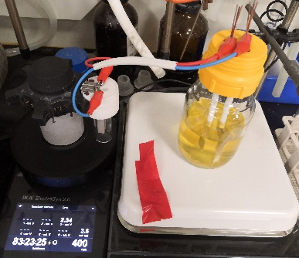
To a 250 mL clean and dry glass chamber charged with a proper stir bar was added 1a (1.5 equiv.), 2a (5 mmol), NHC A (20%, 1mmol), K₂CO₃ (1.5 equiv.), Bu₄NI (1.0 equiv.) and CH₂Cl₂ (150 mL). The glass chamber was sealed with a septum equipped with two Pt electrodes (2.0 × 2.0 cm²) and the reaction mixture was electrolyzed under a constant current of 3.6 mA for 83.5 h. After the reaction was completed, the solvent removed under reduced pressure. The crude product was purified by flash column chromatography affording the desired product 3a in 62% (1.12 g) isolated yield (96% ee).

  - The synthesis of D and E
To a stirred the solution of NHC A (0.5 mmol, 1.0 equiv) in anhydrous THF (4.0 mL) was slowly added LiHMDS (0.55 mmol, 1.1 equiv.) in a flame-dried Schlenk tube under N₂. The resultant mixture was stirred at room temperature for 2 h followed by the addition of I₂ solution (0.6 mmol, 1.2 equiv. in 2 mL THF) carefully and the color of the iodine solution must not be persistent upon addition. The reaction mixture was stirred at room temperature for further 8 h under N₂. The solvent was removed under reduced pressure and the residue was purified by silica gel column chromatography to afford (5aR,10bS)-1-iodo-2-mesityl-5a,10b-dihydro-4H,6H-indeno[2,1-b][1,2,4]triazolo[4,3-d][1,4]oxazin-2-ium iodide (D).
1,3-bis(2,4,6-trimethylphenyl)-2-iodoimidazolium iodide (E) was produced in the same way but replace NHC A with NHC B.
- Radical clock experiments

Allylic alcohol cis-20-S was synthesized following a two-steps procedure from styrene and Ethyl diazoacetate, as described in the literature ¹(ref).
To a solution of cis-20-S (1.0 equiv.) in DCM (0.5 M) was added PCC (1.5 equiv.) portion wise at rt. After overnight stirring at rt, the reaction mixture was filtered through a pad of celite and the filtrate was concentrated in vacuo. The residue was purified by column chromatography on silica gel to afford product cis-20 as described in the literature.¹

The ElectraSyn vial (5 mL) with a stir bar was charged with CH₃OH (0.2 mmol, 2.0 equiv.), NHC A (0.03 mmol, 30%), Cs₂CO₃ (0.03 mmol, 30%.), n-Bu₄NI (0.1 mmol, 1.0 equiv.) and cis-20 (0.1 mmol) followed by anhydrous DMF (2.0 mL) and DCE (1.0 mL). The ElectraSyn vial cap equipped with anode (Pt) and cathode (Pt) were inserted into the mixture. After pre-stirring for 2 minutes, the Electrasyn vial was connected to the Electrasyn 2.0 and the reaction mixture was electrolyzed under a constant current of 0.8 mA for a total reaction time of 9 hours accompanied by magnetic stirring. The ElectraSyn vial cap was removed, and electrodes were rinsed with EtOAc, which was combined with the crude mixture, and extracted with H₂O three times. After concentrated the organic phase under reduced pressure, the crude residue was purified via flash column chromatography to afford trans-21 as a pale yellow oil (15%), according with the description of the literature.²

The ElectraSyn vial (5 mL) with a stir bar was charged with NHC A (0.03 mmol, 30%), Cs₂CO₃ (0.03 mmol, 30%.), n-Bu₄NI (0.1 mmol, 1.0 equiv.) and cis-20 (0.1 mmol) followed by anhydrous DMF (2.0 mL) and DCE (1.0 mL). The ElectraSyn vial cap equipped with anode (Pt) and cathode (Pt) were inserted into the mixture. The Electrasyn vial was for 9 hours accompanied by magnetic stirring. The ElectraSyn vial cap was removed, and electrodes were rinsed with EtOAc, which was combined with the crude mixture, and extracted with H₂O three times. After concentrated the organic phase under reduced pressure, the crude residue was tested by ¹H NMR which shows that there is not the formation of trans-20.

To a flame-dried Schlenk tube equipped with a magnetic stirrer bar was charged with cis-20 (0.2 mmol), NHC A (30%), Cs₂CO₃ (30%), DQ (1.0 equiv.) under air, then the vessel was evacuated and re-filled with N₂ for four times. CH₃OH (2 equiv.) and anhydrous THF (2.0 mL) were added under N₂ counter flow. The Schlenk tube was sealed and the reaction mixture was stirred at the room temperature for 11 h. The crude mixture was tested by ¹H NMR (red line) and purified by column chromatography to provide 92% product cis-21 exclusively.
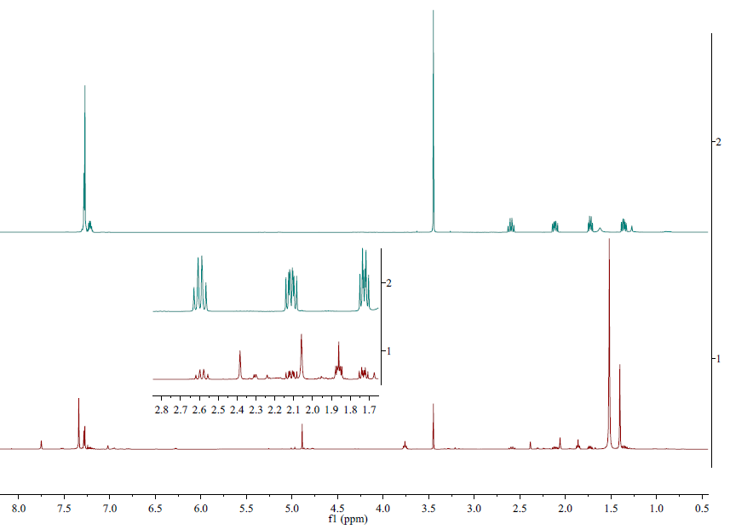

- Cyclic Voltammetry
Cyclic voltammograms were recorded with a Metrohm Autolab M204 workstation at room temperature. n-Bu₄NBF₄ (0.1 M) was used as the supporting electrolyte, and a Pt electrode (diameter 1 mm, length 1 cm) was used as the working electrode. The counter electrode was a Pt electrode (diameter 1 mm, length 1 cm). The reference electrode was used Ag/AgCl reference electrode (saturated KCl aqueous solution). The scan rate was 50 mV·s⁻¹.

Figure S1: Cyclic voltammetry in the mixture solvent of anhydrous CH₂Cl₂ (6 mL) and t-BuOH (3 mL) containing 0.1 M n-Bu₄NBF₄.
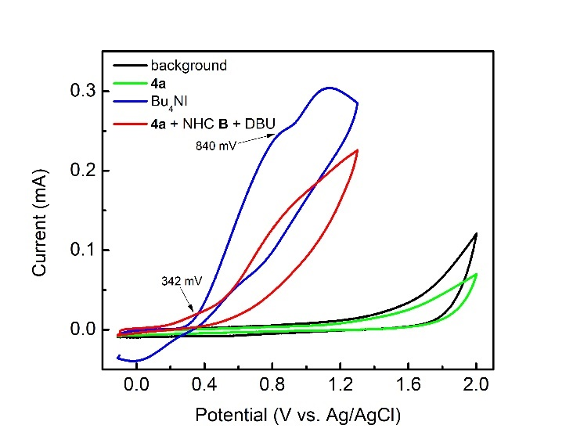
Note: background (black line); 0.3 mmol 4a (green line); 0.1 mmol n-Bu₄NI (blue line); 4a (0.3 mmol), NHC B (0.15 mmol, 50%), and DBU (0.15 mmol, 50%) were added to the mixture (red line).

Figure S2: Cyclic voltammetry in the mixture solvent of anhydrous CH₃CN (4.5 mL) and t-BuOH (4.5 mL) containing 0.1 M n-Bu₄NBF₄.
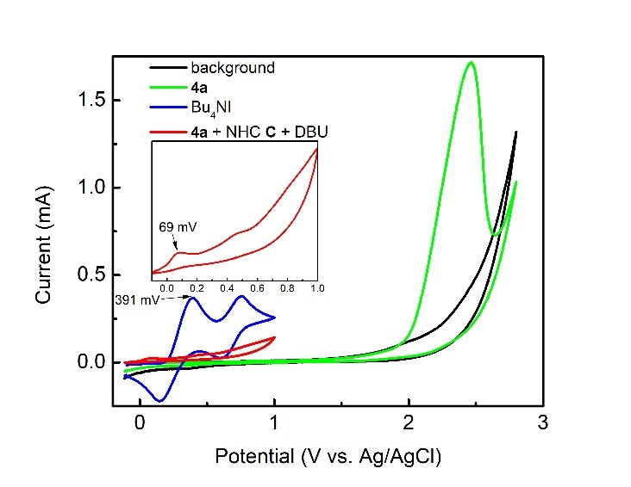
Note: background (black line); 0.3 mmol 4a (green line); 0.1 mmol n-Bu₄NI (blue line); 4a (0.3 mmol), NHC C (0.15 mmol, 50%), and DBU (0.15 mmol, 50%) were added to the mixture (red line).

Figure S3: Cyclic voltammetry in the mixture solvent of anhydrous DMF (6 mL) and DCE (3 mL) containing 0.1 M n-Bu₄NBF₄.
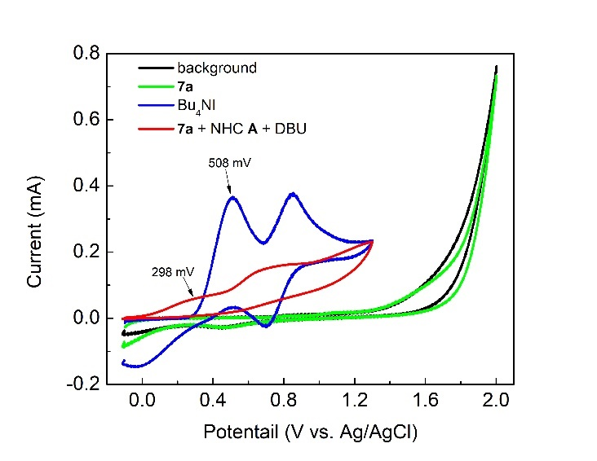
Note: background (black line); 0.3 mmol 7a (green line); 0.1 mmol n-Bu₄NI (blue line); 7a (0.3 mmol), NHC A (0.15 mmol, 50%), and DBU (0.15 mmol, 50%) were added to the mixture (red line).

Figure S4: Cyclic voltammetry in the mixture solvent of anhydrous THF (9 mL) containing 0.1 M n-Bu₄NBF₄.
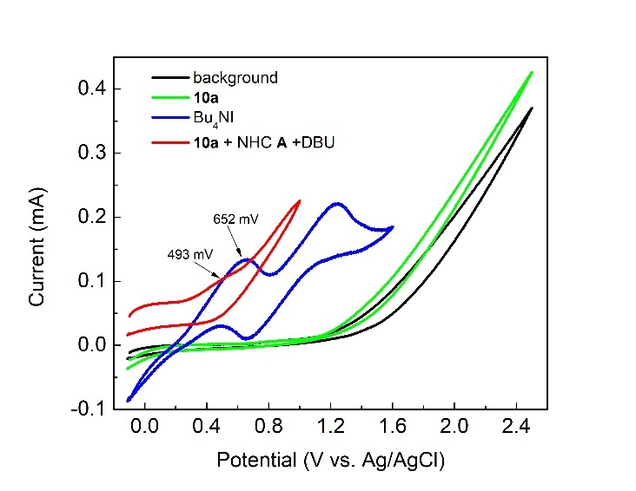
Note: background (black line); 0.3 mmol 10a (green line); 0.1 mmol n-Bu₄NI (blue line); 10a (0.3 mmol), NHC A (0.15 mmol, 50%), and DBU (0.15 mmol, 50%) were added to the mixture (red line).

- Characterization Data
Ethyl (R)-1-benzamido-6-oxo-4-phenyl-1,2,3,6-tetrahydropyridine-2-carboxylate (3a)³: white solid; ¹H NMR (400 MHz, CDCl₃) δ 9.05 (s, 1H), 7.85 (d, J = 7.5 Hz, 2H), 7.55 – 7.46 (m, 3H), 7.46 – 7.39 (m, 5H), 6.34 (d, J = 2.5 Hz, 1H), 4.79 (dd, J = 7.2, 2.3 Hz, 1H), 4.21 (q, J = 7.1 Hz, 2H), 3.60 (ddd, J = 17.6, 7.1, 2.6 Hz, 1H), 3.38 (dd, J = 17.6, 2.4 Hz, 1H), 1.23 (t, J = 7.1 Hz, 3H); ¹³C NMR (100 MHz, CDCl₃) δ 170.8, 166.3, 164.3, 149.6, 136.7, 132.4, 132.0, 130.2, 128.9, 128.7, 127.5, 126.1, 118.5, 62.2, 61.2, 30.1, 14.2; UPCC analysis: 97% ee (Chiralcel OX-3, CO₂/CH₃OH = 85/15, 1.0 mL/min, detector: 290 nm), Rt (minor) = 9.3 min, Rt (major) = 30.3 min.

Ethyl (R)-1-(4-fluorobenzamido)-6-oxo-4-phenyl-1,2,3,6-tetrahydropyridine-2-carboxylate (3b)³: white solid; ¹H NMR (400 MHz, CDCl₃) δ 9.15 (d, J = 8.1 Hz, 1H), 7.92 – 7.83 (m, 2H), 7.54 – 7.47 (m, 2H), 7.46 – 7.39 (m, 3H), 7.09 (t, J = 8.5 Hz, 2H), 6.34 (d, J = 2.5 Hz, 1H), 4.76 (d, J = 6.2 Hz, 1H), 4.22 (q, J = 7.1 Hz, 2H), 3.59 (dd, J = 17.5, 6.3 Hz, 1H), 3.38 (dd, J = 17.6, 2.3 Hz, 1H), 1.24 (t, J = 7.1 Hz, 3H); ¹³C NMR (100 MHz, CDCl₃) δ 170.7, 165.2 (J = 251 Hz), 165.2, 164.3, 149.7, 136.7, 130.2, 130.0 (J = 9 Hz), 128.9, 128.1, 126.1, 118.5, 115.8 (J = 22 Hz), 62.2, 61.2, 30.2, 14.2; ¹⁹F NMR (376 MHz, CDCl₃) δ 106.4; UPCC analysis: 96% ee (Chiralcel OX-3, CO₂/CH₃OH = 85/15, 1.0 mL/min, detector: 290 nm), Rt (minor) = 5.9 min, Rt (major) = 13.2 min.

Ethyl (R)-1-(4-methoxybenzamido)-6-oxo-4-phenyl-1,2,3,6-tetrahydropyridine-2-carboxylate (3c)³: white solid; ¹H NMR (400 MHz, CDCl₃) δ 8.78 (s, 1H), 7.83 (d, J = 8.4 Hz, 2H), 7.57 – 7.38 (m, 5H), 6.92 (d, J = 8.5 Hz, 2H), 6.34 (d, J = 2.4 Hz, 1H), 4.78 (d, J = 6.4 Hz, 1H), 4.22 (q, J = 7.1 Hz, 2H), 3.85 (s, 3H), 3.59 (dd, J = 17.4, 6.4 Hz, 1H), 3.37 (d, J = 17.4 Hz, 1H), 1.24 (t, J = 7.1 Hz, 3H); ¹³C NMR (100 MHz, CDCl₃) δ 170.8, 165.9, 164.3, 162.9, 149.4, 136.8, 130.1, 129.4, 128.9, 126.1, 124.2, 118.6, 113.9, 62.2, 61.2, 55.5, 30.1, 14.2; UPCC analysis: 96% ee (Chiralcel OX-3, CO₂/CH₃OH = 85/15, 1.0 mL/min, detector: 290 nm), Rt (minor) = 14.9 min, Rt (major) = 35.4 min.

Ethyl (R)-1-(3-bromobenzamido)-6-oxo-4-phenyl-1,2,3,6-tetrahydropyridine-2-carboxylate (3d)³: white solid; ¹H NMR (400 MHz, CDCl₃) δ 9.13 (s, 1H), 7.98 (s, 1H), 7.79 (d, J = 7.8 Hz, 1H), 7.65 (d, J = 8.0 Hz, 1H), 7.54 – 7.38 (m, 5H), 7.30 (t, J = 8.0 Hz, 1H), 6.33 (s, 1H), 4.76 (d, J = 6.9 Hz, 1H), 4.23 (q, J = 7.1 Hz, 2H), 3.59 (dd, J = 17.8, 7.0 Hz, 1H), 3.38 (d, J = 17.5 Hz, 1H), 1.25 (t, J = 7.1 Hz, 3H); ¹³C NMR (100 MHz, CDCl₃) δ 170.7, 164.8, 164.3, 149.8, 136.7, 135.3, 133.8, 130.8, 130.3, 130.2, 129.0, 126.1, 126.0, 122.9, 118.4, 62.3, 61.1, 30.1, 14.2; UPCC analysis: 96% ee (Chiralcel OX-3, CO₂/CH₃OH = 85/15, 1.0 mL/min, detector: 290 nm), Rt (minor) = 10.0 min, Rt (major) = 23.1 min.

Ethyl (R)-1-(nicotinamido)-6-oxo-4-phenyl-1,2,3,6-tetrahydropyridine-2-carboxylate (3e): white solid; ¹H NMR (400 MHz, CDCl₃) δ 9.33 (s, 1H), 9.07 (s, 1H), 8.76 (d, J = 4.7 Hz, 1H), 8.17 (d, J = 7.9 Hz, 1H), 7.56 – 7.47 (m, 2H), 7.46 – 7.35 (m, 4H), 6.34 (s, 1H), 4.76 (d, J = 6.9 Hz, 1H), 4.22 (q, J = 7.2 Hz, 2H), 3.60 (dd, J = 17.8, 7.0 Hz, 1H), 3.40 (d, J = 17.5 Hz, 1H), 1.24 (t, J = 7.0 Hz, 3H); ¹³C NMR (100 MHz, CDCl₃) δ 170.6, 164.6, 164.3, 153.0, 149.9, 148.7, 136.6, 135.4, 130.3, 129.0, 127.8, 126.1, 123.5, 118.4, 62.3, 61.2, 30.2, 14.2; IR (film) ν_{max}: 3211, 2982, 1736, 1656, 1420, 1199, 1024, 764, 697; HRMS (ESI) for C₂₀H₂₀N₃O₄⁺ ([M+H]⁺): calcd 366.1448, found 366.1445; UPCC analysis: 95% ee (Chiralcel OX-3, CO₂/CH₃OH, 1.0 mL/min = 85/15, detector: 290 nm), Rt (minor) = 14.5 min, Rt (major) = 15.9 min.

Ethyl (R)-1-(furan-2-carboxamido)-6-oxo-4-phenyl-1,2,3,6-tetrahydropyridine-2-carboxylate (3f)³: white solid; ¹H NMR (400 MHz, CDCl₃) δ 8.77 (s, 1H), 7.54 – 7.46 (m, 3H), 7.46 – 7.39 (m, 3H), 7.22 (d, J = 3.5 Hz, 1H), 6.53 (dd, J = 3.5, 1.7 Hz, 1H), 6.34 (d, J = 2.5 Hz, 1H), 4.72 (dd, J = 7.1, 2.2 Hz, 1H), 4.22 (q, J = 7.1 Hz, 2H), 3.57 (ddd, J = 17.6, 7.1, 2.6 Hz, 1H), 3.37 (dd, J = 17.6, 2.3 Hz, 1H), 1.25 (t, J = 7.1 Hz, 3H); ¹³C NMR (100 MHz, CDCl₃) δ 170.7, 164.2, 157.0, 149.6, 146.1, 144.9, 136.7, 130.2, 128.9, 126.1, 118.6, 116.3, 112.2, 62.3, 61.5, 30.1, 14.2; UPCC analysis: 94% ee (Chiralcel OX-3, CO₂/CH₃OH = 85/15, 1.0 mL/min, detector: 290 nm), Rt (minor) = 9.6 min, Rt (major) = 49.7 min.

Ethyl (R)-1-benzamido-4-(4-chlorophenyl)-6-oxo-1,2,3,6-tetrahydropyridine-2-carboxylate (3g)⁴: white solid; ¹H NMR (400 MHz, CDCl₃) δ 8.73 (s, 1H), 7.86 (d, J = 7.5 Hz, 2H), 7.55 (t, J = 7.4 Hz, 1H), 7.51 – 7.37 (m, 6H), 6.33 (d, J = 2.5 Hz, 1H), 4.79 (d, J = 5.9 Hz, 1H), 4.29 – 4.16 (m, 2H), 3.58 (ddd, J = 17.7, 7.2, 2.6 Hz, 1H), 3.33 (dd, J = 17.5, 2.3 Hz, 1H), 1.24 (t, J = 7.1 Hz, 3H); ¹³C NMR (100 MHz, CDCl₃) δ 170.7, 166.3, 164.0, 148.2, 136.4, 135.1, 132.5, 132.0, 129.2, 128.7, 127.5, 127.3, 118.9, 62.3, 61.1, 30.1, 14.2.; UPCC analysis: 97% ee (Chiralcel OX-3, CO₂/CH₃OH = 80/20, 1.0 mL/min, detector: 290 nm), Rt (minor) = 10.3 min, Rt (major) = 47.2 min.

Ethyl (R)-1-benzamido-4-(4-methoxyphenyl)-6-oxo-1,2,3,6-tetrahydropyridine-2-carboxylate (3h)³: white solid; ¹H NMR (400 MHz, CDCl₃) δ 9.05 (s, 1H), 7.84 (d, J = 7.7 Hz, 2H), 7.56 – 7.38 (m, 5H), 6.93 (d, J = 8.7 Hz, 2H), 6.27 (d, J = 2.4 Hz, 1H), 4.77 (d, J = 5.3 Hz, 1H), 4.20 (q, J = 7.0 Hz, 2H), 3.83 (s, 3H), 3.54 (ddd, J = 17.5, 7.0, 2.6 Hz, 1H), 3.36 (dd, J = 17.4, 2.5 Hz, 1H), 1.22 (t, J = 7.1 Hz, 3H); ¹³C NMR (100 MHz, CDCl₃) δ 170.8, 166.2, 164.6, 161.3, 149.0, 132.3, 132.1, 128.9, 128.6, 127.6, 127.5, 116.5, 114.3, 62.1, 61.1, 55.4, 30.0, 14.2; UPCC analysis: 97% ee (Chiralcel OX-3, CO₂/CH₃OH = 80/20, 1.0 mL/min, detector: 290 nm), Rt (minor) = 10.7 min, Rt (major) = 47.3 min.

Ethyl (R)-1-benzamido-4-(3-chlorophenyl)-6-oxo-1,2,3,6-tetrahydropyridine-2-carboxylate (3i): white solid; ¹H NMR (400 MHz, CDCl₃) δ 8.97 (s, 1H), 7.85 (d, J = 7.6 Hz, 2H), 7.53 (t, J = 7.4 Hz, 1H), 7.48 – 7.31 (m, 6H), 6.32 (d, J = 2.6 Hz, 1H), 4.78 (dd, J = 7.1, 2.3 Hz, 1H), 4.27 – 4.18 (m, 2H), 3.58 (ddd, J = 17.5, 7.0, 2.7 Hz, 1H), 3.31 (dd, J = 17.5, 2.4 Hz, 1H), 1.25 (t, J = 7.1 Hz, 3H); ¹³C NMR (100 MHz, CDCl₃) δ 170.6, 166.2, 163.8, 148.1, 138.6, 135.0, 132.4, 131.8, 130.2, 130.1, 128.7, 127.6, 126.2, 124.2, 119.6, 62.3, 61.0, 30.1, 14.2; IR (film) ν_{max}: 3240, 2981, 1736, 1655, 1425, 1196, 1019, 787, 690; HRMS (ESI) for C₂₁H₂₀ClN₂O₄⁺ ([M+H]⁺): calcd 399.1106, found 399.1103; UPCC analysis: 97% ee (Chiralcel OX-3, CO₂/CH₃OH = 80/20, 1.0 mL/min, detector: 290 nm), Rt (minor) = 6.4 min, Rt (major) = 18.2 min.

Ethyl (R)-1-benzamido-4-(naphthalen-2-yl)-6-oxo-1,2,3,6-tetrahydropyridine-2-carboxylate (3j)³: white solid; ¹H NMR (400 MHz, CDCl₃) δ 8.85 (s, 1H), 7.97 (s, 1H), 7.93 – 7.82 (m, 5H), 7.63 (d, J = 8.6 Hz, 1H), 7.59 – 7.51 (m, 3H), 7.46 (t, J = 7.5 Hz, 2H), 6.50 (d, J = 2.5 Hz, 1H), 4.86 (d, J = 6.0 Hz, 1H), 4.23 (q, J = 7.1 Hz, 2H), 3.71 (dd, J = 17.4, 5.9 Hz, 1H), 3.54 (d, J = 16.8 Hz, 1H), 1.25 (t, J = 7.1 Hz, 3H); ¹³C NMR (100 MHz, CDCl₃) δ 170.8, 166.3, 164.3, 149.2, 134.0, 133.8, 133.1, 132.4, 132.1, 128.8, 128.7, 128.7, 127.7, 127.5, 127.4, 126.9, 126.1, 123.1, 118.8, 62.2, 61.2, 30.1, 14.2; UPCC analysis: 97% ee (Chiralcel OX-3, CO₂/CH₃OH = 80/20, 1.0 mL/min, detector: 290 nm), Rt (minor) = 15.0 min, Rt (major) = 44.9 min.

Isopropyl (R)-1-benzamido-6-oxo-4-phenyl-1,2,3,6-tetrahydropyridine-2-carboxylate (3k)⁵: white solid; ¹H NMR (400 MHz, CDCl₃) δ 8.70 (s, 1H), 7.86 (d, J = 7.5 Hz, 2H), 7.56 (t, J = 7.4 Hz, 1H), 7.52 – 7.40 (m, 7H), 6.34 (s, 1H), 5.07 (hept, J = 6.3 Hz, 1H), 4.76 (d, J = 6.8 Hz, 1H), 3.58 (dd, J = 17.8, 6.9 Hz, 1H), 3.38 (d, J = 17.5 Hz, 1H), 1.24 (d, J = 6.4 Hz, 3H), 1.20 (d, J = 6.1 Hz, 3H); ¹³C NMR (100 MHz, CDCl₃) δ 170.3, 166.2, 164.4, 149.7, 136.8, 132.4, 132.1, 130.2, 129.0, 128.7, 127.5, 126.1, 118.6, 70.2, 61.3, 30.2, 21.8, 21.7; UPCC analysis: 96% ee (Chiralcel OX-3, CO₂/CH₃OH = 85/15, 1.0 mL/min, detector: 290 nm), Rt (minor) = 8.6 min, Rt (major) = 32.5 min.

Benzyl (R)-1-benzamido-6-oxo-4-phenyl-1,2,3,6-tetrahydropyridine-2-carboxylate (3l)⁵: white solid; ¹H NMR (400 MHz, CDCl₃) δ 8.75 (s, 1H), 7.80 (d, J = 7.6 Hz, 2H), 7.55 (t, J = 7.6 Hz, 1H), 7.48 – 7.37 (m, 7H), 7.33 – 7.24 (m, 5H), 6.33 (s, 1H), 5.30 (d, J = 12.1 Hz, 1H), 5.11 (d, J = 12.1 Hz, 1H), 4.85 (d, J = 6.2 Hz, 1H), 3.60 (dd, J = 17.6, 6.2 Hz, 1H), 3.37 (d, J = 17.4 Hz, 1H); ¹³C NMR (100 MHz, CDCl₃) δ 170.7, 166.2, 164.3, 149.6, 136.6, 134.9, 132.4, 131.9, 130.2, 128.9, 128.7, 128.7, 128.7, 128.3, 127.5, 126.1, 118.5, 67.8, 61.2, 30.1; UPCC analysis: 98% ee (Chiralcel OX-3, CO₂/CH₃OH = 80/20, 1.0 mL/min, detector: 290 nm), Rt (minor) = 11.2 min, Rt (major) = 36.3 min.

5-acetyl-6-methyl-4-phenyl-3,4-dihydro-2H-pyran-2-one (6a)⁶: white solid; ¹H NMR (400 MHz, CDCl₃) δ 7.37 – 7.27 (m, 3H), 7.17 – 7.11 (m, 2H), 4.14 (d, J = 6.3 Hz, 1H), 2.97 (dd, J = 15.7, 7.2 Hz, 1H), 2.83 (dd, J = 15.6, 2.6 Hz, 1H), 2.43 (s, 3H), 2.12 (s, 3H); ¹³C NMR (100 MHz, CDCl₃) δ 197.9, 165.6, 160.3, 139.7, 129.5, 128.0, 126.7, 117.3, 38.9, 37.2, 29.8, 19.1.

5-benzoyl-4,6-diphenyl-3,4-dihydro-2H-pyran-2-one (6b)⁶: white solid; ¹H NMR (400 MHz, CDCl₃) δ 7.51 – 7.46 (m, 2H), 7.39 – 7.34 (m, 2H), 7.33 – 7.27 (m, 4H), 7.25 – 7.20 (m, 2H), 7.19 – 7.05 (m, 5H), 4.56 (dd, J = 7.9, 2.4 Hz, 1H), 3.21 (dd, J = 15.9, 7.8 Hz, 1H), 3.06 (dd, J = 15.9, 2.5 Hz, 1H).; ¹³C NMR (100 MHz, CDCl₃) δ 195.9, 166.7, 154.9, 139.7, 137.1, 132.6, 132.0, 130.3, 129.3, 129.0, 128.1, 128.0, 127.8, 126.9, 118.3, 40.4, 36.0.

Ethyl 6-methyl-2-oxo-4-phenyl-3,4-dihydro-2H-pyran-5-carboxylate (6c)⁶: white solid; ¹H NMR (400 MHz, CDCl₃) δ 7.33 – 7.27 (m, 2H), 7.25 – 7.20 (m, 1H), 7.16 – 7.11 (m, 2H), 4.25 (d, J = 7.2 Hz, 1H), 4.13 (q, J = 7.1 Hz, 2H), 2.95 (dd, J = 15.9, 7.6 Hz, 1H), 2.82 (dd, J = 15.8, 2.4 Hz, 1H), 2.47 (s, 3H), 1.19 (t, J = 7.1 Hz, 3H); ¹³C NMR (100 MHz, CDCl₃) δ 166.2, 166.0, 161.3, 140.6, 129.0, 127.5, 126.6, 110.0, 60.9, 37.8, 36.4, 18.9, 14.1.

Ethyl 2-oxo-4,6-diphenyl-3,4-dihydro-2H-pyran-5-carboxylate (6d)⁶: white solid; ¹H NMR (400 MHz, CDCl₃) δ 7.54 – 7.49 (m, 2H), 7.48 – 7.38 (m, 3H), 7.37 – 7.31 (m, 2H), 7.30 – 7.26 (m, 2H), 7.26 – 7.20 (m, 1H), 4.41 (dd, J = 7.7, 2.5 Hz, 1H), 3.98 – 3.89 (m, 2H), 3.11 (dd, J = 15.9, 7.7 Hz, 1H), 2.95 (dd, J = 15.9, 2.6 Hz, 1H), 0.88 (t, J = 7.1 Hz, 3H); ¹³C NMR (100 MHz, CDCl₃) δ 166.4, 166.0, 158.5, 139.9, 133.1, 130.1, 129.2, 128.6, 128.0, 127.8, 126.8, 111.7, 61.0, 38.9, 36.3, 13.5.

5-benzoyl-6-methyl-4-phenyl-3,4-dihydro-2H-pyran-2-one (6e)⁶: yellow solid; ¹H NMR (400 MHz, CDCl₃) δ 7.67 – 7.61 (m, 2H), 7.56 – 7.50 (m, 1H), 7.41 (t, J = 7.6 Hz, 2H), 7.31 – 7.26 (m, 2H), 7.25 – 7.19 (m, 1H), 7.18 – 7.11 (m, 2H), 4.33 (dd, J = 7.9, 3.5 Hz, 1H), 3.08 (dd, J = 16.0, 7.5 Hz, 1H), 2.95 (dd, J = 16.0, 3.6 Hz, 1H), 1.91 (s, 3H); ¹³C NMR (100 MHz, CDCl₃) δ 195.8, 166.5, 154.8, 140.0, 138.4, 133.1, 129.2, 128.8, 128.7, 127.6, 126.8, 117.8, 39.4, 36.2, 19.0.

5-acetyl-4-(4-fluorophenyl)-6-methyl-3,4-dihydro-2H-pyran-2-one (6f)⁷: yellow solid; ¹H NMR (400 MHz, CDCl₃) δ 7.15 – 7.08 (m, 2H), 7.05 – 6.98 (m, 2H), 4.15 (d, J = 6.1 Hz, 1H), 2.95 (dd, J = 15.7, 7.2 Hz, 1H), 2.80 (dd, J = 15.6, 2.6 Hz, 1H), 2.42 (d, J = 1.1 Hz, 3H), 2.13 (s, 3H); ¹³C NMR (100 MHz, CDCl₃) δ 197.6, 165.4, 162.3 (J = 245 Hz), 160.4, 135.5 (J = 3 Hz), 128.4 (J = 8 Hz), 117.4, 116.4 (J = 22 Hz), 38.1, 37.2, 29.8, 19.2.

5-acetyl-4-(4-chlorophenyl)-6-methyl-3,4-dihydro-2H-pyran-2-one (6g)⁷: white solid; ¹H NMR (400 MHz, CDCl₃) δ 7.31 (d, J = 8.1 Hz, 2H), 7.08 (d, J = 8.1 Hz, 2H), 4.15 (d, J = 7.2 Hz, 1H), 2.96 (dd, J = 15.7, 7.3 Hz, 1H), 2.80 (dd, J = 15.7, 2.5 Hz, 1H), 2.43 (s, 3H), 2.14 (s, 3H); ¹³C NMR (100 MHz, CDCl₃) δ 197.4, 165.3, 160.6, 138.3, 133.9, 129.6, 128.1, 117.2, 38.2, 37.0, 29.9, 19.2.

5-acetyl-6-methyl-4-(p-tolyl)-3,4-dihydro-2H-pyran-2-one (6h)⁸: white solid; ¹H NMR (400 MHz, CDCl₃) δ 7.13 (d, J = 7.8 Hz, 2H), 7.02 (d, J = 7.9 Hz, 2H), 4.10 (dd, J = 7.3, 2.5 Hz, 1H), 2.95 (dd, J = 15.6, 7.1 Hz, 1H), 2.81 (dd, J = 15.6, 2.7 Hz, 1H), 2.42 (s, 3H), 2.31 (s, 3H), 2.11 (s, 3H); ¹³C NMR (100 MHz, CDCl₃) δ 198.1, 165.7, 160.1, 137.7, 136.6, 130.1, 126.5, 117.4, 38.5, 37.3, 29.7, 21.0, 19.1.

5-acetyl-4-(4-methoxyphenyl)-6-methyl-3,4-dihydro-2H-pyran-2-one (6i)⁶: yellow solid; ¹H NMR (400 MHz, CDCl₃) δ 7.05 (d, J = 8.6 Hz, 2H), 6.85 (d, J = 8.6 Hz, 2H), 4.09 (d, J = 6.3 Hz, 1H), 3.78 (s, 3H), 2.93 (dd, J = 15.6, 7.1 Hz, 1H), 2.80 (dd, J = 15.6, 2.6 Hz, 1H), 2.41 (s, 3H), 2.12 (s, 3H); ³C NMR (100 MHz, CDCl₃) δ 198.1, 165.8, 160.0, 159.2, 131.5, 127.8, 117.6, 114.8, 55.3, 38.1, 37.4, 29.7, 19.1.

(3S,4S)-3-benzyl-4,6-diphenyl-3,4-dihydro-2H-pyran-2-one (9a)⁹: white solid; ¹H NMR (400 MHz, CDCl₃) δ 7.69 – 7.62 (m, 2H), 7.42 – 7.28 (m, 8H), 7.26 – 7.20 (m, 1H), 7.17 – 7.06 (m, 4H), 6.03 (d, J = 6.7 Hz, 1H), 3.67 (t, J = 6.8 Hz, 1H), 3.40 (ddd, J = 9.2, 6.9, 5.2 Hz, 1H), 3.29 (dd, J = 14.6, 5.1 Hz, 1H), 2.45 (dd, J = 14.7, 9.2 Hz, 1H); ¹³C NMR (100 MHz, CDCl₃) δ 170.2, 150.0, 138.7, 137.8, 132.2, 129.2, 129.0, 129.0, 128.6, 128.5, 128.5, 127.8, 126.5, 124.7, 105.2, 45.7, 40.8, 32.3; UPCC analysis: major diastereomer 99% ee (Chiralcel OD-3, CO₂/CH₃OH = 95/5, 1.0 mL/min, detector: 254 nm), Rt (major) = 12.8 min, Rt (minor) = 14.3 min.

(3S,4S)-3-methyl-4,6-diphenyl-3,4-dihydro-2H-pyran-2-one (9b)⁹: white solid; ¹H NMR (400 MHz, CDCl₃) δ 7.71 (dd, J = 7.7, 1.9 Hz, 2H), 7.45 – 7.27 (m, 6H), 7.20 – 7.13 (m, 2H), 6.08 (d, J = 6.3 Hz, 1H), 3.75 (t, J = 6.8 Hz, 1H), 3.16 (p, J = 7.0 Hz, 1H), 1.09 (d, J = 6.9 Hz, 3H); ¹³C NMR (100 MHz, CDCl₃) δ 171.0, 150.4, 137.7, 132.3, 129.2, 128.9, 128.6, 128.3, 127.7, 124.7, 104.6, 43.3, 39.0, 12.5; UPCC analysis: major diastereomer 98% ee (Chiralcel OD-3, CO₂/CH₃OH = 97/3, 1.0 mL/min, detector: 254 nm), Rt (major) = 10.0 min, Rt (minor) = 10.7 min.

(3S,4S)-3-ethyl-4,6-diphenyl-3,4-dihydro-2H-pyran-2-one (9c)⁹: white solid; ¹H NMR (400 MHz, CDCl₃) δ 7.71 – 7.65 (m, 2H), 7.42 – 7.35 (m, 3H), 7.35 – 7.26 (m, 3H), 7.20 – 7.15 (m, 2H), 6.07 (d, J = 6.3 Hz, 1H), 3.85 (t, J = 6.7 Hz, 1H), 2.86 (q, J = 7.0 Hz, 1H), 1.84 – 1.71 (m, 1H), 1.31 – 1.19 (m, 1H), 1.03 (t, J = 7.4 Hz, 3H); ¹³C NMR (100 MHz, CDCl₃) δ 170.4, 150.2, 138.0, 132.3, 129.1, 128.9, 128.5, 128.1, 127.6, 124.7, 104.8, 46.0, 41.3, 19.8, 12.1; UPCC analysis: major diastereomer 98% ee (Chiralcel OD-3, CO₂/CH₃OH = 99.3/0.7, 1.0 mL/min, detector: 254 nm), Rt (major) = 24.6 min, Rt (minor) = 28.9 min.

(3S,4S)-4,6-diphenyl-3-propyl-3,4-dihydro-2H-pyran-2-one (9d)¹⁰: white solid; ¹H NMR (400 MHz, DCl₃) δ 7.68 (dd, J = 7.7, 1.9 Hz, 2H), 7.43 – 7.35 (m, 3H), 7.35 – 7.26 (m, 3H), 7.20 – 7.14 (m, 2H), 6.07 (d, J = 6.4 Hz, 1H), 3.82 (t, J = 6.7 Hz, 1H), 2.95 (q, J = 6.9 Hz, 1H), 1.76 – 1.64 (m, 1H), 1.53 – 1.38 (m, 2H), 1.27 – 1.12 (m, 1H), 0.89 (t, J = 7.3 Hz, 3H); ¹³C NMR (100 MHz, CDCl₃) δ 170.6, 150.1, 138.1, 132.3, 129.1, 128.9, 128.5, 128.1, 127.6, 124.7, 104.8, 44.0, 41.6, 28.7, 20.6, 13.9; UPCC analysis: major diastereomer 99% ee (Chiralcel OD-3, CO₂/CH₃OH = 97/3, 1.0 mL/min, detector: 254 nm), Rt (major) = 7.9 min, Rt (minor) = 9.5 min.

(3S,4S)-3-benzyl-4-(4-fluorophenyl)-6-phenyl-3,4-dihydro-2H-pyran-2-one (9e): white solid; ¹H NMR (400 MHz, CDCl₃) δ 7.69 – 7.64 (m, 2H), 7.43 – 7.36 (m, 3H), 7.35 – 7.29 (m, 2H), 7.29 – 7.23 (m, 2H), 7.16 – 7.10 (m, 2H), 7.08 – 6.97 (m, 4H), 6.02 (d, J = 6.7 Hz, 1H), 3.66 (t, J = 6.8 Hz, 1H), 3.41 (ddd, J = 9.4, 6.9, 5.0 Hz, 1H), 3.30 (dd, J = 14.7, 5.1 Hz, 1H), 2.41 (dd, J = 14.7, 9.4 Hz, 1H); ¹³C NMR (100 MHz, CDCl₃) δ 170.0, 162.3 (J = 246 Hz), 161.1, 150.2, 138.4, 133.5 (J = 3 Hz), 132.0, 130.1 (J = 8 Hz), 129.3, 128.9, 128.6, 128.6, 126.6, 124.7, 115.8 (J = 21 Hz), 105.0, 45.5, 40.0, 32.3; IR (film) ν_{max}: 3063, 2925, 1769, 1604, 1509, 1227, 1131, 1078, 836, 763, 540; HRMS (ESI) for C₂₄H₁₉FNaO₂⁺ ([M+Na]⁺): calcd 381.1261, found 381.1254; UPCC analysis: major diastereomer 99% ee (Chiralcel OD-3, CO₂/CH₃OH = 95/5, 1.0 mL/min, detector: 254 nm), Rt (major) = 10.0 min, Rt (minor) = 12.8 min.

(3S,4S)-3-benzyl-4-(4-chlorophenyl)-6-phenyl-3,4-dihydro-2H-pyran-2-one (9f)⁹: white solid; ¹H NMR (400 MHz, CDCl₃) δ 7.58 – 7.51 (m, 2H), 7.33 – 7.26 (m, 3H), 7.24 – 7.12 (m, 5H), 7.05 – 6.98 (m, 2H), 6.94 – 6.87 (m, 2H), 5.89 (d, J = 6.7 Hz, 1H), 3.53 (t, J = 6.8 Hz, 1H), 3.30 (ddd, J = 9.4, 6.9, 5.1 Hz, 1H), 3.20 (dd, J = 14.7, 5.1 Hz, 1H), 2.30 (dd, J = 14.7, 9.5 Hz, 1H); ¹³C NMR (100 MHz, CDCl₃) δ 169.9, 150.3, 138.3, 136.3, 133.7, 131.9, 129.8, 129.4, 129.1, 128.9, 128.7, 128.6, 126.7, 124.7, 104.7, 45.3, 40.1, 32.3; UPCC analysis: major diastereomer 96% ee (Chiralcel OD-3, CO₂/CH₃OH = 95/5, 1.0 mL/min, detector: 254 nm), Rt (major) = 15.8 min, Rt (minor) = 21.4 min.

(3S,4S)-3-benzyl-6-phenyl-4-(p-tolyl)-3,4-dihydro-2H-pyran-2-one (9g): white solid; ¹H NMR (400 MHz, CDCl₃) δ 7.69 – 7.62 (m, 2H), 7.43 – 7.28 (m, 5H), 7.26 – 7.21 (m, 1H), 7.14 (d, J = 8.1 Hz, 4H), 6.99 (d, J = 7.6 Hz, 2H), 6.02 (d, J = 6.6 Hz, 1H), 3.63 (t, J = 6.5 Hz, 1H), 3.41 – 3.33 (m, 1H), 3.28 (dd, J = 14.7, 5.0 Hz, 1H), 2.45 (dd, J = 14.3, 9.4 Hz, 1H), 2.35 (s, 3H); ¹³C NMR (100 MHz, CDCl₃) δ 170.3, 149.9, 138.8, 137.6, 134.7, 132.2, 129.6, 129.1, 129.0, 128.5, 128.3, 126.5, 124.6, 105.4, 45.8, 40.4, 32.3, 21.1; IR (film) ν_{max}: 3061, 2924, 1768, 1662, 1496, 1130, 1077, 762, 692, 538; HRMS (ESI) for C₂₅H₂₂NaO₂⁺ ([M+Na]⁺): calcd 377.1512, found 377.1509; UPCC analysis: major diastereomer 99% ee (Chiralcel OD-3, CO₂/CH₃OH = 95/5, 1.0 mL/min, detector: 254 nm), Rt (major) = 12.4 min, Rt (minor) = 14.2 min.

(3S,4S)-3-benzyl-6-(4-methoxyphenyl)-4-phenyl-3,4-dihydro-2H-pyran-2-one (9h): white solid; ¹H NMR (400 MHz, CDCl₃) δ 7.59 (d, J = 8.4 Hz, 2H), 7.37 – 7.21 (m, 6H), 7.12 (dd, J = 14.0, 7.4 Hz, 4H), 6.91 (d, J = 8.4 Hz, 2H), 5.89 (d, J = 6.6 Hz, 1H), 3.83 (s, 3H), 3.64 (t, J = 6.8 Hz, 1H), 3.43 – 3.34 (m, 1H), 3.28 (dd, J = 14.7, 5.1 Hz, 1H), 2.44 (dd, J = 14.7, 9.2 Hz, 1H); ¹³C NMR (100 MHz, CDCl₃) δ 170.4, 160.4, 149.8, 138.7, 138.1, 129.0, 128.9, 128.5, 128.4, 127.8, 126.5, 126.1, 124.8, 113.9, 103.4, 55.4, 45.7, 40.8, 32.4; IR (film) ν_{max}: 3029, 2924, 1765, 1609, 1513, 1455, 1254, 1178, 1078, 764, 698; HRMS (ESI) for C₂₅H₂₂NaO₃⁺ ([M+Na]⁺): calcd 393.1461, found 393.1457; UPCC analysis: major diastereomer 99% ee (Chiralcel OD-3, CO₂/CH₃OH = 95/5, 1.0 mL/min, detector: 254 nm), Rt (major) = 22.1 min, Rt (minor) = 29.7 min.

(3S,4S)-3-benzyl-6-(furan-2-yl)-4-phenyl-3,4-dihydro-2H-pyran-2-one (9i)⁹: white solid; ¹H NMR (400 MHz, CDCl₃) δ 7.39 (d, J = 1.7 Hz, 1H), 7.37 – 7.18 (m, 8H), 7.14 – 7.07 (m, 4H), 6.66 (d, J = 3.4 Hz, 1H), 6.46 (dd, J = 3.4, 1.8 Hz, 1H), 5.98 (d, J = 6.7 Hz, 1H), 3.67 (t, J = 6.8 Hz, 1H), 3.39 (ddd, J = 9.2, 6.9, 5.1 Hz, 1H), 3.27 (dd, J = 14.7, 5.1 Hz, 1H), 2.43 (dd, J = 14.7, 9.2 Hz, 1H); ¹³C NMR (100 MHz, CDCl₃) δ 169.7, 146.8, 143.2, 142.9, 138.5, 137.8, 129.0, 128.5, 128.4, 127.8, 126.6, 111.5, 107.9, 103.6, 45.9, 40.5, 32.4; UPCC analysis: major diastereomer 99% ee (Chiralcel OD-3, CO₂/CH₃OH = 97/3, 1.0 mL/min, detector: 235 nm), Rt (major) = 12.2 min, Rt (minor) = 17.0 min.

(S)-methyl (3-oxo-1,3-dihydroisobenzofuran-1-yl) terephthalate (12a)¹¹: white solid; ¹H NMR (400 MHz, CDCl₃) δ 8.10 (s, 4H), 7.98 (d, J = 7.8 Hz, 1H), 7.78 (t, J = 7.5 Hz, 1H), 7.72 – 7.65 (m, 3H), 3.94 (s, 3H); ¹³C NMR (100 MHz, CDCl₃) δ 167.7, 166.0, 164.4, 144.2, 135.0, 134.9, 132.1, 131.5, 130.1, 129.7, 126.6, 125.9, 123.8, 93.4, 52.5; UPCC analysis: 95% ee (Chiralpak AD-3, CO₂/CH₃OH = 90/10, 1.0 mL/min, detector: 254 nm), Rt (major) = 6.2 min, Rt (minor) = 12.2 min.

(S)-3-oxo-1,3-dihydroisobenzofuran-1-yl 4-chlorobenzoate (12b)¹¹: white solid; ¹H NMR (400 MHz, CDCl₃) δ 8.04 – 7.95 (m, 3H), 7.78 (t, J = 7.5 Hz, 1H), 7.74 – 7.63 (m, 3H), 7.43 (d, J = 8.2 Hz, 2H); ¹³C NMR (100 MHz, CDCl₃) δ 167.8, 164.3, 144.3, 140.7, 134.9, 131.5, 131.4, 129.0, 126.9, 126.6, 125.9, 123.7, 93.3; UPCC analysis: 96% ee (Chiralpak AD-3, CO₂/CH₃OH = 90/10, 1.0 mL/min, detector: 254 nm), Rt (major) = 4.8 min, Rt (minor) = 11.9 min.

(R)-3-oxo-1,3-dihydroisobenzofuran-1-yl nicotinate (12c)¹²: white solid; ¹H NMR (400 MHz, CDCl₃) δ 9.23 (s, 1H), 8.82 (dd, J = 4.9, 1.8 Hz, 1H), 8.35 – 8.27 (m, 1H), 7.98 (d, J = 7.5 Hz, 1H), 7.79 (t, J = 7.6 Hz, 1H), 7.73 – 7.65 (m, 3H), 7.41 (dd, J = 7.9, 5.1 Hz, 1H); ¹³C NMR (100 MHz, CDCl₃) δ 167.6, 163.9, 154.4, 151.3, 144.0, 137.5, 135.0, 131.5, 126.5, 126.0, 124.6, 123.7, 123.5, 93.3; UPCC analysis: 92% ee (Chiralpak AD-3, CO₂/CH₃OH = 85/15, 1.0 mL/min, detector: 254 nm), Rt (major) = 5.5 min, Rt (minor) = 19.0 min.

(S)-3-oxo-1,3-dihydroisobenzofuran-1-yl quinoline-6-carboxylate (12d): white solid; ¹H NMR (400 MHz, CDCl₃) δ 9.01 (d, J = 4.1 Hz, 1H), 8.60 (s, 1H), 8.26 (dd, J = 17.4, 8.6 Hz, 2H), 8.14 (d, J = 8.9 Hz, 1H), 7.98 (d, J = 7.6 Hz, 1H), 7.83 – 7.65 (m, 4H), 7.47 (dd, J = 8.4, 4.2 Hz, 1H); ¹³C NMR (100 MHz, CDCl₃) δ 167.8, 164.6, 153.1, 150.4, 144.3, 137.4, 135.0, 132.1, 131.5, 130.2, 128.9, 127.4, 126.6, 126.3, 125.9, 123.8, 122.1, 93.5; IR (film) ν_{max}: 3055, 1783, 1735, 1624, 1266, 1177, 970, 751, 688; HRMS (ESI) for C₁₈H₁₂NO₄⁺ ([M+H]⁺): calcd 306.0761, found 306.0758; UPCC analysis: 95% ee (Chiralpak AD-3, CO₂/CH₃OH = 85/15, 1.0 mL/min, detector: 254 nm), Rt (major) = 8.8 min, Rt (minor) = 18.1 min.

1-(5'-methyl-[1,1':3',1''-terphenyl]-4'-yl)ethan-1-one (14)¹³: yellow oil; ¹H NMR (400 MHz, CDCl₃) δ 7.68 – 7.60 (m, 2H), 7.50 – 7.34 (m, 10H), 2.41 (s, 3H), 1.97 (s, 3H); ¹³C NMR (100 MHz, CDCl₃) δ 207.6, 141.8, 140.5, 140.2, 139.3, 134.5, 129.0, 128.9, 128.7, 128.4, 127.9, 127.8, 127.2, 126.2, 32.2, 19.8.

(S)-4,6-diphenyl-1-tosyl-3,4-dihydropyridin-2(1H)-one (16)¹⁴: white solid; ¹H NMR (400 MHz, CDCl₃) δ 7.78 (d, J = 7.9 Hz, 2H), 7.45 – 7.27 (m, 9H), 7.25 – 7.14 (m, 3H), 5.99 (d, J = 4.3 Hz, 1H), 3.87 (q, J = 7.0 Hz, 1H), 2.83 (d, J = 8.0 Hz, 2H), 2.44 (s, 3H); ¹³C NMR (100 MHz, CDCl₃) δ 171.7, 145.0, 141.0, 140.5, 137.2, 136.5, 129.2, 129.1, 129.0, 128.4, 128.4, 127.4, 127.1, 126.0, 123.2, 42.9, 37.2, 21.7; UPCC analysis: 97% ee (Chiralcel OX-3, CO₂/CH₃OH = 80/20, 1.0 mL/min, detector: 254 nm), Rt (major) = 6.7min, Rt (minor) = 9.9 min.

Ethyl (S)-7-oxo-9-phenyl-7,10-dihydro-10aH-benzo[4,5]isothiazolo[2,3-a]pyridine-10a carbo-xyl-ate 5,5-dioxide (18)¹⁵: white solid; ¹H NMR (400 MHz, CDCl₃) δ 7.93 (d, J = 7.7 Hz, 1H), 7.81 – 7.76 (m, 2H), 7.74 – 7.67 (m, 1H), 7.58 – 7.53 (m, 2H), 7.50 – 7.44 (m, 3H), 6.40 (d, J = 2.6 Hz, 1H), 4.27 – 4.09 (m, 3H), 3.05 (dd, J = 16.8, 2.7 Hz, 1H), 1.18 (t, J = 7.1 Hz, 3H); ¹³C NMR (100 MHz, CDCl₃) δ 169.0, 160.5, 152.8, 136.2, 134.9, 134.4, 132.4, 131.3, 130.9, 129.2, 126.5, 124.0, 122.2, 119.7, 68.1, 63.8, 36.9, 13.9; UPCC analysis: 88% ee (Trefoil CEL2, CO₂/CH₃OH = 80/20, 1.0 mL/min, detector: 290 nm), Rt (major) = 9.1min, Rt (minor) = 10.6 min.

(5aR,10bS)-1-iodo-2-mesityl-5a,10b-dihydro-4H,6H-indeno[2,1-b][1,2,4]triazolo[4,3-d][1,4] oxazin-2-ium iodide (D)¹⁶: brown solid; ¹H NMR (400 MHz, DMSO-d₆) δ 7.48 (t, J = 6.8 Hz, 2H), 7.41 (t, J = 7.4 Hz, 1H), 7.35 (t, J = 7.4 Hz, 1H), 7.25 (s, 2H), 6.03 (d, J = 3.3 Hz, 1H), 5.27 (d, J = 16.3 Hz, 1H), 4.99 (d, J = 16.4 Hz, 1H), 4.91 (t, J = 3.8 Hz, 1H), 3.48 (dd, J = 16.8, 4.2 Hz, 1H), 3.12 (d, J = 16.7 Hz, 1H), 2.40 (s, 3H), 2.11 (s, 3H), 2.01 (s, 3H); ¹³C NMR (100 MHz, DMSO-d₆) δ 154.0, 142.5, 141.6, 136.8, 136.0, 135.4, 132.1, 130.2, 130.0, 129.6, 127.6, 126.4, 125.0, 78.4, 63.3, 60.6, 37.2, 21.3, 17.5, 17.3; HRMS (ESI) for C₂₁H₂₁IN₃O⁺ (M⁺): calcd 458.0724, found 458.0719.

2-iodo-1,3-dimesityl-1H-imidazol-3-ium iodide (E)¹⁷: white solid; ¹H NMR (400 MHz, CDCl₃) δ 7.43 (s, 1H), 7.03 (s, 2H), 2.37 (s, 3H), 2.00 (s, 6H); ¹³C NMR (100MHz, CDCl₃) δ 141.7, 134.2, 132.2, 130.1, 125.0, 118.9, 21.2, 17.6; HRMS (ESI) for C₂₁H₂₄IN₂⁺ (M⁺): calcd 431.0979, found 431.0974.

cis-2-phenylcyclopropane-1-carbaldehyde (cis-20)¹: colorless oil; ¹H NMR (400 MHz, CDCl₃) δ 8.67 (d, J = 6.7 Hz, 1H), 7.36 – 7.19 (m, 5H), 2.83 (q, J = 8.2 Hz, 1H), 2.14 (ddd, J = 14.7, 8.1, 5.8 Hz, 1H), 1.88 (q, J = 5.6 Hz, 1H), 1.63 – 1.55 (m, 1H); ¹³C NMR (100 MHz, CDCl₃) δ 201.5, 136.0, 129.4, 128.8, 127.4, 29.9, 26.6, 11.8.

methyl trans-2-phenylcyclopropane-1-carboxylate (trans-21)²: pale yellow oil; ¹H NMR (400 MHz, CDCl₃) δ 7.31 – 7.24 (m, 2H), 7.23 – 7.17 (m, 1H), 7.12 – 7.05 (m, 2H), 3.72 (s, 3H), 2.57 – 2.48 (m, 1H), 1.91 (dt, J = 9.1, 4.8 Hz, 1H), 1.61 (dt, J = 9.7, 4.9 Hz, 1H), 1.32 (ddd, J = 8.3, 6.5, 4.7 Hz, 1H); ¹³C NMR (100 MHz, CDCl₃) δ 174.0, 140.2, 128.7, 126.7, 126.4, 52.1, 26.5, 24.1, 17.2.
methyl cis-2-phenylcyclopropane-1-carboxylate (cis-21)² : pale yellow oil; ¹H NMR (400 MHz, CDCl₃) δ 7.31 – 7.19 (m, 5H), 3.45 (s, 3H), 2.60 (q, J = 8.8 Hz, 1H), 2.11 (ddd, J = 9.2, 7.9, 5.6 Hz, 1H), 1.73 (dt, J = 7.5, 5.4 Hz, 1H), 1.36 (td, J = 8.0, 5.1 Hz, 1H); ¹³C NMR (100 MHz, CDCl₃) δ 171.6, 136.6, 129.4, 128.1, 126.9, 51.6, 25.8, 21.8, 11.6.

- Reference
1. Mauleo´n, P.; Krinsky, J. L.; Toste, F. D., Mechanistic studies on Au(I)-catalyzed [3,3]-sigmatropic rearrangements using cyclopropane probes. J. Am. Chem. Soc. 2009, 131, 4513–4520.
2. Sone, Y.; Kimura, Y.; Ota, R.; Mochizuki, T.; Ito, J.; Nishii, Y., Catalytic hydrogenolysis of enantioenriched donor-acceptor cyclopropanes using H₂ and palladium on charcoal. Eur. J. Org. Chem. 2017, 2017, 2842–2847.
3. Xu, J.; Jin, Z.; Chi, R. Y., Organocatalytic enantioselective γ‑aminoalkylation of unsaturated ester: Access to pipecolic acid derivatives. Org. Lett. 2013, 15, 5028–5031.
4. Jia, W.-Q.; Zhang, H.-M.; Zhang, C.-L.; Gao, Z.-H.; Ye, S., N-Heterocyclic carbene-catalyzed [4+2] annulation of α,β-unsaturated carboxylic acids: enantioselective synthesis of dihydropyridinones and spirocyclic oxindolodihydropyridinones. Org. Chem. Front. 2016, 3, 77–81.
5. Wu, X.; Zhang, Y.; Wang, Y.; Ke, J.; Jeret, M.; Reddi, R. N.; Yang, S.; Song, B. A.; Chi, Y. R., Polyhalides as efficient and mild oxidants for oxidative carbene organocatalysis by radical processes. Angew. Chem. Int. Ed . 2017, 56, 2942–2946.
6. De Sarkar, S.; Studer, A., NHC-catalyzed Michael addition to α,β-unsaturated aldehydes by redox activation. Angew. Chem. Int. Ed. 2010, 49, 9266–9269.
7. Yetra, S. R.; Bhunia, A.; Patra, A.; Mane, M. V.; Vanka, K.; Biju, A. T., Enantioselective N-heterocyclic carbene-catalyzed annulations of 2-bromoenals with 1,3-dicarbonyl compounds and enamines via chiral α,β-unsaturated acylazoliums. Adv. Synth. Catal. 2013, 355, 1089–1097.
8. Mo, J.; Shen, L.; Chi, Y. R., Direct β-activation of saturated aldehydes to formal Michael acceptors through oxidative NHC catalysis. Angew. Chem. Int. Ed. 2013, 52, 8588–8591.
9. Mo, J.; Yang, R.; Chen, X.; Tiwari, B.; Chi, Y. R., Direct α-functionalization of simple aldehydes via oxidative N-heterocyclic carbene catalysis. Org. Lett. 2013, 15, 50–53.
10. Zhao, X.; Ruhl, K. E.; Rovis, T., N-heterocyclic-carbene-catalyzed asymmetric oxidative hetero-Diels-Alder reactions with simple aliphatic aldehydes. Angew. Chem. Int. Ed. 2012, 51, 12330–12333.
11. Liu, Y.; Majhi, P. K.; Song, R.; Mou, C.; Hao, L.; Chai, H.; Jin, Z.; Chi, Y. R., Carbene-catalyzed dynamic kinetic resolution and asymmetric acylation of hydroxyphthalides and related natural products. Angew. Chem. Int. Ed. 2020, 59, 3859–3863.
12. Liu, Y.; Chen, Q.; Mou, C.; Pan, L.; Duan, X.; Chen, X.; Chen, H.; Zhao, Y.; Lu, Y.; Jin, Z.; Chi, Y. R., Catalytic asymmetric acetalization of carboxylic acids for access to chiral phthalidyl ester prodrugs. Nat. Commun. 2019, 10, 1675.
13. Zhu, T.; Mou, C.; Li, B.; Smetankova, M.; Song, B. A.; Chi, Y. R., N-heterocyclic carbene-catalyzed δ-carbon LUMO activation of unsaturated aldehydes. J. Am. Chem. Soc. 2015, 137, 5658–5661.
14. Cheng, J.; Huang, Z.; Chi, Y. R., NHC organocatalytic formal LUMO activation of α,β-unsaturated esters for reaction with enamides. Angew. Chem. Int. Ed. 2013, 52, 8592–8596.
15. Zheng, P. C.; Cheng, J.; Su, S.; Jin, Z.; Wang, Y. H.; Yang, S.; Jin, L. H.; Song, B. A.; Chi, Y. R., Oxidative N-heterocyclic carbene-catalyzed γ-carbon addition of enals to imines: Mechanistic studies and access to antimicrobial compounds. Chem. Eur. J. 2015, 21, 9984–9987.
16. Squitieri, R. A.; Fitzpatrick, K. P.; Jaworski, A. A.; Scheidt, K. A., Synthesis and evaluation of azolium-based halogen-bond donors. Chem. Eur. J. 2019, 25, 10069–10073.
17. Chan, Y. C.; Yeung, Y. Y., Halogen bond catalyzed bromocarbocyclization. Angew. Chem. Int. Ed. 2018, 57, 3483–3487.

- Spectra of Compounds
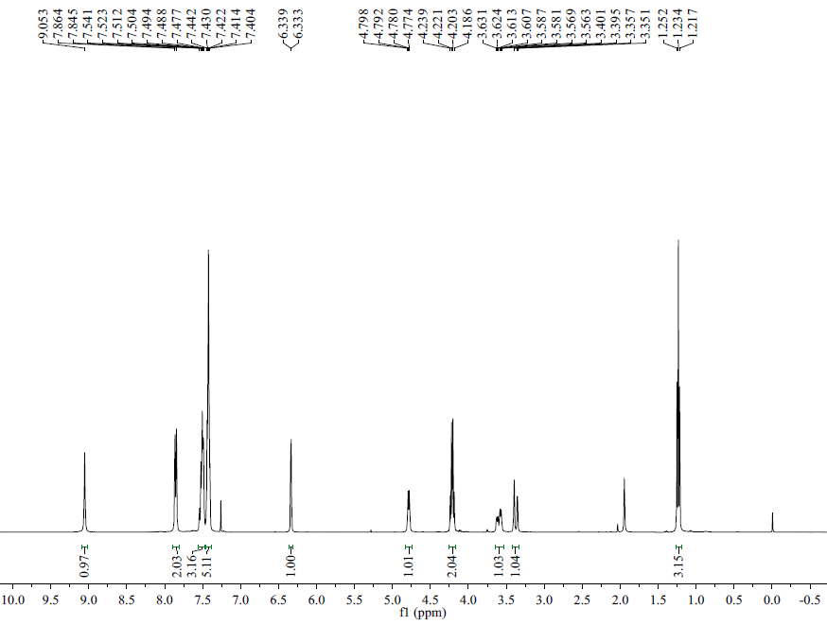
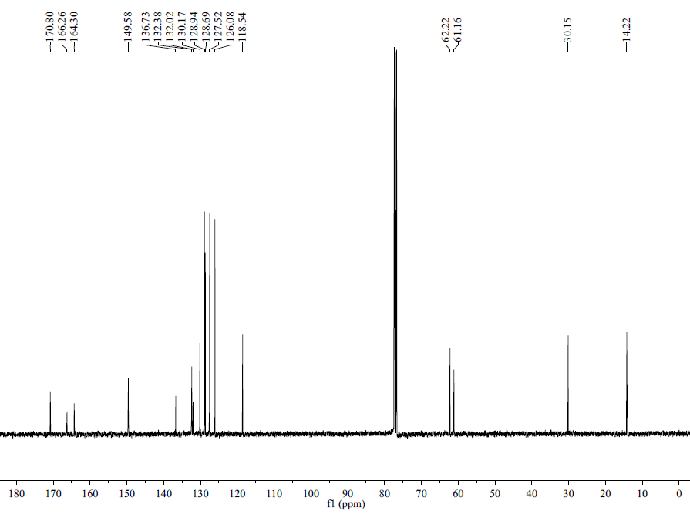
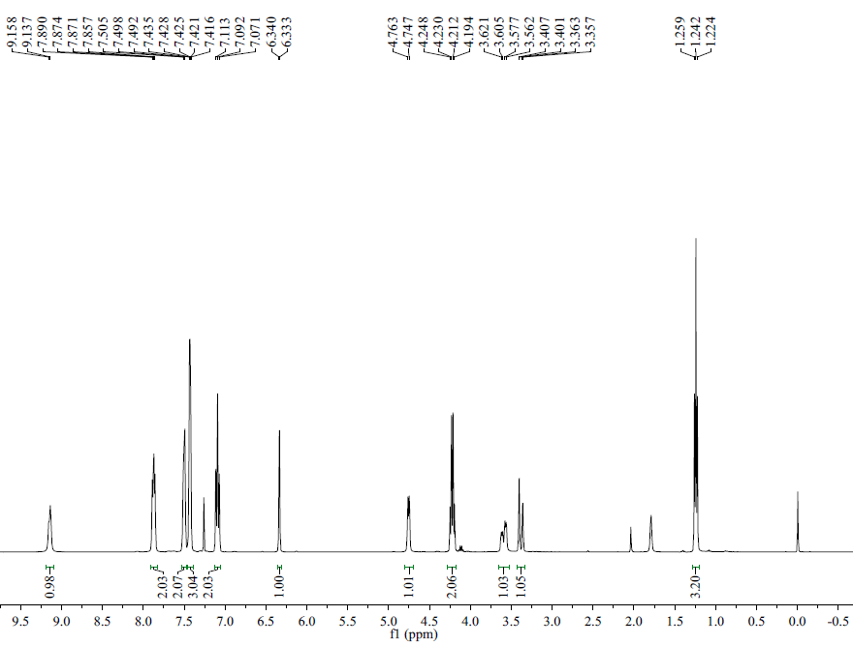

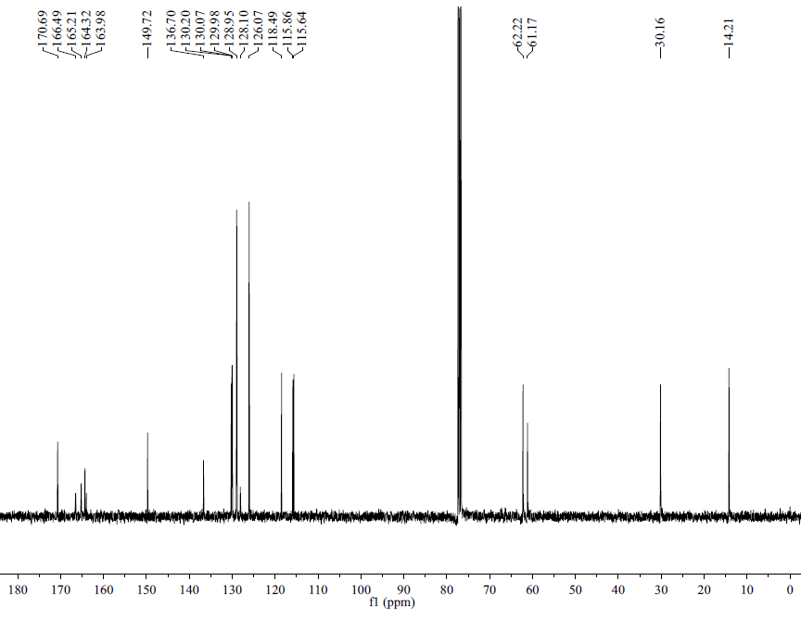
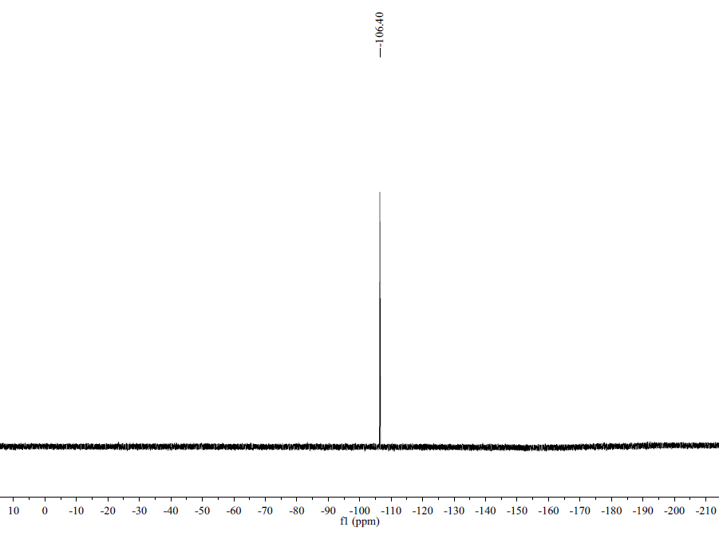

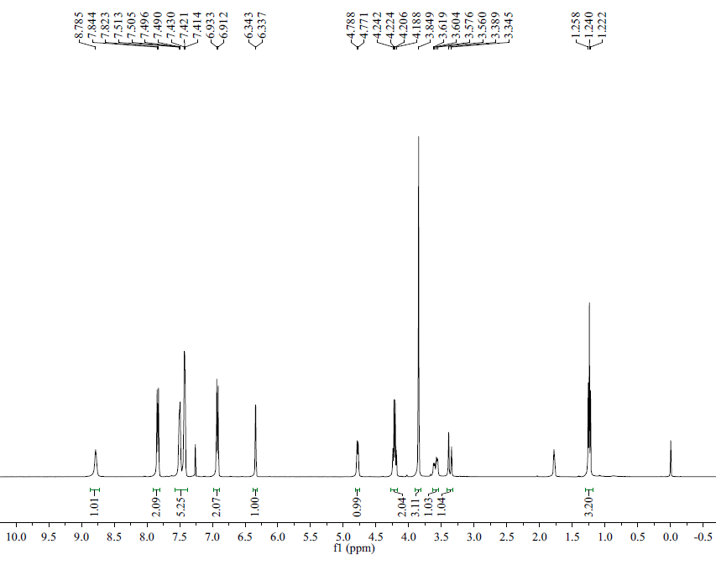

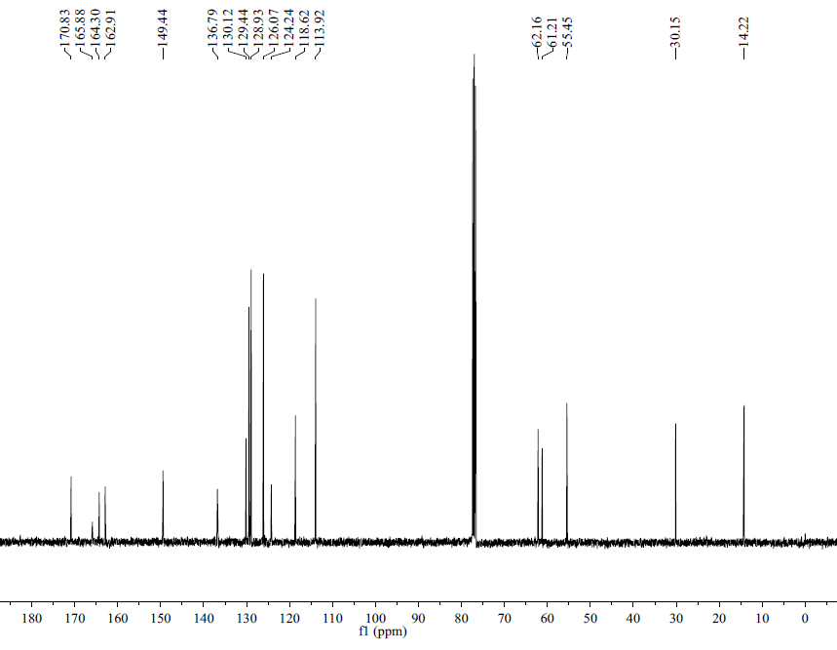
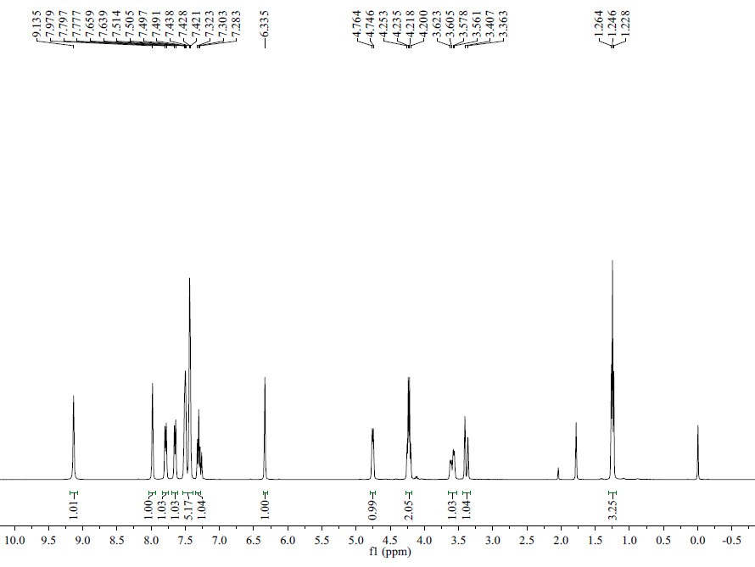
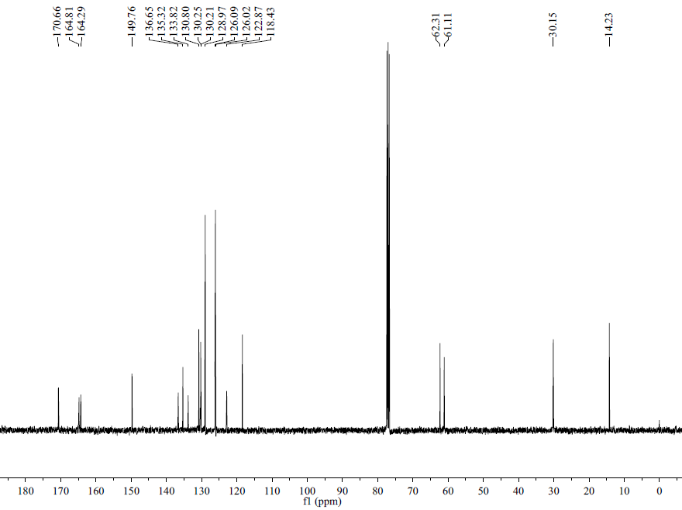
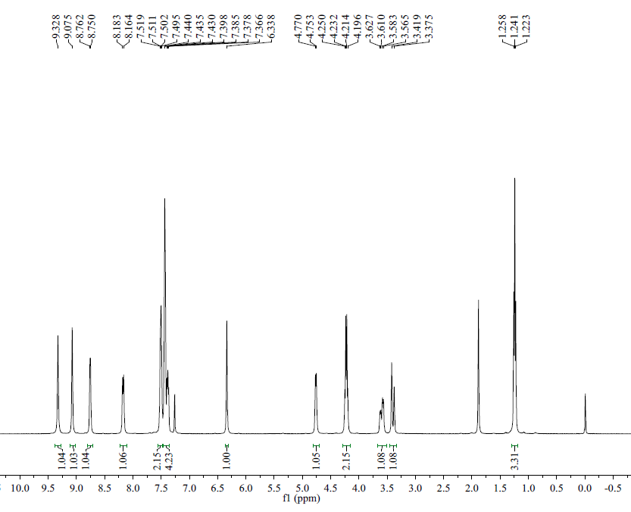
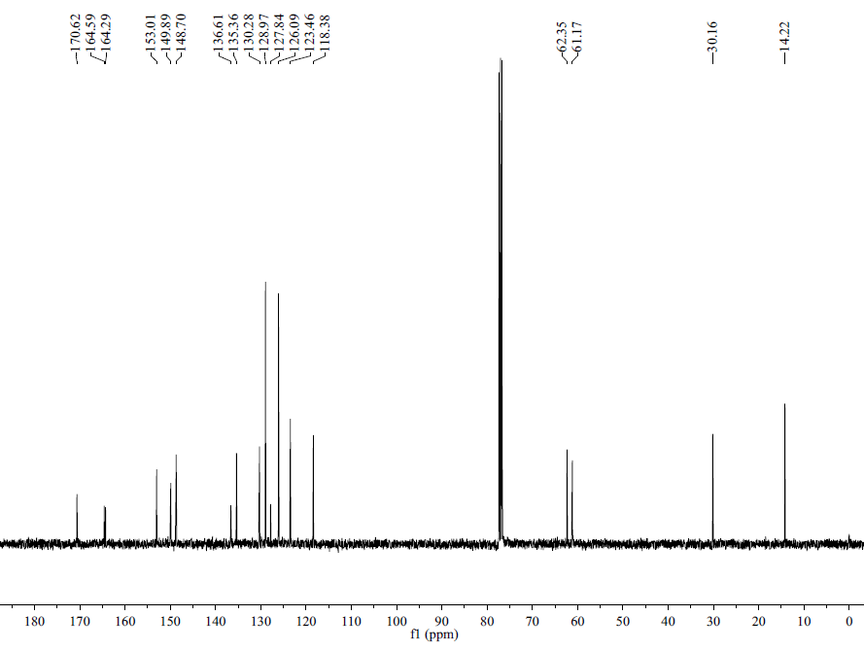
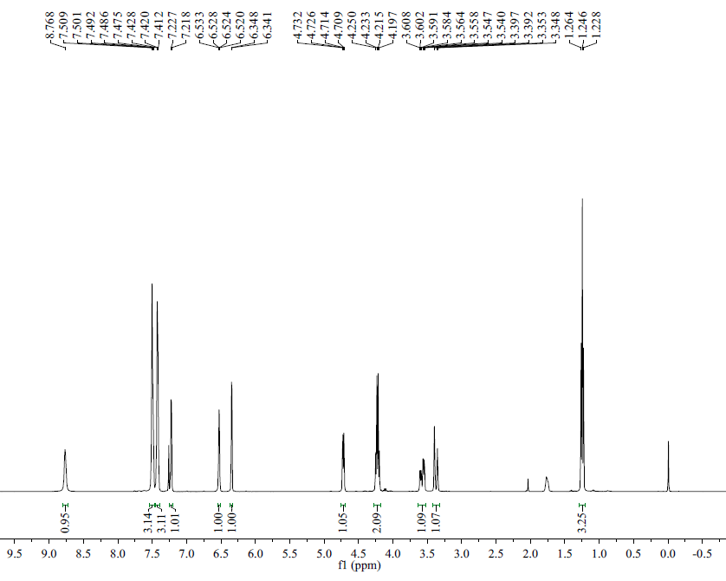
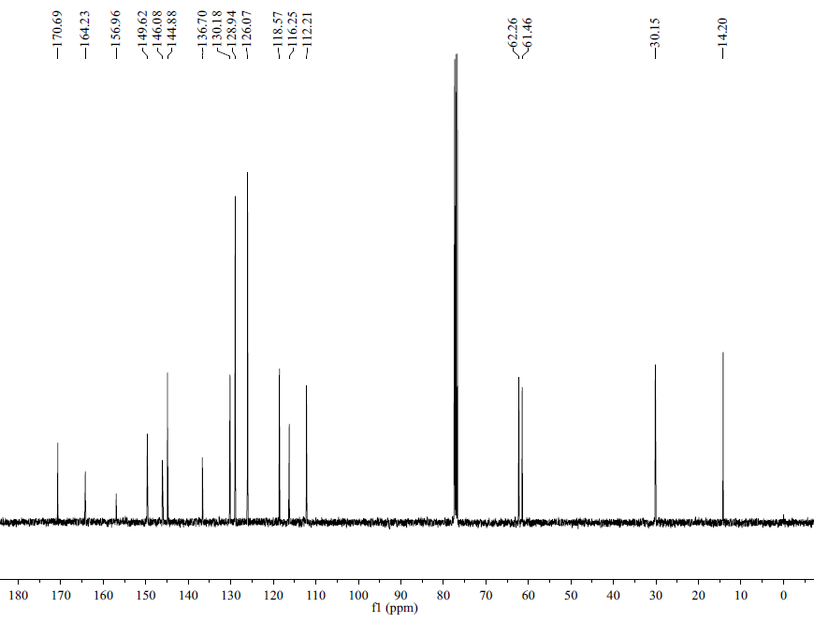
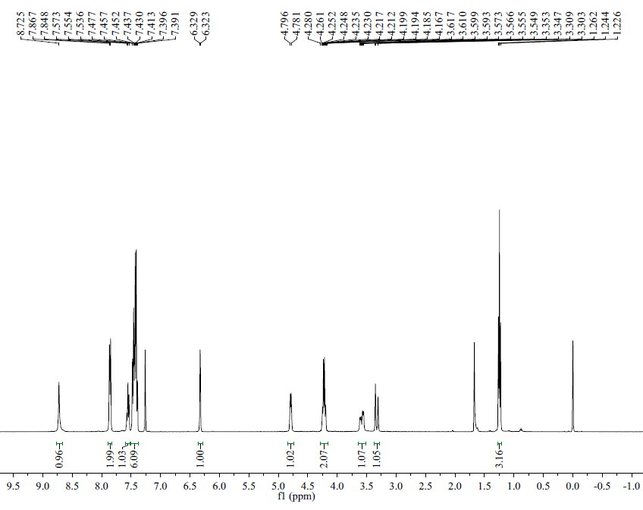
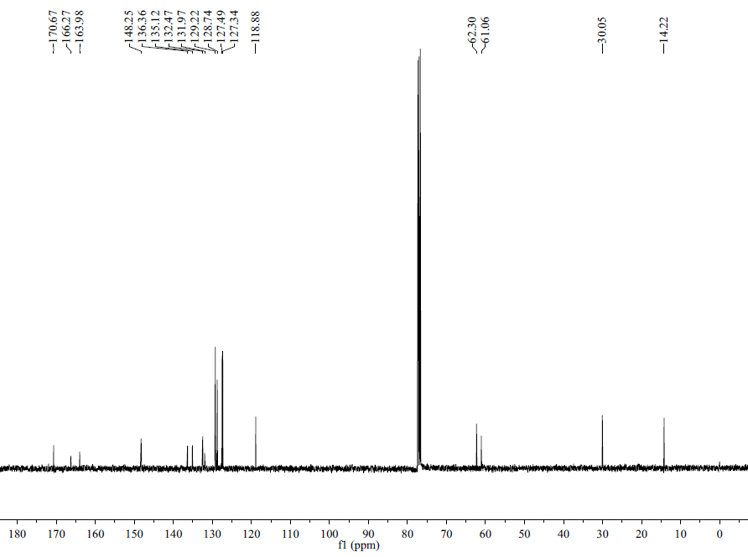
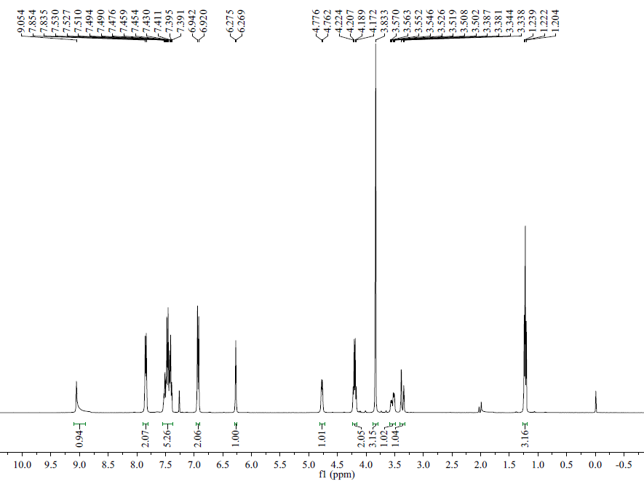
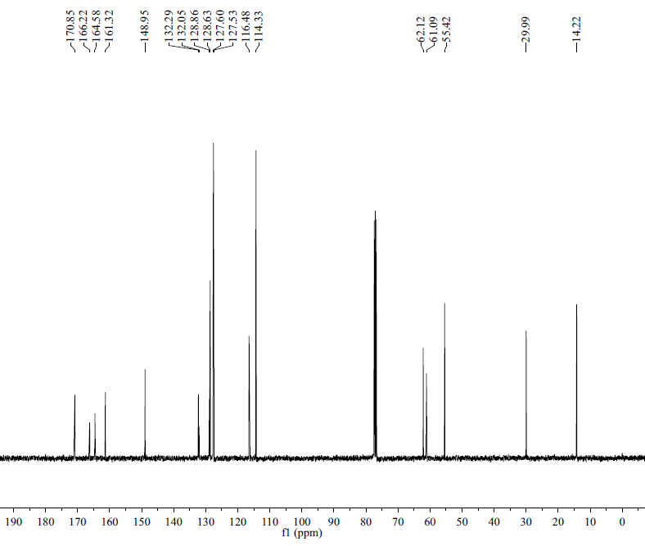
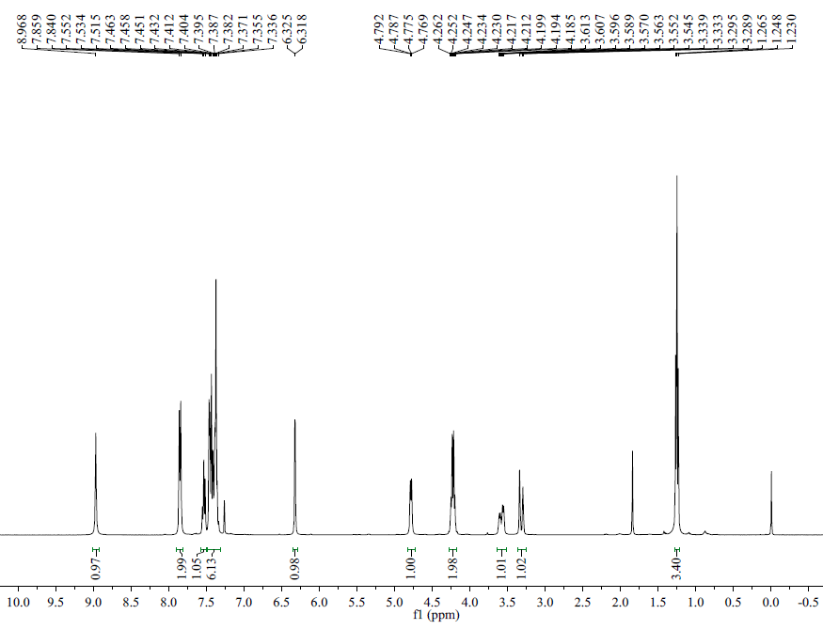
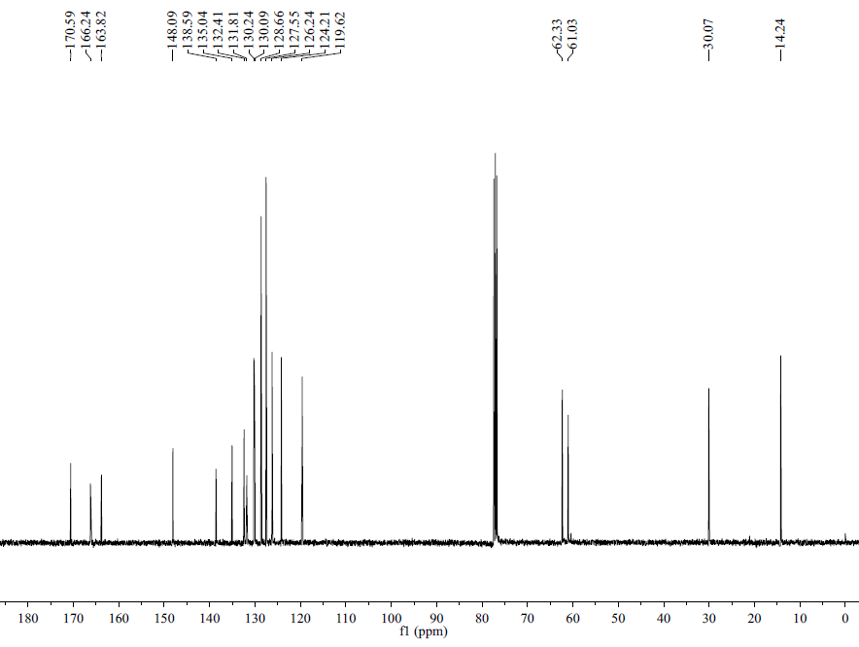
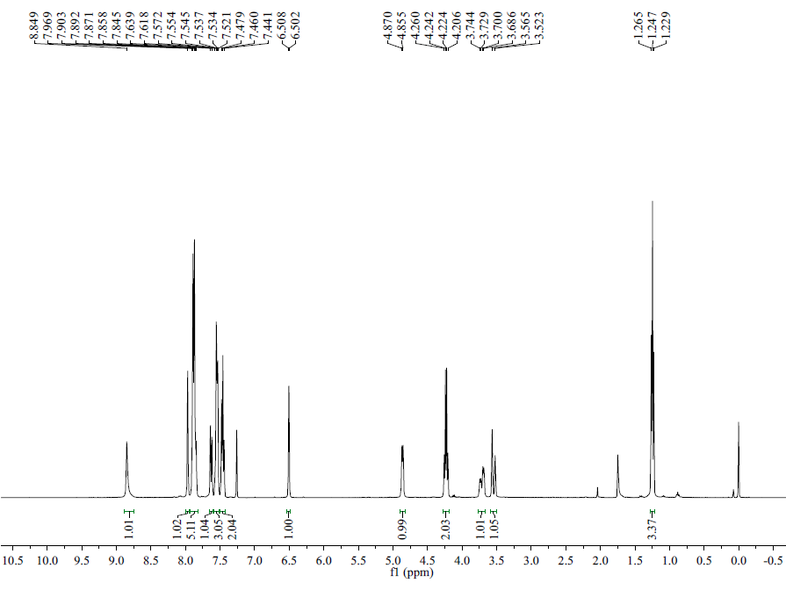
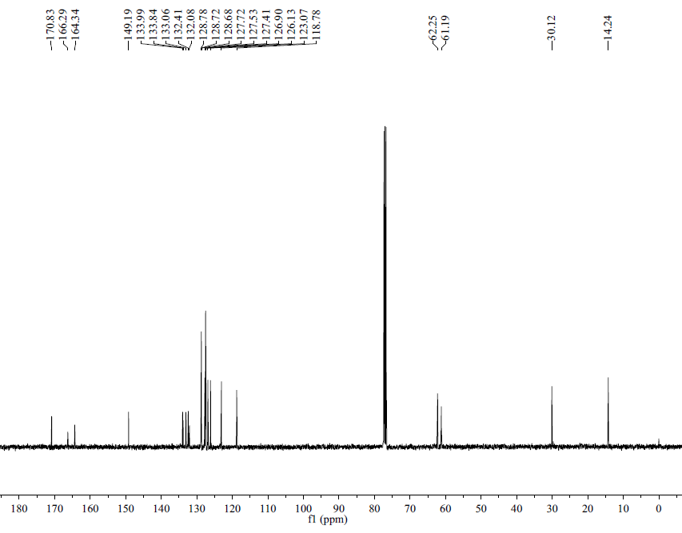
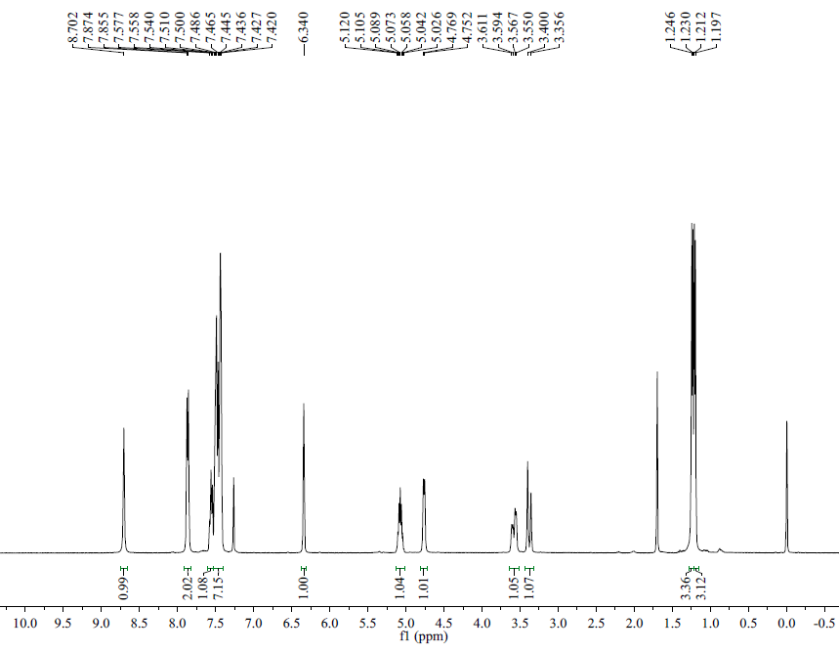
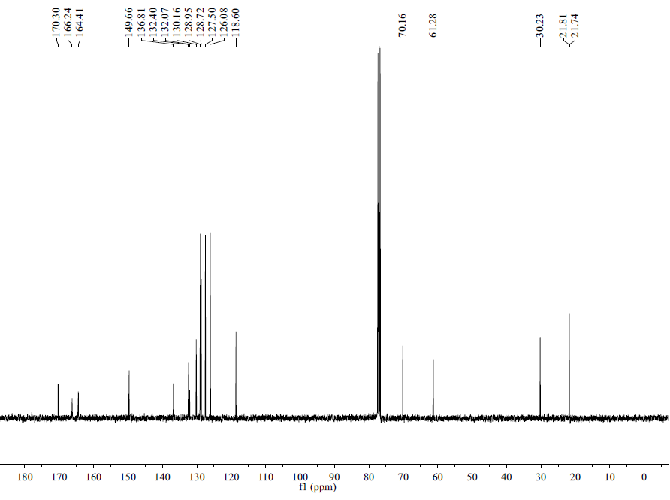
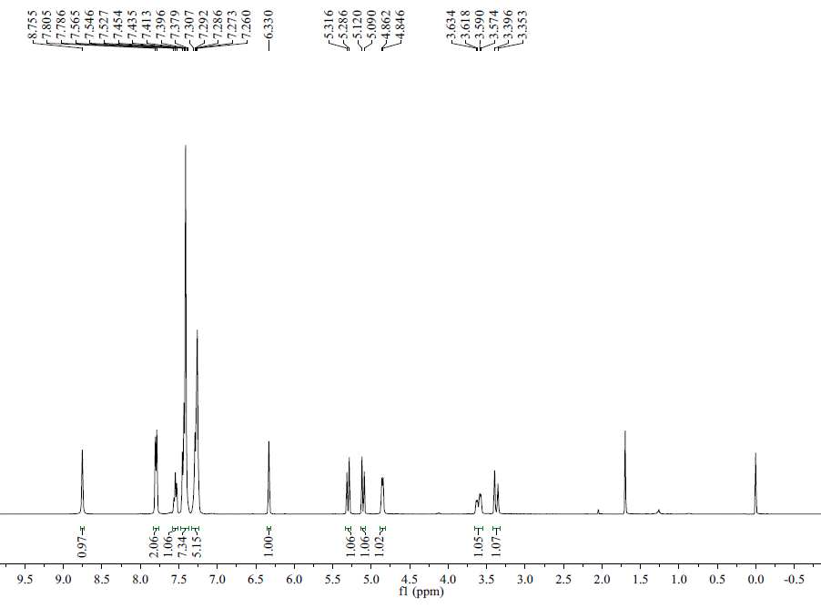
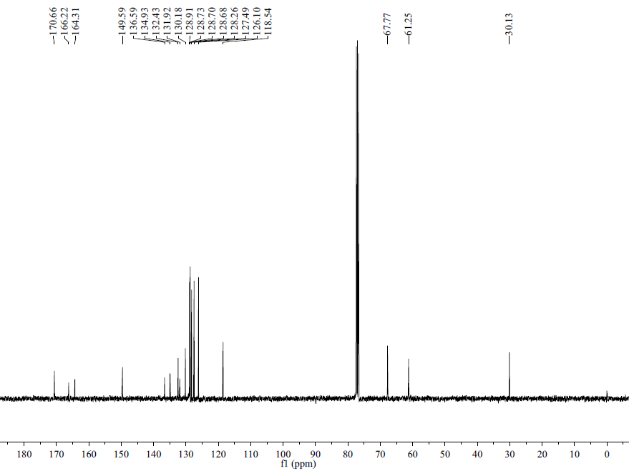
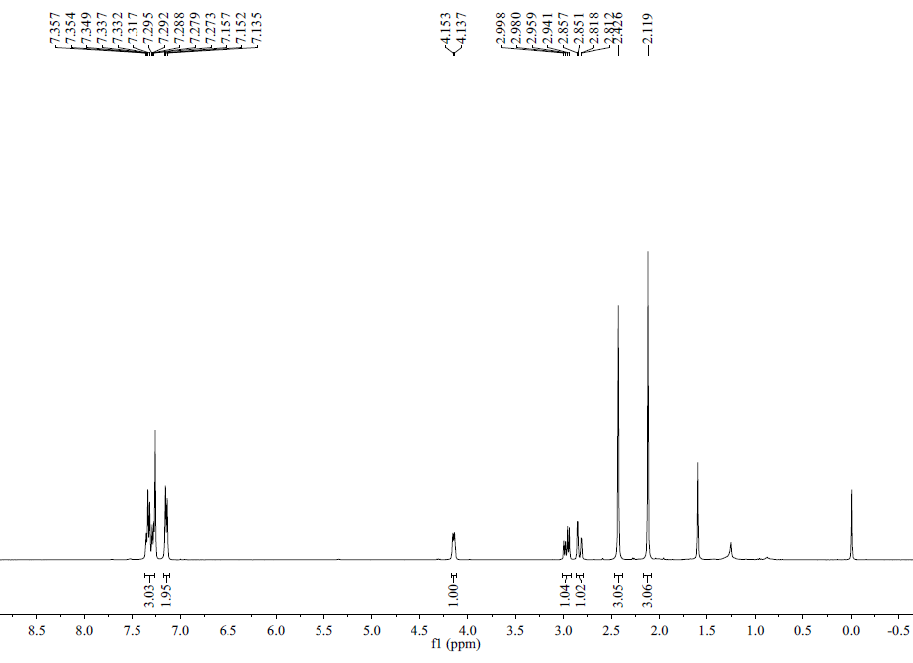

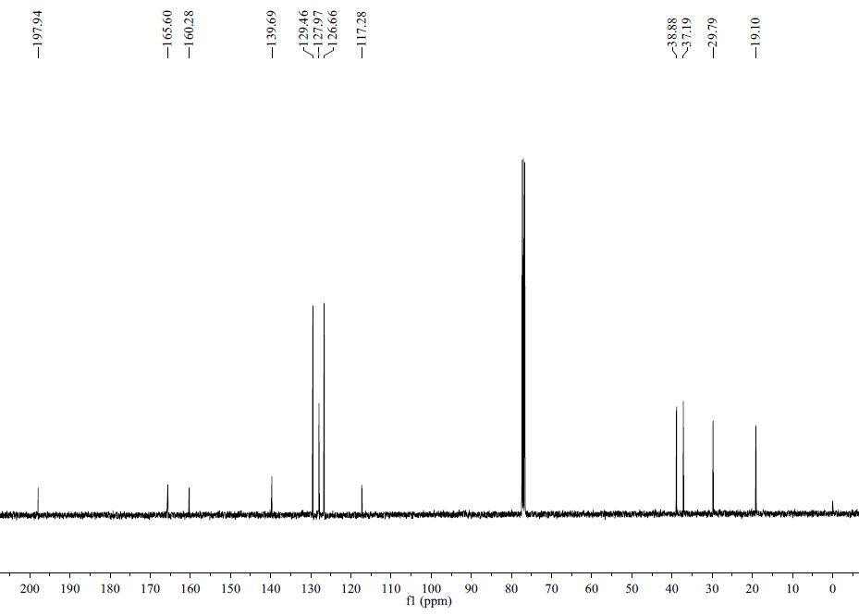
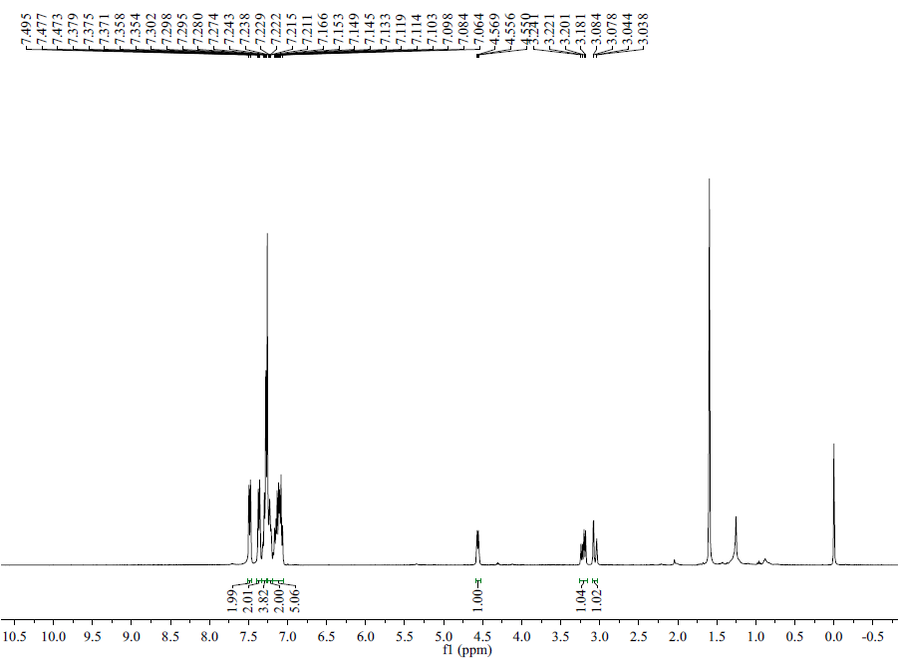

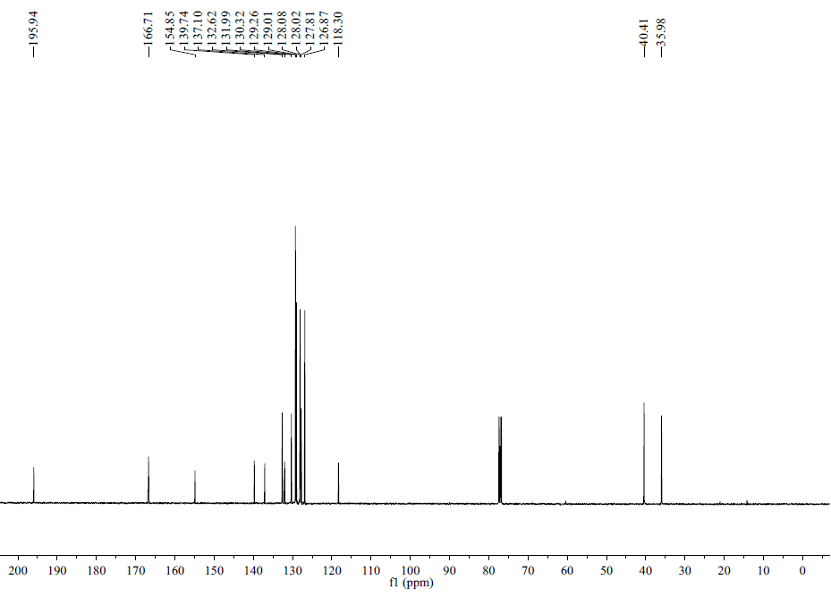
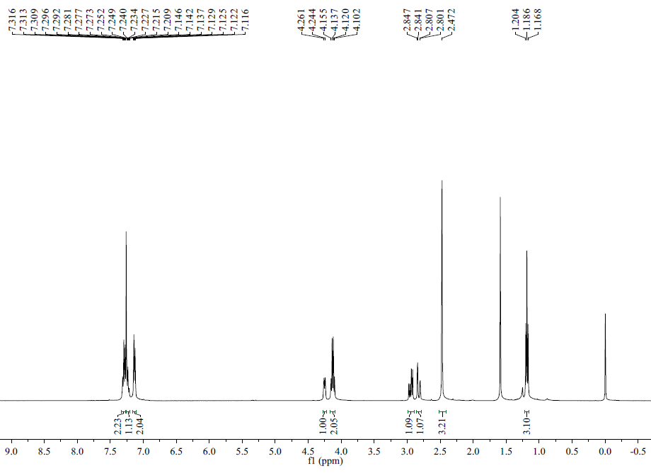

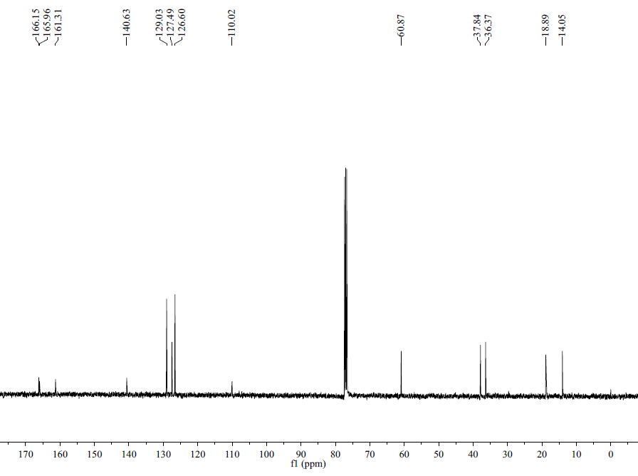
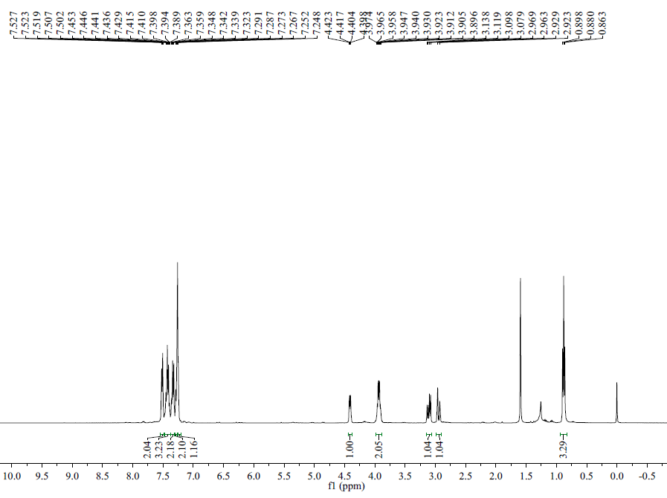

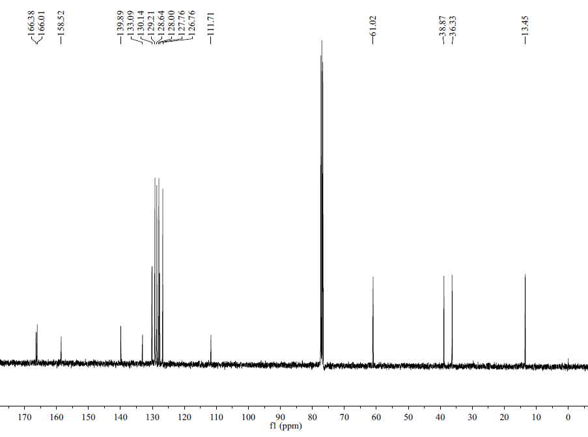
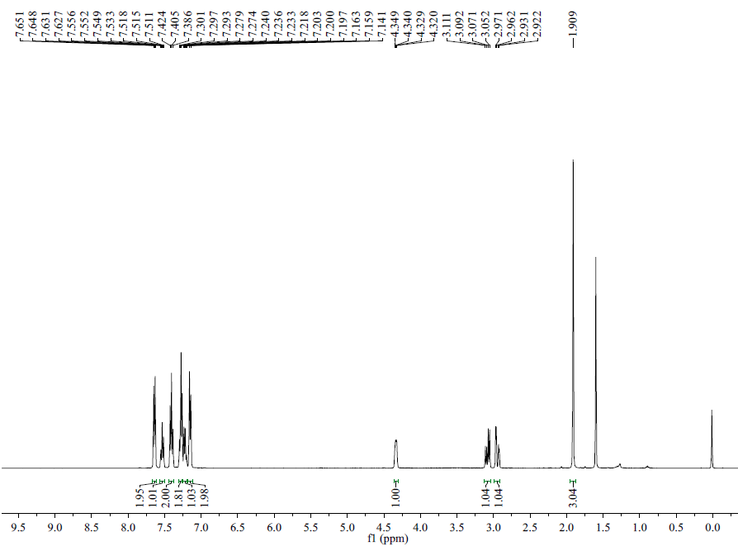

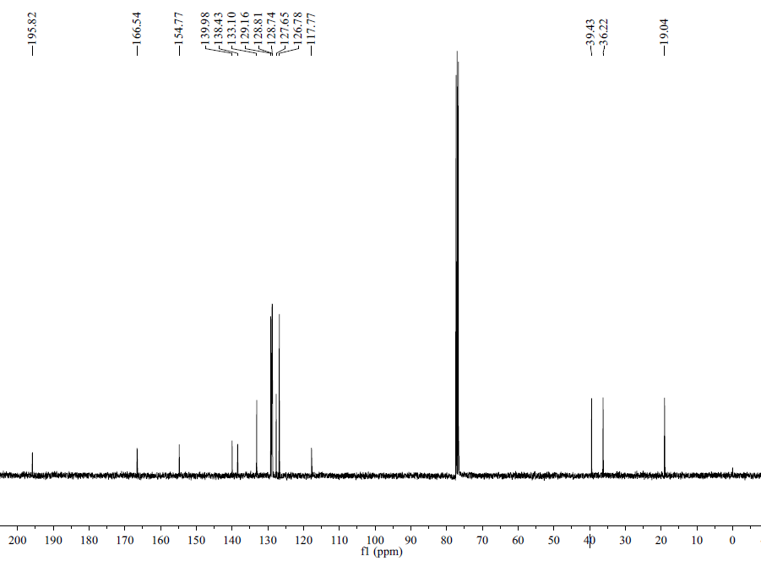
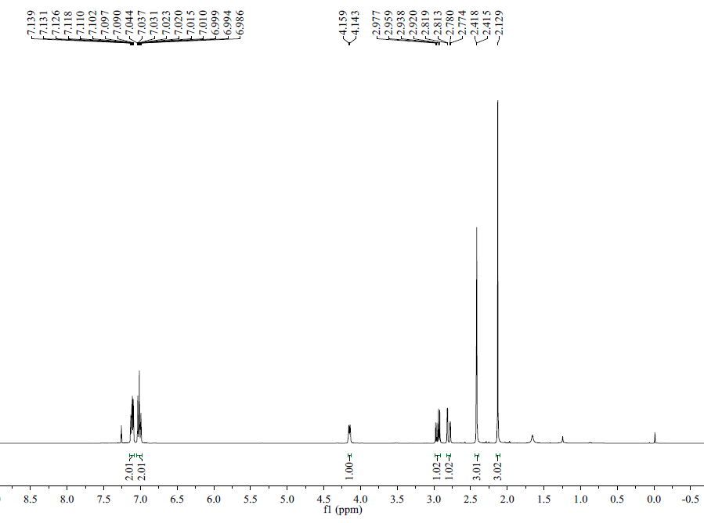

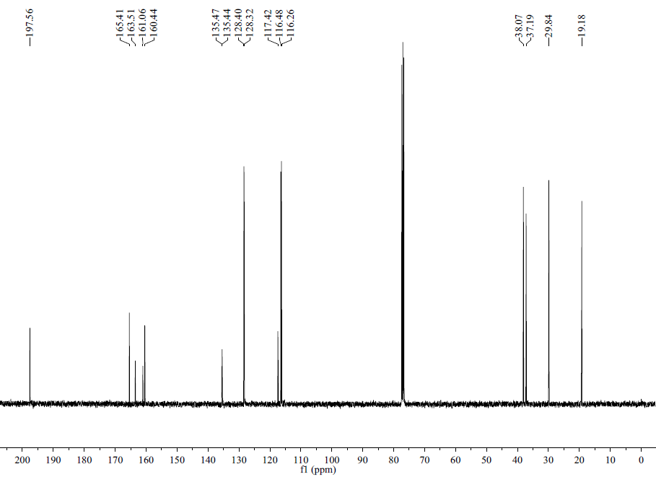
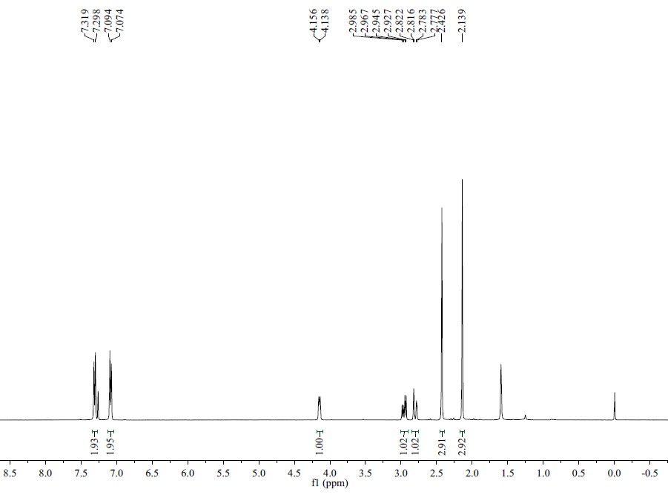

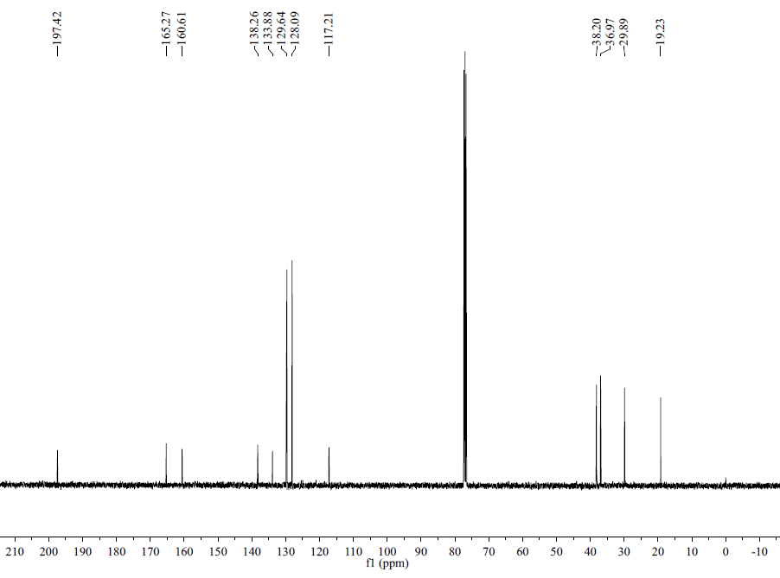
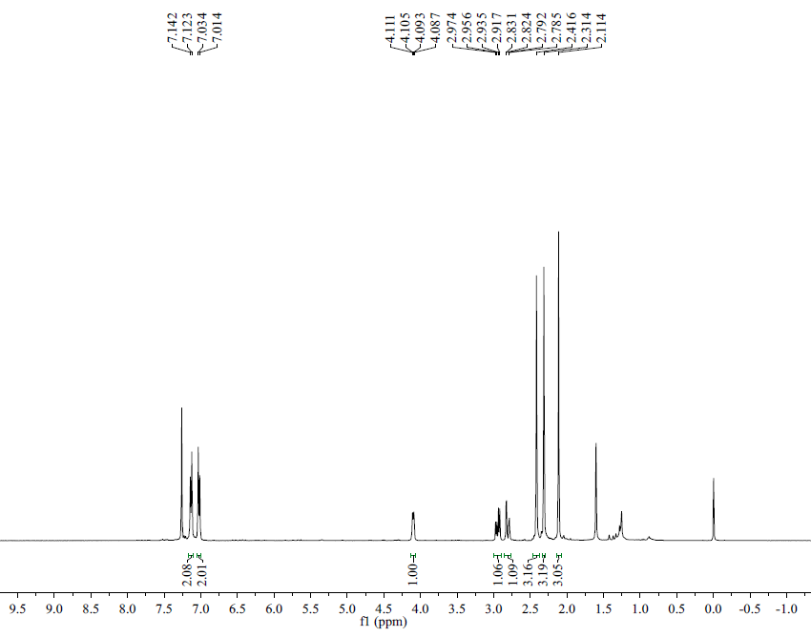
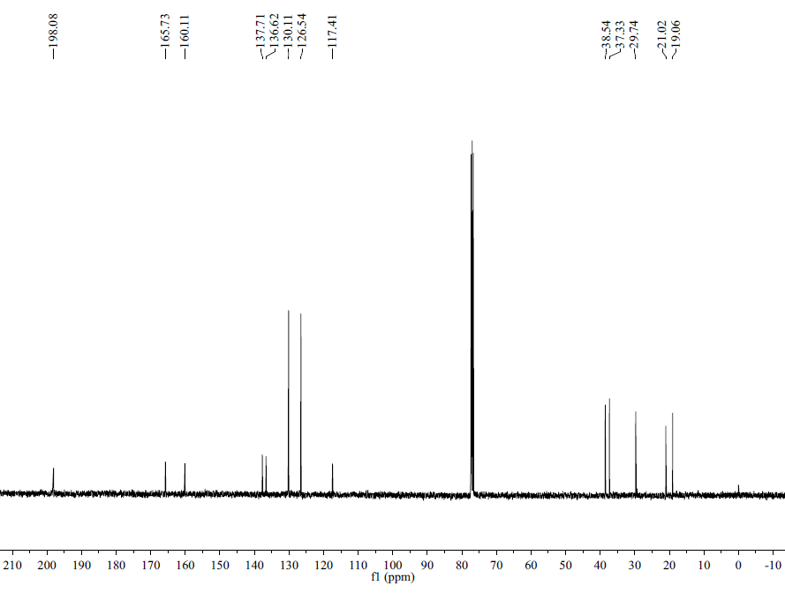
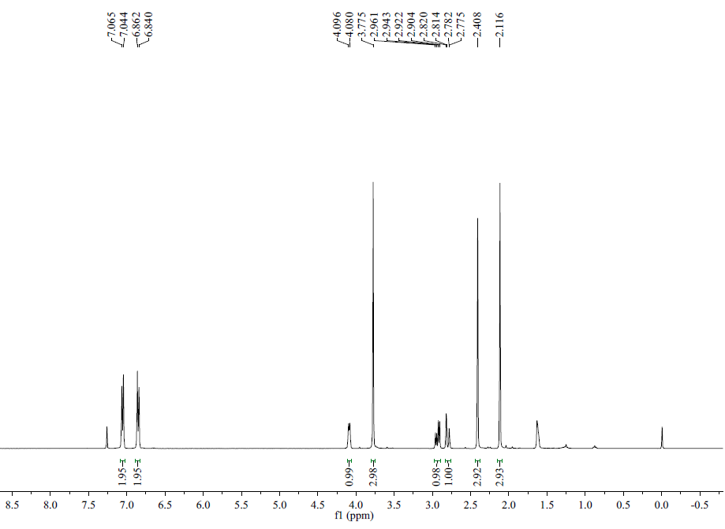
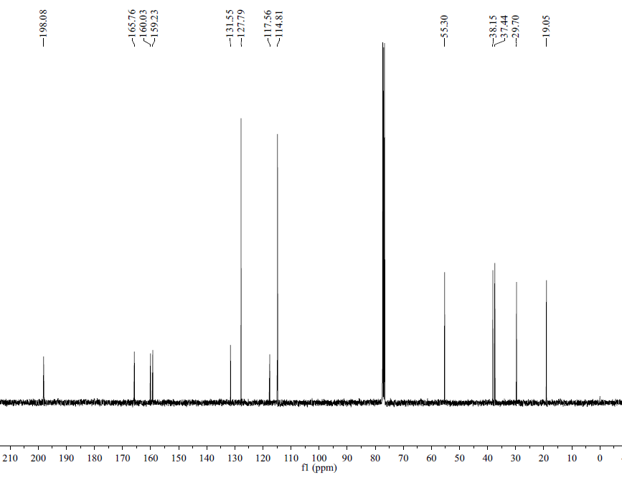
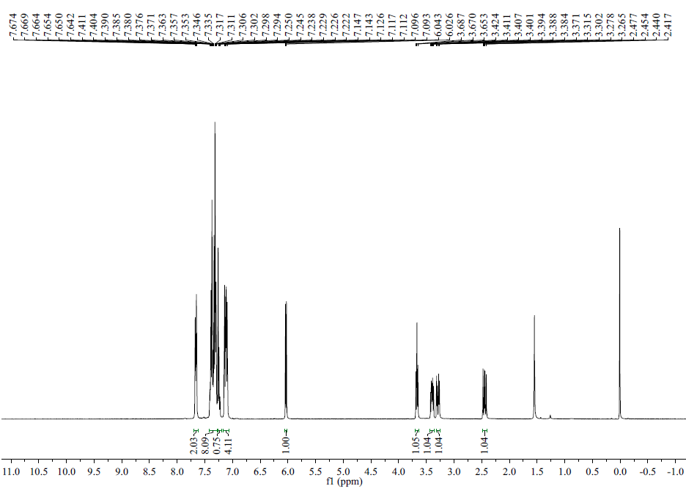
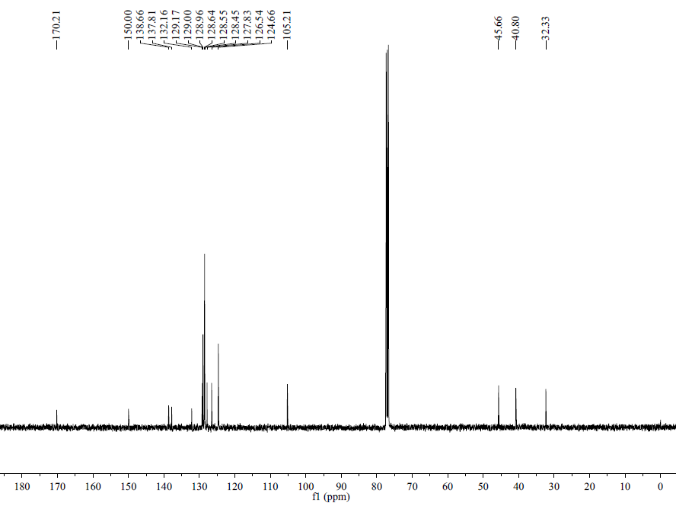
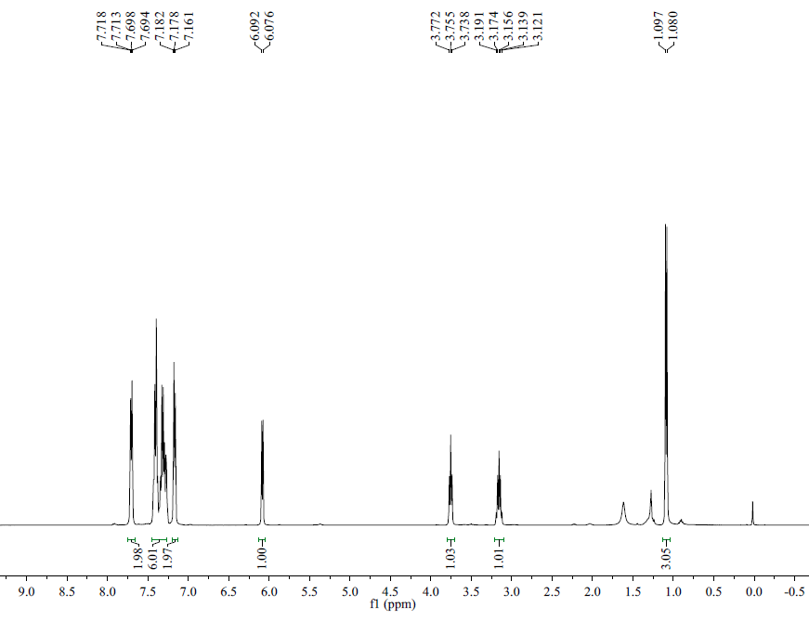
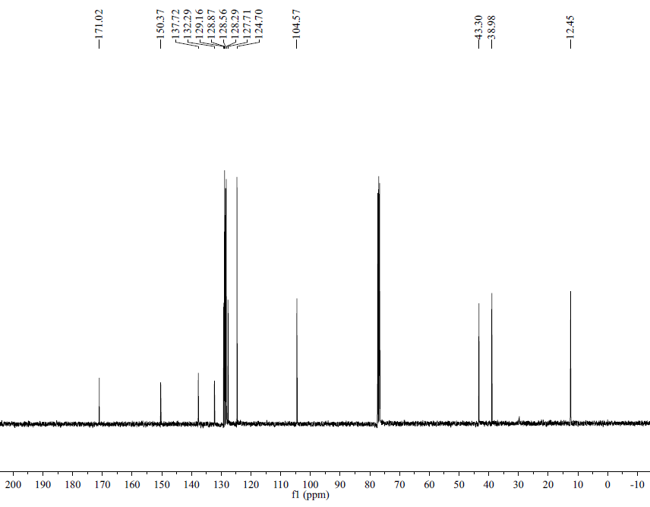
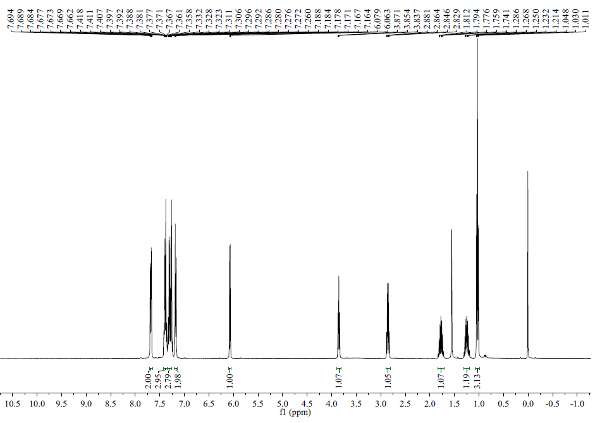

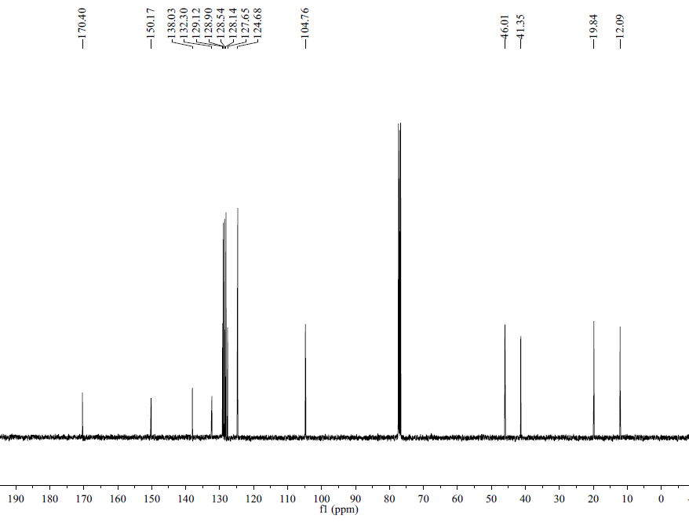
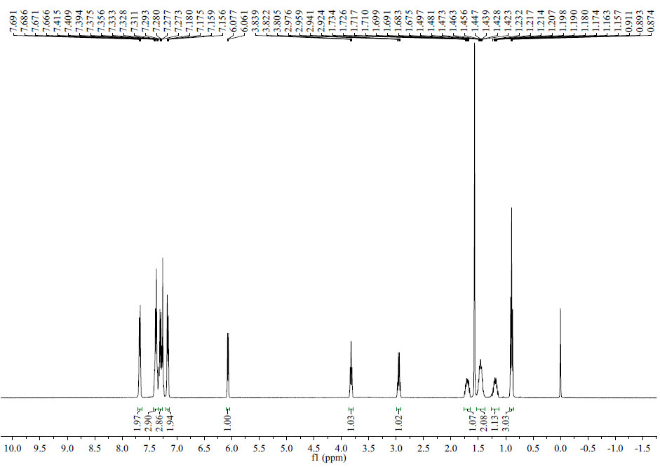

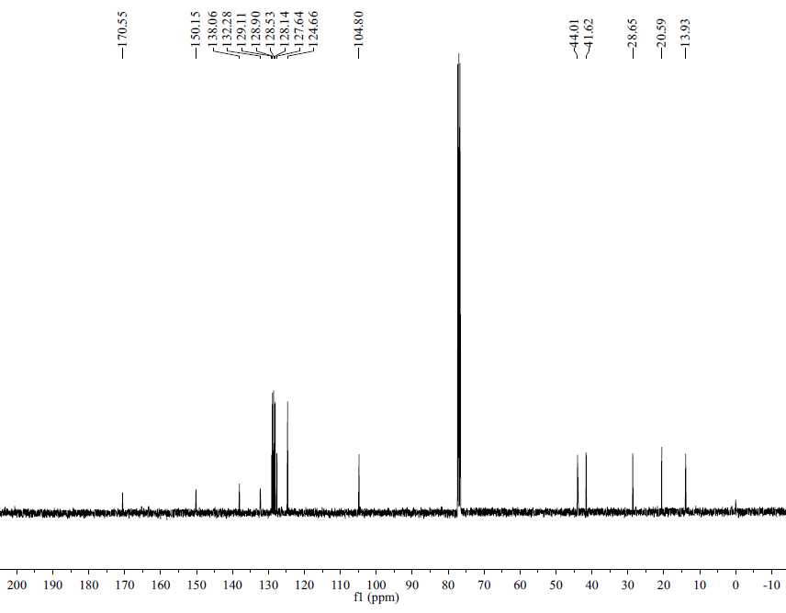
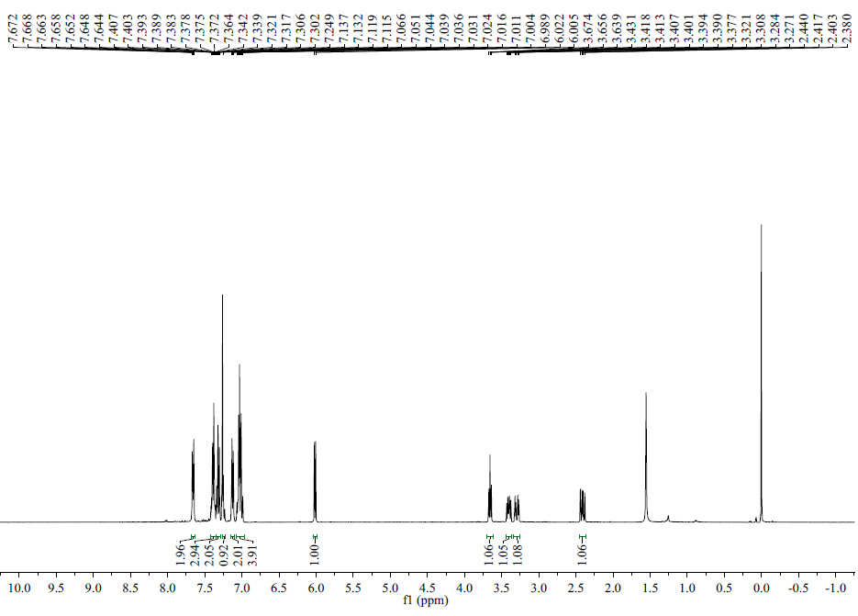
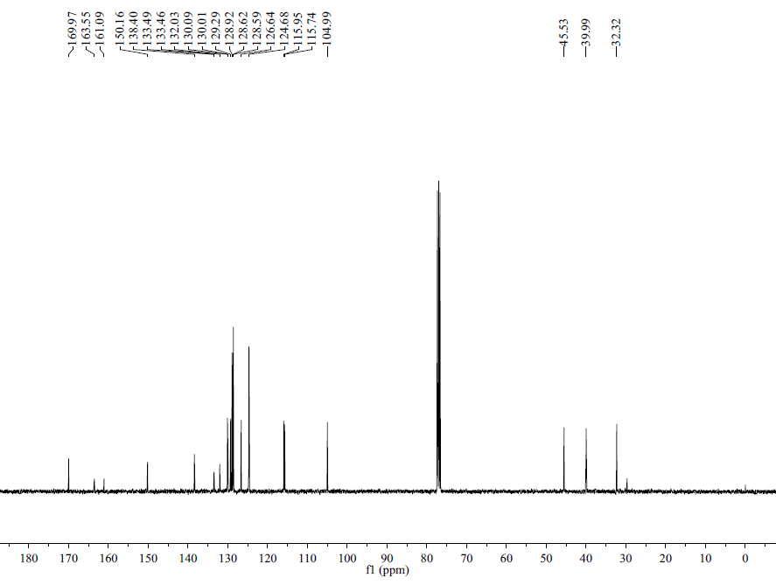
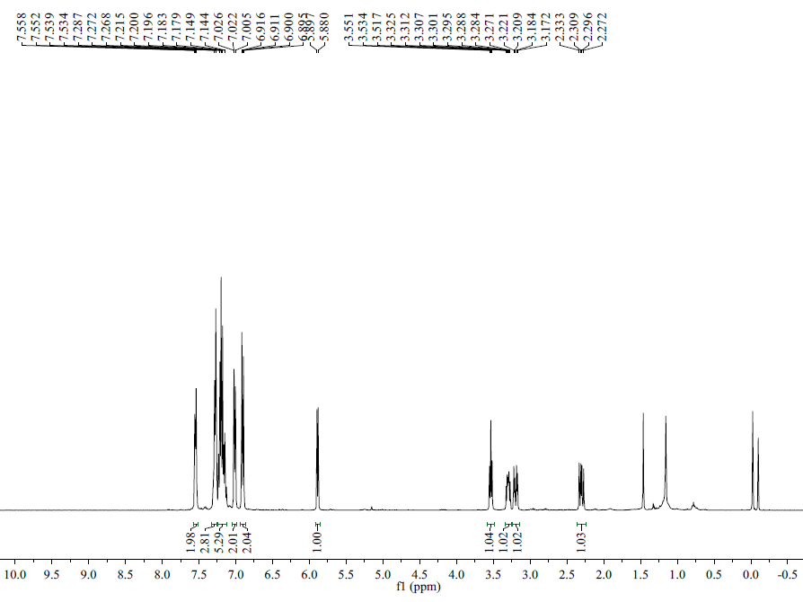
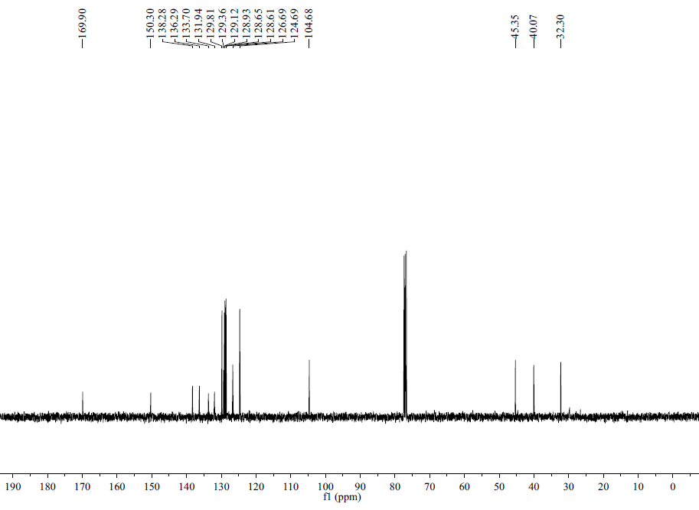
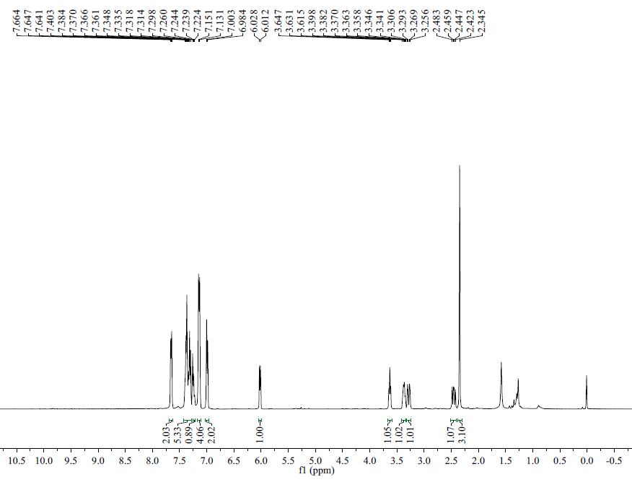
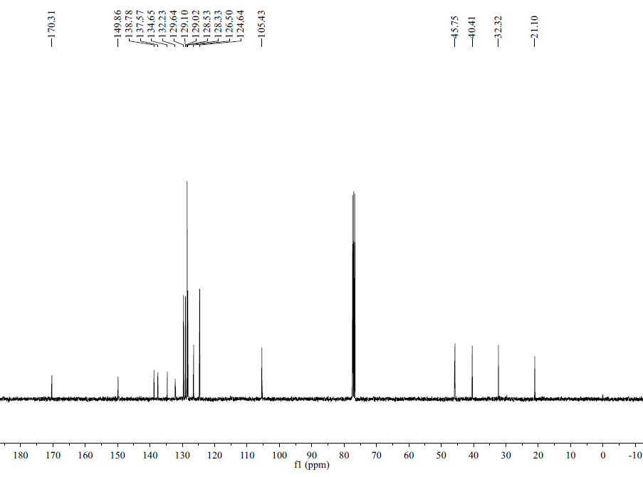
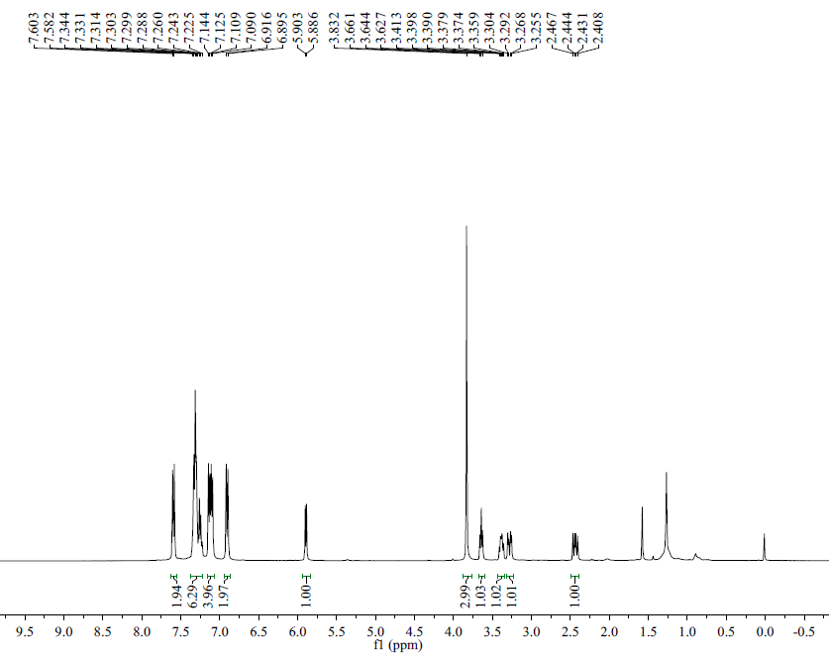
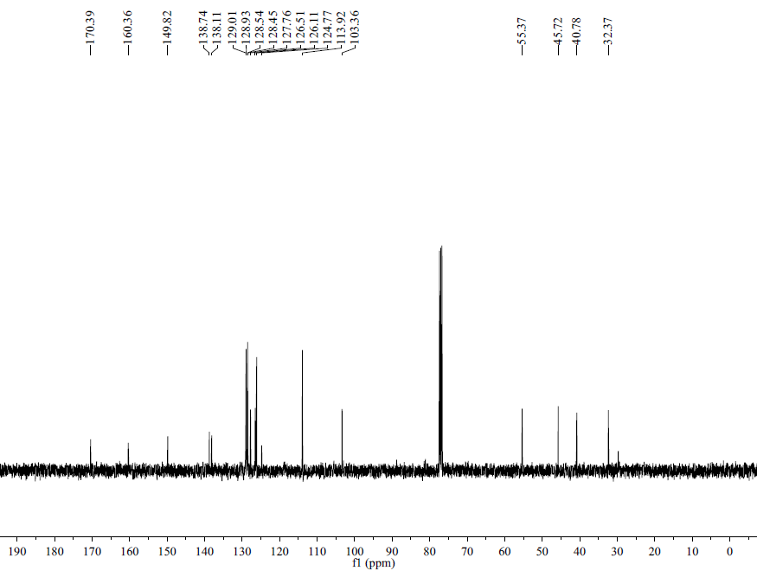
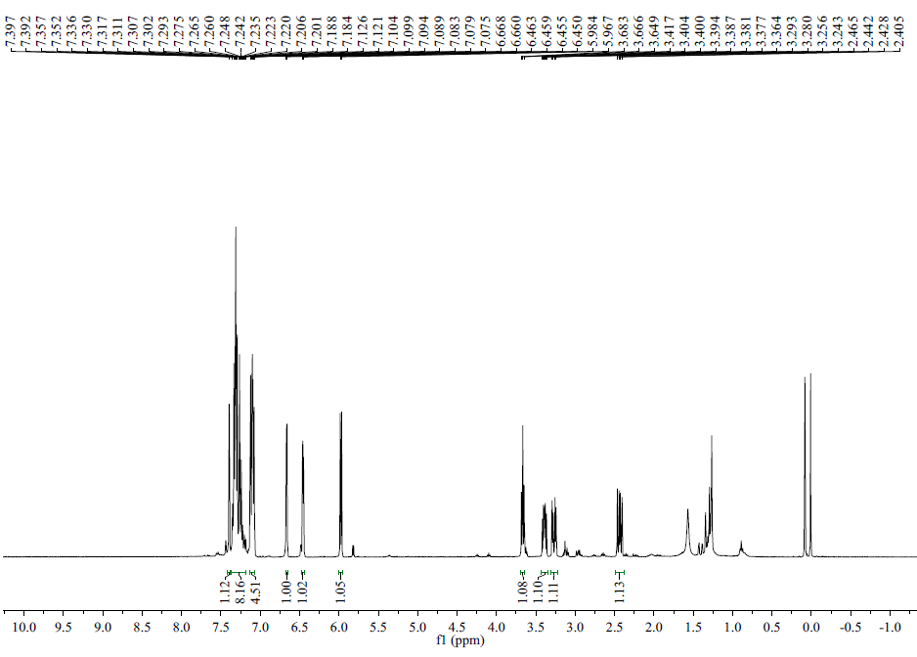
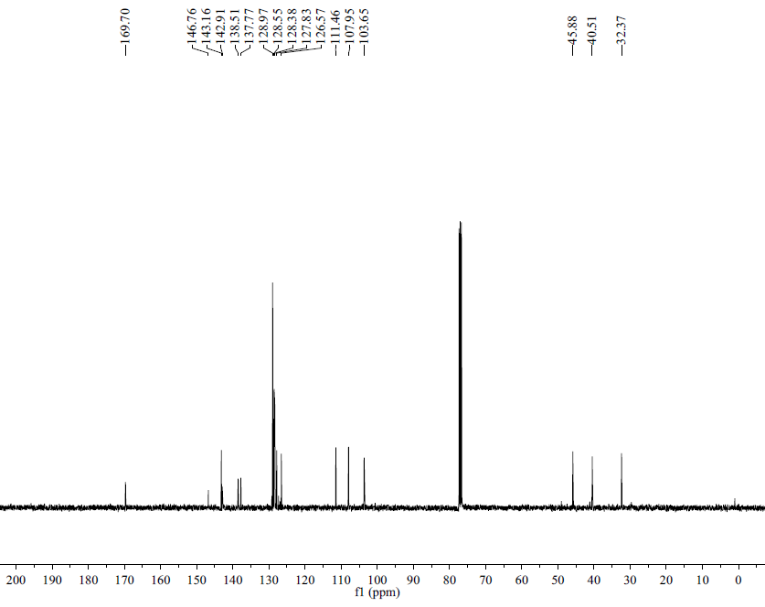
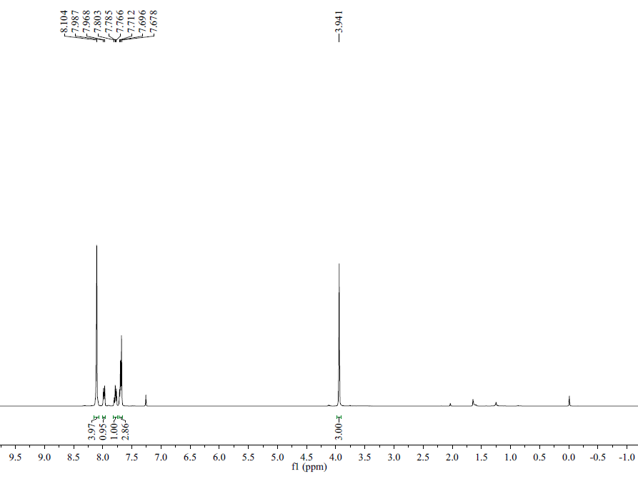
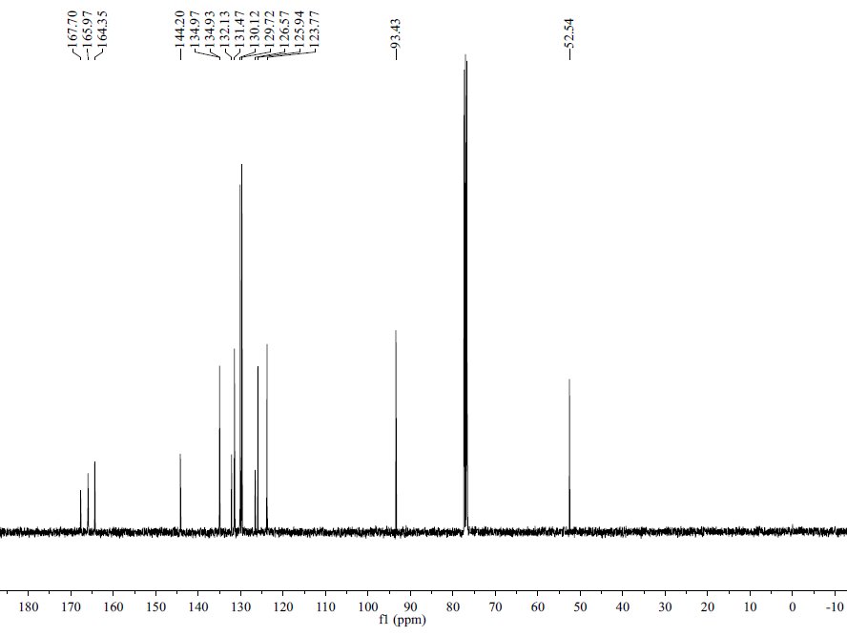
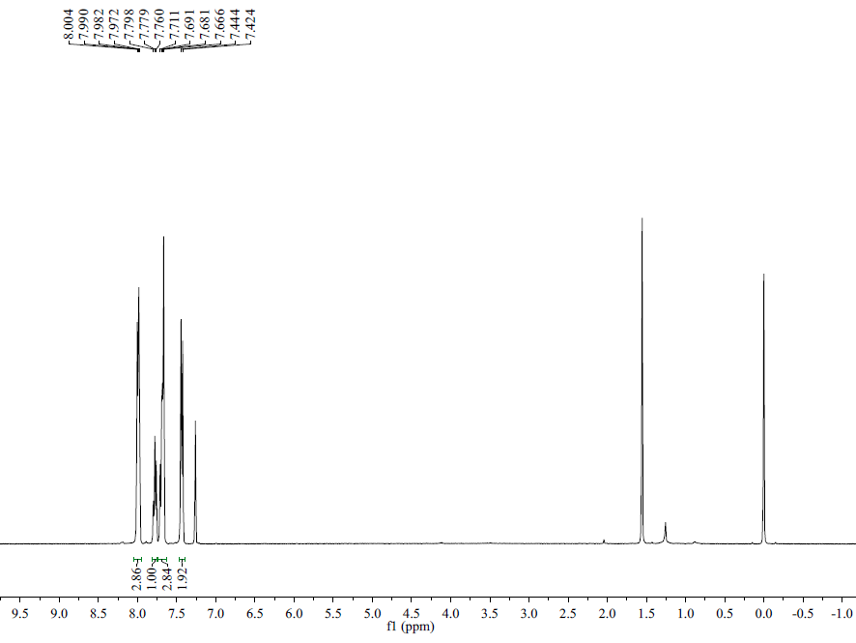
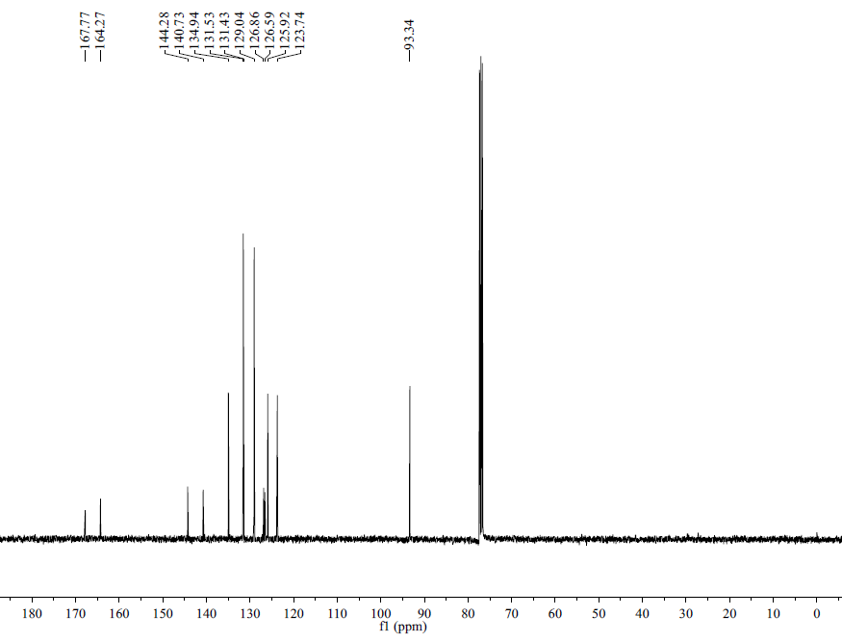
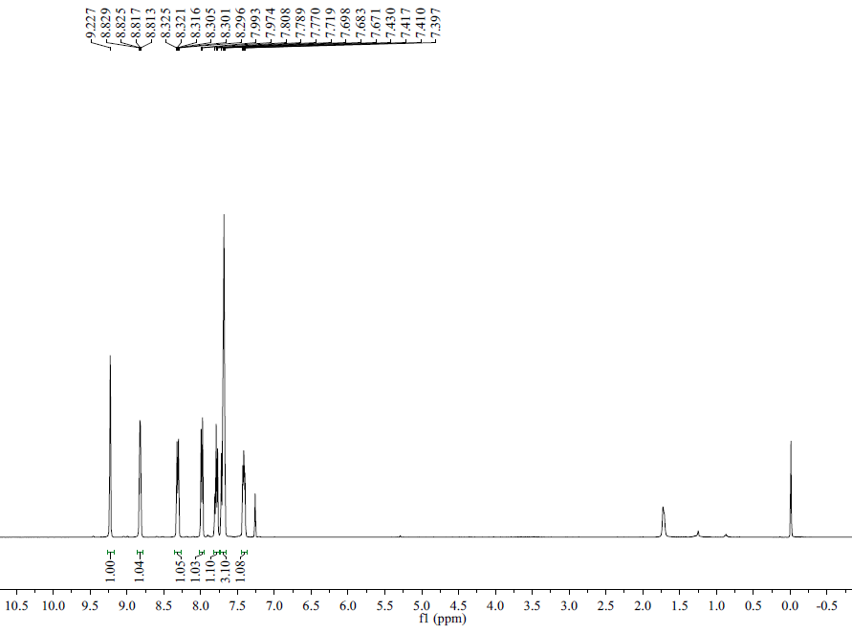
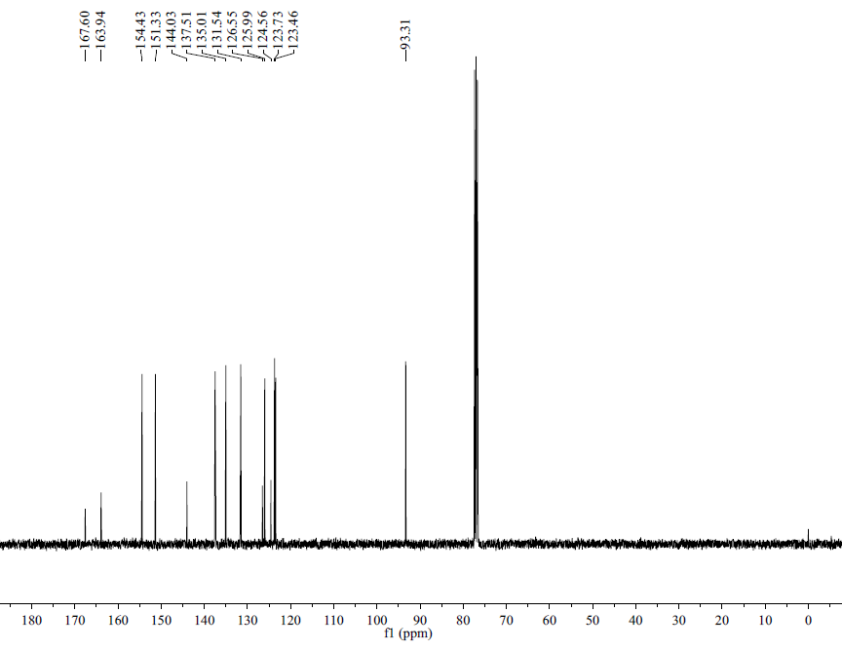
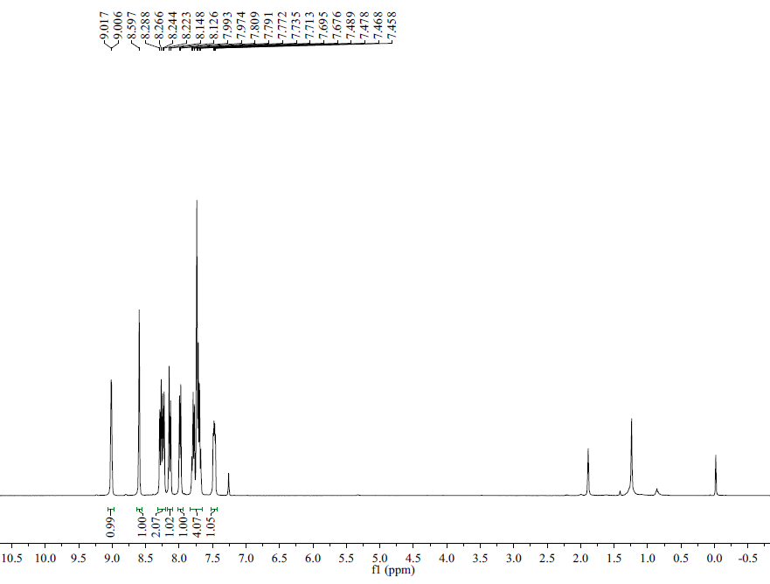
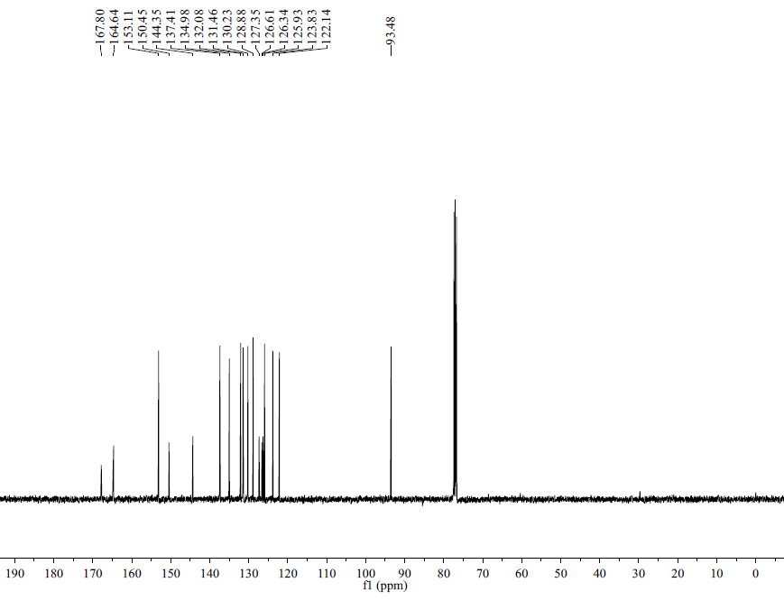
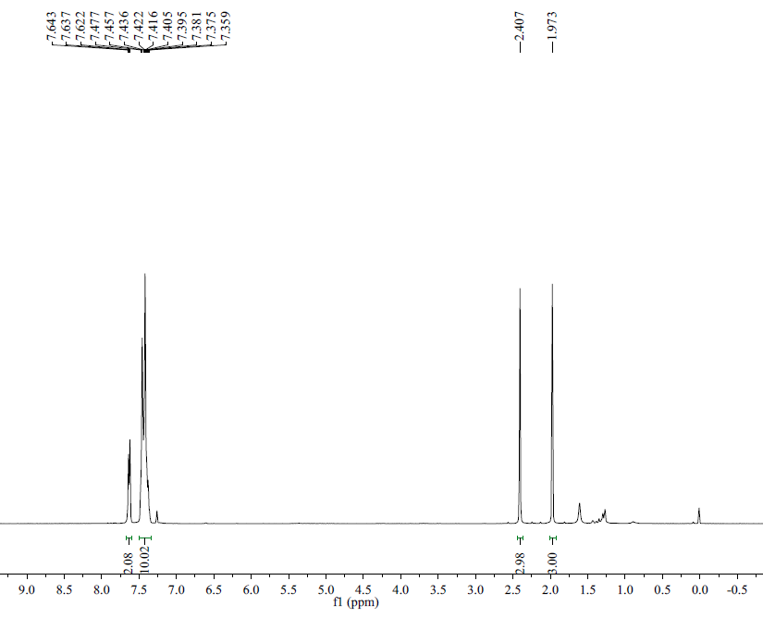
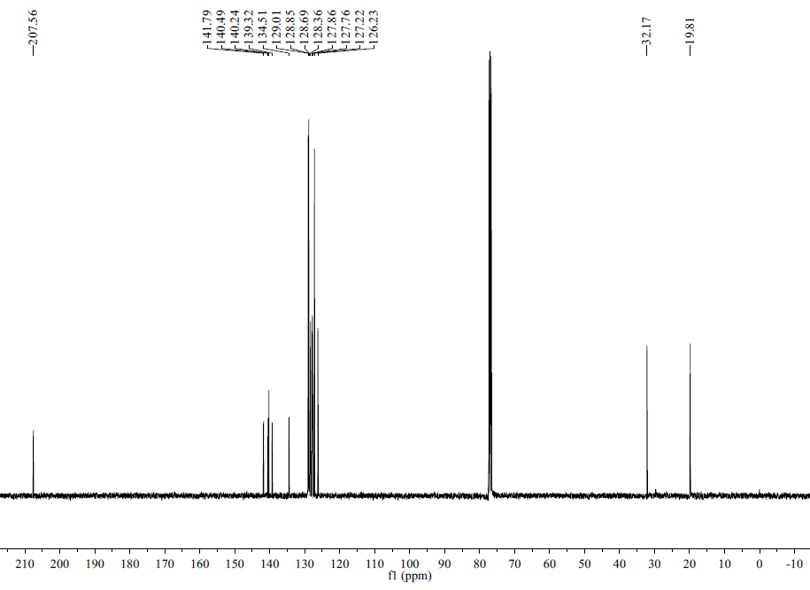
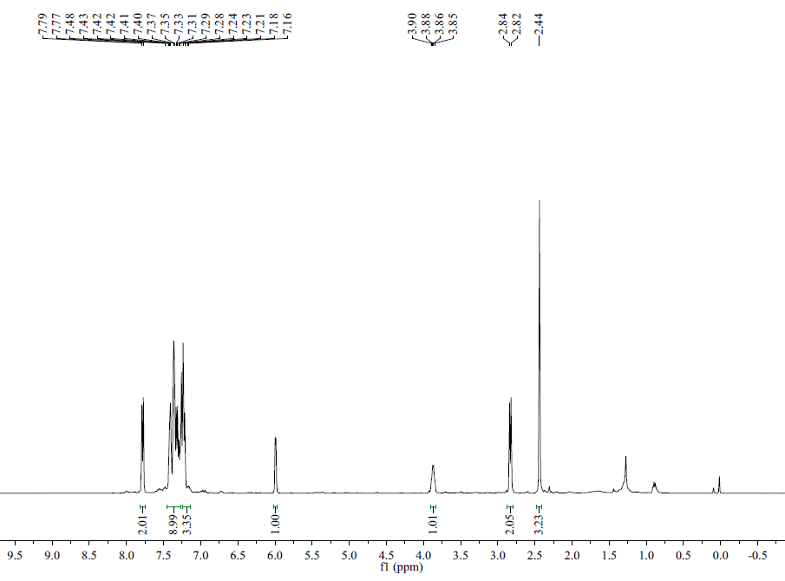
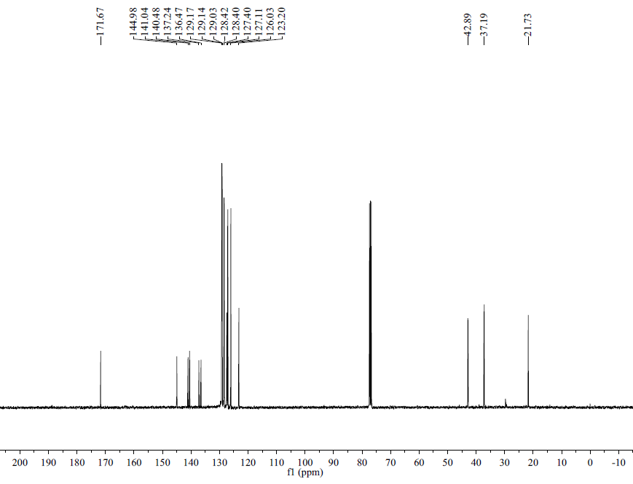
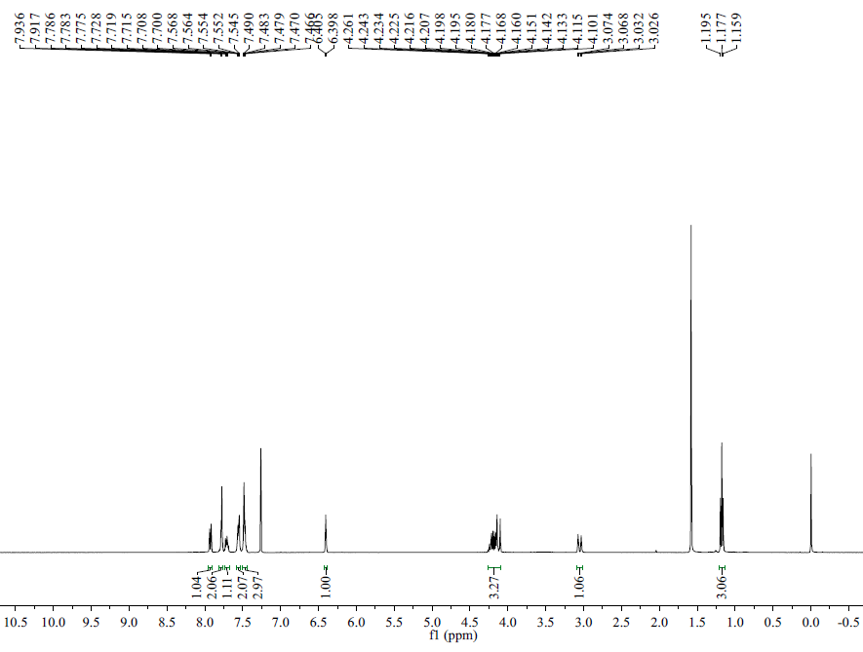
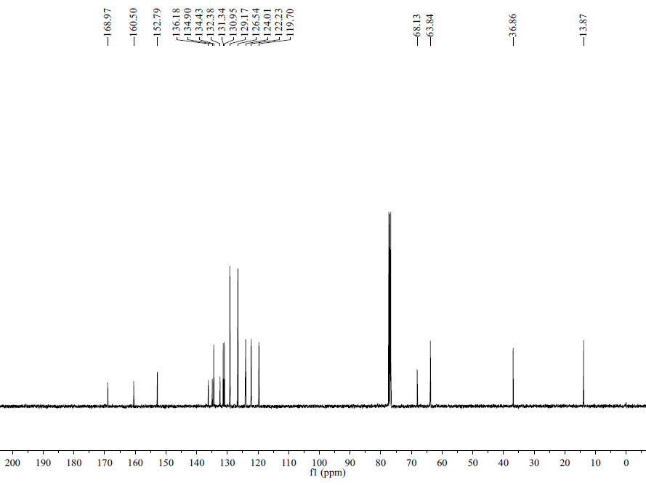
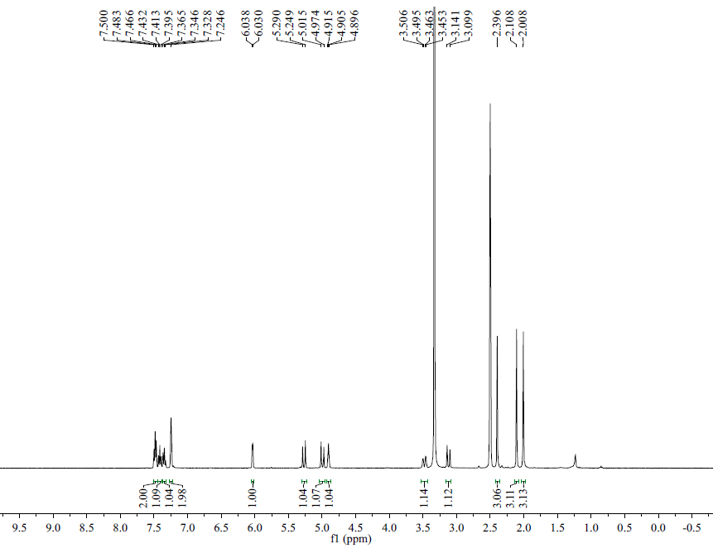
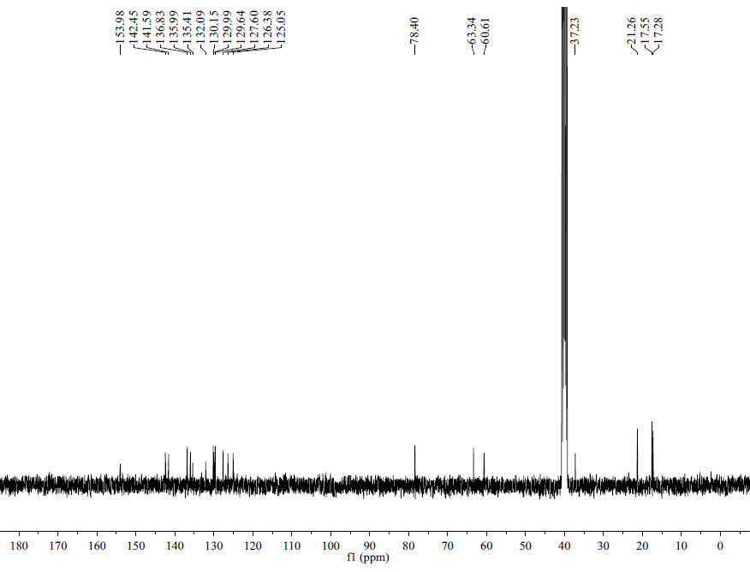
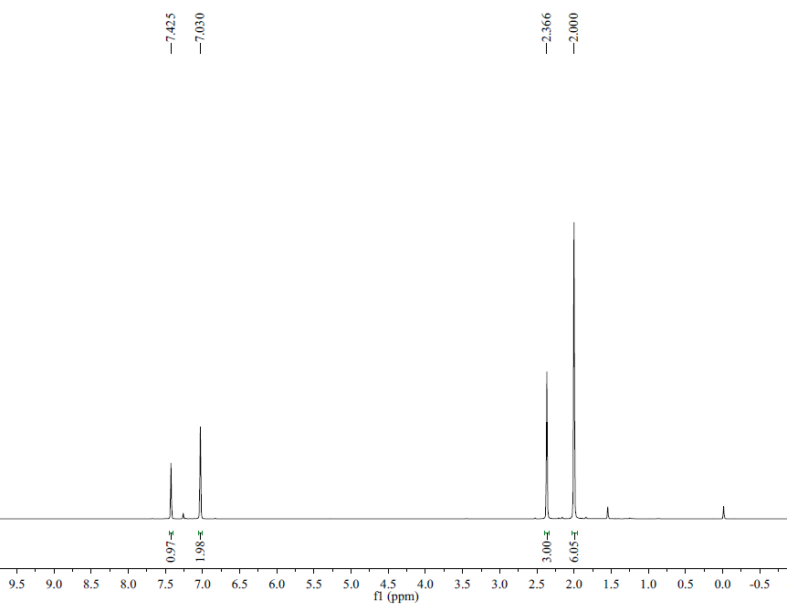
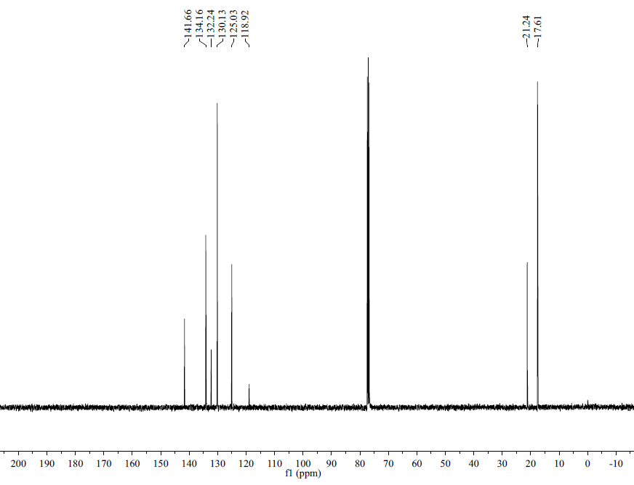

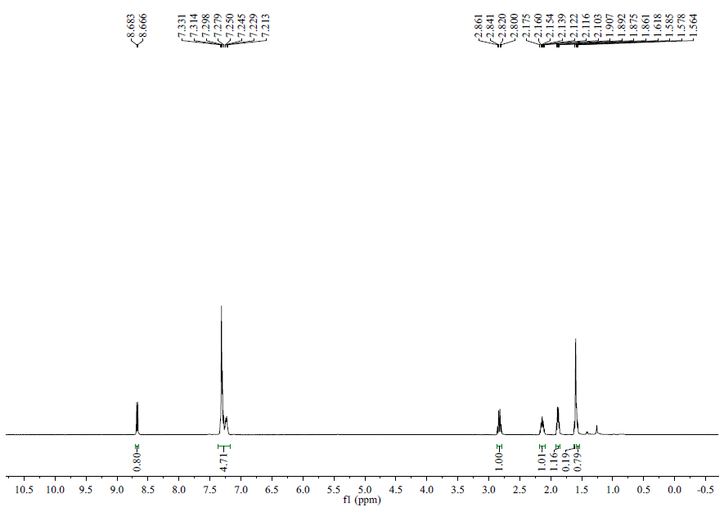

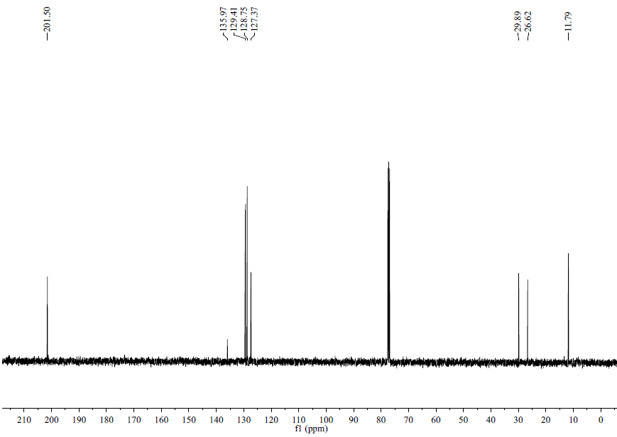

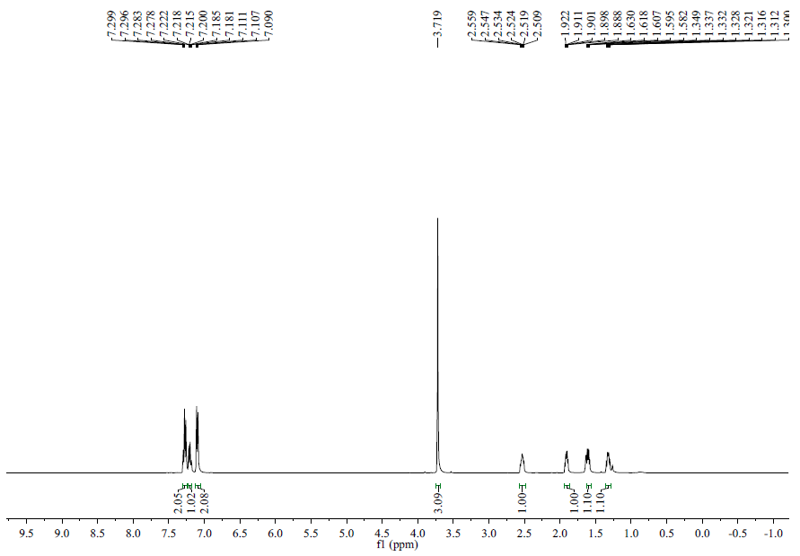

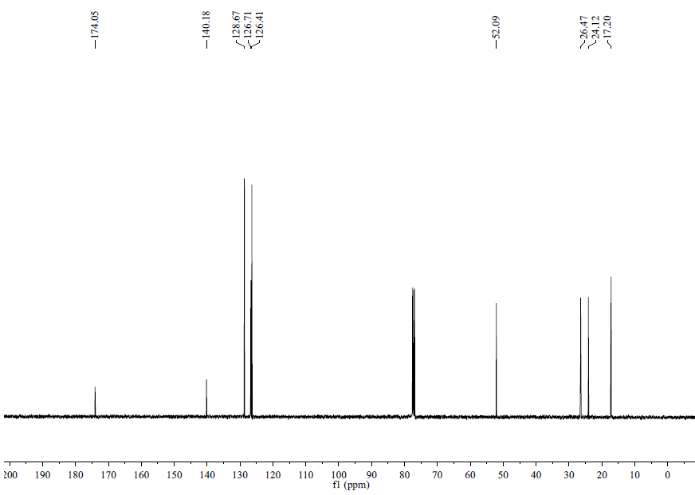

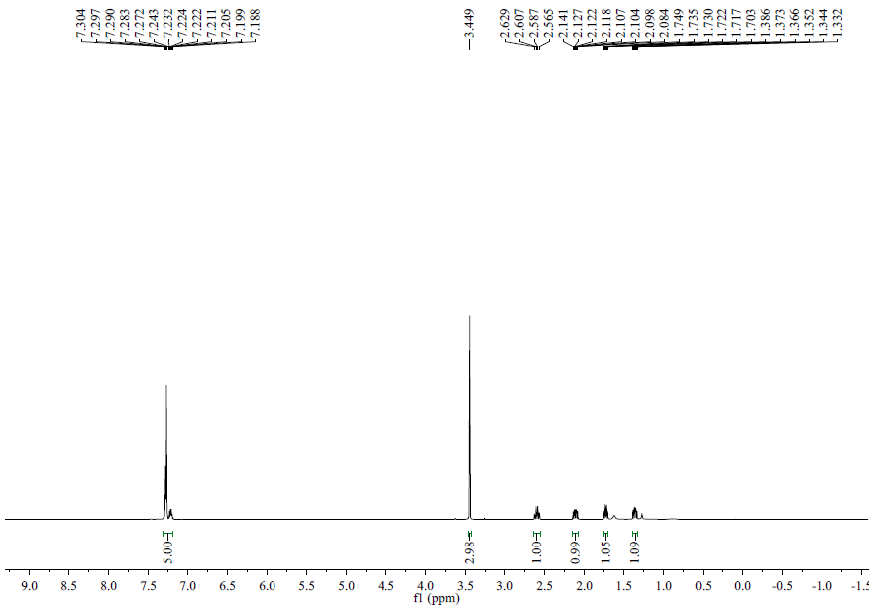

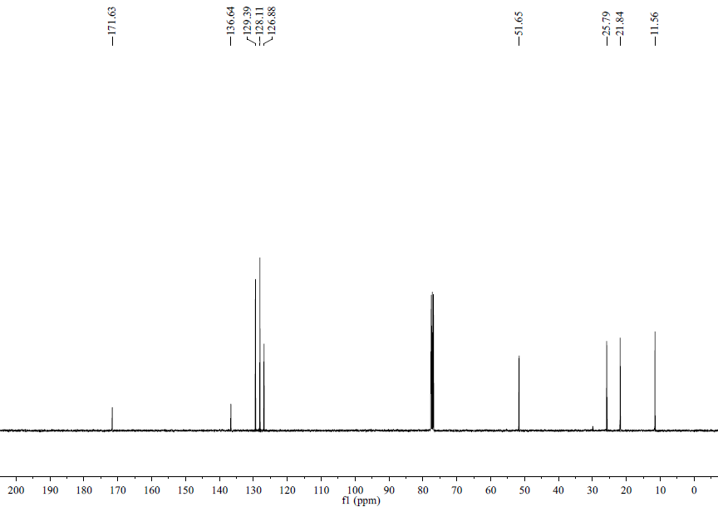
- UPCC Spectra
