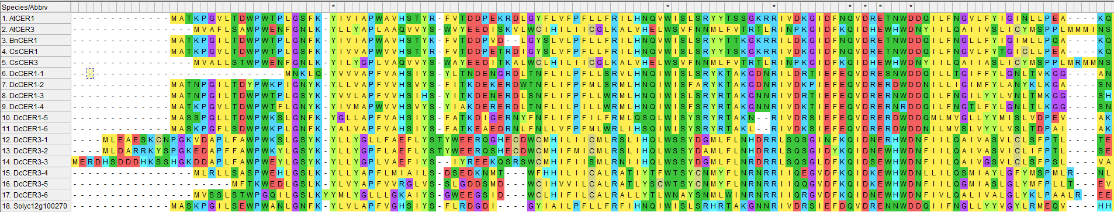
HXXHH
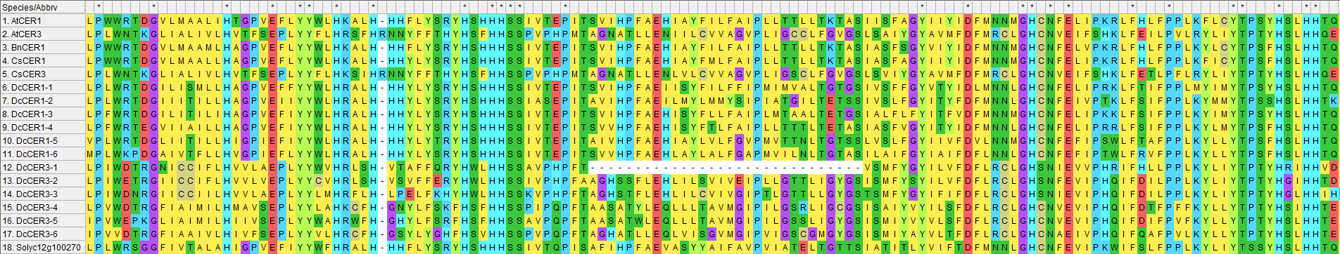
HXXHH
HXXXH
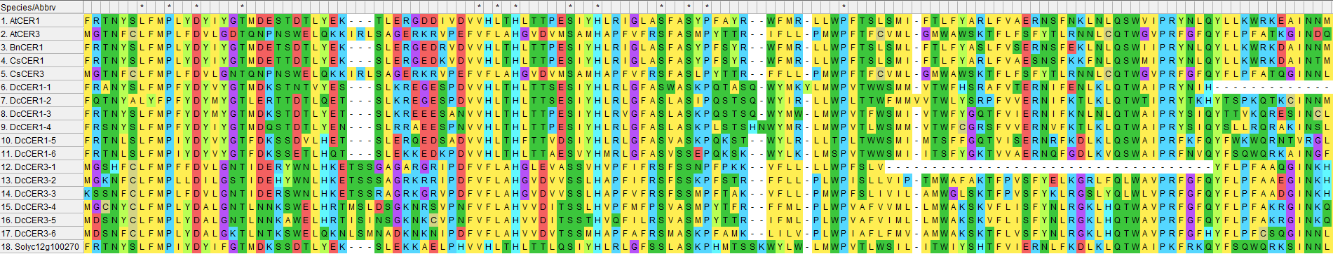
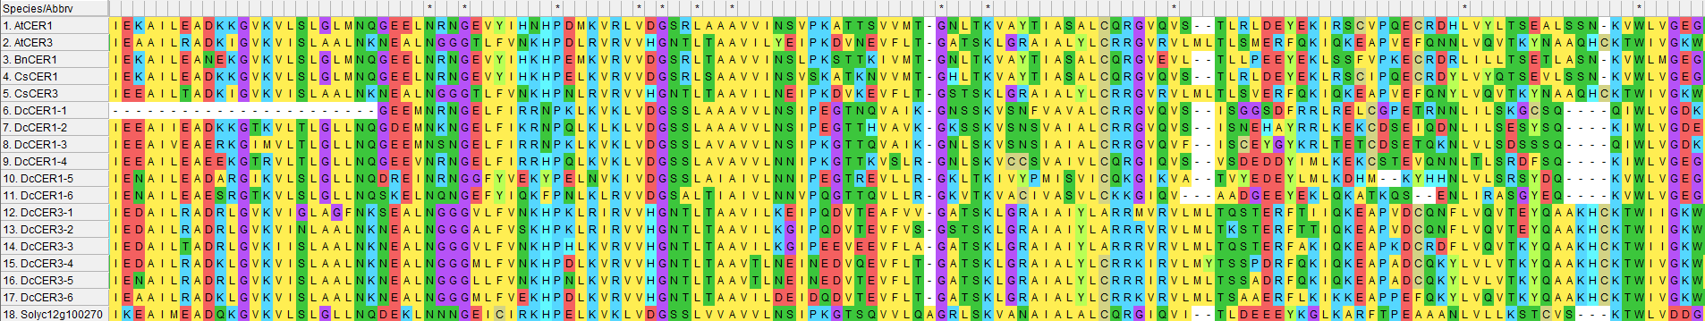

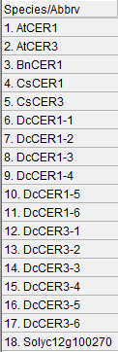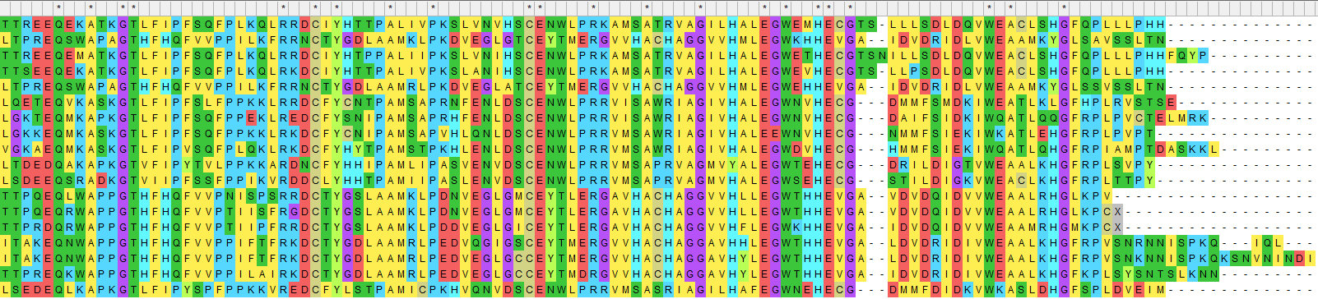

Figure S6 Alignment (MEGA-X, Muscle) of the predicted protein sequences of 12 D. carota CER1 and CER3 genes (see Table 2) and comparison with other known plant CER1/3s (AtCER1_NP_171723.2 and AtCER3_ NP_200588.2 from A. thaliana; CsCER1_KJ461885 and CsCER3_AIE57504.1 from Camelina sativa; BnCER1_KF724897 from Brassica napus) and the putative tomato CER1 gene Solyc12g100270 [27]. Three putative His boxes are underlined.

