**c**

**a**

**b**

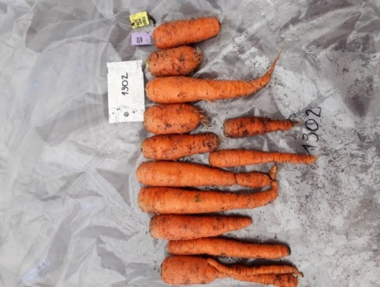 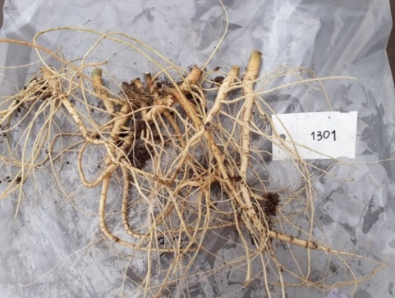 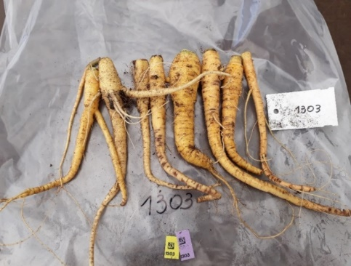



**d FaOH**

**e FaDOH**

**Figure S1** Characteristic carrot root phenotypes of the cultivated inbred line ´345-B´ (**a**), of the inbred line derived from *D. carota* ssp. commutatus accession JKI 1870 ('1870') (**b**) and of the F2 population ´CA´. FaOH and FaDOH levels of each six parental individuals of ´345-B´ and´1870´, and nine F2 individuals of ´CA´ are shown in **d** and **e**, respectively. Due to morphological reasons, root tissue for PA analysis was sampled using the 'PPX' method. For details, see method section.