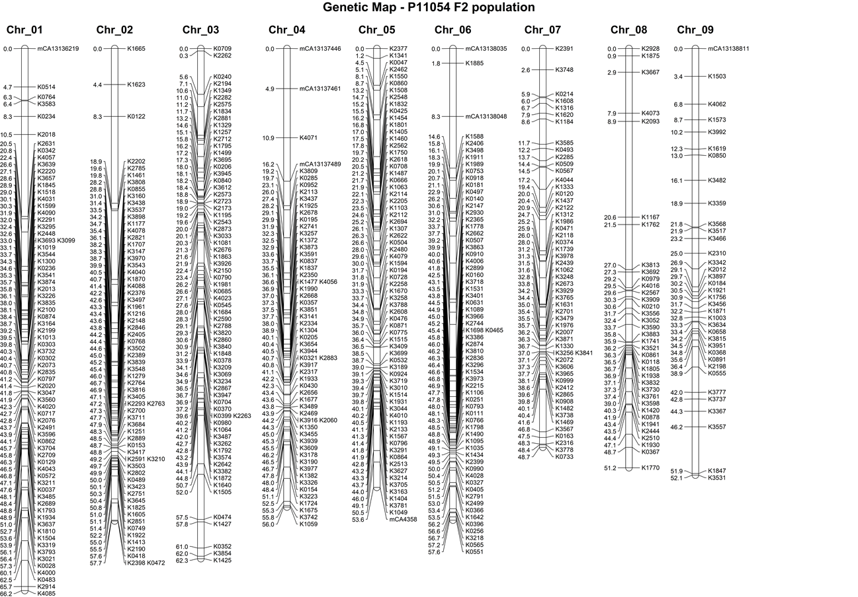
Figure S2 Genetic map of F₂ population P11054 (called CA in this study), based on 374 individuals and 526 SNP markers

