Supplemental materials
Title page
Title: Dynamic microbial network structure and assembly process in rhizosphere and bulk soils along a coniferous plantation chronosequence

Authors: Ying Wang^{1, 2, 3}, Liguo Dong^{1, 2, 3}, Min Zhang^{1, 2, 3}, Xiaoxiong Bai ^{1, 2, 3}, Jiawen Zhang^{1, 2, 3}, Xuan Yu^{1, 2, 3,} *
¹ Department of Forestry, College of Forestry, Northwest A&F University, Yangling 712100, China
² Key Comprehensive Laboratory of Forestry, Shaanxi Province, Yangling 712100, China
³ Key Lab Silviculture Loess Plateau State Forestry, Yangling 712100, China
*Corresponding authors: Xuan Yu, College of Forestry, Northwest A&F University, Yangling, Shaanxi 712100, China
E-mail address: yux@nwsuaf.edu.cn

Table S1 Basic conditions of the three stand sites in Pinus tabulaeformis plantation.
Stand sites | Longitude (°) | Latitude (°) | Altitude (m) | Slope gradient (°) | Slope aspect (°) | Canopy density (%) | Mean DBH (cm) | Mean height (m)
15Y | 109.6606 | 35.7886 | 1197.59 | 25 | 47.67 | 73.67 | 20.58 | 4.12
30Y | 109.6882 | 35.7626 | 1153.56 | 23 | 134.67 | 34.33 | 33.67 | 7.10
60Y | 109.7781 | 35.7844 | 1309.49 | 23 | 216 | 34.67 | 50.98 | 7.57

Table S2 Results of two-way ANOVA showing the effect of chronosequence and soil compartment on soil properties.
Factors | pH | SMC  (%) | SOC  (g·kg⁻¹) | TN  (g·kg⁻¹) | TP  (g·kg⁻¹) | NO₃⁻-N  (mg·kg⁻¹) | NH₄⁺-N  (mg·kg⁻¹) | AP  (mg·kg⁻¹) | C/N
Chronosequence | *** | *** | *** | * | ** | ** | 0.122 | 0.829 | 0.667
15Y | 8.46±0.10a | 15.43±0.25b | 9.92±1.19a | 0.52±0.08a | 0.55±0.02ab | 1.52±0.24b | 3.51±0.31a | 0.45±0.08a | 23.78±6.09a
30Y | 8.29±0.05ab | 18.63±0.40a | 10.25±1.07a | 0.64±0.01a | 0.61±0.03a | 2.74±0.32a | 3.49±0.27a | 0.42±0.05a | 25.09±11.79a
60Y | 8.19±0.01b | 20.45±0.86a | 13.93±1.68a | 0.87±0.12a | 0.46±0.02b | 2.31±0.24ab | 2.9±0.11a | 0.43±0.08a | 17.12±2.25a
Soil compartment | *** | 0.091 | *** | 0.406 | 0.996 | ** | 0.632 | *** | *
BS | 8.43±0.07 | 18.73±0.98 | 8.61±0.49 | 0.72±0.04 | 0.54±0.03 | 2.49±0.27 | 3.24±0.26 | 0.29±0.01 | 12.44±1.30
RS | 8.20±0.01 | 17.60±0.66 | 14.12±0.96 | 0.63±0.13 | 0.54±0.03 | 1.89±0.24 | 3.36±0.17 | 0.57±0.04 | 31.55±7.35
t-tests | * | 0.352 | *** | 0.539 | 0.997 | 0.115 | 0.692 | *** | *
Chronosequence × Soil compartment | *** | 0.497 | 0.343 | * | 0.139 | ** | 0.070 | 0.490 | 0.322
Note. SMC: soil moisture content; SOC: soil organic carbon; TN: total nitrogen; TP: total phosphorus; NO₃⁻-N: nitrate nitrogen; NH₄⁺-N: ammonium nitrogen; AP: available phosphorus; C/N: ratio of SOC and TN; 15Y, 15 years-old; 30Y, 30 year-old; 60Y, 60 year-old; BS: bulk soil; RS: rhizosphere soil. Values are showed as Mean ± SE (Std. Error). Different letters indicated significant difference along the chronosequence (P < 0.05). t-test was used to test the difference between bulk soil and rhizosphere. Chronosequence, Soil compartment and Chronosequence × Soil compartment indicated the effects of chronosequence, soil compartment and their interactions. * P < 0.05, ** P < 0.01, *** P < 0.001.

Table S3 Results of two-way ANOVA showing the effect of chronosequence and soil compartment on microbial alpha diversity.
Factors | Bacteria |  | Fungi
 | Shannon | Chao1 | Shannon | Chao1
Chronosequence | 0.283 | 0.476 | 0.588 | 0.627
15Y | 11.31±0.07a | 7076.90±224.43a | 5.68±0.43a | 746.58±118.38a
30Y | 11.09±0.15a | 6477.37±510.04a | 5.66±0.62a | 906.09±152.89a
60Y | 11.09±0.13a | 6862.21±318.47a | 4.92±0.58a | 679.42±187.71a
Soil compartment | * | * | 0.976 | 0.657
BS | 11.01±0.08 | 6347.57±186.23 | 5.41±0.54 | 733.38±138.89
RS | 11.32±0.10 | 7263.41±316.09 | 5.43±0.35 | 821.34±112.90
t-tests | * | * | 0.935 | 0.670
Chronosequence × Soil compartment | 0.554 | 0.884 | 0.519 | 0.680
Note. 15Y, 15 years-old; 30Y, 30 year-old; 60Y, 60 year-old; BS: bulk soil; RS: rhizosphere soil. * P < 0.05, ** P < 0.01, *** P < 0.001.

Table S4 Mantel tests examined the relationships between soil properties and microbial community.
Soil properties | Bacteria |  | Fungi
 | r | P | r | P
pH | 0.107 | 0.117 | -0.065 | 0.678
SMC | 0.320 | ** | 0.206 | *
SOC | 0.225 | * | -0.008 | 0.506
TN | 0.009 | 0.418 | 0.157 | 0.086
TP | 0.147 | 0.057 | 0.083 | 0.182
NO₃⁻-N | 0.050 | 0.259 | 0.126 | 0.112
NH₄⁺-N | -0.108 | 0.902 | 0.017 | 0.408
AP | 0.188 | * | -0.047 | 0.661
C:N | 0.067 | 0.193 | -0.048 | 0.624
Note. SMC: soil moisture content; SOC: soil organic carbon; TN: total nitrogen; TP: total phosphorus; NO₃⁻-N: nitrate nitrogen; NH₄⁺-N: ammonium nitrogen; AP: available phosphorus; C/N: ratio of SOC and TN. * P < 0.05, ** P < 0.01, *** P < 0.001.
Table S5 The spearman correlation coefficients between the dominate taxa and alpha diversity, and soil properties.
Microbes | pH | SMC | SOC | TN | TP | NO₃⁻-N | NH₄⁺-N | AP | C/N
Bacteria
Acidobacteria | 0.115 | 0.302 | -0.083 | 0.490* | 0.001 | 0.176 | -0.118 | -0.112 | -0.368
Actinobacteria | -0.115 | -0.664** | 0.236 | -0.688** | 0.263 | -0.453 | 0.258 | 0.491* | 0.662**
Gammaproteobacteria | -0.200 | 0.606** | 0.068 | 0.546* | -0.467 | 0.257 | -0.284 | -0.175 | -0.406
Chloroflexi | 0.011 | -0.527* | 0.047 | -0.443 | 0.492* | -0.226 | 0.336 | 0.144 | 0.352
Alphaproteobacteria | -0.632** | 0.055 | 0.710** | -0.154 | -0.069 | -0.059 | 0.172 | 0.676** | 0.525*
Gemmatimonadetes | 0.495* | 0.224 | -0.704** | 0.348 | -0.061 | 0.181 | -0.409 | -0.719** | -0.649**
Deltaproteobacteria | -0.078 | 0.777** | -0.023 | 0.587* | -0.307 | 0.472* | -0.330 | -0.269 | -0.447
Rokubacteria | 0.177 | 0.311 | -0.305 | 0.465 | 0.245 | 0.249 | -0.345 | -0.445 | -0.463
Bacteroidetes | -0.266 | 0.079 | 0.272 | -0.115 | -0.321 | -0.203 | 0.171 | 0.299 | 0.189
Patescibacteria | -0.088 | 0.009 | 0.326 | 0.302 | -0.216 | 0.007 | 0.236 | 0.267 | -0.127
Latescibacteria | 0.133 | 0.527* | -0.342 | 0.486* | -0.346 | 0.311 | -0.304 | -0.553* | -0.540*
Planctomycetes | -0.268 | 0.201 | 0.354 | 0.434 | -0.075 | 0.098 | -0.077 | 0.122 | -0.063
Diversity
Shannon | -0.212 | -0.399 | 0.496* | -0.214 | 0.340 | -0.296 | 0.351 | 0.758** | 0.498*
Chao1 | -0.349 | -0.286 | 0.570* | 0.013 | 0.135 | -0.271 | 0.112 | 0.647** | 0.373
Fungi
Agaricomycetes | -0.096 | 0.127 | 0.140 | 0.381 | 0.319 | 0.121 | 0.080 | 0.027 | -0.112
Sordariomycetes | 0.127 | -0.135 | -0.126 | -0.286 | -0.077 | 0.082 | 0.022 | 0.117 | 0.042
Pezizomycetes | 0.386 | -0.719** | -0.288 | -0.624** | 0.451 | -0.387 | 0.209 | 0.228 | 0.276
Archaeorhizomycetes | 0.188 | -0.164 | -0.231 | -0.349 | -0.118 | -0.094 | -0.004 | 0.025 | 0.055
Mortierellomycetes | 0.208 | -0.288 | -0.159 | -0.282 | -0.135 | -0.061 | -0.011 | 0.142 | 0.040
Leotiomycetes | 0.288 | -0.563* | -0.090 | -0.276 | 0.017 | -0.310 | -0.036 | 0.281 | 0.075
Tremellomycetes | 0.007 | -0.110 | -0.084 | -0.290 | 0.038 | 0.013 | 0.190 | 0.152 | 0.063
Eurotiomycetes | 0.396 | -0.238 | -0.347 | -0.335 | -0.096 | 0.100 | 0.012 | -0.027 | -0.020
Dothideomycetes | 0.055 | -0.218 | 0.015 | -0.106 | -0.137 | 0.067 | 0.044 | 0.195 | 0.030
Saccharomycetes | -0.051 | -0.137 | -0.076 | -0.282 | 0.053 | -0.063 | 0.235 | 0.079 | 0.046
Diversity
Shannon | 0.024 | -0.172 | -0.066 | -0.315 | -0.170 | -0.100 | -0.045 | 0.118 | 0.102
Chao1 | -0.026 | 0.007 | -0.001 | -0.251 | 0.018 | -0.015 | 0.057 | 0.115 | 0.133
Note. SMC: soil moisture content; SOC: soil organic carbon; TN: total nitrogen; TP: total phosphorus; NO₃⁻-N: nitrate nitrogen; NH₄⁺-N: ammonium nitrogen; AP: available phosphorus; C/N: ratio of SOC and TN. * P < 0.05, ** P < 0.01, *** P < 0.001.

Topological properties | Bacteria |  |  |  |  | Fungi
 | 15Y | 30Y | 60Y | BS | RS | 15Y | 30Y | 60Y | BS | RS
Nodes | 363 | 327 | 322 | 320 | 304 | 106 | 134 | 66 | 64 | 86
Edges | 1566 | 1940 | 2574 | 2896 | 2697 | 130 | 274 | 32 | 91 | 188
Average degree | 8.63 | 11.87 | 15.99 | 18.10 | 17.74 | 2.45 | 4.09 | 0.97 | 2.84 | 4.37
Average path length | 4.60 | 3.93 | 3.27 | 3.09 | 3.10 | 4.60 | 3.38 | 2.31 | 4.03 | 3.46
Network diameter | 15.74 | 11.57 | 9.53 | 6.98 | 7.79 | 10.21 | 10.11 | 4.71 | 9.77 | 7.35
Graph density | 0.02 | 0.04 | 0.05 | 0.06 | 0.06 | 0.02 | 0.03 | 0.01 | 0.05 | 0.05
Clustering coefficient | 0.39 | 0.46 | 0.47 | 0.47 | 0.46 | 0.38 | 0.39 | 0.26 | 0.48 | 0.44
Modularity | 0.50 | 0.53 | 0.31 | 0.43 | 0.40 | 0.71 | 0.49 | 0.80 | 0.64 | 0.57
Positive edges (%) | 51.40 | 53.97 | 63.95 | 58.01 | 56.95 | 66.15 | 53.65 | 53.12 | 69.23 | 60.11
Negative edges (%) | 48.60 | 46.03 | 36.05 | 41.99 | 43.05 | 33.85 | 46.35 | 46.88 | 30.77 | 39.89
Table S6 Co-occurrence network topological features statistics across the chronosequence and soil compartment.
Note. 15Y, 15 years-old; 30Y, 30 year-old; 60Y, 60 year-old; BS: bulk soil; RS: rhizosphere soil.

Table S7 The nodes that identified as network hub, module hub and connector in the co-occurrence network and their number distributions.
Microbes | Role | Phylum | Class | Order | 15Y | 30Y | 60Y | BS | RS
Bacteria
 | Network hubs | Actinobacteria | Thermoleophilia | unclassified |  |  | 1
 | Network hubs | Proteobacteria | Alphaproteobacteria | Rhizobiales |  |  | 1 | 1
 | Module hubs  Module hubs  Module hubs  Module hubs  Module hubs  Module hubs  Module hubs  Module hubs  Module hubs  Module hubs | Acidobacteria | Subgroup 6 | unclassified |  | 1
 |  | Actinobacteria | Acidimicrobiia | IMCC26256 |  | 1
 |  | Actinobacteria | Thermoleophilia | Gaiellales |  | 1 | 1 | 1
 |  | Chloroflexi | Chloroflexia | Thermomicrobiales | 1
 |  | Chloroflexi | KD4-96 | unclassified | 1
 |  | Chloroflexi | Gitt-GS-136 | unclassified |  |  | 1
 |  | Proteobacteria | Alphaproteobacteria | Rhizobiales |  | 1 |  | 1
 |  | Proteobacteria | Alphaproteobacteria | Sphingomonadales | 1 | 1 |  | 1
 |  | Proteobacteria | Deltaproteobacteria | NB1-j |  |  | 1
 |  | Proteobacteria | Gammaproteobacteria | Betaproteobacteriales |  |  | 2
 | Connectors | Acidobacteria | Acidobacteriia | Acidobacteriales |  | 1
 | Connectors | Acidobacteria | Acidobacteriia | Solibacterales |  | 1
 | Connectors | Acidobacteria | Blastocatellia (Subgroup 4) | Blastocatellales |  | 2
 | Connectors | Acidobacteria | Blastocatellia (Subgroup 4) | Pyrinomonadales | 11 | 9 | 7 | 6 | 5
 | Connectors | Acidobacteria | Subgroup 17 | unclassified | 4 | 1 | 1 | 2 | 1
 | Connectors | Acidobacteria | Subgroup 18 | unclassified |  |  |  | 1
 | Connectors | Acidobacteria | Subgroup 20 | unclassified |  |  |  | 1
 | Connectors | Acidobacteria | Subgroup 6 | unclassified | 14 | 11 | 14 | 8 | 6
 | Connectors | Actinobacteria | Acidimicrobiia | IMCC26256 | 2 | 1 | 2 |  | 1
 | Connectors | Actinobacteria | Acidimicrobiia | Microtrichales | 3 | 1 | 2 | 1 | 2
 | Connectors | Actinobacteria | Acidimicrobiia | unclassified |  |  |  |  | 1
 | Connectors | Actinobacteria | Actinobacteria | Corynebacteriales | 2 | 1 |  |  | 2
 | Connectors | Actinobacteria | Actinobacteria | Micrococcales | 1 |  |  |  | 1
 | Connectors | Actinobacteria | Actinobacteria | Propionibacteriales |  | 1 |  |  | 1
 | Connectors | Actinobacteria | Actinobacteria | Pseudonocardiales | 1
 | Connectors | Actinobacteria | Actinobacteria | Streptomycetales | 2
 | Connectors | Actinobacteria | MB-A2-108 | unclassified | 7 |  | 1 | 2 | 1
 | Connectors | Actinobacteria | Thermoleophilia | Gaiellales | 15 | 3 | 3 | 3 | 2
 | Connectors | Actinobacteria | Thermoleophilia | Solirubrobacterales | 3 | 2 | 2 | 1 | 1
 | Connectors | Actinobacteria | Thermoleophilia | unclassified |  | 1 |  |  | 1
 | Connectors | Bacteroidetes | Bacteroidia | Cytophagales |  | 1 |  | 1
 | Connectors | Bacteroidetes | Bacteroidia | Chitinophagales |  |  |  | 1 | 2
 | Connectors | Chloroflexi | Anaerolineae | Anaerolineales | 3 | 2
 | Connectors | Chloroflexi | Anaerolineae | SBR1031 |  |  |  | 1
 | Connectors | Chloroflexi | Chloroflexia | Thermomicrobiales | 1 |  |  |  | 1
 | Connectors | Chloroflexi | Dehalococcoidia | S085 | 2 |  |  |  | 1
 | Connectors | Chloroflexi | Gitt-GS-136 | unclassified | 3 | 1 | 1
 | Connectors | Chloroflexi | JG30-KF-CM66 | unclassified |  | 1 |  | 1
 | Connectors | Chloroflexi | KD4-96 | unclassified | 14 | 2 | 6 | 11 | 1
 | Connectors | Chloroflexi | TK10 | unclassified |  | 1 | 1 | 1 | 1
 | Connectors | Chloroflexi | P2-11E | unclassified |  |  |  | 1
 | Connectors | Firmicutes | Bacilli | Bacillales |  |  |  |  | 1
 | Connectors | Gemmatimonadetes | Gemmatimonadetes | Gemmatimonadales | 5 | 5 | 14 | 8 | 4
 | Connectors | Latescibacteria | metagenome | metagenome |  |  | 1
 | Connectors | Latescibacteria | unclassified | unclassified |  |  | 4 | 1
 | Connectors | Patescibacteria | Saccharimonadia | Saccharimonadales |  | 2
 | Connectors | Planctomycetes | Phycisphaerae | Phycisphaerales | 1 |  | 1 |  | 1
 | Connectors | Proteobacteria | Alphaproteobacteria | Azospirillales |  | 1
 | Connectors | Proteobacteria | Alphaproteobacteria | Caulobacterales |  |  |  |  | 1
 | Connectors | Proteobacteria | Alphaproteobacteria | Dongiales | 2 |  | 1 |  | 2
 | Connectors | Proteobacteria | Alphaproteobacteria | Rhizobiales | 5 | 5 | 7 | 2 | 7
 | Connectors | Proteobacteria | Alphaproteobacteria | Sphingomonadales | 5 | 1 | 3 | 4 | 2
 | Connectors | Proteobacteria | Deltaproteobacteria | Desulfarculales |  | 1 | 2
 | Connectors | Proteobacteria | Deltaproteobacteria | Myxococcales | 1 |  |  | 1 | 1
 | Connectors | Proteobacteria | Deltaproteobacteria | MBNT15 |  |  | 1
 | Connectors | Proteobacteria | Deltaproteobacteria | NB1-j | 2 |  | 3 | 1
 | Connectors | Proteobacteria | Deltaproteobacteria | unclassified | 2 | 2 | 1 |  | 1
 | Connectors | Proteobacteria | Gammaproteobacteria | Betaproteobacteriales | 10 | 15 | 9 | 9 | 8
 | Connectors | Proteobacteria | Gammaproteobacteria | Nitrosococcales |  |  | 1
 | Connectors | Proteobacteria | Gammaproteobacteria | Pseudomonadales | 2 |  | 1 | 1
 | Connectors | Proteobacteria | Gammaproteobacteria | PLTA13 |  | 1 | 1
 | Connectors | Proteobacteria | Gammaproteobacteria | Steroidobacterales | 1 | 1
 | Connectors | Proteobacteria | Gammaproteobacteria | Xanthomonadales | 1 | 3 | 1 |  | 2
 | Connectors | Rokubacteria | NC10 | Rokubacteriales | 8 | 3 | 11 | 8 | 2
 | Connectors | Verrucomicrobia | Verrucomicrobiae | Chthoniobacterales |  |  | 1
Fungi
 | Module hubs | Basidiomycota | Tremellomycetes | Filobasidiales |  | 1
 | Connectors | Ascomycota | Archaeorhizomycetes | Archaeorhizomycetales | 1 | 1 |  |  | 2
 | Connectors | Ascomycota | Dothideomycetes | Capnodiales | 1 |  |  | 1 | 1
 | Connectors | Ascomycota | Dothideomycetes | Pleosporales | 2 | 1 |  | 2 | 1
 | Connectors | Ascomycota | Eurotiomycetes | Chaetothyriales | 2 |  |  | 1
 | Connectors | Ascomycota | Eurotiomycetes | Eurotiales |  |  |  | 1 | 2
 | Connectors | Ascomycota | Eurotiomycetes | Onygenales | 1
 | Connectors | Ascomycota | Leotiomycetes | Helotiales | 3
 | Connectors | Ascomycota | Leotiomycetes | unclassified |  |  | 1
 | Connectors | Ascomycota | Orbiliomycetes | Orbiliales |  | 1
 | Connectors | Ascomycota | Pezizomycetes | Pezizales | 3 | 2 |  |  | 1
 | Connectors | Ascomycota | Saccharomycetes | Saccharomycetales | 3 | 2 | 2 | 1 | 3
 | Connectors | Ascomycota | Sordariomycetes | Hypocreales | 4 | 1 | 5 | 5 | 2
 | Connectors | Ascomycota | Sordariomycetes | Microascales |  | 1
 | Connectors | Ascomycota | Sordariomycetes | Sordariales |  | 1 |  |  | 1
 | Connectors | Ascomycota | Sordariomycetes | unclassified | 1
 | Connectors | Ascomycota | unclassified | unclassified | 3 |  |  | 1
 | Connectors | Basidiomycota | Agaricomycetes | Agaricales | 3 | 1 | 3 |  | 2
 | Connectors | Basidiomycota | Agaricomycetes | Atheliales | 1 |  | 1 | 1 | 1
 | Connectors | Basidiomycota | Agaricomycetes | Boletales | 3 | 4 | 2 | 1 | 4
 | Connectors | Basidiomycota | Agaricomycetes | Cantharellales | 1 |  | 2 |  | 1
 | Connectors | Basidiomycota | Agaricomycetes | Russulales |  |  | 1 |  | 1
 | Connectors | Basidiomycota | Agaricomycetes | Sebacinales | 2 | 5 | 7 | 4 | 3
 | Connectors | Basidiomycota | Agaricomycetes | Thelephorales | 3 | 4 | 6 | 3 | 5
 | Connectors | Basidiomycota | Agaricomycetes | unclassified |  | 2
 | Connectors | Basidiomycota | Cystobasidiomycetes | unclassified | 1 | 1 | 1 | 1
 | Connectors | Basidiomycota | Geminibasidiomycetes | Geminibasidiales | 1
 | Connectors | Basidiomycota | Malasseziomycetes | Malasseziales |  | 1 |  |  | 2
 | Connectors | Basidiomycota | Microbotryomycetes | Sporidiobolales |  |  |  |  | 1
 | Connectors | Basidiomycota | Tremellomycetes | Filobasidiales |  |  |  |  | 1
 | Connectors | Basidiomycota | Tremellomycetes | Tremellales | 1 | 2 | 1 | 2
 | Connectors | Basidiomycota | Tremellomycetes | Trichosporonales |  |  | 1 | 1
 | Connectors | Basidiomycota | unclassified | unclassified | 1
 | Connectors | Blastocladiomycota | Blastocladiomycetes | Blastocladiales |  | 1
 | Connectors | Mortierellomycota | Mortierellomycetes | Mortierellales | 5 | 3 | 1 | 3 | 2
 | Connectors | Olpidiomycota | Olpidiomycetes | Olpidiales |  |  | 1 | 1
 | Connectors | unclassified_Fungi |  |  | 8 | 8 | 2 | 3 | 3
Note. 15Y, 15 years-old; 30Y, 30 year-old; 60Y, 60 year-old; BS: bulk soil; RS: rhizosphere soil.

Table S8 Mantel tests examined the relationships between keystone species composition and soil properties.
Soil properties | Bacteria |  |  |  |  | Fungi
 | 15Y | 30Y | 60Y | BS | RS | 15Y | 30Y | 60Y | BS | RS
pH | 0.228 | 0.313 | 0.038 | 0.194 | -0.107 | 0.139 | -0.260 | -0.122 | 0.047 | -0.108
SMC | 0.061 | -0.595 | -0.010 | 0.139 | 0.268 | -0.089 | -0.288 | 0.071 | 0.044 | -0.058
SOC | 0.064 | 0.169 | 0.826* | -0.072 | 0.381 | 0.076 | -0.174 | -0.178 | 0.205 | 0.448*
TN | 0.209 | -0.221 | -0.335 | -0.269 | 0.093 | 0.072 | -0.193 | 0.158 | -0.228 | 0.406*
TP | 0.464 | -0.101 | -0.267 | 0.007 | 0.386* | 0.374 | -0.222 | 0.248 | 0.015 | 0.370*
NO₃⁻-N | 0.083 | 0.208 | 0.329 | -0.090 | 0.403* | 0.117 | 0.064 | -0.174 | 0.100 | 0.218
NH₄⁺-N | -0.212 | -0.042 | 0.675* | 0.032 | -0.290 | 0.361 | 0.194 | -0.213 | 0.179 | -0.052
AP | -0.210 | 0.192 | 0.859* | 0.001 | -0.203 | -0.071 | -0.251 | -0.248 | 0.288* | -0.041
C/N | 0.033 | -0.169 | -0.137 | -0.307 | -0.037 | -0.003 | -0.173 | 0.514 | -0.316 | -0.274
Note. SMC: soil moisture content; SOC: soil organic carbon; TN: total nitrogen; TP: total phosphorus; NO₃⁻-N: nitrate nitrogen; NH₄⁺-N: ammonium nitrogen; AP: available phosphorus; C/N: ratio of SOC and TN; 15Y, 15 years-old; 30Y, 30 year-old; 60Y, 60 year-old; BS: bulk soil; RS: rhizosphere soil. * P < 0.05, ** P < 0.01, *** P < 0.001.

Table S9 Mantel tests examined the relationships between soil properties and βNTI of bacteria and fungi.
Soil properties | Bacteria |  | Fungi
 | r | P | r | P
pH | 0.003 | 0.496 | 0.163 | 0.129
SMC | -0.127 | 0.879 | -0.123 | 0.824
SOC | 0.023 | 0.420 | -0.086 | 0.734
TN | -0.017 | 0.564 | 0.005 | 0.465
TP | -0.134 | 0.927 | 0.059 | 0.274
NO₃⁻-N | -0.118 | 0.868 | -0.130 | 0.849
NH₄⁺-N | -0.104 | 0.835 | -0.256 | 0.982
AP | 0.066 | 0.254 | -0.187 | 0.964
C/N | -0.150 | 0.869 | -0.170 | 0.842
Note. SMC: soil moisture content; SOC: soil organic carbon; TN: total nitrogen; TP: total phosphorus; NO₃⁻-N: nitrate nitrogen; NH₄⁺-N: ammonium nitrogen; AP: available phosphorus; C/N: ratio of SOC and TN. * P < 0.05, ** P < 0.01, *** P < 0.001.

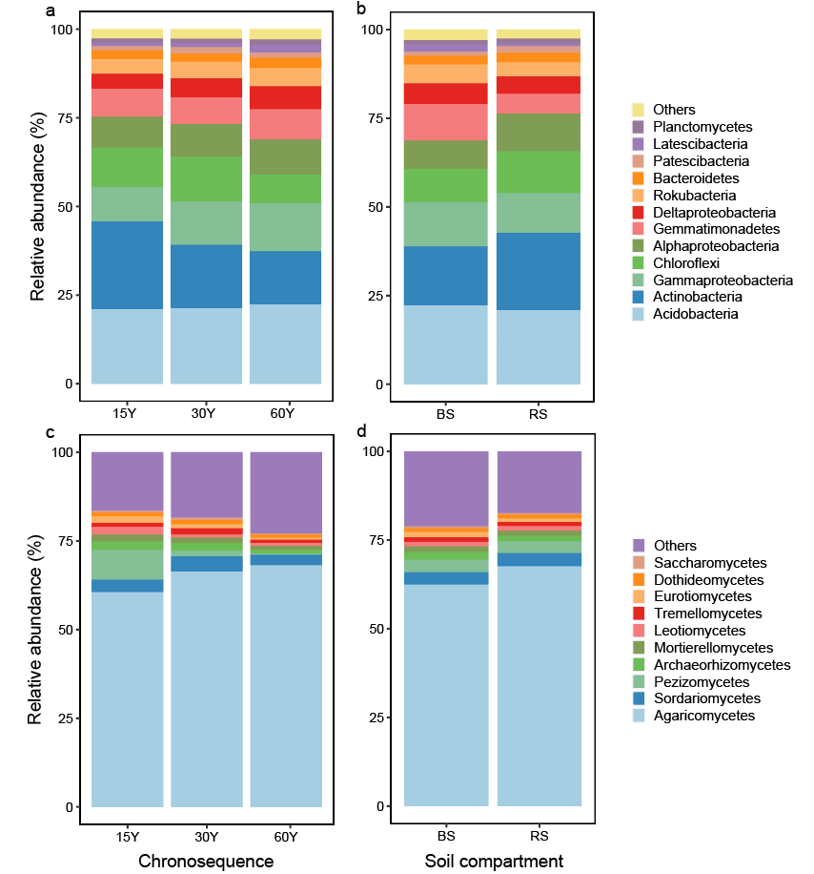
Fig. S1. The relative abundance of dominate taxa of bacteria (a, b) and fungi (c, d) across the chronosequence and soil compartment. 15Y, 15 years-old; 30Y, 30 year-old; 60Y, 60 year-old; BS: bulk soil; RS: rhizosphere soil.

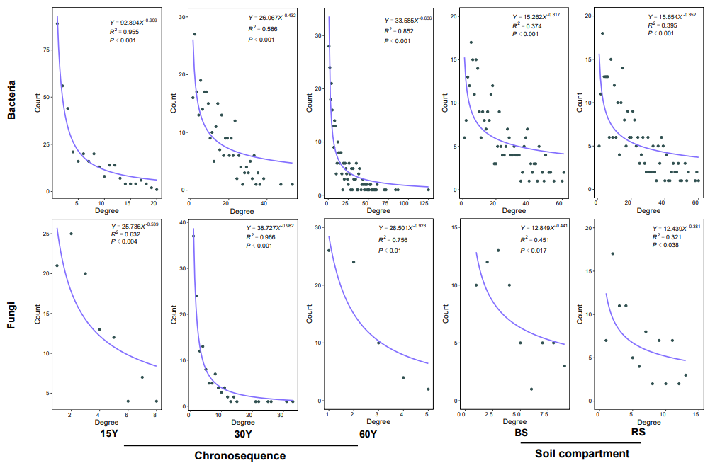
Fig. S2. Degree distribution of bacterial and fungal co-occurrence networks.

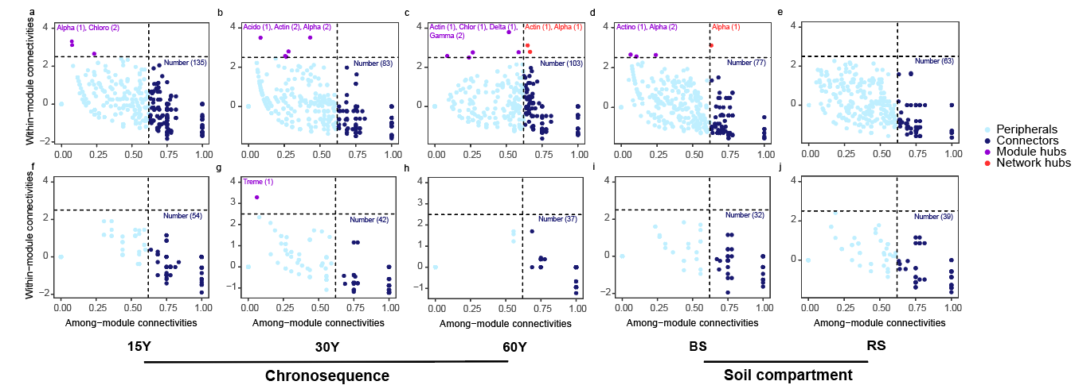
Fig. S3. Network roles of analyzing module feature at ASV level for bacteria (a-e) and fungi (f-j) across the chronosequence and soil compartment. Acido: Acdiobacteria; Actin: Actinobacteria; Chlor: Chloroflexi; Alpha: Alphaproteobacteria; Delta: Deltaproteobacteria; Gamma: Gammaproteobacteria; Treme: Tremellomycetes; 15Y, 15 years-old; 30Y, 30 year-old; 60Y, 60 year-old; BS: bulk soil; RS: rhizosphere soil.

