SUPLEMENTARY INFORMATION
Volcano | Country | Station | Network | # rec. eruptions | Type or  eruptions | Eruptions year | Record years | Continuous data
Pavlof | Alaska, USA | PVV  4 km | AV | 3 | Magmatic | 14, 14,16 | 2 .5 | Yes  69%
Veniaminof | Alaska, USA | VNSS  5.3 km | AV | 2 | Magmatic | 13,18 | 4 | Yes  59%
Bezymianny | Kamchatka, Russia | BELO  1 km | YC | 3 | Magmatic | 07,07,07 | 1 | Yes  99%
Whakaari | New Zealand | WIZ  500 m | NZ | 5 | Phreato-magmatic | 12,13,13,  16,19 | 11 | Yes  96%
Tongariro | New Zealand | KRVZ | NZ | 2 | Phreatic | 12,12 | 14 | Yes  96%
Ruapehu | New Zealand | FWVZ | NZ | 3 | Phreatic | 06,07 | 14 | Yes  91%
Table S1. Basic information on the six volcanoes included in this study indicating the country, the station and network used and its distance to the crater, the number of eruptions recorded, the type and year of eruptions, the length of the seismic record analysed, and the % of continuous data on the record.
Eruption | Time (UTC) | VEI | Type | Duration | Column Height
Whakaari, 2012 | 2012 08 04 16 52 00 | 1 | Phreatic | 10 min
Whakaari, 2013a | 2013 08 19 22 23 00 | 0-1 | Phreatic | 10 min
Whakaari, 2013b | 2013 10 11 07 09 00 | 0 | Phreato-magmatic | 10 min
Whakaari, 2016 | 2016 04 27 09 37 00 | 1 | Phreatic
Whakaari, 2019 | 2019 12 09 01 11 00 | 2 | Phreatic | 2 min
Ruapehu, 2006 | 2006 10 04 09 30 00 | 0 | Phreatic
Ruapehu, 2007 | 2007 09 25 08 20 00 | 1-2 | Phreatic |  | ~5 km
Ruapehu, 2009* | 2009 07 13 06 30 00 | 0 | Phreatic
Tongariro, 2012a | 2012 08 06 11 50 00 | 2 | Phreatic
Tongariro, 2012b | 2012 11 21 00 20 00 | 1 | Phreatic
Pavlof, 2014a | 2014 05 31 17 22 00 | 3 | Magmatic | 1 month | ~7 km
Pavlof, 2014b | 2014 11 13 00 00 00 | 2 | Magmatic | 5 days | ~11 km
Pavlof, 2016 | 2016 03 28 01 33 00 | 3 | Magmatic | 7 days | ~10 km
Bezymiany, 2007a | 2007 09 25 08 30 00 | 3 | Magmatic |  | ~4 km
Bezymiany, 2007b | 2007 10 14 14 27 00 | 2 | Magmatic | 1 day | ~9 km
Bezymiany, 2007c | 2007 11 05 08 43 00 | 3 | Magmatic |  | ~8 km
Veniaminof, 2013 | 2013 06 13 00 00 00 | 2-3 | Magmatic | 4 months | ~6 km
Veniaminof, 2018 | 2018 09 04 00 00 00 | 2 | Magmatic | 4 months | ~5 km

Table S2. Catalogue of eruptions included in this study, indicating its time, volcano explosivity index (VEI), eruption type and duration, and column height. See Figure S1.

Signature | Test volcano | Eruption group | p-value
DSAR median, Whakaari 2019 | Whakaari | 2012, 2013a, 2013b, 2016 | 0.000148
DSAR median, Whakaari 2019 | Ruapehu | 2006, 2007, 2009 | 0.0173
DSAR median, Whakaari 2019 | Tongariro | 2012, 2013 | 0.0659
DSAR median, Whakaari 2019 | Veniaminof | 2013, 2018 | 0.0721
DSAR rate variance, Whakaari 2019 | Whakaari | 2012, 2013a, 2013b, 2016, 2019 | 0.00599
DSAR rate variance, Whakaari 2019 | Ruapehu | 2006, 2007, 2009 | 0.149
DSAR rate variance, Whakaari 2019 | Veniaminof | 2013, 2018 | 0.0940
DSAR rate variance, Whakaari 2019 | Tongariro | 2012, 2013 | 0.146
DSAR median, Veniaminof 2013 | Whakaari | 2012, 2013a, 2013b, 2016, 2019 | 0.000756
DSAR median, Veniaminof 2019 | Ruapehu | 2006, 2007, 2009 | 0.0944
DSAR median, Veniaminof 2019 | Tongariro | 2018 | 0.0641
DSAR rate variance, Ruapehu 2007 | Whakaari | 2012, 2013a, 2013b, 2016, 2019 | 0.000181
DSAR rate variance, Ruapehu 2007 | Ruapehu | 2006, 2009 | 0.206
DSAR rate variance, Ruapehu 2007 | Veniaminof | 2013, 2018 | 0.196

Table S3. Kolmogorov-Smirnov p-values testing the statistical significance of a potential signature against a group of eruptions. Signature patterns are shown in Figs. 1 & 2.

Regime | (1) Magma-hydrothermal system interaction | (2) Pulsating gas flux | (3) Sealing consolidation | (4) Pressurization | (5) Seal breakdown and  Eruption
Period | Nov 11 - Nov 22  ~10 days | Nov 22 - Dec 02  ~10 days | Dec 02 - Dec 06  ~4 days | Dec 06 - Dec 09  ~4 days | Dec 09 01 11 00  ~10 min
Observations from seismic data | Harmonic tremor in RSAM band (2-5 Hz). Intense for 10 days. Weak for 1 month (Figure S7). | Relative increase in MF (4-8Hz) and HF bands (8-16Hz). Relative decrease in RSAM band. Cyclic pulses in the data. Increase in DSAR median. Peak in DSAR rate variance at the end of the cycle. | No pulses in seismic data. Decoupling of MF and HF. MF increases quicker than HF, causing an increase in DSAR median. | Decrease in DSAR median, due to a rapid decrease in MF. Peak in every frequency during decrease of DSAR median (~16 hours before eruption). Inverse RSAM shows a peak and a linear decrease (~16 hours before eruption). | Strong peak in every frequency of the data at the eruption time. Then the signals decrease for 1 day, followed by an increase activity for 4 days (between Dec 10 and Dec 13/14). The system remains with lower activity after that (Figure S10).
Volcanic Alert Bulletin (VAB; Geonet) | Change in geothermal system; surface geysering; lake level increased. VAL is raised to 2. The monitored parameters continue to be in the expected range for moderate volcanic unrest and associated hazards. | More frequent gas emissions and jetting. No lake level change. The monitored parameters continue to be in the expected range for moderate volcanic unrest and associated hazards exist. | - | - | An eruption occurred at ~14:11 local time as an impulsive, short-lived event and affected the crater floor. Activity appears to have diminished since the eruption. Our monitoring data shows that there was a short-lived eruption that generated an ash plume to ~12,000ft above the vent.
External corroboration | Volcanic tremor due to interaction between magma conduit and groundwater system in stratovolcanoes (days to weeks) is a rich source of pressure perturbations: system then enter to pulsation (‘alive’) (Chouet, 1996; Chardot et al. 2015). | Increase in SO2 flux as pulsatory gas fluxes. Strong increase on Dec 02 (Burton et al., 2021).  During eruptive periods strong correlations are observed between degassing and tremor, with a significant contribution of frequency signal in tremor around ~7 Hz (Salerno et al., 2018). | No detection of SO2 peaks during this period. Seal formation is proposed, not specifically during this period (Burton et al., 2021). | Continuous fumarole activity (degassing), system partially sealed (Burton et al., 2021). Strong increase in gas flux (~1hour before eruption) that could have broken the seal (Burton et al., 2021). | -
Hypothesis | Interaction between magma and the hydrothermal system causes the harmonic tremor. | Episodic pulses of magmatic degassing that cause sharp fluctuations in the in data (MF more sensible and HF due to several surface activity). | Seal consolidation (low permeability increase; less fluids or gases moving up). | System is sealed and accumulates pressure beneath it. This causes a decrease in HF (less surface activity) and in MF (less gas rising to the surface). System becomes ‘quiet’. | Seal breaks due to a perturbation on a critically pressurized system. Eruption is trigger by a gas flux pulse that cause a cascading material failure that leads to an explosive eruption.
Table S4. Description of the proposed regimes leading to the Whakaari 2019 eruption.

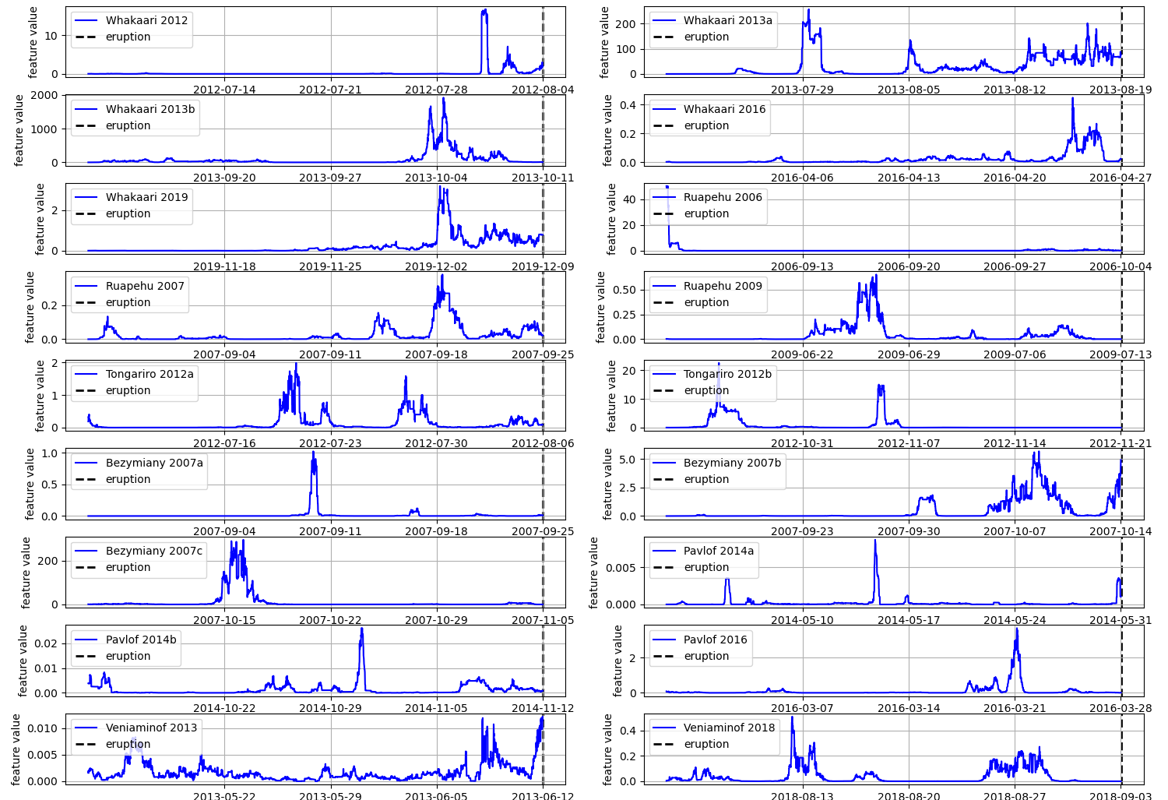
Figure S1. Subplots show the pre-eruptive one-month feature time-series for the 18 eruptions for the feature DSAR rate variance (DSAR change quantiles variance (0.6-0.4)).

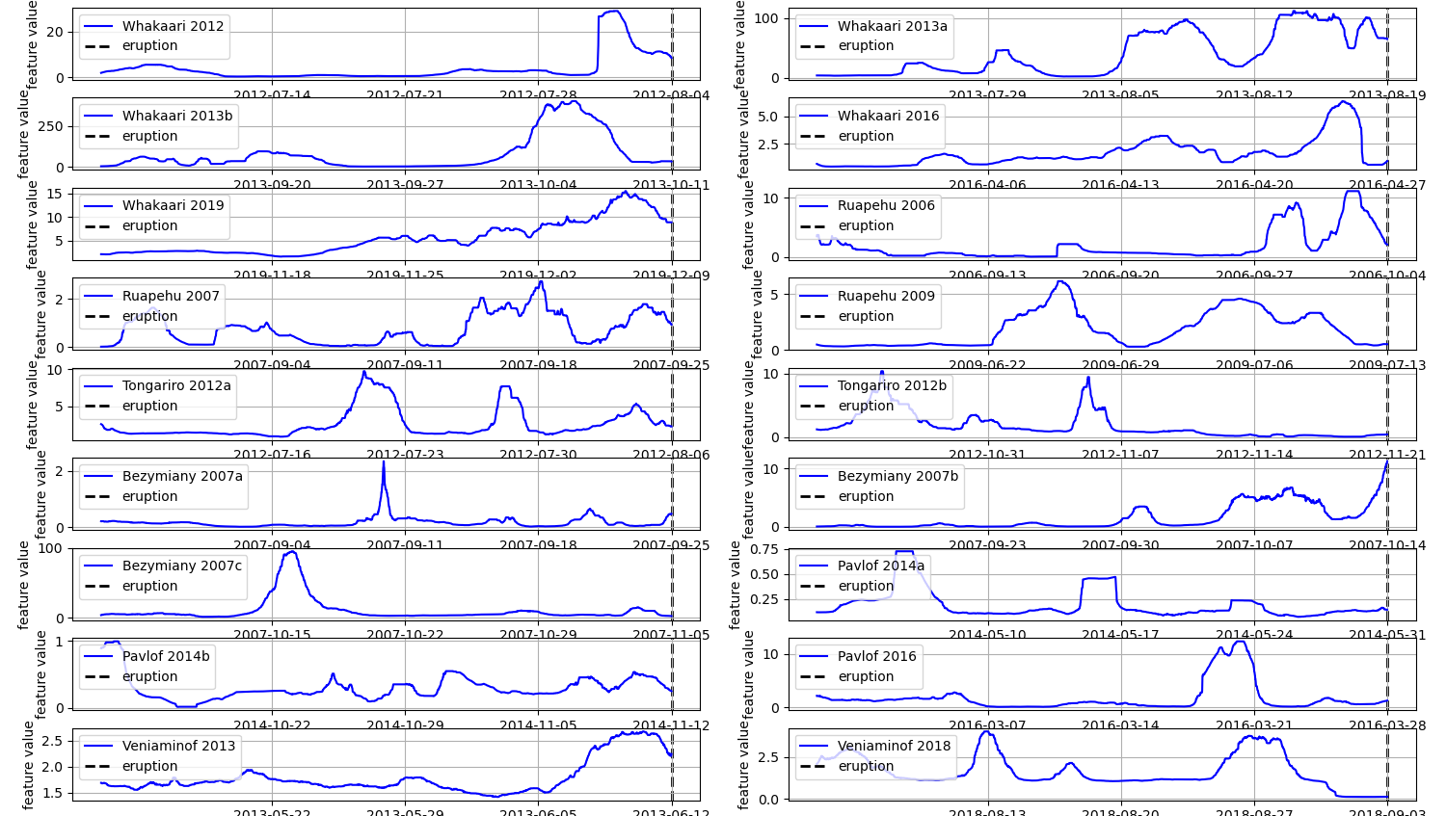
Figure S2. Subplots show the pre-eruptive one-month feature time-series for the 18 eruptions for the feature DSAR median.

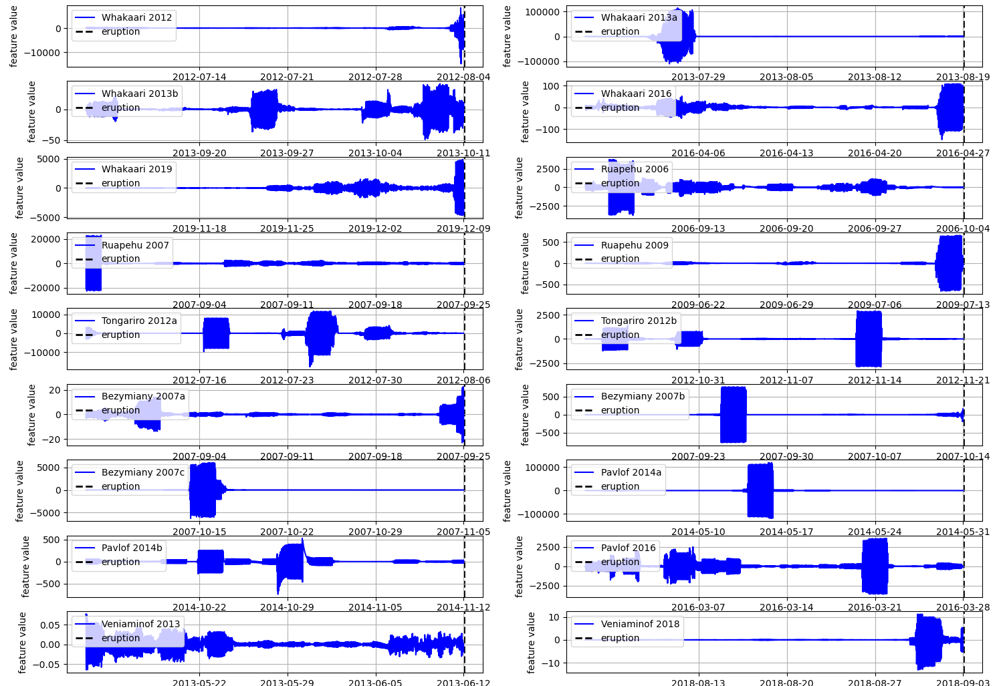
Figure S3. Subplots show the pre-eruptive one-month feature time-series for the 18 eruptions for the feature 75-minute HF harmonic (HF Fourier coeff 38).
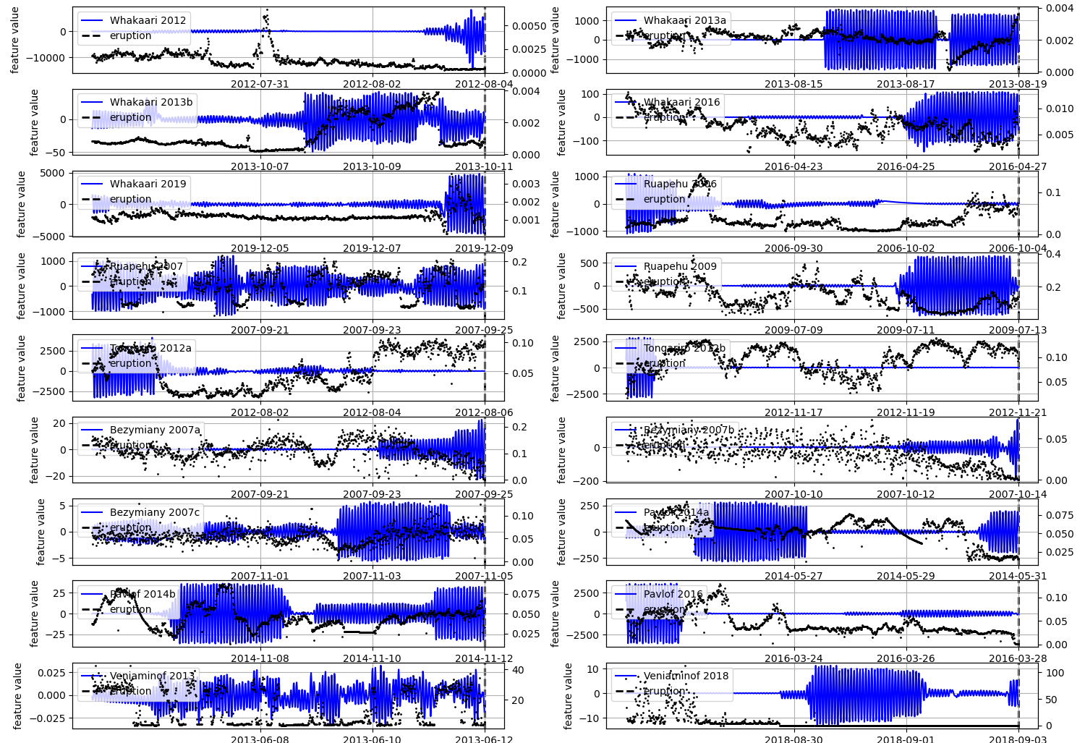
Figure S4. Subplots show the pre-eruptive two-weeks feature time-series for the 18 eruptions for the feature 75-minute HF harmonic (HF Fourier coeff 38), along with the inversion of the RSAM data (black dots).
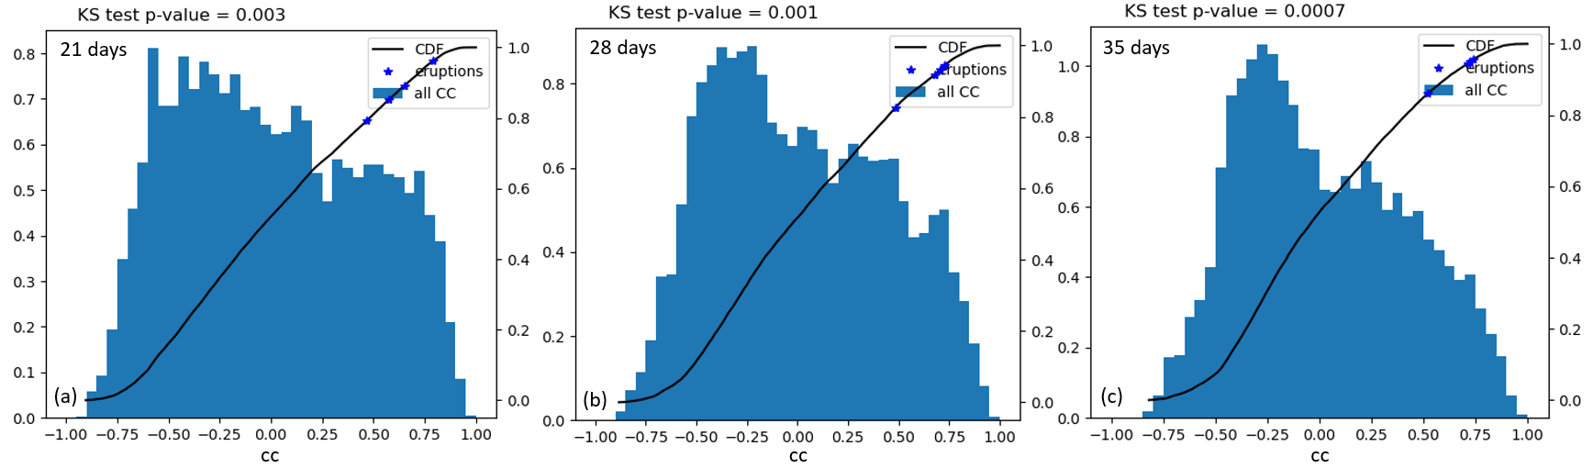
Figure S5. Statistical significance analysis using as archetype feature time series prior to the 2019 Whakaari eruption for 3 different prior time: (a) 3 weeks, (b) 4 weeks, and (c) 5 weeks. The tests are performed over the Whakaari ~10-year record. Figures shown are equivalent to Figure 3a (30 days), but histograms are generated using convolutions (instead of shifting forward one day and correlate; see Methods).
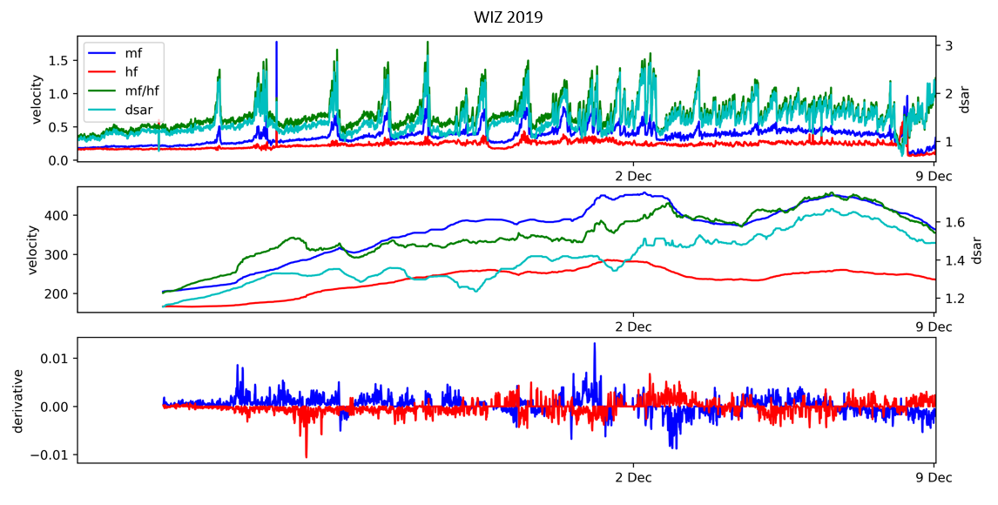
Figure S6. HF, MF and RSAM data streams one month prior to the Whakaari 2019 eruption and their rates of change.
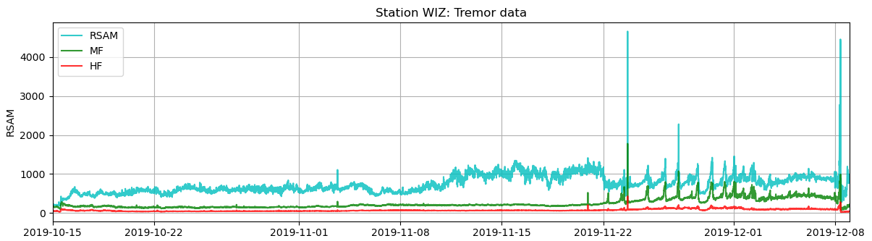
Figure S7. HF, MF and RSAM data streams 53 days before the Whakaari 2019 eruption (from the beginning of the harmonic tremor observed in the RSAM data).
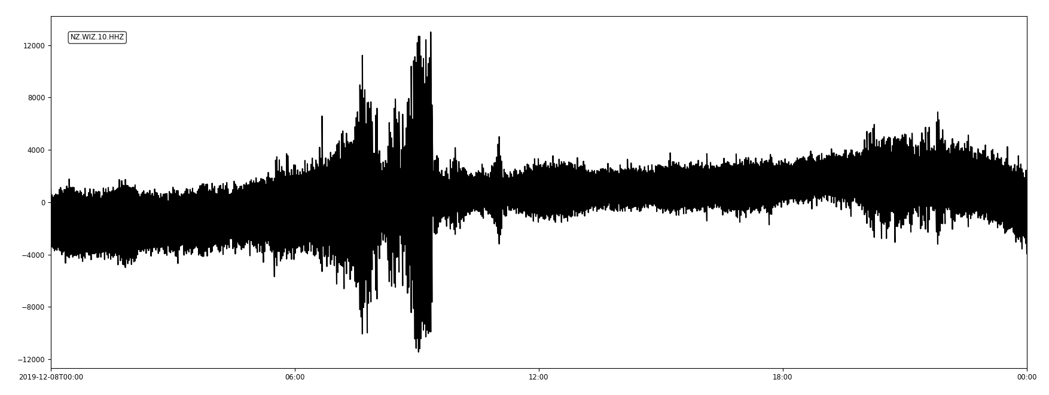
Figure S8. Raw seismic waveform of the peak observed in all data streams 16 hours before the Whakaari 2019 eruption.
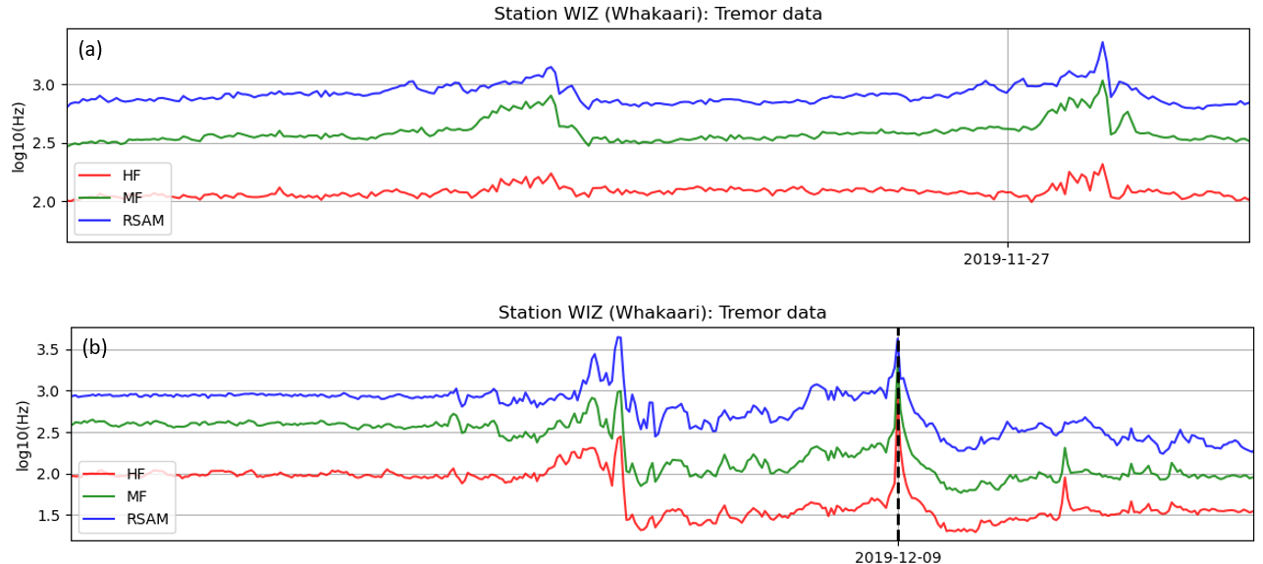
Figure S9. Data streams around the gas flux pulses during regime 2 (a) and regime 4 (b) that preceded the Whakaari 2019 eruption (dash black line).
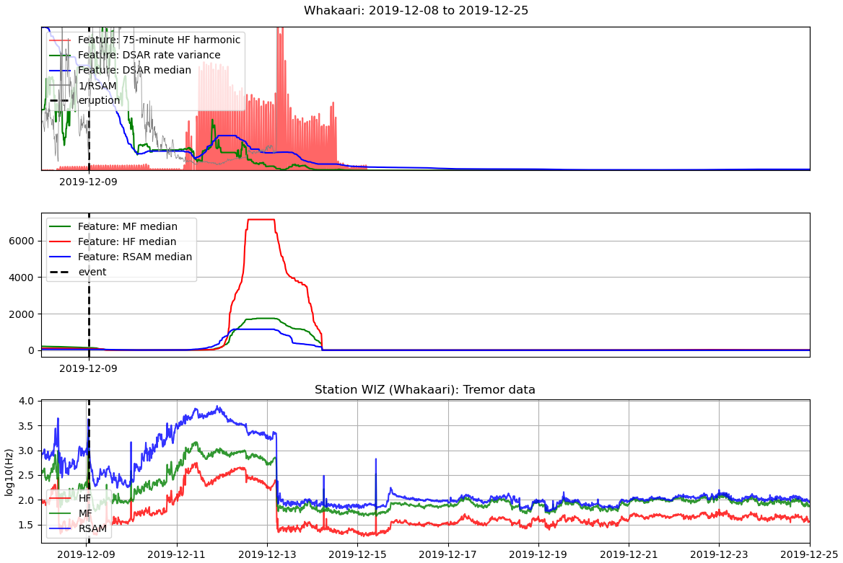
Figure S10. Several features of interest and data streams around two weeks after Whakaari 2019 eruption (top and middle plots show features calculates from normalized data).

