Supplementary Materials for

Vaccination as an alternative to non-drug interventions to prevent local resurgence of COVID-19

Jinhua Pan, Wenlong Zhu, Jie Tian, Zhixi Liu, Ao Xu, Ye Yao, Weibing Wang
Correspondence to: Dr. Ye Yao (yyao@fudan.edu.cn) and Dr. Weibing Wang (wwb@fudan.edu.cn)

This PDF file includes:
Fig. S1
Table S1

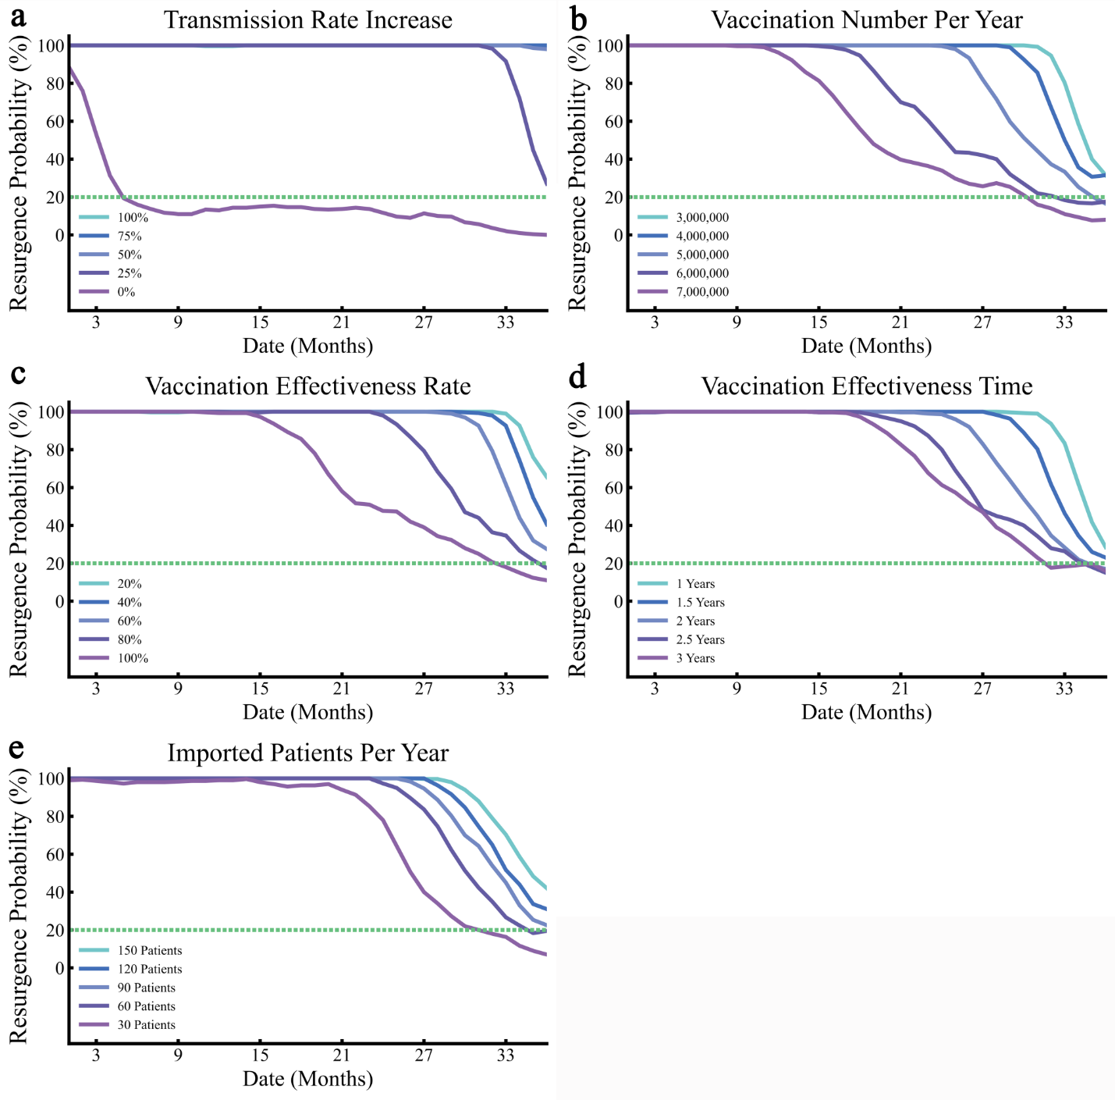
Fig. S1.
Sensitivity analyses on transmission rate (a), vaccination number per year (b), vaccination effectiveness rate (c), vaccination effectiveness time (d) and imported patients per year (e). For each plot, each row represents the date to lift NPIs (months, from the day of vaccination) and each column represents resurgence probability. Colors represent different scenarios of every parameters. Horizontal dotted line in each plot represents the threshold of resurgence probability (20%).

Table S1.
Parameter settings for the main analysis.
Parameter |  | Description |  | Value / Initial State |  | Range
β |  | Transmission rate of COVID-19 |  | 0.16-0.34 |  | Stochastic Process
1/γ₁ |  | Time of patients in I compartment |  | 14 |  | 10% perturbation
1/γ₂ |  | Time of patients in Q compartment |  | 14 |  | 10% perturbation
b |  | Adverse reaction rate |  | 0.0002 |  | 10% perturbation
e |  | Vaccine effectiveness |  | 0.7934 |  | 10% perturbation
V |  | Daily vaccination number |  | Slow Scenarios:  5,000,000 per year  Accelerated Scenarios:  16,000,000 first year |  | 10% perturbation
σ |  | Decline rate of vaccine efficacy |  | 1/730 |  | 10% perturbation
A |  | Sporadic foreign imported COVID-19 cases |  | Frequency: 20/120 |  | Poisson process
C |  | Number of patients selected randomly from a discrete uniform distribution each time |  | 1~7
1/h |  | Mean detection time |  | 5~10 |  | 10% perturbation
d₁ |  | Case fatality rates of I compartment |  | 0.005/21 |  | 10% perturbation
d₂ |  | Case fatality rates of Q compartment |  | 0.005/21 |  | 10% perturbation
N |  | Total population |  | 21,540,000
S |  | Susceptible people |  | 21,540,000
R |  | Recovered people |  | 0

