APPENDIX

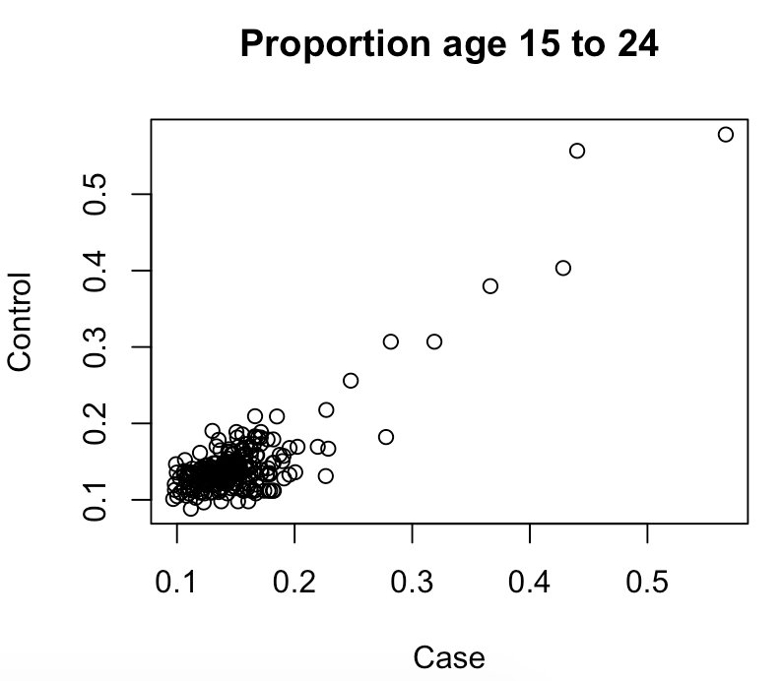
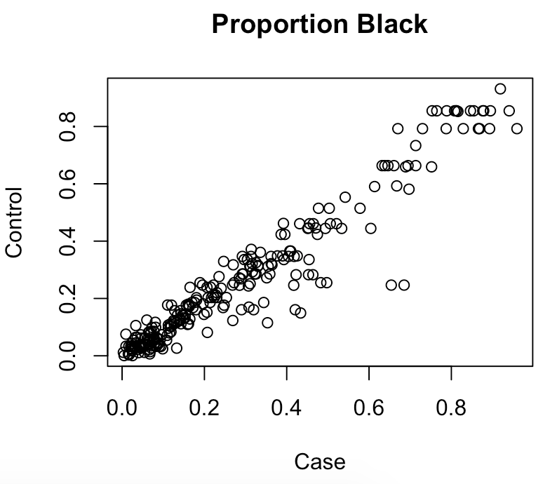

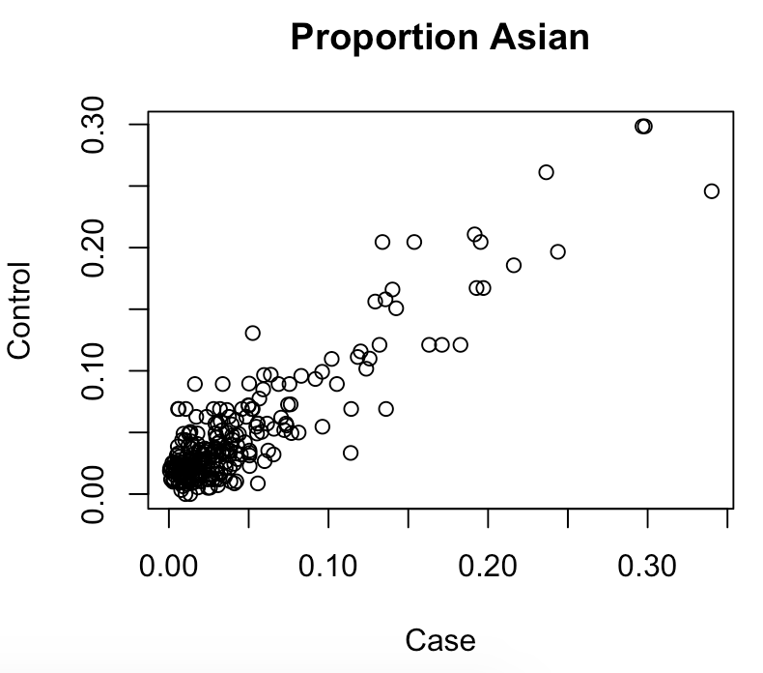
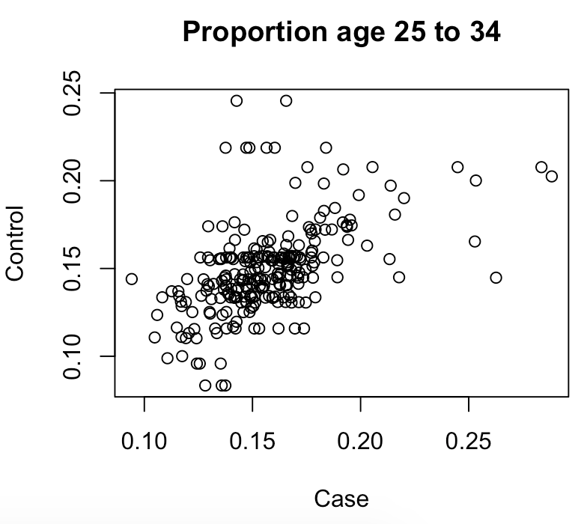

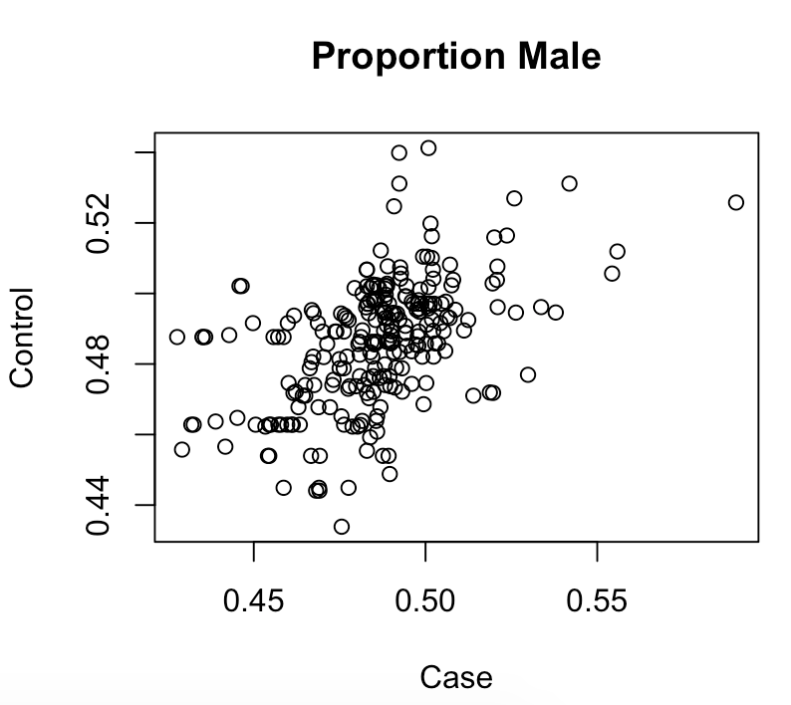
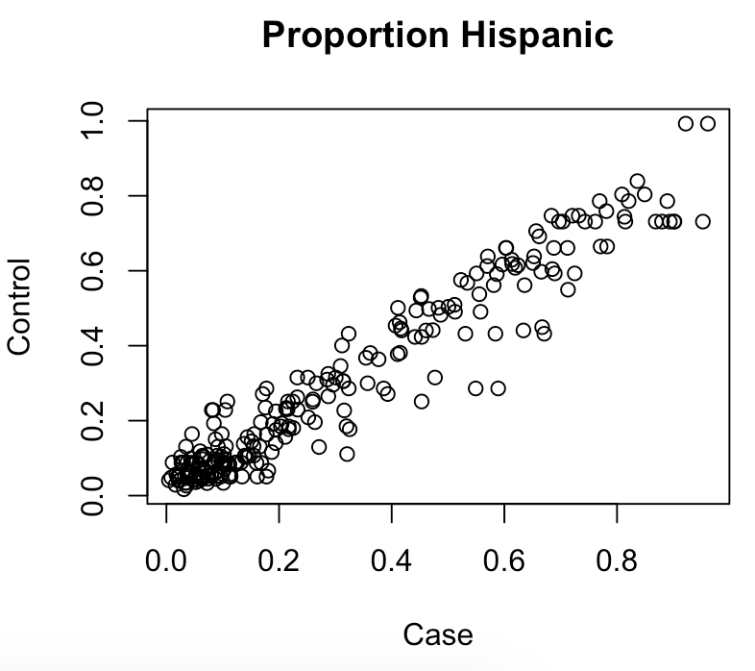

Figure 1. Plots of case-control matched variables

Results from a balanced matrix of the Euclidean distance in 6-dimensional space between all eligible ZIP codes based on 6 demographic characteristics identified in prior studies to be associated with increased incidence of violent homicide death: proportion Black, proportion Hispanic, proportion Asian, proportion male, proportion aged 15 to 24, and proportion aged 25 to 34. Cases were matched to the eligible control that was closest in Euclidian distance, located in a different state, and contained the same USDA Rural-Urban Continuum Code classification (urban, micropolitan, small town, or rural).

Table 1. Distribution of ZIP code-level and state-level attributes for selected cases and randomly selected controls¹
 |  | Cases  (n = 250)  Mean (SD) |  |  | Controls  (n = 250)  Mean (SD) |  |  | P Value
Zip Code Level
Income
 | Median Household Income | 46342.39 | (11415.10) |  | 76399.88 | (25151.21) |  | <0.0001
Income Inequality
 | GINI Coefficient | 0.45 | (0.04) |  | 0.43 | (0.05) |  | 0.0004
Population size |  | 50187.10 | (18438.84) |  | 37688.38 | (12265.81) |  | <0.0001
Age Group
 | % 15 - 24 | 15.10 | (4.95) |  | 13.90 | (7.32) |  | 0.0380
 | % 25 - 34 | 15.70 | (2.77) |  | 13.74 | (4.31) |  | <0.0001
Race Ethnicity
 | % Black | 28.43 | (24.71) |  | 5.79 | (8.13) |  | <0.0001
 | % Asian | 4.47 | (5.40) |  | 8.39 | (10.19) |  | <0.0001
 | % Hispanic | 30.26 | (26.43) |  | 17.04 | (17.17) |  | <0.0001
% Male |  | 48.57 | (2.17) |  | 49.12 | (1.43) |  | 0.001
% Unemployed |  | 4.20 | (1.28) |  | 2.82 | (1.04) |  | <0.0001
Land Use
 | % Land Area that is Retail | 2.50 | (3.50) |  | 2.03 | (2.74) |  | 0.5923
 | % Land Area that is Industrial | 3.32 | (4.73) |  | 1.51 | (2.85) |  | 0.0019
 | % Land Area that is Greenspace | 9.51 | (13.21) |  | 14.24 | (15.99) |  | 0.0003
Population Density (per km2) |  | 3424.29 | (5440.35) |  | 1514.68 | (3424.31) |  | <0.0001
Walk Score |  | 42.31 | (29.58) |  | 31.60 | (30.37) |  | <0.0001
State Level
Income
 | Median Household Income | 60182.41 | (9297.23) |  | 63017.74 | (7530.50) |  | <0.0001
Income Inequality
 | GINI Coefficient | 0.47 | (0.02) |  | 0.48 | (0.02) |  | 0.2524
Race Ethnicity
 | % Black | 13.30 | (8.86) |  | 9.46 | (6.22) |  | <0.0001
 | % Asian | 6.00 | (4.23) |  | 7.70 | (4.84) |  | <0.0001
 | % Hispanic | 18.13 | (12.60) |  | 21.09 | (13.45) |  | 0.0115
% Male |  | 49.18 | (0.57) |  | 49.34 | (0.51) |  | 0.0012
* Bolded values are statistically significant at an alpha of 0.05
¹ Cases and controls were selected from the 35 states participating in the CDC's National Violent Death Reporting System (NVDRS). Case units were defined as the 250 ZIP codes with the highest per capita incidence of violent homicide deaths in 2017. Selected cases had $≥$ 5 deaths. ZIP codes eligible for selection as control units (i) had no violent deaths in 2017 and (ii) were located within the 35 NVDRS states. Cases and controls were matched on proportion Black, proportion Hispanic, proportion Asian, proportion male, proportion aged 15 to 24, and proportion aged 25 to 34

Table 2. Odds ratios and 95% confidence intervals for violent homicide in selected cases and randomly selected controls¹
 |  | Model 1 |  |  |  | Model 2 |  |  |  | Model 3
 |  | OR | 95% CI |  |  | OR | 95% CI |  |  | OR | 95% CI
ZIP Code-Level
 | Median Household Income | 0.04 | 0.01 | 0.12 |  |  |  |  |  | 0.04 | 0.01 | 0.13
 | GINI Coefficient | 1.03 | 0.62 | 1.71 |  |  |  |  |  | 1.27 | 0.77 | 2.09
State-Level
 | Median Household Income |  |  |  |  | 0.88 | 0.67 | 1.17 |  | 1.74 | 0.87 | 3.47
 | GINI Coefficient |  |  |  |  | 0.87 | 0.59 | 1.28 |  | 0.53 | 0.23 | 1.23
* Bolded values are statistically significant at an alpha of 0.05
¹ Cases and controls were selected from the 35 states participating in the CDC's National Violent Death Reporting System (NVDRS). Case units were defined as the 250 ZIP codes with the highest per capita incidence of violent homicide deaths in 2017. Selected cases had $≥$ 5 deaths. ZIP codes eligible for selection as control units (i) had no violent deaths in 2017 and (ii) were located within the 35 NVDRS states. Eligible controls had a population $≥$ 25,000 and were randomly selected with replacement.
Model 1 adjusted for zip-code level variables
Model 2 adjusted for state-level variables
Model 3 adjusted for all variables

