Norbert Ankri & Dominique Debanne
A fast Markovian method for modeling channel noise in neurons

Supplementary Figures

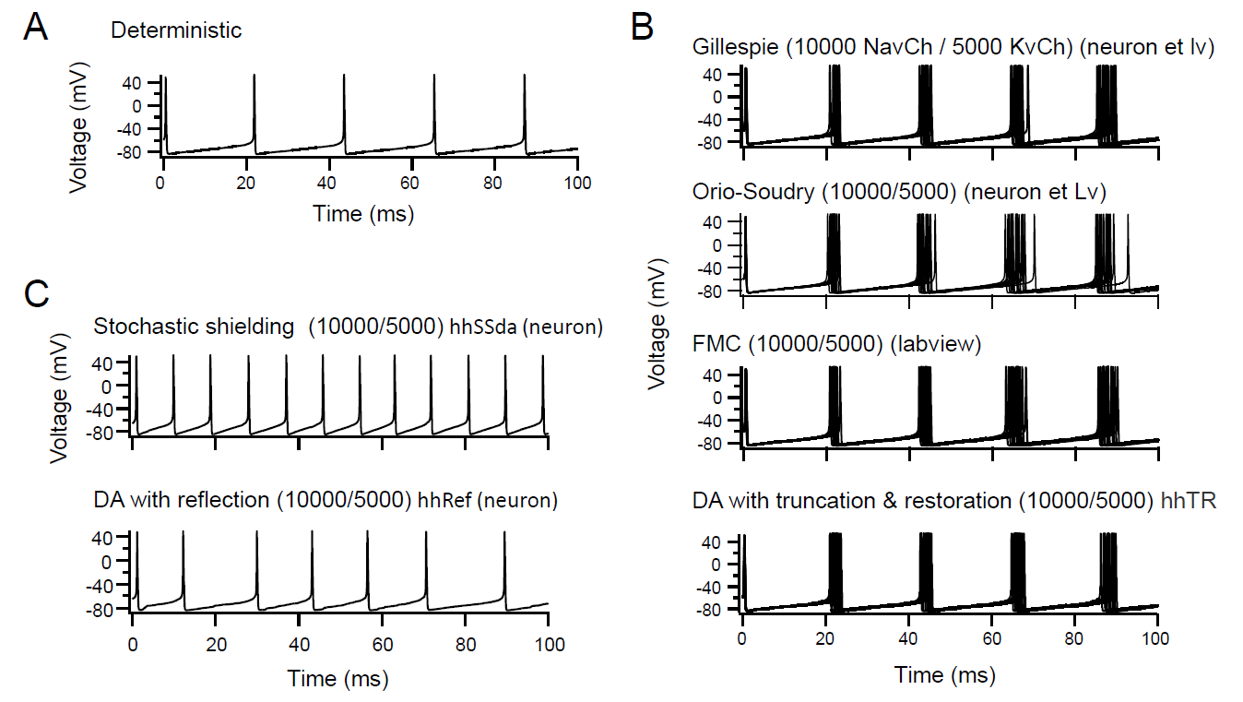
Figure suppl 1. Influence of time-resolution on the frequency of spontaneous spikes
Trial using the parameters of example E (figure 6) for the principal variants of SDE algorithms.
A. Deterministic model (no noise). B. Superposition of 19 runs with 5000 Na-channels showing the build-up of jitter (spike timing variance) with number of APs. From top to bottom for the stochastic Gillespie model, OS model and FMC model. C. Same as B for the HHSS (stochastic shielding) and for the HHRF (DA with reflection) models. HHTR-model which for these parameters is closest to the MC or FMC models HHRF (e) and (f) models show increased excitability. Note that, as already found by Orio-Soudry et al., HHRF and HHSS models overestimate excitability.
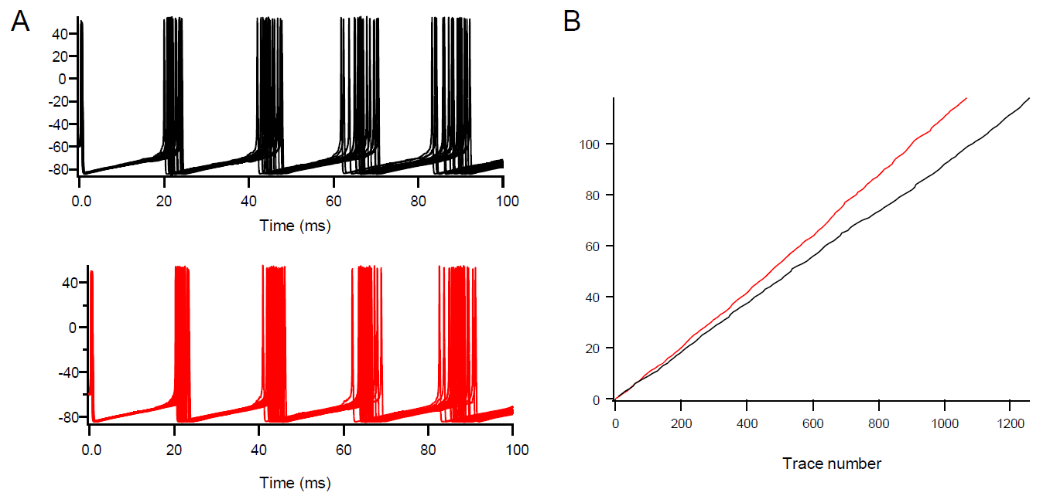
Figure suppl 2. Orio-Soudry procedure and rounded function.
A. Trace simulated fort the EX Model of evoked spikes with 2500 Sodium channels and 1250 potassium channels for the HMC algorithm (black) and OS algorithm using “Round“ function (red). B. Time-course of the number of spontaneous AP (each trace is 1 second), for the model of squid axon, the Gillespie or HMC algorithm (black) and OS algorithm with “Round” function (red). The round function induces an overestimated excitability due to the additional noise (see main text).
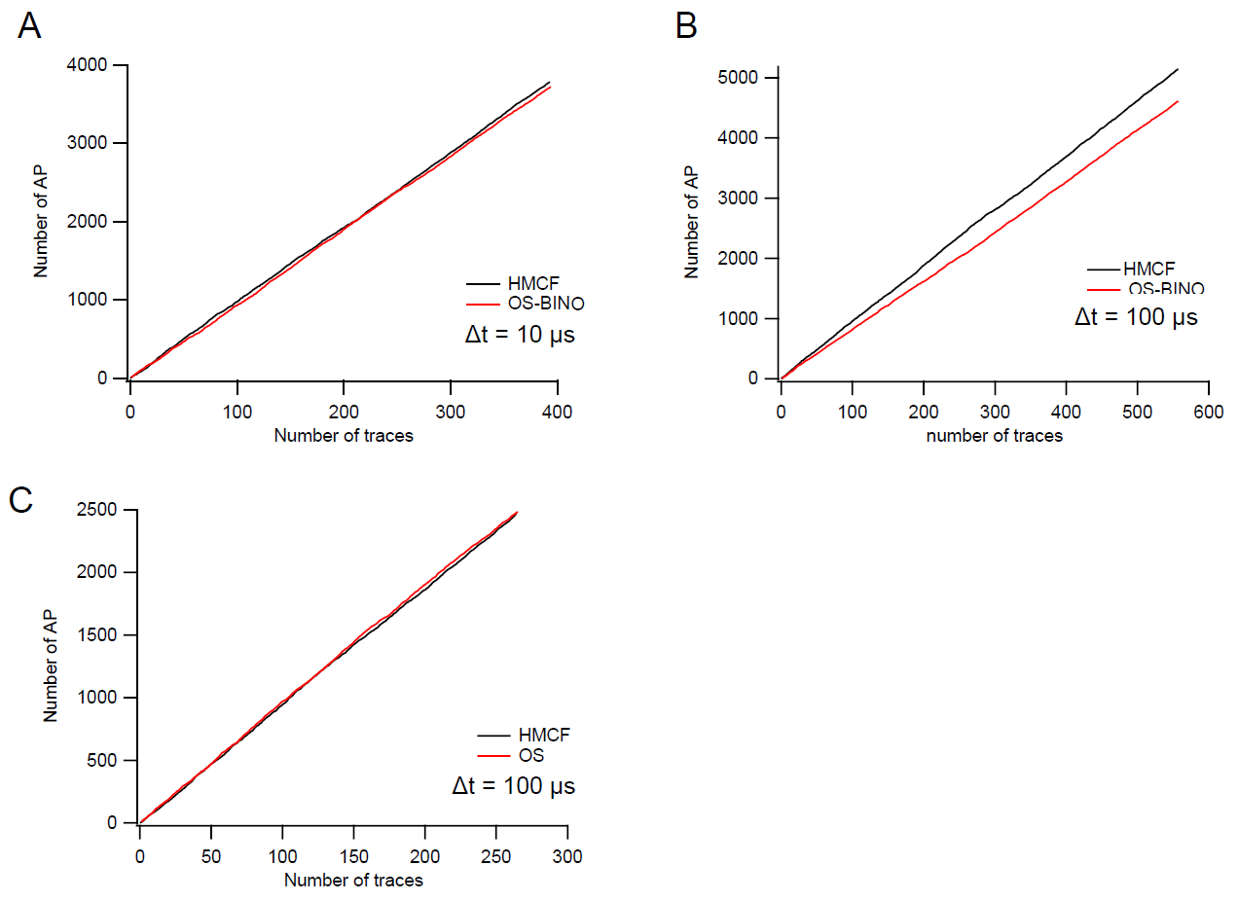
Figure Suppl 3. OS-Bino Algorithm needs higher temporal resolution than OS
Model of Squid giant axon with 6000 channels sodium and 1800 channels potassium in current clamp. Evolution in time for the number of AP (Action potentials) from the beginning.
A. When the resolution time is Δt = 10 µs, OS-Bino produces the correct excitability. B. For Δt = 100 µs, the OS-Bino algorithm does not match with FMC (or Gillespie). C. The original method OS which uses for the noise a Gaussian approximation, continues to produce a suitable result.

