Supporting Information
Metal Doped Layered MgB₂ Nanoparticles as Novel Electrocatalysts for Water Splitting
Ebrahim Sadeghi^{a,b}, Naeimeh Sadat Peighambardoustª, Masoumeh Khatamian^{c}, Ugur Unal^{d,e}, ‎and Umut Aydemir*^{a,e}

ª Koç University Boron and Advanced Materials Application and Research Center (KUBAM), Sariyer, Istanbul, 34450, Turkey,
^{b} Graduate School of Sciences and Engineering, Koç University, Sariyer, Istanbul, 34450, Turkey.
^{c} Inorganic Chemistry Department, Faculty of Chemistry, University of Tabriz, 5166616471, Iran
^{d} Koç University Surface Science and Technology Center (KUYTAM), Sariyer, Istanbul, 34450, Turkey
^{e} Department of Chemistry, Koç University, Sariyer, Istanbul, 34450, Turkey

* Corresponding author:
Email: uaydemir@ku.edu.tr

SEM EDX Analysis Data Before HER/OER

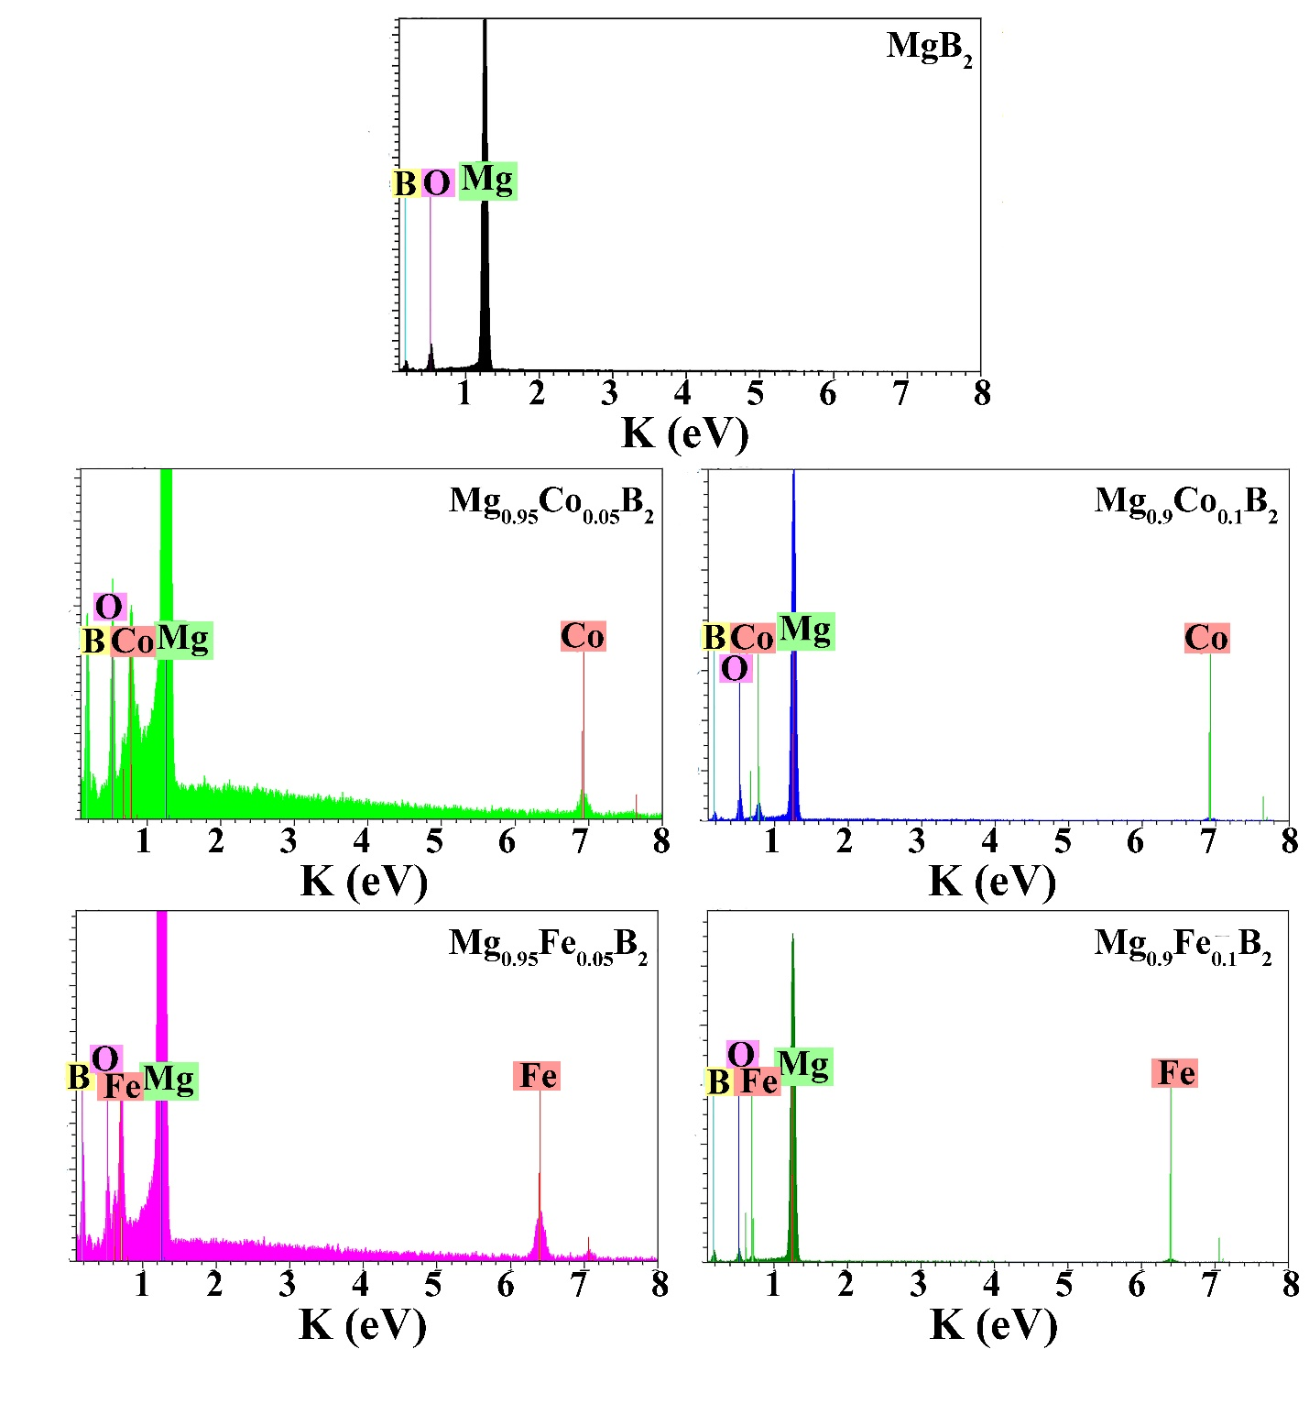
Figure S1. EDX analysis graph of pure MgB₂ and Mg_{1-x}Tm_{x}B₂ (x = 0.05, and 0.1; Tm = Fe and Co) before electrochemical reactions.

Table S1. Energy-dispersive X-ray spectroscopy (EDX) analysis of samples before HER and OER.
Sample | Element | atomic % | atomic %
MgB₂ | Mg  B  O | 30.51  69.49  - | 29.28  63.26  7.46
Mg_{0.95}Fe_{0.05}B₂ | Mg  Fe  B  O | 26.65  1.32  72.03  - | 26.12  1.29  69.58  3.01
Mg_{0.95}Co_{0.05}B₂ | Mg  Co  B  O | 26.22  1.59  72.19  - | 25.62  1.55  69.20  3.63
Mg_{0.9}Fe_{0.1}B₂ | Mg  Fe  B  O | 27.20  2.31  70.49  - | 26.63  2.26  67.99  3.12
Mg_{0.9}Co_{0.1}B₂ | Mg  Co  B  O | 31.45  3.23  65.32  - | 29.54  3.00  58.40  9.06

XPS Spectra

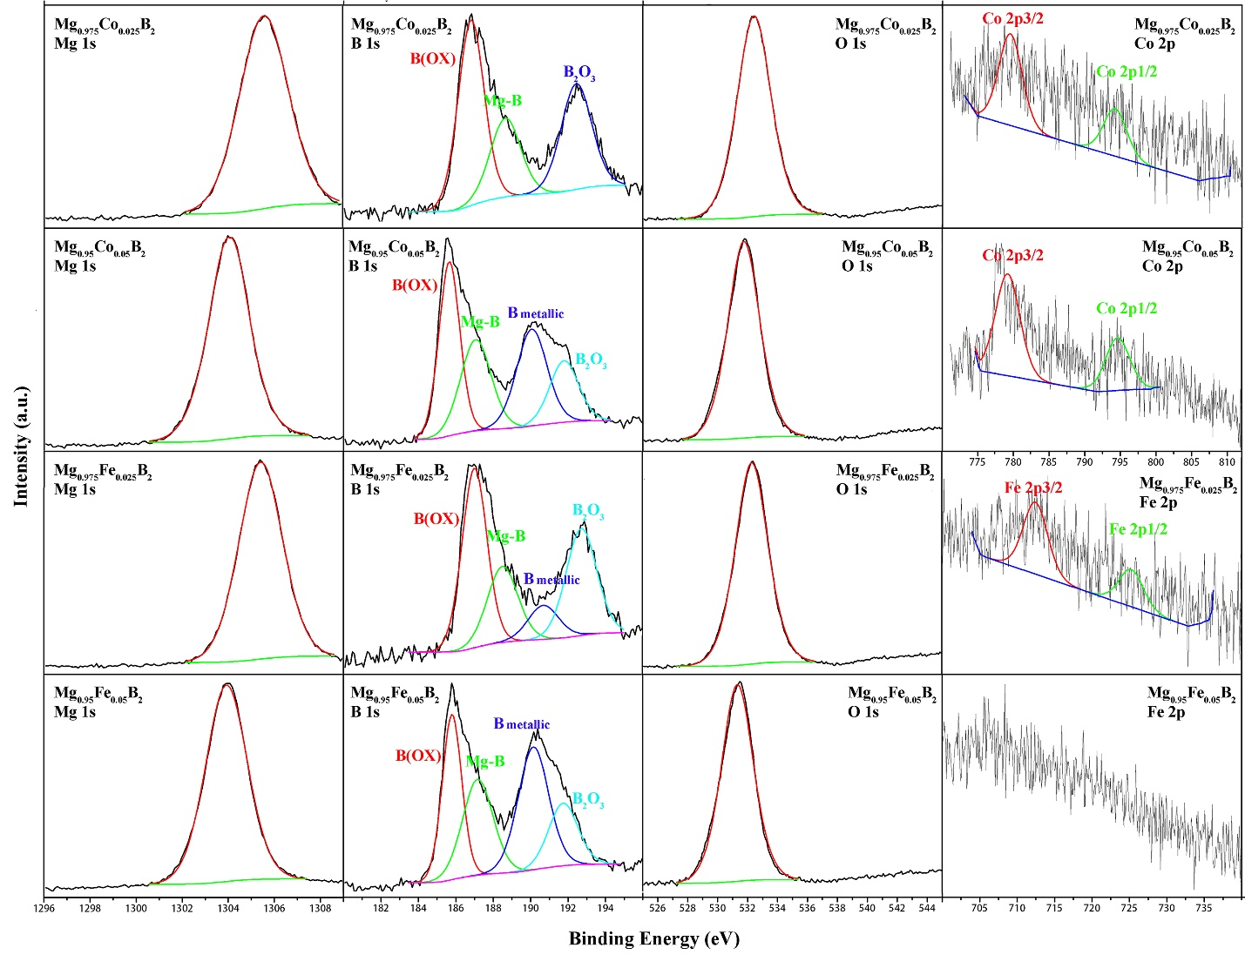
Figure S2. XPS spectra of Mg 1s, B 1s, O 1s, Co 2p, and F e 2p in Mg_{0.975}Co_{0.025}B₂, Mg_{0.95}Co_{0.05}B₂, Mg_{0.975}Fe_{0.025}B₂, and Mg_{0.95}Fe_{0.05}B₂.

SEM Images

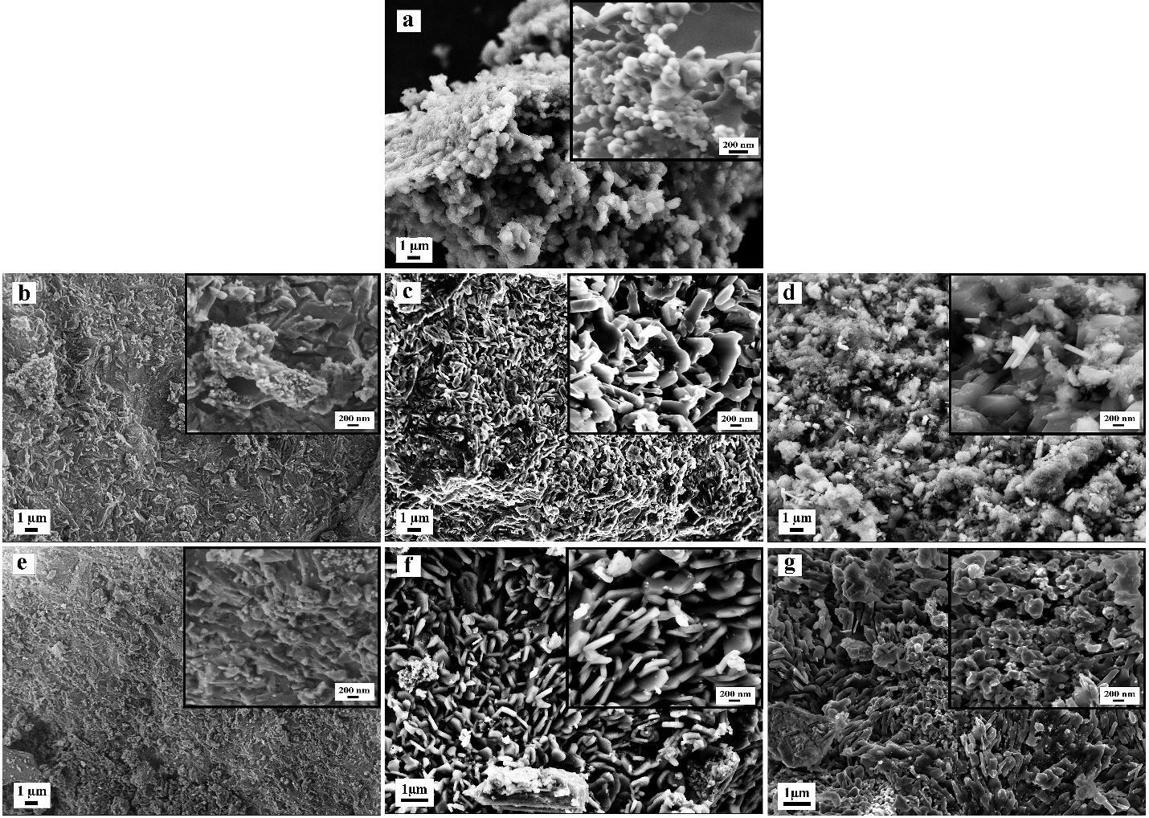
Figure S3. SEM images of a) pure MgB₂, b) Mg_{0.975}Co_{0.025}B₂, c) Mg_{0.95}Co_{0.05}B₂, d) Mg_{0.9}Co_{0.1}B₂, e) Mg_{0.975}Fe_{0.025}B₂, f) ‎Mg_{0.95}Fe_{0.05}B₂, and g) Mg_{0.9}Fe_{0.1}B₂‎

OER Plots

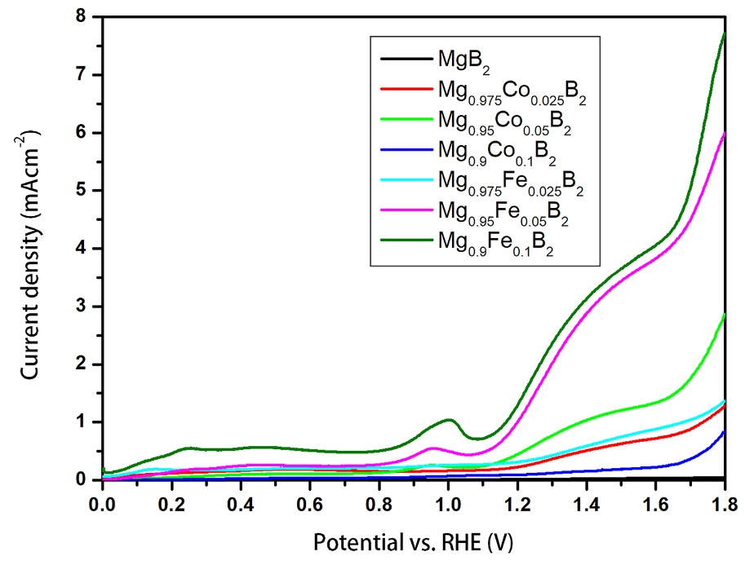
Figure S4. Polarization curves of the OER reaction of pure and doped MgB₂.

EIS Data

Table S2. Equivalent-circuit element values for EIS data in the 1 M KOH electrolyte.
 | Re (Ωcm⁻²) | R1  (kΩ cm⁻²) | CPE1-T  (Fs^{p-1}  cm⁻²) | CPE1-P | R2  (kΩ cm⁻²) | CPE2-T  (Fs^{p-1}  cm⁻²) | CPE2-P
MgB₂ | 130.5 | 10.993 | 2.5E-05 | 0.43 | 127.114 | 5.1E-05 | 0.56
Mg_{0.975}Co_{0.025}B₂ | 12.2 | 1.436 | 4.5E-04 | 0.47 | 18.331 | 2.4E-04 | 0.72
Mg_{0.95}Co_{0.05}B₂ | 13.6 | 0.409 | 1.3E-03 | 0.45 | 10.409 | 5.1E-04 | 0.66
Mg_{0.9}Co_{0.1}B₂ | 13.2 | 3.539 | 3.4E-04 | 0.45 | 13.712 | 2.7E-04 | 0.71
Mg_{0.975}Fe_{0.025}B₂ | 7.52 | 0.454 | 2.7E-04 | 0.36 | 710 | 1.5E-05 | 0.56
Mg_{0.95}Fe_{0.05}B₂ | 13.5 | 0.277 | 3.4E-03 | 0.40 | 14.325 | 6.2E-04 | 0.67
Mg_{0.9}Fe_{0.1}B₂ | 11.9 | 0.332 | 1.6E-03 | 0.45 | 7.980 | 1.2E-03 | 0.62
SEM EDX Analysis Data After HER/OER

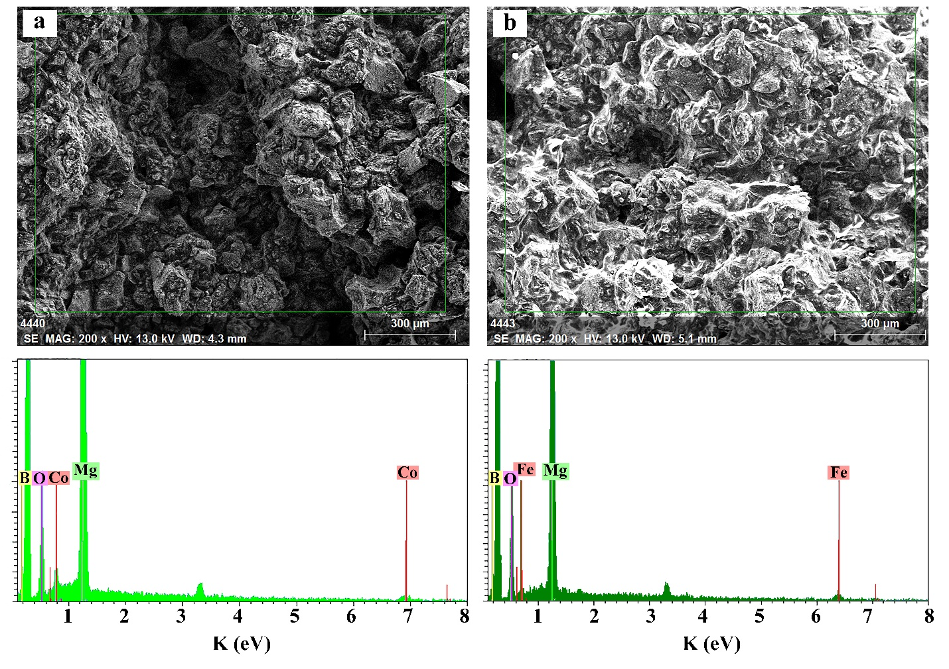
Figure S5. EDX results of the (a) Mg_{0.95}Co_{0.05}B‎₂ and (b) Mg_{0.9}Fe_{0.1}B₂ after electrochemical reactions.

Table S3. Energy-dispersive X-ray spectroscopy (EDX) analysis of the best-performing samples after HER and OER.
Sample | Element | atomic % | atomic %
Mg_{0.95}Co_{0.05}B₂ | Mg  Co  B  O | 25.29  1.19  73.52  - | 23.65  1.09  64.68  10.59
Mg_{0.9}Fe_{0.1}B₂ | Mg  Fe  B  O | 21.71  1.64  76.65  - | 19.59  1.48  64.00  14.93

CV Stability Tests

Aside from catalytic activity, stability is another influential criterion. To appraise the cycling durability of the Mg_{0.95}Co_{0.05}B₂ and Mg_{0.9}Fe_{0.1}B₂ electrodes, the cyclic voltammetry (CV) plots were measured within a potential range of -1 and -0.2 V for 1000 cycles at a scan rate of 50 mV s⁻¹. Fig. S6a and b demonstrate the reordered CV curves of Mg_{0.95}Co_{0.05}B₂ and Mg_{0.9}Fe_{0.1}B₂ electrodes for the 1st and 1000th cycles in 1 M KOH electrolyte. As shown in the figure, it is obvious that after 1000 cycles the current density diminished for both electrodes. Even though the current density did not decrease appreciably, yet further investigations are needed to excel in the stability of these very new electrocatalysts.
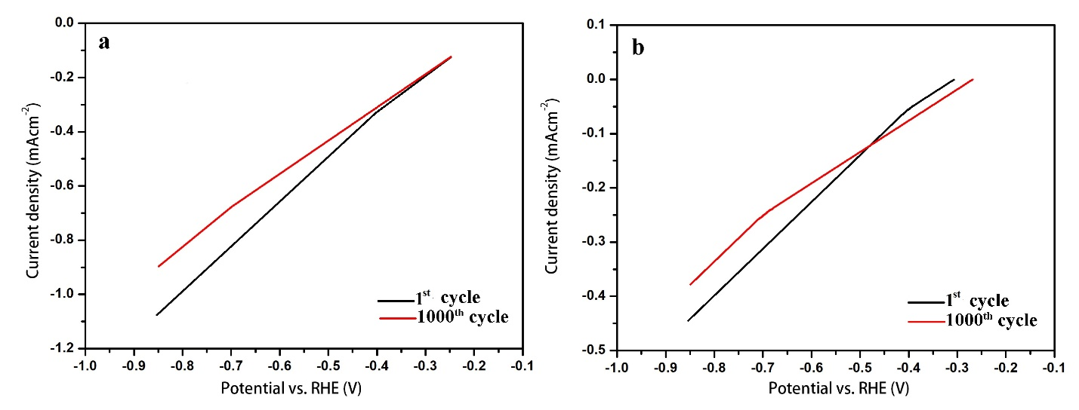
Figure S6. Electrochemical cycling stability measurement. a) and b) CV curves of Mg_{0.95}Co_{0.05}B₂ and Mg_{0.9}Fe_{0.1}B₂, respectively, for 1st and 1000th cycles in a 1 M KOH electrolyte at a scan rate of 50 mV s⁻¹.

