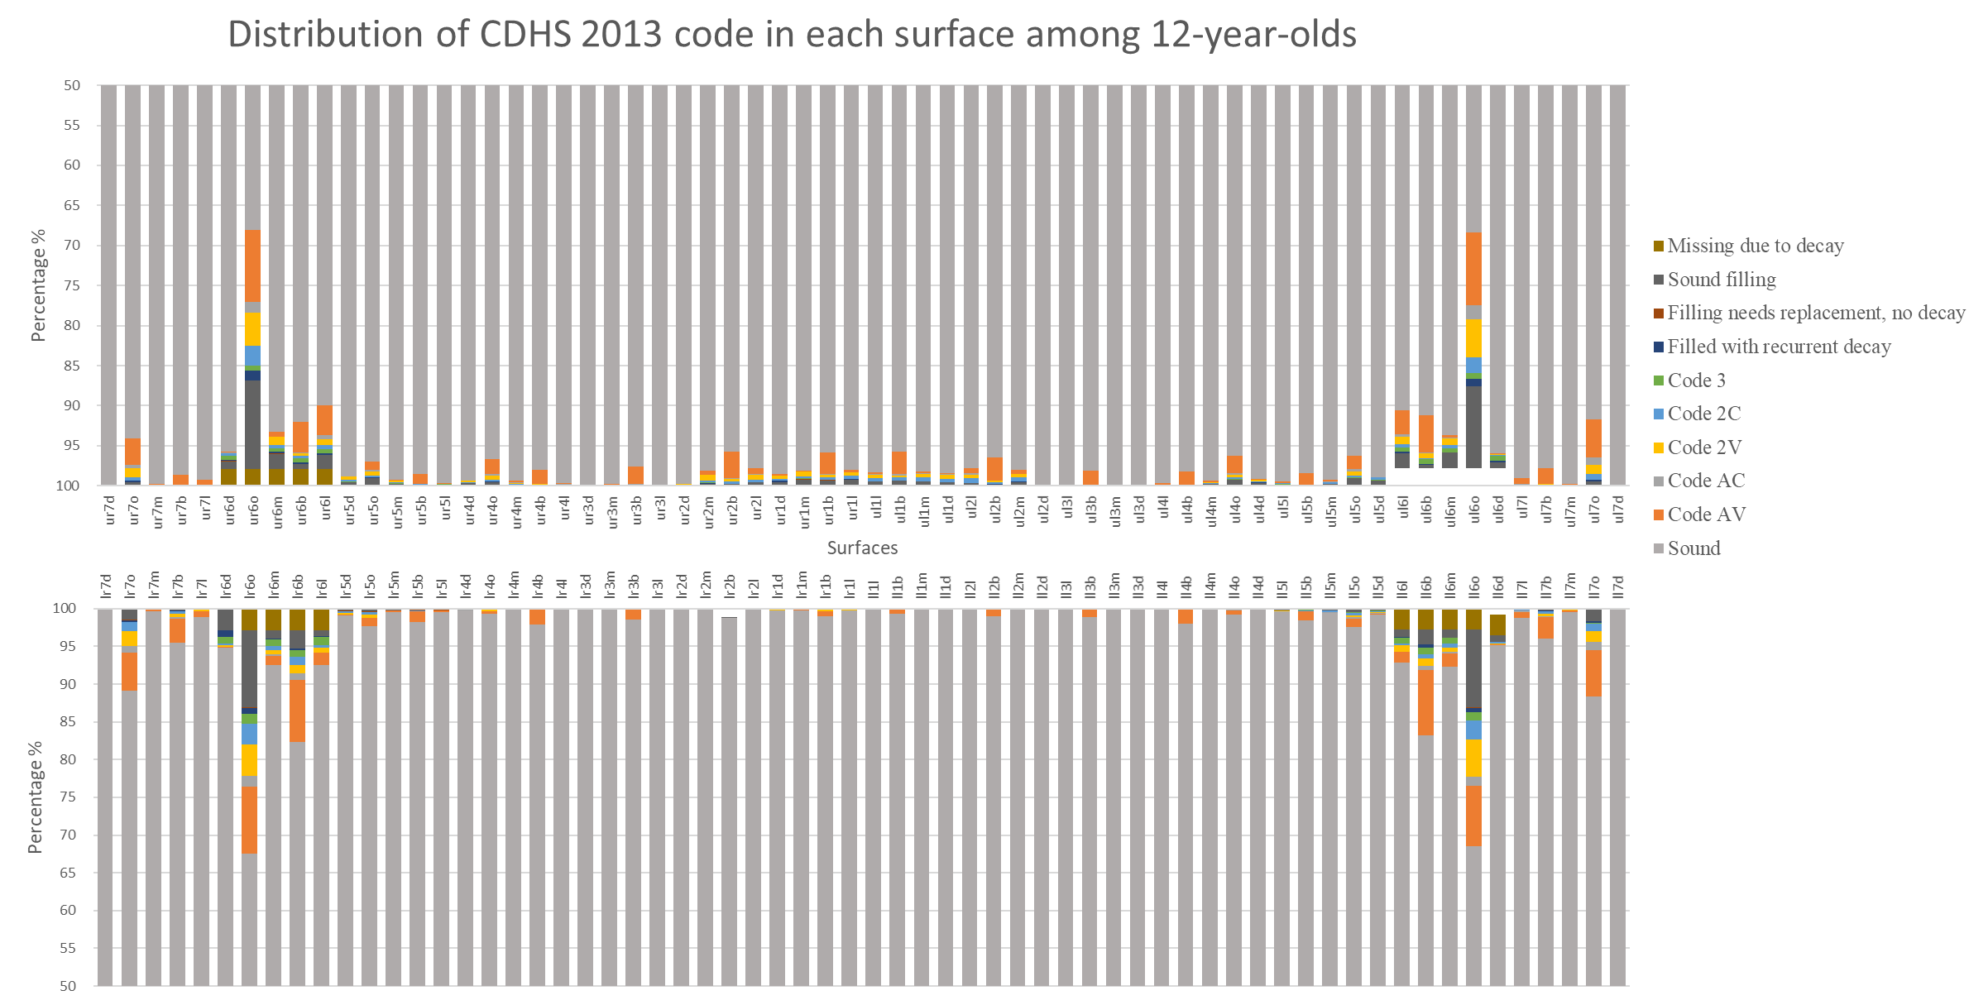
Appendix Figure 1. Distribution of CDHS 2013 code in each surface of 12-year-olds (n = 2,532)

