Supplementary Material
Dental Caries Thresholds among Adolescents in England, Wales and Northern Ireland, 2013 at 12, and 15 years: Implications for Epidemiology and Clinical Care

Xiaozhe Wang,¹ Eduardo Bernabe,² Nigel Pitts,³ Shuguo Zheng,¹ Jennifer E Gallagher ⁴

¹ Department of Preventive Dentistry, Peking University School and Hospital of Stomatology & National Clinical Research Center for Oral Diseases & National Engineering Laboratory for Digital and Material Technology of Stomatology & Beijing Key Laboratory of Digital Stomatology, Beijing, PR China
2 King’s College London, Centre for Host Microbiome Interactions, Denmark Hill Campus, Bessemer Road, London, SE5 9RS, UK
3 King’s College London, Centre for Clinical and Translational Research, Guy’s Hospital Campus, Great Maze Pond, London, SE1 9RT, UK
4 King’s College London, Faculty of Dentistry, Oral & Craniofacial Sciences, Bessemer Road, London, SE5 9RS, UK

Corresponding author(s)
*Correspondence to:
Prof JE Gallagher MBE
Dean for International Affairs
Newland-Pedley Professor of Oral Health Strategy/Hon Consultant in Dental Public Health
King’s College London, Faculty of Dentistry, Oral & Craniofacial Sciences, Bessemer Road, London, SE5 9RS, UK
Telephone 02032995171/3481 Admin (research)
Email: jenny.gallagher@kcl.ac.uk

Dr Xiaozhe Wang
Attending Dentist
Department of Preventive Dentistry, Peking University School and Hospital of Stomatology & National Clinical Research Center for Oral Diseases & National Engineering Laboratory for Digital and Material Technology of Stomatology & Beijing Key Laboratory of Digital Stomatology, 22 Zhongguancun Avenue South, Haidian District, Beijing 100081, PR China
Telephone 08601082195558
Email: neptunewxz@163.com
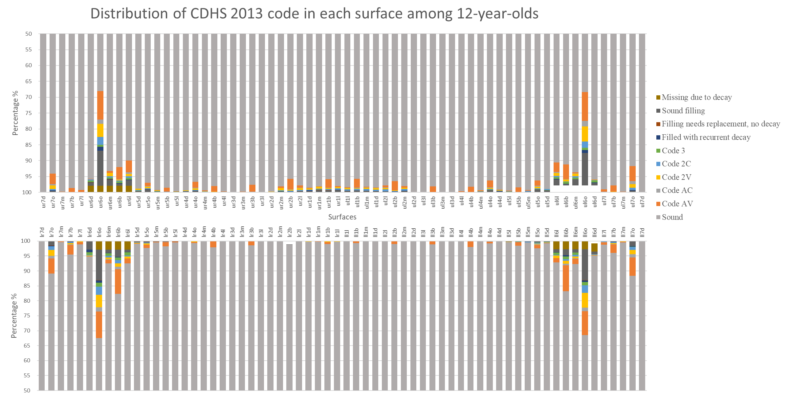
Appendix Figure 1. Distribution of CDHS 2013 code in each surface of 12-year-olds (n = 2,532)

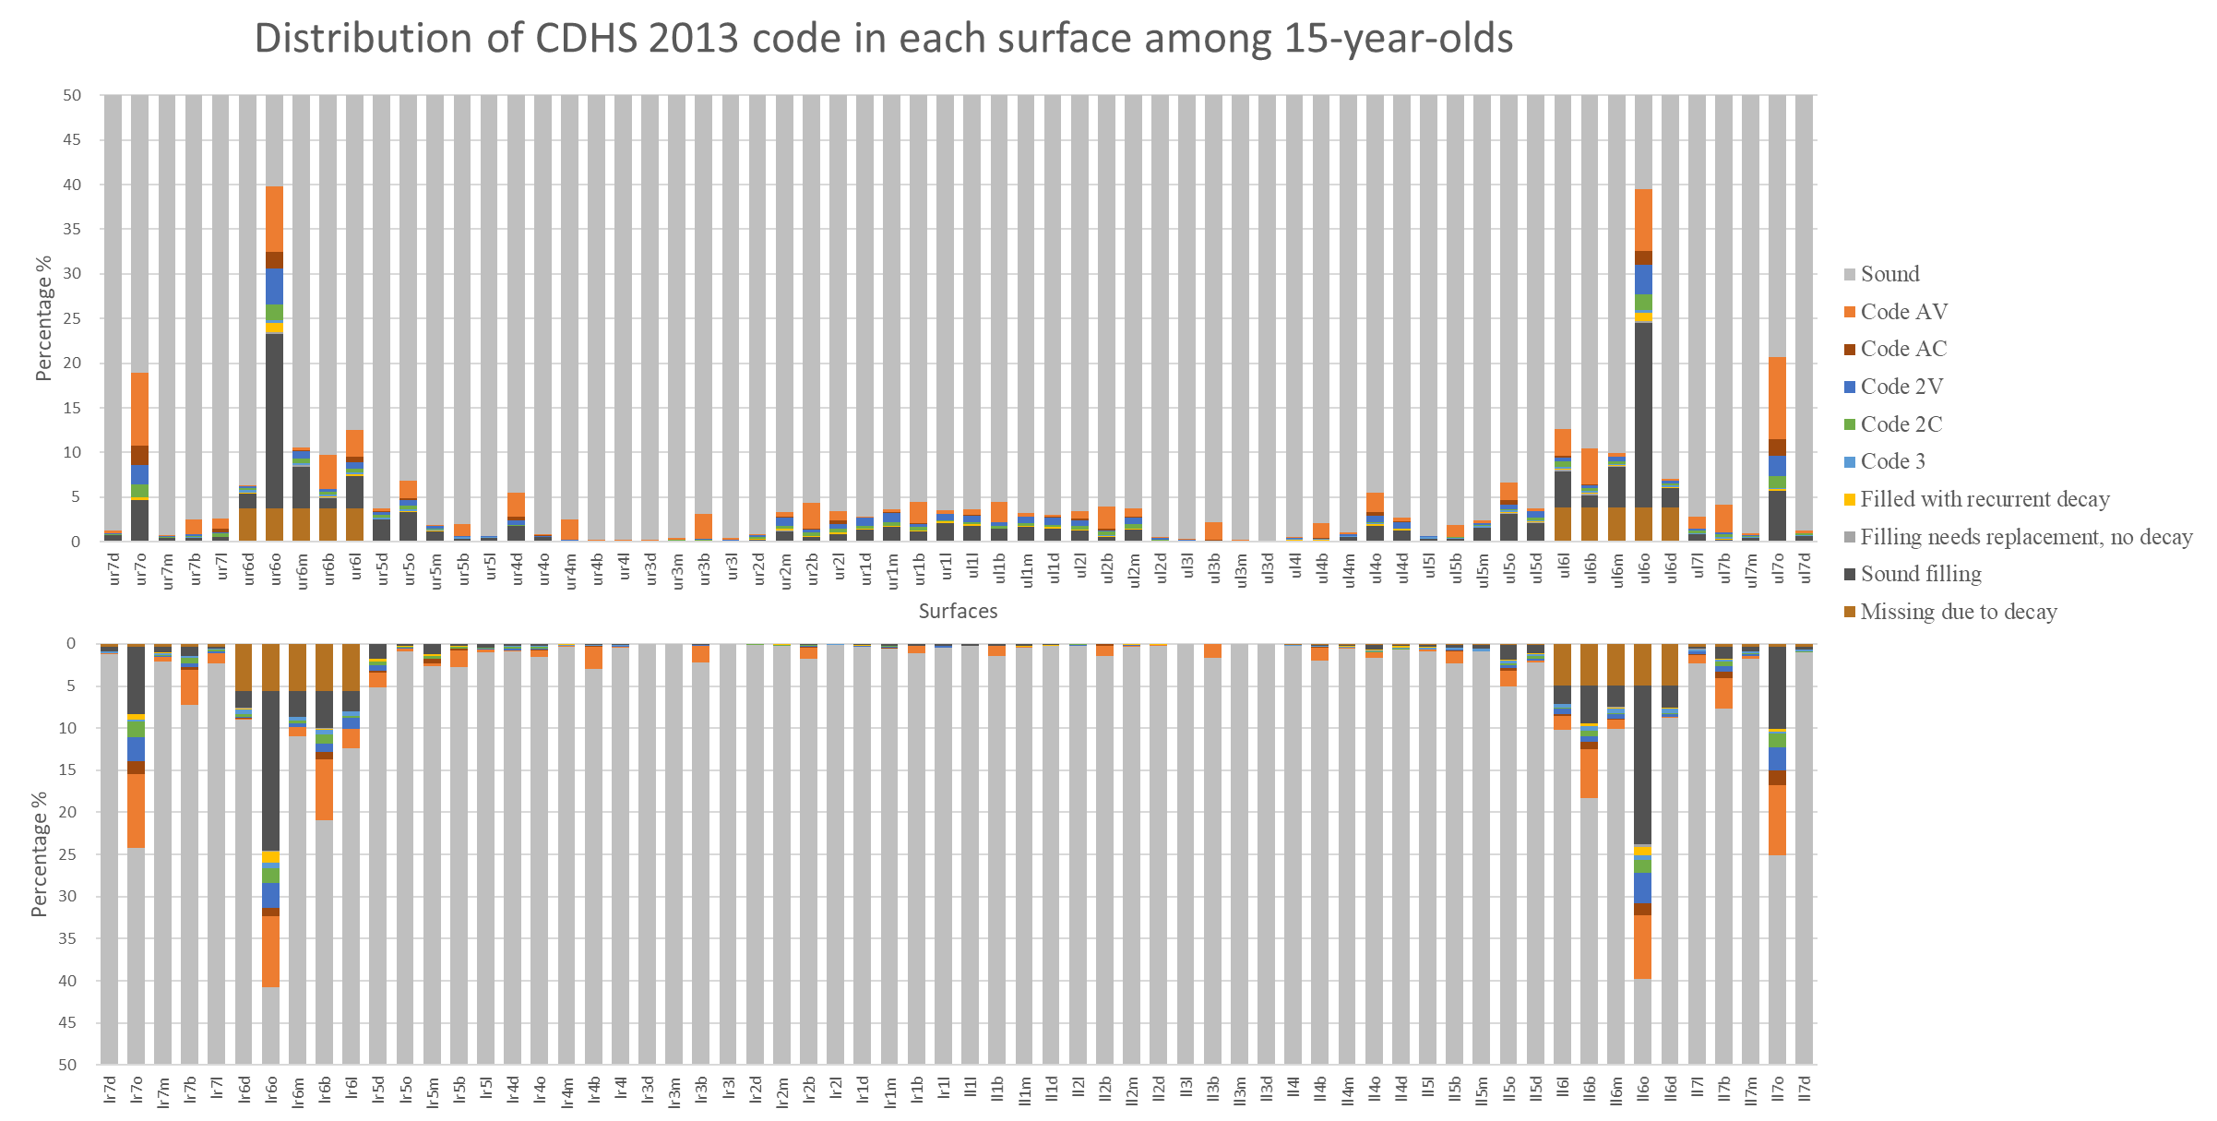
Appendix Figure 2. Distribution of CDHS 2013 code in each surface of 15-year-olds (n = 2,160)

