Supplementary Information

Superionic hcp-Fe alloys and their seismic velocities in Earth’s inner core

Yu He^{1,2,#,*}, Shichuan Sun^{1,3,#}, Duck Young Kim², Bo Gyu Jang², Heping Li¹, Ho-kwang Mao²

¹Key Laboratory of High-Temperature and High-Pressure Study of the Earth’s Interior, Institute of Geochemistry, Chinese Academy of Sciences, Guiyang 550081, Guizhou, China
²Center for High Pressure Science and Technology Advanced Research, Shanghai 201203, China
³University of Chinese Academy of Sciences, Beijing 100049, China

*E-mail: heyu@mail.gyig.ac.cn
# These authors contribute equally to this work
S1. Structure construction and solid-superionic phase transition.
S2. The estimation of melting temperature using the two-phase method.
S3. Diffusion coefficients and ionic conductivities of superionic Fe alloys
S4. DFT + DMFT calculations and electronic conductivities of Fe alloys
S5. AIMD simulations on the elastic properties of superionic Fe alloys
S6. Convergence tests
S7. References
S1. Structure construction and solid-superionic-liquid phase transition.

The stable phase of Fe at Earth’s inner core (IC) conditions is still controversial. Both hexagonal-close-packed (hcp) Fe and body-center-cubic (bcc) Fe are considered as the candidate of the main phase in the IC^{1,2}. Here, we chose hcp-Fe alloys as the simulation models because recent experimental and computational studies suggest hcp-Fe alloys show seismic velocities close to the Preliminary Reference Earth Model (PREM) under the IC conditions³⁻⁹, and the results of this study are compared with the results of previous researches.

The light-element impurities may take substitutional and/or interstitial sites in hcp-Fe. Therefore, the relative thermodynamic stability of H, O, C, S, and Si at interstitial site are investigated at 360 GPa and 0 K. We consider the stability of interstitial defect in binary (Fe-X) Fe alloys (X = H, O, C, S, and Si). A 4×4×2 supercell containing 64 Fe atoms was employed for the calculation. A substitutional defect (X^{s}) was generated by replacing a Fe atom, and an interstitial defect (X^{i}) was generated by adding an X atom at the octahedral interstitial site. When X^{s} and X^{i} are coexisted (Fe-X^{s}-X^{i}), both correlated (dimer) and separated (sub. + inter.) configurations are considered. Geometry optimizations were performed at 360 GPa using conjugate gradients minimization until all of the forces acting on the ions were less than 0.01 eV/Å per atom. A 3×3×4 K-point mesh was adopted. The chemical potential of distinctive element X in hcp-Fe are calculated by
$μ_{x}=\frac{H\left({Fe}_{N}X_{M}\right)-H\left({Fe}_{N}\right)}{M} (1)$
where N and M are the number of Fe and light-element atoms in the structure. As shown in Supplementary Fig. 1, H at interstitial site is energetically much more favorable, which is consistent with previous experimental and computational results^{8,10}. Substitutional structures are more stable for Fe-S and Fe-Si alloys. For C and O, the dimer structure is the most stable one indicating the coexisting of both substitutional and interstitial defects. Li et al.¹¹ investigated the thermodynamic stability of Fe-C alloys at high temperature by quasiharmonic approximation (QHA) method, and they found the stability of the dimer structure is weakened and its relative free energy is slight higher than that of the substitutional structure at 6500 K. Nevertheless, the interstitial defects for C and O may still exist in Earth’s inner core due to the slight energy difference and complicated thermodynamic conditions in Earth’s inner core with different pressures, temperatures, compositions. Thus, it is still valuable to study the influence of C and O interstitial defects on the properties of Fe alloys and compare with geophysical observations. In addition, we evaluated the elastic stability of Fe-H, Fe-O and Fe-C alloys with H, C, and O at interstitial sites by performing ab-initio molecular dynamics (AIMD) simulations, which confirm the elastic stability of these structures at 360 GPa and 3000-6000 K (Supplementary S5). Thus, the properties of light elements at the interstitial sites are studied in this approach.
Supplementary Figure 1 | Calculated chemical potentials of X (X = H, O, C, S, and Si) in hcp-Fe with different configurations at 360 GPa and 0 K.

Regarding the concentration of light element defects, H is known to be soluble in solid Fe at high P-T with the concentration over ~1 wt.%^{12,13}. The solubility of C in hcp-Fe is about 1 wt. % at ~211 GPa¹⁴, while the O concentration in solid Fe can be negligible¹⁵. On the other hand, the Si and S can form solid solution in hcp-Fe with high concentrations up to ~16% for Si and ~5% for S^{7,16-18}. Based on the solubility, light-element bearing hcp-Fe structures were constructed by locating one H, O, C, Si, and S atom at the central site of hcp-Fe supercells (2×1×1 supercell for H and 2×2×1 supercell for O, C, Si and S). The light-element concentration in the Fe₄H, Fe₁₆O, Fe₁₆C, Fe₁₆Si, and Fe₁₆S structures is 0.45, 1.75, 1.33, 3.04, and 3.46 wt. %, respectively. Although the solubility of O in hcp-Fe might be very low under the IC conditions, we still study the Fe₁₆O structure and the result will benefit the understanding on O defects in hcp-Fe. The structure relaxations were performed using the PBE exchange-correlation functional and projector augmented wave (PAW) method¹⁹ as implemented in the Vienna Ab Inito Simulaton Package (VASP)²⁰. In our calculations, a plane wave representation for the wave function with a cutoff energy of 800 eV was adopted. Geometry optimizations were performed at pressures from ~250 to ~360 GPa using conjugate gradients minimization until all of the forces acting on the ions were less than 0.01 eV/Å per atom. K-point mesh with a spacing of ca. 0.03 Å⁻¹ was adopted.

The solid-superionic-liquid phase transitions for these structures under the IC conditions were investigated by ab-initio molecular dynamics (AIMD). AIMD method has been widely used to simulate ionic conductivity^{21,22}, melting temperature^{23,24}, phase transition²⁵⁻²⁷, elastic property^{3-5,8,9,28} of materials at high P-T. Here, enlarged supercells for Fe₆₄H₁₆, and Fe₆₄X₄ (X = O, C, Si and S) were adopted for AIMD simulation. It is worth to note that a bigger supercells containing 128 Fe atoms and 32 H atoms or 8 X (X = O, C, Si and S) atoms did not change the simulation results. The simulations used the canonical ensemble (NVT：N-number of particles, V-volume, T-temperature) with a time step of 1 fs. The simulations lasted ~10-100 ps at temperatures from ~2000 to ~7000 K and pressure from ~250 to ~400 GPa. The mean square displacement (MSD):
$〈{\left[\vec{r}\left(t\right)\right]}^{2}〉=\frac{1}{N}\sum_{i=1}^{N}{〈{\left[\vec{r_{i}}\left(t+t_{0}\right)-\vec{r_{i}}\left(t_{0}\right)\right]}^{2}〉 (2)}$,
is averaged over specific ions, and $\vec{r_{i}}\left(t\right)$ is the displacement of the ith ion at time t, and N is the total number of specific ions in the system. At the solid state, the MSDs of Fe and light elements are close to zero and do not show obvious increase over simulation time. The solid-superionic phase transition take place at temperatures over 3000 K. As shown in Supplementary Fig. 2, the MSD of H, O and C increases monotonically over simulation time, and the MSD of Fe is still stable, demonstrating that the materials are at the superionic state. The highly diffusive light-element defects can also be visualized by their trajectories. A further increase in temperature leads to melting of the lattice and the particles diffuse away from their equilibrium positions and their MSDs increase with simulation time. For Fe₆₄Si₄ and Fe₆₄S₄ alloys, we did not observed a superionic state, the structures transfer directly to a liquid state at ~3000 K and ~ 330 GPa (Supplementary Fig. 3). It suggests the solid Fe₆₄Si₄ and Fe₆₄S₄ hcp-Fe alloys, with Si and S at the interstitial sites, is not stable under the IC conditions.

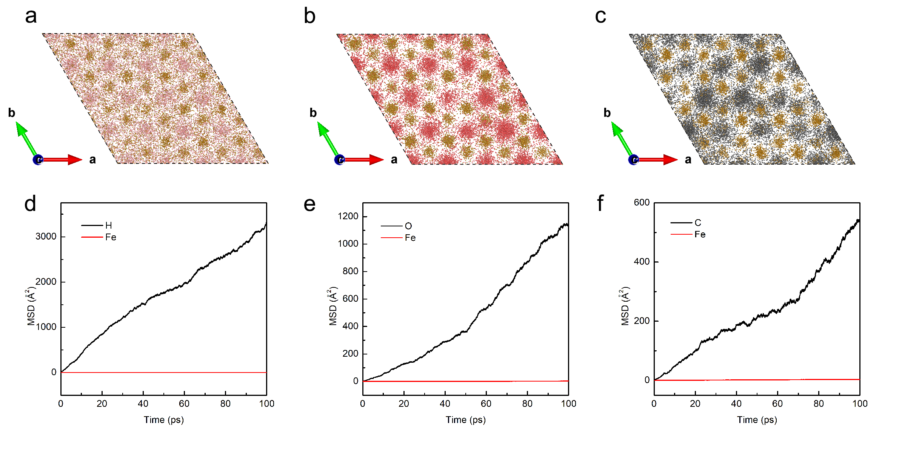
Supplementary Figure 2 | Trajectories and mean square displacements (MSDs) of H, O, C, and Fe in Fe-light-element alloys. Trajectories of a, H and Fe in FeH_{0.25}; b, O and Fe in FeO_{0.0625}; c, C and Fe in FeC_{0.0625} at the superionic state under the IC conditions (~360 GPa and ~5000 K). Small pink, red, black and brown spheres represent the trajectories of H, O, C and Fe, respectively. MSDs of d, H and Fe in FeH_{0.25}; e, O and Fe in FeO_{0.0625}; f, C and Fe in FeC_{0.0625}. The MSDs of H, O and C ions increase obviously with simulation time, while the MSDs of Fe remain close to zero indicating a superionic state.

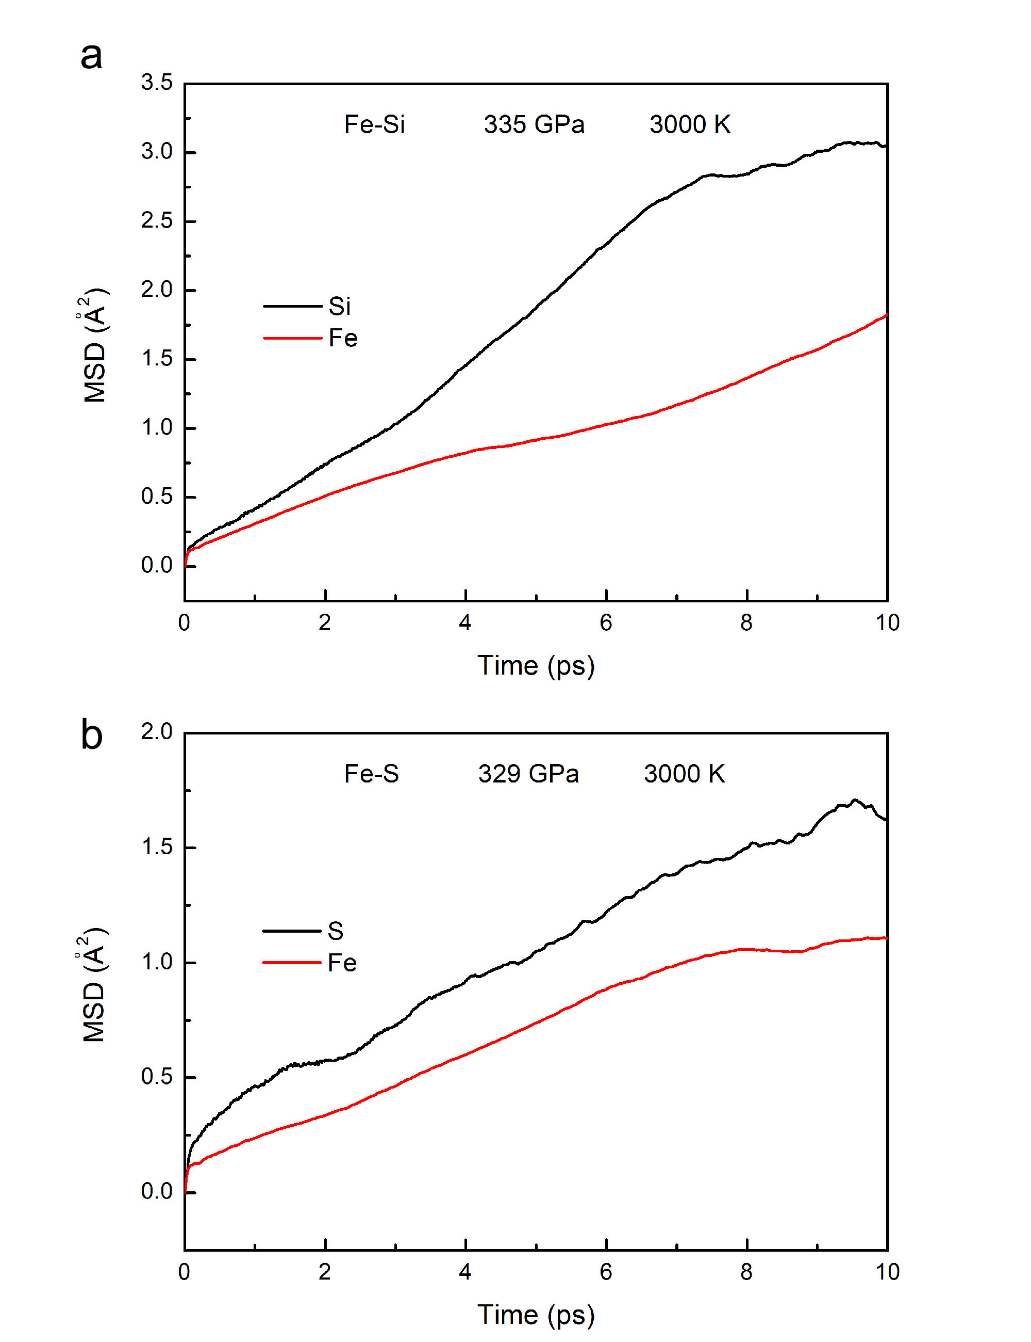
Supplementary Figure 3 | MSDs of Si, S, and Fe in FeSi_{0.0625} and FeS_{0.0625} at ~330 GPa and 3000 K. MSDs of a, Si and Fe in FeSi_{0.0625}; b, S and Fe in FeS_{0.0625}. The MSDs of Si, S and Fe increase obviously with simulation time indicating a liquid state.

S2. The estimation of melting temperature using the two-phase method.
During AIMD simulations, a superheating solid state is obtained above melting temperature (T_{m})^{29,30}. In order to exclude the influence of superheating state, the melting temperatures of these alloys should be estimated. Considering the influence of light element partition between solid and liquid phase³¹, we used the solid and liquid coexisting system, which is also known as two-phase method³²⁻³⁶, to predict the melting temperature. In addition, the computational results are in agreement with the results of previous experimental studies^{12,14,37}. Accordingly, the estimated melting temperatures of FeH_{0.25}, FeO_{0.0625}, and FeC_{0.0625} are approximately within 5500-6000 K, and simulation temperatures of our further studies on elastic properties are constrained below the melting temperatures.

The two-phase method has been widely used to predict the melting temperatures of different materials such as metals^{32,34}, hydrogen³⁵, lithium hydride³⁶, and oxides³³. Under a constant internal energy, coexisted two-phase system can maintain for a long time, and the average temperature and pressure of the coexisted system denotes a melting point. A simulated structure was generated by combining a solid and liquid Fe-light-element structure. The solid structures were obtained from the structures of FeH_{0.25}, FeO_{0.0625}, and FeC_{0.0625} at 360 GPa and 6000, 5500, and 5500 K, respectively. The liquid structures were generated by heating the solid structures at ~9000 K for ~2 ps, and then slowly cooling down to ~6000 K. The simulations were performed in the NVE (N-number of particles, V-volume, E-internal energy) ensemble using supercells with different volumes containing 256 Fe atoms and 64, 16, and 16 of H, O, and C atoms, respectively. The cutoff energy was set to 400 eV with Γ point for k-space sampling. The time step was set at 1 fs with total simulation of over 12 ps. The two-phase coexisting states are maintained during our simulation (Supplementary Fig. 4). The pressures and temperatures in these simulations are presented in Supplementary Fig. 5, and averaged melting temperatures for FeH_{0.25}, FeO_{0.0625}, and FeC_{0.0625} are approximately 5770 (± 200), 5595 (± 200), and 5413 (± 200) K at 324.4 (± 1.0), 320.3 (± 1.0), and 324.3 (± 1.0) GPa, respectively. Compared with previous experimental^{38,39} and computational studies^{24,34,40-42}, these superionic impurities also reduce the melting temperature by about 500-1000 K. In the simulated systems, we also observed the diffusion of H, O, and C in solid phases indicting the superionic state. Interestingly, we observed the inter-diffusion of the light elements between the liquid and solid phases, thus the superionic state of Fe-alloys should be considered when calculating the light element partition at ICB.

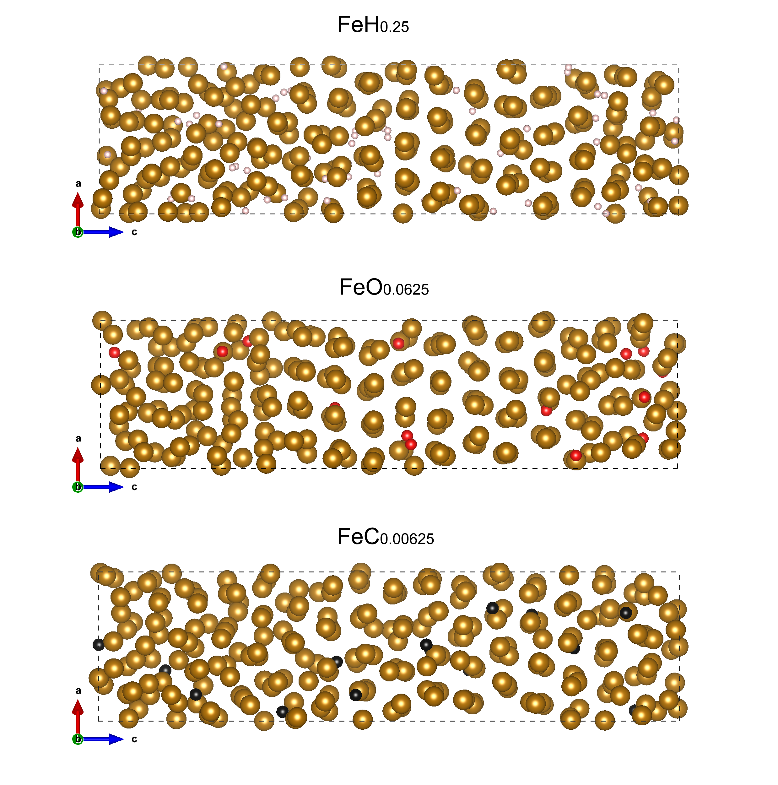
Supplementary Figure 4 | The structures of two-phase systems of Fe-H, Fe-O and Fe-C after the AIMD simulations. These structures suggest the coexistence of solid and liquid Fe alloys. Pink, red, black and brown spheres represent H, O, C and Fe atoms, respectively.

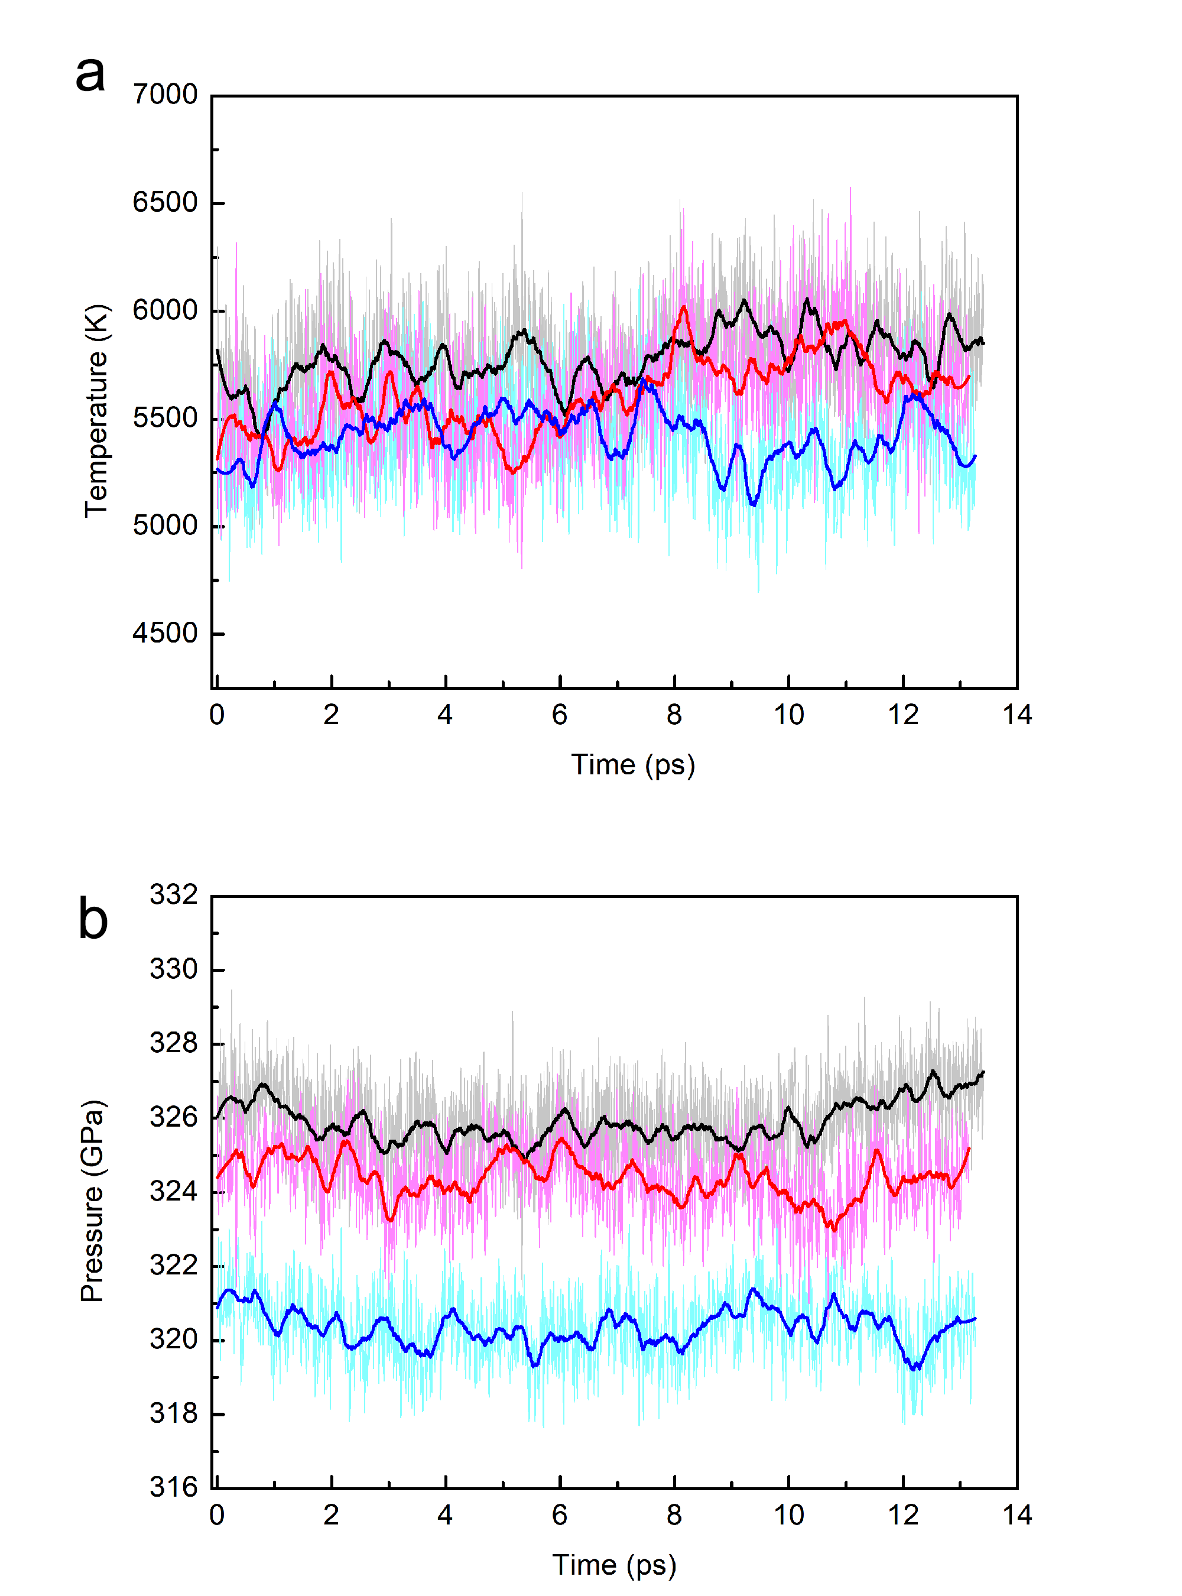
Supplementary Figure 5 | The evolution of temperature and pressure with respect to simulation time in the two-phase coexisting systems for Fe-H, Fe-O and Fe-C alloys. a. temperatures and, b. pressures for Fe-H, Fe-O and Fe-C alloys are shown with light grey, pink and cyan curves, and the averaged data over a 0.5 ps period are shown with thick black, red, and blue curves.

The melting behavior of Fe-H, Fe-C, and Fe-O binary systems has also been studied by previous high pressure experiments^{12,14,37}. The presence of these light elements depresses the melting temperature. However, the eutectic melting experiments were conducted at relatively lower pressures. Thus, Simon–Glatzel equation was used to extrapolate the melting curve to the inner core conditions. The melting temperatures of Fe-rich side Fe binary alloys can be roughly estimated from eutectic temperature and composition as well as the melting point of pure Fe³⁸. Based on the extrapolation of experimental data, the estimated melting temperatures are obtained (green regions in Supplementary Fig. 6), which are basically agree with our simulation results. Therefore, the elastic properties of the Fe alloys at 360 GPa are calculated at temperatures below 6000 K for FeH_{0.25}, and 5500 K for FeO_{0.0625} and FeC_{0.0625}.
Supplementary Figure 6 | Estimated melting temperatures of Fe-H, Fe-O, and Fe-C alloys with different light element contents at 330 and 360 GPa. The melting temperatures are estimated from the extrapolated melting curves of Fe-H, Fe-O, and Fe-C systems measured by high pressure experiments^{12,14,37}. The solid and dash lines represent the melting temperatures at 360 and 330 GPa. The dot-dash lines exhibit the light element content in our simulation modes, with corresponding melting temperatures shown by green regions.
S3. Diffusion coefficients and ionic conductivities of superionic Fe alloys
To study superionic transport rigorously, we calculated the diffusion coefficient for these defects using the MSD ($〈{\left[\vec{r}\left(t\right)\right]}^{2}〉$) of the ionic positions at superionic state. The diffusion coefficient is defined as:
$D=\lim_{0→∞}\left[\frac{1}{2dt}〈{\left[\vec{r}\left(t\right)\right]}^{2}〉\right] (3)$,
where d is the dimension of the lattice on which ion hopping takes place. The value of D obtained at various temperatures can be fitted with an Arrhenius equation:
$D=Aexp\left(-\frac{∆H}{kT}\right) (4)$,
where $∆H$ is the activation enthalpy, A is a pre-exponential factor, k is the Boltzmann constant, and T is the temperature. The ionic conductivity was calculated using the diffusion coefficients and the Nernst-Einstein equation:
$σ=\frac{fDcq^{2}}{kT} (5)$,
in which σ is the ionic conductivity, f is a numerical factor approximately equal to unity, D is the diffusion coefficient, c is the concentration of light-elements defects, q is the electrical charge, k is the Boltzmann constant, and T is the temperature. The ionic conductivity of H, O and C ions are shown in Supplementary Fig. 7.
Supplementary Figure 7 | Ionic conductivities of superionic Fe alloys at the core conditions. Diffusion coefficients calculated using 4 × 4 × 2 supercells and 10 ps simluaiton time are labelled by open symbols. Blue squares: FeH_{0.25} at ~260 GPa; red squares: FeH_{0.25} at ~360 GPa; cyan triangles: FeO_{0.0625} at ~260 GPa; orange triangles: FeO_{0.0625} at ~360 GPa; green circles: FeC_{0.0625} at ~260 GPa; pink circles: FeC_{0.0625} at ~360 GPa. The convergence test results using 4 × 4 × 6 supercell and 100 ps simluaiton time are labeled by crosses and bars. The results of convergence test are presented with yellow, magenta, and cyan symbols for FeH_{0.25}, FeO_{0.0625}, and FeC_{0.0625}, respectively.

S4. DFT + DMFT calculations and electronic conductivities of Fe alloys
To estimate the electronic conductivity of Fe, FeH_{0.25}, FeO_{0.0625}, and FeC_{0.0625}, we considered the resistivity from electron-electron scattering (ρ_{e-e}) and electron-phonon scattering (ρ_{e-ph}). ρ_{e-e} of Fe and Fe alloys were calculated by using the combination of density functional theory with dynamical mean field theory (DFT+DMFT) as implemented in the WIEN2k+eDMFT package (http://hauleweb.rutgers.edu/tutorials/)⁴³. We used the volume obtained from AIMD calculation at ~5500-6000 K in DFT+DMFT calculation to include the volume expansion effect on the electrionic conductivity. Perdew-Burke-Ernzerhof (PBE) generalized gradient approximation (GGA) was used for the exchange correlation functional⁴⁴. The correlation effect of Fe 3d orbital was treated dynamically by local self-energy in DMFT part on the top of an effective one-electron Hamiltonian generated from DFT part. A 1000 k-points mesh was used in DFT+DMFT self-consistent calculation. We used the Coulomb interaction U=5 eV and Hund’s coupling J=0.943 eV, which is consistent with the previous theoretical study on hcp-Fe⁴⁵. The local impurity problem was solved by using continuous time quantum Monte Carlo (CTQMC) impurity solver. A 7000 k-point mesh was used for the conductivity calculation based on the self-energy obtained from the self-consistent calculation with 1000 k-points mesh.

Since the unit cells of Fe alloys are too large to calculate ρ_{e-ph} in first principle manner, we just took previous calculated result on hcp-Fe by using the density functional perturbation theory (DFPT) and Boltzmann transport theory⁴⁵. Therefore, the total resistivity was given by a sum of ρ_{e-e} calculated from DFT+DMFT and reported ρ_{e-ph} of hcp-Fe. Then, the electronic conductivity of Fe and Fe alloys were obtained. Considering the alloy effect on ρ_{e-ph} part, the electrionic conductivity of Fe alloys (FeH_{0.25}, FeO_{0.0625}, and FeC_{0.0625}) can decrease further by ~10%^{46,47}.

We found that the incorporation of light element leads to obvious decrease in electronic conductivity compared with pure Fe^{45,48}, and the electronic conductivities decrease with temperature. However, they are 2-3 orders of magnitude higher than the ionic conductivities of superionic Fe alloys. Therefore, the significant increase in ionic conductivity upon superionic transition (Supplementary Fig. 7) has little influence on the total conductivities of these Fe alloys.
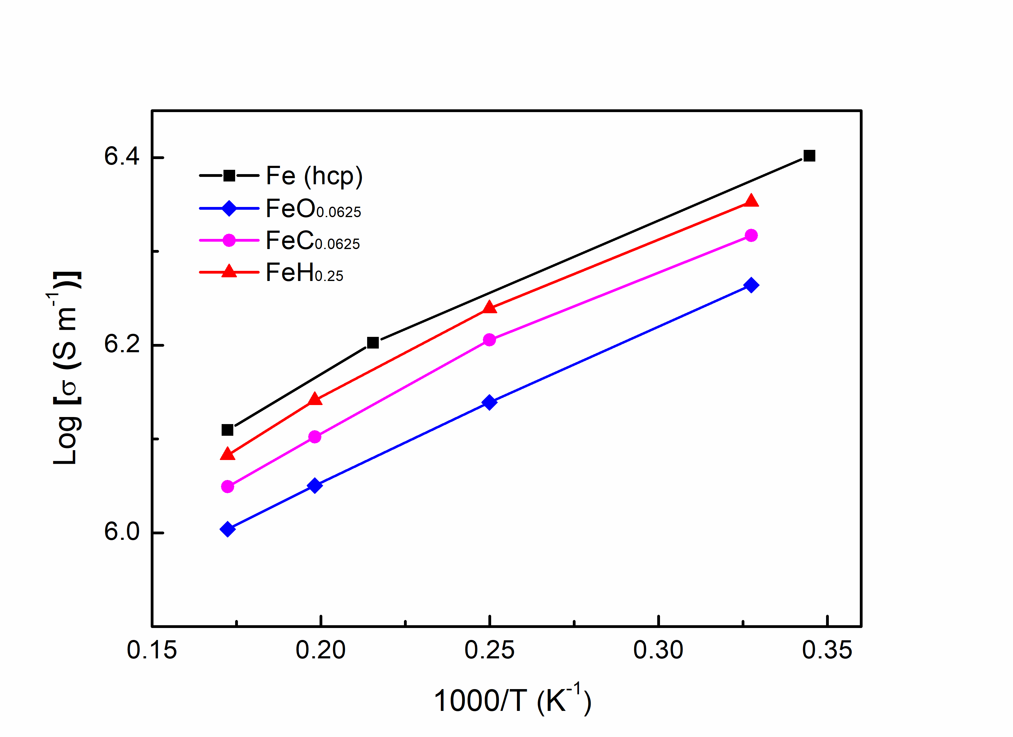
Supplementary Figure 8 | Electronic conductivities of Fe and Fe alloys at 360 GPa with increasing temperature. The electronic conductivities of Fe, FeH_{0.25}, FeO_{0.0625}, and FeC_{0.0625} calculated by DFT + DMFT method are shown by black, blue, red, and magenta symbols.
S5. AIMD simulations on the elastic properties of superionic Fe alloys
We constructed structures for Fe-hcp with C, H and O light elements in 4 × 4 × 2 supercells at 2000-6000 K and 360 GPa. We determined the equilibrium volume and cell parameters at different temperatures by conducting a grid of NVT ensemble simulations over volumes and temperatures using a Nosé thermostat⁴⁹ For each equilibrium structure of different temperature, a 10,000 time-steps (10 ps) simulation was calculated to check for sure that the stress field is hydrostatic. The elastic constant C_{ij} was calculated by distorting the equilibrium structure and solving the stress-strain relations.

The elastic properties of crystal are expressed as the relationship between stress and strain:
$σ_{ij}=C_{ijkl}ε_{kl}$ (6)
where $σ_{ij}$ refers to stress tensor, $ε_{kl}$ refers to strain tensor, and $C_{ijkl}$ represents fourth order elastic modulus. Considering of the symmetry of $C_{ijkl}$ , the equation is simplified as below:
$σ_{i}=C_{ij}ε_{j}$ (7)

The equation could be expanded as follow:
$\left(\begin{matrix}σ1 \\ σ2 \\ σ3 \\ σ4 \\ σ5 \\ σ6\end{matrix}\right)$= $\left(\begin{matrix}C11 & C12 & C13 & C14 & C15 & C16 \\ & C22 & C23 & C24 & C25 & C26 \\ & & C33 & C34 & C35 & C36 \\ & & & C44 & C45 & C46 \\ & & & & C55 & C56 \\ & & & & & C66\end{matrix}\right)$.$\left(\begin{matrix}ε1 \\ ε2 \\ ε3 \\ ε4 \\ ε5 \\ ε6\end{matrix}\right)$ (8)
For the hexagonal system investigated in this work, we have calculated the three non-equivalent elastic constants, $C_{11}$, $C_{12}$, $C_{13}$, $C_{33}$ and $C_{44}$. $C_{11}$, $C_{12}$ and $C_{13}$ could be obtained by a strain tensor:
$ε=\left(\begin{matrix}δ & & \\ & & \\ & & \end{matrix}\right)$ (9)
we obtained $C_{33}$ using a strain tensor:
$ε=\left(\begin{matrix} & & \\ & & \\ & & δ\end{matrix}\right)$ (10)
and we obtained $C_{44}$ using a strain tensor:
$ε=\left(\begin{matrix} & & \\ & & δ/2 \\ & δ/2 & \end{matrix}\right)$ (11)

where $δ$ is the magnitude of distortion. For $δ$ in $±0.01$, $±0.005$ and 0, five group of strains were added by:
$a^{'}=a(I+ε)$ (12)
where a represents a 3 $×3$ cell parameter matrix, and ε represents added strain$∆ε$, $I$represents a $3×3$ identity matrix. Then, we obtained elastic moduli trough dealing with the stress-strain relationship listed in equation (8). In order to ensure the reliability and full convergence of the results, 10 000 time steps of $NVT$ simulations was carried out for each direction of deformation. The final results of strain-stress data show very good linear relationship and were fitted employing central difference method. For each optimizing result, the calculated correlation coefficient R² were larger than 99%. The calculated $C_{ij }$results satisfy with $Born's$ stability conditions:
$C_{11}>|C_{12}|$, $\left(C_{11}+C_{12}\right)C_{33}>2C_{13}^{2}$， $C_{44}>0$, $C_{66}>0$ (13)

We calculated the bulk modulus B and shear modulus G using Voigt average scheme which is proved more appropriate and accurate in calculating the seismic wave properties⁵⁰.
And further calculated the primary wave velocity $V_{P}$，shear wave velocity $V_{S}$, and bulk sound velocity $V_{∅}$:
$V_{P}=\sqrt{\frac{B+\frac{4G}{3}}{ρ}}$, $V_{S}=\sqrt{\frac{G}{ρ}}$, $V_{∅}=\sqrt{\frac{B}{ρ}}$ (14)
The Possion’s ratio is calculated by:
$ν=\frac{3B-G}{2(3B+G)}$ (15),
and shown in Supplementary Fig. 9.

Using the same method, the elastic constants for hcp-Fe at 360 GPa were calculated and compared with the results of the previous report (Supplementary Fig. 10)³. Our results show good consistence with the previous report at temperatures below 7000 K.

Supplementary Table 1 | Densities (ρ), Elastic constants (C_{ij}), sound velocities (V_{Φ}, V_{P} and V_{S}), moduli (B and G) and Poisson’s ratio of FeH_{0.25}, FeC_{0.0625} and FeO_{0.0625} at various temperatures and 360 GPa.
 | T(K) | ρ | C₁₁ | C₁₂ | C₁₃ | C₃₃ | C₄₄ | V_{Φ} | V_{P} | V_{S} | B | G | ν
 |  | (g cm⁻³) | (GPa) | (GPa) | (GPa) | (GPa) | (GPa) | (km s⁻¹) | (km s⁻¹) | (km s⁻¹) | (GPa) | (GPa)
FeH_{0.25} | 0 | 13.75 | 2390.3 | 1201.6 | 1107.3 | 2529.3 | 508 | 10.69 | 12.51 | 6.5 | 1571.23 | 581.7 | 0.335
 | 2000 | 13.65 | 2272.9 | 1177.9 | 1085.4 | 2372.7 | 458.2 | 10.53 | 12.22 | 6.23 | 1512.88 | 530.77 | 0.343
 | 3000 | 13.55 | 2194.4 | 1183.6 | 1070.1 | 2194.8 | 394.8 | 10.42 | 11.98 | 5.93 | 1470.13 | 476.32 | 0.354
 | 4000 | 13.42 | 2050.3 | 1158.5 | 1073.3 | 2059 | 339.6 | 10.28 | 11.69 | 5.56 | 1418.87 | 415.32 | 0.367
 | 5000 | 13.28 | 1868.8 | 1214.2 | 1110.8 | 1829.7 | 247.5 | 10.2 | 11.28 | 4.81 | 1381.1 | 306.56 | 0.397
 | 6000 | 13.11 | 1732.7 | 1177.9 | 1054.2 | 1652.1 | 177.8 | 9.95 | 10.86 | 4.35 | 1298.9 | 248.68 | 0.410
FeC_{0.0625} | 0 | 13.87 | 2275.1 | 1257 | 1199.6 | 2349.9 | 466.4 | 10.67 | 12.26 | 6.03 | 1579.17 | 504.64 | 0.356
 | 3000 | 13.74 | 1940.7 | 1168.1 | 1113.8 | 2041 | 361.9 | 10.15 | 11.46 | 5.33 | 1412.64 | 390.47 | 0.373
 | 4000 | 13.62 | 1986.8 | 1370.5 | 1053.2 | 1897.3 | 274.9 | 10.23 | 11.36 | 4.93 | 1424.97 | 331.18 | 0.392
 | 5000 | 13.49 | 1732 | 1260.4 | 1222.7 | 1705.7 | 189.9 | 10.18 | 10.96 | 4.05 | 1397.92 | 220.71 | 0.425
 | 5500 | 13.41 | 1687.5 | 1256.8 | 1079.7 | 1590.6 | 147 | 9.89 | 10.63 | 3.91 | 1310.89 | 205.17 | 0.427
FeO_{0.0625} | 0 | 13.89 | 2250.7 | 1257.1 | 1216.8 | 2365.3 | 467.7 | 10.67 | 12.24 | 5.99 | 1583.12 | 498.17 | 0.358
 | 3000 | 13.73 | 2095.7 | 1123.7 | 1209.9 | 2038.9 | 338.1 | 10.38 | 11.74 | 5.47 | 1479.7 | 411.56 | 0.373
 | 4000 | 13.64 | 1902.3 | 1219.3 | 1228.6 | 1907.2 | 273.6 | 10.32 | 11.38 | 4.79 | 1451.64 | 313.43 | 0.400
 | 5000 | 13.50 | 1807.3 | 1307 | 1117.2 | 1652.6 | 174.3 | 10.08 | 10.91 | 4.17 | 1372.22 | 234.81 | 0.419
 | 5500 | 13.43 | 1675.6 | 1226.5 | 1227 | 1692.5 | 147.7 | 10.13 | 10.8 | 3.81 | 1378.3 | 194.86 | 0.432

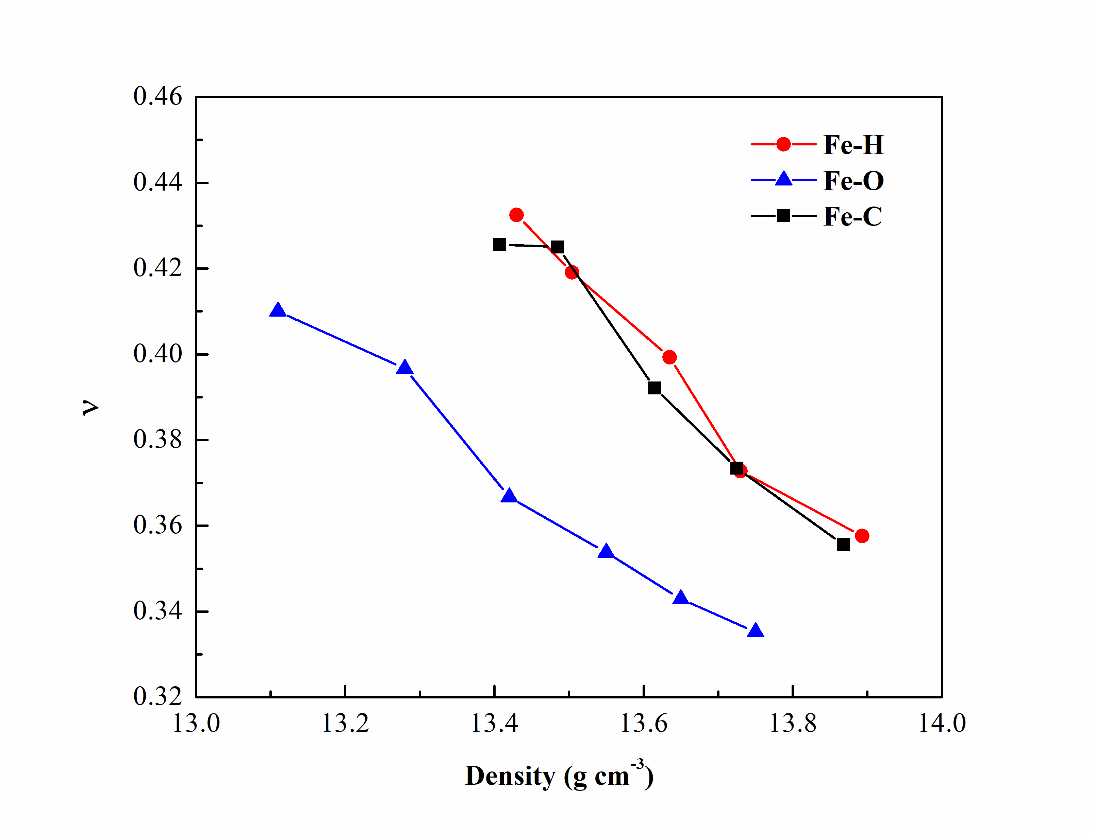
Supplementary Figure 9 | Calculated Poisson’s ratios of FeH_{0.25}, FeC_{0.0625} and FeO_{0.0625} at various temperatures and 360 GPa. Increasing temperature leads to obvious increases in Poisson’s ratios of Fe alloys approaching the Poisson’s ratio of Earth’s inner core (~0.44).

Supplementary Figure 10 | Calculated elastic constants for hcp-Fe as the function of simulation temperature at 360 GPa. Our data represented by open symbols is compared with the results of a previous report represented by solid symbols. The elastic constants C₁₁, C₁₂, C₁₃, C₃₃ and C₄₄ are shown with black, red, blue, green and orange symbols, respectively.

S6. Convergence tests
Convergence tests were performed on FeH_{0.25}, FeO_{0.0625}, and FeC_{0.0625} at 360 GPa and 5000-6000 K with supercells containing over 200 atoms and simulation time above 100 ps. 4 × 4 × 6 supercells containing 240, 204, and 204 atoms for FeH_{0.25}, FeO_{0.0625}, and FeC_{0.0625} are used for AIMD simulations. The simulations clearly confirm the superionic state of these Fe alloys. Also, the calculated diffusion coefficients and ionic conductivities are well converged (Supplementary Fig. 11).

As the calculation results of the elastic constants are also very important in this work, we carried out convergence tests on the stresses of FeH_{0.25} with different supercells. For each test, we made a gird of calculations to ensure the hydrostatic state. Then, we tested the stress with 1% (δ=0.01) strain in the [001] direction and all the simulations lasted ~10000 time steps. Our convergence tests are shown in Supplementary Table 2 and Supplementary Fig. 12. It suggests a larger supercell does not change our results on elastic constants.

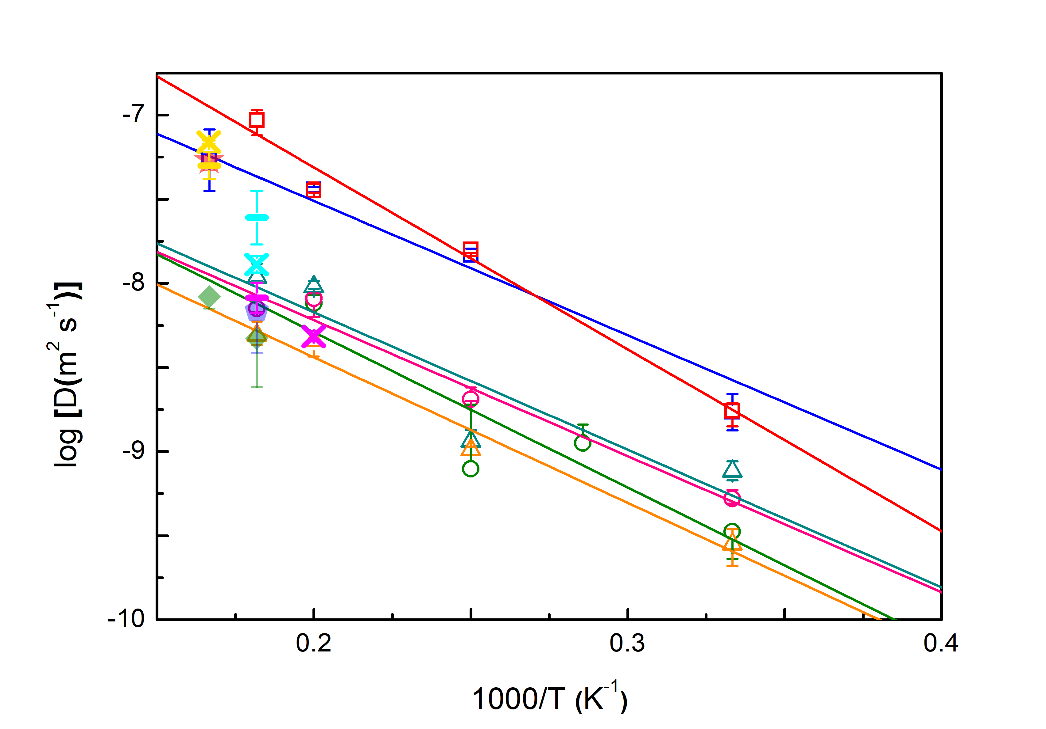
Supplementary Figure 11 | Comparison of calculated diffusion coefficients with different supercells and simulation time. Diffusion coefficients calculated using 4 × 4 × 2 supercells and 10 ps simluaiton time are labelled by different open symbols: FeH_{0.25} at ~260 GPa; red squares: FeH_{0.25} at ~360 GPa; cyan triangles: FeO_{0.0625} at ~260 GPa; orange triangles: FeO_{0.0625} at ~360 GPa; green circles: FeC_{0.0625} at ~260 GPa; pink circles: FeC_{0.0625} at ~360 GPa. The convergence test results using 4 × 4 × 6 supercell and 100 ps simluaiton time are labelled by crosses and bars. The results of convergence test are presented with yellow, magenta, and cyan symbols for FeH_{0.25}, FeO_{0.0625}, and FeC_{0.0625}, respectively. The solid red star, green diamonds and blue pentagon represent the diffusion coefficients of H, O and C in liquid Fe at ~330 GPa.

Supplementary Table 2 | Convergence tests on supercell size.
$$Phase$$ | $P$ (GPa) | $$T$$ | $$Supercell$$ | $$N (atom)$$ | $$Strain (\%)$$ | $$Stress (GPa)$$
$$hcp$$ | 360 $GPa$ | 5000 $K$ | $$4×4×2$$ | 80 | 0.01 | 342.582
$$hcp$$ | 360 $GPa$ | 5000 $K$ | $$4×4×4$$ | 160 | 0.01 | 341.360

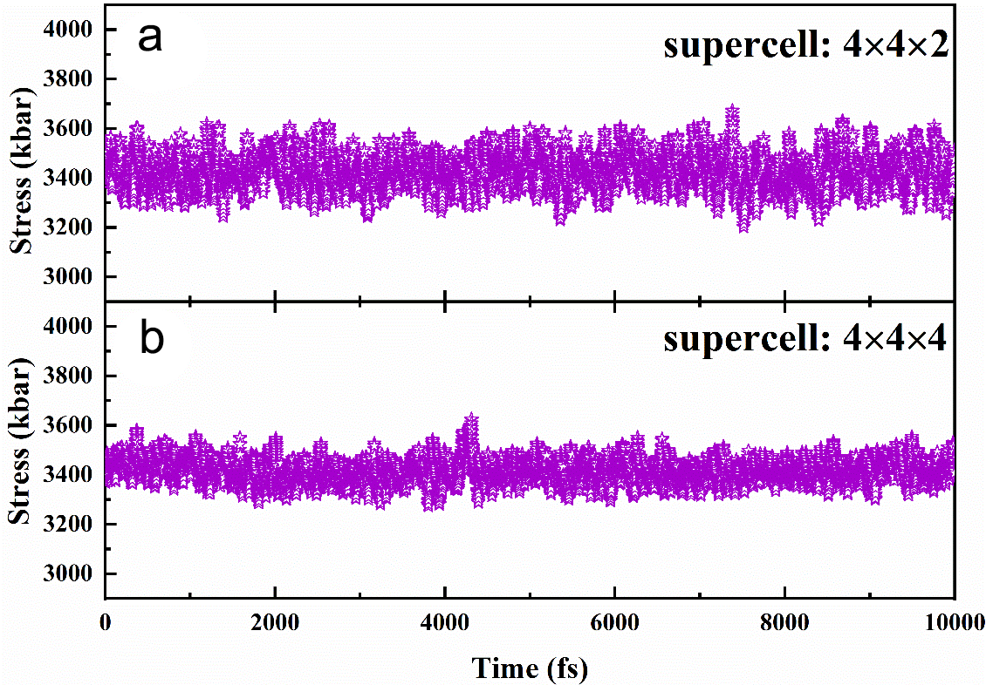
Supplementary Figure 12 | Convergence tests of supercell size on FeH_{0.25}. (a), (b) exhibited the simulated stress, induced by 0.01 strain in $ε_{zz}$, of [001] direction changed with time of a 4×4×2 supercell and 4×4×4 supercell, respectively.

S7. References

- Tateno, S., Hirose, K., Ohishi, Y. & Tatsumi, Y. The Structure of Iron in Earth’s Inner Core. Science 330, 359 (2010).
- Belonoshko, A. B., Rajeev, A. & Johansson, B. Stability of the body-centred-cubic phase of iron in the Earth’s inner core. Nature 424, 1032 (2003).
- Martorell, B., Vočadlo, L., Brodholt, J. & Wood, I. G. Strong Premelting Effect in the Elastic Properties of hcp-Fe Under Inner-Core Conditions. Science 342, 466 (2016).
- Martorell, B., Wood, I.G., Brodholt, J. & Vočadlo, L. The elastic properties of hcp-Fe1-xSix at Earth’s inner-core conditions. Earth Planet. Sci. Lett. 451, 89–96 (2016).
- Li, Y., Vočadlo, L. & Brodholt J. B. The elastic properties of hcp-Fe alloys under the conditions of the Earth's inner core. Earth Planet. Sci. Lett. 493, 118 (2018).
- Sakamaki T. et al., Constraints on Earth’s inner core composition inferred from measurements of the sound velocity of hcp-iron in extreme conditions. Sci. Adv. 2, e1500802, (2016).
- Antonangeli, D. et al., Sound velocities and density measurements of solid hcp-Fe and hcp-Fe–Si (9 wt.%) alloy at high pressure: Constraints on the Si abundance in the Earth’s inner core. Earth Planet. Sci. Lett. 482, 446-453 (2018).
- Caracas, R. The influence of hydrogen on the seismic properties of solid iron, Geophys. Res. Lett., 42, 3780–3785 (2015).
- Caracas, R. The influence of carbon on the seismic properties of solid iron. Geophys. Res. Lett. 44, 128-134 (2017).
- Tagawa, S., Ohta, K., Hirose, K, Kato, C. & Ohishi, Y. Compression of Fe–Si–H alloys to core pressures. Geophys. Res. Lett. 43, 3686-3692, (2016).
- Li, Y., Vočadlo, L., Alfè, D. & Brodholt J. B. Carbon Partitioning Between the Earth's Inner and Outer Core. J. Geophys. Res.: Solid Earth 124, 12812-12824.
- Shibazaki, Y., et al. Sound velocity measurements in dhcp-FeH up to 70 GPa with inelastic X-ray scattering: implications for the composition of the Earth’s core. Earth Planet. Sci. Lett. 313–314, 79–85 (2012).
- Terasaki, H. et al., Stability of Fe–Ni hydride after the reaction between Fe–Ni alloy and hydrous phase (δ-AlOOH) up to 1.2 Mbar: possibility of H contribution to the core density deficit. Phys. Earth Planet. Inter. 194–195, 18–24 (2012).
- Mashino, I., Miozzi, F., Hirose, K., Morard, G. & Sinmyo, R. Melting experiments on the Fe–C binary system up to 255 GPa: Constraints on the carbon content in the Earth’s core. Earth Planet. Sci. Lett. 515, 135-144 (2019).
- Ozawa, H., Hirose, K., Tateno, S., Sata, N. & Ohishi, Y. Phase transition boundary between B1 and B8 structures of FeO up to 210 GPa. Phys. Earth Planet. Inter. 179, 157–163 (2010).
- Tateno, S., Kuwayama, Y., Hirose, K. & Ohishi, Y. The structure of Fe–Si alloy in Earth’s inner core. Earth Planet. Sci. Lett. 418, 11-19 (2015).
- Mori, Y. et al. Melting experiments on Fe-Fe3S system to 254 GPa. Earth Planet. Sci. Lett. 464, 135-141 (2017).
- Fischer, R. A., Campbell, A. J., Caracas, R., Reaman, D. M., Dera, P. & Prakapenka, V. B. Equation of state and phase diagram of Fe–16Si alloy as a candidate component of Earth’s core. 357-358, 268-276 (2012).
- Blöchl, P. E. Projector augmented-wave method. Phys. Rev. B 50, 17953–17979 (1994).
- Kresse, G. Efficient iterative schemes for ab initio total-energy calculations using a plane-wave basis set. Phys. Rev. B 54, 11169–11186 (1996).
- Alfè, D. & Gillan, M. J. First-Principles Calculation of Transport Coefficients. Phys. Rev. Lett. 81, 5161 (1998).
- He, Y. et al. First-principles prediction of fast migration channels of potassium ions in KAlSi3O8 hollandite: Implications for high conductivity anomalies in subduction zones. Geophys. Res. Lett. 43, 6228-6233 (2016).
- Alfè, D. Temperature of the inner-core boundary of the Earth: Melting of iron at high pressure from first-principles coexistence simulations. Phys. Rev. B 79 060101 (2009).
- Belonoshko, A. B., Ahuja, R., & Johansson B. Quasi–Ab Initio Molecular Dynamic Study of Fe Melting. Phys. Rev. Lett. 84, 3638-3641 (2000).
- Mookherjee, M., Stixrude, L. & Karki, B. Hydrous silicate melt at high pressure. Nature 452, 983-986 (2008).
- Hernandez, J. A. & Caracas, R. Superionic-Superionic Phase transitions in body-centered cubic H2O ice. Phys. Rev. Lett. 117, 135503 (2016).
- Belonoshko, A. B. et al. Stabilization of body-centred cubic iron under inner-core conditions. Nature Geosci. 10, 312-316 (2017).
- Steinle-Neumann, G., Stixrude, L., Cohen, R. E., & Gülseren O., Elasticity of iron at the temperature of the Earth’s inner core. Nature 413, 57 (2001).
- Belonoshko, A. B., Skorodumova, N. V., Rosengren, A., & Johansson, B., Melting and critical superheating. Phys. Rev. B 73, 012201 (2006).
- Alfè, D., Cazorla, C. & Gillan, M. J. The kinetics of homogeneous melting beyond the limit of superheating. J. Chem. Phys. 135, 024102 (2011).
- Alfè, D., Gillan, M. J. & Price, G. D. Temperature and composition of the Earth’s core. Contemporary Physics 48, 63–80 (2007)
- Alfè, D. First-principles simulations of direct coexistence of solid and liquid aluminum. Phys. Rev. B 68, 064423 (2003).
- Alfè, D. Melting Curve of MgO from First-Principles Simulations. Phys. Rev. Lett. 94, 235701 (2005).
- Alfè, D. Temperature of the inner-core boundary of the Earth: Melting of iron at high pressure from first-principles coexistence simulations. Phys. Rev. B 79, 060101 (2009).
- Bonev, S. A., Schwegler, E., Ogitsu, T. & Galli, G. A quantum fluid of metallic hydrogen suggested by first-principles calculations. Nature 204, 669-672 (2004).
- Ogitsu, T., Schwegler, E., Gygi, F. & Galli, G. Melting of Lithium Hydride under Pressure. Phys. Rev. Lett. 91, 175502 (2003).
- Morard, G. et al. Fe–FeO and Fe–Fe3C melting relations at Earth’s core–mantle boundary conditions: Implications for a volatile-rich or oxygen-rich core. Earth Planet. Sci. Lett. 473, 94-103 (2017).
- Anzellini, S., Dewaele, A., Mezouar, M., Loubeyre, P. & Morard, G. Melting of Iron at Earth’s Inner Core Boundary Based on Fast X-ray Diffraction. Science 340, 464–466 (2013).
- C. S. Yoo, N. C. Holmes, M. Ross, D. J. Webb, C. Pike, Shock temperatures and melting of iron at Earth core conditions. Phys. Rev. Lett. 70, 3931 (1993).
- Belonoshko, A. B., Rosengren, A., Burakovsky, L., Preston, D. L. & Johansson, B. Melting of Fe and Fe0.9375Si0.0625 at Earth’s core pressures studied using ab initio molecular dynamics. Phys. Rev. B 79, 220102(R) (2009).
- Alfè, D., Price, G. D. & Gillan, M. J. Iron under Earth's core conditions: Liquid-state thermodynamics and high-pressure melting curve from ab initio calculations. Phys. Rev. B 65, 165118 (2002).
- Sola, E. & Alfè, D. Melting of iron under Earth's core conditions from diffusion Monte Carlo free energy calculations. Phys. Rev. Lett. 103, 078501 (2009).
- Haule, K., Yee, C.-H. & Kim, K. Dynamical mean-field theory within the full-potential methods: Electronic structure of CeIrIn5, CeCoIn5, and CeRhIn5. Phys. Rev. B 81, 195107 (2010).
- Perdew, J. P., Burke, K. & Ernzerhof, M. Generalized gradient approximation made simple. Phys. Rev. Lett. 78, 1396 (1997).
- Xu, J. et al. Thermal Conductivity and Electrical Resistivity of Solid Iron at Earth’s Core Conditions from First Principles. Phys. Rev. Lett. 121, 096601 (2018).
- H. Gomi et al. The high conductivity of iron and thermal evolution of the Earth’s core. Phys. Earth Planet. Inter. 224, 88 (2013).
- de Koker, N., Steinle-Neumann, G., & Vlček, V. Electrical resistivity and thermal conductivity of liquid Fe alloys at high P and T, and heat flux in Earth’s core. Proc. Natl. Acad. Sci. U.S.A. 109, 4070 (2012).
- Pozzo, M., Davies, C., Gubbins, D. & Alfè D. Thermal and electrical conductivity of iron at Earth’s core conditions. Nature 485, 355, (2012).
- Nosé, S. A unified formulation of the constant temperature molecular dynamics methods, J. Chem. Phys. 81, 511 (1984).
- Voigt, W. (1928) Lehrbuch der kristallphysik[M]. Leipzig, Teubner, pp 962.

