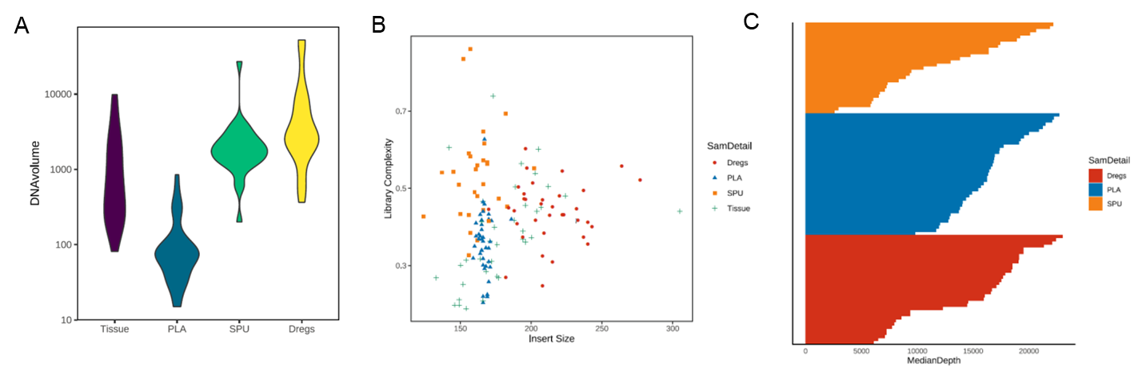
Figure S1. Quality control metrics including the DNA yield expressed in nanograms (A), the correlation between library complexity and insert size of the fragments (in base pairs) for sequencing (B), and the median sequencing depth (C) of all the samples analyzed in the study.

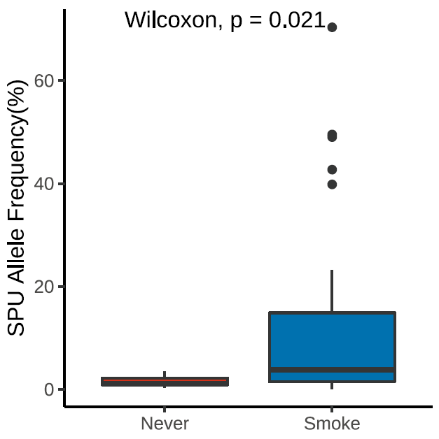
Figure S2. Smokers had significantly higher allelic fraction of sputum supernatant. Box plot illustrating the distribution of allelic frequencies in sputum supernatant (SPU) from smokers and never-smokers.

Table S1. Distribution of samples according to available sample type
Availability of samples | Sample type
 | Tissue | Blood | Sputum-supernatant | Sputum-sediment
All available | 19 | 19 | 19 | 19
No sputum sediment | 6 | 6 | 6 | 0
No sputum supernatant | 11 | 11 | 0 | 11
No blood | 1 | 0 | 1 | 1
No blood and sputum supernatant | 1 | 0 | 0 | 1
No tissue | 0 | 3 | 3 | 3
Total | 38 | 39 | 29 | 35

Table S2. By variant comparison between the mutations detected from sputum supernatant and corresponding sediment samples of the 23 patients
 | Total # of mutations in sputum supernatant | Total # of mutations in sputum sediment | # of mutations shared | # of mutations detected only in supernatant | # of mutations detected only in sediment | Concordance rate (%)
168 genes
SNV + Indels | 48 | 55 | 24 | 24 | 31 | 30.4%
CNV | 1 | 0 | 0 | 1 | 0 | 0%
Fusions | 5 | 4 | 4 | 1 | 0 | 80.0%
8 driver genes
SNV + Indels | 13 | 7 | 5 | 8 | 2 | 33.3%
CNV | 0 | 0 | 0 | 0 | 0 | NA
Fusions | 4 | 4 | 4 | 0 | 0 | 100%
Abbreviations: SNV, single nucleotide variation; Indels, small insertion or deletions; CNV, copy number variation

Table S3. By variant comparison between the mutations detected from sputum supernatant and matched tissue samples of the 26 patients
 | Total # of mutations in sputum supernatant | Total # of mutations in tissue samples | # of mutations shared | # of mutations detected only in sputum supernatant | # of mutations detected only in tissue samples | Concordance rate (%)
168 genes
SNV + Indels | 43 | 91 | 34 | 9 | 57 | 34.0%
CNV | 2 | 12 | 1 | 1 | 11 | 7.7%
Fusions | 6 | 8 | 6 | 0 | 2 | 75.0%
8 driver genes
SNV + Indels | 16 | 33 | 14 | 2 | 19 | 40.0%
CNV | 1 | 3 | 0 | 1 | 3 | 0%
Fusions | 5 | 6 | 5 | 0 | 1 | 83.3%
Abbreviations: SNV, single nucleotide variation; Indels, small insertion or deletions; CNV, copy number variation

Table S4. By variant comparison between the mutations detected from sputum supernatant and matched plasma samples of the 28 patients
 | Total # of mutations in sputum supernatant | Total # of mutations in plasma samples | # of mutations shared | # of mutations detected only in sputum supernatant | # of mutations detected only in plasma samples | Concordance rate (%)
168 genes
SNV + Indels | 53 | 57 | 26 | 27 | 31 | 31.0%
CNV | 3 | 11 | 1 | 2 | 10 | 7.7%
Fusions | 6 | 5 | 5 | 1 | 0 | 83.5%
8 driver genes
SNV + Indels | 18 | 20 | 12 | 6 | 8 | 46.2%
CNV | 1 | 3 | 0 | 1 | 3 | 0%
Fusions | 5 | 4 | 4 | 1 | 0 | 80%
Abbreviations: SNV, single nucleotide variation; Indels, small insertion or deletions; CNV, copy number variation
Table S5. Univariate analysis between clinicopathologic features and either mutation detection rates or maximum allelic fraction in sputum supernatant and sediment samples of the cohort
Clinicopathologic features | Mutation detection rate |  | Maximum allelic fraction
 | Sputum supernatant | Sputum sediment | Sputum supernatant | Sputum sediment
Age | P=0.922 | P=0.944 | P=0.299 | P=0.285
Gender | P=0.390 | P=1.000 | P=0.060 | P=0.269
Smoking status | P=0.083 | P=0.705 | P=0.018* | P=0.728
Histology | P=0.442 | P=1.000 | P=0.576 | P=0.911
Degree of cellular differentiation of sputum cytology | P=0.544 | P=0.408 | P=0.227 | P=0.908
Location of primary tumor | P=1.000 | P=1.000 | P=0.972 | P=0.581
Disease stage | P=1.000 | P=1.000 | P=0.828 | P=0.885
Note: Asterisk (*) denotes statistical significance.

