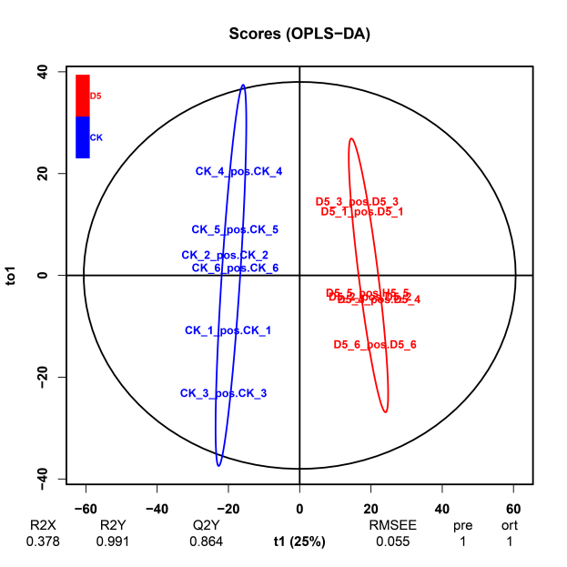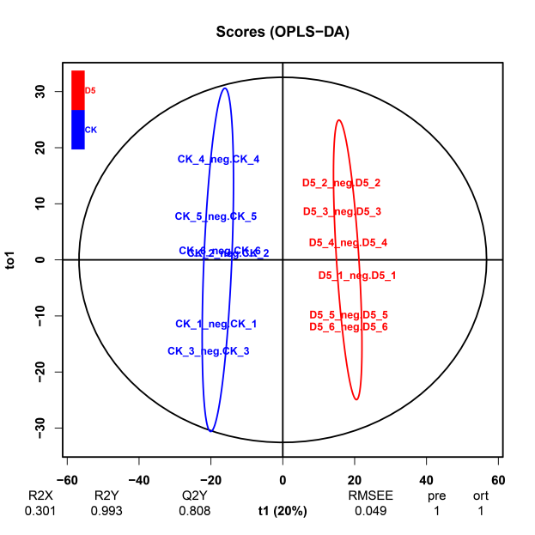
b
a

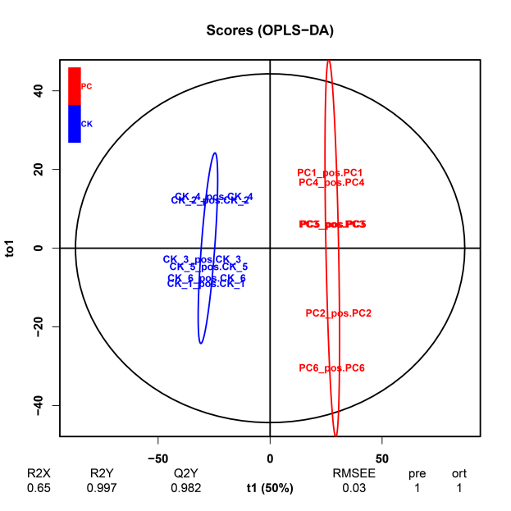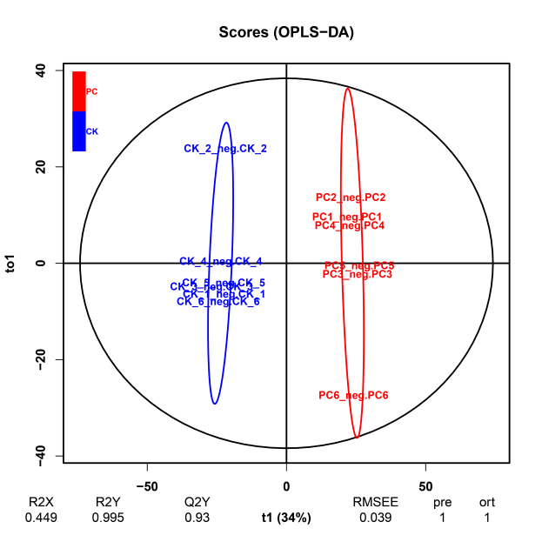
c
d
Fig. S4 Orthogonal projections to latent structures-discriminant analysis of MS data, all detected molecular features were analysed. (a) CK vs. D5 in positive ion mode; (b) CK vs. D5 in negative ion mode; (c) CK vs. PC in positive ion mode; (d) CK vs. PC in negative ion mode. CK represents the control group of vegetative cells in the exponential phase, D5 represents the group of cold and darkness treatment for five hours, PC represents the group of pellicle cysts

