Supplementary Information
North American boreal forests are a large carbon source due to wildfires from 1986 to 2016
Bailu Zhao¹, Qianlai Zhuang^{1,2}, Narasinha Shurpali³, Kajar Köster⁴, Frank Berninger⁵, Jukka Pumpanen⁶

¹Department of Earth, Atmospheric, and Planetary Sciences, Purdue University, West Lafayette, Indiana, 47907
²Department of Agronomy, Purdue University, West Lafayette, IN 47907
³Natural Resources Institute Finland (Luke)
⁴Department of Forest Sciences, University of Helsinki, PO Box 27, FI-00014 University of Helsinki, Finland
⁵Department of Environmental and Biological Sciences, University of Eastern Finland, PO Box 111, FI-80101 Joensuu, Finland
⁶Department of Environmental and Biological Sciences, University of Eastern Finland, PO Box 1627, FI-70211 Kuopio, Finland
* Correspondence to: qzhuang@purdue.edu

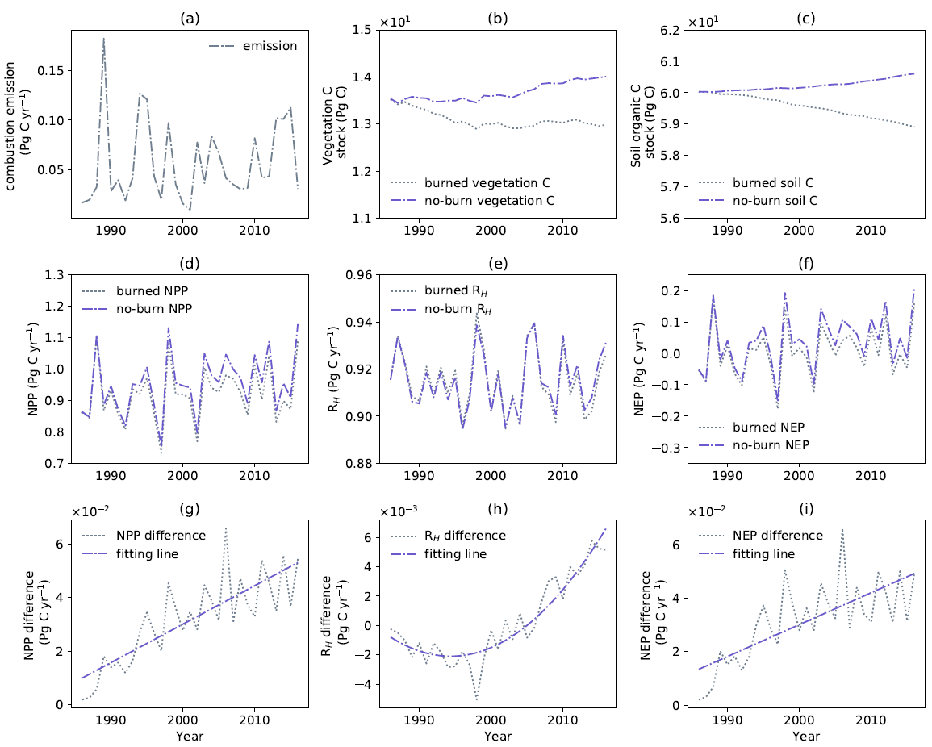
Supplementary Figure 1. Temporal variations (1986-2016) of ecosystem C flux and stock in the NA boreal forest (flux in Pg C yr⁻¹, stock in Pg C). The variation of (a) annual C emitted by biomass combustion; (b) annual regional average vegetation C storage under fire and no-fire scenario; (c) annual regional average soil organic C storage under fire and no-fire scenario; (d) annual regional total NPP under fire and no-fire scenario; (e) annual regional total R_{H} under fire and no-fire scenario; (f) annual regional total NEP under fire and no-fire scenario; (g) annual regional total NPP difference between fire and no-fire scenario and its fitting line; (h) annual regional total R_{H} difference between fire and no-fire scenario and its fitting line; (i) annual regional total NEP difference between fire and no-fire scenario and its fitting line.

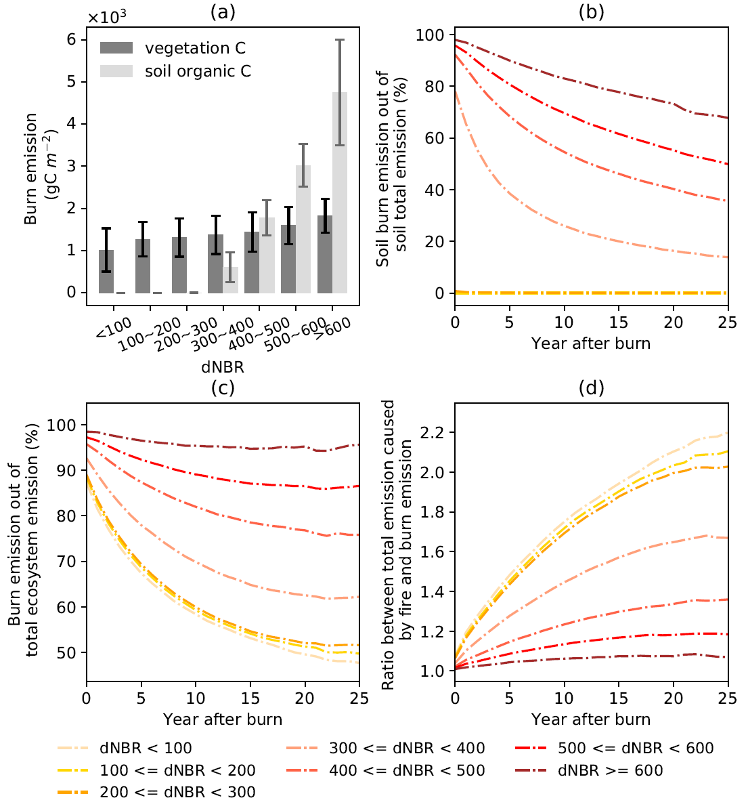
Supplementary Figure 2. Emission pattern during- and post-fires: (a) The amount of C combustion from vegetation and soils. The values are based on the average and standard deviation of all fire events. (b) In the total soil emission since the year of fire, the percentage contributed by soil organic combustion. (c) In the total ecosystem emission since the year of fire, the percentage contributed by combustion (vegetation plus soil emissions). (d) The ratio between the total emission related to fire (i.e., the emission difference between the fire and the no-fire scenario) and the during-fire emission. Figure (b), (c) and (d) are generated from simulations that burned only once.

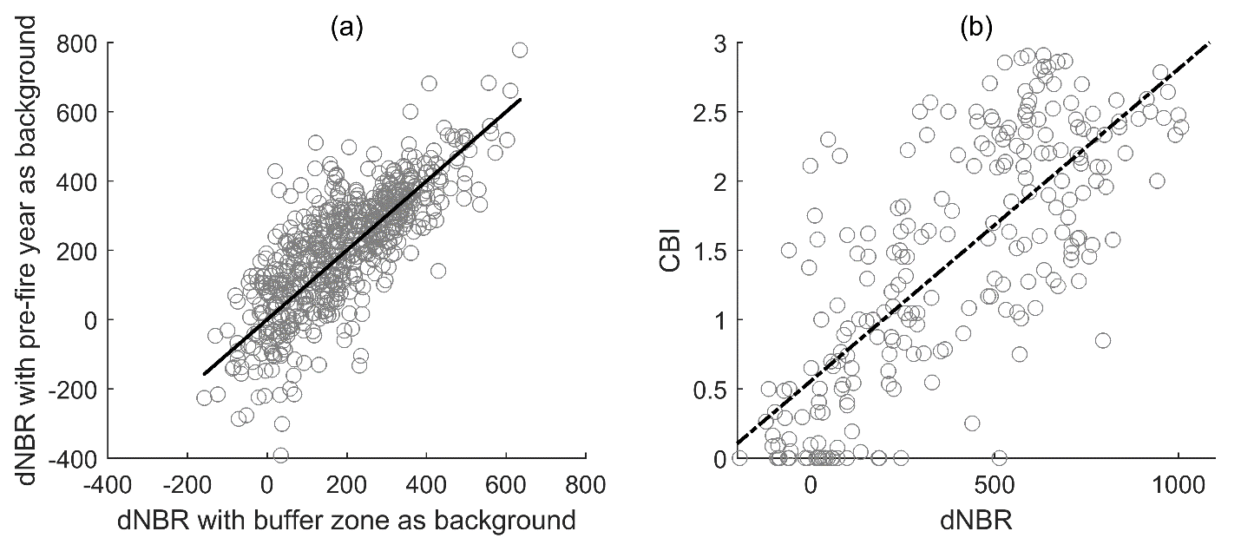
Supplementary Figure 3. Comparison between two methods of extracting dNBR and correlation between dNBR and CBI: (a) The comparison between two different methods to calculate the background dNBR. For the x axis, ‘buffer zone’ refers to the area between 1500 and 1800m out of the fire boundary. The black line represents the 1:1 line of x axis. The samples are all fire events in Alaska boreal forest during 2014-2018 (n = 634). (b) The linear correlation between dNBR and CBI (n = 234).

Supplementary Table 1. Comparison on combustion emission per unit area
Region | Combustion (kg C m⁻²) | Method | Source
Alaska | 1.4 | Estimated from dNBR and C stock | This study
 | 2.5 | Use nonlinear multiplicative model to environmental variables, fire time, pre-fire tree cover and dNBR | Veraverbeke, et al. ¹
 | 2.0 ± 0.3 | Field measurement | Rogers, et al. ²
 | 3.3 (1.5-4.6) | Field measurement | Boby, et al. ³
 | 1.6 ± 0.6 | Field measurement | Randerson, et al. ⁴
 | 1.7-3.0 | Estimated by fuel type | Kasischke and Hoy ⁵
 | 3.1 ± 0.7 | Estimated from land cover, drainage type and C stock | Tan, et al. ⁶
 | 3.0±0.12 | Field measurement | Turetsky, et al. ⁷
 | 2.5 | Summary from previous work | Turetsky, et al. ⁷
 | 2.2* | Estimated based on literature | Turquety, et al. ⁸
 | 2.8* | Field measurement | Turquety, et al. ⁸
 | 2.0 (1.7-2.4) | Estimated by severity, biomass and fire area | French, et al. ⁹
Canada | 2.1 | Estimated from dNBR and C stock | This study
 | 1.3 (1.8-3.9) | Estimated by fuel type and ecozone | Amiro, et al. ¹⁰
 | 3.2±0.5 | Estimated by Fire Behavior Prediction System | de Groot, et al. ¹¹
 | 4.3±1.1 | Estimated based on Boreal Fire Effects Model | de Groot, et al. ¹¹
 | 3.35 | Field measurement | Walker, et al. ¹²
 | 3.3 ± 1.1 | Field measurement | Dieleman, et al. ¹³
 | 2.5 ± 1.1 | Spatial modeling | Dieleman, et al. ¹³
 | 1.9* | Estimated based on literature | Turquety, et al. ⁸
 | 1.4-2.8* | Field measurement | Stocks, et al. ¹⁴
North America | 2.0 | Estimated by fuel type | This study
 | 2.7 | Estimated based on tree cover, climate and fire persistence | van der Werf, et al. ¹⁵
Global | 2.6-3.3 | Model simulation based on baseline conditions | Kasischke, et al. ¹⁶
 | 1.1-2.8 | Estimated from Boreal Wildland-Fire Emissions Model | Kasischke, et al. ¹⁷

* The values in the original literature are in dry matter per unit area, which are multiplied by 0.5 to convert into C per unit area.
Supplementary Table 2. Comparison between modeled and field-measured variables

Burn year | Soil organic layer thickness (cm) | Estimated soil combustion (%) | dNBR |  |  | Vegetation C (g C m⁻²) |  | Soil organic C (g C m⁻²)
 |  |  | estimated | actual |  | measured | modeled | measured |  | modeled
1969 | 14.1 | 25.0% | 506.5 | - |  | 2148.7 ± 581.4 | 1718.7 | 5556.0 ± 3245.6 |  | 5674.9
1990 | 10.2 | 40.0% | 633.3 | 686.7 |  | 698.9 ± 178.2 | 889.3 | 7460.9 ± 8298.7 |  | 5043.7
2012 | 5.0 | 65.0% | 844.7 | 811.5 |  | 220.4 ± 88.4 | 186.7 | 2612.3 ± 1422.2 |  | 3596.3
 | Soil organic N (g N m⁻²) |  | 5cm soil temperature (°C) |  |  |  | 10cm soil temperature (°C)
 | measured | modeled | measured |  | Modeled |  | measured |  | modeled
1969 | 197.0 ± 4.1 | 258.3 | 7.6 ± 2.0 |  | 9.2 |  | 5.3 ± 1.1 |  | 7.5
1990 | 264.6 ± 10.4 | 209.9 | 9.8 ± 0.5 |  | 8.0 |  | 7.7 ± 0.9 |  | 6.9
2012 | 108.1 ± 2.4 | 124.4 | 9.6 ± 2.8 |  | 7.8 |  | 6.8 ± 2.1 |  | 7.6

SI References

1 Veraverbeke, S., Rogers, B. M. & Randerson, J. T. Daily burned area and carbon emissions from boreal fires in Alaska. Biogeosciences 12, 3579-3601, doi:10.5194/bg-12-3579-2015 (2015).
2 Rogers, B. M. et al. Quantifying fire-wide carbon emissions in interior Alaska using field measurements and Landsat imagery. Journal of Geophysical Research: Biogeosciences 119, 1608-1629, doi:10.1002/2014jg002657 (2014).
3 Boby, L. A., Schuur, E. A. G., Mack, M. C., Verbyla, D. & Johnstone, J. F. Quantifying fire severity, carbon, and nitrogen emissions in Alaska's boreal forest. Ecological Applications 20, 1633-1647, doi:10.1890/08-2295.1 (2010).
4 Randerson, J. T. et al. The Impact of Boreal Forest Fire on Climate Warming. Science 314, 1130, doi:10.1126/science.1132075 (2006).
5 Kasischke, E. S. & Hoy, E. E. Controls on carbon consumption during Alaskan wildland fires. Global Change Biology 18, 685-699, doi:10.1111/j.1365-2486.2011.02573.x (2012).
6 Tan, Z., Tieszen, L. L., Zhu, Z., Liu, S. & Howard, S. M. An estimate of carbon emissions from 2004 wildfires across Alaskan Yukon River Basin. Carbon Balance and Management 2, 12, doi:10.1186/1750-0680-2-12 (2007).
7 Turetsky, M. R. et al. Recent acceleration of biomass burning and carbon losses in Alaskan forests and peatlands. Nature Geoscience 4, 27-31, doi:10.1038/ngeo1027 (2011).
8 Turquety, S. et al. Inventory of boreal fire emissions for North America in 2004: Importance of peat burning and pyroconvective injection. Journal of Geophysical Research: Atmospheres 112, doi:10.1029/2006JD007281 (2007).
9 French, N., Kasischke, E. & Williams, D. Variability in the emission of carbon-based trace gases from wildfire in the Alaskan boreal forest. J. Geophys. Res 107, doi:10.1029/2001JD000480 (2002).
10 Amiro, B. D. et al. Direct carbon emissions from Canadian forest fires, 1959-1999. Canadian Journal of Forest Research 31, 512-525, doi:10.1139/x00-197 (2001).
11 de Groot, W. et al. Estimating direct carbon emissions from Canadian wildland fires. International Journal of Wildland Fire 16, doi:10.1071/WF06150 (2007).
12 Walker, X. J. et al. Cross-scale controls on carbon emissions from boreal forest megafires. Global Change Biology 24, 4251-4265, doi:10.1111/gcb.14287 (2018).
13 Dieleman, C. M. et al. Wildfire combustion and carbon stocks in the southern Canadian boreal forest: Implications for a warming world. Global Change Biology 26, 6062-6079, doi:10.1111/gcb.15158 (2020).
14 Stocks, B. et al. Crown fire behaviour in a northern jack pine - Black spruce forest. Canadian Journal of Forest Research-revue Canadienne De Recherche Forestiere - CAN J FOREST RES 36, doi:10.1139/X06-185 (2004).
15 van der Werf, G. R. et al. Global fire emissions and the contribution of deforestation, savanna, forest, agricultural, and peat fires (1997–2009). Atmos. Chem. Phys. 10, 11707-11735, doi:10.5194/acp-10-11707-2010 (2010).
16 Kasischke, E. S., Christensen, N. L. & Stocks, B. J. Fire, Global Warming, and the Carbon Balance of Boreal Forests. Ecological Applications 5, 437-451, doi:10.2307/1942034 (1995).
17 Kasischke, E. S. et al. Influences of boreal fire emissions on Northern Hemisphere atmospheric carbon and carbon monoxide. Global Biogeochemical Cycles 19, doi:10.1029/2004GB002300 (2005).

