TgWRKY1
TgWRKY2
TgWRKY3
TgWRKY4
TgWRKY5
TgWRKY6
TgWRKY7
TgWRKY8
TgWRKY9
TgWRKY10
TgWRKY11
TgWRKY12
TgWRKY13
TgWRKY14
TgWRKY15
TgWRKY16
TgWRKY17
TgWRKY18
TgWRKY19
TgWRKY20
TgWRKY21
TgWRKY22
TgWRKY23
TgWRKY24
TgWRKY25
TgWRKY26
TgWRKY27
TgWRKY28
TgWRKY29
TgWRKY30
TgWRKY31
TgWRKY32
TgWRKY33
TgWRKY34
TgWRKY35
TgWRKY36
TgWRKY37
TgWRKY38
TgWRKY39
TgWRKY40
TgWRKY41
TgWRKY42
TgWRKY43
TgWRKY44
TgWRKY45
TgWRKY46
TgWRKY47
TgWRKY48
TgWRKY49
TgWRKY50
TgWRKY51
TgWRKY52
TgWRKY53
TgWRKY54
TgWRKY55
TgWRKY56
TgWRKY57
TgWRKY58
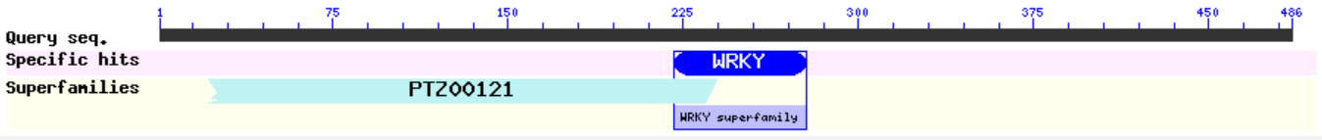
TgWRKY59
TgWRKY60
TgWRKY61
TgWRKY62
TgWRKY63
TgWRKY64
TgWRKY65
TgWRKY66
TgWRKY67
TgWRKY68
TgWRKY69
TgWRKY70
TgWRKY71
TgWRKY72
TgWRKY73
TgWRKY74
TgWRKY75
TgWRKY76
TgWRKY77
TgWRKY78
TgWRKY79
TgWRKY80
TgWRKY81
TgWRKY82
TgWRKY83
TgWRKY84
TgWRKY85
TgWRKY86
TgWRKY87
TgWRKY88
TgWRKY89
TgWRKY90
TgWRKY91
TgWRKY92
TgWRKY93
TgWRKY94
TgWRKY95
TgWRKY96
TgWRKY97
TgWRKY98
TgWRKY99
TgWRKY100
TgWRKY101
TgWRKY102

