SPINK7 expression changes accompanied by HER2, P53 and RB1 can be relevant to predict oral squamous cell carcinoma at molecular level

Gina Pennacchiotti, DMD^{1,7}; Fabio Valdés Garrido, MD²; Wilfredo A González-Arriagada, PhD³; Héctor F Montes, MD⁴; Judith MR Parra, DMD⁵; Valeria A Guida, DMD⁵; Silvina E Gómez, Bsc⁶; Martín E Guerrero-Gimenez, MD⁶; Juan M Fernandez-Muñoz, Bsc⁶; Felipe CM Zopino, PhD⁶; Rubén W Carón, PhD⁶; Marcelo E Ezquer, PhD⁷; Ricardo Fernández-Ramires, PhD⁸ and Flavia A Bruna, PhD^{5,6,7}.

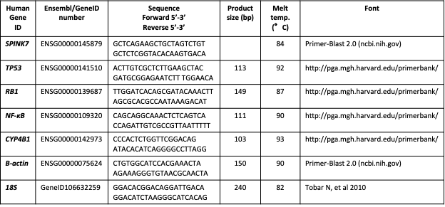
Supplementary table 1. Primers data used in the qPCR analysis

