Supplementary documents

Viral Hepatitis-HIV Co-Infection and their associated factors in Negeri Sembilan - a cross sectional study from HIV Case Registry
(NMRR ID: NMRR-19-3803-52335 (IIR)
Siti Aishah Binti Abas^{1*}, Ahmad Taufik Bin Jamil¹, Mohd Shahril Bin Ahmad Saman¹, Mariam Binti Mohammad^{1,} Sharifah Nor Binti Ahmad ²
¹Department of Public Health Medicine, Faculty of Medicine, Universiti Teknologi Mara (UiTM) Sungai Buloh Campus, 47000, Selangor, Malaysia
²HIV, Sexually Transmitted Disease and Hepatitis C Unit, Negeri Sembilan State Health Department, Jalan Rasah, Bukit Rasah, 70300 Seremban, Negeri Sembilan
*Correspondence: aishah.abas@gmail.com

Appendix 1
Table 1: Operational definition for dependent variables
Variables | Operational Definition | Scale of measurement
Human Immunodeficiency Virus | A diagnosis confirm by a series of few different assays which are usually Rapid Diagnostic Test (RDTs) followed by Enzyme Immunoassays (EIAs) | Categorical (nominal)  Yes or No
HBV (Hepatitis B Virus)-HIV coinfection | Diagnosed when positive Hep B s Ag (HbsAg) and Anti-Hep Bs (HbsAb), consider for testing for Anti-hep b core antibody (HBc Ab total ) if Hep Bs Ag negative and liver function test abnormal | Categorical (nominal)  Yes or No
Hepatitis C (HCV)-HIV Coinfection | Diagnostic should be when anti-HCV are detected ,the presence of HCV RNA or alternatively HCV core antigen( if HCV RNA assays are not available and /not affordable) in serum or plasma.  Currently Malaysia using RDT SD Bioline by finger prick or venous whole blood sample | Categorical (nominal)  Yes or No

Table 2: Operational definition of independent variables
Variables | Operational Definition | Scale of measurement
Age | Age of respondent during HIV diagnosis | Numerical (continuous data ) then will be categorized into 20-29,30-39 ,40-49,>51 years old. [68]
CD4 level | CD4+ T helper cells are white blood cells that are an essential part of the human immune system, CD4 level. Which HIV virus kills. When the CD4 count drops below 200, a person is diagnosed with AIDS. | Numerical (continuous data ) then will be categorized into , <199, 200-349 (cells/mm3) ,>350 (cells/mm3) according to WHO clinical stage of HIV-infected patients (WHO,2007)
Race | Respondent’s ethnicity | Categorical (nominal)  Malay,Chinese,others
Gender | Respondent’s sex | Categorical (nomimal )  Male or female
Marital status | Respondent’s marital status | Categorical (nominal)  Single,Married,divorce
Modes of transmission | How respondent’s acquired HIV | Categorical (nominal)  IVDU,Heteroseksual,Biseksual,Homoseksual in descriptive part but further classified into either sexual transmission and IVDU in analysis part
Occupation | Occupation of respondent | Categorical (nominal)  Professional  Non professional  Student
Type of facilities | Where patient seek for treatment | Categorical (nominal)  Klinik Kesihatan ,Hospital
Source of case | From which screening program did the patient knew their HIV status | Categorical (nominal)  1)General Population screening (Blood Donation screening ,Prevention Mother To Child Transmission screening, Preweding screening)  2) Voluntary screening( Medical check up and Voluntary Counseling Testing)  3)Diagnostic screening(Advice by doctor)  4)High Risk screening(Prison and Methadone program)

Appendix 2: Ethical Approval letters from Medical Research and Ethics Commitee
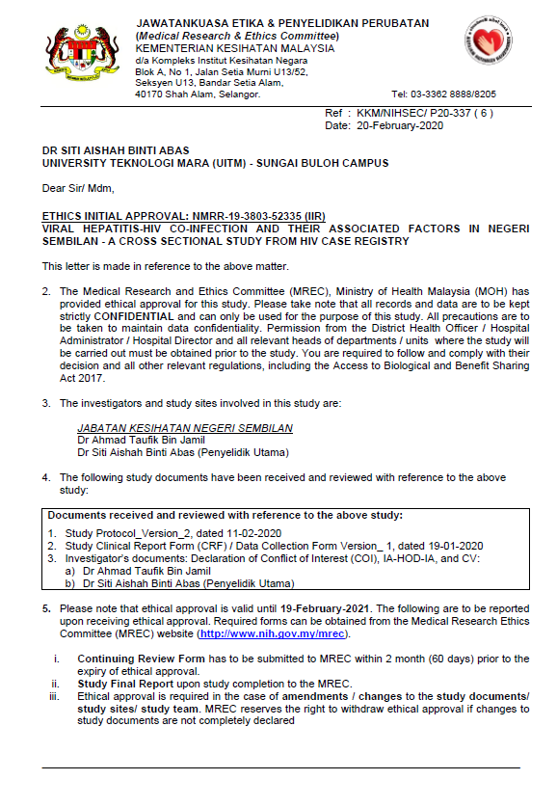
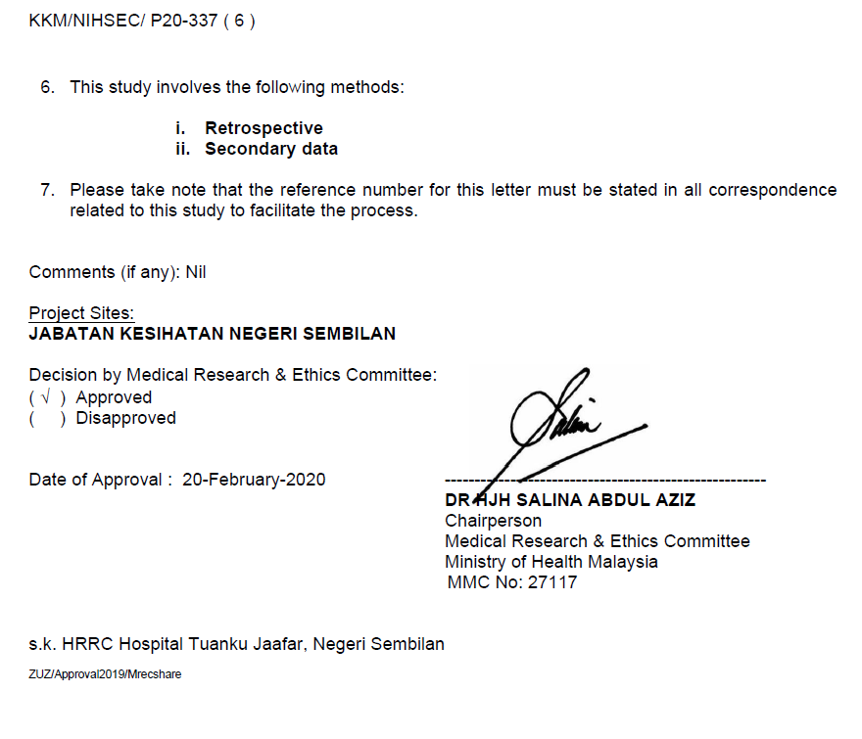

Appendix 3: Approval letter from Negeri Sembilan State Health Department,Malaysia

