**Fig. 6a** The interaction of MdMYB73 andMdWRKY31 was verified via yeast two-hybrid assays.

**-T/-L**

**10 10-1 10-2 10-3**

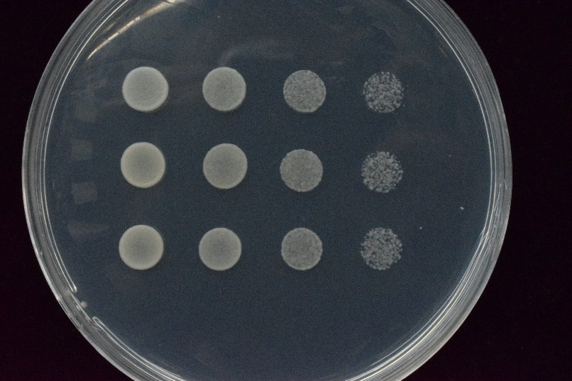

**pGAD pGBD**

**MdWRKY31+MdMYB73**

**MdWRKY31+ pGBD**

**pGAD+MdMYB73**

**-T/-L/-H/-A**

**10 10-1 10-2 10-3**

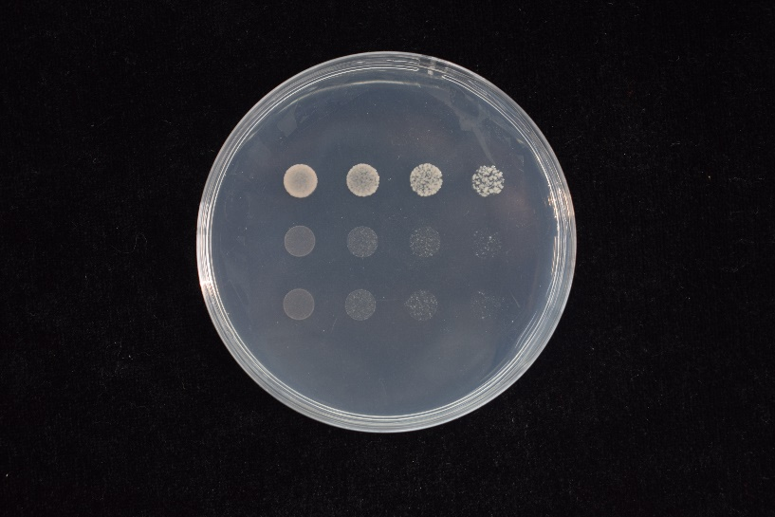

**pGAD pGBD**

**MdWRKY31+MdMYB73**

**MdWRKY31+ pGBD**

**pGAD+MdMYB73**

**Fig. 6b** *In vitro* pull-down assays were performed to verify the interaction between MdMYB73 and MdWRKY31. Pound sign represents GST protein. Asterisk represents MdMYB73-GST protein.

**MdWRKY31-His**

**MdMYB73-GST**

**GST**

**Input Pull down**

**+ + + +**

**- + - +**

**+ - + -**

**WB: anti-His**





**Input Pull down**

**+ + + +**

* **+ - +**

**+ - + -**

**#**

**\***

**MdWRKY31-His**

**MdMYB73-GST**

**GST**

**WB：anti-GST**

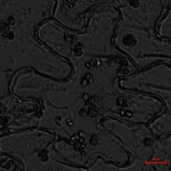**Fig. 6c** MdMYB73 was confirmed to interact with MdWRKY31 in the bimolecular fluorescence complementary assay.

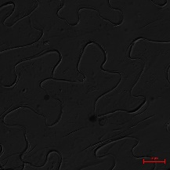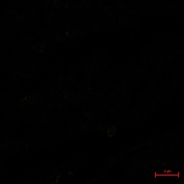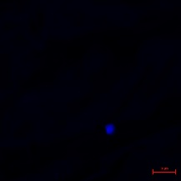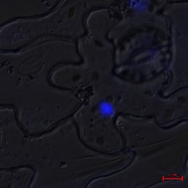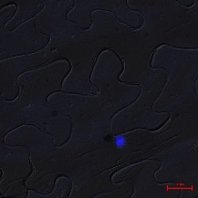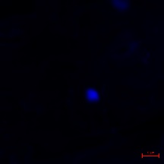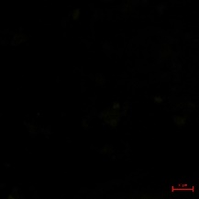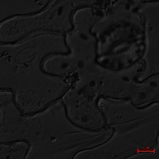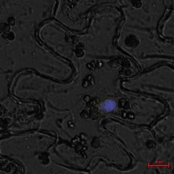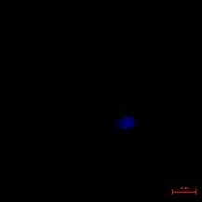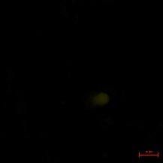

**MdMYB73-YFPN+**

**YFPC**

**MdWRKY31-YFPC+**

**YFPN**

**MdWRKY31-YFPC+**

**MdMYB73-YFPN**

**Merge**

**DAPI**

**YFP**

**BF**