Characteristics of PCDD/Fs in PM_{2.5} from Emission Stacks and the Nearby Ambient Air in Taiwan
Supplementary Material
Shih Yu Pan ¹, Yi Ting Liou¹, Moo Been Chang ², Charles C.-K. Chou ³,
Tuan Hung Ngo^{1, 4} and Kai Hsien Chi¹*
¹ Institute of Environmental and Occupational Health Sciences, National Yang Ming University, Taipei 112, Taiwan.
² Graduate Institute of Environmental Engineering, National Central University, Chungli 320, Taiwan.
³ Research Center for Environmental Changes, Academia Sinica, Taipei 115, Taiwan.
⁴ International Health Program, National Yang Ming University, Taipei, 112, Taiwan.

Corresponding author:
Kai Hsien Chi, email: khchi2@ym.edu.tw
Co-author:
Yi Ting Liou, email: yiti0408@gmail.com
Moo Been Chang, email: mbchang@ncuen.ncu.edu.tw
Charles C.-K. Chou, email: ckchou@gate.sinica.edu.tw
Tuan Hung Ngo, email: tuanhung0712@gmail.com

Table S1 Chemical compounds of PM_{2.5} measured in flue gas of different facilities
Emission Sources (μg/m³) | CFB (n=6) | MWI (n=6) | EAF (n=6)
Na⁺ | 1.16±0.27 | 36.4±7.78 | 7.69±2.66
NH₄⁺ | 0.185 | - | 0.206±0.183
K⁺ | 0.641±0.099 | 51.0±11.9 | 7.42±2.42
Mg²⁺ | 3.67±1.71 | 0.436±0.121 | 0.386±0.318
Ca²⁺ | 88.3±16.5 | 12.5±4.56 | 1.96±0.567
Cl⁻ | 34.9±55.2 | 95.1±25.0 | 30.3±9.67
NO₃⁻ | 5.96±5.19 | - | 4.32±1.52
PO₄³⁻ | 4.51±0.906 | 0.468±0.069 | -
SO₄²⁻ | 112±29.7 | 35.2±9.01 | 3.56±0.822

Table S2 Concentrations of water-soluble ion in atmospheric PM_{2.5} measured in the vicinity of different emission sources.
Site  (μg/m³) | C 1  (n=3) | C2  (n=3) | M 1  (n=3) | M 2  (n=3) | E 1  (n=3) | E 2  (n=3) | Background  (n=4)
Na⁺ | 0.286±0.096 | 0.305±0.081 | 0.284±0.298 | 0.224±0.256 | 0.188±0.027 | 0.191±0.031 | 0.024±0.015
NH₄⁺ | 0.936±0.380 | 0.990±0.400 | 0.684±0.573 | 0.631±0.655 | 4.47±0.504 | 5.21±0.599 | 0.079±0.068
K⁺ | 0.150±0.025 | 0.175±0.038 | 0.091±0.025 | 0.103±0.029 | 0.286±0.123 | 0.337±0.113 | 0.013±0.008
Mg²⁺ | 0.043±0.011 | 0.044±0.011 | 0.046±0.030 | 0.036±0.026 | 0.049±0.009 | 0.054±0.014 | 0.023±0.007
Ca²⁺ | 0.144±0.013 | 0.170±0.014 | 0.170±0.033 | 0.173±0.035 | 0.149±0.018 | 0.163±0.027 | 0.169±0.032
Cl⁻ | 0.095±0.099 | 0.066±0.038 | 0.105±0.422 | 0.130±0.339 | 0.235±0.044 | 0.266±0.069 | 0.048±0.019
NO₃⁻ | 0.606±0.059 | 0.619±0.101 | 0.287±0.160 | 0.422±0.266 | 1.69±0.827 | 2.87±0.928 | 0.156±0.080
PO₄³⁻ | 0.017±0.010 | 0.025±0.010 | 014±0.005 | 0.017±0.006 | 056±0.026 | 0.058±0.029 | 005±0.002
nss-SO₄²⁻ | 2.74±0.838 | 2.99±0.922 | 2.33±1.56 | 2.18±1.65 | 9.29±0.843 | 10.0±0.599 | 0.557±0.236

Table S3 Enrichment Factor (EF) value of trace metals in atmospheric PM_{2.5} measured in the vicinity of different emission sources.
Site  Compound | C1 | C2 | M1 | M2 | E1 | E2 | Background
Al | 1.0 | 1.0 | 1.0 | 1.0 | 1.0 | 1.0 | 1.0
Fe | 1.58 | 1.5 | 0.55 | 0.63 | 0.83 | 0.87 | 0.5
Na | 11.6 | 8.89 | 6.01 | 5.46 | 4.83 | 5.00 | 2.25
Mg | 1.87 | 1.59 | 1.64 | 1.55 | 1.38 | 1.45 | 1.16
K | 6.88 | 5.44 | 2.28 | 2.59 | 3.97 | 4.55 | 1.51
Ca | 1.64 | 1.63 | 2.33 | 2.57 | 2.43 | 2.48 | 2.96
Sr | 2.06 | 1.39 | 1.46 | 1.48 | 1.84 | 2.03 | 1.35
Ba | 5.73 | 3.18 | 4.93 | 6.00 | 5.7 | 6.65 | 7.41
Ti | 0.7 | 0.79 | 0.55 | 0.68 | 0.61 | 0.68 | 0.6
Mn | 3.54 | 5.57 | 1.31 | 1.58 | 3.57 | 3.25 | 1.14
Co | 1.49 | 2.08 | 1.24 | 1.3 | 3.17 | 2.34 | 0.88
Ni | 23.6 | 18.3 | 12.5 | 12.4 | 32.8 | 21.2 | 24.9
Cu | 56.9 | 250 | 17.4 | 21.2 | 44.1 | 52.5 | 18.8
Zn | 283 | 218 | 100 | 114 | 303 | 371 | 51
Mo | 9114 | 4,499 | 20289 | 19516 | 19759 | 20563 | 3839
Cd | 1130 | 875 | 252 | 317 | 1076 | 1123 | 122
Sn | 1631 | 1020 | 123 | 168 | 503 | 519 | 21
Sb | 3331 | 3328 | 1251 | 2013 | 2725 | 3422 | 143
Tl | 62.1 | 69.5 | 13.6 | 19.4 | 59.2 | 65 | 6.25
Pb | 270 | 279 | 91.6 | 70.3 | 228 | 251 | 22.6
V | 40.3 | 24.6 | 3.95 | 3.86 | 15.4 | 16.9 | 1.71
Cr | 21.9 | 17 | 17.6 | 19.6 | 23.1 | 21.8 | 20.8
As | 254 | 215 | 61.4 | 84.9 | 282 | 310 | 14.4
Y | 6.66 | 3.53 | 14.1 | 13.6 | 13.9 | 14.7 | 12.5
Se | 28137 | 18982 | 1180 | 1998 | 9572 | 10803 | 1509
Zr | 11.6 | 7.00 | 20.9 | 20.8 | 21.3 | 22.5 | 17.4
Ge | 176 | 127 | 359 | 357 | 366 | 380 | 267
Rb | 2.62 | 2.43 | 1.09 | 1.22 | 1.87 | 2.11 | 1.08
Cs | 4.08 | 4.32 | 1.65 | 2.00 | 4.58 | 5.13 | 1.46
Ga | 10.9 | 7.88 | 8.4 | 9.28 | 12.8 | 14.7 | 9.79
La | 2.92 | 3.01 | 3.76 | 3.77 | 3.83 | 3.97 | 2.37
Ce | 1.38 | 1.5 | 3.16 | 3.26 | 3.13 | 3.24 | 2.35
Nd | 1.74 | 1.7 | 3.4 | 3.52 | 3.37 | 3.5 | 2.5

Table S4 The relative risk of mortality between PM_{2.5} mass concentrations exposure group in E 2 vs M 1.
E 2 vs M 1  Cause of Death | ALL |  | Male |  | Female
 | Relative Risk(95%CI) | p-value | Relative Risk(95%CI) | p-value | Relative Risk(95%CI) | p-value
All causes of death (A00-Y98) | 1.432(1.251-1.640) | <.0001 | 1.384(1.229-1.557) | <.0001 | 1.492(1.272-1.750) | <.0001
Cerebrovascular disease (I60-I69) | 1.473(0.863-2.513) | 0.156 | 1.327(0.836-2.105) | 0.230 | 1.589(0.851-2.968) | 0.146
Pneumonia (J12-J18) | 1.992(1.146-3.462) | 0.015 | 2.084(1.296-3.349) | 0.002 | 1.777(0.910-3.471) | 0.092
Malignant neoplasms (C00-C97) | 1.362(1.065-1.741) | 0.014 | 1.408(1.135-1.746) | 0.002 | 1.273(0.955-1.696) | 0.100
Cancers of liver and intrahepatic bile ducts (C22) | 2.158(1.125-4.139) | 0.021 | 2.005(1.182-3.403) | 0.01 | 2.427(1.001-5.887) | 0.050
Cancers of trachea, bronchus and lung (C33-C34) | 1.432(0.808-2.536) | 0.219 | 1.297(0.774-2.174) | 0.323 | 1.596(0.842-3.027) | 0.152
Cancers of colon, rectum and anus (C18-C21) | 1.154(0.576-2.309) | 0.686 | 0.951(0.490-1.845) | 0.881 | 1.404(0.678-2.904) | 0.361
Female breast cancer (C50) | - | - | - | - | 1.349(0.595-3.057) | 0.474

Table S5. The relative risk of mortality between PCDD/F concentrations exposure group in C2 vs M1.
C 2 vs M 1  Cause of Death | ALL |  | Male |  | Female
 | Relative Risk(95%CI) | p-value | Relative Risk(95%CI) | p-value | Relative Risk(95%CI) | p-value
All causes of death (A00-Y98) | 1.236(1.075-1.422) | 0.003 | 1.158(1.024-1.309) | 0.020 | 1.276(1.082-1.505) | 0.004
Cerebrovascular disease (I60-I69) | 1.521(0.895-2.587) | 0.121 | 1.344(0.848-2.129) | 0.209 | 1.526(0.813-2.864) | 0.188
Pneumonia (J12-J18) | 0.987(0.520-1.872) | 0.968 | 0.843(0.474-1.501) | 0.563 | 1.101(0.525-2.307) | 0.800
Malignant neoplasms (C00-C97) | 1.094(0.845-1.416) | 0.496 | 1.053(0.837-1.326) | 0.659 | 1.099(0.817-1.479) | 0.532
Cancers of liver and intrahepatic bile ducts (C22) | 1.466(0.729-2.947) | 0.283 | 1.121(0.619-2.031) | 0.706 | 2.121(0.858-5.240) | 0.103
Cancers of trachea, bronchus and lung (C33-C34) | 1.275(0.710-2.291) | 0.416 | 1.363(0.818-2.273) | 0.235 | 1.046(0.519-2.111) | 0.900
Cancers of colon, rectum and anus (C18-C21) | 0.965(0.468-1.992) | 0.923 | 0.922(0.473-1.800) | 0.813 | 0.950(0.429-2.105) | 0.899
Female breast cancer (C50) | - | - | - | - | 1.096(0.465-2.583) | 0.834

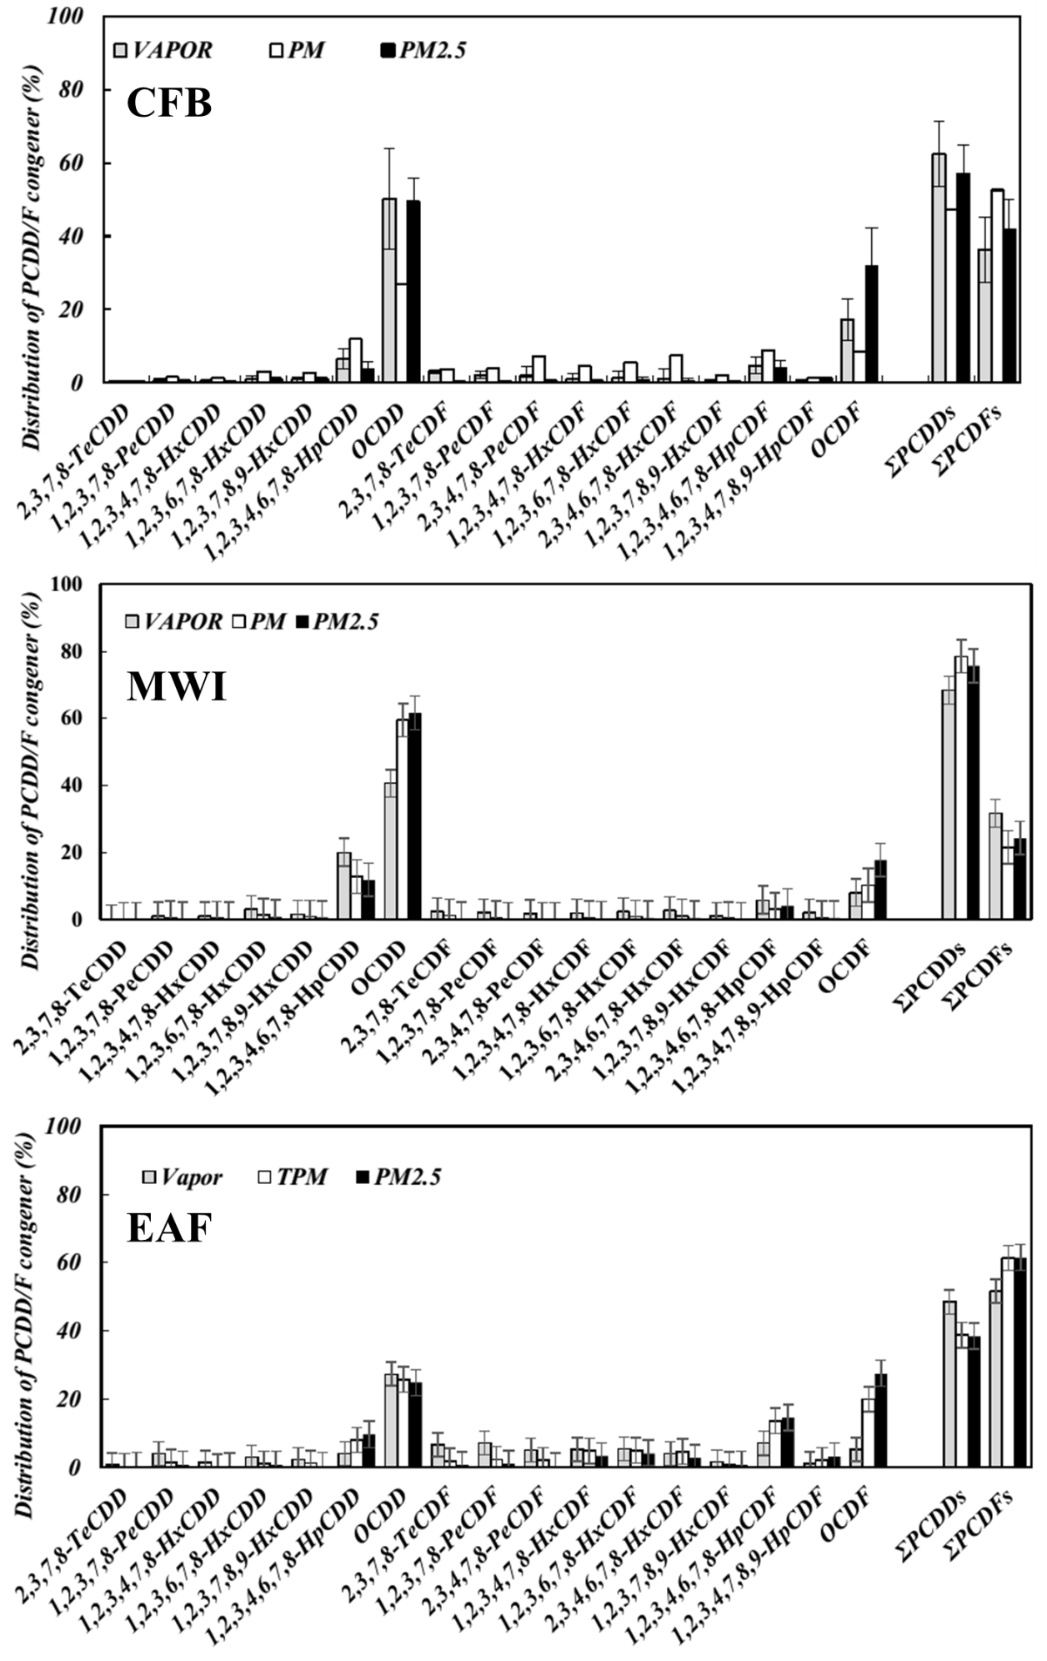

Fig.S1 The distribution of PCDD/F congeners measured in stack gases at different facilities.

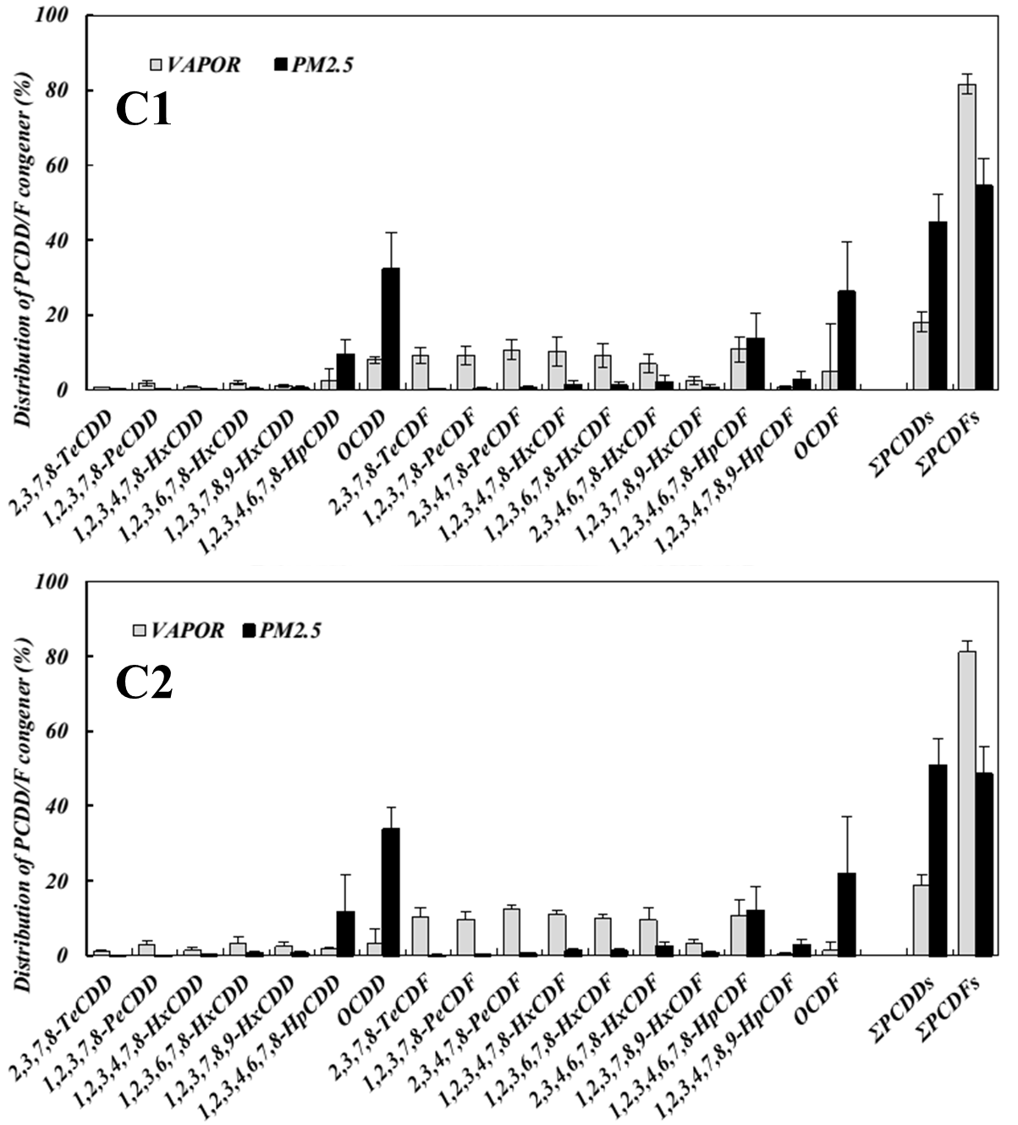

Fig.S2 The distribution of PCDD/F congeners measured in ambient air in the coal-fired boiler (CFB).

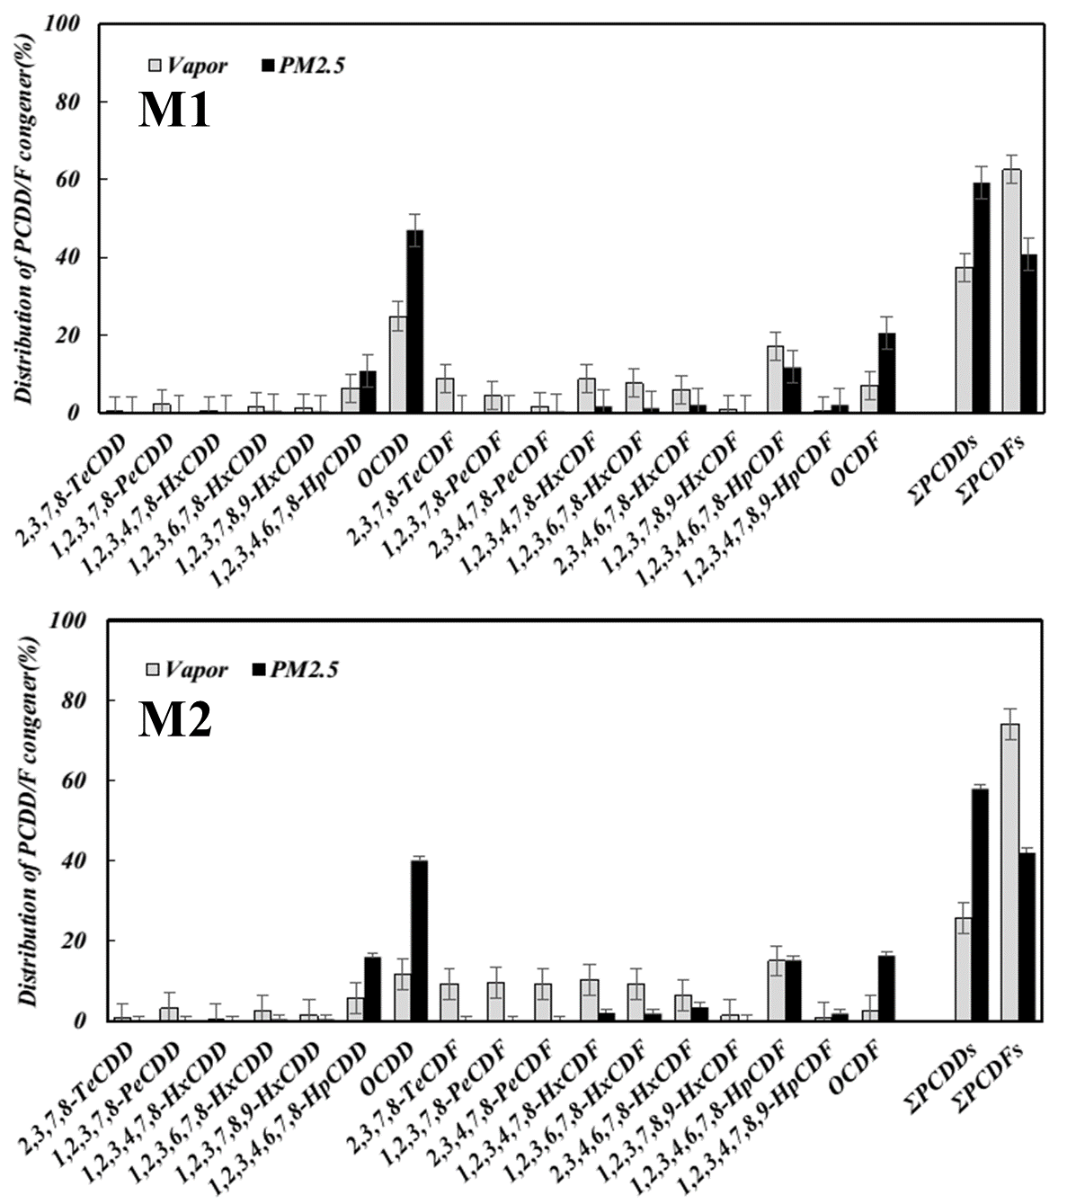

Fig.S3 The distribution of PCDD/F congeners measured in ambient air in the municipal waste incinerator (MWI).

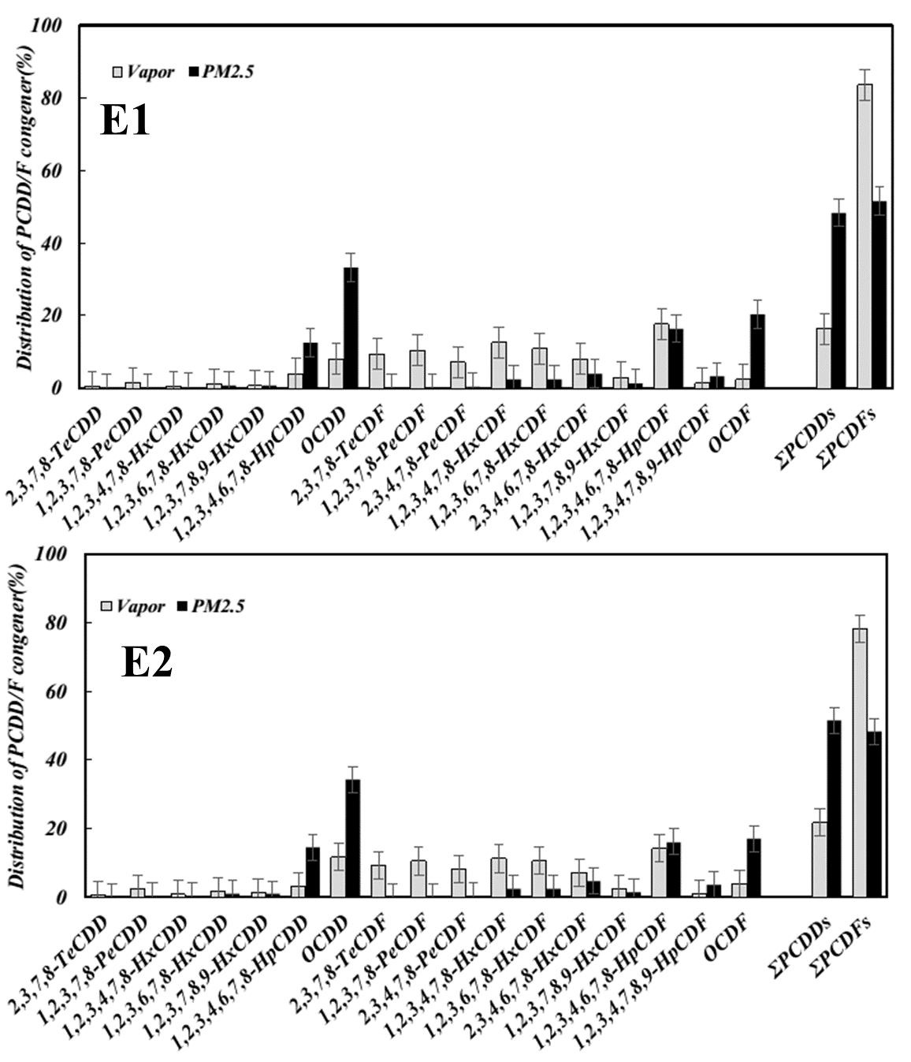

Fig.S4 The distribution of PCDD/F congeners measured in ambient air in the electric arc furnace (EAF).

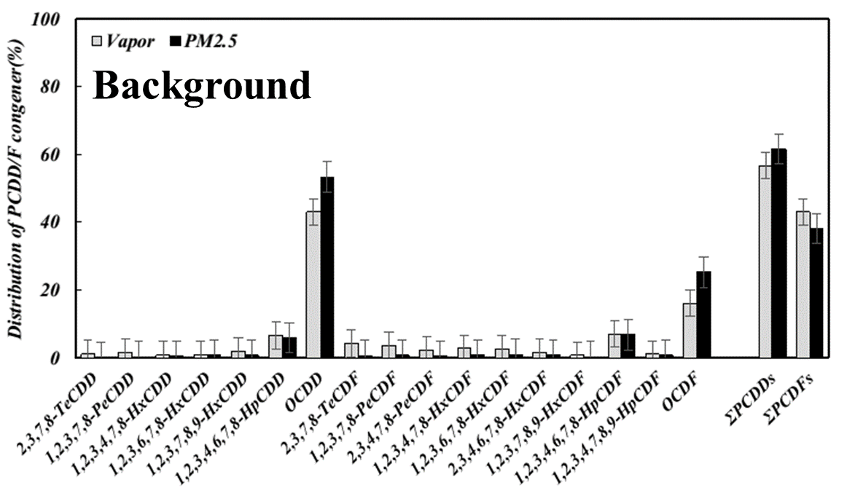

Fig.S5 The distribution of PCDD/F congeners measured in ambient air in the background site (Mt.Lulin).
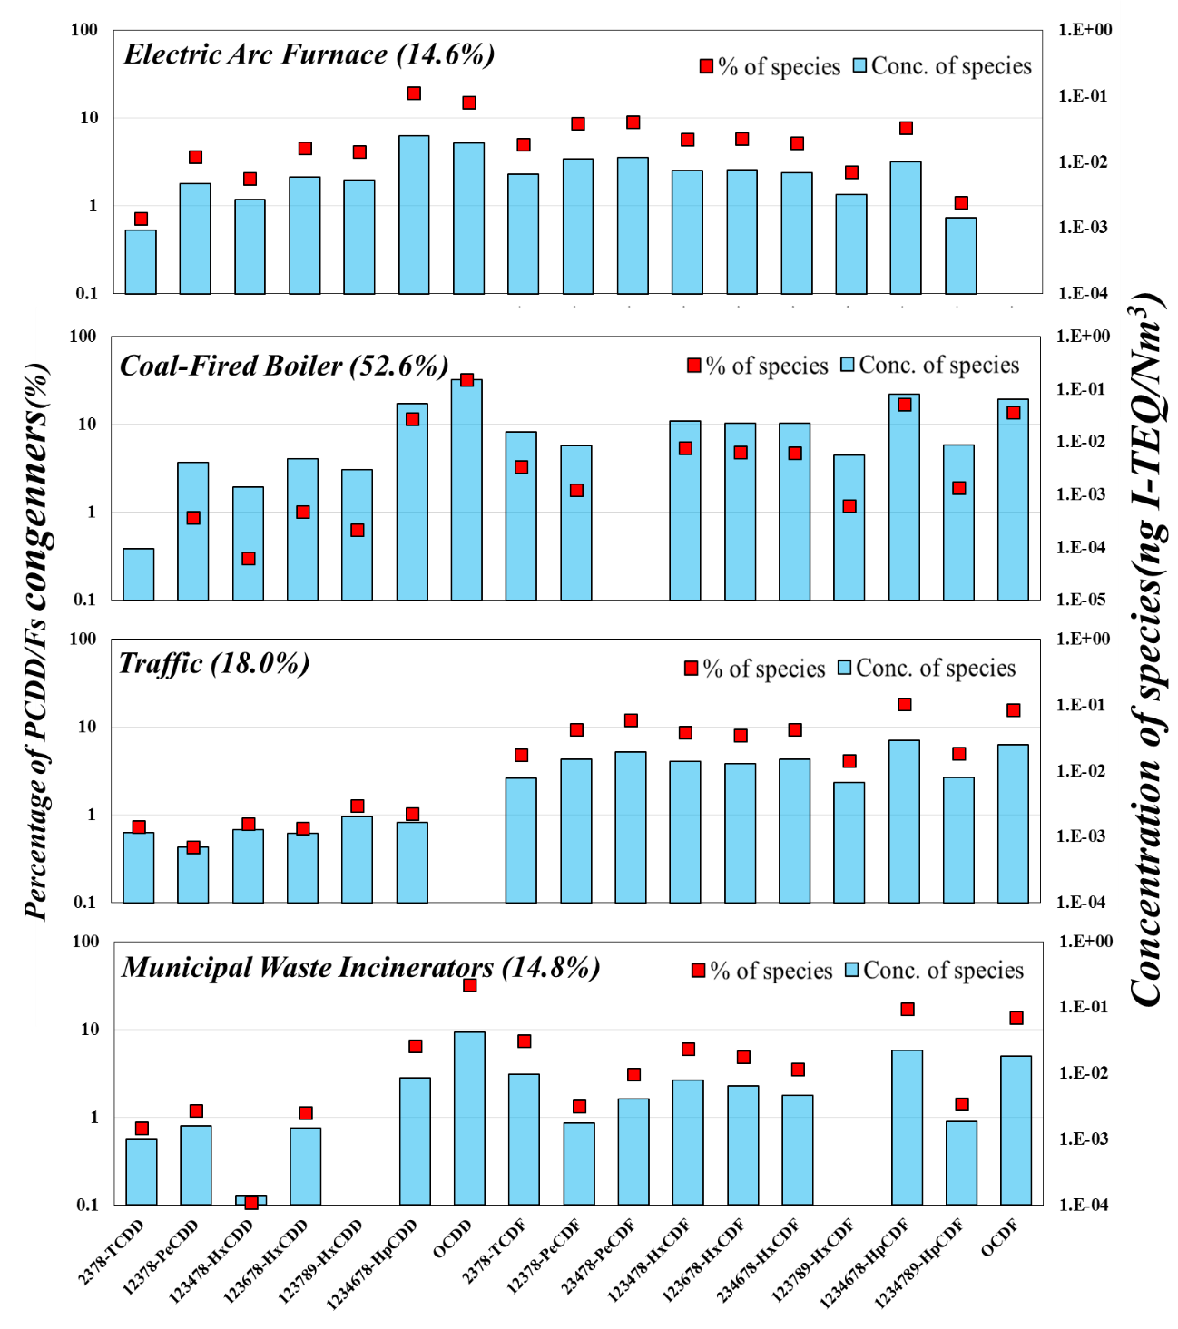

Fig.S6 Source apportionment of atmospheric PCDD/Fs in the vicinity of stationary pollution in Taiwan by using PMF.

