SUPPLEMENTARY INFORMATION

Low dose hydroxychloroquine is associated with lower mortality in COVID-19: a meta-analysis of 27 studies and 44,684 patients
Augusto Di Castelnuovo (1), Simona Costanzo (2), Antonio Cassone (3), Roberto Cauda (4), Giovanni de Gaetano (2) and Licia Iacoviello (2, 5)
(1) Mediterranea Cardiocentro, Napoli, Italy. (2) Department of Epidemiology and Prevention, IRCCS Neuromed, Pozzilli, Italy. (3) Polo della genomica, genetica e biologia, Università di Siena, Italy. (4) Fondazione Policlinico Universitario A. Gemelli IRCCS Università Cattolica S. Cuore Roma. (5) Research Centre in Epidemiology and Preventive Medicine (EPIMED), Department of Medicine and Surgery, University of Insubria, Varese, Italy

Running title: Hydroxychloroquine and mortality in COVID-19 patients

Address for correspondence: Licia Iacoviello, MD, PhD
Department of Epidemiology and Prevention, IRCCS Neuromed
Via dell'Elettronica, 86077 Pozzilli (IS), Italy
Phone: +39 3485108779
E-mail: licia.iacoviello@moli-sani.org

Word count: 3139, Number of tables: 2, Number of figures: 3, Number of supplementary figures: 6
Keywords: Sars-Cov-2, COVID-19, hydroxychloroquine, mortality

Supplementary Figure 1
Forest plot for association of hydroxychloroquine use with COVID-19 mortality (random effects), according to daily dose (as estimated in the days of treatment following the first)
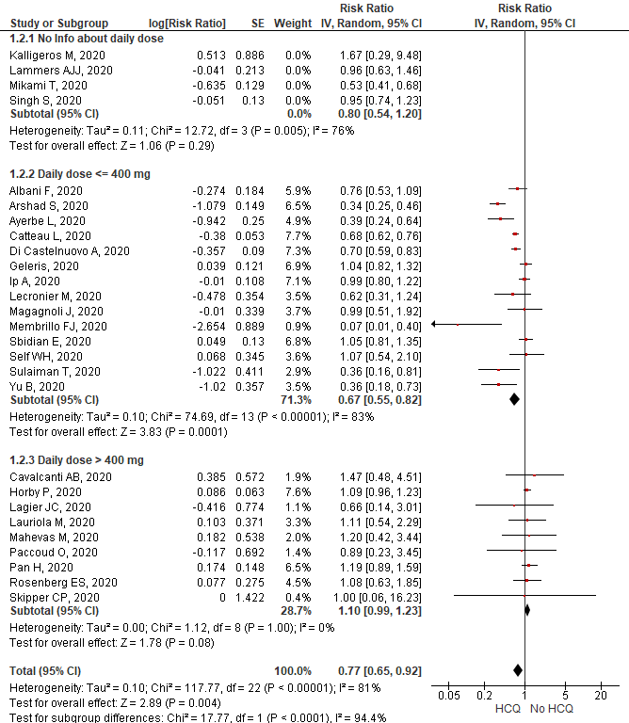
Supplementary Figure 2
Forest plot for association of hydroxychloroquine use with COVID-19 mortality (random effects), according to duration of treatment
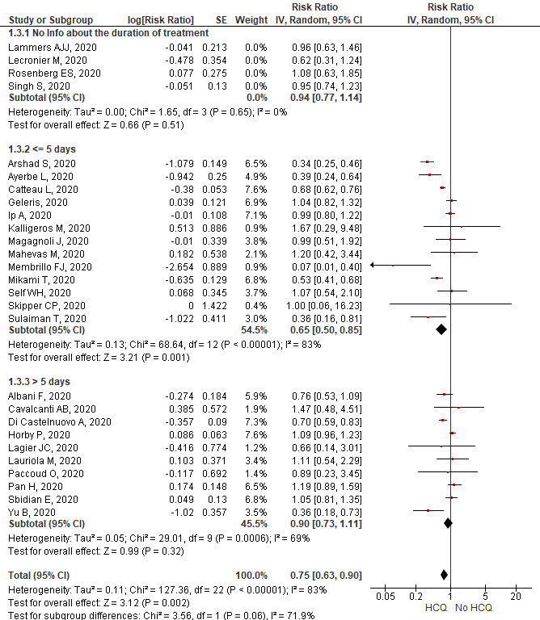
Supplementary Figure 3
Forest plot for association of hydroxychloroquine use with COVID-19 mortality (random effects), according to total dose (calculated as the sum of the amount of drug used in the first day plus daily dose multiplied by number of days of treatment following the first) 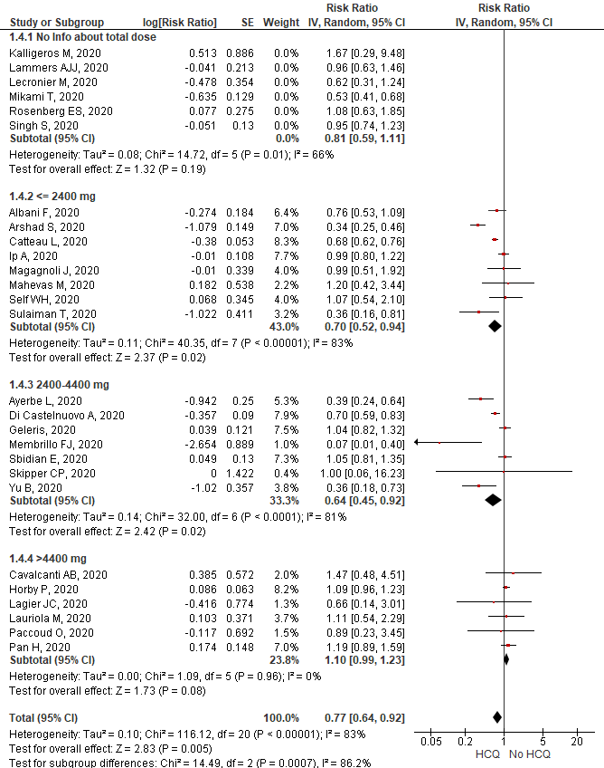
Supplementary Figure 4
Forest plot for association of hydroxychloroquine use with COVID-19 mortality (random effects), according to both daily dosing and number of days of treatment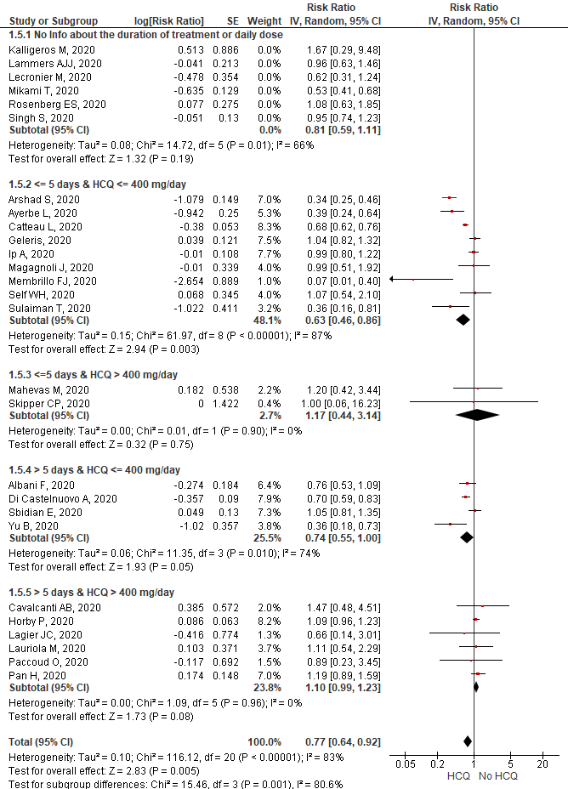
Supplementary Figure 5
Forest plot for association between HCQ treatment (panel A) or HCQ+AZM (panel B) and mortality in COVID-19 patients
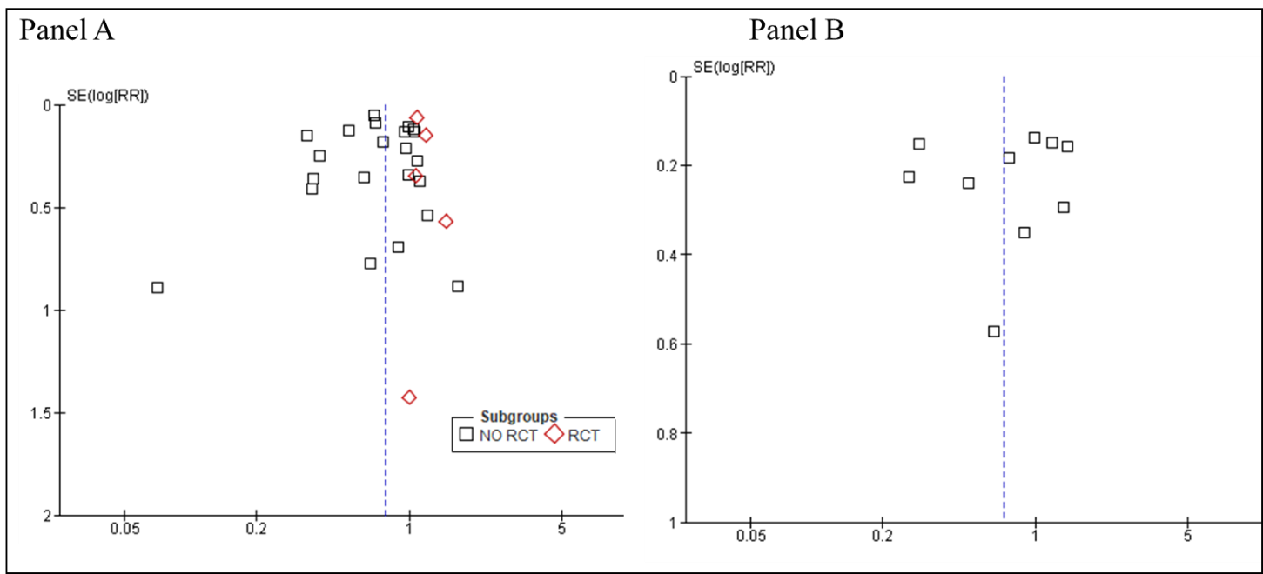

RCT mean randomized controlled trial; RR means relative risk; SE means standard error; HCQ means hydroxychloroquine; AZM means azithromycin

Supplementary Figure 6
Forest plot for association of hydroxychloroquine use with any (panel A) or major (panel B) adverse effects. Data are from randomised clinical trials. The study by Mitja et al. (ref=meta esclusi 3) was not included in the meta-analysis on mortality since the authors found no deaths both in HCQ and control group.

A)

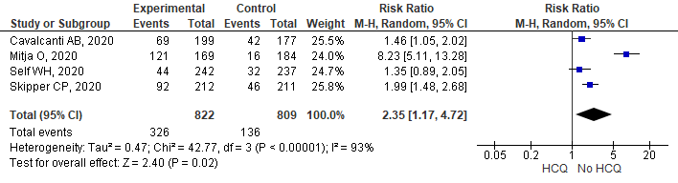
B)
