**Appendix 1: Summary of STAR MAMA Weekly Topics**

**MOM**

**BABY**

**Legend**

**Mom**

**Legend**

**Baby**

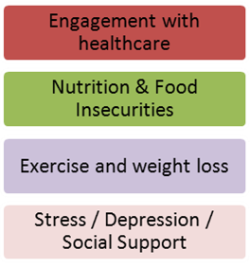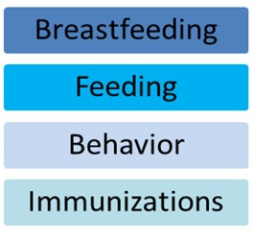

**MOM**

**Facts about Carbs-2**

**BABY**

**MOM**

**BABY**

**MOM**

**BABY**

**MOM**

**BABY**