Supplementary Information for

BEAR reveals that increased fidelity variants can successfully reduce the mismatch-tolerance of adenine but not cytosine base editors

András Tálas*, Dorottya A. Simon, Péter I. Kulcsár, Éva Varga, Ervin Welker*

* Corresponding author. E-mail: talas.andras@ttk.hu, welker.ervin@ttk.hu

Contents:

Supplementary Figure 1 – Canonical and non-canonical 5’ splice sites examined in BEAR

Supplementary Figure 2 – Splice site variants for identifying candidate BEAR sequences

Supplementary Figure 3 – Versatility of BEAR allowing of its compatibility with different sequences

Supplementary Figure 4 – Correlations between the editing efficiencies of ABE and CBE variants

Supplementary Figure 5 – Correlations between base editor activities with 50 mismatching sgRNAs

Supplementary Figure 6 – Off-target activities of different ABE variants on target 7 with 50 mismatching sgRNAs

Supplementary Figure 7 – Off-target activities of different ABE variants on three additional targets with 31 mismatching sgRNAs
Supplementary Methods – Detailed plasmid construction
Supplementary Table 1 – List of oligonucleotides

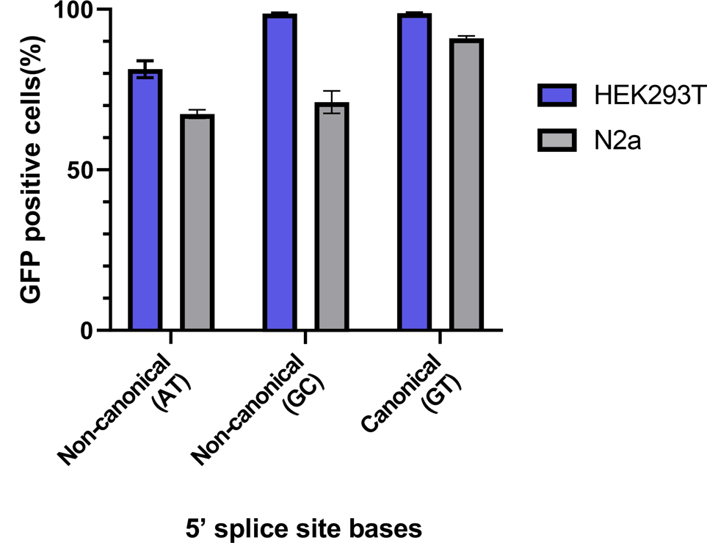

Figure S1 – Canonical and non-canonical 5’ splice sites examined in BEAR
Canonical (GT) or non-canonical (AT or GC) 5’ splice sites were constructed into the split GFP coding plasmid (Fig. 1) and were transformed either into HEK293T (blue) or N2a (grey) cells. Columns represent means +/- SD of three parallel transfections.

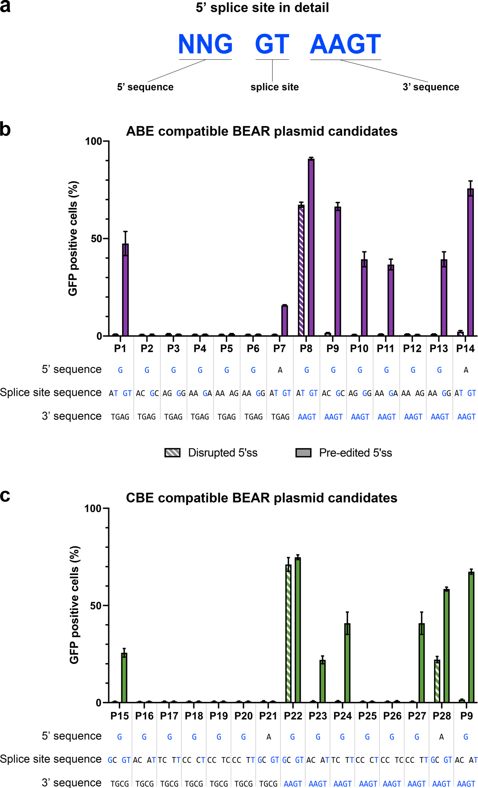

Figure S2 – Splice site variants for identifying candidate BEAR sequences in N2a cells
Flow cytometry measurements of GFP positive N2a cells transfected with ABE (b) or CBE (c) editing compatible reporter plasmids harboring systematically altered splice sites. The letters beneath the column charts represent the intended disrupted or pre-edited splice site sequences. Letters highlighted in blue indicate the bases that correspond to the canonical (a) 5’ - G GT AAGT - 3’ consensus splice site sequence, and sequence alterations are shown in black. Columns represent means, +/- SD of three parallel transfections.

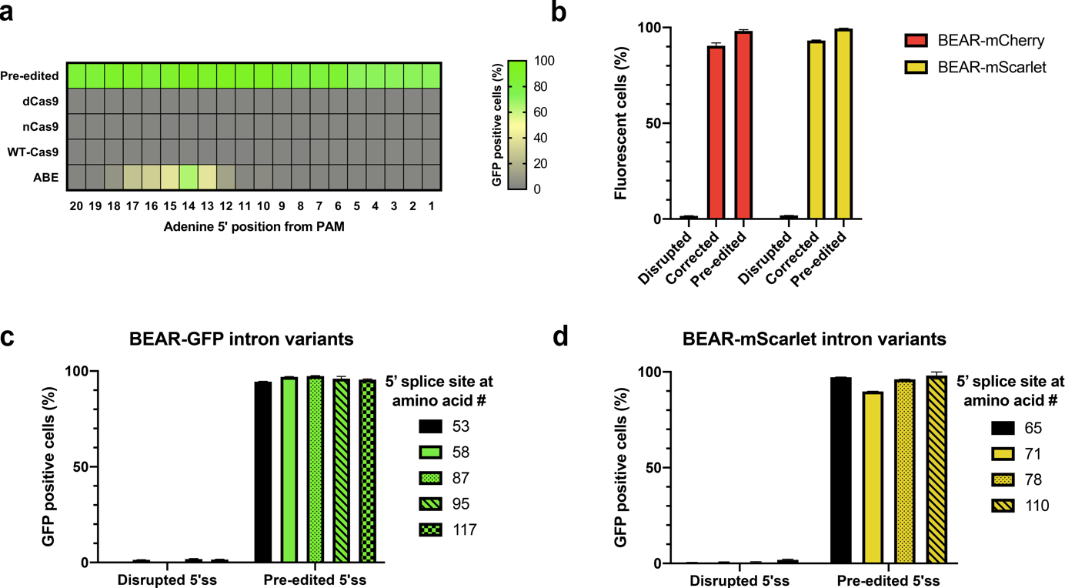

Figure S3 – Versatility of BEAR allowing of its compatibility with different sequences
(a) The PAM motif was freely moved in context of the edited base in the entire span of the spacer, thus the editing window of ABE could be monitored. As a positive control for each edited position, a pre-edited plasmid was constructed. As negative controls, the disrupted 5’ss was co-transfected with dead nickase and nuclease (WT) SpCas9 and the corresponding sgRNAs. The heatmap shows the mean rates of GFP positive cells derived from three parallel transfections.
(b) Split mCherry (red) and mScarlet (yellow) coding sequences were separated by exactly the same intron and splice site that were used with GFP. Plasmids with disrupted splice sites were co-transfected with ABE (corrected), and splice site correction mediated fluorescence could be detected for both proteins. As positive controls, pre-edited plasmids were constructed to monitor the maximum theoretical extent of base editing. Columns represent means +/- SD of three parallel transfections.
GFP (c) and mScarlet (d) proteins were split at different amino acid positions within their sequence as indicated in the figure. All constructs expressed a high level of GFP and mScarlet, regardless of the protein or the amino acid site of splitting. Columns represent means +/- SD of three parallel transfections.

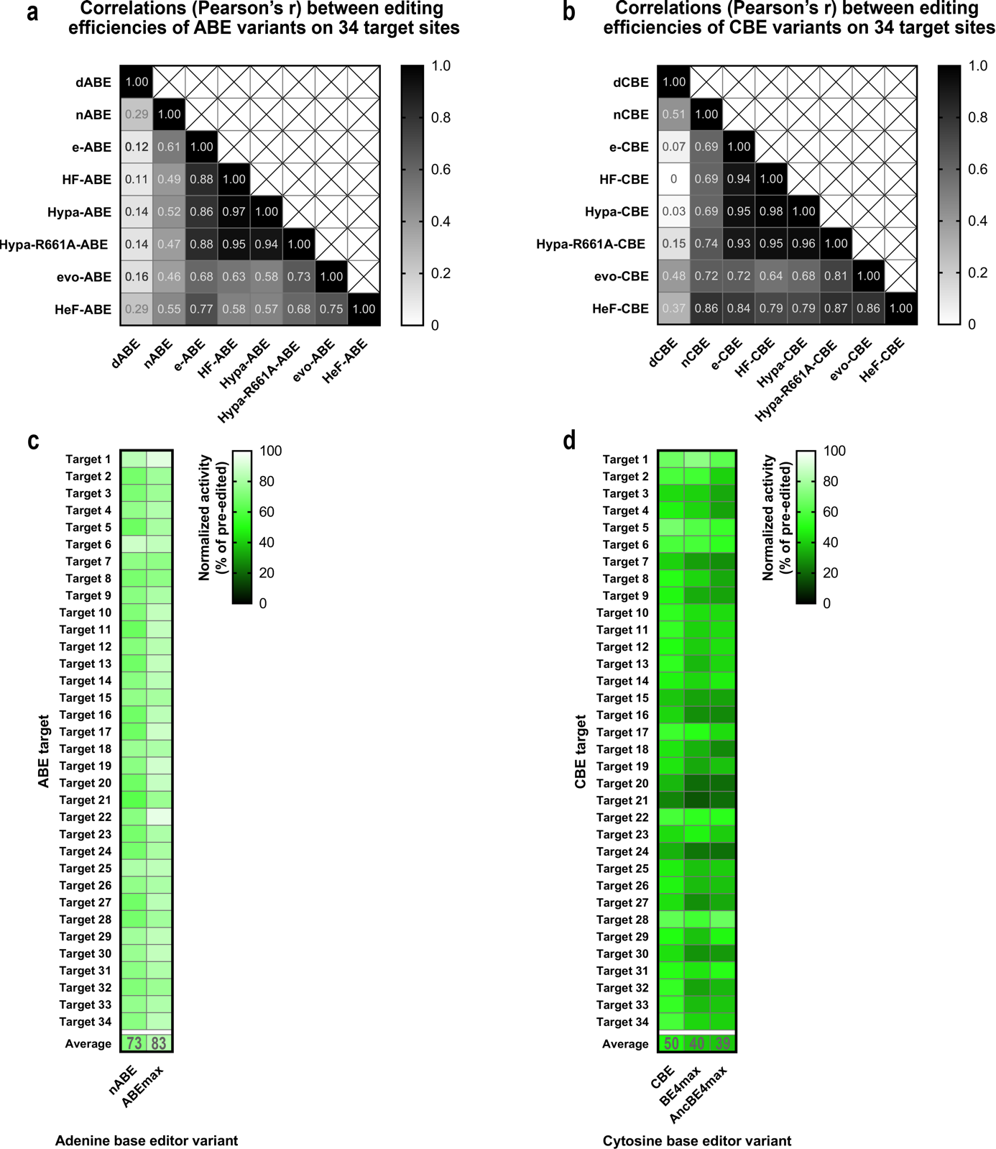

Figure S4 – Correlations between the editing efficiencies of ABE and CBE variants
Pearson’s correlation coefficients are shown for 34 on-target cleavage results (see Figure 5) compared for different ABE (a) and CBE (b) editors.
A total of 34 target sequences (from Fig. 5) were targeted by two codon optimized ABEs: ABERA (nABE) and ABEmax (c). These sequences were also targeted by three codon optimized CBEs: FNLS-CBE (CBE), BE4max and AncBE4max (d). The heatmaps show normalized on-target activity (measured/pre-edited) derived from three parallel transfections.

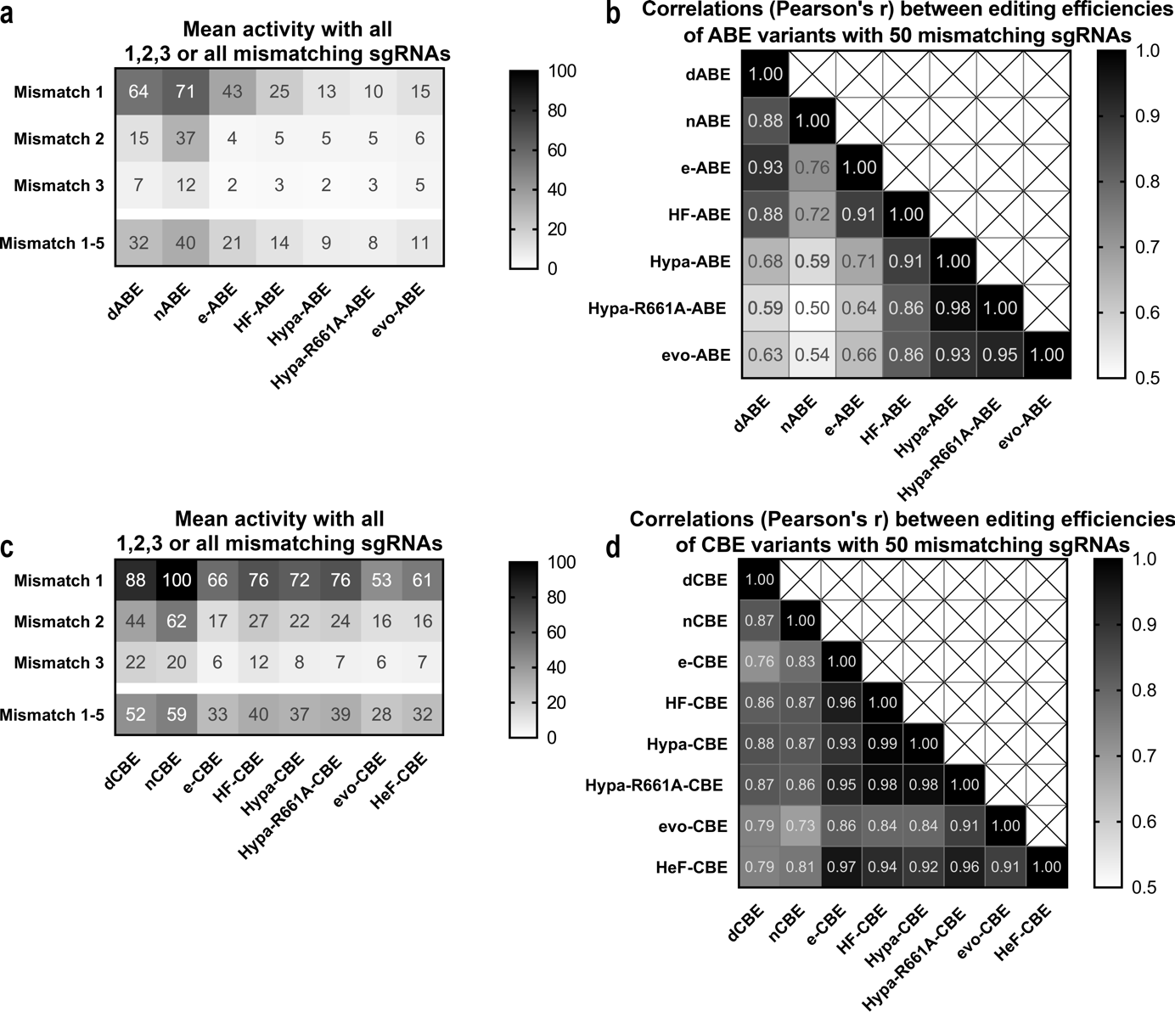

Figure S5 – Correlations between base editor activities with 50 mismatching sgRNAs
(a) Mean activity of different ABE variants with 1, 2, 3 or all mismatching sgRNAs shown in Figure 6.
(b) Pearson’s correlation coefficients characterizing the correlations between the editing activities of 7 ABE variants with 50 mismatching sgRNAs shown in Figure 6.
(c) Mean activity of different CBE variants with 1, 2, 3 or all mismatching sgRNAs shown in Figure 6.
(d) Pearson’s correlation coefficients characterizing the correlations between the editing activities of 8 CBE variants with 50 mismatching sgRNAs shown in Figure 6.

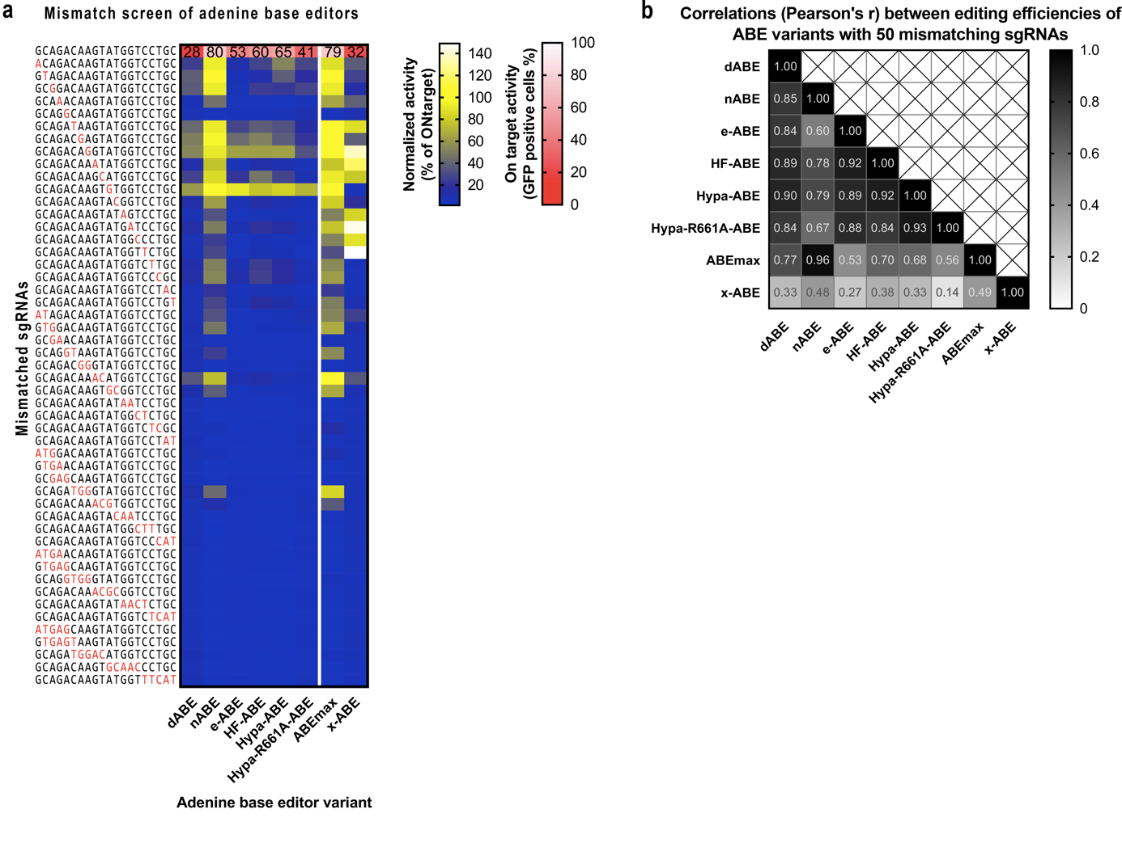

Figure S6 – Off-target activities of different ABE variants on target 7 with 50 mismatching sgRNAs
(a) Mismatch tolerance of dABE, nABE, ABEmax, x-ABE and 4 high fidelity ABE variants were compared utilizing exactly the same matching sgRNA (target 7 in Fig. 5) and 50 sgRNAs mismatching in one, two, three, four or five positions. Blue-yellow heatmaps show the mean normalized activity (off-target/on-target) derived from three parallel transfections. White-red heatmaps show the on-target activity (mean rates of GFP positive cells) derived from three parallel transfections.
(b) Pearson’s correlation coefficients characterizing the correlations between the editing activities of 8 ABE variants shown in Figure S6a.

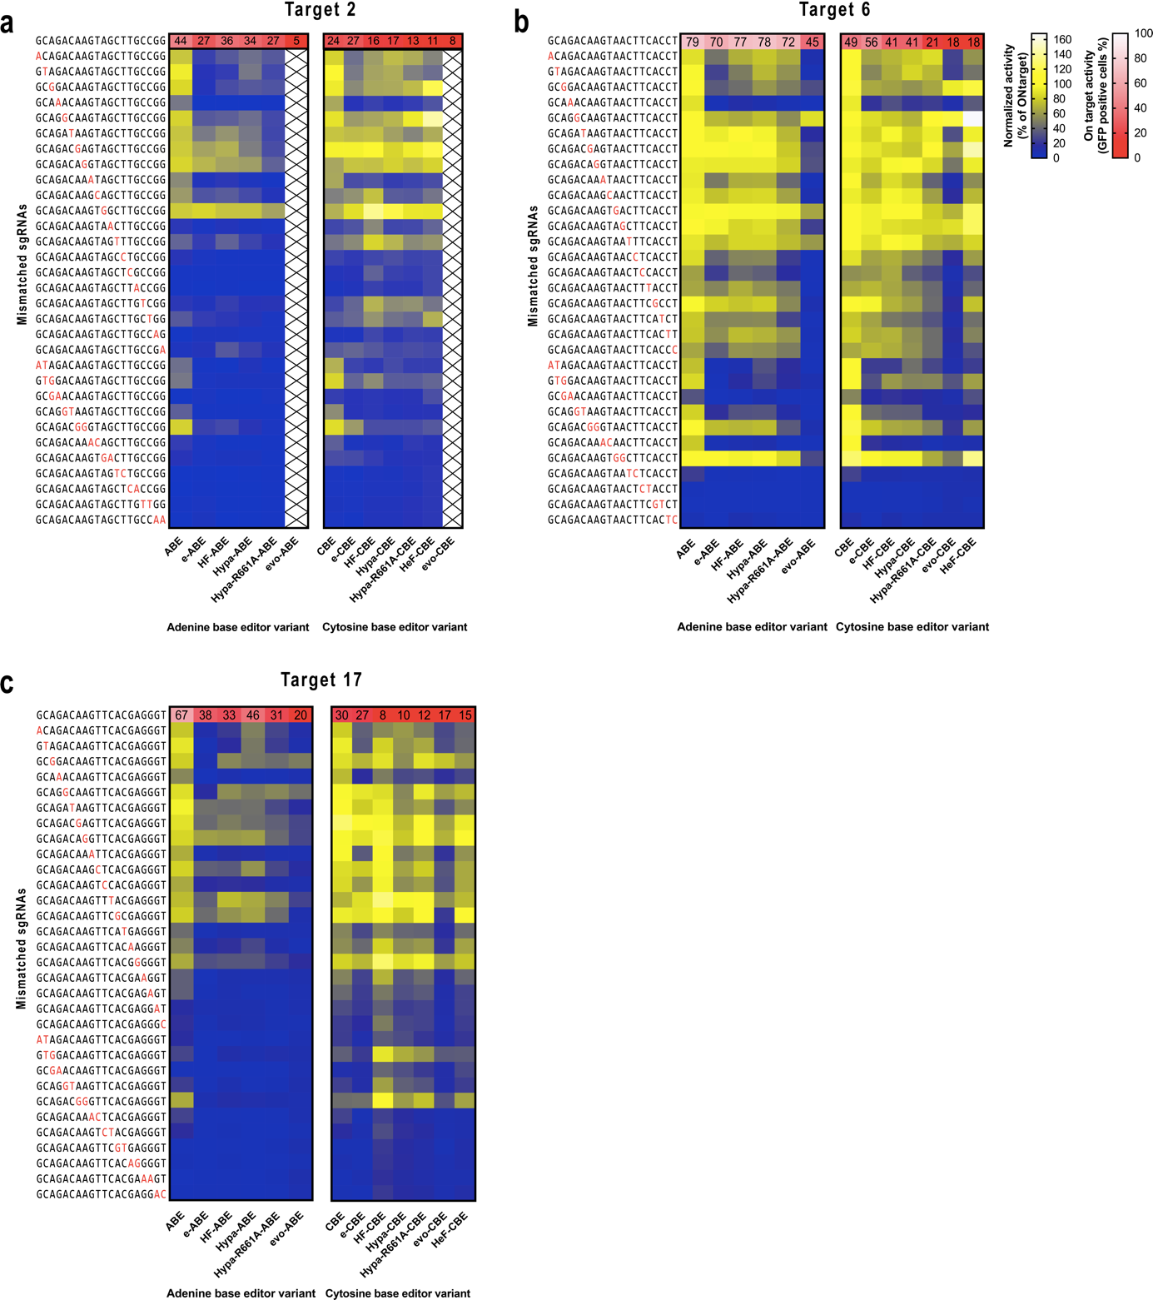

Figure S7 – Off-target activities of different ABE variants on three additional targets with 31 mismatching sgRNAs
Mismatch tolerance of ABE and CBE and their high fidelity variants were compared utilizing exactly the same matching and 31 mismatching sgRNAs, the latter mismatching in either one or two positions, on targets 2 (a), 6 (b) and 17 (c). Blue-yellow heatmaps show the normalized activity (off-target/on-target) derived from three parallel transfections. White-red heatmaps show the on-target activity (mean rates of GFP positive cells) derived from three parallel transfections.

Supplementary Methods – Detailed plasmid construction
The sequences of oligos used to construct all plasmids are listed in Supplementary Table 1.
To construct BEAR-GFP plasmid candidates, a target cloning plasmid (pAT9624-BEAR-cloning) was cloned first, in which the target sequence is freely variable and can be cloned between the Esp3I sites via one-pot cloning (see below). The GFP halves were amplified via PCR from pEGFP-C1 (Clonthech) using primers pAT9624-i1-for and pAT9624-i1-rev and pAT9624-i3-for and pAT9624-i3-rev. The Vim intron sequence was amplified from the N2a genomic DNA with primers pAT9624-i2-for and pAT9624-i2-rev. The three inserts were cloned into an EcoRI and BshTI digested EGFP-C1 plasmid via Hi-Fi Assembly.
For splice site screens and for on-target experiments all BEAR targets were cloned to pAT9624-BEAR-cloning between the Esp3I sites via one-pot cloning. Briefly, 2 units of Esp3I enzyme, 1.5 units of DNA ligase, 1 mM DTT, 500 μM ATP, 50 ng vector and 5-5 μM of target-coding oligonucleotides were mixed in Tango buffer, and the mixture was incubated at 37 °C for 30 minutes before being transformed into NEB5-alpha competent cells.
To clone sgRNA targets used with BEAR-GFP, an sgRNA cloning plasmid pAT9658-sgRNA-mCherry was constructed from an EF1-mCherry coding plasmid and a pU6-pegRNA-GG-acceptor (Addgene #132777) via Hi-Fi Assembly. This plasmid expresses an mCherry protein in mammalian cells, which is applicable to monitor transfection efficiency, and an mRFP sequence in bacteria between the target cloning sites, which induces bacterial colonies to turn white instead of red upon successful cloning. The cloning site is BpiI, so all other enzyme recognition sites were mutated by introducing silent mutations into the mRFP1 plasmid. All sgRNA targets were cloned into this plasmid, to the BpiI sites, via one-pot cloning using the above described protocol with minute modifications (i.e. Green buffer and no DTT was used).
To clone the sgRNA targets used with BEAR-mScarlet and -mCherry, an sgRNA cloning plasmid pAT9679-BFP-sgRNA was constructed. mCherry in plasmid pAT9658-sgRNA-mCherry was replaced with BFP at the BamHI and BglII sites via amplifying BFP by PCR, using primers pAT9679-for and -rev, and assembling the fragments via Hi-Fi Assembly. This plasmid expresses a BFP protein in mammalian cells, which is applicable to monitor transfection efficiency, and can be used along with mScarlet and mCherry coding BEAR plasmids.
To construct the ABE coding pAT9676-ABE plasmid, the ABE coding sequence was amplified from pLenti-ABERA-P2A-Puro (Addgene #112675) using primers pAT9676-ABE-for and -rev, and it was cloned to the ZraI and PscI sites of a pUC19 plasmid via Hi-Fi Assembly. A BGH polyA sequence was amplified via PCR with primers pAT9676-BGH-for and -rev, and it was cloned to the PscI site of the previous construct via Hi-Fi Assembly.
To construct the dABE coding pAT9749-dABE plasmid from pAT9676-ABE, site-directed mutagenesis was applied to mutate the H840A amino acid, in order to gain a nuclease inactive ABE. pAT9676-ABE was digested with PscI and Eco32I. The respective discarded section of Cas9 was amplified from the same plasmid, in two fragments, using primers pAT9749-F1-for and -rev and pAT9749-F2-for and -rev, in which the overlapping parts coded the mutant amino acid. The vector and the two fragments were assembled via Hi-Fi Assembly.
To construct the CBE coding pAT9675-CBE plasmid, the CBE coding sequence was amplified from pLenti-FNLS-P2A-Puro (Addgene #110841) with primers pAT9675-CBE-for and -rev, and it was cloned to the ZraI and PscI sites of a pUC19 plasmid via Hi-Fi Assembly. A BGH polyA sequence was amplified by PCR, using primers pAT9675-BGH-for and pAT9676-BGH-rev, and it was cloned to the PscI site of the previous construct via Hi-Fi Assembly.
To construct the dCBE coding pAT9748-dCBE plasmid from pAT9675-CBE, site directed mutagenesis was applied to mutate the H840A amino acid, in order to gain a nuclease inactive CBE. pAT9675-CBE was digested with PscI and Eco32I. The respective discarded section of Cas9 was amplified from the same plasmid, in two fragments, with primers pAT9749-F1-for and -rev and pAT9749-F2-for and -rev, in which the overlapping parts coded the mutant amino acid. The vector and the two fragments were assembled via Hi-Fi Assembly.
The Cas9 coding plasmid used was pX330-Flag-wtSpCas9 (Addgene #92353). The dCas9 coding plasmid used was pX330-Flag-dSpCas9 (Addgene #92113). The nCas9 coding plasmid used was pX330-Flag-wtSpCas9-D10A (Addgene #80448).
To construct the pAT9750-BEAR-mCherry plasmid with disrupted 5’ss, the two mCherry halves were amplified from a pcDNA3.1-mCherry (Addgene #128744) plasmid via PCR using primers pAT9750-i1-for and -rev and pAT9750-i3-for and -rev. The Vim intron sequence was amplified from pAT9651-BEAR-GFP with primers pAT9750-i2-for and pAT9750-i2-rev. The three inserts were cloned into an EcoRI and BshTI digested EGFP-C1 plasmid via Hi-Fi Assembly.
To construct the pAT9751-BEAR-mCherry-preedited plasmid with pre-edited 5’ss, the two mCherry halves were amplified from a pcDNA3.1-mCherry (Addgene #128744) plasmid via PCR using primers pAT9751-i1-for and pAT9750-i1-rev and pAT9750-i3-for and -rev. The Vim intron sequence was amplified from pAT9651-BEAR-GFP with primers pAT9750-i2-for and pAT9750-i2-rev. The three inserts were cloned into an EcoRI and BshTI digested EGFP-C1 plasmid via Hi-Fi Assembly.
To construct the BEAR-mScarlet plasmids, mScarlet CDS from pCytERM_mScarlet_N1 (Addgene #85066) was cloned into pEGFP-C1 (pmScarlet-C1). To construct pAT9752-BEAR-mScarlet with disrupted 5’ss, the two pmScarlet halves were amplified from the mScarlet-C1 plasmid via PCR using primers pAT9624-i1-for and pAT9752-i1-rev and pAT9752-i3-for and pAT9624-i3-rev. The Vim intron sequence was amplified from pAT9651-BEAR-GFP with primers pAT9750-i2-for and pAT9752-i2-rev. The three inserts were cloned into an EcoRI and BshTI digested EGFP-C1 plasmid via Hi-Fi Assembly.
To construct pAT9753-BEAR-mScarlet with pre-edited 5’ss, the two mScarlet halves were amplified from the mScarlet-C1 plasmid via PCR using primers pAT9624-i1-for and pAT9753-i1-rev and pAT9752-i3-for and pAT9624-i3-rev. The Vim intron sequence was amplified from pAT9651-BEAR-GFP with primers pAT9750-i2-for and pAT9752-i2-rev. The three inserts were cloned into an EcoRI and BshTI digested EGFP-C1 plasmid via Hi-Fi Assembly.
To construct high fidelity ABE and CBE variants and xABE (pAT9991-eABE, pAT9992-HF-ABE, pAT9993-Hypa-ABE, pAT9994-HypaR661A-ABE, pAT9995-evoABE, pAT9996-HeF-ABE, pAT15064-eCBE, pAT15065-HF-CBE, pAT15066-Hypa-CBE, pAT15067-HypaR661A-CBE, pAT15068-evoCBE, pAT15069-HeF-CBE, pAT9784-xABE) increased fidelity Cas9 and xCas9 coding sequences (pX330-Flag-eSpCas9, -SpCas9-HF1, -HypaSpCas9, -Hypa-A-SpCas9, -evoSpCas9, -HeFSpCas9 – Addgene #126754-126459 and an in-house made xCas9 coding plasmid) were amplified by PCR using primers pAT9991-for and pAT9749-F2-rev. To construct the ABE variants, the amplified increased fidelity Cas9 fragments were cloned to a PScI and BglII digested pAT9676-ABE plasmid via Hi-Fi Assembly. To construct the CBE variants, the amplified increased fidelity Cas9 fragments were cloned to a PScI and BglII digested pAT9675-CBE plasmid via Hi-Fi Assembly. To append the UGI sequence to the CBE variants, high fidelity variant constructs and pAT9675-CBE were digested with NotI and Mva1269I, respectively and the UGI containing fragment was ligated with a T4 ligase.
To construct the editing window screen target plasmids with pre-edited or disrupted 5’ss, GFP halves were amplified from the EGFP-C1 plasmid with primers listed in the primer list below (insert 1 and insert 3), and the intron sequence (insert 2) was amplified from the pAT9651-BEAR-GFP plasmid with primers listed in the primer list below. The three inserts were cloned into an EcoRI and BshTI digested EGFP-C1 plasmid via Hi-Fi Assembly. All sgRNA targets were cloned to the plasmid pAT9658-sgRNA-mCherry plasmid using the protocol described above.
To construct BEAR-GFP and BEAR-mScarlet plasmids with different intron positions, GFP and mScarlet halves were amplified from pEGFP-C1 and mScarlet-C1 plasmids via PCR, using “insert 1 and insert 3” primers, as indicated in Supplementary Table 1 under the title “BEAR plasmids with different intron positions”. The Vim intron sequence was amplified from the pAT9651-BEAR-GFP plasmid via PCR, using “insert 2” primers.
To construct BEAR-GFP and BEAR-mScarlet expressing cell lines, the pSc1-puro (Addgene #80438) plasmid was modified to eliminate the sgRNA coding sequence, but not its target site. The GFP sequence was replaced by the coding sequences of BEAR-GFP and BEAR-mScarlet, which were cloned to the BshTI and EcoRI sites of this plasmid. The spacer that targets and linearizes these plasmids within the cells was cloned to pmCherry-gRNA (Addgene #80457) using the above described one-pot cloning method, utilizing oligos U6-TL oligo-1 and -2. AAVS1 targeting spacers (AAVS1-a and -b) were cloned to pmCherry-gRNA (Addgene #80457) using the above described one-pot cloning method, utilizing oligos AAVS1-a and -b, oligo-1 and -2. U6-AAVS1-a was used to construct BEAR-GFP, and U6-AAVS1-b was used to create BEAR-mScarlet cell lines.
For the enrichment experiments genomic targets were cloned to pmCherry-gRNA (Addgene #80457) using the above described one-pot cloning method, utilizing oligos sgRNA FANCF site 2 – oligo1, -2, sgRNA VEGFA site 3 – oligo1, -2, sgRNA HEK site 4 – oligo1, -2. Genomic PCRs were conducted with primers FANCFsite2-for and -rev, VEGFAsite3-for and -rev and HEKsite4-for and -rev, respectively.
For the on-target experiments, sgRNA spacers (T1-T34) were cloned into the plasmid pAT9658-sgRNA-mCherry plasmid.
For the off-target experiments, mismatching sgRNA spacers (targets: T1, T2, T6, T7 and T17) were cloned into the plasmid pAT9658-sgRNA-mCherry plasmid.
To construct pAT15000-BE4max, pAT15001-AncBE4max and pAT15002-ABEmax, BE4max, AncBe4max and ABEmax, the corresponding coding sequences were amplified by PCR, using pCMV_BE4max (Addgene # 112093), pCMV_AncBE4max (Addgene # 112100) and pCMV_ABEmax (Addgene # 112101), utilizing oligos pAT15000-for and -rev, and the products were cloned into an NcoI and PscI digested pAT9675-CBE plasmid via HiFi Assembly.

Supplementary Table 1 – List of oligonucleotides
Oligonucleotides used for BEAR-GFP target cloning plasmid pAT9624
oligo name | oligo sequence
pAT9624-i1-for | GTGAACCGTCAGATCCGCTAG
pAT9624-i1-rev | TGAGACGTAAGATCTCCTCGTCTCGCACGTAGCCTTCGGGCATG
pAT9624-i2-for | GAGACGAGGAGATCTTACGTCTCAATTTTTTAGTTAAAATATGGGAAAG
pAT9624-i2-rev | CGTCCTTGAAGAAGATGGTGCGCTCCTGCTCAAAAAAGAAAC
pAT9624-i3-for | GAGCGCACCATCTTCTTCAAGGACG
pAT9624-i3-rev | CCCGCGGTACCGTCGAC
Oligonucleotides used for cloning splice site screen target plasmids (Fig. 2, Supplementary Fig.2)
plasmid name | oligo1 | oligo2
P1 - pre-edited | CGTGCAGGTTGAGGCATAGACTGCGGGTTG | AAATCAACCCGCAGTCTATGCCTCAACCTG
P1 - disrupted | CGTGCAGATTGAGGCATAGACTGCGGGTTG | AAATCAACCCGCAGTCTATGCCTCAATCTG
P2 - pre-edited | CGTGCAGGCTGAGGCATAGACTGCGGGTTG | AAATCAACCCGCAGTCTATGCCTCAGCCTG
P2 - disrupted | CGTGCAGACTGAGGCATAGACTGCGGGTTG | AAATCAACCCGCAGTCTATGCCTCAGTCTG
P3 - pre-edited | CGTGCAGGGTGAGGCATAGACTGCGGGTTG | AAATCAACCCGCAGTCTATGCCTCACCCTG
P3 - disrupted | CGTGCAGAGTGAGGCATAGACTGCGGGTTG | AAATCAACCCGCAGTCTATGCCTCACTCTG
P4 - pre-edited | CGTGCAGGATGAGGCATAGACTGCGGGTTG | AAATCAACCCGCAGTCTATGCCTCATCCTG
P4 - disrupted | CGTGCAGAATGAGGCATAGACTGCGGGTTG | AAATCAACCCGCAGTCTATGCCTCATTCTG
P5 - pre-edited | CGTGCAGAGTGAGGCATAGACTGCGGGTTG | AAATCAACCCGCAGTCTATGCCTCACTCTG
P5 - disrupted | CGTGCAGAATGAGGCATAGACTGCGGGTTG | AAATCAACCCGCAGTCTATGCCTCATTCTG
P6 - pre-edited | CGTGCAGGGTGAGGCATAGACTGCGGGTTG | AAATCAACCCGCAGTCTATGCCTCACCCTG
P6 - disrupted | CGTGCAGAATGAGGCATAGACTGCGGGTTG | AAATCAACCCGCAGTCTATGCCTCATTCTG
P7 - pre-edited | CGTGCAAGTTGAGGCATAGACTGCGGGTTG | AAATCAACCCGCAGTCTATGCCTCAACTTG
P7 - disrupted | CGTGCAAATTGAGGCATAGACTGCGGGTTG | AAATCAACCCGCAGTCTATGCCTCAATTTG
P8 - pre-edited | CGTGCAGGTAAGTGCATAGACTGCGGGTTG | AAATCAACCCGCAGTCTATGCACTTACCTG
P8 - disrupted | CGTGCAGATAAGTGCATAGACTGCGGGTTG | AAATCAACCCGCAGTCTATGCACTTATCTG
P9 - pre-edited | CGTGCAGGCAAGTGCATAGACTGCGGGTTG | AAATCAACCCGCAGTCTATGCACTTGCCTG
P9 - disrupted | CGTGCAGACAAGTGCATAGACTGCGGGTTG | AAATCAACCCGCAGTCTATGCACTTGTCTG
P10 - pre-edited | CGTGCAGGCAAGTGCATAGACTGCGGGTTG | AAATCAACCCGCAGTCTATGCACTTGCCTG
P10 - disrupted | CGTGCAGACAAGTGCATAGACTGCGGGTTG | AAATCAACCCGCAGTCTATGCACTTGTCTG
P11 - pre-edited | CGTGCAGGGAAGTGCATAGACTGCGGGTTG | AAATCAACCCGCAGTCTATGCACTTCCCTG
P11 - disrupted | CGTGCAGAGAAGTGCATAGACTGCGGGTTG | AAATCAACCCGCAGTCTATGCACTTCTCTG
P12 - pre-edited | CGTGCAGAGAAGTGCATAGACTGCGGGTTG | AAATCAACCCGCAGTCTATGCACTTCTCTG
P12 - disrupted | CGTGCAGAAAAGTGCATAGACTGCGGGTTG | AAATCAACCCGCAGTCTATGCACTTTTCTG
P13 - pre-edited | CGTGCAGGGAAGTGCATAGACTGCGGGTTG | AAATCAACCCGCAGTCTATGCACTTCCCTG
P13 - disrupted | CGTGCAGAAAAGTGCATAGACTGCGGGTTG | AAATCAACCCGCAGTCTATGCACTTTTCTG
P14 - pre-edited | CGTGCAAGTAAGTGCATAGACTGCGGGTTG | AAATCAACCCGCAGTCTATGCACTTACTTG
P14 - disrupted | CGTGCAAATAAGTGCATAGACTGCGGGTTG | AAATCAACCCGCAGTCTATGCACTTATTTG
P15 - pre-edited | CGTGCAGGTTGCGGCTGGAGGTGGGGGTTG | AAATCAACCCCCACCTCCAGCCGCAACCTG
P15 - disrupted | CGTGCAGGCTGCGGCTGGAGGTGGGGGTTG | AAATCAACCCCCACCTCCAGCCGCAGCCTG
P16 - pre-edited | CGTGCAGATTGCGGCTGGAGGTGGGGGTTG | AAATCAACCCCCACCTCCAGCCGCAATCTG
P16 - disrupted | CGTGCAGACTGCGGCTGGAGGTGGGGGTTG | AAATCAACCCCCACCTCCAGCCGCAGTCTG
P17 - pre-edited | CGTGCAGTTTGCGGCTGGAGGTGGGGGTTG | AAATCAACCCCCACCTCCAGCCGCAAACTG
P17 - disrupted | CGTGCAGTCTGCGGCTGGAGGTGGGGGTTG | AAATCAACCCCCACCTCCAGCCGCAGACTG
P18 - pre-edited | CGTGCAGCTTGCGGCTGGAGGTGGGGGTTG | AAATCAACCCCCACCTCCAGCCGCAAGCTG
P18 - disrupted | CGTGCAGCCTGCGGCTGGAGGTGGGGGTTG | AAATCAACCCCCACCTCCAGCCGCAGGCTG
P19 - pre-edited | CGTGCAGTCTGCGGCTGGAGGTGGGGGTTG | AAATCAACCCCCACCTCCAGCCGCAGACTG
P19 - disrupted | CGTGCAGCCTGCGGCTGGAGGTGGGGGTTG | AAATCAACCCCCACCTCCAGCCGCAGGCTG
P20 - pre-edited | CGTGCAGTTTGCGGCTGGAGGTGGGGGTTG | AAATCAACCCCCACCTCCAGCCGCAAACTG
P20 - disrupted | CGTGCAGCCTGCGGCTGGAGGTGGGGGTTG | AAATCAACCCCCACCTCCAGCCGCAGGCTG
P21 - pre-edited | CGTGCAAGTTGCGGCTGGAGGTGGGGGTTG | AAATCAACCCCCACCTCCAGCCGCAACTTG
P21 - disrupted | CGTGCAAGCTGCGGCTGGAGGTGGGGGTTG | AAATCAACCCCCACCTCCAGCCGCAGCTTG
P22 - pre-edited | CGTGCAGGTAAGTGCTGGAGGTGGGGGTTG | AAATCAACCCCCACCTCCAGCACTTACCTG
P22 - disrupted | CGTGCAGGCAAGTGCTGGAGGTGGGGGTTG | AAATCAACCCCCACCTCCAGCACTTGCCTG
P23 - pre-edited | CGTGCAGATAAGTGCTGGAGGTGGGGGTTG | AAATCAACCCCCACCTCCAGCACTTATCTG
P23 - disrupted | CGTGCAGACAAGTGCTGGAGGTGGGGGTTG | AAATCAACCCCCACCTCCAGCACTTGTCTG
P24 - pre-edited | CGTGCAGTTAAGTGCTGGAGGTGGGGGTTG | AAATCAACCCCCACCTCCAGCACTTAACTG
P24 - disrupted | CGTGCAGTCAAGTGCTGGAGGTGGGGGTTG | AAATCAACCCCCACCTCCAGCACTTGACTG
P25 - pre-edited | CGTGCAGTTAAGTGCTGGAGGTGGGGGTTG | AAATCAACCCCCACCTCCAGCACTTAACTG
P25 - disrupted | CGTGCAGCCAAGTGCTGGAGGTGGGGGTTG | AAATCAACCCCCACCTCCAGCACTTGGCTG
P26 - pre-edited | CGTGCAGTCAAGTGCTGGAGGTGGGGGTTG | AAATCAACCCCCACCTCCAGCACTTGACTG
P26 - disrupted | CGTGCAGCCAAGTGCTGGAGGTGGGGGTTG | AAATCAACCCCCACCTCCAGCACTTGGCTG
P27 - pre-edited | CGTGCAGTTAAGTGCTGGAGGTGGGGGTTG | AAATCAACCCCCACCTCCAGCACTTAACTG
P27 - disrupted | CGTGCAGCCAAGTGCTGGAGGTGGGGGTTG | AAATCAACCCCCACCTCCAGCACTTGGCTG
P28 - pre-edited | CGTGCAAGTAAGTGCTGGAGGTGGGGGTTG | AAATCAACCCCCACCTCCAGCACTTACTTG
P28 - disrupted | CGTGCAAGCAAGTGCTGGAGGTGGGGGTTG | AAATCAACCCCCACCTCCAGCACTTGCTTG
Oligonucleotides used for cloning sgRNA targets on Fig. 2c, d
plasmid name | oligo1 | oligo2
P1-gRNA | CACCGCAGATTGAGGCATAGACTG | AAACCAGTCTATGCCTCAATCTGC
P9-gRNA | CACCGCAGACAAGTGCATAGACTG | AAACCAGTCTATGCACTTGTCTGC
P14-gRNA | CACCGCAAATAAGTGCATAGACTG | AAACCAGTCTATGCACTTATTTGC
P15-gRNA | CACCGCAGGCTGCGGCTGGAGGTG | AAACCACCTCCAGCCGCAGCCTGC
P24-gRNA | CACCGCAGTCAAGTGCTGGAGGTG | AAACCACCTCCAGCACTTGACTGC
Oligonucleotides used for cloning ABE, -CBE, dABE, -dCBE and their increased fidelity variants, Fig. 2-6
oligo name | oligo sequence
pAT9676-ABE-for | ATTTCCCCGAAAAGTGCCACCTGACGTCCAGCAGAGATCCACTTTGG
pAT9676-ABE-rev | TGGCCTTTTGCTGGCCTTTTGCTCACATGTCATTTCTTTTTCTTAGCTTGACCAG
pAT9676-BGH-for | GCTAAGAAAAAGAAATGACATGTCCTAGAGCTCGCTGATCAGCCTCG
pAT9676-BGH-rev | TTTTGCTGGCCTTTTGCTCAGCGGCCGCTCCCCAG
pAT9749-F1-for | GAGGAAAACGAGGACATTCTGGAAGAT
pAT9749-F1-rev | GAAAGCTCTGAGGCACGATGGCGTCCACATCGTAGTCGG
pAT9749-F2-for | CCGACTACGATGTGGACGCCATCGTGCCTCAGAGCTTTC
pAT9749-F2-rev | GGCTGATCAGCGAGCTCTAGG
pAT9675-CBE-for | ATTTCCCCGAAAAGTGCCACCTGACGTCCAGCAGAGATCCACTTTGG
pAT9675-CBE-rev | TGGCCTTTTGCTGGCCTTTTGCTCACATGTCAGACTTTCCTCTTCTTCTTGG
pAT9675-BGH-for | AGAAGAAGAGGAAAGTCTGACATGTCCTAGAGCTCGCTGATCAGCCTCG
pAT9991-for | GAACCGGATCTGCTATCTGCAAGA
Oligonucleotides used for cloning editing window BEAR target plasmids (Fig. 3a)
oligo name | insert1 - fwd oligo
Window - disrupted - A20-1-i1-for | GTGAACCGTCAGATCCGCTAG
Window - disrupted - A20-19-i1-rev | CCGCAGTCTATGCCACACCCATCAGGGCACGGGCAG
Window - disrupted - A20-1-i2-rev | GGGTGGTCACGAGGGTGGGCCTGCTCAAAAAAGAAAC
Window - disrupted - A20-1-i3-for | GCCCACCCTCGTGACCAC
Window - disrupted - A20-1-i3-rev | CCCGCGGTACCGTCGAC
Window - disrupted - A20-19-i1-rev | CCGCAGTCTATGCCACACCCATCAGGGCACGGGCAG
Window - disrupted - A20-19-i2-for | GGGTGTGGCATAGACTGCGGG
Window - disrupted - A18-i2-for | CAAGCTGCCCGTGCCCTGATGGGTTGGCATAGACTGCGGG
Window - disrupted - A17-i2-for | CAAGCTGCCCGTGCCCTGATGGGTGGCATAGACTGCGGG
Window - disrupted - A16-i2-for | CAAGCTGCCCGTGCCCTGATGGGTGCATAGACTGCGGG
Window - disrupted - A15-i2-for | CAAGCTGCCCGTGCCCTGATGGGTCATAGACTGCGGGTTG
Window - disrupted - A14-i2-for | CAAGCTGCCCGTGCCCTGATGGGTATAGACTGCGGGTTG
Window - disrupted - A13-i2-for | CAAGCTGCCCGTGCCCTGATGGGTTAGACTGCGGGTTG
Window - disrupted - A12-i2-for | CAAGCTGCCCGTGCCCTGATGGGTAGACTGCGGGTTG
Window - disrupted - A11-i2-for | CAAGCTGCCCGTGCCCTGATGGGTGACTGCGGGTTGA
Window - disrupted - A10-i2-for | CAAGCTGCCCGTGCCCTGATGGGTACTGCGGGTTGATTTTTTAG
Window - disrupted - A9-i2-for | CAAGCTGCCCGTGCCCTGATGGGTCTGCGGGTTGATTTTTTAG
Window - disrupted - A8-i2-for | CAAGCTGCCCGTGCCCTGATGGGTGCGGGTTGATTTTTTAG
Window - disrupted - A7-i2-for | CAAGCTGCCCGTGCCCTGATGGGTCGGGTTGATTTTTTAG
Window - disrupted - A6-i2-for | CAAGCTGCCCGTGCCCTGATGGGTGGGTTGATTTTTTAGTTAAAATATG
Window - disrupted - A5-1-i2-for | CAAGCTGCCCGTGCCCTGATGGGGGGTTGATTTTTTAGTTAAAATATG
Window - preedited 20-1-i1-for | GTGAACCGTCAGATCCGCTAG
Window - preedited 20-1-i2-rev | GGGTGGTCACGAGGGTGGGCCTGCTCAAAAAAGAAAC
Window - preedited 20-1-i3-for | GCCCACCCTCGTGACCAC
Window - preedited 20-1-i3-rev | CCCGCGGTACCGTCGAC
Window - preedited 20-19-i1-rev | CCGCAGTCTATGCCACACCCACCAGGGCACGGGCAG
Window - preedited 18-1-i1-rev | ACCAGGGCACGGGCAG
Window - preedited 20-19-i2-rev | GGGTGTGGCATAGACTGCGGG
Window - preedited 18-i2-rev | CAAGCTGCCCGTGCCCTGGTGGGTTGGCATAGACTGCGGG
Window - preedited 17-i2-rev | CAAGCTGCCCGTGCCCTGGTGGGTGGCATAGACTGCGGG
Window - preedited 16-i2-rev | CAAGCTGCCCGTGCCCTGGTGGGTGCATAGACTGCGGG
Window - preedited 15-i2-rev | CAAGCTGCCCGTGCCCTGGTGGGTCATAGACTGCGGGTTG
Window - preedited 14-i2-rev | CAAGCTGCCCGTGCCCTGGTGGGTATAGACTGCGGGTTG
Window - preedited 13-i2-rev | CAAGCTGCCCGTGCCCTGGTGGGTTAGACTGCGGGTTG
Window - preedited 12-i2-rev | CAAGCTGCCCGTGCCCTGGTGGGTAGACTGCGGGTTG
Window - preedited 11-i2-rev | CAAGCTGCCCGTGCCCTGGTGGGTGACTGCGGGTTGA
Window - preedited 10-i2-rev | CAAGCTGCCCGTGCCCTGGTGGGTACTGCGGGTTGATTTTTTAG
Window - preedited 9-i2-rev | CAAGCTGCCCGTGCCCTGGTGGGTCTGCGGGTTGATTTTTTAG
Window - preedited 8-i2-rev | CAAGCTGCCCGTGCCCTGGTGGGTGCGGGTTGATTTTTTAG
Window - preedited 7-i2-rev | CAAGCTGCCCGTGCCCTGGTGGGTCGGGTTGATTTTTTAG
Window - preedited 6-i2-rev | CAAGCTGCCCGTGCCCTGGTGGGTGGGTTGATTTTTTAGTTAAAATATG
Window - preedited 5-1-i2-rev | CAAGCTGCCCGTGCCCTGGTGGGGGGTTGATTTTTTAGTTAAAATATG
Oligonucleotides used for cloning editing window sgRNA targets
plasmid name | oligo1 | oligo2
sgRNA - window - 20 | CACCATGGGTGTGGCATAGACTGC | AAACGCAGTCTATGCCACACCCAT
sgRNA - window - 19 | CACCGATGGGTGTGGCATAGACTG | AAACCAGTCTATGCCACACCCATC
sgRNA - window - 18 | CACCGTGATGGGTTGGCATAGACTG | AAACCAGTCTATGCCAACCCATCAC
sgRNA - window - 17 | CACCGCTGATGGGTGGCATAGACTG | AAACCAGTCTATGCCACCCATCAGC
sgRNA - window - 16 | CACCGCCTGATGGGTGCATAGACTG | AAACCAGTCTATGCACCCATCAGGC
sgRNA - window - 15 | CACCGCCCTGATGGGTCATAGACTG | AAACCAGTCTATGACCCATCAGGGC
sgRNA - window - 14 | CACCGCCCTGATGGGTATAGACTG | AAACCAGTCTATACCCATCAGGGC
sgRNA - window - 13 | CACCGTGCCCTGATGGGTTAGACTG | AAACCAGTCTAACCCATCAGGGCAC
sgRNA - window - 12 | CACCGGTGCCCTGATGGGTAGACTG | AAACCAGTCTACCCATCAGGGCACC
sgRNA - window - 11 | CACCGCGTGCCCTGATGGGTGACTG | AAACCAGTCACCCATCAGGGCACGC
sgRNA - window - 10 | CACCGCCGTGCCCTGATGGGTACTG | AAACCAGTACCCATCAGGGCACGGC
sgRNA - window - 9 | CACCGCCCGTGCCCTGATGGGTCTG | AAACCAGACCCATCAGGGCACGGGC
sgRNA - window - 8 | CACCGCCCGTGCCCTGATGGGTGC | AAACGCACCCATCAGGGCACGGGC
sgRNA - window - 7 | CACCGTGCCCGTGCCCTGATGGGTC | AAACGACCCATCAGGGCACGGGCAC
sgRNA - window - 6 | CACCGCTGCCCGTGCCCTGATGGGT | AAACACCCATCAGGGCACGGGCAGC
sgRNA - window - 5 | CACCGCTGCCCGTGCCCTGATGGG | AAACCCCATCAGGGCACGGGCAGC
sgRNA - window - 4 | CACCAGCTGCCCGTGCCCTGATGG | AAACCCATCAGGGCACGGGCAGCT
sgRNA - window - 3 | CACCAAGCTGCCCGTGCCCTGATG | AAACCATCAGGGCACGGGCAGCTT
sgRNA - window - 2 | CACCGCAAGCTGCCCGTGCCCTGAT | AAACATCAGGGCACGGGCAGCTTGC
sgRNA - window - 1 | CACCGCAAGCTGCCCGTGCCCTGA | AAACTCAGGGCACGGGCAGCTTGC
Oligonucleotides used for cloning BEAR-mScarlet and BEAR-mCherry plasmids (Fig. 3b)
oligo name | oligo sequence
pAT9750-i1-for | CGTCAGATCCGCTAGCGCTACCGGTCGCCACCATGGTGAGCAAG
pAT9750-i1-rev | ACCCGCAGTCTATGCACTTGTCTGCAGGGAGGAGTCC
pAT9750-i2-for | CAAGTGCATAGACTGC
pAT9750-i2-rev | ACTCGCCGTCCTGCTCAAAAAAGAAAC
pAT9750-i3-for | TTTTGAGCAGGACGGCGAGTTC
pAT9750-i3-rev | CGCGGTACCGTCGACTGCAGCCCTCTAGATGCATGCTCG
pAT9751-i1-rev | ACCCGCAGTCTATGCACTTGCCTGCAGGGAGGAGTCC
pAT9752-i1-rev | ACCCGCAGTCTATGCACTTGTCTGCGTCACGGTCACGGCG
pAT9752-i2-rev | AGGGAGGTGTCCTGCTCAAAAAAGAAAC
pAT9752-i3-for | TTTTGAGCAGGACACCTCCCTGGAGG
pAT9753-i1-rev | ACCCGCAGTCTATGCACTTGCCTGCGTCACGGTCACGGCG
Oligonucleotides used for cloning pAT9679-BFP-sgRNA (Fig. 3b)
oligo name | oligo sequence
pAT9679-for | ACACAGGTGTCGTGACGCGGGATCCGCCACCATGAGCG
pAT9679-rev | AGCGAGCTCTAGGACATGTAGATCTTAATTAAGCTTGTGCCCCAG
BEAR plasmids with different intron positions (Fig. 3c, d)
oligo name | oligo sequence
all intron constructs - i1-for | GTGAACCGTCAGATCCGCTAG
all intron constructs - i3-rev | CCCGCGGTACCGTCGAC
GFP 53-i1-rev | CTGTGGTGCAGATAAACTTCAGGGTCAGCTTGCC
GFP 53-i2-for | GAAGTTTATCTGCACCACAGGCAAGTGCATAGACTGCG
GFP 53-i2-rev | GGCAGCTTGCCTGCTCAAAAAAGAAAC
GFP 53-i3-for | TTTTGAGCAGGCAAGCTGCCCGTGCC
GFP 58-i1-rev | ATCAGGGCACGGGCAG
GFP 58-i2-for | CAAGCTGCCCGTGCCCTGATGGGTATAGACTGCGGGTTG
GFP 58-i2-rev | GGGTGGTCACGAGGGTGGGCCTGCTCAAAAAAGAAAC
GFP 58-i3-for | GCCCACCCTCGTGACCAC
GFP 87-i1-rev | CTGACTTGAAGAAATCGTGCTGCTTCATG
GFP 87-i2-for | GCACGATTTCTTCAAGTCAGGCAAGTGCATAGACTGCG
GFP 87-i2-rev | CCTTCGGGCATGGCTGCTCAAAAAAGAAAC
GFP 87-i3-for | TGAGCAGCCATGCCCGAAGGCTACG
GFP 117-i1-rev | CCGCAGTCTATGCCACACCCACCCTCAAACTTCACCTCGGCGCG
GFP 117-i2-for | GGGTGTGGCATAGACTGCGGG
GFP 117-i2-rev | CGGTTCACCAGGGTGTCGCCTGCTCAAAAAAGAAAC
GFP 117-i3-for | GCGACACCCTGGTGAACCG
mScarlet 65-i1-rev | CTGAGGGGAAAGGATGTCCCAGGAGAAGGG
mScarlet 65-i2-for | GGGACATCCTTTCCCCTCAGGCAAGTGCATAGACTGCG
mScarlet 65-i2-rev | CGTACATGAACTGCTCAAAAAAGAAAC
mScarlet 65-i3-for | TTTTGAGCAGTTCATGTACGGCTCCAGGG
mScarlet 71-i1-rev | CTGGAGCCGTACATAAACTGAGGGGACAGGATG
mScarlet 71-i2-for | CAGTTTATGTACGGCTCCAGGCAAGTGCATAGACTGCG
mScarlet 71-i2-rev | GGTGAAGGCCCTGCTCAAAAAAGAAAC
mScarlet 71-i3-for | TTTTGAGCAGGGCCTTCACCAAGCACC
mScarlet 78-i1-rev | CTGGGTGCTTGGTAAAGGCCCTGGAGCCGTA
mScarlet 78-i2-for | GGCCTTTACCAAGCACCCAGGCAAGTGCATAGACTGCG
mScarlet 78-i2-rev | GGGATGTCGGCTGCTCAAAAAAGAAAC
mScarlet 78-i3-for | TTTTGAGCAGCCGACATCCCCGACTACTATAAGCAG
mScarlet 110-i1-rev | ACCCGCAGTCTATGCACTTGCCTGCAGGGAGGAGTCC
mScarlet 110-i2-for | CAAGTGCATAGACTGC
mScarlet 110-i2-rev | ACTCGCCGTCCTGCTCAAAAAAGAAAC
mScarlet 110-i3-for | TTTTGAGCAGGACGGCGAGTTC
Oligonucleotides used for plasmids used in creating BEAR cell lines (Supplementary Fig.3, Fig. 4)
plasmid name | oligo1 | oligo2
U6-TL | CACCGGCGCAACGCGATCGCGTAA | AAACTTACGCGATCGCGTTGCGCC
U6-AAVS-1-a | CACCACAGTGGGGCCACTAGGGAC | AAACGTCCCTAGTGGCCCCACTGT
U6-AAVS-1-b | CACCGGTCCCTAGTGGCCCCACTG | AAACCAGTGGGGCCACTAGGGACC
Oligonucleotides used for cloning genomic sgRNA targets (Fig. 4)
plasmid name | oligo1 | oligo2
sgRNA FANCF site 2 | CACCGCTGCAGAAGGGATTCCATG | AAACCATGGAATCCCTTCTGCAGC
sgRNA VEGFA site 3 | CACCGGTGAGTGAGTGTGTGCGTG | AAACCACGCACACACTCACTCACC
sgRNA HEK site 4 | CACCGGCACTGCGGCTGGAGGTGG | AAACCCACCTCCAGCCGCAGTGCC
Oligos for amplifying genomic targets (Fig. 4)
oligo name | oligo sequence
FANCFsite2-for | GGGCCGGGAAAGAGTTGCTG
FANCFsite2-rev | GCCCTACATCTGCTCTCCCTCC
VEGFAsite3-for | TCCAGATGGCACATTGTCAG
VEGFAsite3-rev | AGGGAGCAGGAAAGTGAGGT
HEKsite4-for | TCGTCGGCAGCGTCAGATGTGTATAAGAGACAGGAACCCAGGTAGCCAGAGAC
HEKsite4-rev | GTCTCGTGGGCTCGGAGATGTGTATAAGAGACAGTCCTTTCAACCCGAACGGAG
Oligonucleotides used for cloning on-target screen, target plasmids (Fig. 5)
On-target T1 | see "p9 not-edited" cloning, above
On-target T2 | CGTGCAGACAAGTAGCTTGCCGGTGG | AAATCCACCGGCAAGCTACTTGTCTG
On-target T3 | CGTGCAGACAAGTGCGACGTAAACGG | AAATCCGTTTACGTCGCACTTGTCTG
On-target T4 | CGTGCAGACAAGTATGAACTTCAGGG | AAATCCCTGAAGTTCATACTTGTCTG
On-target T5 | CGTGCAGACAAGTATCTTCTTCAAGG | AAATCCTTGAAGAAGATACTTGTCTG
On-target T6 | CGTGCAGACAAGTAACTTCACCTCGG | AAATCCGAGGTGAAGTTACTTGTCTG
On-target T7 | CGTGCAGACAAGTATGGTCCTGCTGG | AAATCCAGCAGGACCATACTTGTCTG
On-target T8 | CGTGCAGACAAGTAGAGTGATCCCGG | AAATCCGGGATCACTCTACTTGTCTG
On-target T9 | CGTGCAGACAAGTTTGAAGAAGATGG | AAATCCATCTTCTTCAAACTTGTCTG
On-target T10 | CGTGCAGACAAGTGGCGACACCCTGG | AAATCCAGGGTGTCGCCACTTGTCTG
On-target T11 | CGTGCAGACAAGTAGGGCGGACTGGG | AAATCCCAGTCCGCCCTACTTGTCTG
On-target T12 | CGTGCAGACAAGTAGTGGTTGTCGGG | AAATCCCGACAACCACTACTTGTCTG
On-target T13 | CGTGCAGACAAGTTCGCCCTCGCCGG | AAATCCGGCGAGGGCGAACTTGTCTG
On-target T14 | CGTGCAGACAAGTATGCCACCTACGG | AAATCCGTAGGTGGCATACTTGTCTG
On-target T15 | CGTGCAGACAAGTTGCACGCCGTAGG | AAATCCTACGGCGTGCAACTTGTCTG
On-target T16 | CGTGCAGACAAGTTCGAGCTGAAGGG | AAATCCCTTCAGCTCGAACTTGTCTG
On-target T17 | CGTGCAGACAAGTTCACGAGGGTGGG | AAATCCCACCCTCGTGAACTTGTCTG
On-target T18 | CGTGCAGACAAGTTCGGGCATGGCGG | AAATCCGCCATGCCCGAACTTGTCTG
On-target T19 | CGTGCAGACAAGTTCAAGGAGGACGG | AAATCCGTCCTCCTTGAACTTGTCTG
On-target T20 | CGTGCAGACAAGTTGGTAGTGGTCGG | AAATCCGACCACTACCAACTTGTCTG
On-target T21 | CGTGCAGACAAGTGGGTGGGCCAGGG | AAATCCCTGGCCCACCCACTTGTCTG
On-target T22 | CGTGCAGACAAGTCTGTTCACCGGGG | AAATCCCCGGTGAACAGACTTGTCTG
On-target T23 | CGTGCAGACAAGTGGCACCACCCCGG | AAATCCGGGGTGGTGCCACTTGTCTG
On-target T24 | CGTGCAGACAAGTCTGGTCGAGCTGG | AAATCCAGCTCGACCAGACTTGTCTG
On-target T25 | CGTGCAGACAAGTTCGACCAGGATGG | AAATCCATCCTGGTCGAACTTGTCTG
On-target T26 | CGTGCAGACAAGTTCAGCGTGTCCGG | AAATCCGGACACGCTGAACTTGTCTG
On-target T27 | CGTGCAGACAAGTAGGGTGGGCCAGG | AAATCCTGGCCCACCCTACTTGTCTG
On-target T28 | CGTGCAGACAAGTGTCACGAGGGTGG | AAATCCACCCTCGTGACACTTGTCTG
On-target T29 | CGTGCAGACAAGTGTGGTCACGAGGG | AAATCCCTCGTGACCACACTTGTCTG
On-target T30 | CGTGCAGACAAGTCCGTAGGTCAGGG | AAATCCCTGACCTACGGACTTGTCTG
On-target T31 | CGTGCAGACAAGTGTCGGGGTAGCGG | AAATCCGCTACCCCGACACTTGTCTG
On-target T32 | CGTGCAGACAAGTATCGAGCTGAAGG | AAATCCTTCAGCTCGATACTTGTCTG
On-target T33 | CGTGCAGACAAGTGACTTCAAGGAGG | AAATCCTCCTTGAAGTCACTTGTCTG
On-target T34 | CGTGCAGACAAGTGTCGCCGATGGGG | AAATCCCCATCGGCGACACTTGTCTG
Oligonucleotides used for cloning on-target screen sgRNA plasmids
sgRNA - On-target T1 | see "P9-gRNA" cloning
sgRNA - On-target T2 | CACCGCAGACAAGTAGCTTGCCGG | AAACCCGGCAAGCTACTTGTCTGC
sgRNA - On-target T3 | CACCGCAGACAAGTGCGACGTAAA | AAACTTTACGTCGCACTTGTCTGC
sgRNA - On-target T4 | CACCGCAGACAAGTATGAACTTCA | AAACTGAAGTTCATACTTGTCTGC
sgRNA - On-target T5 | CACCGCAGACAAGTATCTTCTTCA | AAACTGAAGAAGATACTTGTCTGC
sgRNA - On-target T6 | CACCGCAGACAAGTAACTTCACCT | AAACAGGTGAAGTTACTTGTCTGC
sgRNA - On-target T7 | CACCGCAGACAAGTATGGTCCTGC | AAACGCAGGACCATACTTGTCTGC
sgRNA - On-target T8 | CACCGCAGACAAGTAGAGTGATCC | AAACGGATCACTCTACTTGTCTGC
sgRNA - On-target T9 | CACCGCAGACAAGTTTGAAGAAGA | AAACTCTTCTTCAAACTTGTCTGC
sgRNA - On-target T10 | CACCGCAGACAAGTGGCGACACCC | AAACGGGTGTCGCCACTTGTCTGC
sgRNA - On-target T11 | CACCGCAGACAAGTAGGGCGGACT | AAACAGTCCGCCCTACTTGTCTGC
sgRNA - On-target T12 | CACCGCAGACAAGTAGTGGTTGTC | AAACGACAACCACTACTTGTCTGC
sgRNA - On-target T13 | CACCGCAGACAAGTTCGCCCTCGC | AAACGCGAGGGCGAACTTGTCTGC
sgRNA - On-target T14 | CACCGCAGACAAGTATGCCACCTA | AAACTAGGTGGCATACTTGTCTGC
sgRNA - On-target T15 | CACCGCAGACAAGTTGCACGCCGT | AAACACGGCGTGCAACTTGTCTGC
sgRNA - On-target T16 | CACCGCAGACAAGTTCGAGCTGAA | AAACTTCAGCTCGAACTTGTCTGC
sgRNA - On-target T17 | CACCGCAGACAAGTTCACGAGGGT | AAACACCCTCGTGAACTTGTCTGC
sgRNA - On-target T18 | CACCGCAGACAAGTTCGGGCATGG | AAACCCATGCCCGAACTTGTCTGC
sgRNA - On-target T19 | CACCGCAGACAAGTTCAAGGAGGA | AAACTCCTCCTTGAACTTGTCTGC
sgRNA - On-target T20 | CACCGCAGACAAGTTGGTAGTGGT | AAACACCACTACCAACTTGTCTGC
sgRNA - On-target T21 | CACCGCAGACAAGTGGGTGGGCCA | AAACTGGCCCACCCACTTGTCTGC
sgRNA - On-target T22 | CACCGCAGACAAGTCTGTTCACCG | AAACCGGTGAACAGACTTGTCTGC
sgRNA - On-target T23 | CACCGCAGACAAGTGGCACCACCC | AAACGGGTGGTGCCACTTGTCTGC
sgRNA - On-target T24 | CACCGCAGACAAGTCTGGTCGAGC | AAACGCTCGACCAGACTTGTCTGC
sgRNA - On-target T25 | CACCGCAGACAAGTTCGACCAGGA | AAACTCCTGGTCGAACTTGTCTGC
sgRNA - On-target T26 | CACCGCAGACAAGTTCAGCGTGTC | AAACGACACGCTGAACTTGTCTGC
sgRNA - On-target T27 | CACCGCAGACAAGTAGGGTGGGCC | AAACGGCCCACCCTACTTGTCTGC
sgRNA - On-target T28 | CACCGCAGACAAGTGTCACGAGGG | AAACCCCTCGTGACACTTGTCTGC
sgRNA - On-target T29 | CACCGCAGACAAGTGTGGTCACGA | AAACTCGTGACCACACTTGTCTGC
sgRNA - On-target T30 | CACCGCAGACAAGTCCGTAGGTCA | AAACTGACCTACGGACTTGTCTGC
sgRNA - On-target T31 | CACCGCAGACAAGTGTCGGGGTAG | AAACCTACCCCGACACTTGTCTGC
sgRNA - On-target T32 | CACCGCAGACAAGTATCGAGCTGA | AAACTCAGCTCGATACTTGTCTGC
sgRNA - On-target T33 | CACCGCAGACAAGTGACTTCAAGG | AAACCCTTGAAGTCACTTGTCTGC
sgRNA - On-target T34 | CACCGCAGACAAGTGTCGCCGATG | AAACCATCGGCGACACTTGTCTGC
Oligonucleotides used for cloning mismatching sgRNAs (Fig6, Supplementary Fig.6, Supplementary Fig.7)
Target 1 mismatching sgRNAs (Fig. 6)
plasmid name | oligo1 | oligo2
T1-1MM1 | CACCACAGACAAGTGCATAGACTG | AAACCAGTCTATGCACTTGTCTGT
T1-1MM2 | CACCGTAGACAAGTGCATAGACTG | AAACCAGTCTATGCACTTGTCTAC
T1-1MM3 | CACCGCGGACAAGTGCATAGACTG | AAACCAGTCTATGCACTTGTCCGC
T1-1MM4 | CACCGCAAACAAGTGCATAGACTG | AAACCAGTCTATGCACTTGTTTGC
T1-1MM5 | CACCGCAGGCAAGTGCATAGACTG | AAACCAGTCTATGCACTTGCCTGC
T1-1MM6 | CACCGCAGATAAGTGCATAGACTG | AAACCAGTCTATGCACTTATCTGC
T1-1MM7 | CACCGCAGACGAGTGCATAGACTG | AAACCAGTCTATGCACTCGTCTGC
T1-1MM8 | CACCGCAGACAGGTGCATAGACTG | AAACCAGTCTATGCACCTGTCTGC
T1-1MM9 | CACCGCAGACAAATGCATAGACTG | AAACCAGTCTATGCATTTGTCTGC
T1-1MM10 | CACCGCAGACAAGAGCATAGACTG | AAACCAGTCTATGCTCTTGTCTGC
T1-1MM11 | CACCGCAGACAAGTACATAGACTG | AAACCAGTCTATGTACTTGTCTGC
T1-1MM12 | CACCGCAGACAAGTGTATAGACTG | AAACCAGTCTATACACTTGTCTGC
T1-1MM13 | CACCGCAGACAAGTGCGTAGACTG | AAACCAGTCTACGCACTTGTCTGC
T1-1MM14 | CACCGCAGACAAGTGCAAAGACTG | AAACCAGTCTTTGCACTTGTCTGC
T1-1MM15 | CACCGCAGACAAGTGCATGGACTG | AAACCAGTCCATGCACTTGTCTGC
T1-1MM16 | CACCGCAGACAAGTGCATAAACTG | AAACCAGTTTATGCACTTGTCTGC
T1-1MM17 | CACCGCAGACAAGTGCATAGGCTG | AAACCAGCCTATGCACTTGTCTGC
T1-1MM18 | CACCGCAGACAAGTGCATAGATTG | AAACCAATCTATGCACTTGTCTGC
T1-1MM19 | CACCGCAGACAAGTGCATAGACAG | AAACCTGTCTATGCACTTGTCTGC
T1-1MM20 | CACCGCAGACAAGTGCATAGACTA | AAACTAGTCTATGCACTTGTCTGC
T1-2MM1 | CACCATAGACAAGTGCATAGACTG | AAACCAGTCTATGCACTTGTCTAT
T1-2MM2 | CACCGTGGACAAGTGCATAGACTG | AAACCAGTCTATGCACTTGTCCAC
T1-2MM3 | CACCGCGAACAAGTGCATAGACTG | AAACCAGTCTATGCACTTGTTCGC
T1-2MM5 | CACCGCAGGTAAGTGCATAGACTG | AAACCAGTCTATGCACTTACCTGC
T1-2MM7 | CACCGCAGACGGGTGCATAGACTG | AAACCAGTCTATGCACCCGTCTGC
T1-2MM9 | CACCGCAGACAAAAGCATAGACTG | AAACCAGTCTATGCTTTTGTCTGC
T1-2MM11 | CACCGCAGACAAGTATATAGACTG | AAACCAGTCTATATACTTGTCTGC
T1-2MM13 | CACCGCAGACAAGTGCGAAGACTG | AAACCAGTCTTCGCACTTGTCTGC
T1-2MM15 | CACCGCAGACAAGTGCATGAACTG | AAACCAGTTCATGCACTTGTCTGC
T1-2MM17 | CACCGCAGACAAGTGCATAGGTTG | AAACCAACCTATGCACTTGTCTGC
T1-2MM19 | CACCGCAGACAAGTGCATAGACAA | AAACTTGTCTATGCACTTGTCTGC
T1-3MM1 | CACCATGGACAAGTGCATAGACTG | AAACCAGTCTATGCACTTGTCCAT
T1-3MM2 | CACCGTGAACAAGTGCATAGACTG | AAACCAGTCTATGCACTTGTTCAC
T1-3MM3 | CACCGCGAGCAAGTGCATAGACTG | AAACCAGTCTATGCACTTGCTCGC
T1-3MM6 | CACCGCAGATGGGTGCATAGACTG | AAACCAGTCTATGCACCCATCTGC
T1-3MM9 | CACCGCAGACAAAAACATAGACTG | AAACCAGTCTATGTTTTTGTCTGC
T1-3MM12 | CACCGCAGACAAGTGTGAAGACTG | AAACCAGTCTTCACACTTGTCTGC
T1-3MM15 | CACCGCAGACAAGTGCATGAGCTG | AAACCAGCTCATGCACTTGTCTGC
T1-3MM18 | CACCGCAGACAAGTGCATAGATAA | AAACTTATCTATGCACTTGTCTGC
T1-4MM1 | CACCATGAACAAGTGCATAGACTG | AAACCAGTCTATGCACTTGTTCAT
T1-4MM2 | CACCGTGAGCAAGTGCATAGACTG | AAACCAGTCTATGCACTTGCTCAC
T1-4MM5 | CACCGCAGGTGGGTGCATAGACTG | AAACCAGTCTATGCACCCACCTGC
T1-4MM9 | CACCGCAGACAAAAATATAGACTG | AAACCAGTCTATATTTTTGTCTGC
T1-4MM13 | CACCGCAGACAAGTGCGAGAACTG | AAACCAGTTCTCGCACTTGTCTGC
T1-4MM17 | CACCGCAGACAAGTGCATAGGTAA | AAACTTACCTATGCACTTGTCTGC
T1-5MM1 | CACCATGAGCAAGTGCATAGACTG | AAACCAGTCTATGCACTTGCTCAT
T1-5MM2 | CACCGTGAGTAAGTGCATAGACTG | AAACCAGTCTATGCACTTACTCAC
T1-5MM6 | CACCGCAGATGGAAGCATAGACTG | AAACCAGTCTATGCTTCCATCTGC
T1-5MM11 | CACCGCAGACAAGTATGAGGACTG | AAACCAGTCCTCATACTTGTCTGC
T1-5MM16 | CACCGCAGACAAGTGCATAAGTAA | AAACTTACTTATGCACTTGTCTGC
Target 7 mismatching sgRNAs (Supplementary Fig.6)
plasmid name | oligo1 | oligo2
T7-1MM1 | CACCACAGACAAGTATGGTCCTGC | AAACGCAGGACCATACTTGTCTGT
T7-1MM2 | CACCGTAGACAAGTATGGTCCTGC | AAACGCAGGACCATACTTGTCTAC
T7-1MM3 | CACCGCGGACAAGTATGGTCCTGC | AAACGCAGGACCATACTTGTCCGC
T7-1MM4 | CACCGCAAACAAGTATGGTCCTGC | AAACGCAGGACCATACTTGTTTGC
T7-1MM5 | CACCGCAGGCAAGTATGGTCCTGC | AAACGCAGGACCATACTTGCCTGC
T7-1MM6 | CACCGCAGATAAGTATGGTCCTGC | AAACGCAGGACCATACTTATCTGC
T7-1MM7 | CACCGCAGACGAGTATGGTCCTGC | AAACGCAGGACCATACTCGTCTGC
T7-1MM8 | CACCGCAGACAGGTATGGTCCTGC | AAACGCAGGACCATACCTGTCTGC
T7-1MM9 | CACCGCAGACAAATATGGTCCTGC | AAACGCAGGACCATATTTGTCTGC
T7-1MM10 | CACCGCAGACAAGCATGGTCCTGC | AAACGCAGGACCATGCTTGTCTGC
T7-1MM11 | CACCGCAGACAAGTGTGGTCCTGC | AAACGCAGGACCACACTTGTCTGC
T7-1MM12 | CACCGCAGACAAGTACGGTCCTGC | AAACGCAGGACCGTACTTGTCTGC
T7-1MM13 | CACCGCAGACAAGTATAGTCCTGC | AAACGCAGGACTATACTTGTCTGC
T7-1MM14 | CACCGCAGACAAGTATGATCCTGC | AAACGCAGGATCATACTTGTCTGC
T7-1MM15 | CACCGCAGACAAGTATGGCCCTGC | AAACGCAGGGCCATACTTGTCTGC
T7-1MM16 | CACCGCAGACAAGTATGGTTCTGC | AAACGCAGAACCATACTTGTCTGC
T7-1MM17 | CACCGCAGACAAGTATGGTCTTGC | AAACGCAAGACCATACTTGTCTGC
T7-1MM18 | CACCGCAGACAAGTATGGTCCCGC | AAACGCGGGACCATACTTGTCTGC
T7-1MM19 | CACCGCAGACAAGTATGGTCCTAC | AAACGTAGGACCATACTTGTCTGC
T7-1MM20 | CACCGCAGACAAGTATGGTCCTGT | AAACACAGGACCATACTTGTCTGC
T7-2MM1 | CACCATAGACAAGTATGGTCCTGC | AAACGCAGGACCATACTTGTCTAT
T7-2MM2 | CACCGTGGACAAGTATGGTCCTGC | AAACGCAGGACCATACTTGTCCAC
T7-2MM3 | CACCGCGAACAAGTATGGTCCTGC | AAACGCAGGACCATACTTGTTCGC
T7-2MM5 | CACCGCAGGTAAGTATGGTCCTGC | AAACGCAGGACCATACTTACCTGC
T7-2MM7 | CACCGCAGACGGGTATGGTCCTGC | AAACGCAGGACCATACCCGTCTGC
T7-2MM9 | CACCGCAGACAAACATGGTCCTGC | AAACGCAGGACCATGTTTGTCTGC
T7-2MM11 | CACCGCAGACAAGTGCGGTCCTGC | AAACGCAGGACCGCACTTGTCTGC
T7-2MM13 | CACCGCAGACAAGTATAATCCTGC | AAACGCAGGATTATACTTGTCTGC
T7-2MM15 | CACCGCAGACAAGTATGGCTCTGC | AAACGCAGAGCCATACTTGTCTGC
T7-2MM17 | CACCGCAGACAAGTATGGTCTCGC | AAACGCGAGACCATACTTGTCTGC
T7-2MM19 | CACCGCAGACAAGTATGGTCCTAT | AAACATAGGACCATACTTGTCTGC
T7-3MM1 | CACCATGGACAAGTATGGTCCTGC | AAACGCAGGACCATACTTGTCCAT
T7-3MM2 | CACCGTGAACAAGTATGGTCCTGC | AAACGCAGGACCATACTTGTTCAC
T7-3MM3 | CACCGCGAGCAAGTATGGTCCTGC | AAACGCAGGACCATACTTGCTCGC
T7-3MM6 | CACCGCAGATGGGTATGGTCCTGC | AAACGCAGGACCATACCCATCTGC
T7-3MM9 | CACCGCAGACAAACGTGGTCCTGC | AAACGCAGGACCACGTTTGTCTGC
T7-3MM12 | CACCGCAGACAAGTACAATCCTGC | AAACGCAGGATTGTACTTGTCTGC
T7-3MM15 | CACCGCAGACAAGTATGGCTTTGC | AAACGCAAAGCCATACTTGTCTGC
T7-3MM18 | CACCGCAGACAAGTATGGTCCCAT | AAACATGGGACCATACTTGTCTGC
T7-4MM1 | CACCATGAACAAGTATGGTCCTGC | AAACGCAGGACCATACTTGTTCAT
T7-4MM2 | CACCGTGAGCAAGTATGGTCCTGC | AAACGCAGGACCATACTTGCTCAC
T7-4MM5 | CACCGCAGGTGGGTATGGTCCTGC | AAACGCAGGACCATACCCACCTGC
T7-4MM9 | CACCGCAGACAAACGCGGTCCTGC | AAACGCAGGACCGCGTTTGTCTGC
T7-4MM13 | CACCGCAGACAAGTATAACTCTGC | AAACGCAGAGTTATACTTGTCTGC
T7-4MM17 | CACCGCAGACAAGTATGGTCTCAT | AAACATGAGACCATACTTGTCTGC
T7-5MM1 | CACCATGAGCAAGTATGGTCCTGC | AAACGCAGGACCATACTTGCTCAT
T7-5MM2 | CACCGTGAGTAAGTATGGTCCTGC | AAACGCAGGACCATACTTACTCAC
T7-5MM6 | CACCGCAGATGGACATGGTCCTGC | AAACGCAGGACCATGTCCATCTGC
T7-5MM11 | CACCGCAGACAAGTGCAACCCTGC | AAACGCAGGGTTGCACTTGTCTGC
T7-5MM16 | CACCGCAGACAAGTATGGTTTCAT | AAACATGAAACCATACTTGTCTGC
Target 2 mismatching sgRNAs (Supplementary Fig.7)
plasmid name | oligo1 | oligo2
T2-1MM1 | CACCACAGACAAGTAGCTTGCCGG | AAACCCGGCAAGCTACTTGTCTGT
T2-1MM2 | CACCGTAGACAAGTAGCTTGCCGG | AAACCCGGCAAGCTACTTGTCTAC
T2-1MM3 | CACCGCGGACAAGTAGCTTGCCGG | AAACCCGGCAAGCTACTTGTCCGC
T2-1MM4 | CACCGCAAACAAGTAGCTTGCCGG | AAACCCGGCAAGCTACTTGTTTGC
T2-1MM5 | CACCGCAGGCAAGTAGCTTGCCGG | AAACCCGGCAAGCTACTTGCCTGC
T2-1MM6 | CACCGCAGATAAGTAGCTTGCCGG | AAACCCGGCAAGCTACTTATCTGC
T2-1MM7 | CACCGCAGACGAGTAGCTTGCCGG | AAACCCGGCAAGCTACTCGTCTGC
T2-1MM8 | CACCGCAGACAGGTAGCTTGCCGG | AAACCCGGCAAGCTACCTGTCTGC
T2-1MM9 | CACCGCAGACAAATAGCTTGCCGG | AAACCCGGCAAGCTATTTGTCTGC
T2-1MM10 | CACCGCAGACAAGCAGCTTGCCGG | AAACCCGGCAAGCTGCTTGTCTGC
T2-1MM11 | CACCGCAGACAAGTGGCTTGCCGG | AAACCCGGCAAGCCACTTGTCTGC
T2-1MM12 | CACCGCAGACAAGTAACTTGCCGG | AAACCCGGCAAGTTACTTGTCTGC
T2-1MM13 | CACCGCAGACAAGTAGTTTGCCGG | AAACCCGGCAAACTACTTGTCTGC
T2-1MM14 | CACCGCAGACAAGTAGCCTGCCGG | AAACCCGGCAGGCTACTTGTCTGC
T2-1MM15 | CACCGCAGACAAGTAGCTCGCCGG | AAACCCGGCGAGCTACTTGTCTGC
T2-1MM16 | CACCGCAGACAAGTAGCTTACCGG | AAACCCGGTAAGCTACTTGTCTGC
T2-1MM17 | CACCGCAGACAAGTAGCTTGTCGG | AAACCCGACAAGCTACTTGTCTGC
T2-1MM18 | CACCGCAGACAAGTAGCTTGCTGG | AAACCCAGCAAGCTACTTGTCTGC
T2-1MM19 | CACCGCAGACAAGTAGCTTGCCAG | AAACCTGGCAAGCTACTTGTCTGC
T2-1MM20 | CACCGCAGACAAGTAGCTTGCCGA | AAACTCGGCAAGCTACTTGTCTGC
T2-2MM1 | CACCATAGACAAGTAGCTTGCCGG | AAACCCGGCAAGCTACTTGTCTAT
T2-2MM2 | CACCGTGGACAAGTAGCTTGCCGG | AAACCCGGCAAGCTACTTGTCCAC
T2-2MM3 | CACCGCGAACAAGTAGCTTGCCGG | AAACCCGGCAAGCTACTTGTTCGC
T2-2MM5 | CACCGCAGGTAAGTAGCTTGCCGG | AAACCCGGCAAGCTACTTACCTGC
T2-2MM7 | CACCGCAGACGGGTAGCTTGCCGG | AAACCCGGCAAGCTACCCGTCTGC
T2-2MM9 | CACCGCAGACAAACAGCTTGCCGG | AAACCCGGCAAGCTGTTTGTCTGC
T2-2MM11 | CACCGCAGACAAGTGACTTGCCGG | AAACCCGGCAAGTCACTTGTCTGC
T2-2MM13 | CACCGCAGACAAGTAGTCTGCCGG | AAACCCGGCAGACTACTTGTCTGC
T2-2MM15 | CACCGCAGACAAGTAGCTCACCGG | AAACCCGGTGAGCTACTTGTCTGC
T2-2MM17 | CACCGCAGACAAGTAGCTTGTTGG | AAACCCAACAAGCTACTTGTCTGC
T2-2MM19 | CACCGCAGACAAGTAGCTTGCCAA | AAACTTGGCAAGCTACTTGTCTGC
Target 6 mismatching sgRNAs (Supplementary Fig.7)
plasmid name | oligo1 | oligo2
T6-1MM1 | CACCACAGACAAGTAACTTCACCT | AAACAGGTGAAGTTACTTGTCTGT
T6-1MM2 | CACCGTAGACAAGTAACTTCACCT | AAACAGGTGAAGTTACTTGTCTAC
T6-1MM3 | CACCGCGGACAAGTAACTTCACCT | AAACAGGTGAAGTTACTTGTCCGC
T6-1MM4 | CACCGCAAACAAGTAACTTCACCT | AAACAGGTGAAGTTACTTGTTTGC
T6-1MM5 | CACCGCAGGCAAGTAACTTCACCT | AAACAGGTGAAGTTACTTGCCTGC
T6-1MM6 | CACCGCAGATAAGTAACTTCACCT | AAACAGGTGAAGTTACTTATCTGC
T6-1MM7 | CACCGCAGACGAGTAACTTCACCT | AAACAGGTGAAGTTACTCGTCTGC
T6-1MM8 | CACCGCAGACAGGTAACTTCACCT | AAACAGGTGAAGTTACCTGTCTGC
T6-1MM9 | CACCGCAGACAAATAACTTCACCT | AAACAGGTGAAGTTATTTGTCTGC
T6-1MM10 | CACCGCAGACAAGCAACTTCACCT | AAACAGGTGAAGTTGCTTGTCTGC
T6-1MM11 | CACCGCAGACAAGTGACTTCACCT | AAACAGGTGAAGTCACTTGTCTGC
T6-1MM12 | CACCGCAGACAAGTAGCTTCACCT | AAACAGGTGAAGCTACTTGTCTGC
T6-1MM13 | CACCGCAGACAAGTAATTTCACCT | AAACAGGTGAAATTACTTGTCTGC
T6-1MM14 | CACCGCAGACAAGTAACCTCACCT | AAACAGGTGAGGTTACTTGTCTGC
T6-1MM15 | CACCGCAGACAAGTAACTCCACCT | AAACAGGTGGAGTTACTTGTCTGC
T6-1MM16 | CACCGCAGACAAGTAACTTTACCT | AAACAGGTAAAGTTACTTGTCTGC
T6-1MM17 | CACCGCAGACAAGTAACTTCGCCT | AAACAGGCGAAGTTACTTGTCTGC
T6-1MM18 | CACCGCAGACAAGTAACTTCATCT | AAACAGATGAAGTTACTTGTCTGC
T6-1MM19 | CACCGCAGACAAGTAACTTCACTT | AAACAAGTGAAGTTACTTGTCTGC
T6-1MM20 | CACCGCAGACAAGTAACTTCACCC | AAACGGGTGAAGTTACTTGTCTGC
T6-2MM1 | CACCATAGACAAGTAACTTCACCT | AAACAGGTGAAGTTACTTGTCTAT
T6-2MM2 | CACCGTGGACAAGTAACTTCACCT | AAACAGGTGAAGTTACTTGTCCAC
T6-2MM3 | CACCGCGAACAAGTAACTTCACCT | AAACAGGTGAAGTTACTTGTTCGC
T6-2MM5 | CACCGCAGGTAAGTAACTTCACCT | AAACAGGTGAAGTTACTTACCTGC
T6-2MM7 | CACCGCAGACGGGTAACTTCACCT | AAACAGGTGAAGTTACCCGTCTGC
T6-2MM9 | CACCGCAGACAAACAACTTCACCT | AAACAGGTGAAGTTGTTTGTCTGC
T6-2MM11 | CACCGCAGACAAGTGGCTTCACCT | AAACAGGTGAAGCCACTTGTCTGC
T6-2MM13 | CACCGCAGACAAGTAATCTCACCT | AAACAGGTGAGATTACTTGTCTGC
T6-2MM15 | CACCGCAGACAAGTAACTCTACCT | AAACAGGTAGAGTTACTTGTCTGC
T6-2MM17 | CACCGCAGACAAGTAACTTCGTCT | AAACAGACGAAGTTACTTGTCTGC
T6-2MM19 | CACCGCAGACAAGTAACTTCACTC | AAACGAGTGAAGTTACTTGTCTGC
Target 17 mismatching sgRNAs (Supplementary Fig.7)
plasmid name | oligo1 | oligo2
T17-1MM1 | CACCACAGACAAGTTCACGAGGGT | AAACACCCTCGTGAACTTGTCTGT
T17-1MM2 | CACCGTAGACAAGTTCACGAGGGT | AAACACCCTCGTGAACTTGTCTAC
T17-1MM3 | CACCGCGGACAAGTTCACGAGGGT | AAACACCCTCGTGAACTTGTCCGC
T17-1MM4 | CACCGCAAACAAGTTCACGAGGGT | AAACACCCTCGTGAACTTGTTTGC
T17-1MM5 | CACCGCAGGCAAGTTCACGAGGGT | AAACACCCTCGTGAACTTGCCTGC
T17-1MM6 | CACCGCAGATAAGTTCACGAGGGT | AAACACCCTCGTGAACTTATCTGC
T17-1MM7 | CACCGCAGACGAGTTCACGAGGGT | AAACACCCTCGTGAACTCGTCTGC
T17-1MM8 | CACCGCAGACAGGTTCACGAGGGT | AAACACCCTCGTGAACCTGTCTGC
T17-1MM9 | CACCGCAGACAAATTCACGAGGGT | AAACACCCTCGTGAATTTGTCTGC
T17-1MM10 | CACCGCAGACAAGCTCACGAGGGT | AAACACCCTCGTGAGCTTGTCTGC
T17-1MM11 | CACCGCAGACAAGTCCACGAGGGT | AAACACCCTCGTGGACTTGTCTGC
T17-1MM12 | CACCGCAGACAAGTTTACGAGGGT | AAACACCCTCGTAAACTTGTCTGC
T17-1MM13 | CACCGCAGACAAGTTCGCGAGGGT | AAACACCCTCGCGAACTTGTCTGC
T17-1MM14 | CACCGCAGACAAGTTCATGAGGGT | AAACACCCTCATGAACTTGTCTGC
T17-1MM15 | CACCGCAGACAAGTTCACAAGGGT | AAACACCCTTGTGAACTTGTCTGC
T17-1MM16 | CACCGCAGACAAGTTCACGGGGGT | AAACACCCCCGTGAACTTGTCTGC
T17-1MM17 | CACCGCAGACAAGTTCACGAAGGT | AAACACCTTCGTGAACTTGTCTGC
T17-1MM18 | CACCGCAGACAAGTTCACGAGAGT | AAACACTCTCGTGAACTTGTCTGC
T17-1MM19 | CACCGCAGACAAGTTCACGAGGAT | AAACATCCTCGTGAACTTGTCTGC
T17-1MM20 | CACCGCAGACAAGTTCACGAGGGC | AAACGCCCTCGTGAACTTGTCTGC
T17-2MM1 | CACCATAGACAAGTTCACGAGGGT | AAACACCCTCGTGAACTTGTCTAT
T17-2MM2 | CACCGTGGACAAGTTCACGAGGGT | AAACACCCTCGTGAACTTGTCCAC
T17-2MM3 | CACCGCGAACAAGTTCACGAGGGT | AAACACCCTCGTGAACTTGTTCGC
T17-2MM5 | CACCGCAGGTAAGTTCACGAGGGT | AAACACCCTCGTGAACTTACCTGC
T17-2MM7 | CACCGCAGACGGGTTCACGAGGGT | AAACACCCTCGTGAACCCGTCTGC
T17-2MM9 | CACCGCAGACAAACTCACGAGGGT | AAACACCCTCGTGAGTTTGTCTGC
T17-2MM11 | CACCGCAGACAAGTCTACGAGGGT | AAACACCCTCGTAGACTTGTCTGC
T17-2MM13 | CACCGCAGACAAGTTCGTGAGGGT | AAACACCCTCACGAACTTGTCTGC
T17-2MM15 | CACCGCAGACAAGTTCACAGGGGT | AAACACCCCTGTGAACTTGTCTGC
T17-2MM17 | CACCGCAGACAAGTTCACGAAAGT | AAACACTTTCGTGAACTTGTCTGC
T17-2MM19 | CACCGCAGACAAGTTCACGAGGAC | AAACGTCCTCGTGAACTTGTCTGC

