Supplementary Material

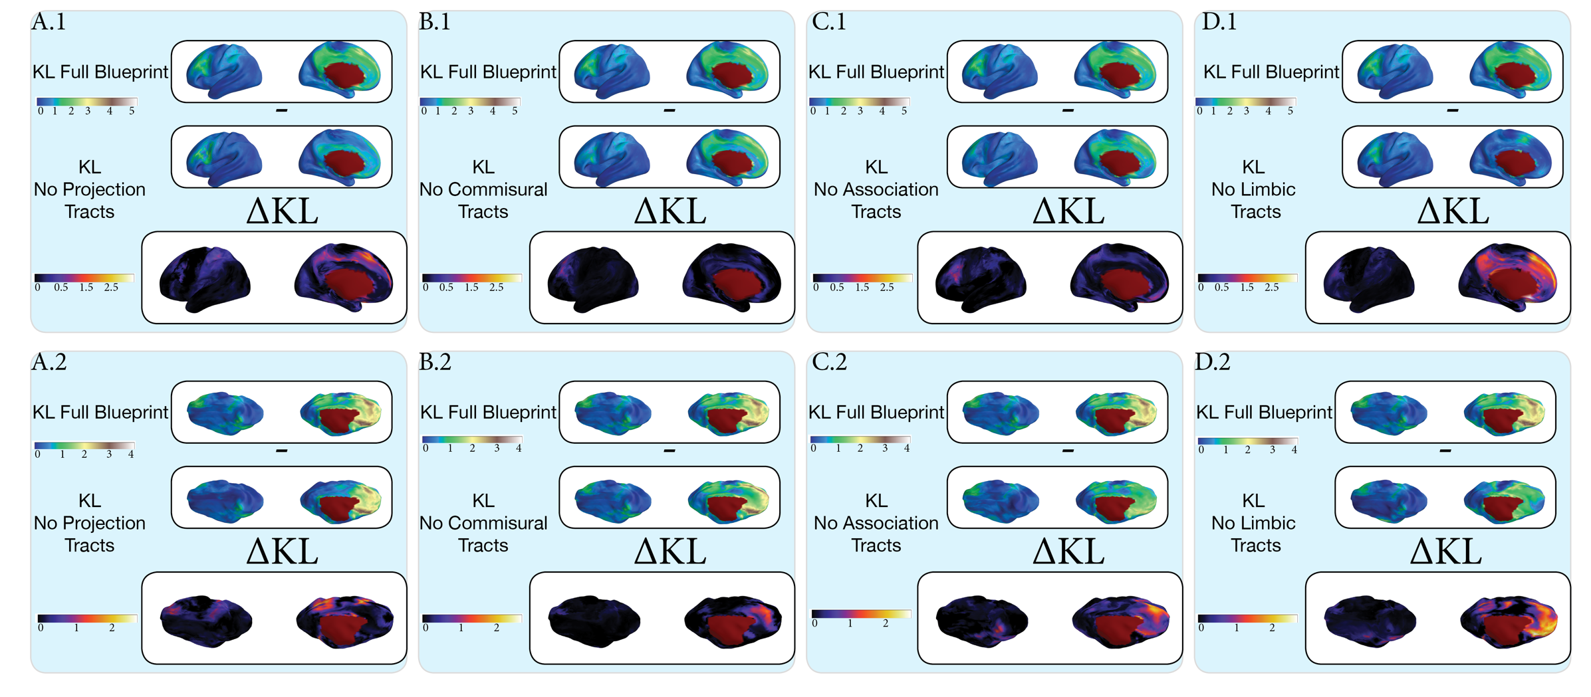
Figure S1. The impact of each tract group on the spatial distribution of KL divergence is demonstrated by calculating the difference between the KL blueprint containing all WM and a secondary set of four blueprints where each tract group has been left out while the rest of the tracts are present. A) The projection tracts are removed from the full KL blueprint for both the human and pig and the subsequent difference in KL divergence shows the regions most impacted by their removal such as the regions corresponding to the posterior thalamic radiations (PTR) in A.1 and A.2 A.1) The differences of KL divergence corresponds to areas in the medial frontal cortex and the precuneus. A.2) The KL difference corresponds to the frontal division of the coronal sulcus where the frontal and somatosensory regions divide in the pig. B). The commissural tracts are removed from the full KL blueprint for both the human and pig. B.1) Mildly changes in KL divergence are associated primarily in the region of the lateral projections of the Forceps Minor (FMI). B.2) Changes in the KL divergence are shown in the medial territory of the FMI and Forceps Major (FMA). C) The association tracts are removed from the full KL blueprint for both the human and pig. C.1) ∆KL is observed to change in the medial frontal gyrus implicating the association tracts as responsible for the KL divergence values of the full blueprint in this region. C.2) ∆KL in the pig shows changes to the superior frontal cortex along the medial surface, as well as the inferior temporal gyrus. D). The limbic tracts are removed from the full KL blueprint for both the human and pig causing the greatest difference between the full KL blueprint of any of the tract groups (Figure S2). D.1) ∆KL increases substantially along the body of the cingulum but not the fornix. The limbic tracts show a significant role in the divergence of the medial frontal cortex as well as the precuneus. D.2) ∆KL shows peaks in the frontal cortex of the pig as well as in the precuneus, but unlike the human does not outline a central body of the cingulum along the anterior-posterior axis.

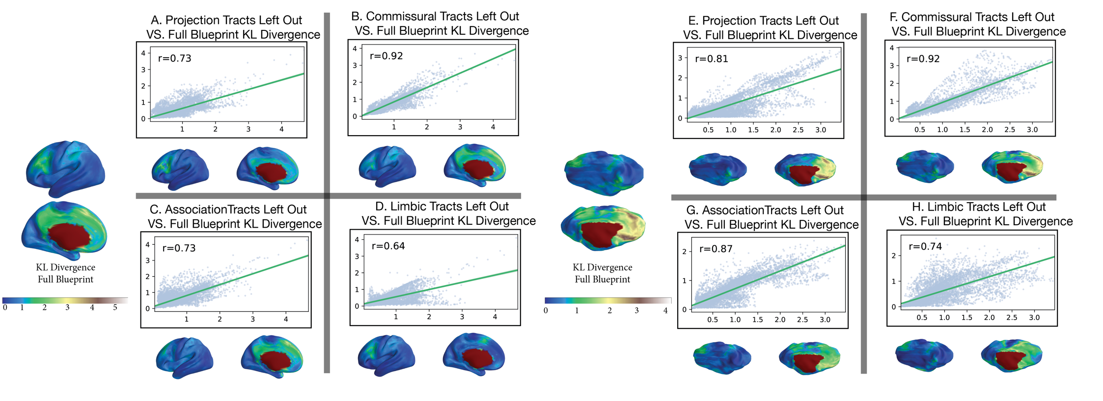
Figure S2. Spatial correlation of the minimum KL divergence of the full KL blueprint as compared to minimum KL divergence of blueprints which have had a single tract group removed. A) The projection tracts in the human blueprint significantly drive the overall KL divergence of the full blueprint as shown by a low spatial cross correlation of r=0.73 B). The impact of the commissural tracts is minimal at r=0.92 implying that these tracts are highly conserved between the pig and human and minimally alter the overall KL divergence between both species. C). The association tracts tie with the projection tracts with r=0.73 showing they play a considerable role in driving the dissimilarity measured in the human cortex. D). The limbic tracts show the worst spatial correlation (r=0.64) between the min-KL of the full blueprint identifying them as the tract group which most drives the presence of non-shard connectivity fingerprints in the pig and human. E). As in the human a significant portion of the KL divergence can be attributed to the presence of the projection tracts (r=0.81). F) Similarly we the commissural tracts play a minimal role in forming the min-KL of the whole blueprint (r=0.92) suggesting this is the group of tracts most conserved between species. G) Unlike in the human the association tracts play a smaller role in driving the full blueprint KL divergence than the projection tracts (r=0.87) suggesting they may not be well conserved as their effect on the KL divergence of the full blueprint differs substantially for both species. H). As in the human the limbic tracts are the primary drivers of the KL divergence in the full connectivity blueprint as shown through minimal spatial correlation (r=0.74). From this we conclude that the limbic tracts are the least conserved tracts between the pig and human cortex.

