Supplementary information
From macro to micro: multi-scale study of plasmonic nanocoating self-assembled on multijunction bulk solar cells
Dan Su^{1,&}, Xiao-Yang Zhang^{2,3,&}, Lei Lv²,Huan-Li Zhou², Shan-Jiang Wang², Yi Yang², Jing-Yuan Wu⁴, Ning Zhao^{1,2,3}, Tong Zhang^{1,2,3, *}
1. Key Laboratory of Micro-Inertial Instrument and Advanced Navigation Technology, Ministry of Education, School of Instrument Science and Engineering, Southeast University, Nanjing, 210096, People's Republic of China
2. Joint International Research Laboratory of Information Display and Visualization, School of Electronic Science and Engineering, Southeast University, Nanjing, 210096, People's Republic of China.
3. Suzhou Key Laboratory of Metal Nano-Optoelectronic Technology, Southeast University Suzhou Campus, Suzhou, 215123, People's Republic of China
4. Photonics Laboratory and Institute of Functional Materials, College of Science, Donghua University, Shanghai, 201620, People's Republic of China
& These authors contributed equally to this work and should be considered co-first authors
* Corresponding author, E-mail: tzhang@seu.edu.cn

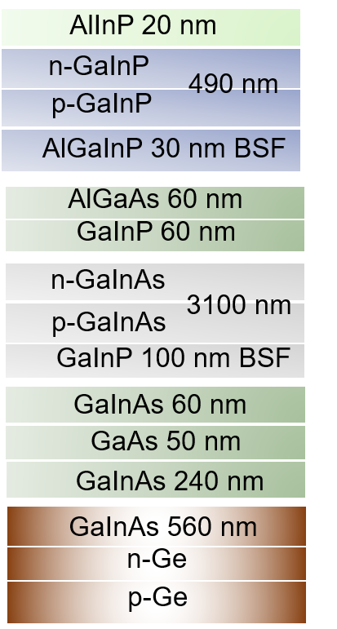
Supplementary Fig. 1| Simulation structural parameters of MJSC.
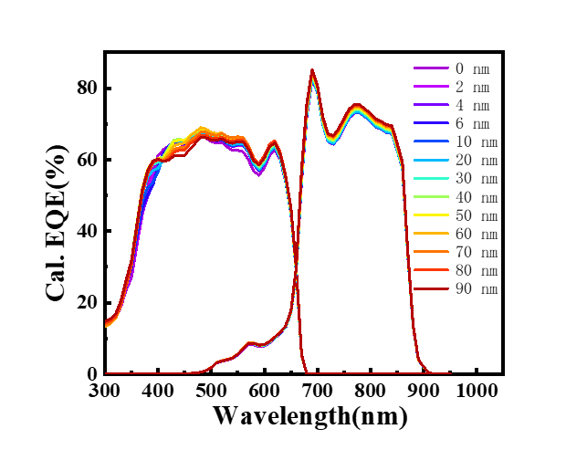
Supplementary Fig. 2| Calculated EQE of the single dispersed particle on MJSC.
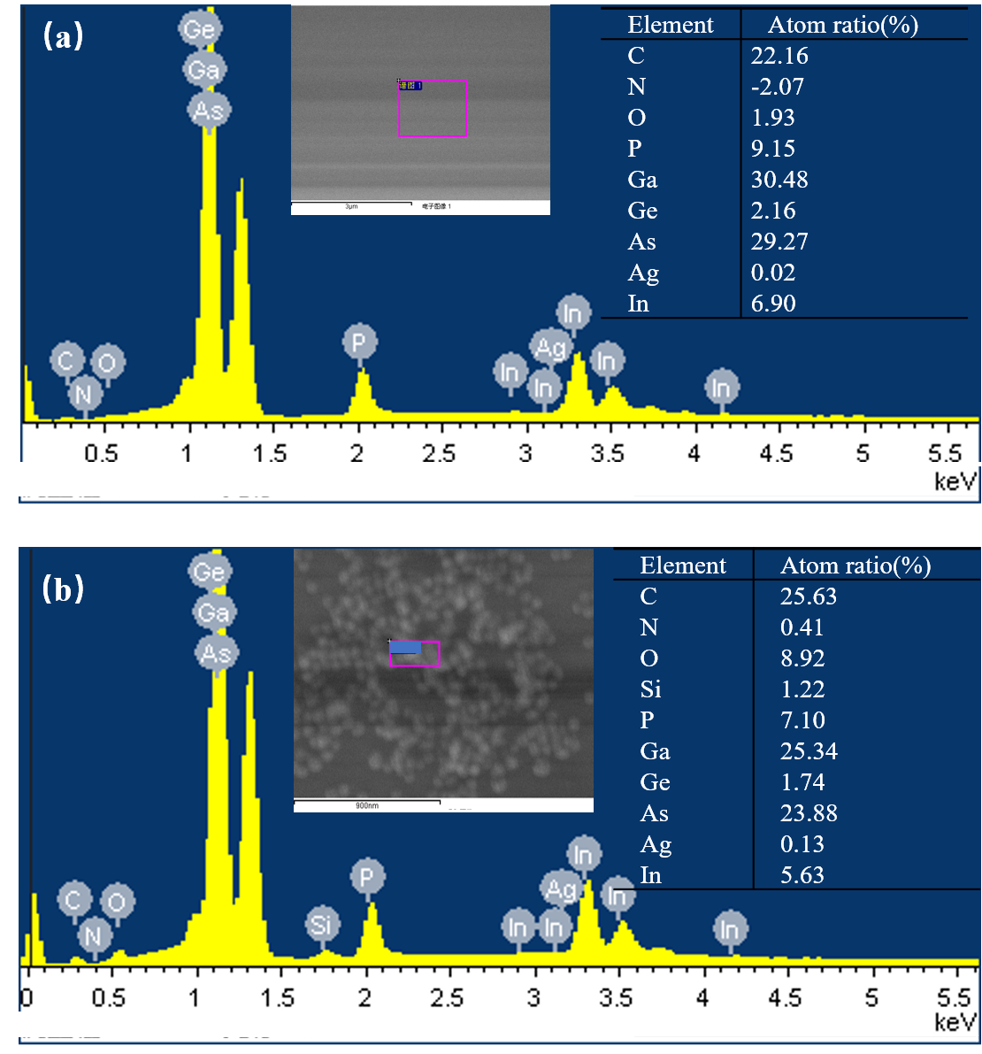
Supplementary Fig. 3| EDS Characterization of Ag@SiO₂ core-shell nanostructure on InGaP-GaAs-Ge MJSC.

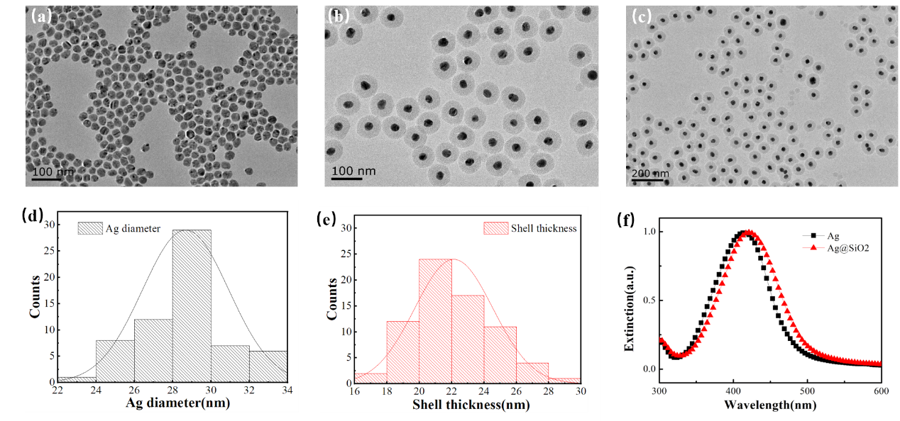
Supplementary Fig. 4| Characterization of Ag@SiO₂ core-shell nanostructure. TEM images of the Ag nanospheres (a) and Ag@SiO₂ core-shell nanostructure (b), (c) for different magnifications. Structural parameters analysis of Ag diameter (d) and SiO₂ shell thickness (e). (f) The extinction spectra of Ag and Ag@SiO₂ core-shell nanostructure.
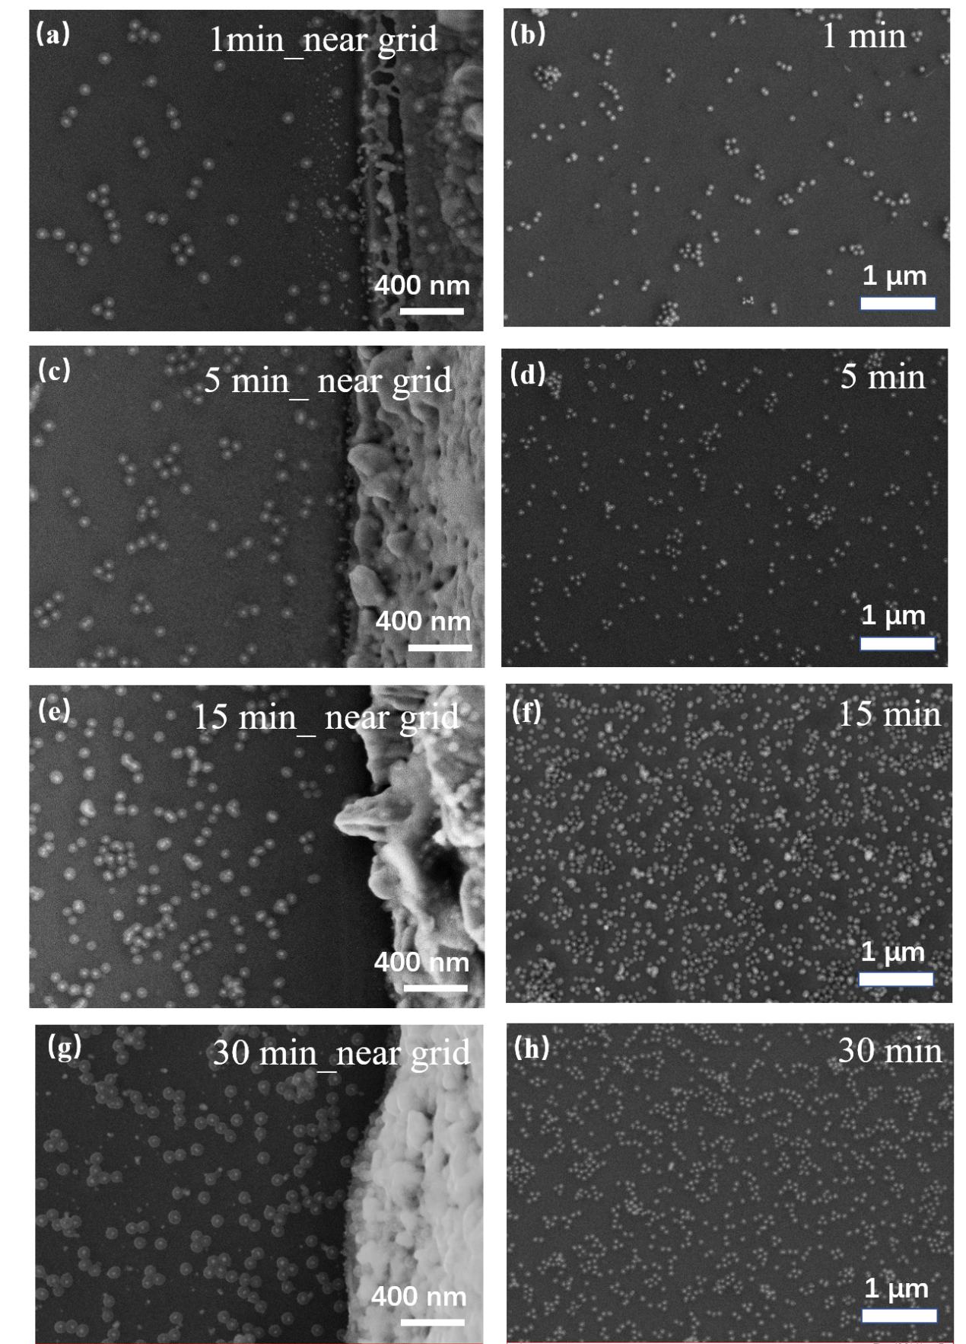
Supplementary Fig. 5| Extra SEM Characterization of Ag@SiO₂ core-shell nanostructure on InGaP-GaAs-Ge MJSC. Regions near gird 1 min (a), 5 min (b), and 15 min (c). Large-area SEM image of different assembly time 1 min (d), 5 min (e), and 15 min (f).

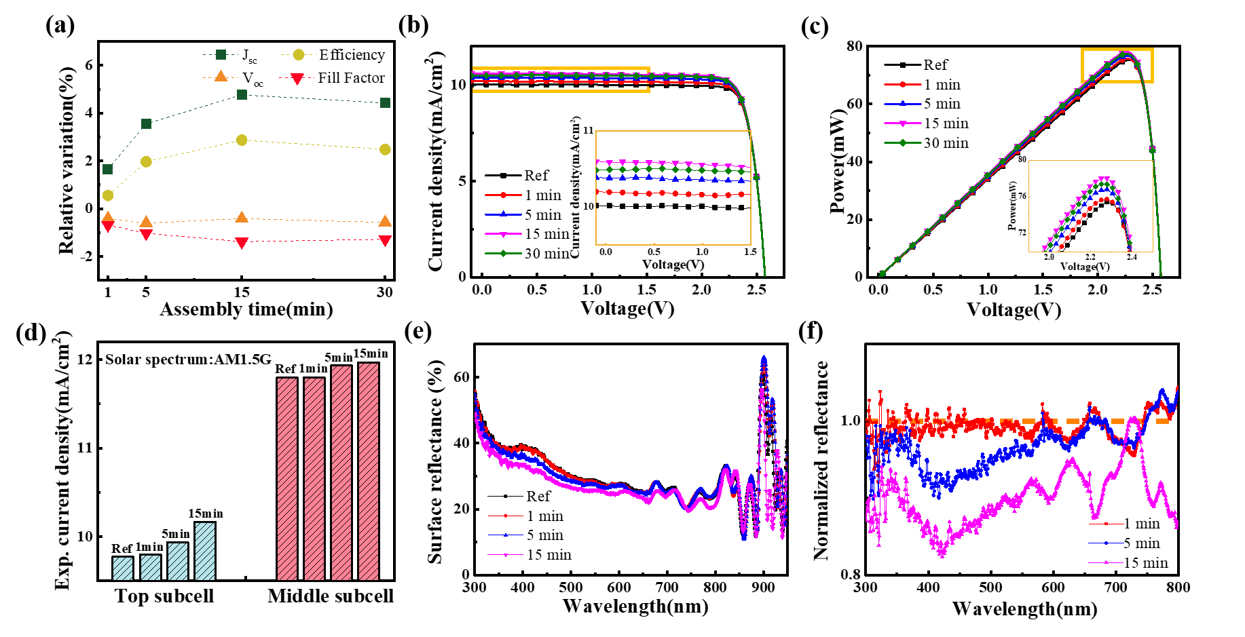
Supplementary Fig. 6| Macro electrical performance of MJSC with self-assembly nanostructured layers. a Relative variation of the short-circuit current density (J_{sc}), the efficiency, the open-circuit voltage (V_{oc}), and the fill factor for assembly times. Current relation(b) and Power-voltage relation (c) of InGaP-GaAs-Ge MJSCs with different self-assembly time. d Current density of the top cell and the middle cell under different assembly time. e Surface reflection spectra of MJSCs with different assembly time.f Relative reflectance variation normalized to the reference MJSC without a nanostructured layer.

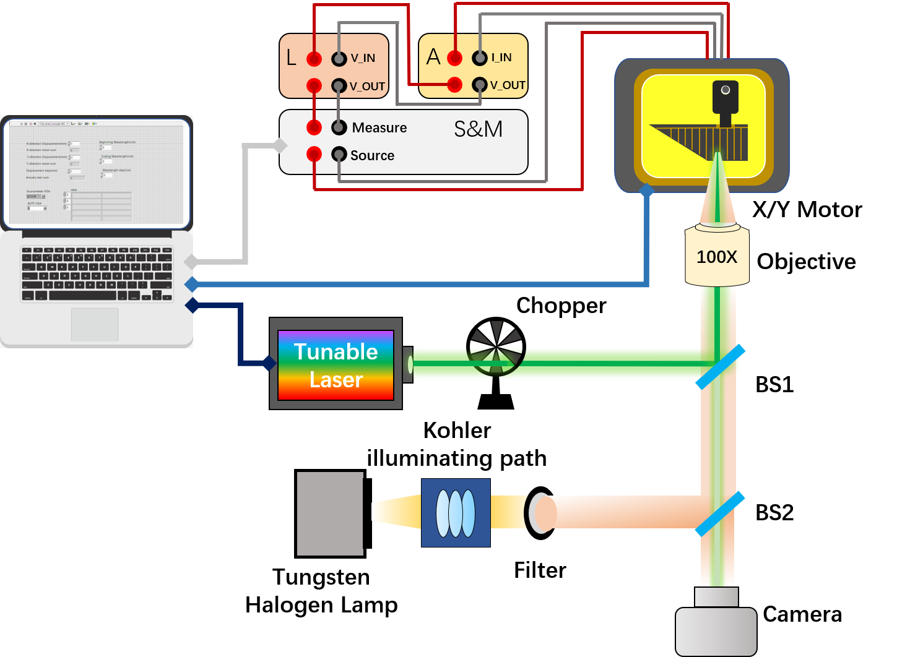
Supplementary Fig. 7| Schematic of the micro-region photocurrent measurement system for MJSC

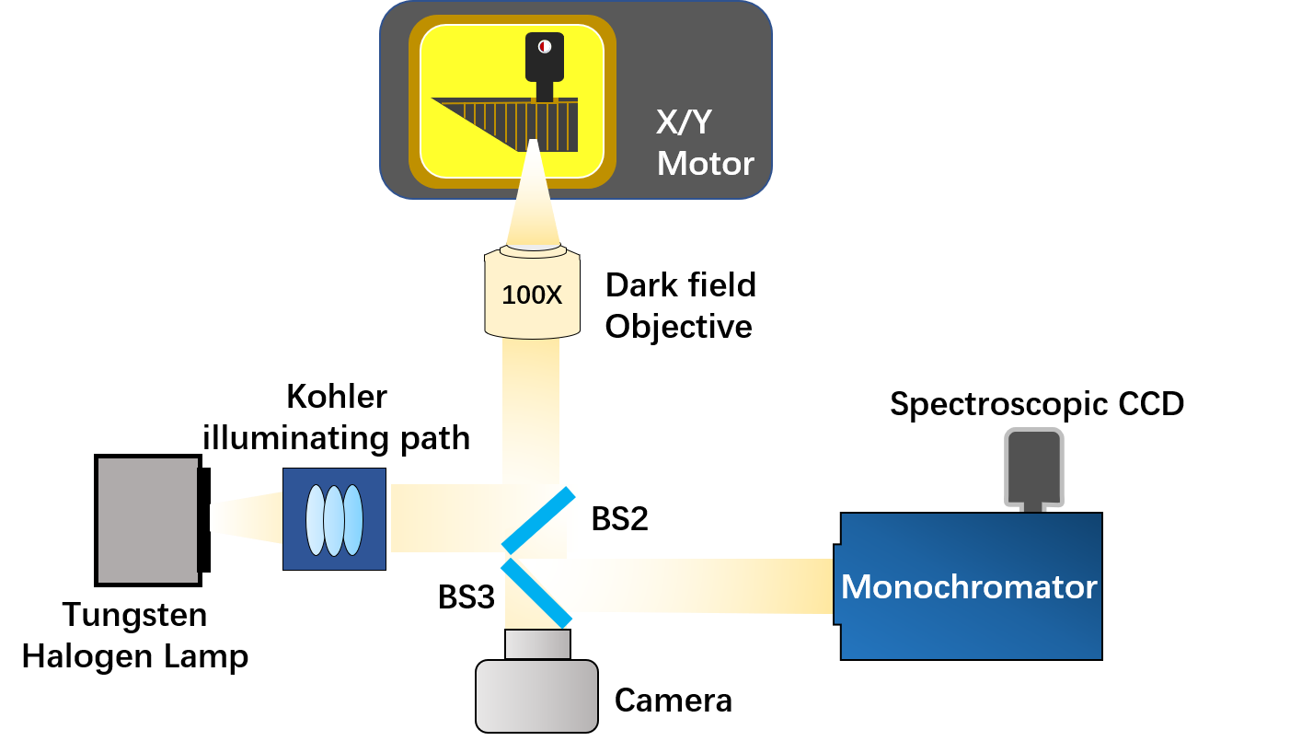
Supplementary Fig. 8| Schematic of the micro-region optical characterization system for MJSC
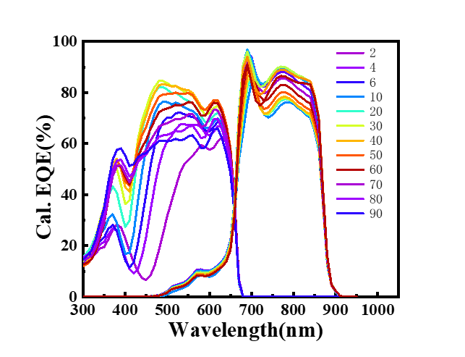
Supplementary Fig. 9| Calculated EQE for different shell thickness under the closely packed condition

Supplementary Table 1| Electrical parameters under AM1.5G illumination.
Description | V_{oc}(V) | J_{sc}(mA/cm²) | Fill Factor(%) | Efficiency(%)
30 min | 2.56±0.01 | 10.80±0.09 | 84.43±0.26 | 23.36±0.15

Supplementary Table 2| Micro background EQE analysis of MJSC.
Wavelength(nm) | Mean EQE relative Var. (%) | Max EQE relative Var. (%) | Min EQE relative Var. (%) | EQE relative Var. S.D.
450 | 0 | 1.63 | -2.03 | 0.98
480 | 0 | 1.72 | -2.10 | 0.72
500 | 0 | 1.16 | -0.74 | 0.39
520 | 0 | 0.55 | -0.57 | 0.29
540 | 0 | 0.50 | -0.20 | 0.26
600 | 0 | 0.45 | -0.37 | 0.23

Supplementary Table 3| Micro EQE analysis of 5 minutes of self-assembly MJSC.
Wavelength(nm) | Mean EQE relative Var. (%) | Max EQE relative Var. (%) | Min EQE relative Var. (%) | EQE relative Var. S.D.
450 | 0.79 | 3.28 | -1.96 | 1.14
480 | 6.23 | 8.97 | 3.98 | 1.18
500 | 7.44 | 9.58 | 5.90 | 1.00
520 | 5.40 | 5.64 | 5.24 | 0.10
540 | 3.69 | 5.07 | 2.98 | 0.49
600 | 1.47 | 2.10 | 0.99 | 0.31

