Fig. S1: Microscopic observation of SSW-01 and SSW-02
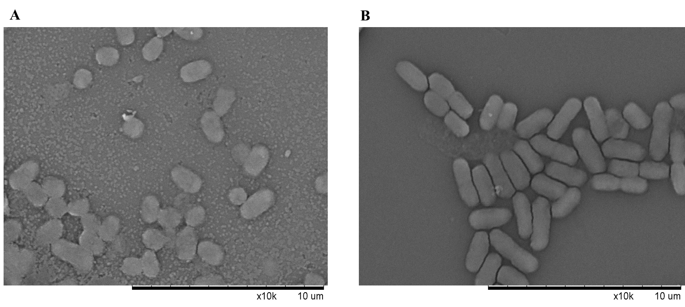
(A) SSW-01 cells were shorter than (B) SSW-02 cells.

