Table S1. Information sheet of nephrite objects (Some samples have a dark/black color on the glossy surface due to excessive reflection).
Sample No. | Type | Description | Photo
M1:6 | Ring | A circle of rope pattern, white with brown, translucent | 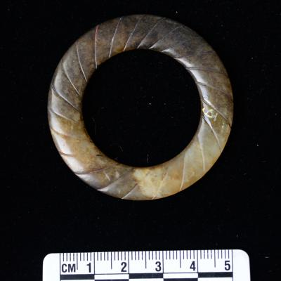
M1:11 | Flake ornament | Notched edges, yellow with black, translucent | 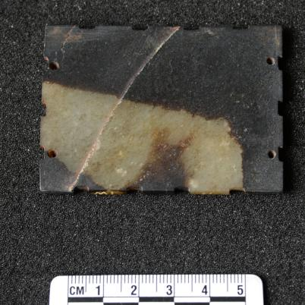
M1:12 | Oblong pendant | Exquisitely decorated, uniform hues, well-polished, translucent | 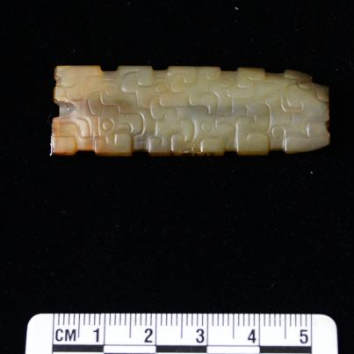
M1:13 | Tube | Exquisitely decorated, partly corroded, brown with white and yellow, opaque | 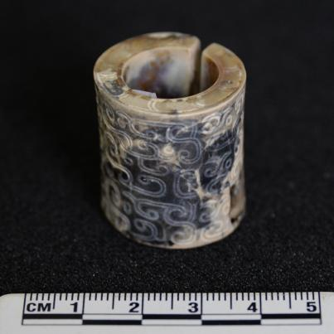
M1:15 | Huang (pendant) | With blade, gray-green, perforated, well-polished, opaque | 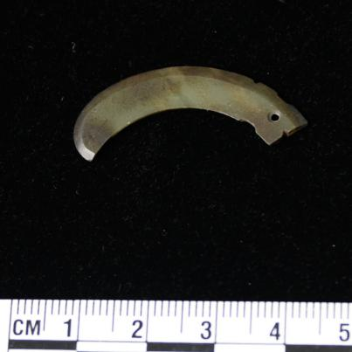
M1:18 | Slit ring pendant | With blade, brown with yellow spots, perforated, opaque | 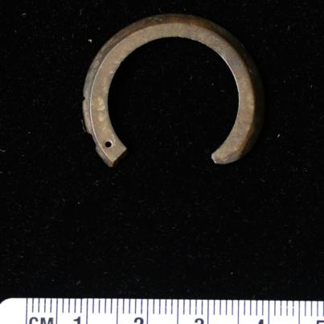
M1:29 | Fish | Exquisite shape, severe weathered, opaque | 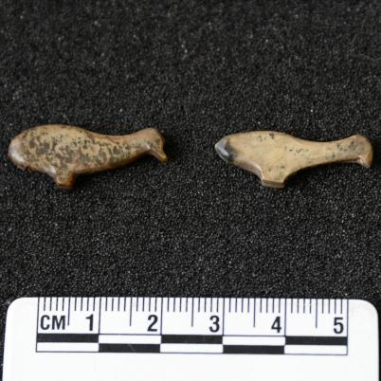
M1:30 | Dear | Exquisite shape, occasional black patches, well-polished, translucent | 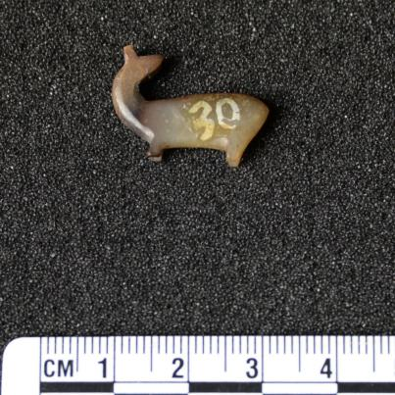
M1:31 | Flake ornament | Notched edges, black, opaque | 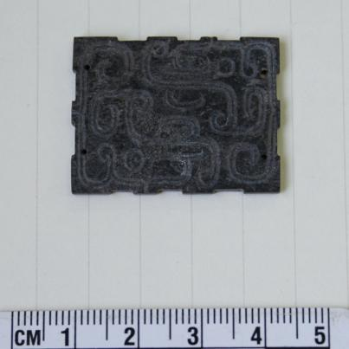
M1:42 | Bird pendant | The phoenix shape, well decorated, visible signs of repair after breakage, yellow with black,perforated, translucent | 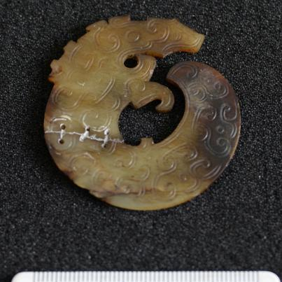
M1:70 | Ring | Black with white spots, broken, opaque | 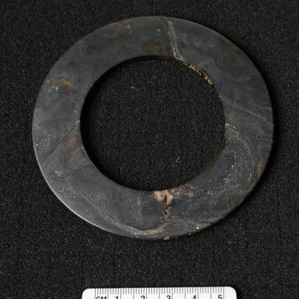
M1:78 | Bird pendant | Exquisite shaped and decorated, yellow with black patches at the edges, well-polished, translucent | 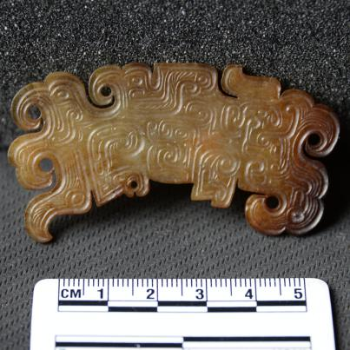
M1:79 | Tiger ornament | Exquisite shaped and decorated, brown, perforated, well-polished, semi translucent | 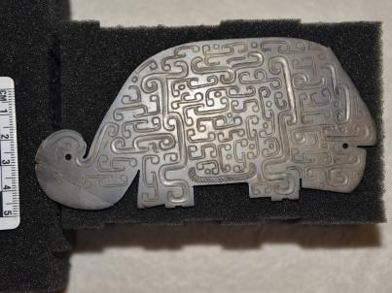
M1:80 | Rectangular pendant | Notched edges, slight yellow, perforated, translucent | 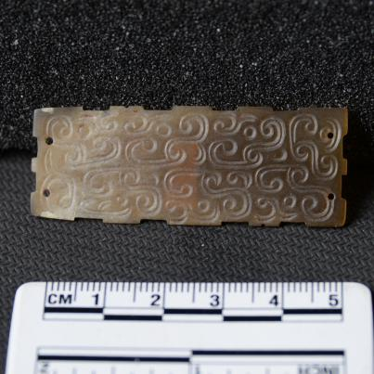
M1:83 | Ornament | Partly corroded, yellow with brown and white spots, opaque | 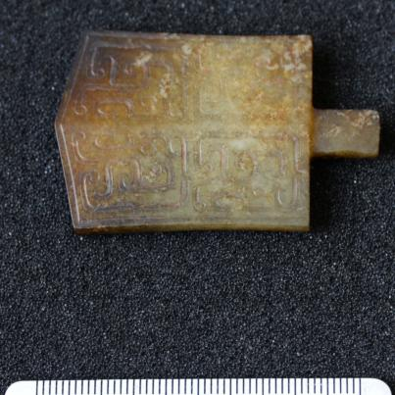
M1:84 | Animal ornament | Exquisite shape, black with red patches, perforated, opaque | 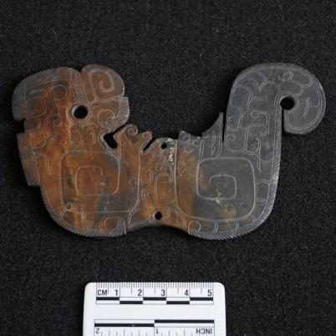
M1:85 | Ring | Brown with white spots, weathered, opaque | 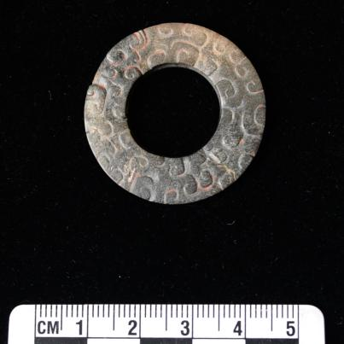
M1:86 | Zhang | Intact shape, well-polished, black with red and white spots, perforated, opaque | 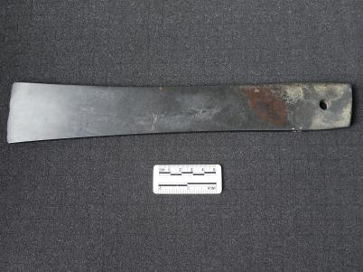
M1:93 | Rectangular ornament | Intricate decorations, white with black spots, translucent | 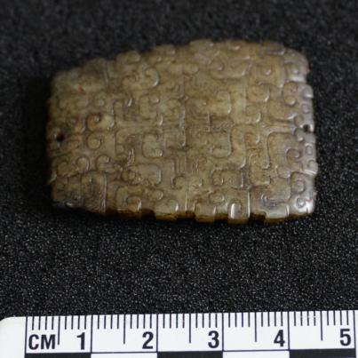
M1:98 | Dagger-shape | With damage, well-polished, yellow with brown | 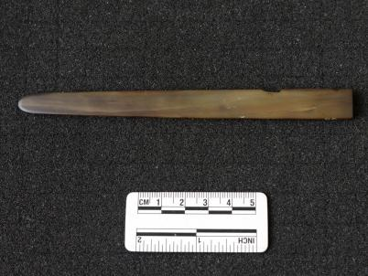
M1:99 | Ring | Black with gray and brown patches, broken, opaque | 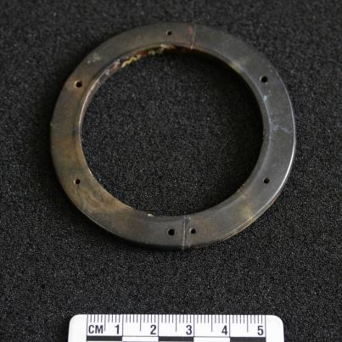
M1:100 | Oblong pendant | Exquisitely decorated, gray with black dots, translucent | 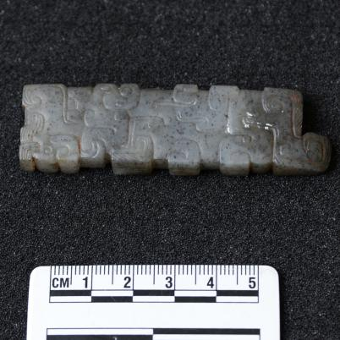
M1:101 | Ring | White with yellow spots, well-polished, translucent | 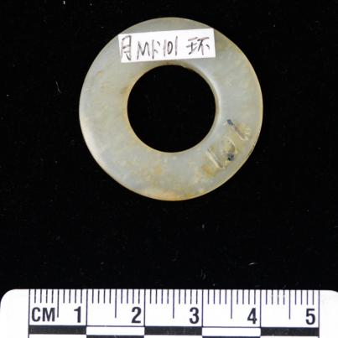
M1:102 | Ring | Brown with black spots, well-polished, opaque | 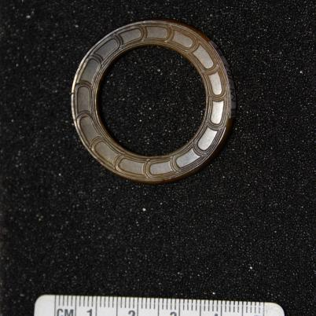
M1:103 | Gui | Corroded, brown with black spots, perforated, opaque | 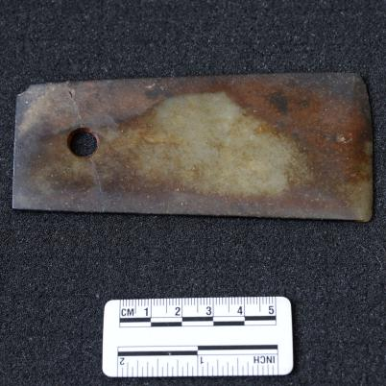
M1:110 | Knife | Exquisitely decorated, uniform black, well-polished, opaque | 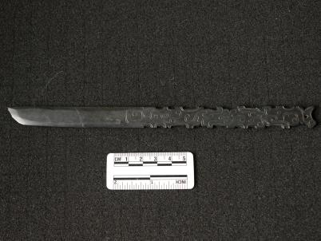
M1:111 | Huang | Exquisitely decorated, brown, well-polished, opaque | 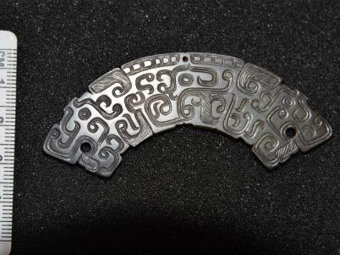
M1:112 | Huang | White with black spots, semi translucent | 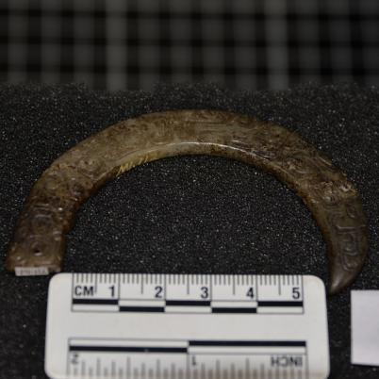
M1:115 | Rectangular ornament | Black, opaque | 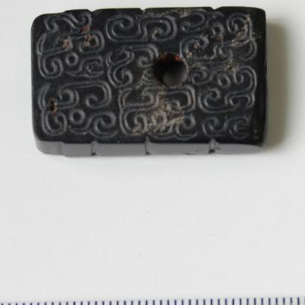
M1:117 | Xi (to untie knots) | With a sharp point, black, broken, opaque | 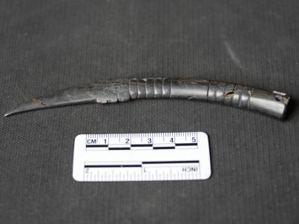
M1:121 | Flake ornament | Black with red and white spots, perforated, opaque | 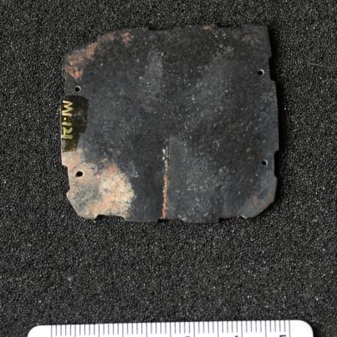
M1:122 | Huang | White with black patches, perforated, translucent | 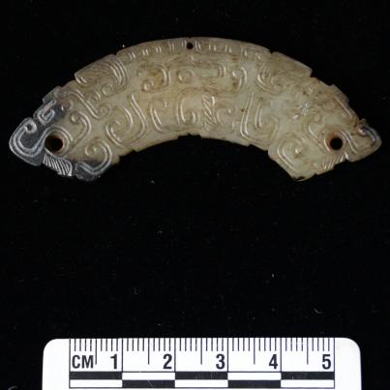
M1:123 | Ornament | Exquisitely shaped and decorated, white with a few impurities, well-polished, opaque | 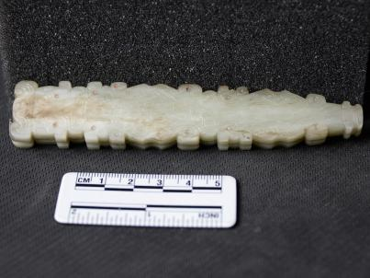
M1:129 | Oblong pendant | Exquisitely decorated, gray with brown spots, well-polished, translucent | 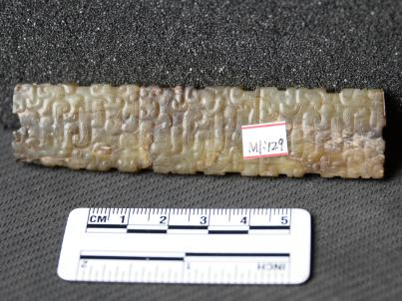
M1:130 | Tube | Silkworm-like shaped, black, well-polished, opaque | 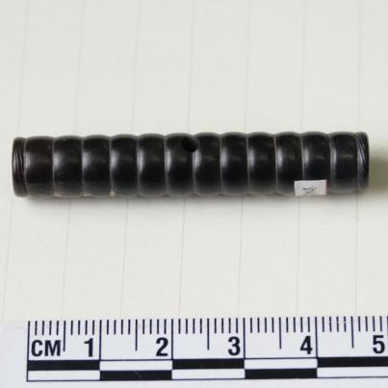
M1:135 | Ear picks | Exquisitely shaped and decorated, brown, well-polished, opaque | 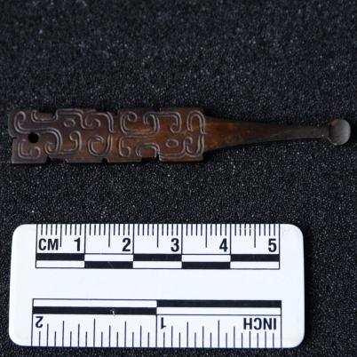
M1:136 | Sword hilt | Exquisitely shaped and decorated, white with yellow spots, well-polished, translucent | 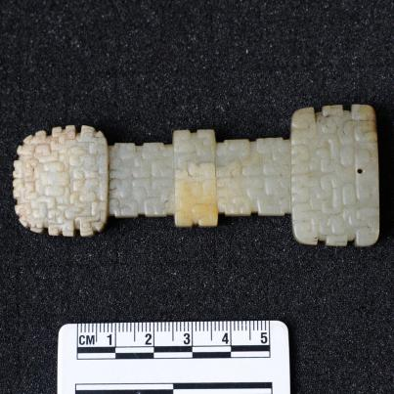
M1:137 | Jue (slit ring) | Notched edges, well decorated, weathered, gray with white patches, translucent | 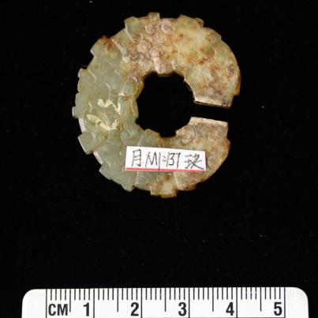
M1:140 | Cong | Well polished, gray with black patches, semi translucent | 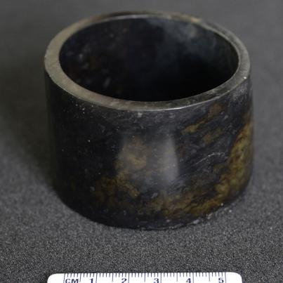
M1:142 | Zhang | Well shaped, black with brown patches, opaque | 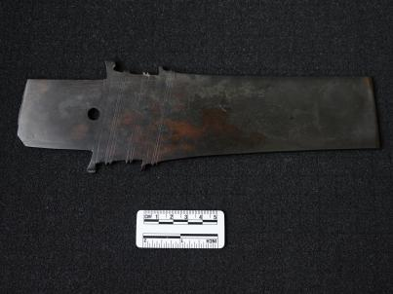
M1:143 | Ornament | Exquisitely shaped and decorated, partly corroded, gray with brown and white patches, translucent | 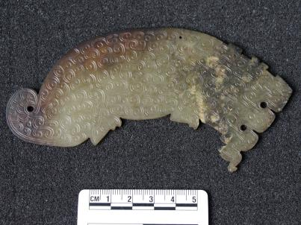
M1:151 | Tube | Well polished, brown and white spots, semi translucent | 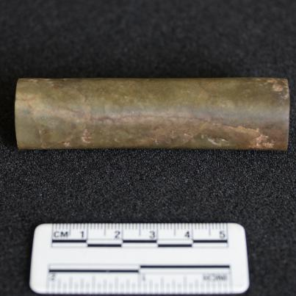
M1:156 | Oblong pendant | Well shaped, brown, translucent | 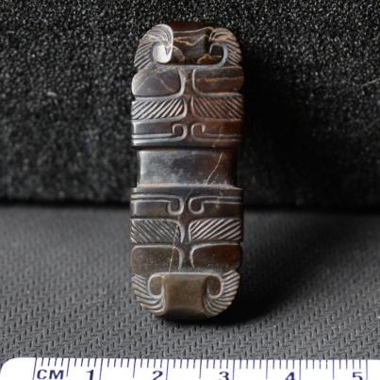
M1:157 | Tube | Uniform white, well polished, semi translucent | 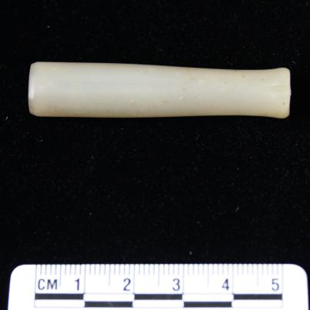
M1:158 | Ring | Well shaped and decorated, brown, semi translucent | 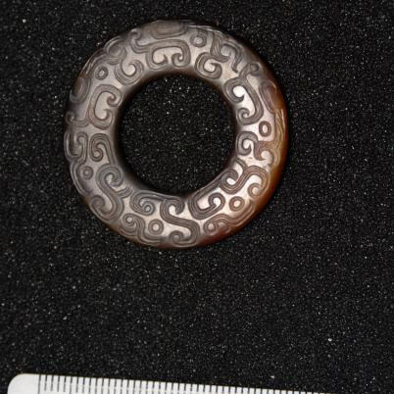
M1:159 | Flake ornament | Notched edges, white with black spots, perforated, translucent | 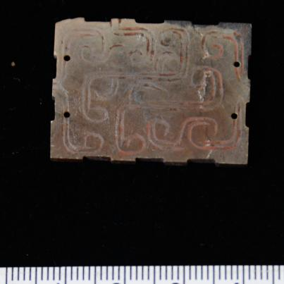
M1:161 | Animal ornament | Exquisitely shaped and decorated, gray with black spots, translucent | 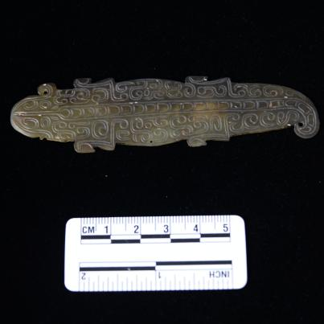
M1:162 | Flake ornament | Notched edges, gray with black spots, perforated, translucent | 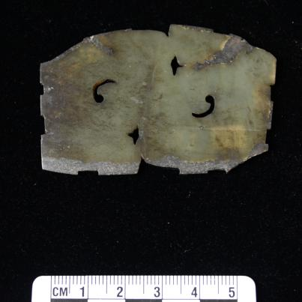
M1:162-2 | Huang | Brown with red spots, perforated, opaque | 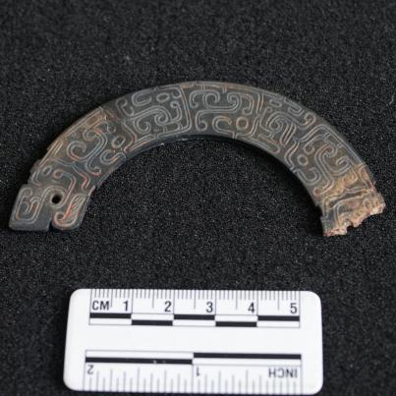
M1:163 | Oblong ornament | Well shaped and decorated, gray with black spots, translucent | 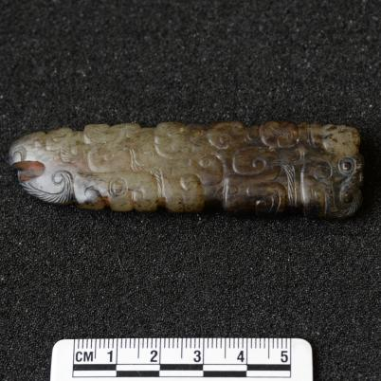
M1:164 | Oblong ornament | Well shaped and decorated, gray with black spots, translucent | 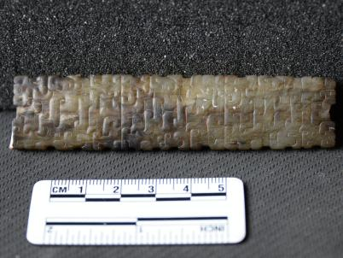
M1:165 | Ring | Uniform black, broken, opaque | 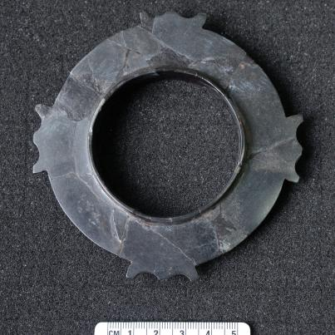
M1:167 | Human-shaped pendant | Exquisitely shaped and decorated, gray, translucent | 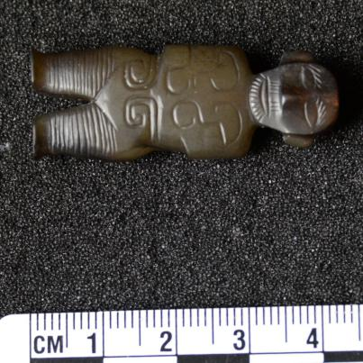
M1:174 | Flake ornament | Notched edges, white with black spots, perforated, semi translucent | 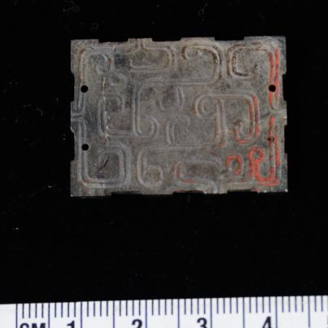
M1:183 | Huang | Gray, perforated, broken, translucent | 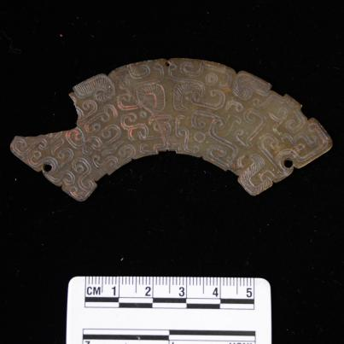
M1:185 | Flake ornament | Notched edges, gray with black spots, perforated, translucent | 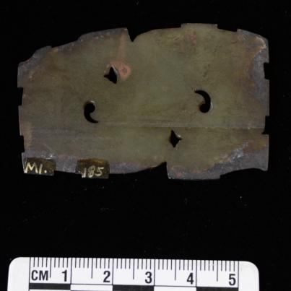
M1:186 | Flake ornament | Notched edges, gray with black and white spots, perforated, translucent | 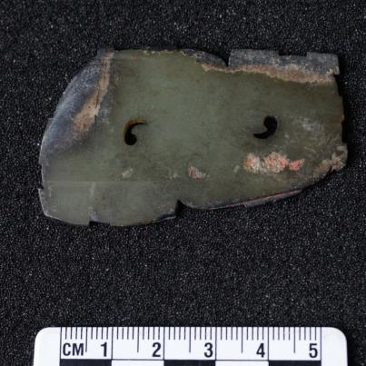
M1:187 | Gui | Gray with brown spots, well-polished, opaque | 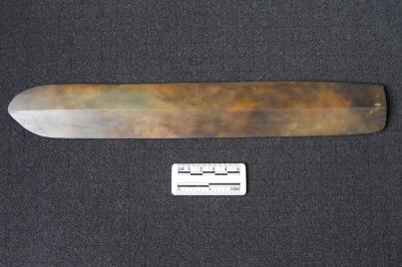
M1:191 | Knife | With blade, black with red and white spots, perforated, well-polished, opaque | 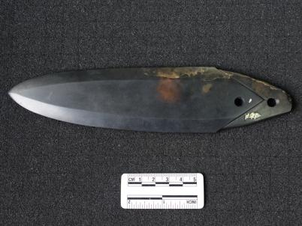
M1:202 | Oblong ornament | Exquisitely shaped and decorated, white with brown spots, well polished, translucent | 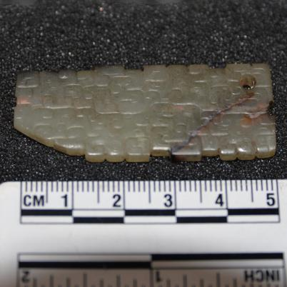
M1:208 | Triangular ornament | Notched edges, white with brown and black patches, perforated, opaque | 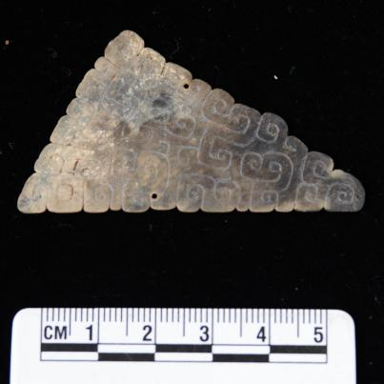
M1:222 | Flake ornament | Exquisitely shaped and decorated, white with brown, well polished, translucent | 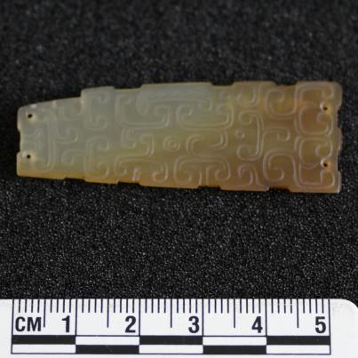
M1:233 | Flake ornament | Notched edges, white with brown and black patches, perforated, opaque | 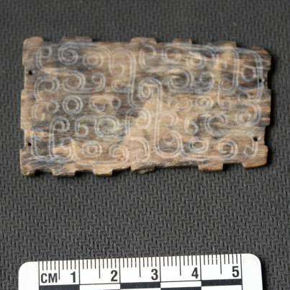
M1:235 | Bi (Ring) | Exquisitely shaped and decorated, brown with red and white spots, opaque | 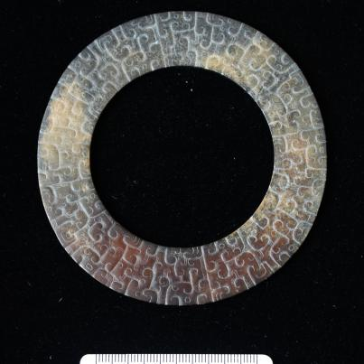
M1:239 | Animal ornament | Exquisitely shaped and decorated, brown with red and white spots, perforated, opaque | 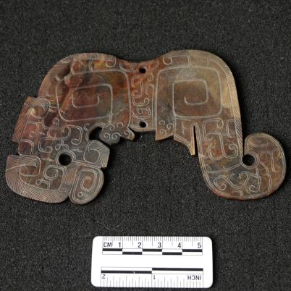
M1:245 | Bi (Ring) | Partly corroded, light gray with black and white patches, well polished, opaque | 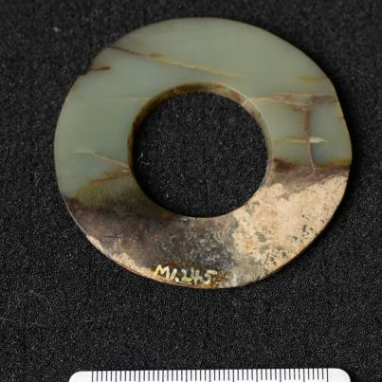
M1:247 | Triangular ornament | White with brown and black patches, perforated, opaque | 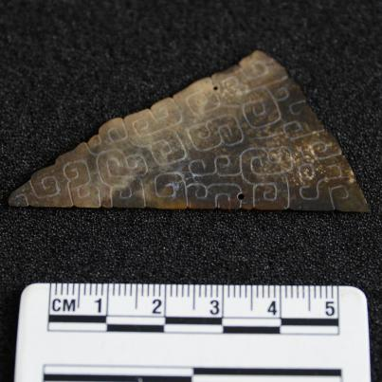
M1:248 | Animal pendant | The phoenix shape, well decorated, gray with black and brown spots, translucent | 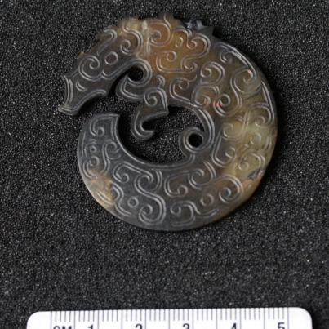
M1:253 | Flake ornament | Notched edges, gray with brown spots, perforated, opaque | 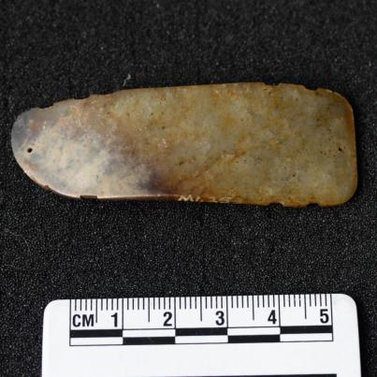
M1:258 | Jue | Weathered, gray with brown and black spots, perforated, opaque | 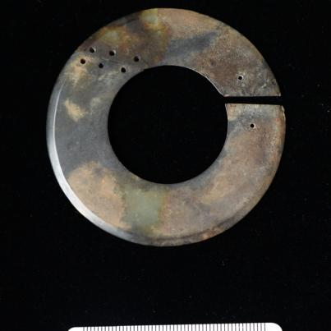
M1:259 | Bird pendant | Well shaped and decorated, gray with black spots, opaque | 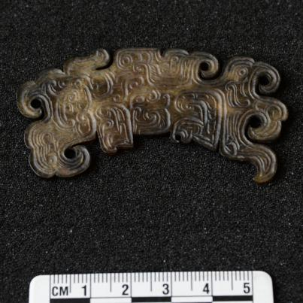
M1:264 | Flake ornament | Notched edges, gray with black spots, perforated, opaque | 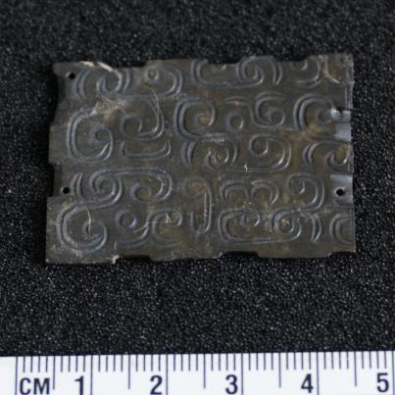
M1:265 | Jue | Well shaped, gray with black and brown patches, semi translucent | 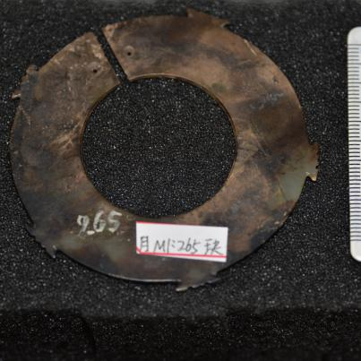
M1:268 | Bi (Ring) | Brown, opaque | 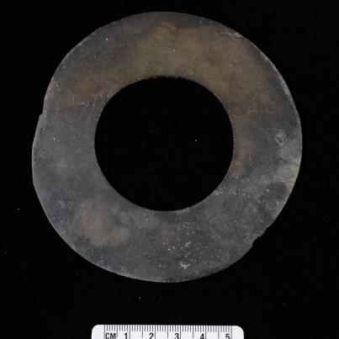
M1:298 | Huang | Notched edges, black, perforated, opaque | 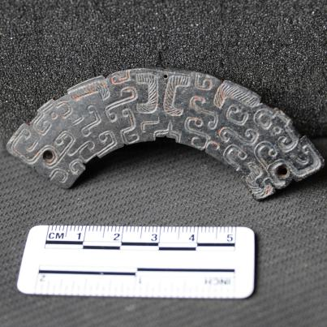
M1:300 | Ring | Black, well polished, opaque | 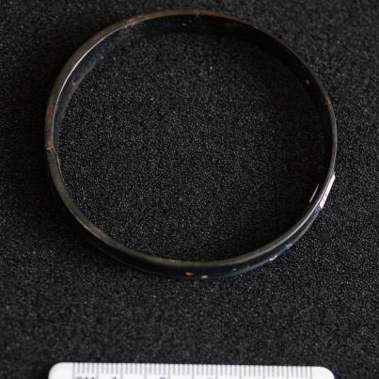
M1:304 | Huang | Well decorated, gray with black spots, perforated, semi translucent | 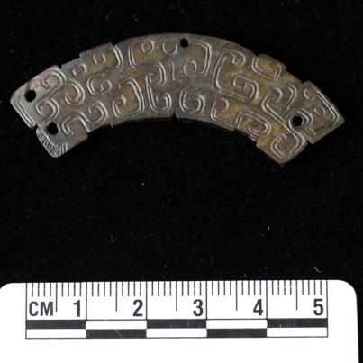
M1:308 | Huang | White with black spots, perforated, semi translucent | 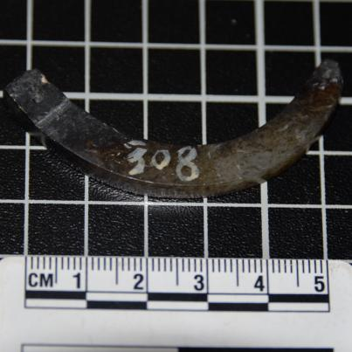
M1:309 | Huang | White with black spots, perforated, semi translucent | 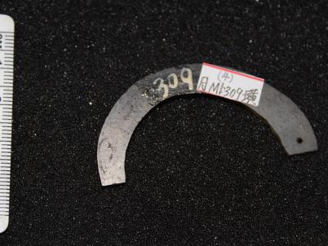
M1:311 | Crescent pendant | Well decorated, white with black spots, perforated, translucent | 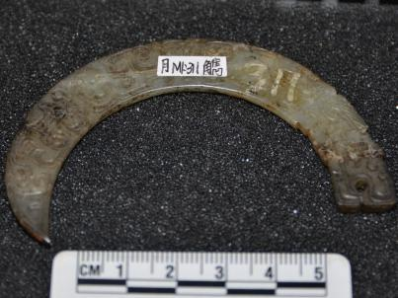
M1:318 | Oblong ornament | Exquisitely shaped and decorated, white with black dots, translucent | 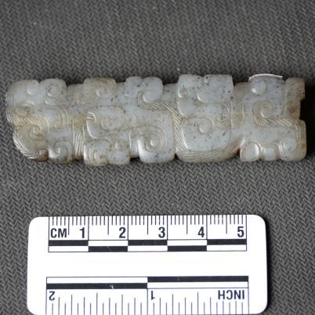
M1:321 | Huang | Well decorated, gray with black spots, perforated, semi translucent | 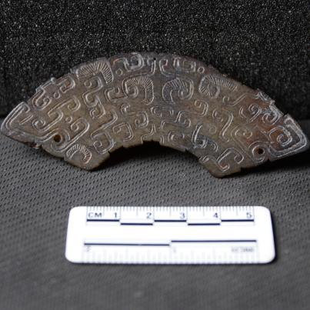
M1:329 | Huang | Well decorated, gray with black dots, perforated, semi translucent | 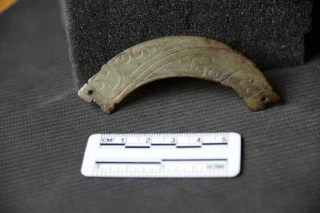
M1:336 | Crescent pendant | White with black spots, perforated, semi translucent | 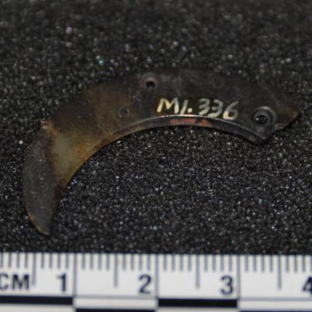
M1:341 | Ring | Black with white spots, perforated, semi translucent | 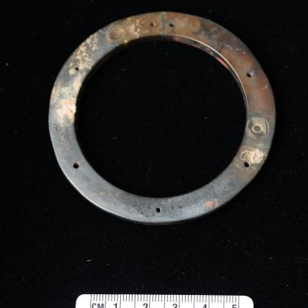
M1:344 | Huang | Black, perforated, opaque | 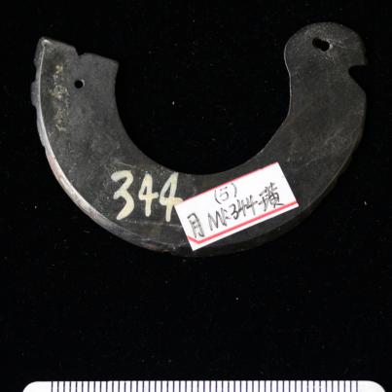
M1:345 | Crescent pendant | Gray with black patches and white dots, perforated, semi translucent | 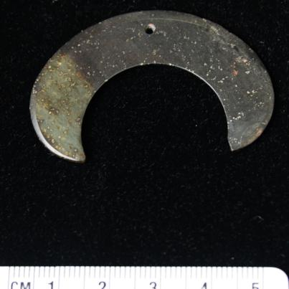
M1:346 | Tiger ornament | Exquisitely shaped and decorated, gray with brown and white patches, perforated, semi translucent | 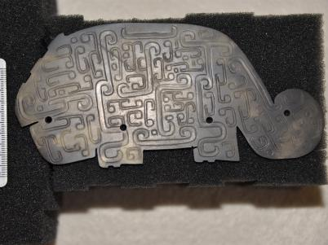
M1:347 | Animal ornament | Exquisitely shaped and decorated, gray with brown spots, translucent | 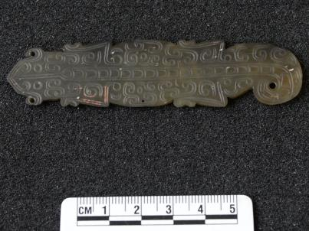
M1:348 | Huang | Black, perforated, semi translucent | 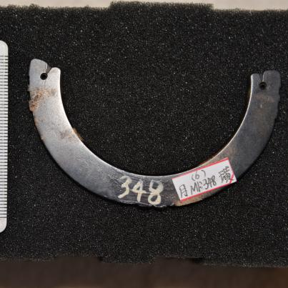
M1:349 | Bi | Exquisitely shaped and decorated, brown, semi translucent | 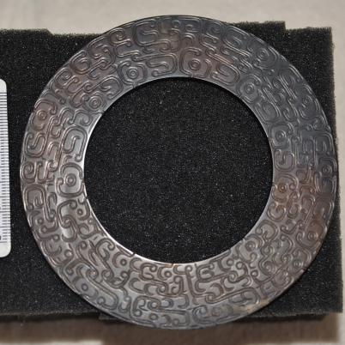
M1:350 | Animal ornament | Exquisitely shaped and decorated, gray with black patches, translucent | 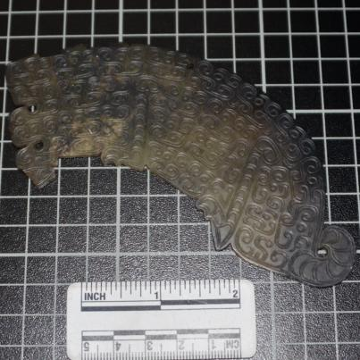
M1:351 | Jue | Gray with black and brown patches, opaque | 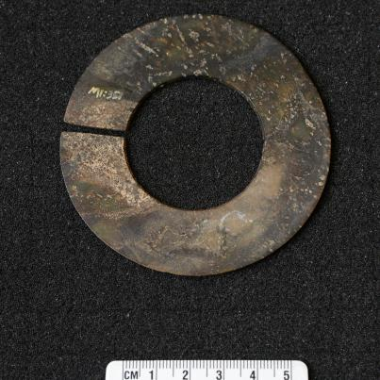
M1:355 | Bi (Ring) | Black and brown patches, opaque | 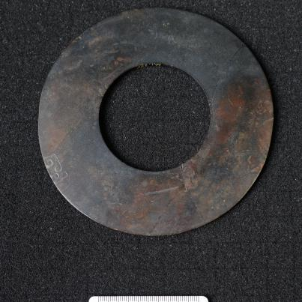
M1:357 | Tiger ornament | Well shaped and decorated, black with white patches, perforated, opaque | 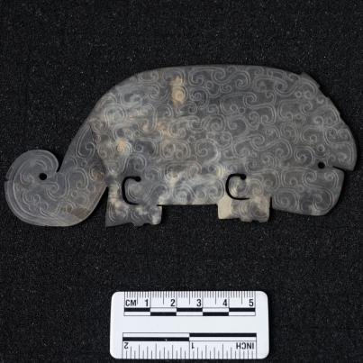
M1:381 | Animal ornament | Exquisitely shaped and decorated, corroded, white with black spots, perforated, opaque | 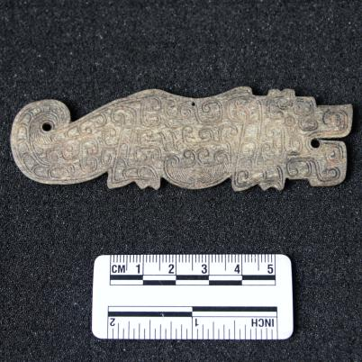
M1:384 | Animal pendant | Well shaped, gray, perforated, translucent | 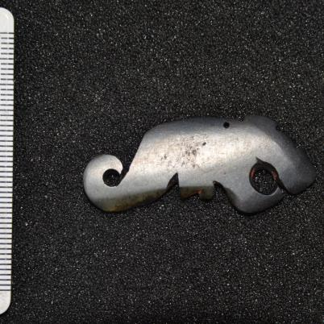
M1:385 | Ornament | Well decorated, black, opaque | 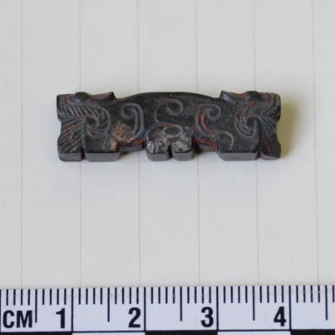
M1:386 | Ring | Yellow with brown spots, perforated, semi translucent | 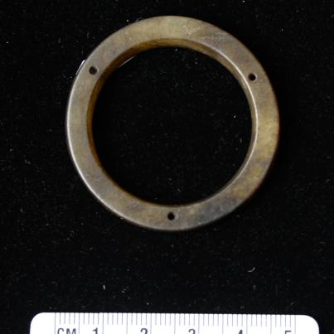
M1:388 | Tiger pendant | Well shaped and decorated, black, perforated, translucent | 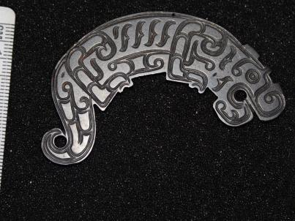
M1:388-2 | Crescent pendant | Black, perforated, semi translucent | 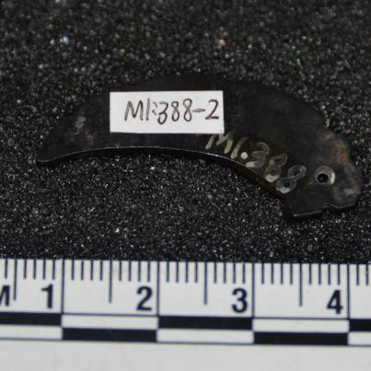
M1:391 | Flake ornament | Notched edges, gray with black spots, perforated, translucent | 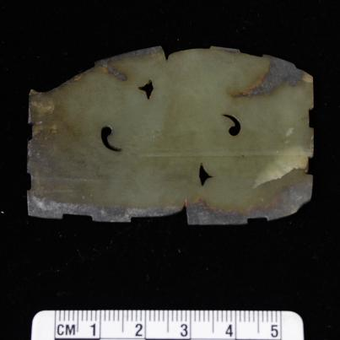
M1:397 | Triangular ornament | Notched edges, severely corroded, black with white patches, opaque | 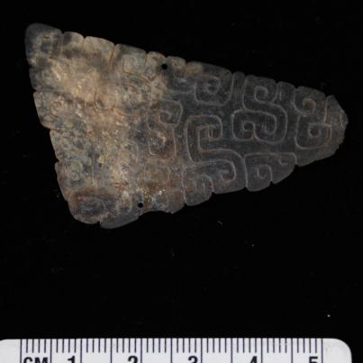
M1:399 | Jue | Well shaped, partly corroded, gray with black and brown patches, semi translucent | 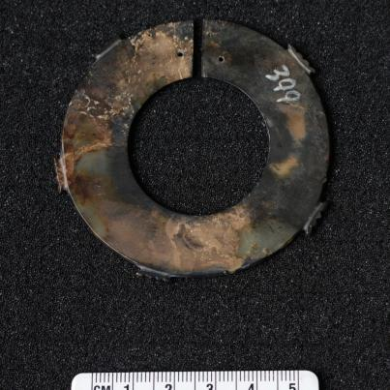
M1:North 1 | Thumb ring | Exquisitely shaped and decorated, red with brown patches, semi translucent | 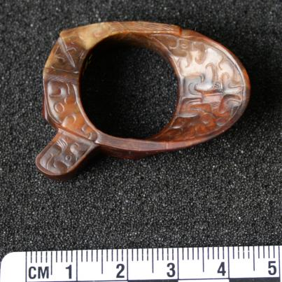
M1:North 8 | Tube | Severely corroded, white with gray patches, opaque | 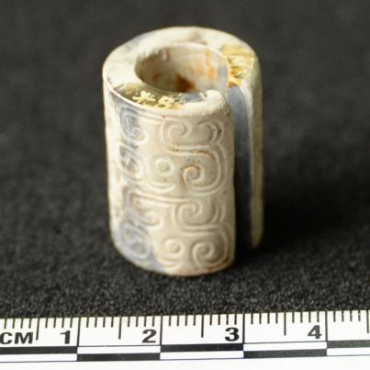
M1:North 10 | Tube | Weathered, white with brown patches, semi translucent | 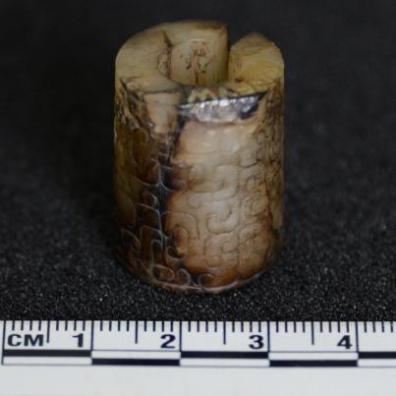
M1:North 18 | Gui | White with yellow spots, perforated, translucent | 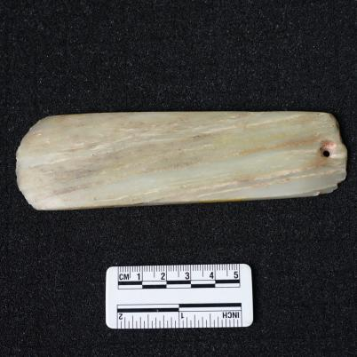
M1:North 19 | Gui | Brown with yellow spots, perforated, translucent | 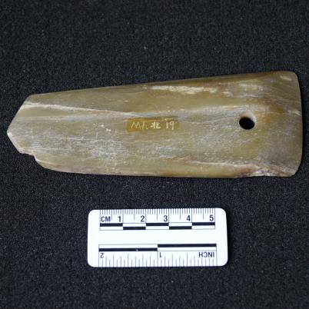
M1:North 21 | Gui | White with yellow spots, perforated, translucent | 