Supplementary materials – article “Drought-induced forest dieback increases taxonomic and functional diversity but not phylogenetic diversity of saproxylic beetles at both local and landscape scales”

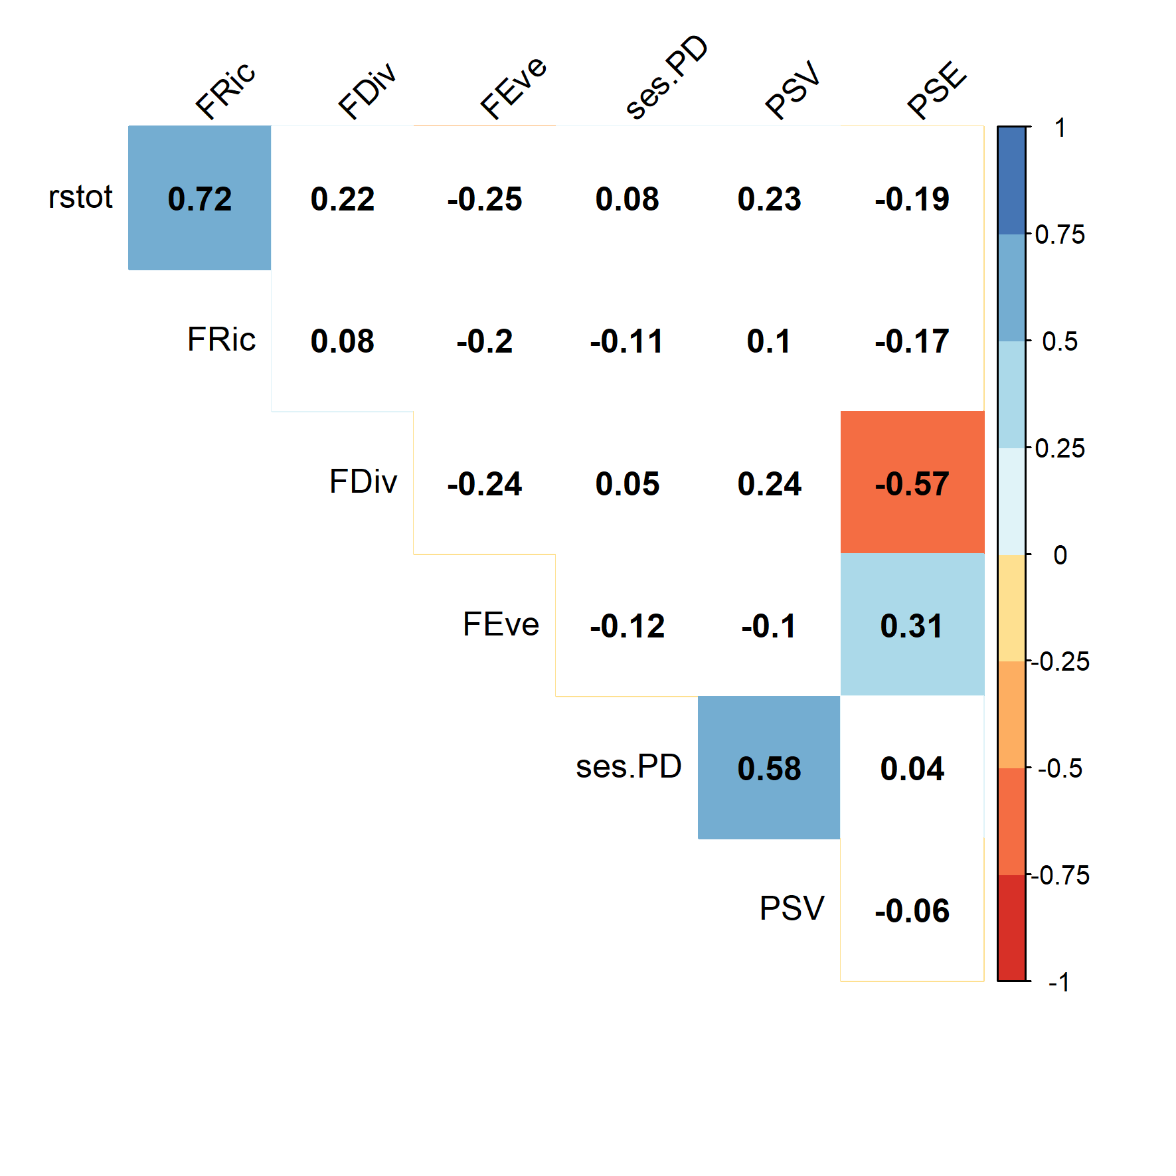
Figure S1. Correlation table for the diversity indices. Coloured relationships are statistically significant at an α-level of 0.05. Blue represents positive correlations while red represents negative correlations. Numbers are the Pearson’s r values. See Results.

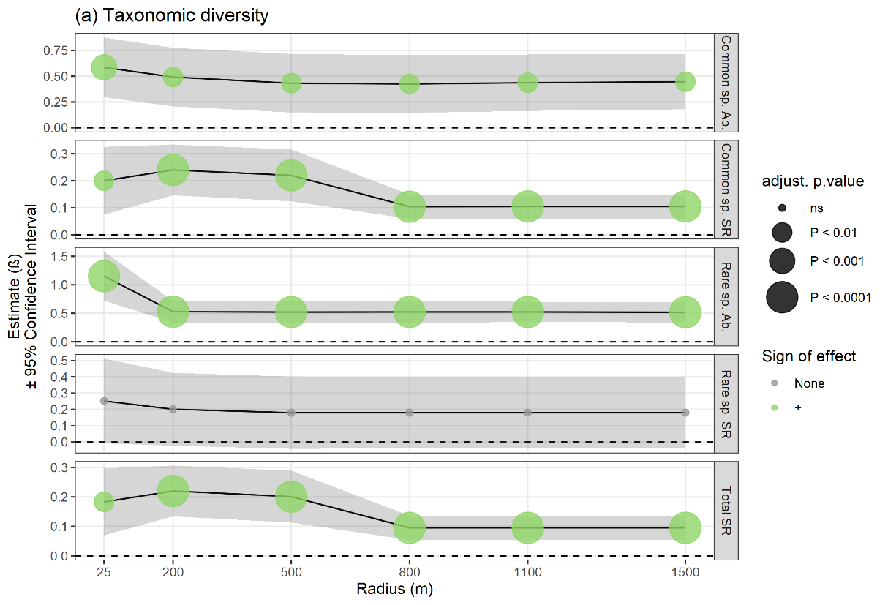
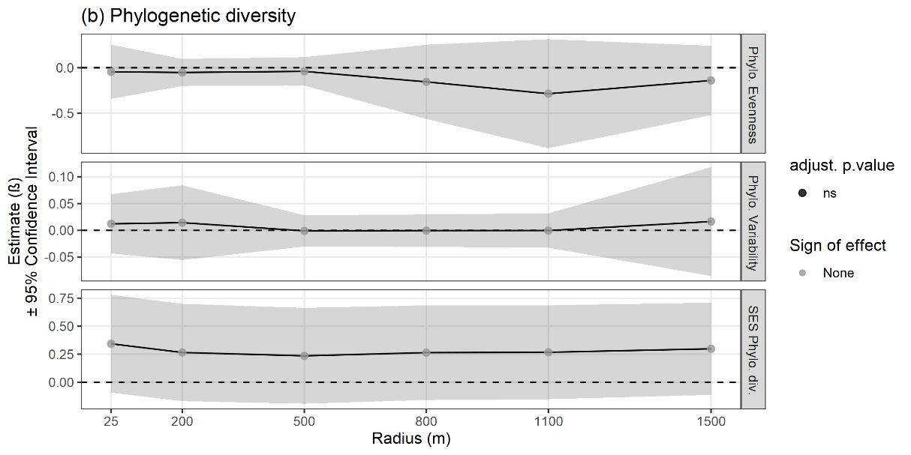
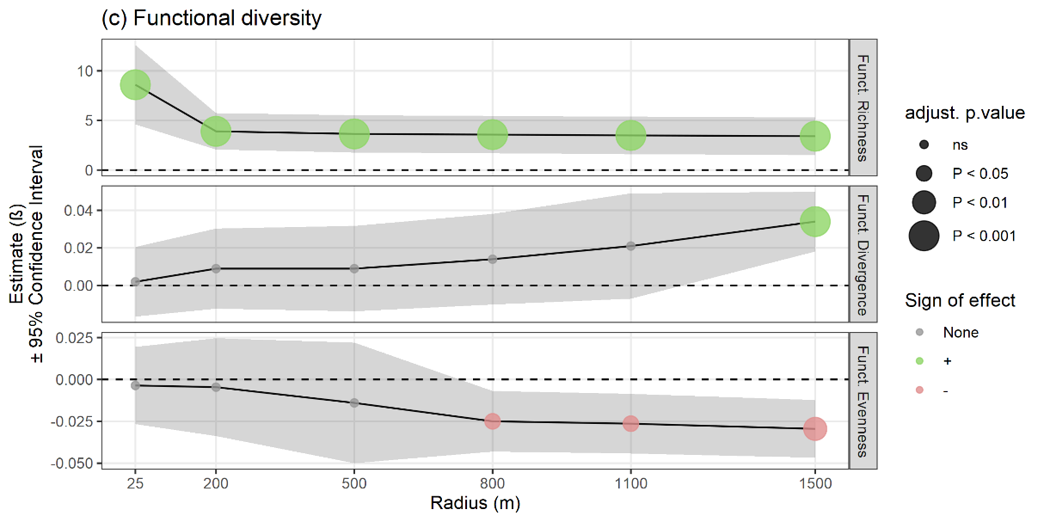
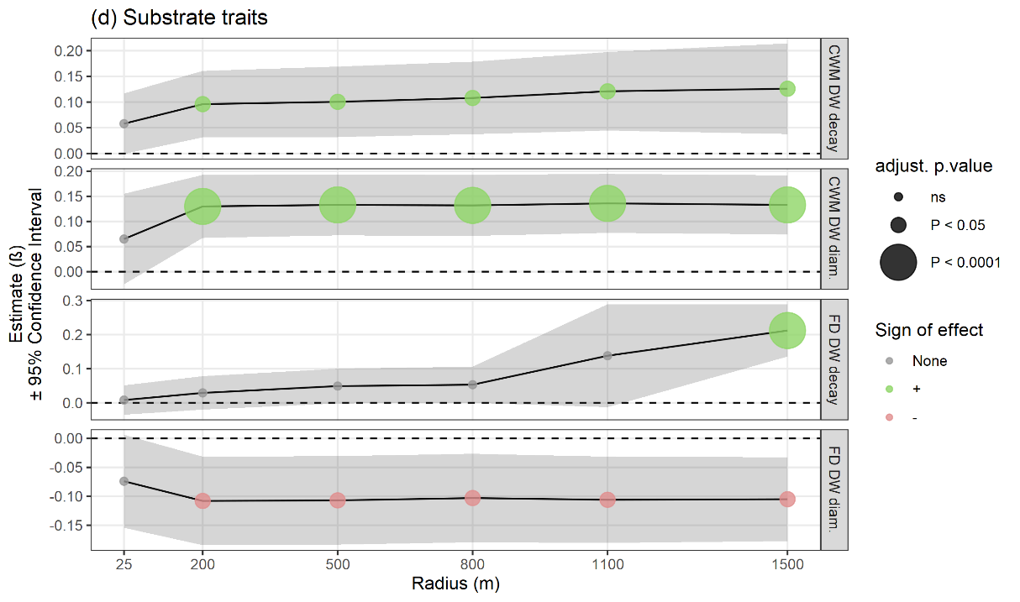
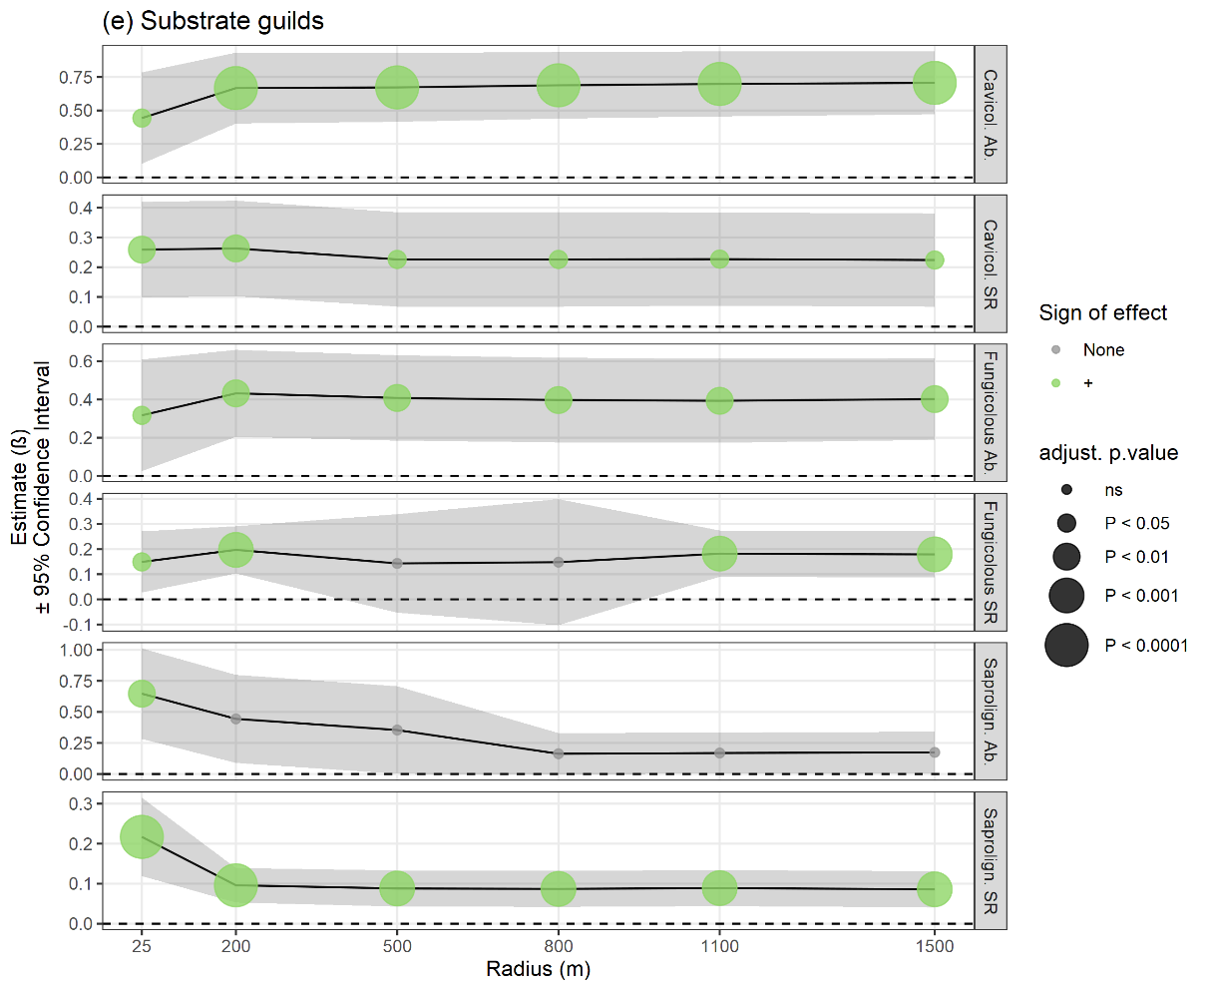
Figure S2. Response of local general saproxylic beetle guilds to dieback severity measured over different spatial scales (a = taxonomic diversity; b = phylogenetic diversity; c = functional diversity; d = substrate traits; e = substrate guilds). Coloured circles indicate β-estimates from the univariate glmmTMB models; their diameter varies with adjusted p-value. The shaded grey area indicates the 95% confidence interval of each β-estimate. “DW” = “deadwood”

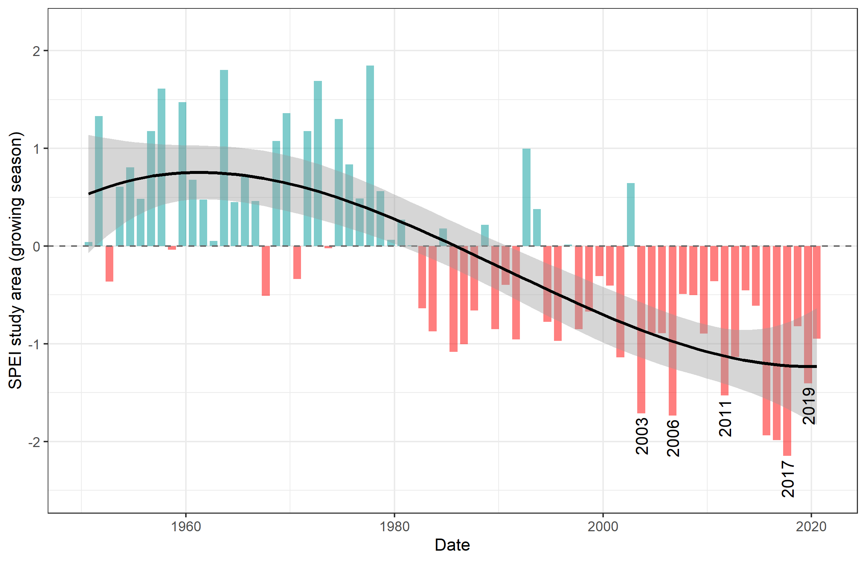
Figure S3. Changes in the Standardised Precipitation-Evapotranspiration Index (SPEI) (Vicente-Serrano et al. 2010) from 1950 to 2020 for the whole study area. Years marked by severe droughts are given under the corresponding bar; red: negative annual water balance (drought); blue: positive annual water balance (water surplus).

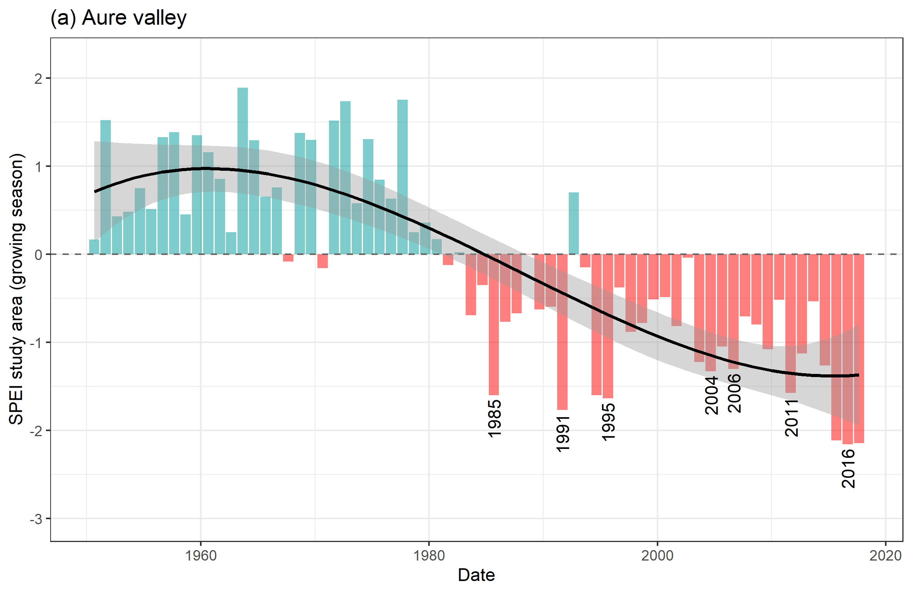
Figure S4. Changes in the Standardised Precipitation-Evapotranspiration Index (SPEI) (Vicente-Serrano et al. 2010) from 1950 to 2017 in Aure Valley area. Years marked by severe drought are given under the corresponding bar; red: negative annual water balance (drought); blue: positive annual water balance (water surplus).

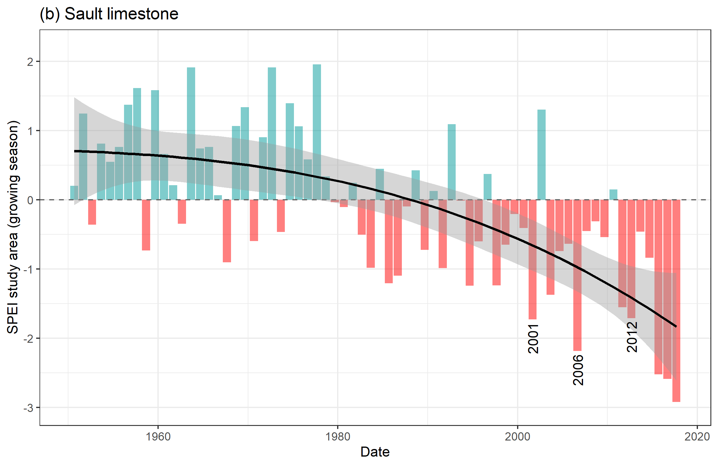
Figure S5. Changes in the Standardised Precipitation-Evapotranspiration Index (SPEI) (Vicente-Serrano et al. 2010) from 1950 to 2017 in the Sault limestone plateau area. Years marked by severe drought are are given under the corresponding bar; red: negative annual water balance (drought); blue: positive annual water balance (water surplus).

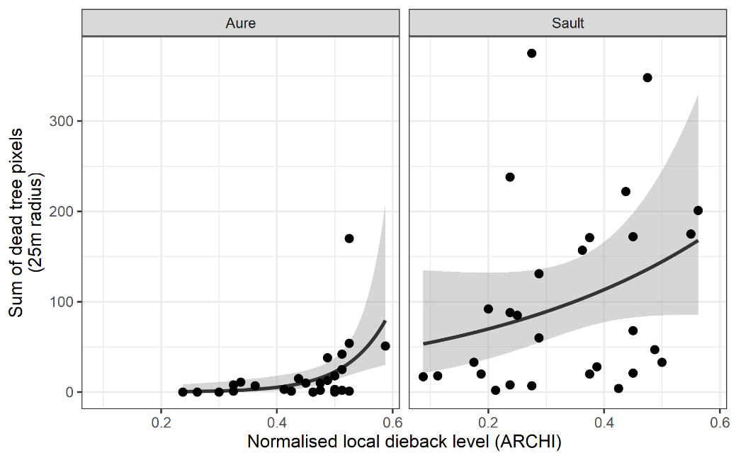
Figure S6. Relationship between the sum of dead crown pixels in a 25m radius around study plot centres (from machine learning) and the actual forest dieback level quantified in the study plots with the ARCHI method.

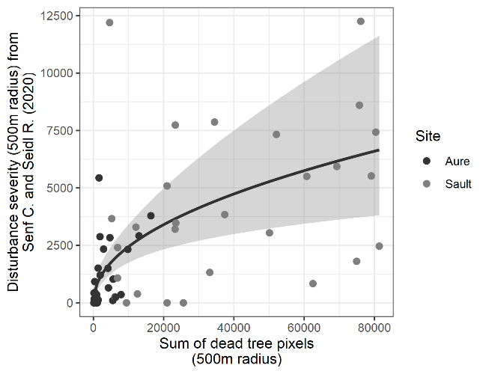 | 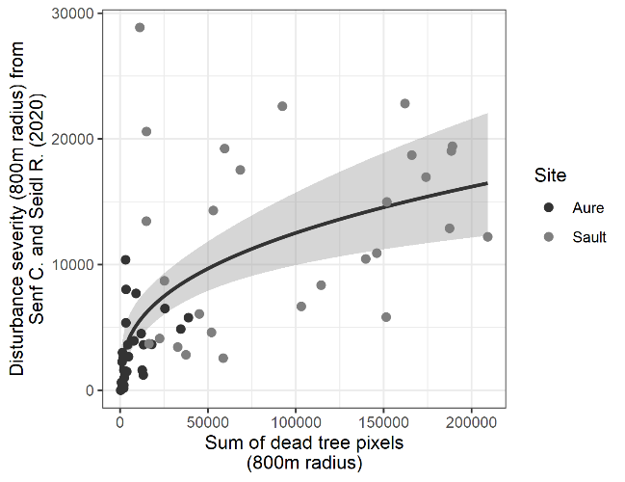
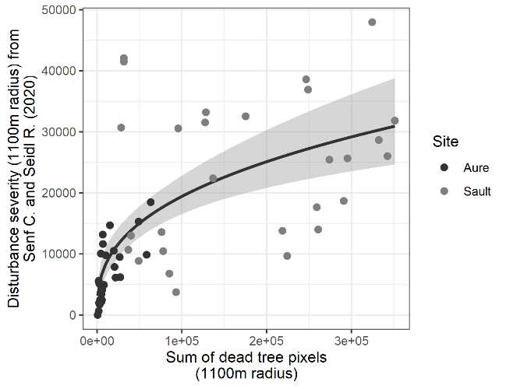 | 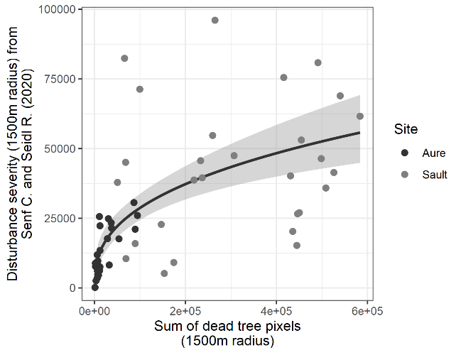
Figure S7. Relationships between the sum of dead crown pixels at different landscape scales around the study plot centres (from machine learning) and the actual forest dieback level quantified in Senf and Seidl (2021).

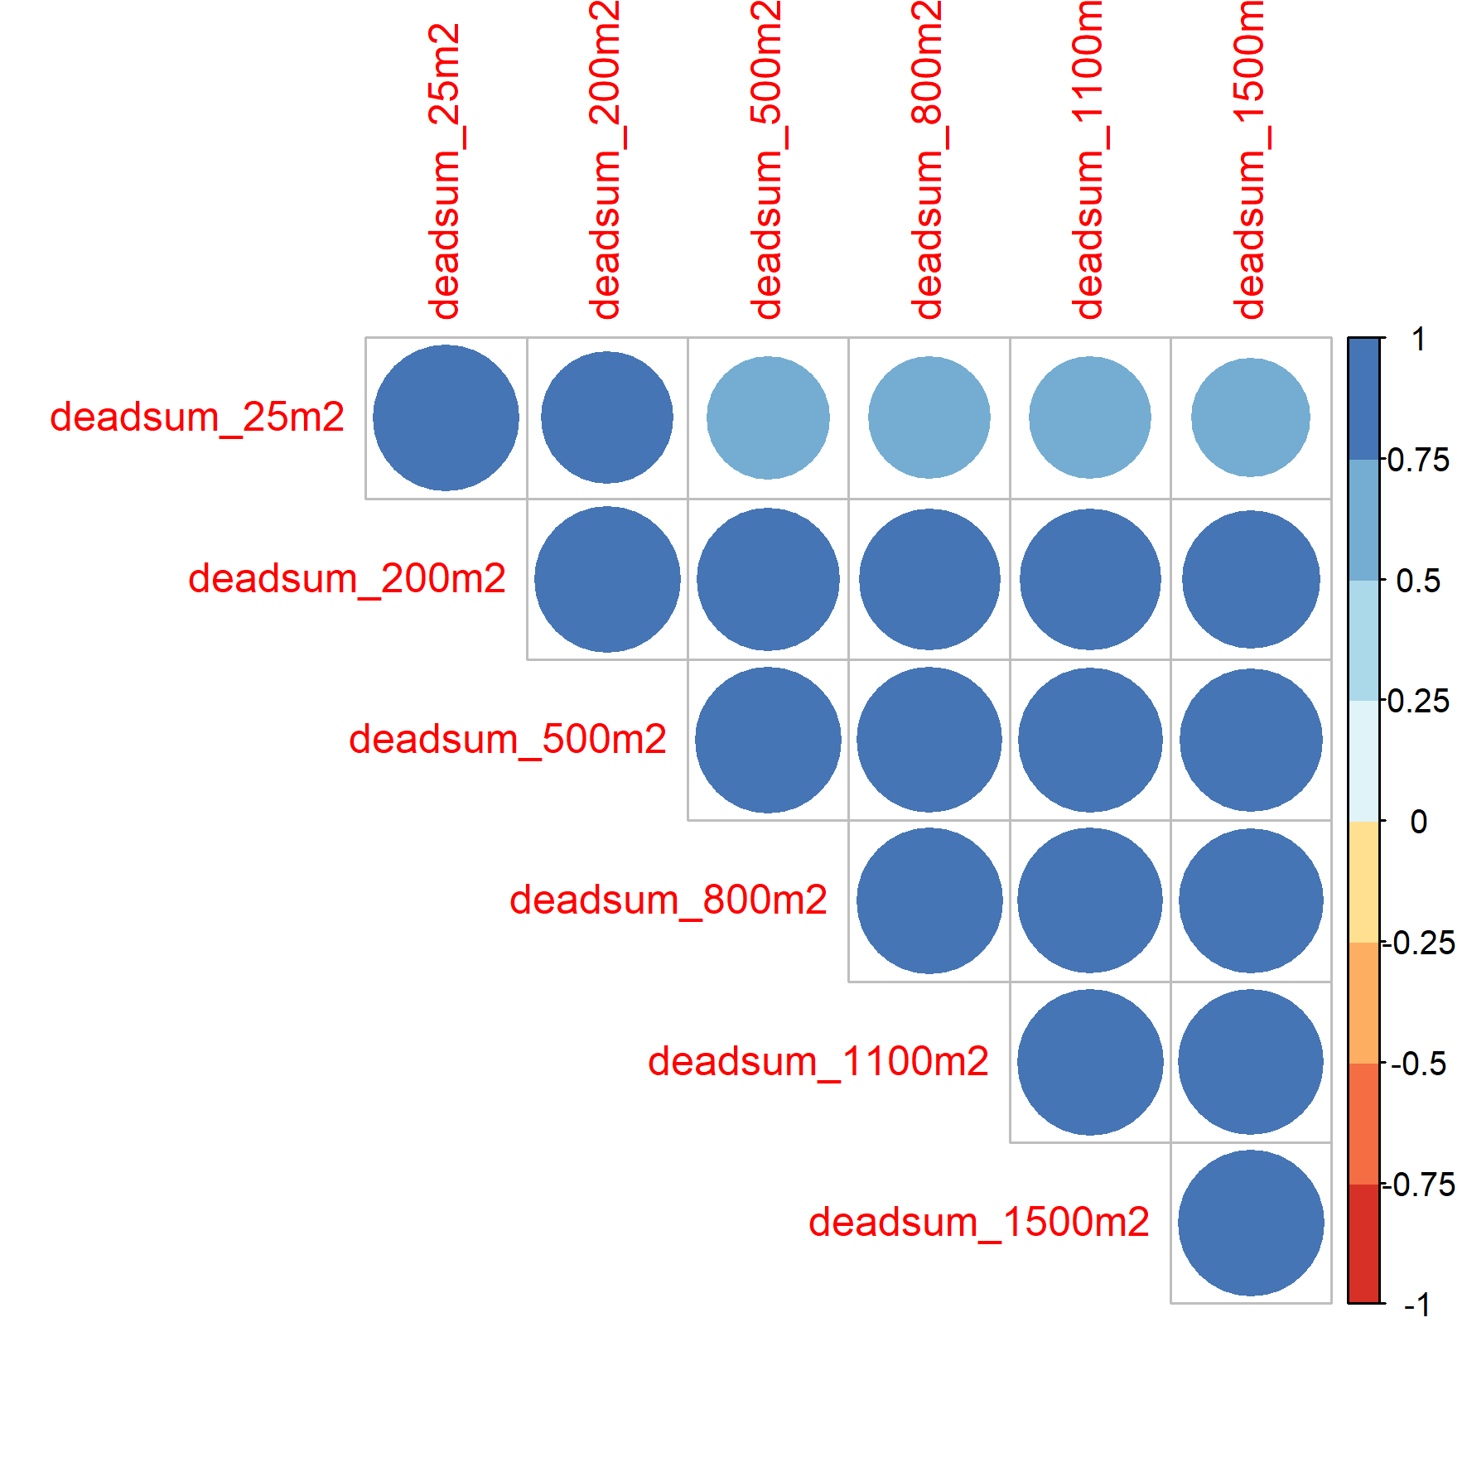 | 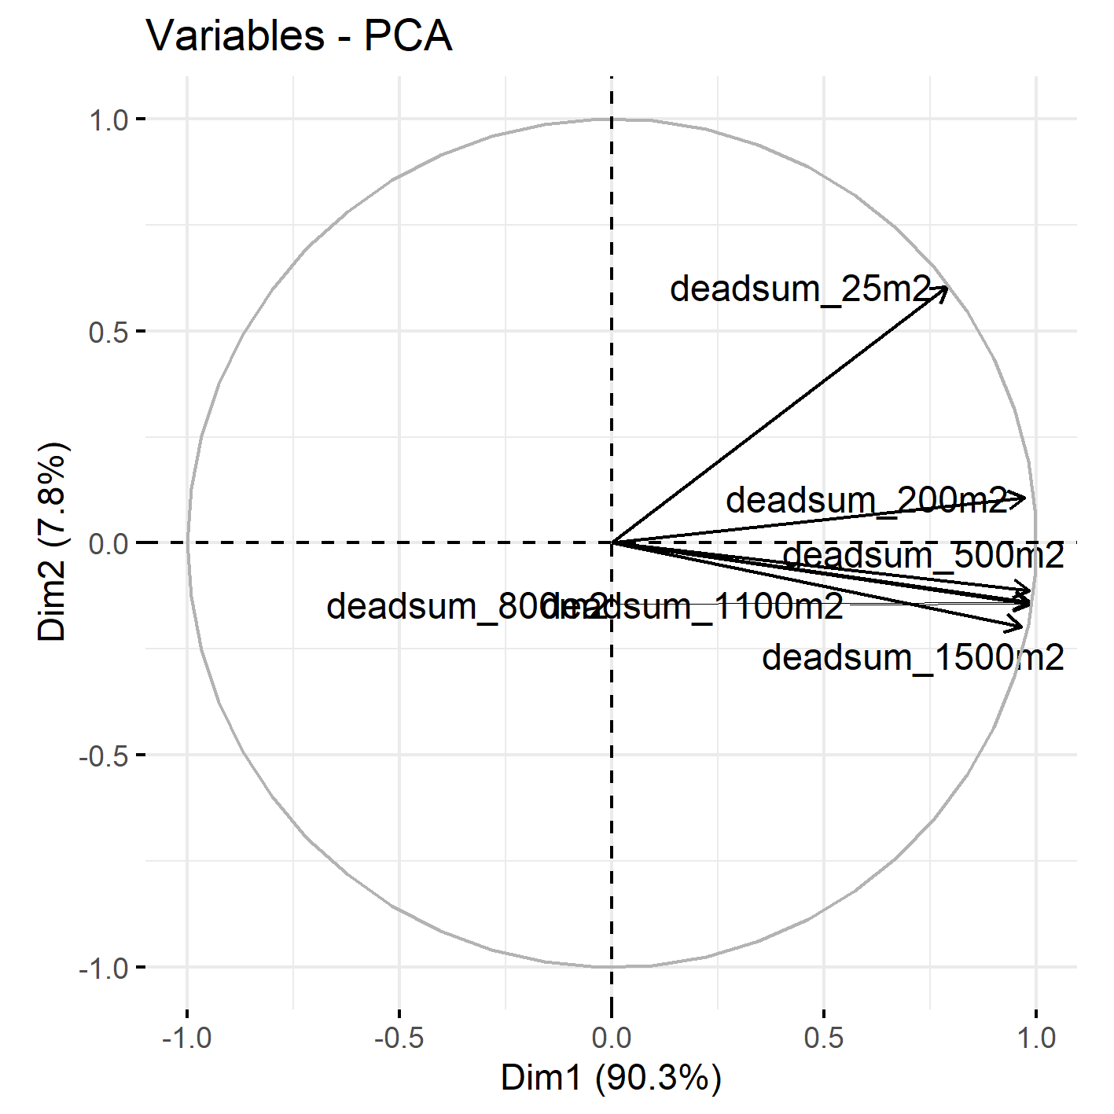
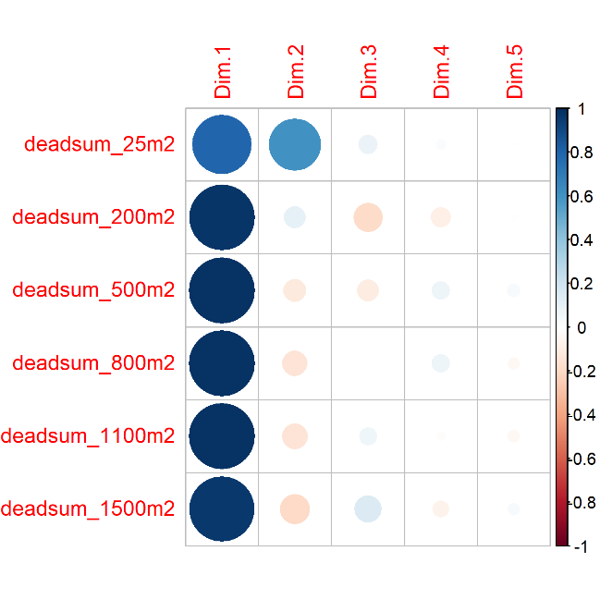 | 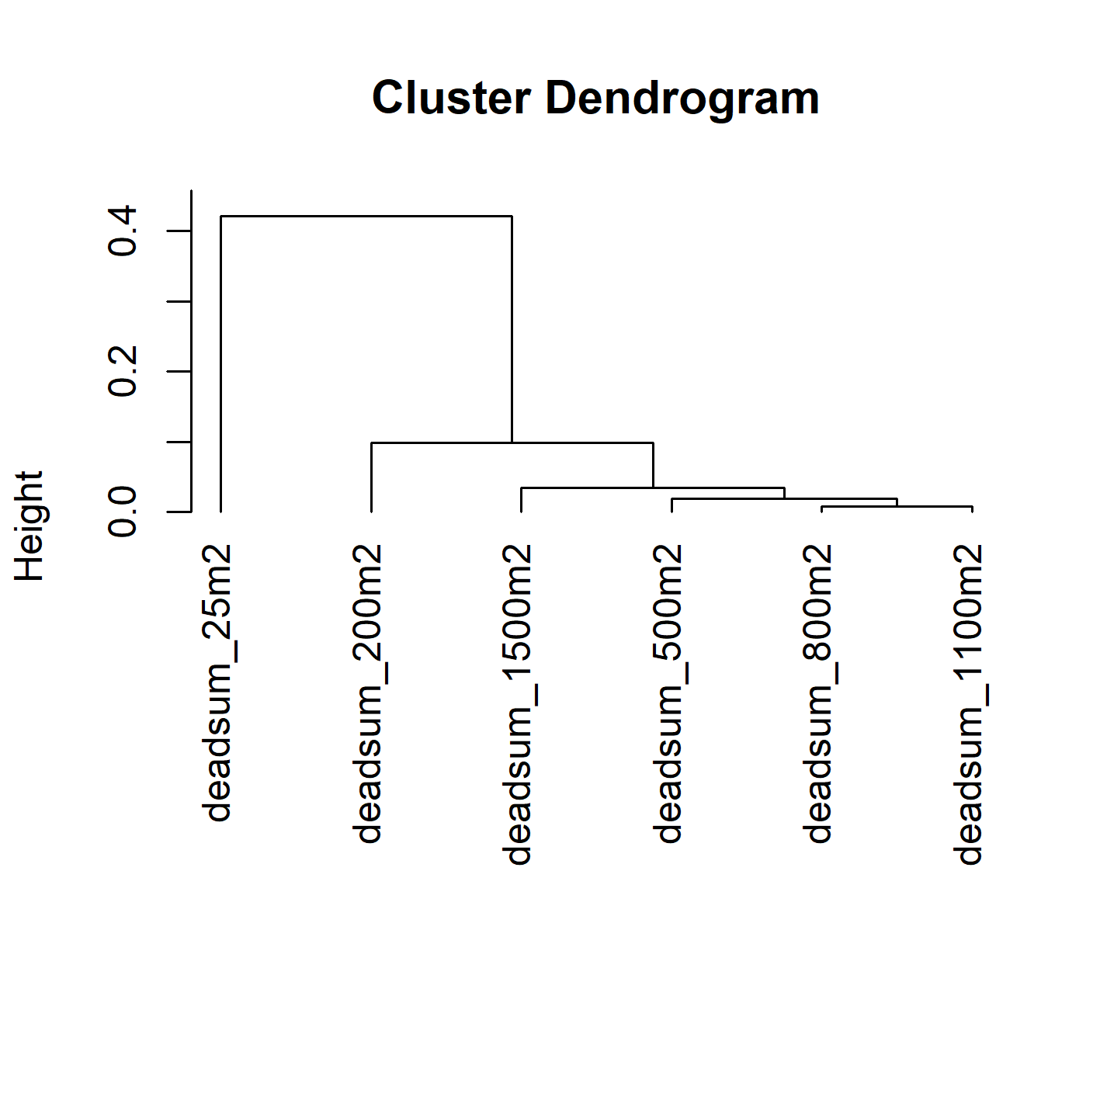
Figure S8. Above-left: correlation table with dead crown sums according to different spatial scales.
Above-right: results from the Principal component analysis (PCA) of all the spatial scales for forest dieback. Bottom-left: correlation between the dead crown sums and PCA dimensions at different spatial scales.
Bottom-right: cluster dendrogram of the dead crown sums at different spatial scales. There are three main clusters: local (25m radius), intermediate-landscape (200m radius) and large-landscape (500m to 1500m radius) scales.

