Bruceine D and Afatinib combination inhibits ovarian cancer cells proliferation and migration through DNA damage repair and EGFR pathway

Feng Lin^{a,#}, Ju-fan Zhu^{a,#}, Luo Wang^{b}, Yuan-jun Yangª, Ru-ru Zhengª, Xu Zhang^{a,*}, Yan Hu^{a,*}

ª Department of Gynecology, The First Affiliated Hospital of Wenzhou Medical University, Wenzhou 325000, Zhejiang, China
^{b} Medical College of Zhejiang University, Hangzhou 310003, Zhejiang, China

# These authors contribute equally to this work.

* Corresponding author:
Xu Zhang, Ph.D, Attending Physician
Department of Gynecology, The First Affiliated Hospital of Wenzhou Medical University, Wenzhou 325000, Zhejiang, China
Tel: (+86)-577- 665900; Fax: (+86) -0577- 55579163
E-mail: viczju@126.com

And Yan Hu, Ph.D, Director
Department of Gynecology, The First Affiliated Hospital of Wenzhou Medical University, Wenzhou 325000, Zhejiang, China
Tel: (+86)-577- 665900; Fax: (+86) -0577- 55579163
E-mail: huyanteach2021@163.com

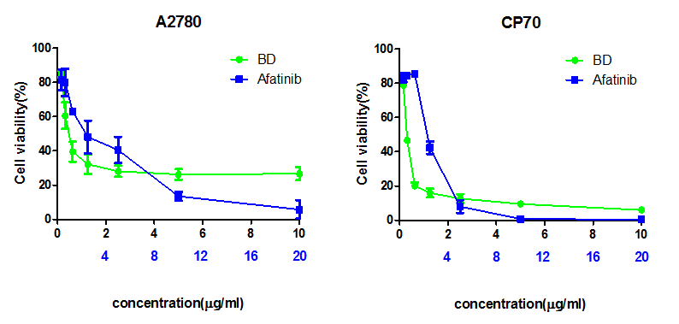
Supplementary Figure 1. BD and afatinib interact with concentrations of A2780 and CP70 cells. The A2780 and CP70 cells were treated with BD or afatinib at the indicated concentration for 48 hours. Then, the cell viability was detected with the use of MTT assay

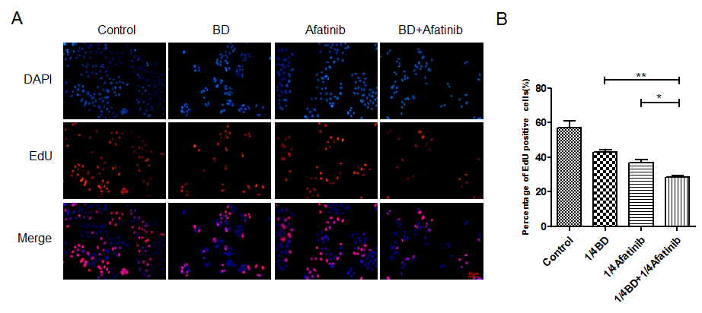
Supplementary Figure 2. The combination of BD and afatinib slowed down DNA repair rate. (A) EdU staining for cell proliferation and evaluation of CP70 cells. (B) Quantification of (A). Statistical significance was analysed using unpaired student’s two-tailed t-tests (ns, not significant, *p < 0.05, **p < 0.01, ***p < 0.001).

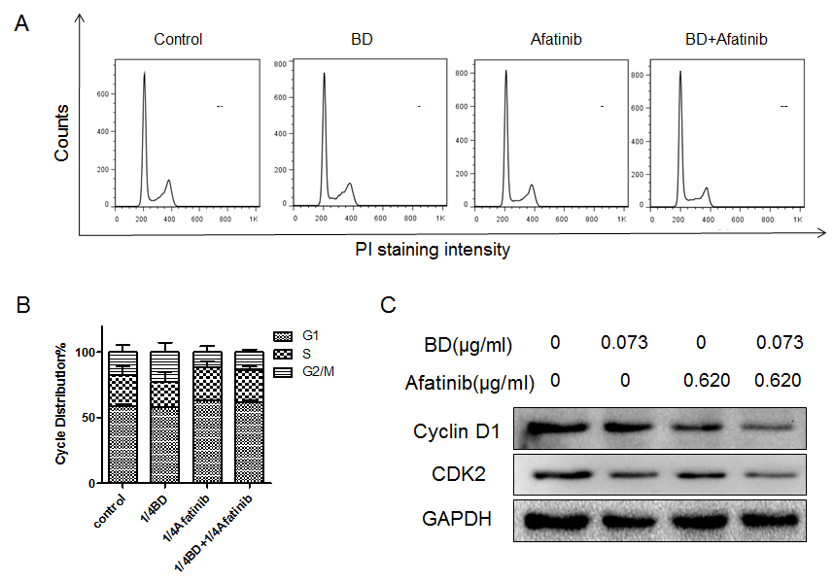
Supplementary Figure 3. The combination of BD and afatinib induced cell cycle G0/G1 arrest. (A) FACS analysis of the cell cycle of CP70 cells in the presence of BD (0.073 μg/ml), afatinib (0.620 μg/ml), or the combination of BD (0.073 μg/ml) and afatinib (0.620 μg/ml) for 48 hours. (B) Quantification of (A). (C) Western blot analysis of cyclin D1 and CDK2 of A2780 cells in the presence of BD (0.073 μg/ml), afatinib (0.620 μg/ml), or the combination of BD (0.073μg/ml) and afatinib (0.620 μg/ml) for 48 hours. GAPDH was used as a loading control. Statistical significance was analysed using unpaired student’s two-tailed t-tests (ns, not significant, *p < 0.05, **p < 0.01, ***p < 0.001).

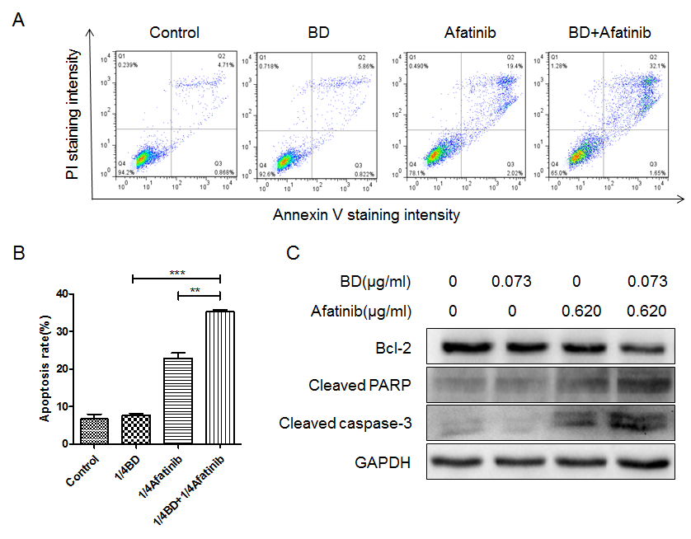
Supplementary Figure 4. The combination of BD and afatinib induced apoptosis of CP70 cells. (A) CP70 cells were treated with BD (0.113 μg/ml), afatinib (0.620 μg/ml), or the combination of BD (0.113 μg/ml) and afatinib (0.620 μg/ml) for 48 hours. Apoptotic cells were assayed by Annexin V/PI staining and FACS analysis. (B) Quantification of (A). (C) Western blot analysis of Bcl-2, cleaved PARP, and cleaved caspase-3 of A2780 cells in the presence of BD (0.073 μg/ml), afatinib (0.620 μg/ml), or the combination of BD (0.113 μg/ml) and afatinib (0.620 μg/ml) for 48 hours. GAPDH was used as a loading control. Statistical significance was analysed using unpaired student’s two-tailed t-tests (ns, not significant, *p < 0.05, **p < 0.01, ***p < 0.001).

