Supplementary Information for
Interfacial Shear at the Atomic Scale

Growth of epitaxial graphene on SiC(0001)
Large area, epitaxial graphene films were grown on the Si-face of on-axis 6H SiC (II-VI inc.) by the thermal decomposition method¹. In particular, we grew one large-area (5x5 mm²) film covered primarily with 1-layer epitaxial graphene (1L/Bfl/SiC), including some areas of 2-layer epitaxial graphene (2L/Bfl/SiC). Before the graphene growth, the semi-insulating (Vanadium-doped) 500 µm thick SiC wafer with both faces CMP polished, was diced into 5x5 mm² rectangles. Then, the diced pieces were cleaned and sonicated in acetone and isopropyl alcohol. The graphene sample was grown at 1650◦C for 5 minutes, in argon atmosphere with argon flow of 30 SLPH. More information about the growth of epitaxial graphene films is provided in Ref¹. The schematics of the lattice structure of the as-prepared epitaxial graphene on SiC samples are depicted in Figure S 1(a).
Hydrogen intercalation of epitaxial graphene
Hydrogen intercalation was used to prepare the 1-layer quasi-free standing graphene (1L/H-SiC) and the 2-layer quasi-free standing graphene (2L/H-SiC) samples. Intercalating hydrogen in a buffer layer film yields 1L/H-SiC, while the 2L/H-SiC is obtained by hydrogen intercalation of 1L epitaxial graphene - see Fig. S1(b). Temperature, time, and hydrogen flow were optimized to obtain large homogeneous intercalated area, and to avoid hydrogen etching of graphene/SiC. Details are provided in Refs.^{2,3}.
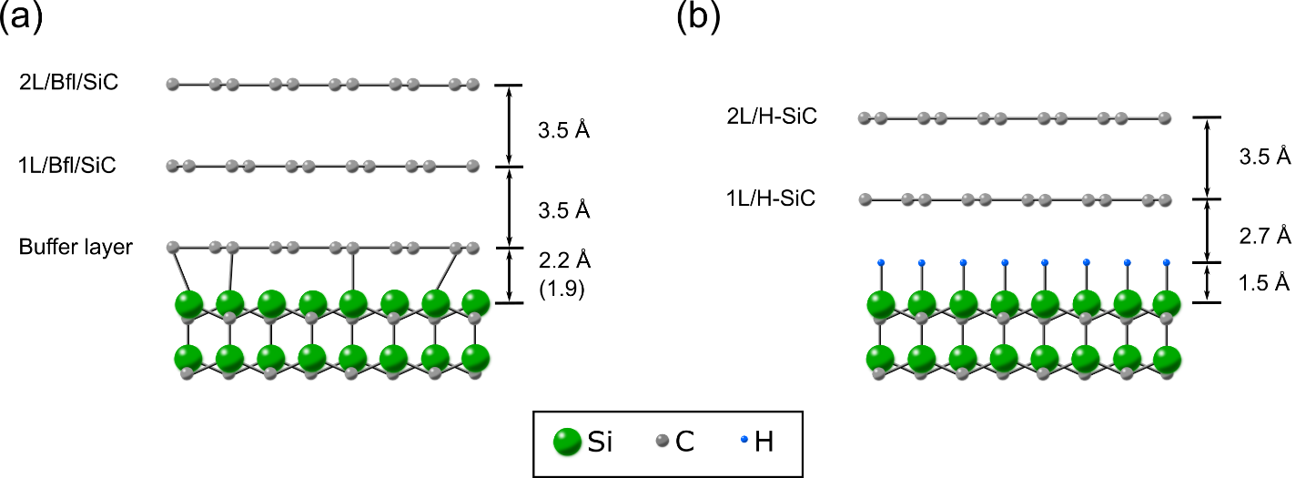
Figure S 1: Schemes of (a) the epitaxial graphene layers grown on the SiC (0001) and (b) quasi free-standing graphene layers on SiC (0001) after hydrogen intercalation.
Raman spectroscopy
Raman spectroscopy was used to characterize the intercalated and non-intercalated samples. Measurements were performed with the micro-Raman confocal microscope WITec alpha300 RSA. The samples were excited by the laser with central wavelength at 532nm and laser power <20mW. The excitation light was focused on the investigated area by an objective with a 100x magnification and numerical aperture NA=0.9. The signal from the sample was collected with the same objective and were acquired by a spectrometer. For all samples, 5 spectra were taken with 2 x 5s integration time from 5 different regions on the sample surface, to attest the homogeneity of the films.
The Raman spectra of the examined samples are displayed in Figure S2. The Raman spectrum collected on the 1L/Bfl/SiC (red line) exhibits the characteristic 2D peak at 2721 cm⁻¹ with full width at half maximum (FWHM) around 30.9 cm⁻¹, which originates from double-resonant Raman scattering processes^{4,5}. The 1L/Bfl/SiC Raman spectrum has a broad D peak at 1364 cm⁻¹ (with FWHM 10.0 cm⁻¹), which comprises the D peak of 1L graphene and the D peak band from the underlying buffer layer. A G peak appears at 1599 cm⁻¹ with FWHM 12.9 cm⁻¹. The 2L/Bfl/SiC Raman spectrum (blue line) shows a 2D peak at 2728 cm⁻¹ with FWHM 48.2 cm⁻¹. Such wavenumber and FWHM are typical of bilayer graphene⁶. The D peak of 2L graphene appears at 1367 cm⁻¹ with FWHM 10.0 cm⁻¹.
The 1L/H-SiC Raman spectrum (green line) shows a narrow 2D peak at 2679 cm⁻¹ with FWHM 22.7 cm⁻¹. Such 2D peak, together with a D peak (1344 cm⁻¹; FWHM 8.0 cm⁻¹) without the typical background arising from the buffer layer, indicate the replacement of the Si-C covalent bonds between the SiC substrate and the buffer layer (typical of non-intercalated epitaxial graphene) with C-H bonds. This confirms the successful intercalation of the epitaxial graphene films and the formation of quasi free-standing graphene. A narrow G peak is found at 1592 cm⁻¹ with FWHM 6.5 cm⁻¹. The 2L/H-SiC sample (cyan line) has a 2D peak at 2725 cm⁻¹ with FWHM 47.7 cm⁻¹. The G peak is located at 1599 with FWHM 10.0 cm⁻¹, and there is no sign of the D peak. The position, the FWHM and the intensity of the 2D peak and G peak measured for the four samples studied in the paper are summarized in Table S1. 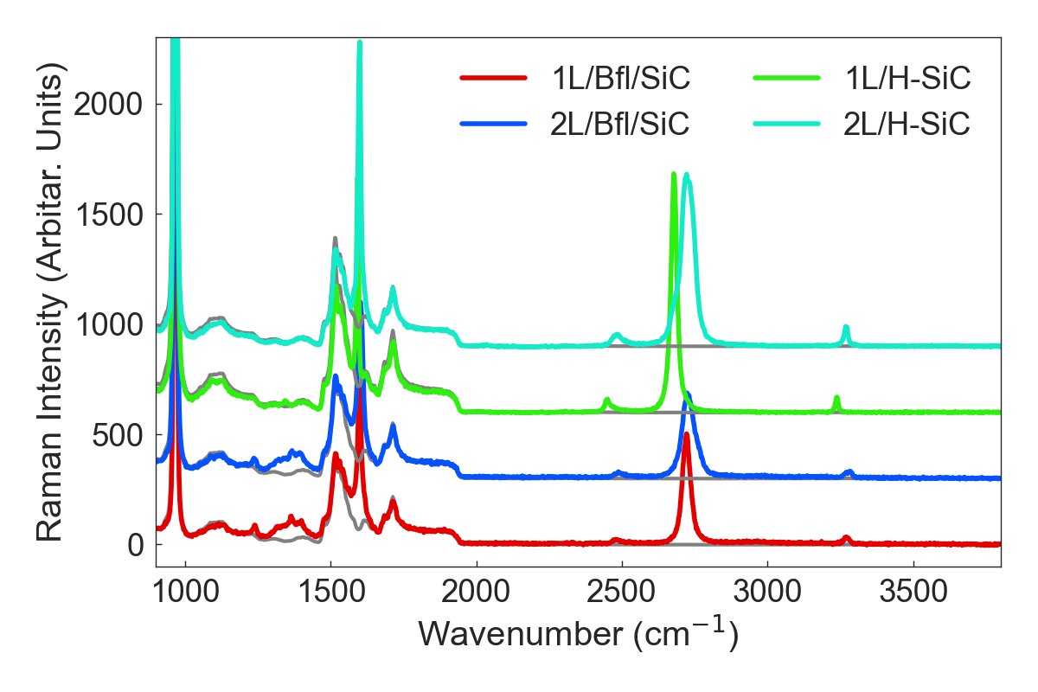
Figure S2: Raman spectra of the two pairs of intercalated and non-intercalated graphene samples. The spectra are shifted vertically for clarity. The Raman spectrum of a bare SiC substrate is added as a reference (grey curves).

Table S 1: Properties of Raman peaks
 |  | G peak |  |  | 2D peak
Sample | Position  cm⁻¹ | FWHM  cm⁻¹ | Intensity count | Position  cm⁻¹ | FWHM  cm⁻¹ | Intensity count
1L/Bfl/SiC | 1599 | 12.9 | 547 | 2721 | 30.8 | 508
2L/Bfl/SiC | 1602 | 15.8 | 663 | 2728 | 48.2 | 389
1L/H-SiC | 1592 | 6.5 | 909 | 2679 | 22.7 | 1101
2L/H-SiC | 1599 | 10.0 | 1278 | 2725 | 47.7 | 827

The AFM modulated nano-shear experiments
The AFM-based modulated nano-shear (MoNS) experiments were performed on an Agilent PicoPlus AFM (see MoNS experiment schematic in Fig. S3). In general, the contact stiffness is defined as the force per unit displacement necessary to deform an elastic contact in a specific direction. An AFM probe is brought into contact with the sample surface with a specific normal load, F_{N}. When the tip induces a lateral shear in a purely elastic regime with the surface, the variation of the lateral force ΔF_{L} as a function of the lateral displacement Δx is equal to the total lateral stiffness of the contact $k_{total}^{lateral}$ – as depicted in Fig. S4 (see Eq. 2 in the main text). The total lateral stiffness $k_{total}^{lateral}$ is defined by the contribution of the torsional spring constant of the cantilever $k_{lever}^{t}$ and the lateral contact stiffness $k_{cont}^{lateral}$. By oscillating the AFM tip in the in-plane (horizontal) direction, while in elastic contact with the sample surface, and recording the variation of the lateral force with the lateral displacement, it is therefore possible to measure the lateral contact stiffness $k_{cont}^{lateral}$, which is directly proportional to the interfacial shear modulus⁷.
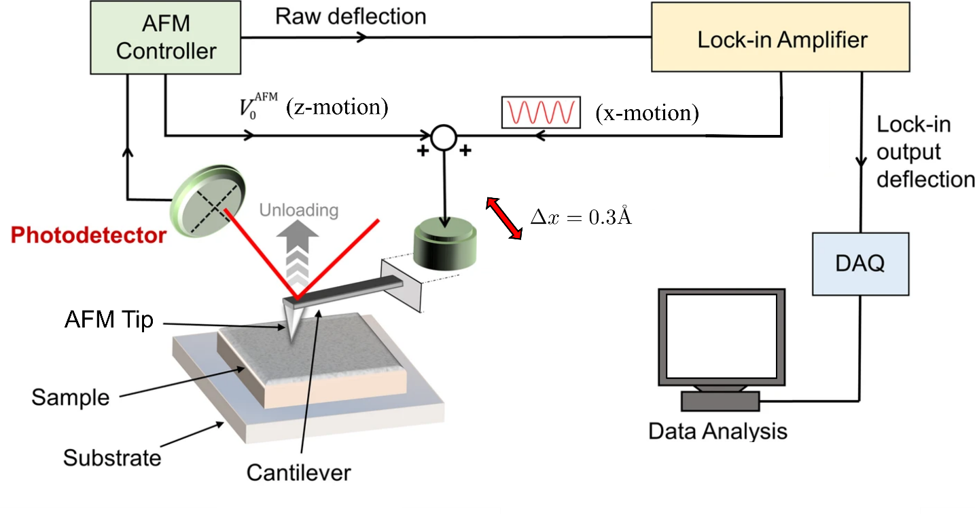
Figure S3: A schematic representation of the setup for MoNS experiment.

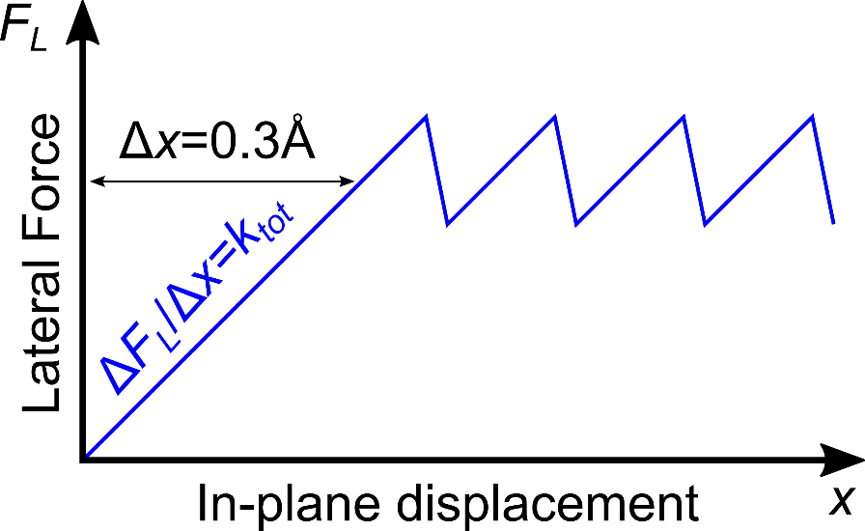
Figure S4: Variation of the lateral force signal as a function of the tip lateral displacement.
The frequency f and amplitude Δx of the in-plane oscillation are controlled by a commercially available Lock-in amplifier (Stanford Research System SR830). For our experiments we used f=2.121kHz and Δx=0.3Å. The oscillation frequency was set far from the resonance frequency of the piezoelectric stage (f_{res} = 0.584 kHz). The resonance behavior of the scanner in x-direction is shown in Figure S5. The tip was brought into the contact with bare SiC at 20nN, then the sinusoidal oscillations were applied to the scanner in x-direction at different frequencies varied from 10 Hz to 3 kHz via Lock-in amplifier, while the signal was recorded with the same Lock-in amplifier. The amplitude of the applied oscillations was small (0.004V) to manage that there is no slippage between tip and the surface when there is no resonance. The sub-Å oscillation allows to keep the tip sticking to the top of the sample surface in elastic regime, namely without energy dissipation, that is necessary for obtaining the shear modulus correctly. The initial normal load is set to F_{N} = 20 nN.
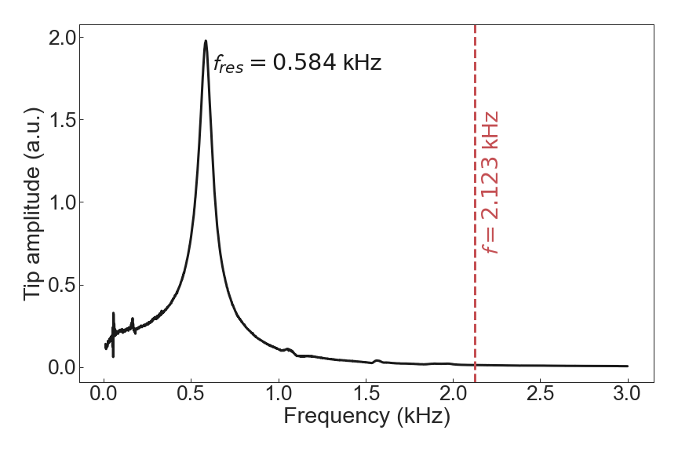
Figure S5: The resonance behavior of the scanner in the x-direction.
The lateral force (friction force) F_{L} is obtained by recording the lateral (torsional) deflection of the cantilever during oscillations in an elastic regime – see the next section AFM Friction force microscopy and Eq. S6 for more details. The lateral force signal is acquired and filtered by the Lock-in amplifier. These settings allow us to measure the total lateral spring constant $k_{total}^{lateral}$ (which is equivalent to two coupled springs in series) for a specific normal load F_{N}, based on the Eq. 4 in the main text. The torsional spring constant $k_{lever}^{t}$ is calculated based on the following equation valid for rectangular cantilevers⁸
$k_{lever}^{t}=\frac{G_{tip}wt^{3}}{3L{\left(d+t/2\right)}^{2}}$, (S1)
where, w is the width of the cantilever, d is the tip height, L is the cantilever length, and t is the thickness of the cantilever. We used a silicon AFM probe (PPP-LFMR, purchased from Nanosensors) with w=46 µm, t=1.5 µm, L=225 µm, and d=12 µm. Shear modulus of the silicon tip is G_{tip}=50 GPa. These values lead to $k_{lever}^{t}$=70.7 N/m.
Based on the Hertz theory and the contact area dependence of an elastic contact^{7,9}, the $k_{cont}^{lateral}$ can be described as a function of the effective interfacial shear modulus G_{int}* and contact radius a⁷
$k_{cont}^{lateral}\left(F_{N}\right)=8G_{int}^{*}a=8G_{int}^{*}{\left(\frac{3R_{tip}}{4E^{*}}\left(F_{N}+F_{adh}\right)\right)}^{1/3}$. (S2)
Here, R_{tip} is the AFM tip radius, F_{adh} is the adhesion force, and E* is the effective Young’s modulus.
In our modulated lateral force microscopy, we start our experiment with the tip oscillating in pure elastic contact at a specific normal load F_{N} = 20nN, and then progressively decrease the load while retracting the tip until complete detachment from the surface is achieved, at a rate of 0.9 nN/s. In this way, we can record the $k_{cont}^{lateral}$ as a function of decreasing normal load F_{N}, and obtain the curves reported in Fig. 2 of the main text. We then fit the $k_{cont}^{lateral}$ vs F_{N} curves with Eq. 5 (Eq. S2) using $G_{int}^{*}$ and F_{adh} as the fitting parameters to obtain the values of the interfacial shear modulus G_{int} for the samples. Indeed, the effective interfacial shear modulus $G_{int}^{*}$ and effective Young’s modulus E* are described, respectively, by the following equations
$G_{int}^{*}={\left(\frac{2-ν_{tip}}{G_{tip}}+\frac{2-ν}{G_{int}}\right)}^{-1}$, (S3)
$E^{*}={\left(\frac{1-ν_{tip}^{2}}{E_{tip}}+\frac{1-ν^{2}}{E_{sample}}\right)}^{-1}$. (S4)

Here G_{tip}, E_{tip} and ν_{tip} are the shear modulus, Young’s modulus and Poisson’s ratio of the AFM tip, and G_{int}, E_{sample} and ν are the interfacial shear modulus, Young’s modulus and Poisson’s ratio of the sample, respectively. In our experiments, G_{tip} = 50 GPa, E_{tip} = 169 GPa and ν_{tip} = ν = 0.2, while E_{sample} is measured via Modulated Nanoindentation experiments (see the dedicated following section).

Reproducibility of the shear modulus measurements
The contact stiffness versus normal load curves in the modulated lateral force experiments were acquired on 4 different regions, for each sample. At least 30 curves were acquired for each graphene sample and fitted using Eq. 5. The normalized distributions of the results are reported in Fig. S6 and are fitted by the Gaussian distribution. We attribute the standard deviation of the Gaussian distribution to inhomogeneity of the samples’ surface.
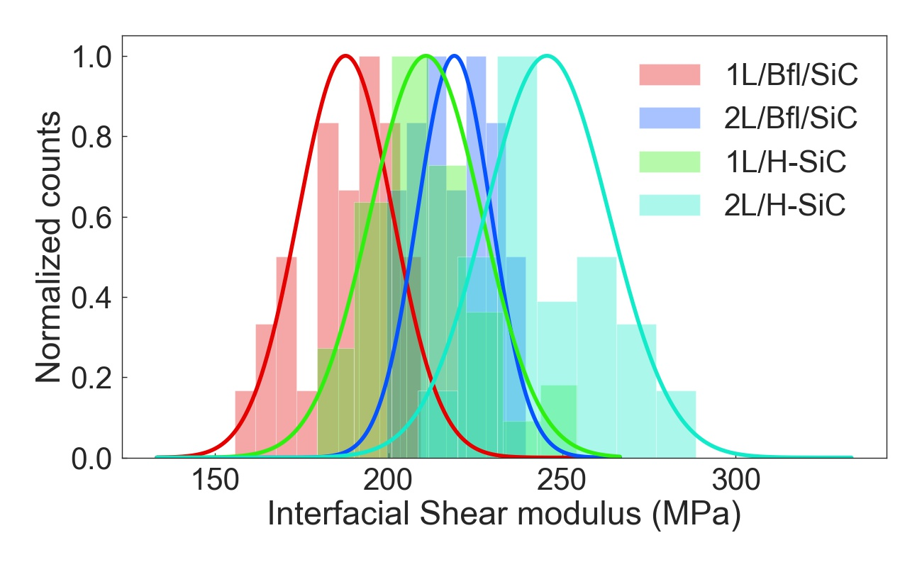
Figure S6: Normalized distribution of the shear moduli measured for 1L/Bfl/SiC (188±14 MPa), 2L/Bfl/SiC (220±10 MPa), 1L/H-SiC (211±16 MPa), and 2L/H-SiC (246±18 MPa).
AFM Friction Force Microscopy
The AFM Friction Force Microscopy (FFM) experiments were conducted on a Brucker Multimode 8 AFM using a silicon tip suitable for contact measurements (PPP-LFMR, Nanosensors, tip radius R_{tip} ~ 10 nm). The normal spring constant k_{lever}=0.3 N/m was calibrated using the thermal noise method¹⁰.
During the FFM measurements, the AFM tip scans a sample area of 1.5x1.5 μm² with a scanning speed 6 μm/s. The friction force F_{F} is obtained by acquiring the cantilever lateral (torsional) deflection signal (Defl) – expressed in mV – and by using the following equation
$F_{F}=2\left(\frac{d}{L}\right)k_{lever}^{t}S_{n}Defl\left(mV\right)$. (S5)
Where d is the tip height, L is the cantilever length. Here, S_{n} is the AFM detector sensitivity (express in nm/V), measured from the slope of an AFM force-distance curve.
The AFM friction force measurements are performed on different regions per each sample in ambient condition (RH ~15%, T~24°C). For each normal load the distribution of friction forces was calculated from more than 12000 data points (Figure S77).
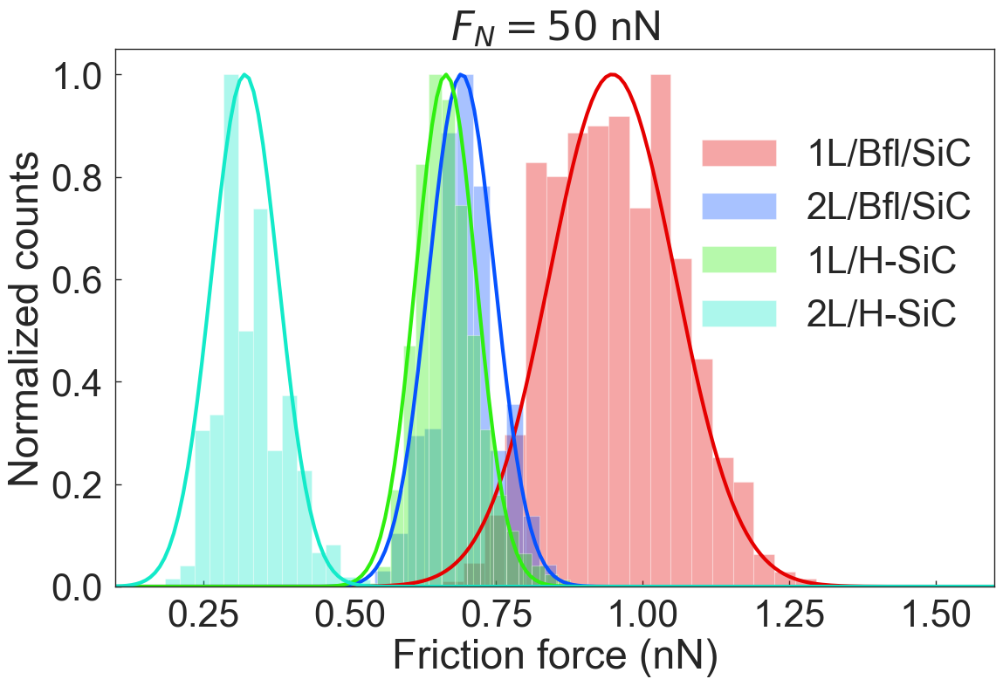
Figure S7: Normalized distribution of friction forces at normal load 50 nN.
Modulated Nanoindentation (MoNI/Å-I)
The modulated nanoindentation (MoNI/Å-I) experiments were performed on an Agilent PicoPlus AFM. A vertical oscillation of amplitude < 0.6 mV at frequency 991 kHz is applied on the AFM piezo tube, using a commercial lock-in amplifier (Stanford Research Systems, SR830), to drive a small oscillation ($Δz$ ~ 0.35Å) in the AFM cantilever. A diamond AFM tip with a spring constant around 90 N/m and the tip radius R_{tip} ~100 nm is brought into contact with the sample surface at initial normal load between 100-200 nN. Then the normal load F_{N} is progressively decreased, and the AFM tip is retracted from the surface, while the variation in the normal load ΔF_{N} due to the sub-Å oscillation $Δz$ is recorded by the Lock-in amplifier at each progressive normal load F_{N}. This allows us to calculate the total stiffness k_{tot} at each normal load F_{N}
$\frac{ΔF_{N}}{Δz}=k_{tot}\left(F_{N}\right)={\left(\frac{1}{k_{lev}}+\frac{1}{k_{cont}}\right)}^{-1}$, (S6)
where k_{tot} is described as two springs in series, with the cantilever spring constant k_{lev} and the tip-sample contact with stiffness k_{cont}. Force F_{N} vs indentation depth z_{indent} curves are obtained by integration of the k_{cont} versus F_{N} from the following equation
$z_{indent}\left(F_{N}\right)=z_{indent}\left(F_{po}\right)+\int_{F_{po}}^{F_{N}}{\frac{dF_{N}}{k_{cont}\left(F_{N}\right)}}$. (S7)
Here, F_{po} is the pull-out force measured by the AFM when the tip loses contact with the sample’s surface. The effective Young’s modulus E* can be estimated by fitting the force versus indentation curves (see Fig. S7) with the modified Hertz (DMT) model¹¹
$F_{N}=\frac{4E*\sqrt{R_{tip}}}{3}z_{indent}^{3/2}$. (S8)
The sample Young’s modulus is then obtained by using Eq. S4, with ν_{sample} = 0.2, E_{tip} = 1050 GPa, and ν_{tip} = 0.2. A detailed description of the MoNI/Å-I technique is reported in Refs.^{12,13}. The force vs indentation curves acquired on the four samples (1LG/Bfl/SiC, 2L/Bfl/SiC, 1L/H-SiC, 2L/H-SiC) and on two materials with well-known Young’s modulus, CVD diamond and sapphire are depicted in Fig. S8. These two materials are used as a reference for comparing the stiffness measured on the four graphene samples. The Young’s moduli obtained on CVD diamond (962 GPa) and on sapphire (387 GPa) are in excellent agreement with the values expected for these two materials, confirming the accuracy of MoNI/Å-I in quantitatively determining the elastic stiffness of stiff surfaces, and the validity of the data obtained on the four graphene samples.
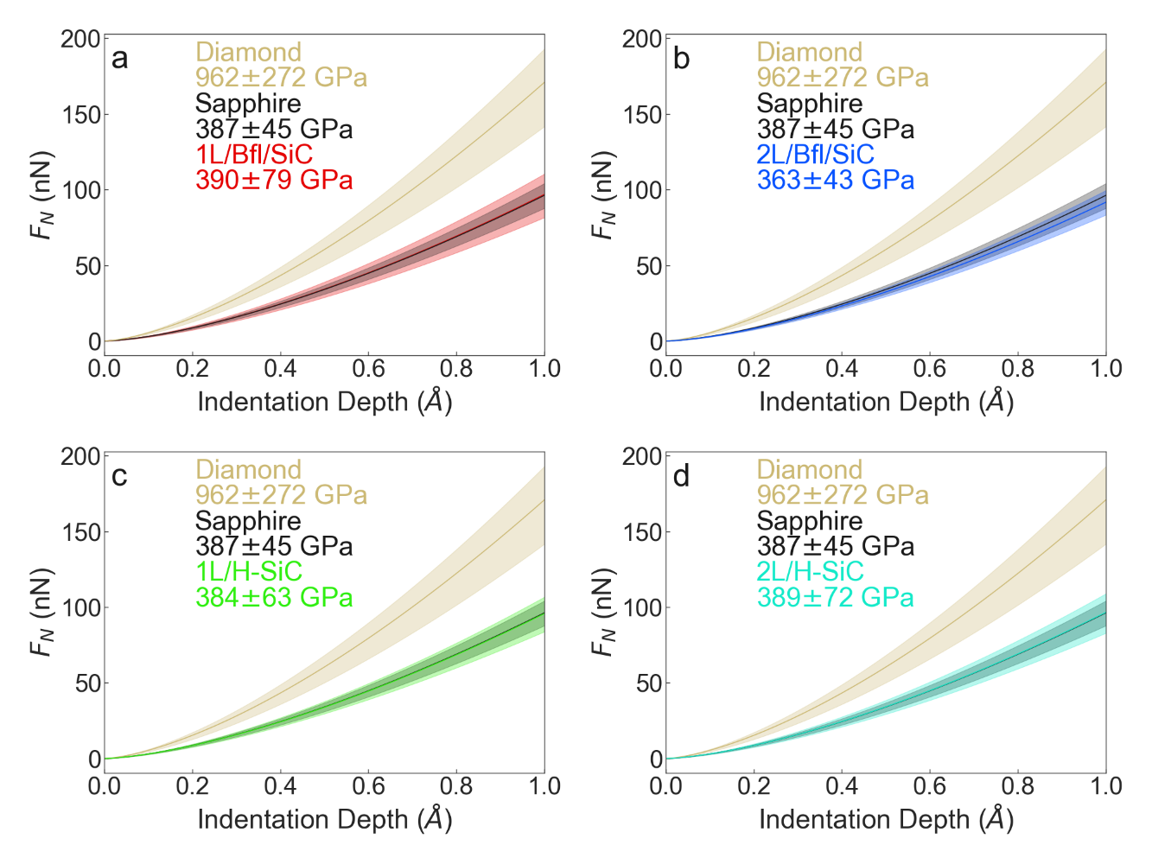
Figure S8: Force (F_{N}) versus indentation depth (z_{indent}) curves obtained from MoNI/Å-I experiments on the four different graphene samples, namely 1L/Bfl/SiC (a), 2L/Bfl/SiC (b), 1L/H-SiC (c) and 2L/H-SiC (d).
Adhesion force and roughness
We analyzed the adhesion forces and roughness of investigated samples in order to confirm that observed friction behavior is not caused by these factors. We measured AFM force-distance curves to obtain the pull-off force, which represents the adhesion forces experienced by the tip¹⁴, these are displayed in Fig. S9. As we can see, the pull-off forces, and hence the adhesion forces, are similar in each graphene sample.
The surface roughness was extracted from AFM topography maps obtained during the AFM friction experiments, as root mean square (RMS) of the surface topography. The measured RMS (around 0.25 Å) is similar for all four graphene samples (Table S2).

Table S2: Roughness and adhesion forces
 | 1L/Bfl/SiC | 2L/Bfl/SiC | 1L/H-SiC | 2L/H-SiC
RMS (Å) | 0.22 | 0.24 | 0.26 | 0.26
F_{adh} (nN) | 13 | 10 | 12 | 12
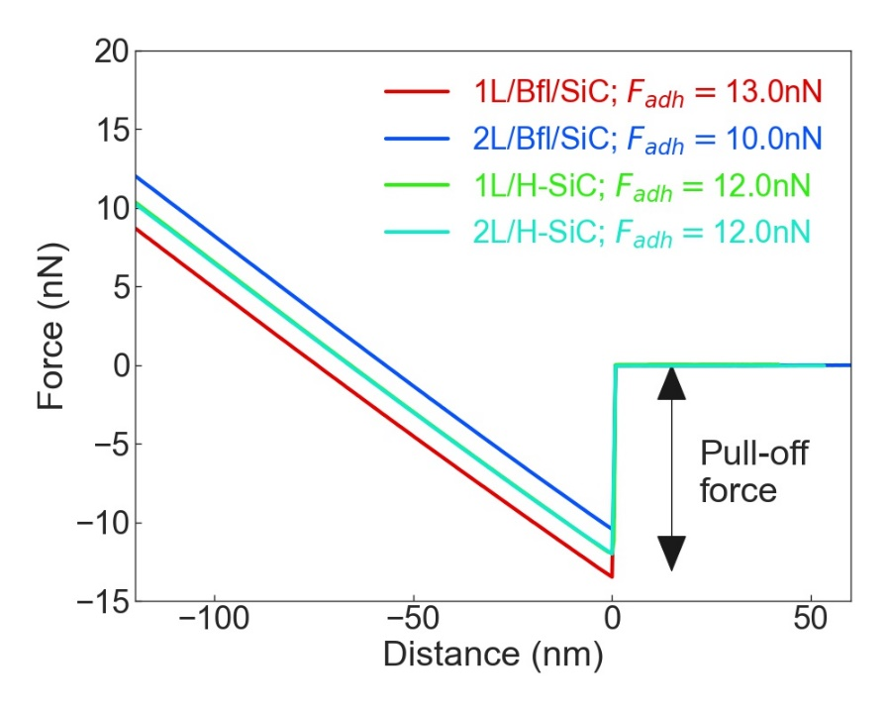
Figure S9: AFM Force distance curves acquired on the two non-intercalated and the two H-intercalated graphene samples. The pull-off force represents the adhesion force experienced by the tip when detaching from the sample surface.
Friction force simulations
Prandtl-Tomlinson model
The simple Prandtl-Tomlinson (PT) model is used to simulate atomic friction behavior of graphene layers. The equation of motion (Eq. 8 of the main text) is solved with the total potential energy described by Eqs. 6 and 9 with the parameters: mass m=501.40m_{carbon}, the damping parameter η=18.75 ps⁻¹, velocity v=1 m/s, the lattice parameter a=2.5 Å and the corrugation amplitude V=1. The time solution is calculated for two different values of $k_{total}^{lateral}$ using a Python code with a time step of 2.5 ps and is shown in Figure 5a. We can see that for higher $k_{total}^{lateral}$ the steady state friction decreases. The equations S1 and S4 clearly show that higher $k_{total}^{lateral}$ leads to higher G_{int,} which supports our conclusion that the interfacial shear modulus is the key factor controlling the steady state friction. Furthermore, the time evolution of the total potential (Eqs. 6 and 9) depicted in Figure S10 shows that for higher $k_{total}^{lateral}$ the total potential reaches its steady state faster with lower final value. The curves indicate that when the tip starts sliding (slip event) on the sample with larger G_{int}, the same tip still has an energy barrier to overcome before starting to slide on a sample with lower G_{int}.
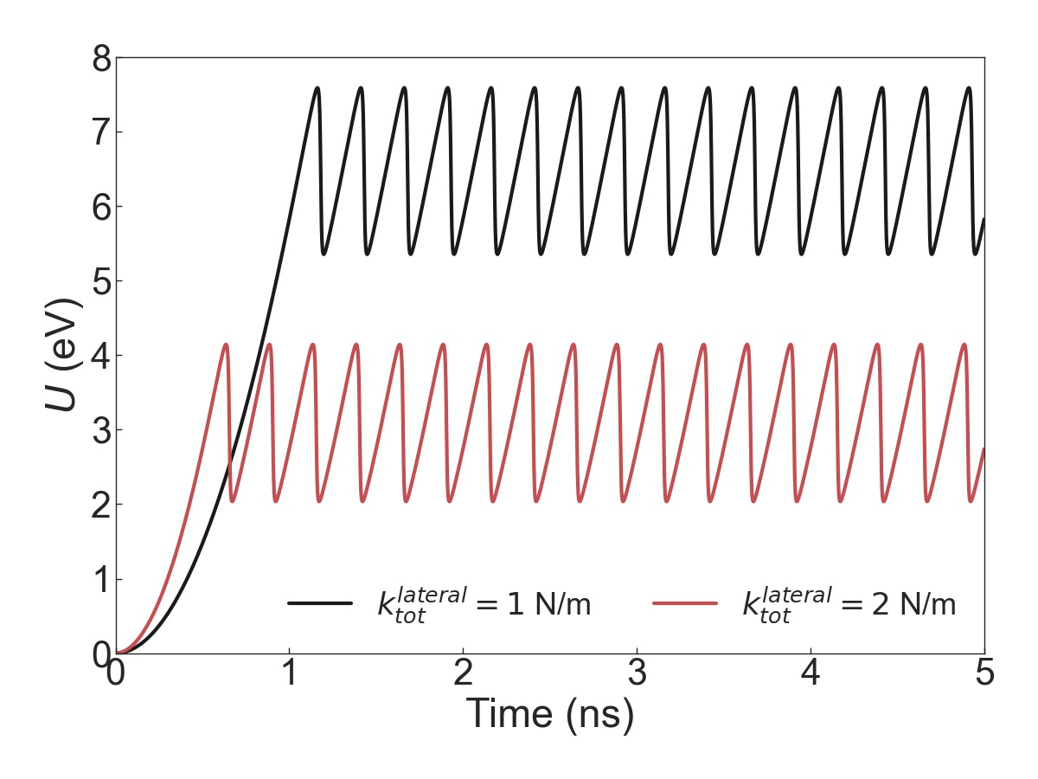
Figure S10: Time evolution of the total potential for two values of $k_{total}^{lateral}$.
Frenkel-Kontorova model
Non equilibrium model molecular dynamics simulations are carried out with a home-made code. The epitaxial graphene is mimicked with one dimensional Frenkel-Kontorova harmonic chain, and a substrate is described by rigid sinusoidal potential of amplitude A with the same spacing as the chain at rest. A point “tip” of mass M and coordinates (X_{t} ,Z₀) interacting with chain atoms x_{i} through a purely repulsive potential scaling as 1/R_{i}⁻⁶ where$R_{i}^{2}={\left(X_{t}-x_{i}\right)}^{2}+Z_{0}^{2}$ is dragged by a spring whose pulling velocity is gradually increased to reach a constant steady state value v. Vertical movement of the tip Z₀ is allowed by a second hard spring, while the chain is constrained to one dimensional X motion only, as would befit a membrane whose adhesion to a substrate is much larger that its corrugation barrier against sliding. Periodic boundary conditions are enforced, and the chain as a whole is long enough not to slide. Thus, all frictional sliding of chain atoms is localized: compressed in front of the tip and stretched behind it. The dissipated energy is removed by a Langevin damping gamma. A stick-slip advancement is found in all cases, but a particular choice of parameters is made so as to obtain a useful cartoon for the extraction of friction interfacial stiffness.

1 Kunc, J. et al. Effect of Residual Gas Composition on Epitaxial Growth of Graphene on SiC. Physical Review Applied 8, doi:10.1103/PhysRevApplied.8.044011 (2017).
2 Kunc, J., Rejhon, M. & Hlidek, P. Hydrogen intercalation of epitaxial graphene and buffer layer probed by mid-infrared absorption and Raman spectroscopy. Aip Advances 8, doi:10.1063/1.5024132 (2018).
3 Rejhon, M. & Kunc, J. ZO phonon of a buffer layer and Raman mapping of hydrogenated buffer on SiC(0001). Journal of Raman Spectroscopy 50, 465-473, doi:10.1002/jrs.5533 (2018).
4 Paillet, M., Parret, R., Sauvajol, J.-L. & Colomban, P. Graphene and related 2D materials: An overview of the Raman studies. Journal of Raman Spectroscopy 49, 8-12, doi:10.1002/jrs.5295 (2018).
5 Thomsen, C. & Reich, S. Double resonant raman scattering in graphite. Phys Rev Lett 85, 5214-5217, doi:10.1103/PhysRevLett.85.5214 (2000).
6 Ferralis, N. Probing mechanical properties of graphene with Raman spectroscopy. Journal of Materials Science 45, 5135-5149, doi:10.1007/s10853-010-4673-3 (2010).
7 Carpick, R. W., Ogletree, D. F. & Salmeron, M. Lateral stiffness: A new nanomechanical measurement for the determination of shear strengths with friction force microscopy. Applied Physics Letters 70, 1548-1550, doi:10.1063/1.118639 (1997).
8 Liu, W., Bonin, K. & Guthold, M. Easy and direct method for calibrating atomic force microscopy lateral force measurements. Review of scientific instruments 78, 063707 (2007).
9 Fogden, A. & White, L. R. Contact elasticity in the presence of capillary condensation. Journal of Colloid and Interface Science 138, 414-430, doi:10.1016/0021-9797(90)90224-c (1990).
10 Butt, H. J. & Jaschke, M. Calculation of thermal noise in atomic force microscopy. Nanotechnology 6, 1-7, doi:10.1088/0957-4484/6/1/001 (1995).
11 Derjaguin, B. V., Muller, V. M. & Toporov, Y. P. Effect of contact deformations on the adhesion of particles. Journal of Colloid and interface science 53, 314-326 (1975).
12 Cellini, F., Gao, Y. & Riedo, E. Å-Indentation for non-destructive elastic moduli measurements of supported ultra-hard ultra-thin films and nanostructures. Scientific Reports 9, doi:10.1038/s41598-019-40636-0 (2019).
13 Gao, Y. et al. Ultrahard carbon film from epitaxial two-layer graphene. Nat Nanotechnol 13, 133-138, doi:10.1038/s41565-017-0023-9 (2018).
14 Jiang, T. & Zhu, Y. Measuring graphene adhesion using atomic force microscopy with a microsphere tip. Nanoscale 7, 10760-10766, doi:10.1039/c5nr02480c (2015).

