Grain-boundary-rich 2D materials for attomolar-ability biochemical sensors
Lixuan Liu^{1,2,#}, Kun Ye^{1,#},Changqing Lin⁵, Zhiyan Jia^{3,4}, Tianyu Xue^{1,*}, Anmin Nie^{1,*}, Yingchun Cheng⁵, JianYong Xiang¹, CongPu Mu¹, Bochong Wang¹, Fusheng Wen¹, Kun Zhai¹, Zhisheng Zhao¹, Yongji Gong^{2,*}, Zhongyuan Liu^{1,*}, Yongjun Tian¹
¹Center for High Pressure Science, State Key Lab of Metastable Materials Science and Technology, Yanshan University, Qinhuangdao 066004, People’s Republic of China
²School of Materials Science and Engineering, Beihang University, Beijing 100191, People’s Republic of China
³International Collaborative Laboratory of 2D Materials for Optoelectronic Science and Technology of Ministry of Education, Engineering Technology Research Center for 2D Materials Information Functional Devices and Systems of Guangdong Province, Institute of Microscale Optoelectronics, Shenzhen University, Shenzhen 518060, People’s Republic of China
⁴International Iberian Nanotechnology Laboratory (INL), Avenida Mestre José Veiga, Braga, 4715-330, Portugal
⁵Key Laboratory of Flexible Electronics & Institute of Advanced Materials, Jiangsu National Synergetic Innovation Center for Advanced Materials, Nanjing Tech University, 30 South Puzhu Road, Nanjing 211816, China

CVD growth of polycrystalline WS₂ and MoS₂:
The centimeter-scale monolayer polycrystalline WS₂ and MoS₂ films were grown on SiO₂ (300 nm)/Si substratesin a homemade two-zone furnacewith a 60 mm diameter quartz tube as reported in our previousworks^{1,2}. Two 1.3 mm diameter inner quartz tubes were used as carrier gas (Ar) pathwaysfor delivery of the S and W sources. For WS₂, the two temperature zones were heated to 930 °C and 800 °C in 40min. The H₂S gas as S source (50sccm) and WO₃ (0.5 g, Alfa Aesar, purity 99.99%)vapors as W source were carried by Ar gas in two individual pathways (20 and 50sccm, respectively)to the substrate, and the pressure inside the tube was maintained at about 0.1 kPa. The reaction takes 30min, after which the furnace is naturally cooled for 15min, and then opened for quick cool-down. The tail gas was filtered through NaOH (sat. aq.).MoS₂ synthesis follows a similar procedure, but the two temperature zones were set at 450 °C and 925 °C, respectively.
Material characterization:
OM and FL images were acquired with an optical microscope (DM4000 M, Leica). Raman and PL spectra, line scans and mapping images were obtained with a Horiba Jobin Yvon LabRAMHR-Evolution Raman microscope under 532nm laser irradiation. AFM characterizations were performed on Multimode 8 (Bruker). TEM, HAADF and SAED measurements were performed using a transmission electron microscope (Talos F200X, Thermo Fisher) operated at 200kV. XPS spectra were acquired using an Axis Ultra spectrometer (ESCALAB 250Xi, Thermo Fisher).
DFT calculation details:
All first principles calculations were performed by using PWmat code^{6,7}with the scalar-relativistic (SG15) norm-conserving pseudopotential⁸. To mimic grain boundaries in WS₂, we employed the supercell approach with a vacuum thickness of 20 Å. Three different types of GBs were considered. All GBs were relaxed until the force on each atom was less than 0.03 eV/Å with Γ centered Monkhorst-Pack k-point mesh and an energy cutoff of 350 eV. The adsorption energies of Hg on GBs are evaluated by using E_{ads}=E_{slab}^{ads} - E^{ads}– E_{slab}, where E_{slab}^{ads}, E^{ads} and E_{slab} are the energies of calculated adsorbates-slab, adsorbates in gas phase and pure slab⁹.

Fig. S1.Characterization of CVD-grown polycrystalline 1L WS₂ films on SiO₂ (300 nm)/Si substrates. Optical photographs (a) of as-grown 1L WS₂ film on SiO₂ (300 nm)/Si substrate (top) and the transferred one on to Au (50 nm) coated cover glass substrate (bottom). AFM (b), OM (c) and corresponding FL (d) images of as-grown 1L WS₂ film on SiO₂ (300 nm)/Si substrate. A scratch was made on the 1L WS₂ film to differentiate between the film and Si substrate due to their contrast difference. Inset in (b) is a height profile taken along the dash line, showing the thickness of 0.8 nm. Raman (e) and PL (f) spectra measured with 520 nm laser excitation. Raman and PL line scans (g) across the 1L WS₂ film. All Raman and PL measurements were performed by using 532 nm laser light excitation.
In OM image of Fig. S1c, the 1L WS₂ film can be distinctly recognized due to the difference in optical contrasts between the film and bare SiO₂/Si substrate. The as-synthesized 1L WS₂ film exhibits uniform optical contrast, signifying an even and high-quality continuous film. In the FL image of Fig. S1d, the uniformity of FL intensity across the film implies the monolayer nature and high quality of the as-synthesized 1L WS₂ film. As displayed in Figs. S1e and f, the observed Raman modes of E(M) (345.1 cm⁻¹), 2LA(M) (352.15 cm⁻¹), E(Γ) (356.9 cm⁻¹) and A_{1g} (Γ) (417.6 cm⁻¹), as well as the single photon emission at ~ 1.99 eV are in good agreement with previous spectral results regarding CVD-grown 1L WS₂.^{1,3-5} The Raman intensity ratio of I_{2LA(M)}/I_{A1g(Γ)} is determined to be 7.6, which is a characteristic of monolayer thickness, as I_{2LA(M)}/I_{A1g(Γ)} is larger than 2 only for monolayer WS₂.⁵ Raman and PL line scans in Fig. S1g demonstrate the high consistency in peak position and intensity at different film locations, confirming the high quality of the as-synthesized polycrystalline 1L WS₂ film.

Fig. S2. Raman 2LA(M) images of the as-synthesized GB-rich 1L WS₂ film. 520 nm laser was used for excitation. Raman mapping images demonstrate the high consistency in peak position and intensity at different film locations

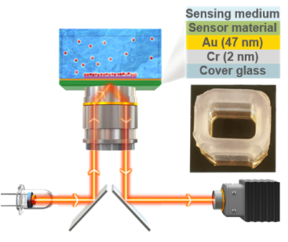
Fig. S3. Schematic illustration of the SPR imaging setup and the sensor device based on GB-rich 1L WS₂ film.

Fig. S4. Atomic scale HAADF-STEM imageof typical GB in the polycrystalline 1L WS₂ films.

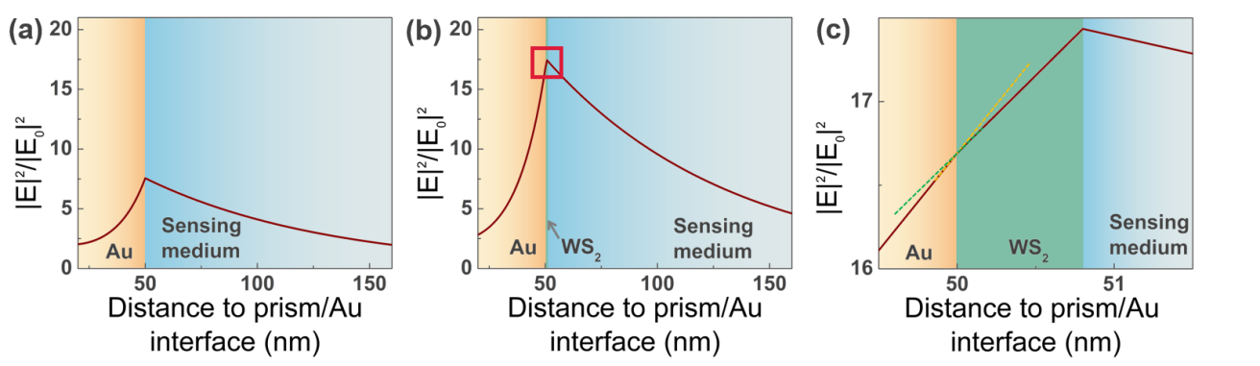
Fig. S5. Simulated electric field distributions between bare 50 nm Au film and sensing medium (a) and between the covered 50 nm Au with polycrystalline 1L WS₂ film and sensing medium

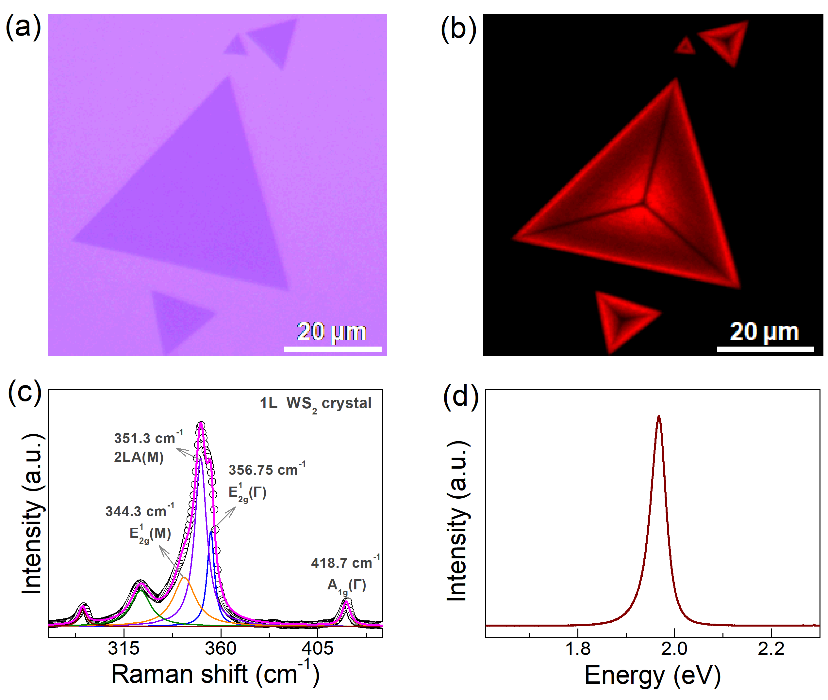
Fig. S6. OM (a), corresponding FL (b) images, Raman (c) and PL (d) spectra of CVD-grown 1L WS₂ crystals on SiO₂ (300 nm)/Si substrate. In the FL image of Fig. S5b, the observed strong FL signal indicates the monolayer nature of CVD-grown WS₂ crystals. The measured Raman and PL spectra in Fig. S5c and d, respectively, are consistent with the previously reported ones for 1L WS₂ crystals.⁵
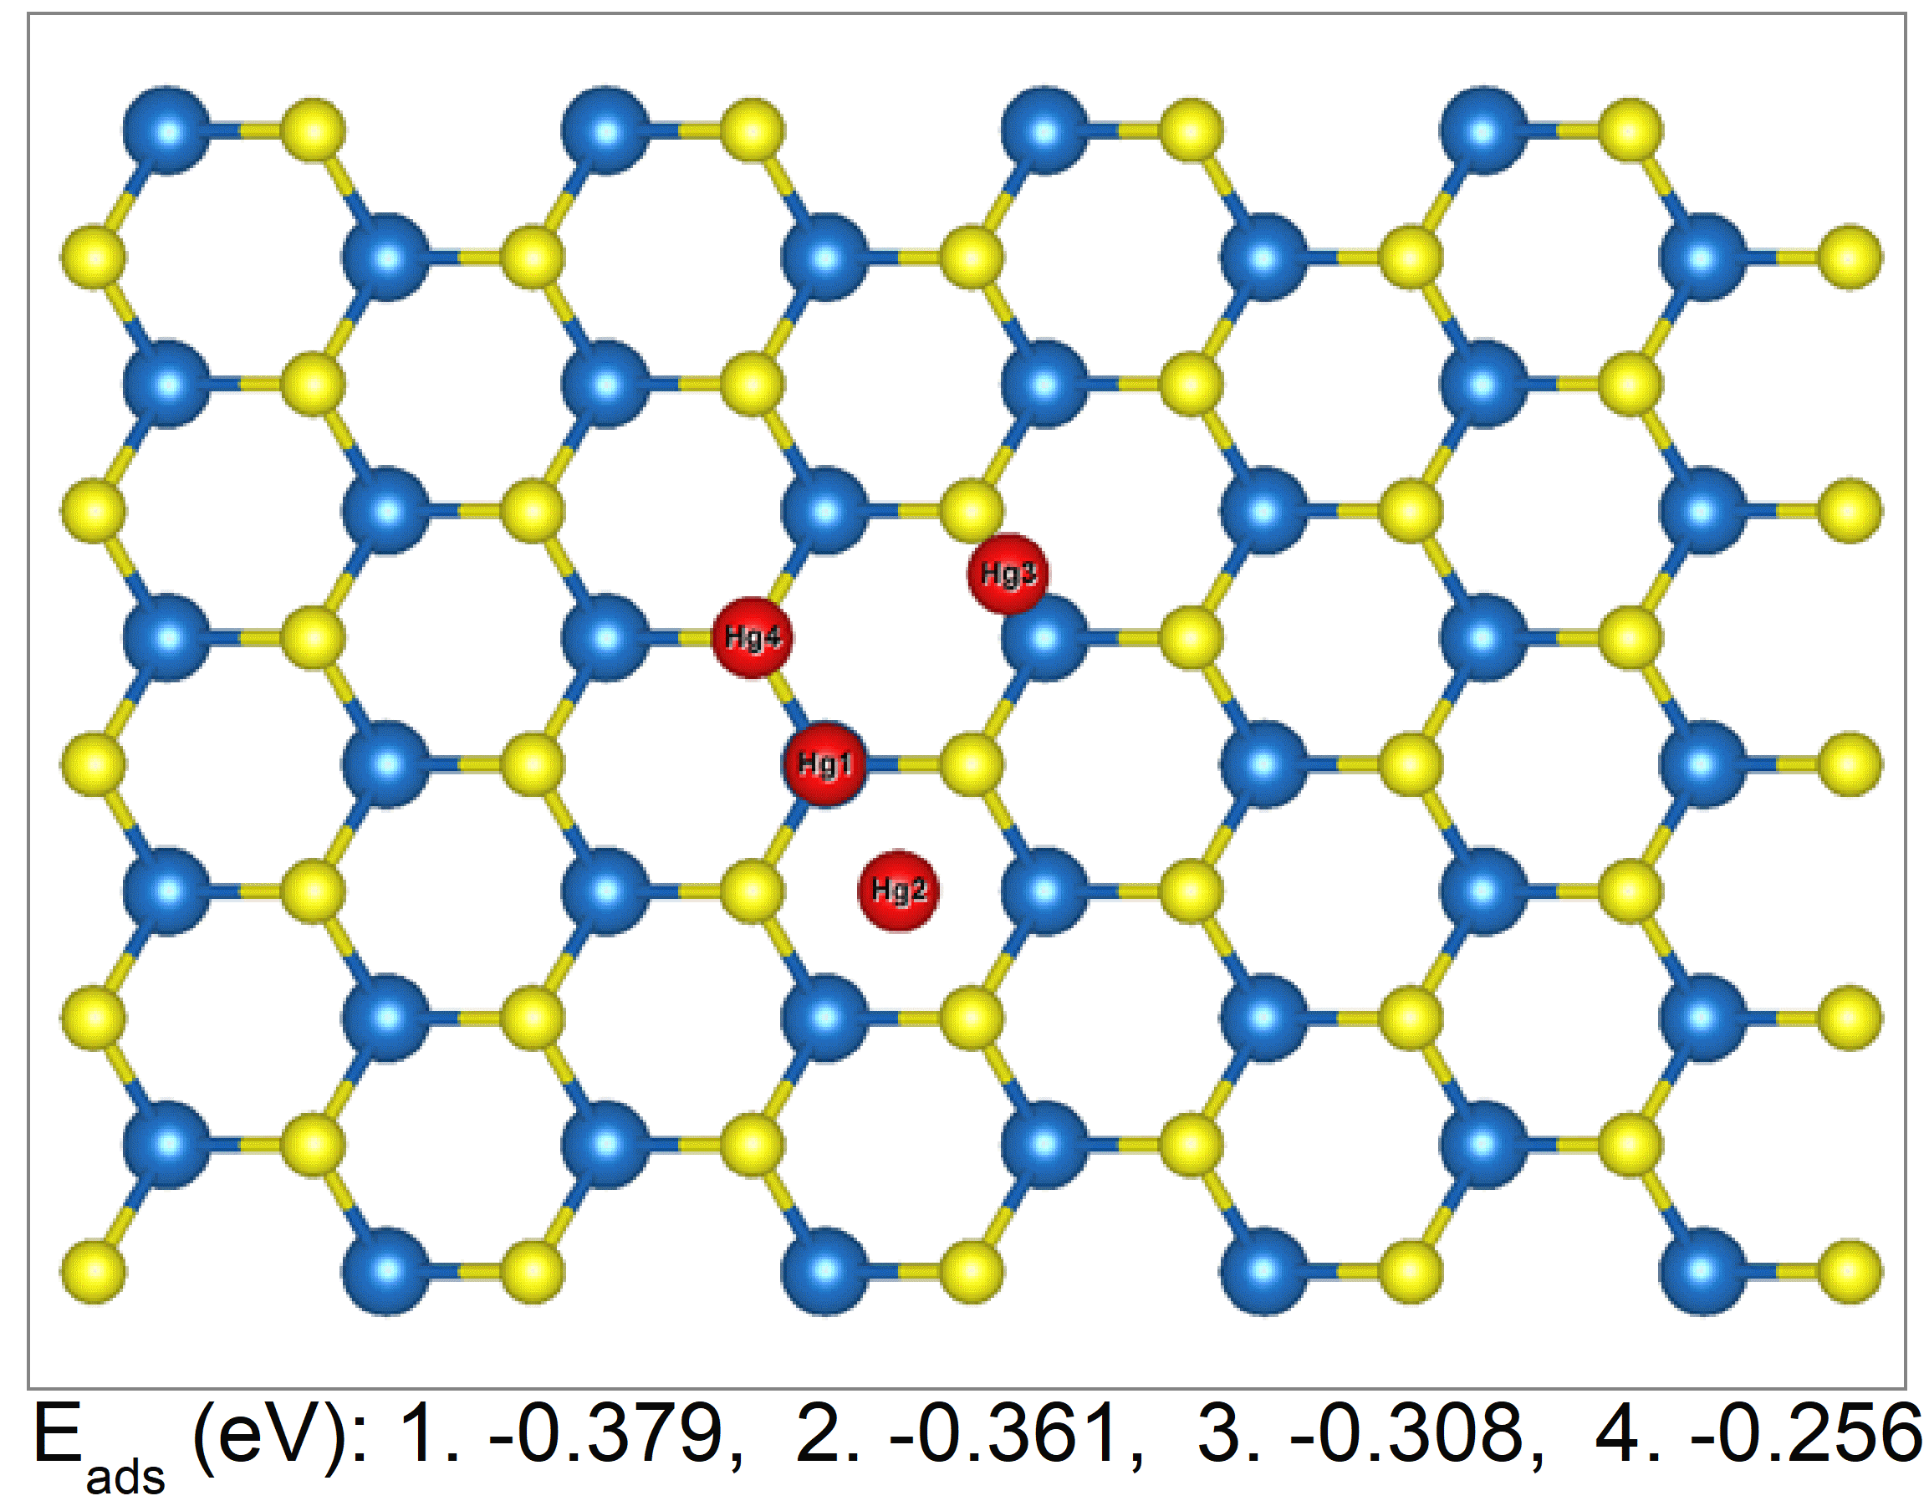
Fig. S7. DFT calculations about different adsorption positions of Hg atom away from the GBs in 1L WS₂ film labeled out with number 1-4. Yellow, blue and red balls represent S, W and Hg atoms, respectively. The calculated adsorption energies of E_{ads} at four different positions 1-4 are listed on bottom.

Fig. S8. Hg²⁺ detection of SPR sensor based on GB-rich 1L MoS₂ film. SPR spectra at Hg²⁺ concentrations ranging from 10⁻¹⁸ M to 10⁻¹²M (a) and extracted resonance angle shifts Δθ (b).

References
- Jia, Z.; Dong, J.; Liu, L.; Xiang, J.; Nie, A.; Wen, F.; Mu, C.; Wang, B.; Zhai, K.; Yu, Z.; Kang, M.; Liu, Z., One-step growth of wafer-scale monolayer tungsten disulfide via hydrogen sulfide assisted chemical vapor deposition. Appl. Phys. Lett. 2019,115, 163104.
- Liu, L.; Ye, K.; Yu, Z.; Jia, Z.; Xiang, J.; Nie, A.; Wen, F.; Mu, C.; Wang, B.; Li, Y.; Gong, Y.; Liu, Z., Photodetection application of one-step synthesized wafer-scale monolayer MoS₂ by chemical vapor deposition. 2D Materials 2020,7, 025020.
- Zeng, H.; Liu, G. B.; Dai, J.; Yan, Y.; Zhu, B.; He, R.; Xie, L.; Xu, S.; Chen, X.; Yao, W.; Cui, X., Optical signature of symmetry variations and spin-valley coupling in atomically thin tungsten dichalcogenides. Sci. Rep.2013,3, 1608.
- Gutierrez, H. R.; Perea-Lopez, N.; Elias, A. L.; Berkdemir, A.; Wang, B.; Lv, R.; Lopez-Urias, F.; Crespi, V. H.; Terrones, H.; Terrones, M., Extraordinary room-temperature photoluminescence in triangular WS₂ monolayers. Nano Lett.2013,13, 3447-3454.
- Berkdemir, A.; Gutiérrez, H. R.; Botello-Méndez, A. R.; Perea-López, N.; Elías, A. L.; Chia, C.-I.; Wang, B.; Crespi, V. H.; López-Urías, F.; Charlier, J.-C.; Terrones, H.; Terrones, M., Identification of individual and few layers of WS₂ using Raman Spectroscopy. Sci. Rep.2013,3, 1755.
6. Jia, W.; Fu, J.; Cao, Z.; Wang, L.; Chi, X.; Gao, W.; Wang, L. W., Fast plane wave density functional theory molecular dynamics calculations on multi-GPU machines. J. Comput. Phys. 2013,251, 102-115.
7. Jia, W.; Cao, Z.; Wang, L.; Fu, J.; Chi, X.; Gao, W.; Wang, L.W., (2013). The analysis of a plane wave pseudopotential density functional theory code on a GPU machine. Comput. Phys. Commun.2013,184, 9-18.
8. Schlipf, M.; Gygi, F., Optimization algorithm for the generation of ONCV pseudopotentials. Comput. Phys. Commun.2015,196, 36-44.
9. Garcia-Muelas, R.; Li, Q.; Lopez, N., Density Functional Theory Comparison of Methanol Decomposition and Reverse Reactions on Metal Surfaces. ACS Catal.2015,5, 1027-1036.

