The splitting 660 km discontinuity associated with lithospheric delamination in the northern part of the North-South seismic zone, China
Chuansong He
Corresponding author: C.S. He, email: hechuansong@aliyun.com

Institute of Geophysics, CEA, Beijing 100081, China

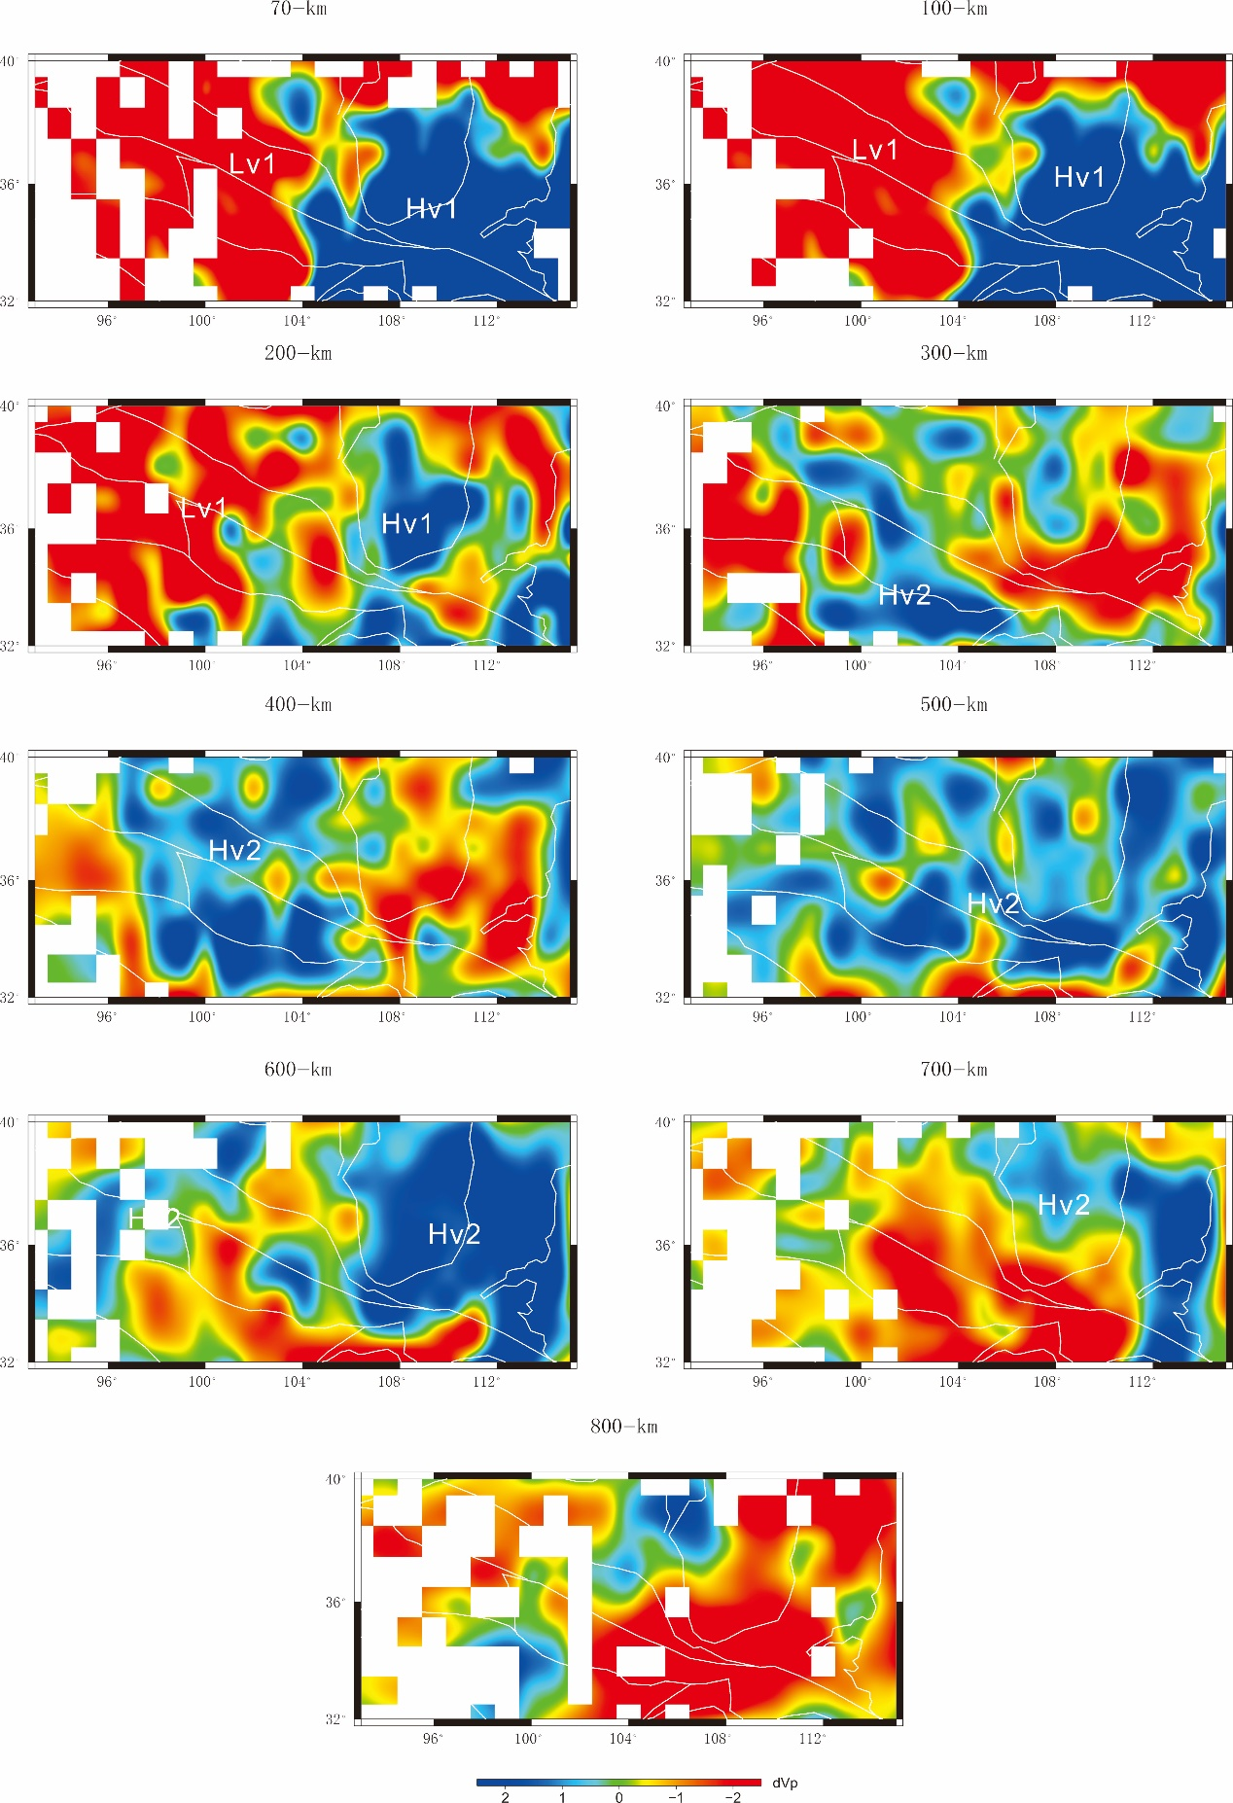
Fig. S1 P-wave velocity perturbation at different depths (He and Santosh, 2017). Portions of the model are not shown where the recovery from the input velocity model is below 20% [the figure was generated by Chuansong He using Generic Mapping Tools (https://www.generic-mapping-tools.org/)].
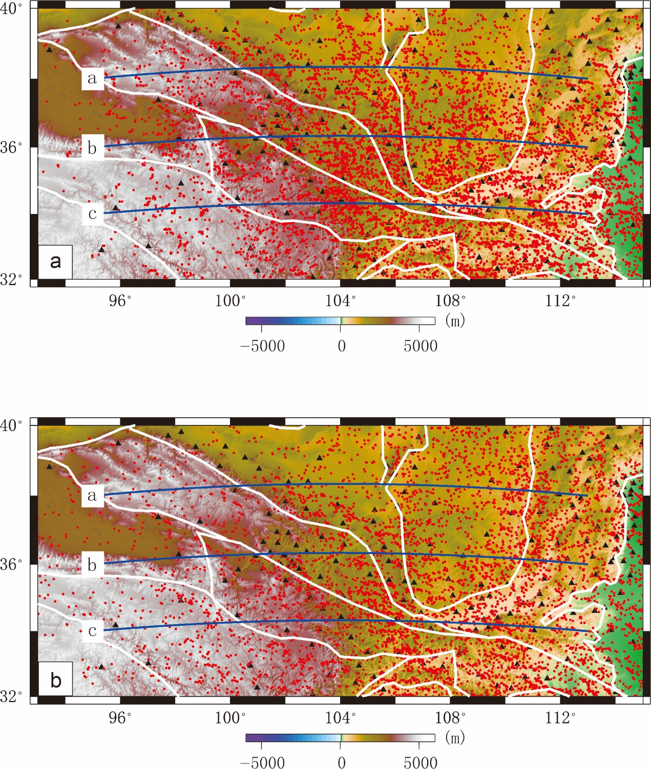
Fig. S2. Piercing points at depth of 410 km (a) and at depth of 660 km (b). Red points: piercing points at depths of 410 km and 660 km. Blue lines: profiles of P-wave velocity perturbation and CCP stacking profiles of receiver functions [the figure was generated by Chuansong He using Generic Mapping Tools (https://www.generic-mapping-tools.org/)].
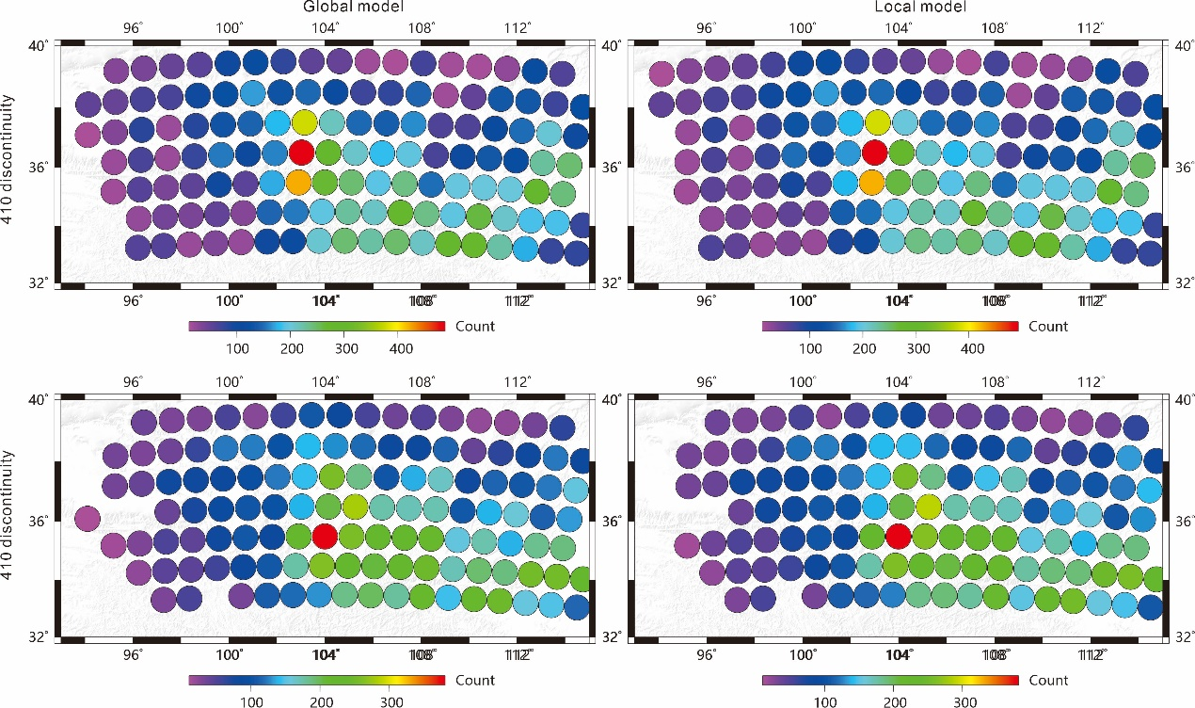
Fig. S3. Stacking points at 410 km and 660 km discontinuities [the figure was generated by Chuansong He using Generic Mapping Tools (https://www.generic-mapping-tools.org/)].
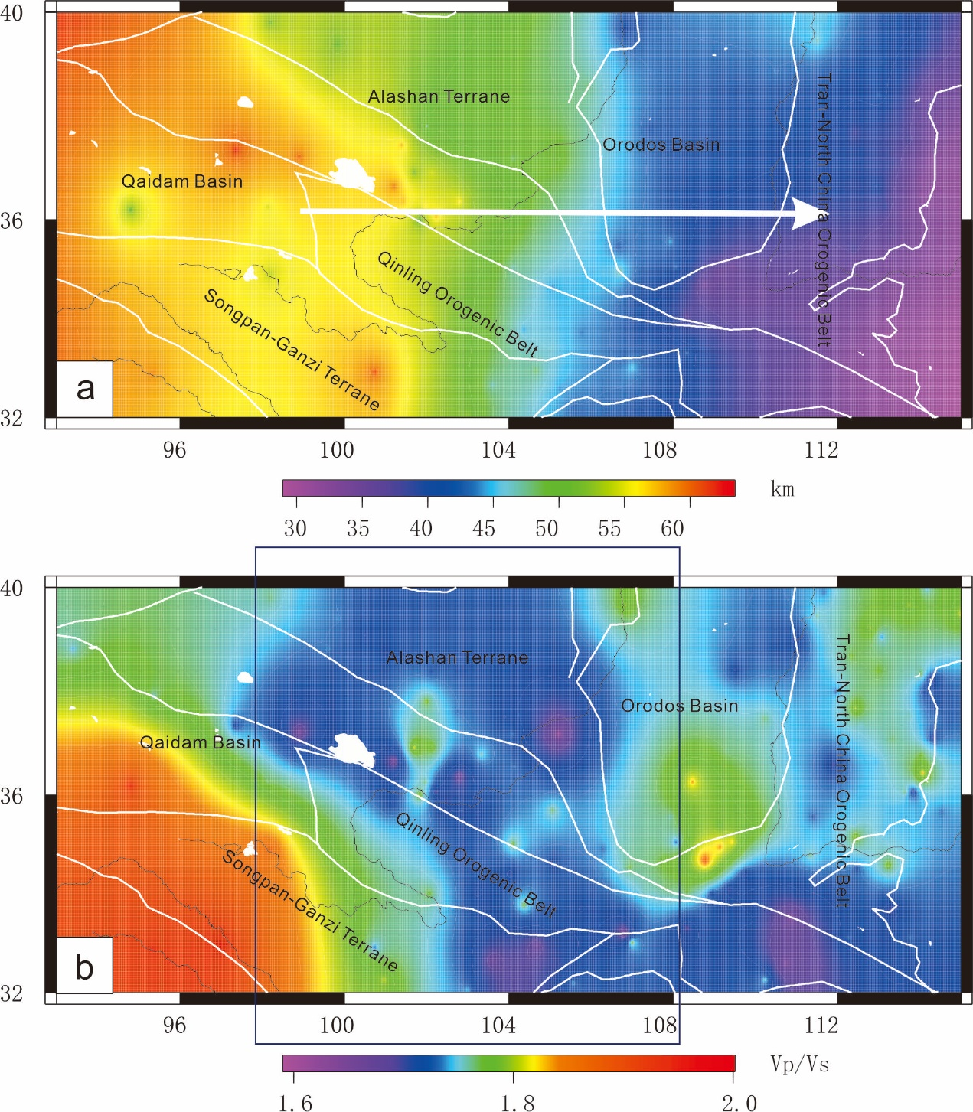
Fig. S4. Crustal thickness (a) and Vp/Vs ratio (b) in the northern part of the NSSZ. Yellow triangles: seismic stations. Lower Vp/Vs ratios in the northern part of the NSSZ are generated by a deep process of lithospheric delamination (He et al., 2014) [the figure was generated by Chuansong He using Generic Mapping Tools (https://www.generic-mapping-tools.org/)].

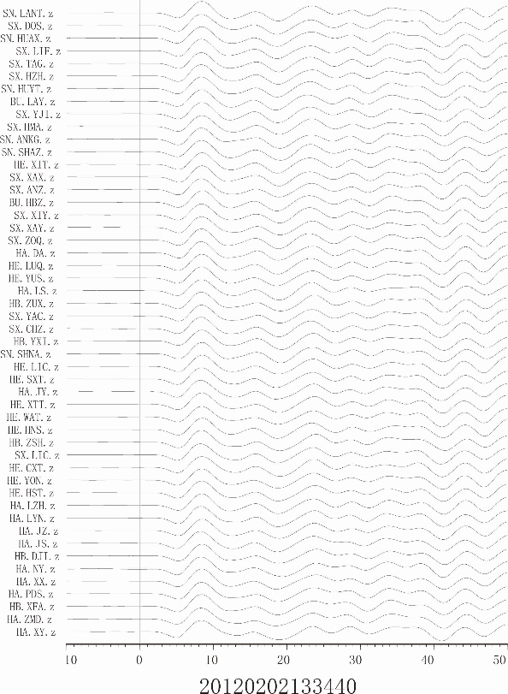
Fig. S5 Vertical component at each seismic station for the 20120202133440 event [the figure was generated by Chuansong He using Generic Mapping Tools (https://www.generic-mapping-tools.org/)].

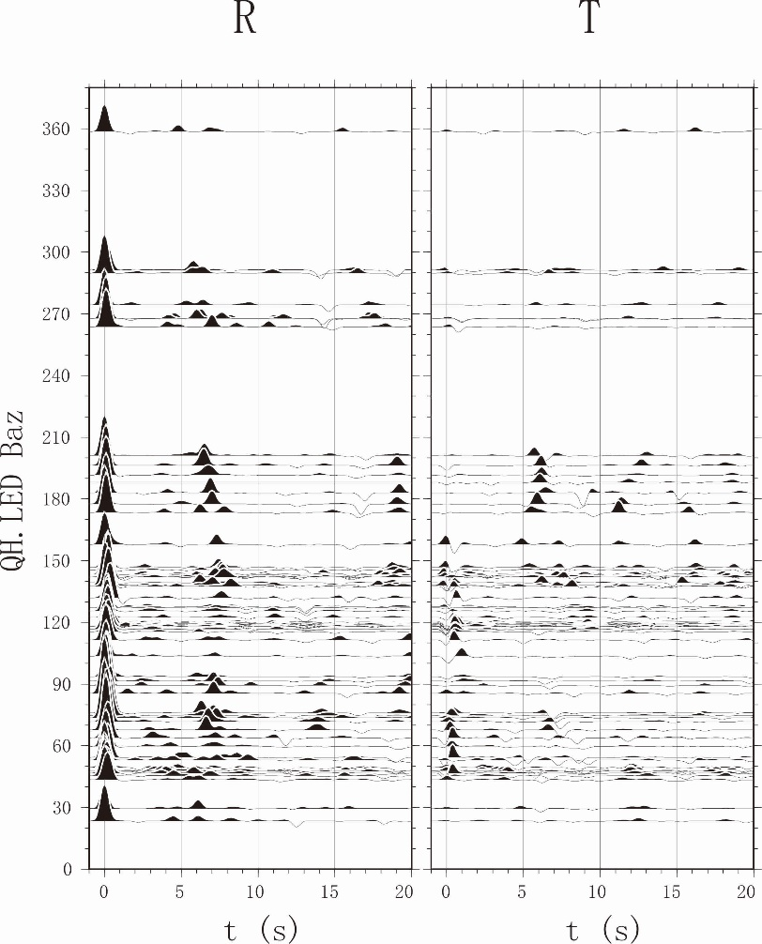
Fig. S6 R and T receiver functions for the QH.LED station [the figure was generated by Chuansong He using Generic Mapping Tools (https://www.generic-mapping-tools.org/)].

