Supplementary materials
Supplementary Tables
Supplementary Table 1 Association between the candidate lncRNA SNPs and risk of gastric cancer.
Supplementary Table 2 Association between the candidate SNPs and risk of gastric cancer.

Supplementary Table 3 Association between GRS quantile group and susceptibility to gastric cancer.

Supplementary Figures

Supplementary figure 1 PRS normal distribution of lncRNA SNPs (A) and commom SNPs (B).

Supplementary figure 2 Distribution of lncRNA SNPs (left) and commom SNPs (wGRS) (right) in cases and controls

Supplementary figure 3 Distribution of lncRNA SNPs (left) and commom SNPs (PRS) (right) in cases and controls.

Supplementary Table 1 Association between the candidate lncRNA SNPs and risk of gastric cancer
SNP(rs#) | lncRNA | Risk allele/Ref. | Chr. | Location
rs1859168 | lnc-EVX1-3:3 | C/A | Chr 7 | 27242359
rs3815254 | lnc-MACC1-1:7 | A/G | Chr 7 | 19983014
rs4784659 | lnc-AMFR-1:1 | C/T | Chr 16 | 56387000
rs579501 | lnc-ZNF33B-2:1 | A/C | Chr 10 | 43246795
rs77628730 | lnc-CCAT1 | A/T | Chr 8 | 128220966
rs6989575 | lnc-CCAT1 | C/T | Chr 8 | 128226195
rs7816475 | lnc-CCAT1 | A/G | Chr 8 | 128225440
rs6470502 | lnc-CCAT1 | T/C | Chr 8 | 128221510
rs1518338 | lncRNA-TUSC7 | C/G | Chr 3 | 116429325
rs2867837 | lncRNA-TUSC7 | G/A | Chr 3 | 116436449
rs12494960 | lncRNA-TUSC7 | A/C | Chr 3 | 116435140
rs74798803 | lncRNA-CASC9 | T/C | Chr 8 | 76136496
rs7818137 | lncRNA-CASC9 | T/C | Chr 8 | 76135674
rs550894 | lncRNA-NEAT1 | T/G | Chr 11 | 65211940
rs3825071 | lncRNA-NEAT1 | A/G | Chr 11 | 65212122
rs580933 | lncRNA-NEAT1 | G/C | Chr 11 | 65196884
rs7943779 | lncRNA-NEAT1 | A/G | Chr 11 | 65194586
rs911157 | lncRNA-NKILA | T/C | Chr 20 | 56286443
rs16981280 | lncRNA-NKILA | C/G | Chr 20 | 56287862
rs2273534 | lncRNA-NKILA | C/T | Chr 20 | 56285540
rs957313 | lncRNA-NKILA | T/G | Chr 20 | 56286812

Supplementary Table 2 Association between the candidate SNPs and risk of gastric cancer
SNP | Gene | Risk allele/Ref. | Chr. | Position
rs861539 | XRCC3 | G/A | Chr 14 |  | 104165753
rs2294008 | PSCA | C/T | Chr 8 |  | 143761931
rs731236 | VDR | G/A | Chr 12 |  | 48238757
rs25487 | XRCC1 | C/T | Chr 19 |  | 44055726
rs751402 | ERCC5 | G/A | Chr 13 |  | 103498198
rs1801133 | MTHFR | G/A | Chr 1 |  | 11856378
rs1799782 | XRCC1 | G/A | Chr 19 |  | 44057574
rs763780 | IL17F | C/T | Chr 6 |  | 52101739
rs8193036 | IL17A | C/T | Chr 6 |  | 52050493
rs4072037 | MUC1 | C/T | Chr 1 |  | 155162067
rs2274223 | PLCE1 | G/A | Chr 10 |  | 96066341
rs2275913 | IL17A | G/A | Chr 6 |  | 52051033
rs1799929 | NAT2 | C/T | Chr 8 |  | 18257994
rs20417 | PACERR | G/C | Chr 1 |  | 186650321
rs1800896 | IL10 | C/T | Chr 1 |  | 206946897
rs13361707 | PRKAA1 | C/T | Chr 5 |  | 40791884
rs3773651 | TGFBR2 | G/A | Chr 3 |  | 30718532
rs1799930 | NAT2 | G/A | Chr 8 |  | 18258103
GSTM1 | GSTM1 | P/D | Chr 1 |  | 109694069
GSTT1 | GSTT1 | P/D | Chr 22 |  | 270452
GSTM1 and GSTT1 are the insertion or deletion of the whole gene, P represents gene insertion and D represents gene deletion
.
Supplementary Table 3 Association between GRS quantile group and susceptibility to gastric cancer
Group | lncRNA SNPs  wGRS | Mean | Subjects | OR(95%CI) | P | Validation SNPs  wGRS | Mean | Subjects | OR(95%CI) | P
1 | [0-1] | 0.577 | 582 | 1.00 | - | [0-1] | 0.777 | 306 | 1.00 | -
2 | (1-1.5] | 1.233 | 273 | 2.724(2.025,3.663) | <0.001 | (1-1.5] | 1.256 | 350 | 1.640(1.197,2.247) | 0.002
3 | (1.5-2] | 1.725 | 170 | 3.891(2.719,5.567) | <0.001 | (1.5-2] | 1.721 | 235 | 1.908(1.348,2.700) | <0.000
4 | (2-2.5] | 2.252 | 161 | 3.313(2.188,4.488) | <0.001 | (2-2.5] | 2.224 | 152 | 2.297(1.545,3.416) | <0.000
5 | (2.5-3] | 2.727 | 71 | 5.659(3.298,9.833) | <0.001 | (2.5-3] | 2.712 | 94 | 3.780(2.315,6.170) | <0.000
6 | (3-4] | 3.423 | 63 | 7.878(4.207,14.522) | <0.001 | (3-4] | 3.432 | 104 | 3.230(2.033,5.133) | <0.000
7 | >4 | 5.870 | 67 | 10.236(5.350,19.583) | <0.001 | >4 | 5.440 | 79 | 4.819(2.794,8.312) | <0.000

Supplementary figure 1A and B Cumulative frequency and distribution of 22 SNPs (A) and Q-Q normal distribution plots (B).

Supplementary figure 1 PRS normal distribution of lncRNA SNPs (A) and commom SNPs (B).

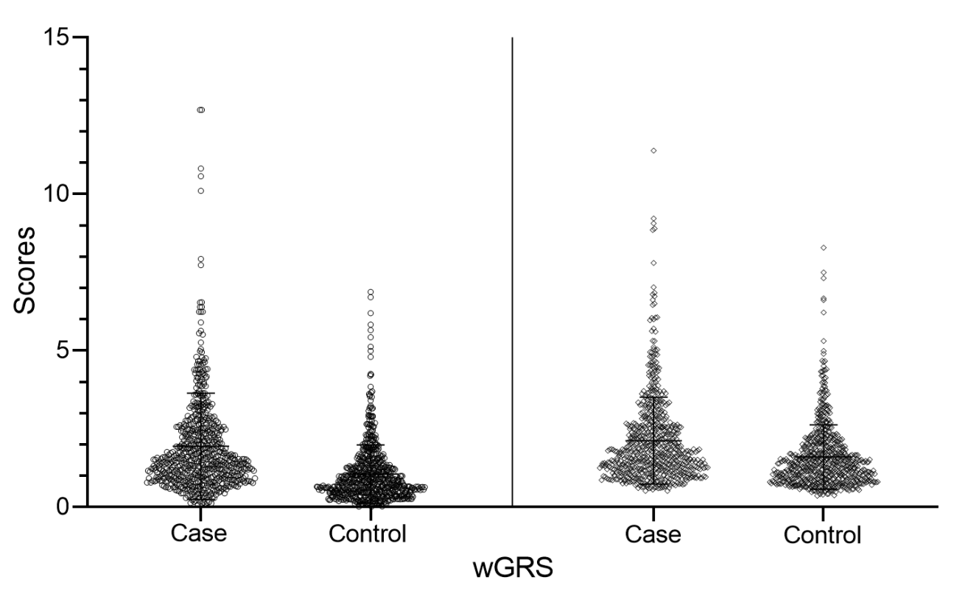
Supplementary figure 2 Distribution of lncRNA SNPs (left) and commom SNPs (wGRS) (right) in cases and controls.

Supplementary figure 3 Distribution of lncRNA SNPs (left) and commom SNPs (PRS) (right) in cases and controls.

