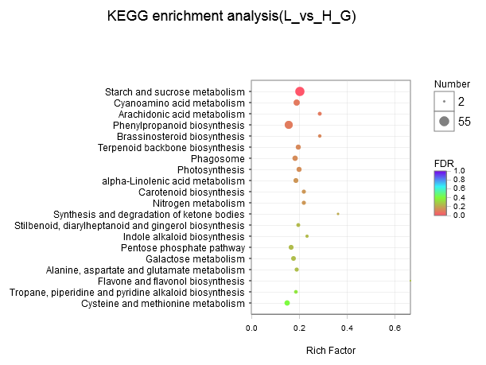
Figure S4. KEGG enrichment analysis of differentially expressed genes

