Intergenerational Transmission of Body Mass Index and Associations with Educational Attainment
Hekmat Alrouh^{1,2} (0000-0003-2224-149X),
Elsje van Bergen^{1,2} (0000-0002-5860-5745),
Eveline de Zeeuw^{1,2,3} (0000-0001-9042-7419),
Conor Dolan^{1,2} (0000-0002-2496-8492),
Dorret I. Boomsma^{1,2} (0000-0002-7099-7972)
¹ Department of Biological Psychology, Faculty of Behavioral and Movement Sciences, Vrije Universiteit Amsterdam, Amsterdam, Netherlands
² Amsterdam Public Health research institute, Amsterdam, Netherlands
³ Inspectorate of Education, Ministry of Education, Culture and Science, Utrecht, Netherlands
Contact info:
Hekmat Alrouh, Vrije Universiteit Amsterdam, Dept Biological Psychology
Van der Boechorststraat 7-9, Room MF-H557,
1081 BT Amsterdam, The Netherlands
Tel: + 31 20 598 5923 / Email: h.alrouh@vu.nl

Supporting Information:
Table S1: Distribution of parents and offspring among families
 |  | Number of offspring per family |  |  |  |  |  |  | Total
 |  | 0 | 1 | 2 | 3 | 4 | 5 | 6
Number of parents per family | 0 | 0 | 2239 | 1456 | 232 | 47 | 5 | 7 | 3986
 | 1 | 1234 | 726 | 679 | 195 | 20 | 3 | 2 | 2859
 | 2 | 346 | 454 | 813 | 363 | 38 | 7 | 0 | 2021
Total |  | 1580 | 3419 | 2948 | 790 | 105 | 15 | 9 | 8866

Table S2: Distribution of body mass index (BMI) for parents and offspring among families
 |  | Number of offspring with BMI data |  |  |  |  |  |  | Total
 |  | 0 | 1 | 2 | 3 | 4 | 5 | 6
Number of parents with BMI data | 0 | 133 | 2272 | 1400 | 216 | 42 | 6 | 5 | 4074
 | 1 | 1238 | 746 | 668 | 182 | 19 | 2 | 2 | 2857
 | 2 | 340 | 476 | 764 | 315 | 34 | 6 | 0 | 1935
Total |  | 1711 | 3494 | 2832 | 713 | 95 | 14 | 7 | 8866
BMI: body mass index

Table S3: Distribution of educational attainment (EA) for parents and offspring among families
 |  | number of offspring with EA data |  |  |  |  |  |  | Total
 |  | 0 | 1 | 2 | 3 | 4 | 5 | 6
Number of parents with EA data | 0 | 2731 | 1386 | 1008 | 177 | 39 | 6 | 6 | 5353
 | 1 | 1573 | 255 | 197 | 64 | 6 | 3 | 1 | 2099
 | 2 | 851 | 239 | 205 | 102 | 15 | 2 | 0 | 1414
Total |  | 5155 | 1880 | 1410 | 343 | 60 | 11 | 7 | 8866
EA: educational attainment

Table S4: Unadjusted covariance and correlation table.
 | Offspring BMI (male/female) | Offspring EA (male/female) | Paternal BMI | Maternal BMI | Paternal EA | Maternal EA
Offspring BMI (male/female) | 12.177/  14.778 | -1.342/  -1.472 | 2.019/  2.347 | 2.243/  3.580 | -0.728/  -0.621 | -0.789/  -0.693
Offspring EA (male/female) | -0.220/  -0.230 | 3.053/  2.759 | -0.586/  -0.739 | -0.954/  -0.773 | 0.897/  0.623 | 0.628/  0.603
Paternal BMI | 0.178/  0.188 | -0.103/  -0.137 | 10.536 | 3.303 | -0.629 | -0.591
Maternal BMI | 0.145/0.210 | -0.123/-0.105 | 0.230 | 19.593 | -1.419 | -1.110
Paternal EA | -0.114/-0.0880 | 0.279/0.204 | -0.105 | -0.175 | 3.374 | 1.529
Maternal EA | -0.138/-0.110 | 0.219/0.222 | -0.111 | -0.153 | 0.508 | 2.684
Upper triangle, covariance. Lower triangle: correlation. Diagonal: variance.
Abbreviations: BMI, body mass index; EA, educational attainment

Table S5: Chi-square (likelihood ratio) test results for path model fit of transmission coefficients equality constraint across male and female offspring (see figure 1).

 | Constrained coefficients | df | x² | x² diff | df diff | p (>x²)
Full model | - | 44 | 52.132 | - | - | -
All paths (Omnibus test) | e3, e4, e5, e6, b3, b4, b5, b6 | 52 | 84.836 | 32.704 | 8 | 0.0001
P EA → O EA | e3 | 45 | 56.303 | 4.171 | 1 | 0.0411
M EA → O EA | e4 | 45 | 54.999 | 2.868 | 1 | 0.0904
P BMI → O EA | e5 | 45 | 52.230 | 0.099 | 1 | 0.7534
M BMI → O EA | e6 | 45 | 53.135 | 1.003 | 1 | 0.3165
P EA → O BMI | b3 | 45 | 52.132 | 0.000 | 1 | 0.9929
M EA → O BMI | b4 | 45 | 52.192 | 0.060 | 1 | 0.8062
P BMI → O BMI | b5 | 45 | 53.551 | 1.420 | 1 | 0.2335
M BMI → O BMI | b6 | 45 | 68.168 | 16.037 | 1 | 0.0001*
Abbreviations: df, degrees of freedom; x², chi-square; diff, difference; P, paternal; M, maternal; EA, educational attainment; BMI, body mass index. *significant test after Bonferroni correction (p<0.00125)

Table S6: Chi-square (likelihood ratio) test results for path model fit of transmission coefficients equality constraint across fathers and mothers (see figure 1).

Constrained path | Constrained coefficients | Df | x² | x² diff | df diff | p (>x²)
Full model | - | 44 | 52.132 | - | - | -
All paths (Omnibus test) | e3=e4, e5=e6, b3=b4, b5=b6 | 52 | 65.019 | 12.887 | 8 | 0.1632
P EA → O EA (m) | e3m = e4m | 45 | 52.863 | 0.732 | 1 | 0.3591
P EA → O EA (f) | e3f = e4f | 45 | 56.570 | 4.438 | 1 | 0.0253
P BMI → O EA (m) | e5m = e6m | 45 | 52.133 | 0.001 | 1 | 0.9707
P BMI → O EA (f) | e5f = e6f | 45 | 53.417 | 1.286 | 1 | 0.3148
P EA → O BMI (m) | b3m = b4m | 45 | 52.139 | 0.007 | 1 | 0.9355
P EA → O BMI (f) | b3f = b4f | 45 | 52.144 | 0.012 | 1 | 0.9166
P BMI → O BMI (m) | b5m = b6m | 45 | 57.699 | 5.567 | 1 | 0.0587
P BMI → O BMI (f) | b5f = b6f | 45 | 52.963 | 0.832 | 1 | 0.4044
Abbreviations: df, degrees of freedom; x², chi-square; diff, difference; P, paternal; M, maternal; EA, educational attainment; BMI, body mass index.

Table S7: model fit measures
 | model 1 (full model) | model 2 (parsimonious)
x² | 52.1317 | 61.67543
cfi | 0.99762 | 0.99776
tli | 0.99352 | 0.99502
rmsea | 0.00458 | 0.00402
rmsea lower ci | 0 | 0
rmsea upper ci | 0.00886 | 0.00811
srmr | 0.02377 | 0.02721

Figure S1: Mean BMI by age, all participants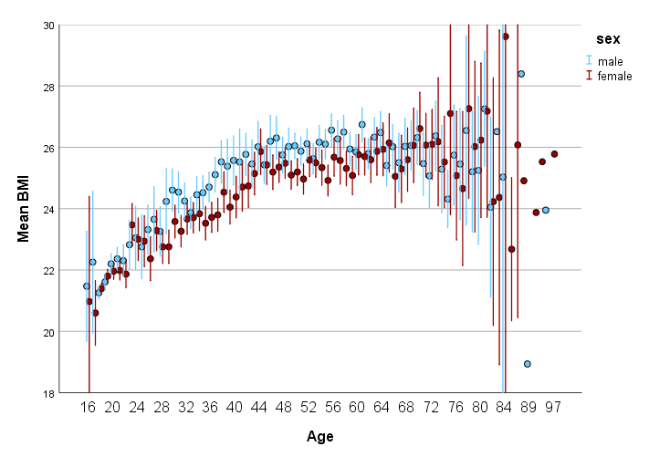
Error bars: 95% confidence intervals
Abbreviations: BMI, body mass index

Figure S2: Mean educational attainment by age, all participants 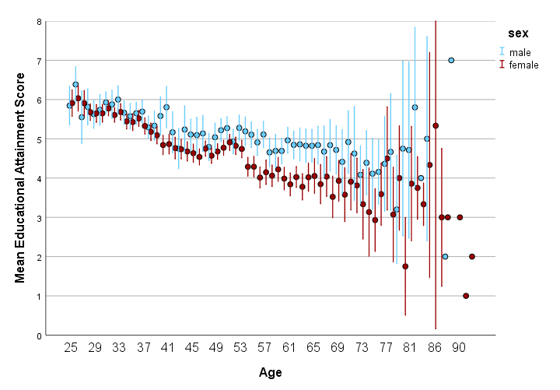
Error bars: 95% confidence intervals

