Screening of organic micropollutants in raw and drinking water in the Yangtze River Delta, China
Hanwei Renª, Rikard Tröger^{b}, Lutz Ahrens^{b}, Karin Wiberg^{b*}, Daqiang Yin^{a*}

ªKey Laboratory of Yangtze River Water Environment, Ministry of Education, College of Environmental Science and Engineering, Tongji University, Shanghai 200092, China
^{b}Department of Aquatic Sciences and Assessment, Swedish University of Agricultural Sciences (SLU)
Box 7050, SE-750 07 Uppsala, Sweden
*Corresponding authors: Daqiang Yin, yindq@tongji.edu.cn; Karin Wiberg, karin.wiberg@slu.se

Abstract
Background: The vast occurrence of organic micropollutants in surface waters has raised concerns about drinking water safety and public health. The Tai Hu Basin region in China, a typical developing and populous area, is facing the challenge of water pollution. To ensure drinking water safety, the knowledge on how treatment techniques and raw water quality affect the quality of finished water must be improved. The aim of the current study was to evaluate drinking water quality with respect to organic micropollutants and how the purity of finished water depends on source water contamination and drinking water treatment strategies. Five drinking water treatment plants (DWTPs), using three different source waters in the Tai Hu River Basin, (i) Yangtze River, (ii) Wetland River Network, and (iii) Lake Tai Hu, were studied by analyzing 291 micropollutants in raw and finished water.
Results: Major differences in concentrations and composition profiles of organic micropollutants were observed between the source waters. Among the studied micropollutants, the dominating group was pesticides in the wetland river network and flame retardants in Yangtze. The total concentration of poly- and perfluoroalkyl substances (PFASs) in Tai Hu water was far higher than in other samples. In total, 51 compounds were detected in finished water, with an overall average total concentration of 730 ± 160 ng L⁻¹. The removal efficiency of the detected compounds in the DWTPs averaged 24 ± 150 %, which highlights the major challenge for the DWTPs to remove emerging organic micropollutants through current treatment processes.
Conclusions: Our study showed that if the source water contains high levels of PFASs and organophosphorus flame retardants, even advanced treatment procedures are inefficient in removing the micropollutants, and the finished drinking water may contain cumulative levels of organic micropollutants in the mg L⁻¹ range. On the other hand, if pesticides and pharmaceuticals dominate, high overall treatment efficiencies may be obtained if using advanced treatment techniques. DWTPs are advised to use advanced treatment techniques or alternative water sources to guarantee the safety of drinking water. As surface water systems are highly impacted by upstream activities, efforts should also be made in the water sector for improved surface water quality.

Key words
screening; micropollutants; Tai Hu Basin; source water; drinking water; removal efficiency; flame retardants; PFASs; pesticides; industrial chemicals

Background
Access to clean drinking water is an indispensable resource for people's daily lives and one of the United Nations’ sustainable development goals. The presence of organic micropollutants in raw and finished drinking water have raised concerns about drinking water safety and public health, and there is a need to protect source water from ongoing and future contamination [1-4]. China, the most populous country on the globe, is extremely scarce in terms of per capita water resources. Therefore, how to ensure the safety of drinking water for the citizens is a great challenge that needs to be faced.
The Chinese population is unevenly distributed, with the main population distributed in the southeastern coastal areas. The Yangtze River, China’s most important drinking water supply, enters the East China Sea 6,300 kilometers downstream the primary catchment area in the west. The river delta is centered on the City of Shanghai and comprises in total three provinces (Jiangsu, Zhejiang and Anhui) and 26 cities, which together constitutes an important population center and development area. The Yangtze River Delta occupies an important maritime transportation hub, with the Tai Hu River Basin covering most of the area. Therefore, agriculture, industry and trade activities are well developed in this region.
Surface water is the main water source of drinking water in Yangtze River Delta and Tai Hu River Basins. Since Yangtze River Delta is one of the most urbanized areas in China, with a population of 150 million (Tai Hu River Basins has 36 million people), this part of China exemplifies an area with extraordinary high anthropogenic impact [5]. A number studies have reported on the presence of organic micropollutants in surface waters in this region, e.g. antibiotics [6], phthalate esters [7], organochlorine pesticides [8, 9], flame retardants [9-11] and poly- and perfluoroalkyl substances (PFASs) [12]. The occurrence of organic micropollutants has been reviewed in the Yangtze River showing that the pollutants were diluted due to an excess of water, which reduces the risks but not entirely eliminate them [13]. Furthermore, PFASs [14], flame retardants [15] and some drug metabolites [16] have also been detected in finished drinking water, posing a health risks for citizens in this region.
Treatment of raw water at drinking water treatment plants (DWTPs) can reduce levels and complexity of the water. The removal efficiency is, however, highly dependent on treatment strategies [17], and conventional treatment has shown largely inefficient [18]. Although previous studies revealed the presence of a number of compound groups (e.g. PFASs) and pollution categories (e.g. pesticides and flame retardants) in both raw and drinking water from this region of China, the relative impact of groups of pollutants has not been thoroughly investigated.
The aim of the current study was to evaluate drinking water quality with respect to organic micropollutants and how the purity of finished water depends on source water contamination and drinking water treatment strategies. Five DWTPs in the Tai Hu River Basin, using three different water sources and various treatment strategies were studied. Almost 300 organic micropollutants were analyzed in water samples before and after DWTP treatment to evaluate the treatment efficiency for individual compounds. The organic micropollutants represented a broad variety of usage categories and compound groups, such as pharmaceuticals and personal care products (PCCPs), pesticides, PFASs, flame retardants, industrial chemicals, hormones, phthalates, and food additives. There was a large variability in pollutant levels and complexity in both raw and finished water, and conclusions could be drawn about the suitability of treatment options for different source water qualities.

Methods and Materials

Reference standards and chemicals
In total 291 organic micropollutants were targeted including pharmaceuticals (n=108), pesticides (n=99), PFASs (n=18), flame retardants (n=14), industrial chemicals (n=14), hormones (n=8), food additives (n=6), phthalates (n=5), personal care products (n=4), surfactants (n=4), fatty acids (n=4), siloxanes (n=2), stimulants (n=2), isoflavones (n=2), and contrast media (n=1) (Table A1 in Supporting Information). Additionally, 21 isotope labelled internal standards (ISs) were used (Table A2 in Supporting Information). The pesticide standards (native and isotope-labelled) were purchased from Teknolab Sorbent (Kungsbacka, Sweden) as accredited mixtures. Wellington Laboratories (Guelph, Canada) was the provider of the all PFAS standards. The remaining standards were bought from Sigma-Aldrich (Buchs, Switzerland) as solutions or crystalline of individual compounds, at analytical purity or higher, and were made into stock solutions in methanol or acetonitrile at a concentration of 1 mg mL⁻¹.
Ultrapure water (Milli-Q) for solid phase extraction (SPE) and mobile phases in the UPLC-system was generated in-house by a water purification system (Millipore; Bedford, USA). The buffers, acids and bases used for mobile phases were of LC-MS grade and purchased from Sigma Aldrich (Buchs, Switzerland). The methanol and acetonitrile (LC-MS grade) were from Merck (Darmstadt, Germany) and the ethanol (AnalaR quality) was purchased from VWR International (Fontenay-sous-Bois, France).

Sampling sites and sample collection
Grab samples (4 L) of raw water (n=1) and finished water (n=1, named ‘Drinking water’ in the figures) were collected in September 2018 from five different drinking water treatment plants (N1(s), N2(s), N3, N4, and N5) located around Lake Tai Hu in the southeast of China and near the delta of the Yangtze River (Figure 1). Additionally, two of the DWTPs were sampled a second time three months later (December 2018; N1(w) and N2(w); duplicate samples at each site; n=2+2; 4 L per sample). In the following, all N1 and N2 samples (September (n=1) and December (n=2); in total n = 3 × 2 (raw and finished) × 2 (sites) = 12 samples) are named as the Su Tai samples, and the N3, N4 and N5 samples are named the Wu Tai (n=1 × 2 (raw and finished) = 2), the Yangtze (n=1 × 2 = 2) and river network (n=1 × 2 = 2) samples, respectively. The selected DWTPs provide drinking water to two cities in the Jiangsu province and one city in the Zhejiang province for in total about 8 million people. Detailed information on the five DWTPs including their source water and treatment strategies, are given in Table 1 and Figure 1b. Note that the Yangzte DWTP receives its raw water from another DWTP, i.e. finished water, but transported approximately 36 km through a pipeline.
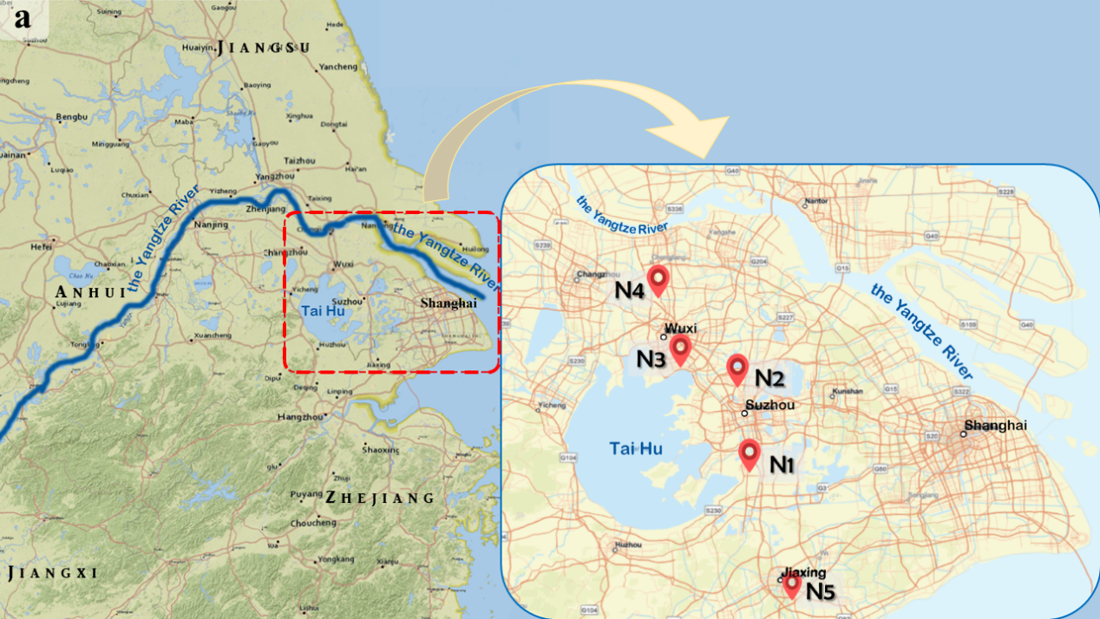

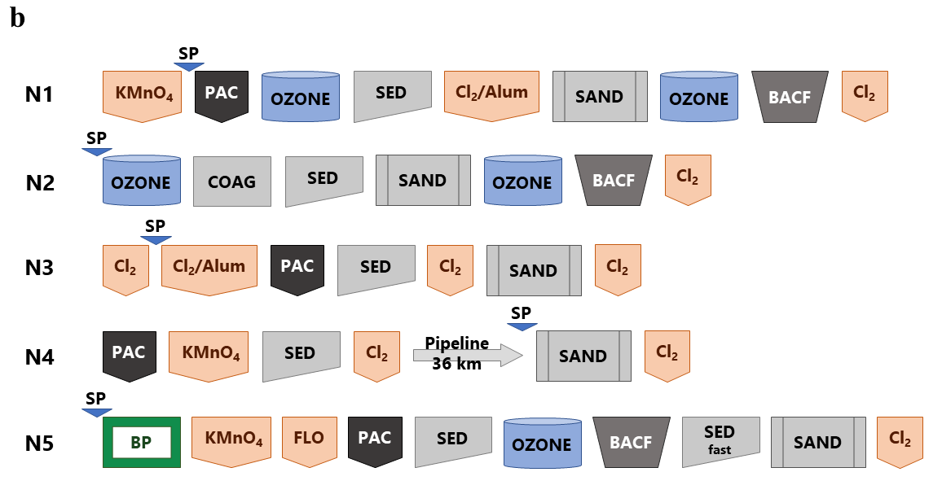

Figure 1 (a) Map showing the sampling locations at the Tai Hu Basin within the Yangtze River Delta (N1-N5). (b) DWTP treatment strategies and raw water sampling point. N1-N5: 5 different DWTP. PAC = powdered activated carbon, BACF = biological activated carbon filter, OZONE = ozone contactor, SED = flocculation/sedimentation, SAND = sand filter, COAG = aluminum coagulation, BP = biological pretreatment, FLO = flocculant, KMnO₄/Cl₂/Alum = chemical additive, SP = sampling point of raw water.

Table 1 Detailed information of the sampling locations
Sample name | Sampling site | Sampling date | Source water | Description of raw water
N1(s) | Su Tai | 2018-09-30 | Tai Hu | Water from Lake Tai Hu with pre-oxidation
N2(s) | Su Tai | 2018-09-30 | Tai Hu | Water from Lake Tai Hu
N3 | Wu Tai | 2018-09-30 | Tai Hu | Water from Lake Tai Hu with prechlorination
N4 | Yangtze | 2018-09-30 | Yangtze River | Already treated at another DWTP, transported via pipeline (~36 km)
N5 | River Network | 2018-09-30 | river | River draining a wetland
N1(w) | Su Tai | 2018-12-01 | same as N1(s) | same as N1(s)
N2(w) | Su Tai | 2018-12-01 | same as N2(s) | same as N2(s)
ª The treatment processes at the five DWTPs and the sampling points for raw and finished water in the DWTPs are shown in Figure 1b.

All samples were collected directly from tap in 4 L pre-cleaned glass containers. The pH was immediately adjusted to 3 using hydrochloric acid solution. The samples were transported to the laboratory at Tongji University, China, within 8 hours and stored at 4℃ until sample preparation. One field blank sample was prepared using Milli-Q water in the same type of glass container.

Sample preparation
The water samples were filtered through 0.7 μm glass fiber filters (Grade GF/F circles 47 mm, Whatman, UK) including the field blank (Milli-Q water) control sample. Each sample was divided into four 1 L samples and extracted using SPE cartridges in series: Oasis® HLB 6 cc Vac Cartridge (500 mg Sorbent per cartridge, Waters, USA) and Supelclean™ Coconut Charcoal SPE Tube (2 g, 6 mL, Sigma-Aldrich, USA). After loading and drying, the SPE cartridges were stored at -40℃. One randomly selected pair of SPE cartridges (out of the four pairs; consisting of one HLB and one Cocoa Charcoal cartridge), i.e. in total 18 × 2 = 36 cartridges plus the field blank, were shipped to the Department of Aquatic Sciences and Assessment, Swedish University of Agricultural Sciences (SLU, Uppsala, Sweden) and stored at 4℃ until SPE elution. Before elution of the SPE cartridges, the 21 ISs were added (50 ng per IS) after dilution in Milli-Q water (approx. 40 mL).
The two cartridges (HLB and Cocoa Charcoal ) were eluted separately, first with 10 mL of a mixture of acetone and hexane (V_{acetone}:V_{hexane}=1:1) and then 10 mL of methanol [19] (Figure A1 in the Supporting Information). Each eluate was collected in a separate glass tube. The HLB and Cocoa Charcoal eluates were combined separately and evaporated under a gentle stream of nitrogen until approximately 4 mL. The HLB and Cocoa Charcoal eluates were then combined and reduced to below 0.5 mL and transferred to an LC-MS vial. After each transfer step, the previous container was washed twice with methanol, which was also transferred to the next vial. The final extract was evaporated to less than 500 μL in the vial and diluted to 1 mL with methanol (Figure A1 in Supporting Information).

Instrumental analysis
The instrumental analysis was performed as described previously by Tröger et al. [17]. In brief, a time-of-flight mass spectrometer (ToF) (Xevo G2-S, Waters, Micromass; Manchester, UK) coupled to a ultra-performance liquid chromatography (UPLC) system (Acquity H-Class with FTN injector; Waters, Milford, MA, USA) equipped with either an Acquity UPLC HSS T3-C18 column (positive ionisation mode) or UPLC BEH-C18 column (negative mode) was used. The mobile phase was a gradient containing Milli-Q water and acetonitrile, and the injection volume was 10 µL. All data were collected in MS^{E}-mode, with a resolution of ~30 000 at 556.28 m/z using leucine enkephalin for the lock spray and UNIFI v1.8.2 as the software for data collection and evaluation. Details of the targeted compounds and the analytical procedure (including IS used for each analyte) are given in Table A3 in Supporting Information.

Quality assurance and method performance
Calibration curves were run for each target compound with a concentration range of 0.1-120 ng L⁻¹. The concentrations in the samples were mostly within this range, except a few data for tris(2-chloroethyl) phosphate (TCEP), triethyl phosphate (TEP), and butyl dihydrogen phosphate and a high fraction of the laurilsulfate data, which reached higher levels (Table A4 in Supporting Information). Data reported outside the calibration curve are marked in the table and should be interpreted with care.
The lowest level detected in the calibration curve was used as the method detect limit (MDL; Table A3 in Supporting Information). The results of the four duplicate samples (raw and drinking water for N1(w) and N2(w), respectively) were tested for similarity using two-sided Student’s paired t-test and the data for compounds detected above the MDL. There was no significant difference between the duplicates at a p-level of <0.05 for any of the duplicates. The average relative standard deviation of the concentration data for the duplicate samples (n=4 and 68 detected compounds) were within the range 16-30%.
The apparent recovery of the ISs, calculated from the relative responses of each IS in all samples, was on average 39% (± 20%) (Table A2 in Supporting Information). The levels in the field blank were generally low (on average <1% of levels in samples), except for six compounds (laurilsulfate, lidocaine, cresyl diphenyl phosphate (CDP), triphenyl phosphate (TPHP), tris(2-butoxyethyl) phosphate (TBEP), laureth-5), for which occasionally higher levels were detected (35-75%) (Table A4 in Supporting Information). The sample concentrations were corrected by subtracting the blank levels.

Results and Discussion

Raw water quality
In total 68 (23 %) of the 291 targeted compounds were detected above the MDL in at least one raw water sample, and the number of detected compounds per sampling site ranged from 49 to 64. The detected micropollutants represented a wide variety of compounds including pesticides (n=27), pharmaceuticals (n=15), PFASs (n=10), organophosphorus flame retardants (n=7), food additives (n=2), industrial chemicals (n=2), surfactants (n=3), and a fatty acid (n=1), stimulant (n=1). The detected compounds and their concentrations at each sampling point are given in Table A4 in the Supporting Information.
The number of detected micropollutants on a category basis were rather similar between the five DWTPs (Figure 2; raw water). This indicates a rather even distribution of emission sources in the Tai Hu Lake and the Yangtze River Delta area, with the exception of pesticides, which showed a higher number of detected compounds at the river network site. Overall, pesticides was the most detected pollutant category with on average 35% ± 2% of all compounds detected (including all samples and sampling sites; n=18), followed by pharmaceuticals (19% ± 2%), PFASs (17% ± 2%), ‘Others’ (16% ± 2%: food additives, industrial chemicals, surfactants, stimulant and fatty acid), and flame retardants (13% ± 1%).
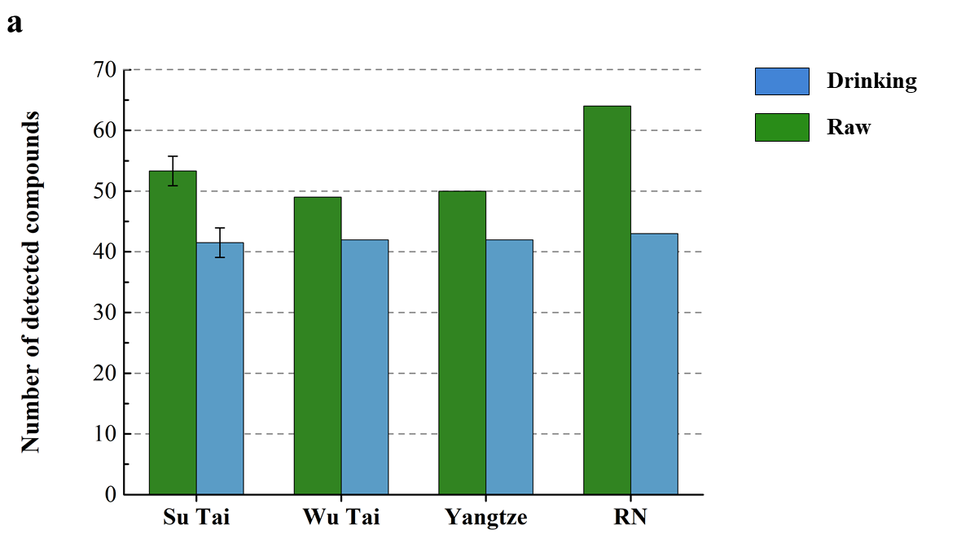
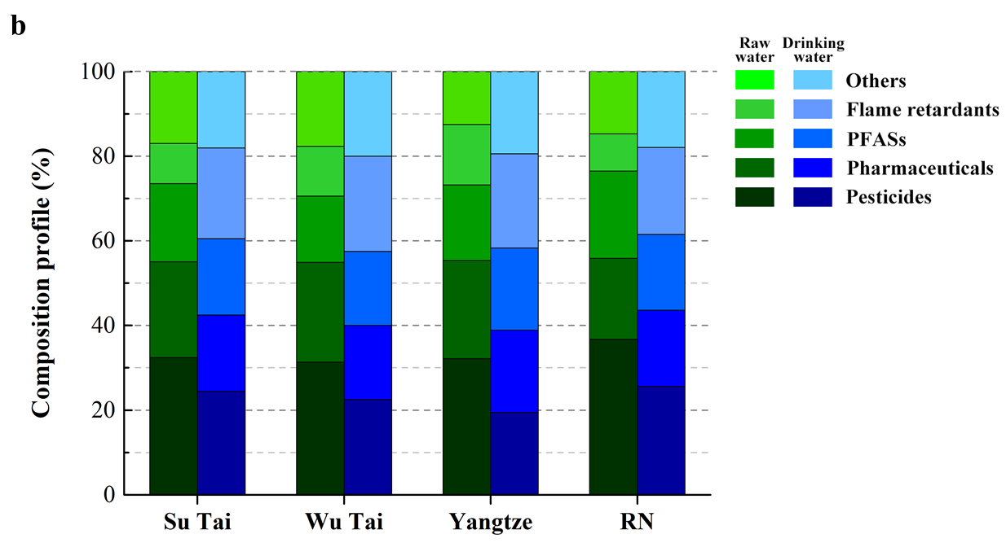

Figure 2 (a) Total number of compounds detected above MDL in raw and drinking (finished) water at the different sites. Su Tai shows the average (and error bars) of samples from N1 and N2 (n=6: 2 sites, 2 sampling occasions and 1 duplicate sample), while other bars show the result from n=1; (b) The fraction of the number of detected compounds (in relation to total) is shown on a compound category basis for each site. Compounds detected above MDL and their concentrations are given in Table A4 in Supporting Information. RN=river network.

The total concentrations of the micropollutants in the raw water (Figure 3) showed that the wetland river network was the most polluted site with respect to organic micropollutants (4 000 ng L⁻¹), followed by the Tai Hu Lake (1 600 ng L⁻¹ for Su Tai and Wu Tai, respectively; using the same source water). As expected, Yangtze, with its raw water already treated through serval steps at another DWTP (Figure 1b), showed the lowest total level (1 000 ng L⁻¹).
Overall, the most prevalent micropollutant was sucralose (food additive), which contributed to about one quarter of the total concentration in the water from Su Tai and Wu Tai (Figure 3), and even more in the water from the Yangtze River (48%; Figure 3). In contrast, sucralose made up only 5% of the total concentration in the river network. Sucralose is frequently detected in rivers and lakes all over the world, with a reported concentration range of 0.08-1.0 μg L⁻¹ in Europe [20], 18-175 ng L⁻¹ in River Rhine [21], and 200-400 ng L⁻¹ in northern China [22].
There were also other clear differences in the composition of the three source waters: Yangtze, river network and Tai Hu (Su Tai/Wu Tai). In the river network, the fraction made up by pesticides was 71% of the cumulative concentration, which was significantly higher than at the other three sites (8-23%; Fig. 3). The cumulative concentration was 2 800 ng L⁻¹ in the river network, which is almost 10 times higher than the average concentrations at Tai Hu (340 ± 100 ng L⁻¹) and 30 times higher than the Yangtze River raw water (97 ng L⁻¹). The reason for the high dominance of pesticides in the river network can be attributed to the land use in the river catchment, which has a high proportion of agricultural areas. Moreover, although both Su Tai and Wu Tai are using Lake Tai Hu raw water, the Su Tai samples showed higher levels (370 ± 47 ng L⁻¹; 23% of total) than that at Wu Tai (130 ng L⁻¹; 8%). The pesticides with the highest concentrations at river network were carbendazim, imidacloprid, bentazon and azoxystrobin, which were detected at levels in the range 420-670 ng L⁻¹. Overall (all sites), other common pesticides included bentazon (85 ± 47 ng L⁻¹), carbendazim (60 ± 40 ng L⁻¹), N, N-diethyl-m-toluamide (DEET) (38 ± 32 ng L⁻¹) and atrazine (32 ± 11 ng L⁻¹), which showed high detection frequency in source waters. These concentrations are corresponding or higher to those reported from Europe, where e.g., DEET averaged 4.0 ng L⁻¹ and atrazine averaged 2.2 ng L⁻¹ in rivers in southeast Spain [23], and reported concentration ranges in River Rhine were 1-16 ng L⁻¹ for bentazone, 7-105 ng L⁻¹ carbendazim, 6-120 ng L⁻¹ for DEET, and 1-6 ng L⁻¹ for atrazine [21].

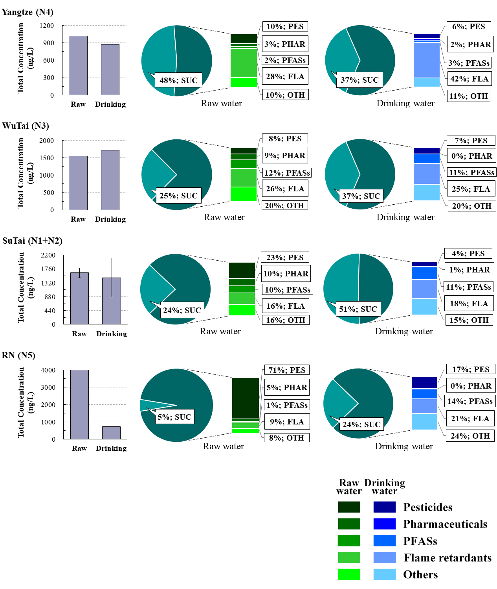

Figure 3 Total concentrations of detected micropollutants and percentage composition of sucralose and main compound categories in raw and drinking (finished) water for each site, with the most northern on top (N4), then going south (N3, N1+N2, and N5). Detected compounds above MDL and their concentrations are shown in Table A4 in Supporting Information. PES = pesticide, PHAR = pharmaceutical, FLA = flame retardant, PFAS = poly- and perfluoroalkyl substances, OTH = Others (food additive, fatty acid, surfactant, industrial chemical), ALL = all detected compounds in each DWTP.

The number of detected PFASs differed between the sampling sites, with the lowest number at the Yangtze River site (n=7; 14% of total number of detected compounds), whereas for other raw waters, the number of detected PFASs ranged from 9 to 10 (18%-18%), indicating upstream point sources of PFASs. The average concentration of ∑PFASs in the Tai Hu raw water (168 ± 22 ng L⁻¹) was significantly higher (two-sided Student’s t-test) than in the Yangtze River water (20 ng L⁻¹), and the water from the wetland river network (56 ng L⁻¹) (p=0.0003). Perfluorohexane sulfonic acid (PFHxS) was dominant in the Tai Hu water (60% of the ∑PFASs), whereas perfluorooctanoic acid (PFOA) was dominant in the water from wetland river network (63%). On the other hand, PFHxS, PFOA and perfluorobutanoic acid (PFBA) were equally dominant in the Yangtze River water (22%, 23 % and 27%, respectively). The PFAS concentrations were generally comparable to other river water concentrations in China [24] or in the River Rhine watershed in Europe [25], but lower than other parts of the world such as Sweden [26], or India [27].
Organophosphorus flame retardants was the major group of compounds in the Yangtze and Wu Tai water, with cumulative concentrations of 290 ng L⁻¹ and 405 ng L⁻¹ (28% and 26%), respectively. These levels are similar to Su Tai levels (266 ± 48 ng L⁻¹, but there the fraction of flame retardants was lower (16%). Previous research has also reported frequent detection of organophosphorus flame retardants, e.g., in Yangtze River water [9] and river water in Sweden [28]. Since the use of brominated flame retardants is decreasing because of environmental and human health risks, organophosphorus flame retardants has become widely produced and used since the 1970s [10]. Phosphorus flame retardants have been detected in abiotic compartments as well as in living organisms including humans [29, 30], indicating potential risk for environmental and human hazards.
The concentrations of the compound category ‘Others’, such as industrial chemicals (Table A4 in Supporting Information), were in the range 250-400 ng L⁻¹. The most dominating compound was butyl dihydrogen phosphate, a surface-active agent used as e.g., additive in lubricants and paints, with an overall (all sites) average concentration of 140 ± 48 ng L⁻¹.
An overall observation was that there was a composition profile change from north to south, i.e. going from Yangtze (N4), towards Wu Tai (N3), Su Tai (N1+N2) and river network (N5), with an increasing proportion of pesticides and a decreasing proportion of flame retardants in the samples. This tendency shows that local emission sources and land use play a large role for the overall pollution. It also suggests that the Yangtze River in the north and the river network in the south may influence different parts of Lake Tai Hu.

Drinking water quality
The number of micropollutants detected above MDL decreased with on average 22% through the drinking water treatment process (Figure 2 a). In total, 51 compounds were detected in at least one sample including pesticides (n=17), pharmaceuticals (n=9), PFASs (n=10), organophosphorus flame retardants (n=7), food additives (n=2), industrial chemicals (n=2), surfactants (n=3), and a fatty acid (n=1). Similar to the raw water, the pesticide group was the most prevalent pollution category with on average 13 compounds per sample, followed by PFASs (n=10), flame retardants (n=7), pharmaceuticals (n=6), and food additives (n=1).
The total concentrations of the micropollutants mostly decreased but also increased through the drinking water treatment process (Figure 3, bar charts). The overall (n=9) average total concentration was 730 ± 160 ng L⁻¹, and the concentration range was 720-2 700 ng L⁻¹. As in the raw water, sucralose dominated the concentration in every sample with a top concentration of 1 900 ng L⁻¹ (N1(s); 71% of total) and an overall average concentration of 630 ± 520 ng L⁻¹, which corresponds to a proportion of 30% or more in most of the samples. The average concentration is far higher than levels found in drinking water from northern China (110-160 ng L⁻¹) [31], and also higher than waste water treatment plant (WWTP) influents in some American cities (78-120 ng L⁻¹) [32].
The cumulative concentrations of other detected micropollutants (without sucralose) were in the range of 540-1 100 ng L⁻¹ including all sites. The lowest value was 550 ng L⁻¹ (river network), which is approximately 10 times higher than the micropollutant concentration in drinking water from northern Europe (Sweden) [18], where a similar set of compounds were targeted (134 compounds and an overlap of 43% with the current study). Because of the relatively high removal rates of pesticides and pharmaceuticals, the PFASs, flame retardants and the category ‘Others’ were the dominant micropollutants in the drinking water (Figure 3).
The concentration of ∑PFASs ranged from 110 to 200 ng L⁻¹ at N1-N3 (Tai Hu Basin water; Su Tai/Wu Tai), and was 27 ng L⁻¹ in the sample from N4 (Yangtze River water). The PFHxS was the dominant PFAS in Tai Hu (60-120 ng L⁻¹, N1-N3), while PFBA was the highest PFAS in Yangtze River (11 ng L⁻¹) and PFOA was the highest in the river network water (54 ng L⁻¹). The PFAS concentrations in drinking water were generally higher than those in drinking water from USA, Brazil, Spain, and France [33-35].
Flame retardants was the main micropollutant category in drinking water from the Yangtze River (370 ng L⁻¹; 42 % of total) and generally contributed to more than 20% of the total concentration of all compounds in the drinking water at all sites, except for N1(s). Overall (all sites), the compounds with the highest concentrations were TEP (average 120 ng L⁻¹) and TCEP (average 96 ng L⁻¹). These two organophosphorus flame retardants are at almost the same concentration as levels reported from the Netherlands (48-100 ng L⁻¹) [16]. Another compound with high concentration was butyl dihydrogen phosphate (average 130 ng L⁻¹), an industrial chemical, rarely (if ever) reported as present in drinking water before. The occurrence of micropollutants in drinking water is dependent on the quality of water source (Figure 3) as well as on the treatment efficiency at the DWTP. In the next section, the impact of the treatment process is examined.

Removal efficiency
The removal efficiencies for all compounds at all DWTPs are given in Table A5 in Supporting Information and are illustrated in Figure 4. The overall average removal efficiency of all compounds averaged 24 ± 149 % (N1-N5, n=9, including the two extra samples and the duplicates at N1+N2). The removal of pesticides averaged 65 ± 50 % and the pharmaceuticals 74 ± 49 %, while the removal of other compound categories were significantly lower (p<10⁻⁸, two-sided Student’s t-test), with average efficiencies of 3 ± 99 % for ‘Others’ (food additives, surfactant, industrial chemicals, fatty acid), -1 ± 13% for flame retardants, and -140 ± 329% for PFASs. Thus, the flame retardants showed negative treatment efficiencies, which means they boosted through the treatment process. Similarly, the removal of PFASs was often inefficient or even negative at the investigated DWTPs. Previous studies have shown that conventional treatment techniques are inefficient in removing PFASs [36]. Negative removal efficiency may be explained by time-dependent concentrations and the lag time between sampling raw and finished water, degradation of PFAS precursors to persistent PFASs [37] and desorption/breakthrough of PFASs from granular activated carbon (GAC) or other filter types within the DWTP [38]. GAC and anion exchange filters are currently used for removal of PFASs in DWTPs; however, development of new treatment options are needed, in particular for the shorter chain PFASs [38-40].
There were no significant differences in the removal efficiencies of all detected compounds among the five DWTP (p>0.06, two-sided Student’s t-test), although the DWTPs used different treatment strategies (Figures 1b and 4a). It should be noted that three of the DWTPs use ozonation, i.e. advanced treatment technology; yet removal efficiencies are moderate to low. This demonstrates the major challenge in removing organic micropollutants through modern drinking water treatment technologies.
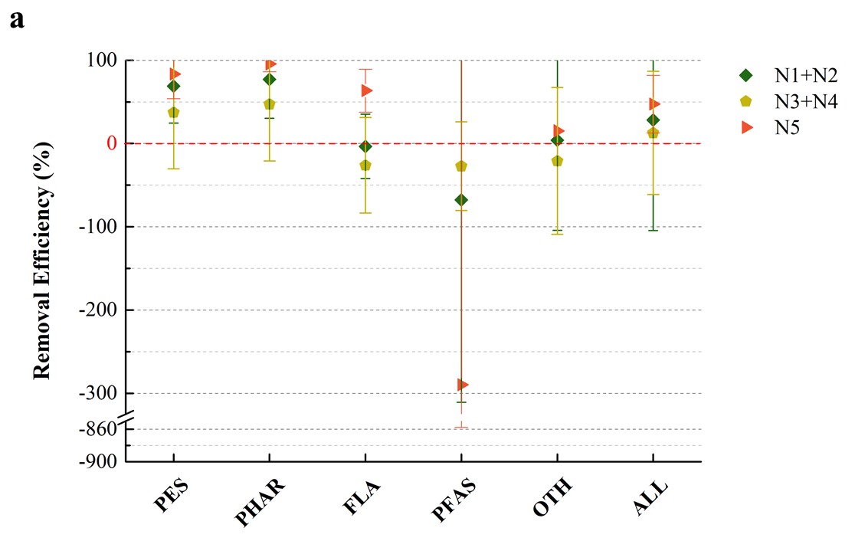

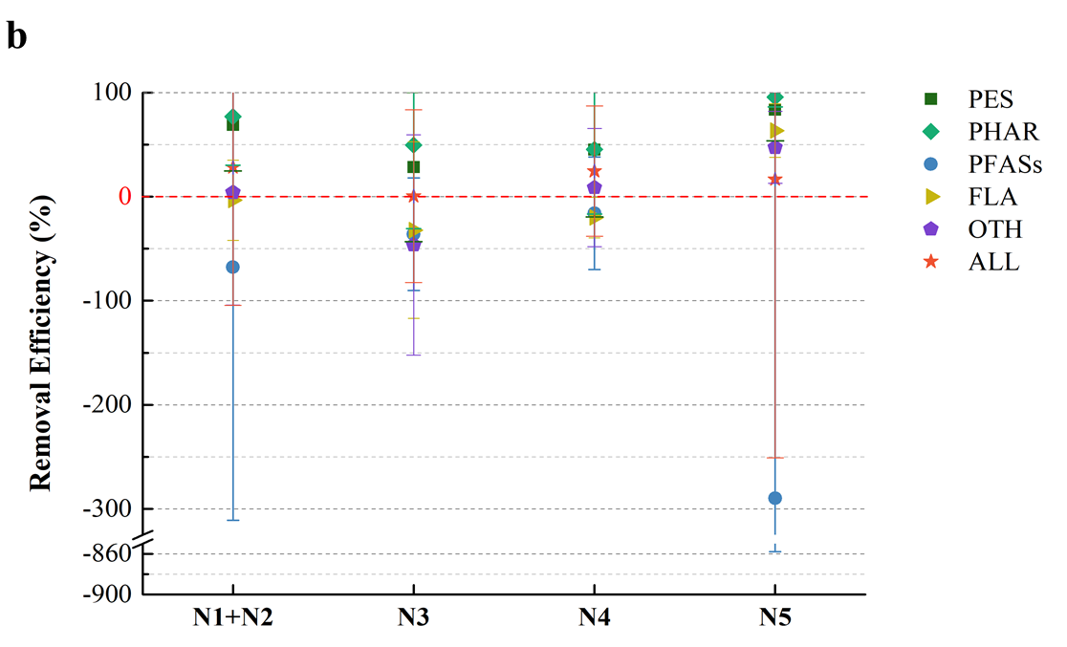

Figure 4 Treatment efficiency for (a) each compound category for DTWPs with similar treatment strategy and (b) DWTPs with similar treatment strategy per compound category. PES = pesticide, PHAR = pharmaceutical, FLA = flame retardant, PFAS = poly- and perfluoroalkyl substances, OTH = Others (food additive, fatty acid, surfactant, industrial chemical), ALL = all detected compounds in each DWTP.

The removal efficiencies among different treatment strategies are shown in Figure 4b. N1, N2 and N5 have ozone treatment and biological activated carbon filter (BACF) in contrast to N3 and N4. Additionally, N5 has an extra biological pretreatment step as compared to N1-N4. The removal efficiencies of the pesticides and the pharmaceuticals at N3+N4 were significantly lower than at N1+N2 and N5 (p<0.05, two-sided Student’s t-test), which shows that the conventional treatment (sedimentation, filtration and disinfection) cannot remove pesticides and pharmaceuticals in water effectively. On the other hand, N1+N2 and N5 with their more advanced treatment process (including ozonation) were successful with these two substance groups. This is also illustrated for N5 in Figure 3, with a 5-fold drop in total concentration from raw to drinking water (from 3990 to 720 ng L⁻¹, going from 76% ‘pesticides + pharmaceuticals’ of total to 17%). The removal efficiency of flame retardants in N5 was also rather efficient, with significantly higher efficiency than N1+N2 and N3+N4 (p<0.02, two-sided Student’s t-test). This suggests that the biological treatment has the ability to remove flame retardants in water.
[36][37][38]

Potential human health risks of sucralose
The artificial sweetener sucralose was the dominant micropollutant in both raw and drinking water and this may cause human health concern. Sucralose is widely used in the food industry since the 1970s, because of its sweet taste and stability. Sucralose has been shown to be a persistent, ubiquitously occurring environmental pollutant [20, 41] and is
commonly detected in wastewater, surface water, groundwater and [20, 22]drinking water [20, 22, 42]. It has been tested for toxicity, and there are some reports on that exposure may led to negative effects e.g., on locomotion and physiological behavior of crustaceans [43]. However, there is a lack of studies focusing on chronical and low-dose effects [44, 45]. Rahn et al. [46] found that sucralose can degrade and produce chloropropanols (3-monochloropropanediol and 1,2- and 1,3-dichloropropanols) under thermal decomposition. These metabolites are known as a potentially toxic class of compounds that may cause cancer [47]. Another study indicated that ingestion of sucralose may affect the glucose metabolism of obese people who rarely use non-nutritive sweeteners [48]. More studies on the toxicity of sucralose are needed, and it is also important to consider the potential toxicity of its metabolites, which e.g., are formed during cooking under high temperature [49], a common practice in China.

Conclusions
Our study has shown that finished (drinking) water quality is dependent both on source water quality and treatment strategies. If the source water contains high levels of PFASs, flame retardants and other pollutants (e.g. sucralose and butyl dihydrogen phosphate), even advanced treatment procedures, including e.g. ozonation, are inefficient and the finished water may contain cumulative micropollutant levels in the mg L⁻¹ range. On the other hand, if the dominating pollution categories are pesticides and pharmaceuticals, high overall treatment efficiencies can be obtained if using advanced treatment steps, while DWTPs using conventional treatment likely have poor removal of organic micropollutants. DWTPs have the challenging task of purifying “reused” water, i.e. water that was contaminated by organic micropollutants originating from upstream effluents, such as WWTP and industrial effluents. For improved overall drinking water quality, it is imperative that water quality comes into focus in the water sector as a whole. DWTPs should pay attention to the characteristics of their source water and make efforts in using efficient treatment processes, enhancing the quality of finished water. In our study, organic micropollutants were found in drinking water at cumulative levels from 0.7 mg L⁻¹ up to 2.7 mg L⁻¹, clearly demonstrating the challenge with organic micropollutants in the water from source to tap. Thus, advanced drinking water treatment techniques or alternative drinking water source areas are needed to guarantee safety of drinking water. Overall, more data on human health risks associated with a continues intake of potentially hazardous organic micropollutants and mixtures (cocktails) of them are needed to support risk assessment activities for drinking water.

List of abbreviations
Drinking water treatment plant (DWTP)
Waste water treatment plant (WWTP)
Pharmaceuticals and personal care products (PCCPs)
Internal standards (ISs)
Ultra-performance liquid chromatography (UPLC)
Time-of-flight mass spectrometer (ToF MS)
Method detect limit (MDL)
Solid phase extraction (SPE)
Phthalate esters (PAEs)
Organochlorine pesticides (OCPs)
Poly- and perfluoroalkyl substances (PFASs)
Cresyl diphenyl phosphate (CDP)
Triphenyl phosphate (TPHP)
Tris(2-butoxyethyl) phosphate (TBEP)
Tris(2-chloroethyl) phosphate (TCEP)
Triethyl phosphate (TEP)
N, N-diethyl-m-toluamide (DEET)
Perfluorohexane sulfonic acid (PFHxS)
Perfluorooctanoic acid (PFOA)
Perfluorobutanoic acid (PFBA)
Granular activated carbon (GAC)
Biological activated carbon filter (BACF)

Supporting Information
Supporting Information.docx

Declarations

Ethics approval and consent to participate
Not applicable

Consent for publication
Not applicable.

Availability of data and material
Not applicable.

Competing interests
The authors declare that they have no competing interests.

Funding
This work was supported by the National Major Science and Technology Project of China (2018ZX07701001-22), the National Natural Science Foundation of China (grant number 21876136), and the Swedish Research Council for Sustainable Development (Formas) through the DANTE and LakePOPs projects (grant numbers 2018-02256 and 2016-01173).

Authors’contributions
HR was the major contributor in experiments, data analysis and manuscript writing. HR and DY designed the study. RT helped with the instrumental analysis, micropollutant quantification, and quality assurance / quality control of data. KW and LA contributed to data evaluation and manuscript writing. KW and DY contributed to improvements of the manuscript. All authors read and approved the final manuscript.

Acknowledgements
This work was supported by the National Major Science and Technology Project of China (2018ZX07701001-22), the National Natural Science Foundation of China (grant number 21876136), and the Swedish Research Council for Sustainable Development (Formas) through the DANTE and LakePOPs projects (grant numbers 2018-02256 and 2016-01173).

Authors’ details
ª Key Laboratory of Yangtze River Water Environment, Ministry of Education, College of Environmental Science and Engineering, Tongji University, Shanghai 200092, China
^{b} Department of Aquatic Sciences and Assessment, Swedish University of Agricultural Sciences (SLU), Box 7050, SE-750 07 Uppsala, Sweden

Figure Captions
Figure 1 (a) Map showing the sampling locations at the Tai Hu Basin within the Yangtze River Delta (N1-N5). (b) DWTP treatment strategies and raw water sampling point. N1-N5: 5 different DWTP. PAC = powdered activated carbon, BACF = biological activated carbon filter, OZONE = ozone contactor, SED = flocculation/sedimentation, SAND = sand filter, COAG = aluminum coagulation, BP = biological pretreatment, FLO = flocculant, KMnO₄/Cl₂/Alum = chemical additive, SP = sampling point of raw water.

Figure 2 (a) Total number of compounds detected above MDL in raw and drinking (finished) water at the different sites. Su Tai shows the average (and error bars) of samples from N1 and N2 (n=6: 2 sites, 2 sampling occasions and 1 duplicate sample), while other bars show the result from n=1; (b) The fraction of the number of detected compounds (in relation to total) is shown on a compound category basis for each site. Compounds detected above MDL and their concentrations are given in Table A4 in Supporting Information. RN=river network.

Figure 3 Total concentrations of detected micropollutants and percentage composition of sucralose and main compound categories in raw and drinking (finished) water for each site, with the most northern on top (N4), then going south (N3, N1+N2, and N5). Detected compounds above MDL and their concentrations are shown in Table A4 in Supporting Information. PES = pesticide, PHAR = pharmaceutical, FLA = flame retardant, PFAS = poly- and perfluoroalkyl substances, OTH = Others (food additive, fatty acid, surfactant, industrial chemical), ALL = all detected compounds in each DWTP.
Figure 4 Treatment efficiency for (a) each compound category for DTWPs with similar treatment strategy and (b) DWTPs with similar treatment strategy per compound category. PES = pesticide, PHAR = pharmaceutical, FLA = flame retardant, PFAS = poly- and perfluoroalkyl substances, OTH = Others (food additive, fatty acid, surfactant, industrial chemical), ALL = all detected compounds in each DWTP.

Refences
1. Schwarzenbach, R.P., et al., The challenge of micropollutants in aquatic systems. Science, 2006. 313(5790): p. 1072-1077.
2. Reemtsma, T., et al., Mind the Gap: Persistent and Mobile Organic Compounds Water Contaminants That Slip Through. Environmental Science & Technology, 2016. 50(19): p. 10308-10315.
3. Benotti, M.J., et al., Pharmaceuticals and endocrine disrupting compounds in US drinking water. Environmental science & technology, 2008. 43(3): p. 597-603.
4. Niimi, A.J. and B.G. Oliver, Biological half-lives of polychlorinated biphenyl (PCB) congeners in whole fish and muscle of rainbow trout (Salmo gairdneri). Can.J.Fish.Aquat.Sci., 1983. 40: p. 1388-1394.
5. Tiehm, A., et al., Tai Hu (China): Water quality and processes - From the source to the tap. Science of the Total Environment, 2020. 712: p. 5.
6. Yan, C., et al., Antibiotics in the surface water of the Yangtze Estuary: occurrence, distribution and risk assessment. Environ Pollut, 2013. 175: p. 22-9.
7. Chen, H., et al., Distribution, source, and environmental risk assessment of phthalate esters (PAEs) in water, suspended particulate matter, and sediment of a typical Yangtze River Delta City, China. Environ Sci Pollut Res Int, 2019. 26(24): p. 24609-24619.
8. Jin, X., et al., Risk assessment of organochlorine pesticides in drinking water source of the Yangtze River. Ecotoxicol Environ Saf, 2019. 182: p. 109390.
9. Peng, Y., et al., Screening hundreds of emerging organic pollutants (EOPs) in surface water from the Yangtze River Delta (YRD): Occurrence, distribution, ecological risk. Environ Pollut, 2018. 241: p. 484-493.
10. Zhu, B., et al., Conventional and emerging halogenated flame retardants (HFRs) in sediment of Yangtze River Delta (YRD) region, East China. Chemosphere, 2013. 93(3): p. 555-60.
11. Su, G., et al., Occurrence of additive brominated flame retardants in aquatic organisms from Tai Lake and Yangtze River in Eastern China, 2009-2012. Chemosphere, 2014. 114: p. 340-6.
12. Zheng, B., et al., Distribution characteristics of poly- and perfluoroalkyl substances in the Yangtze River Delta. J Environ Sci (China), 2017. 61: p. 97-109.
13. Floehr, T., et al., Solution by dilution?-A review on the pollution status of the Yangtze River. Environmental Science and Pollution Research, 2013. 20(10): p. 6934-6971.
14. Qu, Y., et al., Poly- and perfluoroalkyl substances in a drinking water treatment plant in the Yangtze River Delta of China: Temporal trend, removal and human health risk. Science of The Total Environment, 2019. 696: p. 133949.
15. Richardson, S.D., Disinfection by-products and other emerging contaminants in drinking water. Trac-Trends in Analytical Chemistry, 2003. 22(10): p. 666-684.
16. Houtman, C.J., et al., Statistical analysis of a large set of semi-quantitative GC-MS screening data to evaluate and prioritize organic contaminants in surface and drinking water of the Netherlands. Sci Total Environ, 2019. 697: p. 133806.
17. Troger, R., et al., A case study of organic micropollutants in a major Swedish water source - Removal efficiency in seven drinking water treatment plants and influence of operational age of granulated active carbon filters. The Science of the total environment, 2019: p. 135680-135680.
18. Troger, R., et al., Micropollutants in drinking water from source to tap - Method development and application of a multiresidue screening method. Science of the Total Environment, 2018. 627: p. 1404-1432.
19. Escher, B.I., et al., Benchmarking Organic Micropollutants in Wastewater, Recycled Water and Drinking Water with In Vitro Bioassays. Environ Sci Technol. 48: p. 1940−1956.
20. Lange, F.T., M. Scheurer, and H.-J. Brauch, Artificial sweeteners—a recently recognized class of emerging environmental contaminants: a review. Analytical and bioanalytical chemistry, 2012. 403(9): p. 2503-2518.
21. Ruff, M., et al., Quantitative target and systematic non-target analysis of polar organic micro-pollutants along the river Rhine using high-resolution mass-spectrometry - Identification of unknown sources and compounds. Water Research, 2015. 87: p. 145-154.
22. Morlock, G.E., L. Schuele, and S. Grashorn, Development of a quantitative high-performance thin-layer chromatographic method for sucralose in sewage effluent, surface water, and drinking water. J Chromatogr A, 2011. 1218(19): p. 2745-53.
23. Robles-Molina, J., et al., Monitoring of selected priority and emerging contaminants in the Guadalquivir River and other related surface waters in the province of Jaen, South East Spain. Sci Total Environ, 2014. 479-480: p. 247-57.
24. Lu, Z., et al., Occurrence and trends in concentrations of perfluoroalkyl substances (PFASs) in surface waters of eastern China. Chemosphere, 2015. 119: p. 820-827.
25. Moller, A., et al., Distribution and sources of polyfluoroalkyl substances (PFAS) in the River Rhine watershed. Environmental Pollution, 2010. 158(10): p. 3243-3250.
26. Gobelius, L., et al., Per- and Polyfluoroalkyl Substances in Swedish Groundwater and Surface Water: Implications for Environmental Quality Standards and Drinking Water Guidelines. Environmental Science & Technology, 2018. 52(7): p. 4340-4349.
27. Sharma, B.M., et al., Perfluoroalkyl substances (PFAS) in river and ground/drinking water of the Ganges River basin: Emissions and implications for human exposure. Environmental Pollution, 2016. 208: p. 704-713.
28. Gustavsson, J., et al., Seasonal trends of legacy and alternative flame retardants in river water in a boreal catchment. Sci Total Environ, 2019. 692: p. 1097-1105.
29. Wei, G.L., et al., Organophosphorus flame retardants and plasticizers: sources, occurrence, toxicity and human exposure. Environ Pollut, 2015. 196: p. 29-46.
30. Greaves, A.K. and R.J. Letcher, A Review of Organophosphate Esters in the Environment from Biological Effects to Distribution and Fate. Bull Environ Contam Toxicol, 2017. 98(1): p. 2-7.
31. Gan, Z., et al., A novel solid-phase extraction for the concentration of sweeteners in water and analysis by ion-pair liquid chromatography-triple quadrupole mass spectrometry. J Chromatogr A, 2013. 1274: p. 87-96.
32. Currens, B.J., et al., Use of acetaminophen and sucralose as co-analytes to differentiate sources of human excreta in surface waters. Water Res, 2019. 157: p. 1-7.
33. Hu, X.C., et al., Detection of Poly- and Perfluoroalkyl Substances (PFASs) in US Drinking Water Linked to Industrial Sites, Military Fire Training Areas, and Wastewater Treatment Plants. Environmental Science & Technology Letters, 2016. 3(10): p. 344-350.
34. Ericson, I., et al., Levels of Perfluorinated Chemicals in Municipal Drinking Water from Catalonia, Spain: Public Health Implications. Archives of Environmental Contamination and Toxicology, 2009. 57(4): p. 631-638.
35. Schwanz, T.G., et al., Perfluoroalkyl substances assessment in drinking waters from Brazil, France and Spain. Science of the Total Environment, 2016. 539: p. 143-152.
36. Post, G.B., P.D. Cohn, and K.R. Cooper, Perfluorooctanoic acid (PFOA), an emerging drinking water contaminant: A critical review of recent literature. Environmental Research, 2012. 116: p. 93-117.
37. Butt, C.M., D.C.G. Muir, and S.A. Mabury, BIOTRANSFORMATION PATHWAYS OF FLUOROTELOMER-BASED POLYFLUOROALKYL SUBSTANCES: A REVIEW. Environmental Toxicology and Chemistry, 2014. 33(2): p. 243-267.
38. McCleaf, P., et al., Removal efficiency of multiple poly- and perfluoroalkyl substances (PFASs) in drinking water using granular activated carbon (GAC) and anion exchange (AE) column tests. Water Res, 2017. 120: p. 77-87.
39. Ateia, M., et al., Efficient PFAS Removal by Amine-Functionalized Sorbents: Critical Review of the Current Literature. Environmental Science & Technology Letters, 2019. 6(12): p. 688-695.
40. Gagliano, E., et al., Removal of poly- and perfluoroalkyl substances (PFAS) from water by adsorption: Role of PFAS chain length, effect of organic matter and challenges in adsorbent regeneration. Water Research, 2020. 171: p. 31.
41. Soh, L., et al., Fate of sucralose through environmental and water treatment processes and impact on plant indicator species. Environ Sci Technol, 2011. 45(4): p. 1363-9.
42. Buerge, I.J., et al., Ubiquitous Occurrence of the Artificial Sweetener Acesulfame in the Aquatic Environment: An Ideal Chemical Marker of Domestic Wastewater in Groundwater. Environmental Science & Technology, 2009. 43(12): p. 4381-4385.
43. Hjorth, M., J.H. Hansen, and L. Camus, Short-term effects of sucralose on Calanus finmarchicus and Calanus glacialisin Disko Bay, Greenland. Chemistry and Ecology, 2010. 26(5): p. 385-393.
44. Grotz, V.L., et al., A 12-week randomized clinical trial investigating the potential for sucralose to affect glucose homeostasis. Regul Toxicol Pharmacol, 2017. 88: p. 22-33.
45. Berry, C., et al., Sucralose Non-Carcinogenicity: A Review of the Scientific and Regulatory Rationale. Nutr Cancer, 2016. 68(8): p. 1247-1261.
46. Rahn, A. and V.A. Yaylayan, Thermal degradation of sucralose and its potential in generating chloropropanols in the presence of glycerol. Food Chemistry, 2010. 118(1): p. 56-61.
47. Farooqui and A. A., High Calorie Diet and the Human Brain. 10.1007/978-3-319-15254-7.
48. Pepino, M.Y., et al., Sucralose affects glycemic and hormonal responses to an oral glucose load. Diabetes Care, 2013. 36(9): p. 2530-5.
49. Pu, G.W., et al., Study on the Use of Cooking Oil in Chinese Dishes. International Journal of Environmental Research and Public Health, 2019. 16(18): p. 7.

